LIMNOLOGICAL DETERMINANTS OF PERIPHYTIC ALGAE ASSEMBLAGE ON MACROPHYTE IN THE HUMIC FRESHWATER ECOSYSTEM OF ENIONG RIVER, ITU NIGERIA

.
ABSTRACT

Aims: This research evaluate how limnological parameters influence the composition and distribution of periphytic algal communities in the Eniong River, a humic freshwater ecosystem in Itu, Nigeria.
Study design:A stratified random sampling design was employed to ensure comprehensive coverage of the river ecosystem. The river was divided into four zones based on geomorphological characteristics and land use patterns and four representative sampling stations were selected for analysis..
Place and Duration of Study:The study was conducted along the Eniong River in Itu, Nigeria, during the wet season from April to October 2024 and a dry season from November 2023 to March 2024 to capture the influence of nutrient runoff and anthropogenic activities on water quality.
Methodology:Periphytic algae were collected manually from submerged surfaces of aquatic macrophytes using a standardized scraping technique, with samples preserved in Lugol’s iodine solution.Algal identification was carried out under a compound microscope using established taxonomic keyswhile Limnological variables were conducted based on standard methods as described in APHA. A total of 48 species were identified
Results: Physicochemical conditions indicated significant eutrophication and heavy metal stress. The pH ranged from 6.15 to 6.715, slightly below the upper limit of recommended standards, while water temperature remained consistently around 26 °C. Although conductivity and TDS were low, the system displayed very low alkalinity and hardness, rendering it vulnerable to pH fluctuations and metal toxicity. Nutrient concentrations were alarmingly high, with nitrate and phosphate levels far exceeding WHO and NESREA limits, driving eutrophication. Concurrently, elevated levels of heavy metals (chromium, lead, iron, nickel, and cadmium) were observed. These combined stressors favored the proliferation of opportunistic, eutrophication- and metal-tolerant periphytic algae such as Closterium moniliferum and Fragilaria javanica while more sensitive taxa were notably absent.
Conclusion:The findings underscore the critical role of multivariate limnological factors in shaping algal assemblages and highlight the potential of periphytic algae as bioindicators for assessing ecosystem health in tropical freshwater environments.

Keywords: Periphytic algae, Limnology, Black water, Diversity, Pollution

1. INTRODUCTION

Freshwater ecosystems are indispensable for maintaining global biodiversity, serving as habitats for a diverse array of aquatic organisms. Among these, periphytic algae are complex communities of microorganisms adhering to submerged surfaces and play a pivotal role in primary production, nutrient cycling, and as foundational elements of aquatic food webs (Denise et al., 2022). The composition and diversity of periphytic algae are intricately influenced by various limnological factors, including light availability, nutrient concentrations, and hydrological conditions (Bellinger and Sigee, 2015). Humic substances, derived from the decomposition of organic matter, impart a characteristic brown coloration to water bodies and can significantly affect light penetration and nutrient dynamics within aquatic systems (Sharma and Anthal, 2016). The Eniong River in Itu, Nigeria, exemplifies a humic freshwater ecosystem where these interactions are pronounced (Essien et al., 2025). Understanding how limnological determinants shape periphytic algae assemblages in such environments is essential for assessing ecosystem health and functionality. Given the ecological significance of periphytic algae and the unique characteristics of humic freshwater systems, it is imperative to investigate the specific limnological determinants that govern periphytic algal assemblages on macrophytes in the Eniong River. Such studies will enhance our understanding of ecosystem processes and inform conservation and management strategies for similar freshwater environments.

Sources

2. material and methods

2.1 Study Area Description

The study was conducted on the Eniong River, a tributary of the Cross River, located in Itu Local Government Area of Akwa Ibom State, Nigeria. The river lies approximately between latitudes 5°10' and 5°30' N and longitudes 7°45' and 8°00' E (Etuk et al., 2020). The climate of the area is characterized by two distinct seasons: a the wet season from April to October 2024 and a dry season from November 2023 to March 2024. The area is well represented by structurally controlled ridges, denudation, hills, extensive wetlands and alluvial plains forming soil covers of silty clay, sandy and heavily weathered loamy and alluvium. The area enjoys tropical climate and the temperature ranges from 26º to 32º C. The fluctuations in temperature are fairly uniform in character, except during the dry months when the rise in temperature is higher than it is during the long wet period and the level of humidity is high (84%) due to close proximity to the main Cross River Channel. The mean annual rainfall ranges from 2000 to 3000 mm (Akpan et al., 2018). The Eniong River flows through a landscape dominated by tropical rainforest and mangrove swamps. The river basin is influenced by natural processes and anthropogenic activities, including agriculture, fishing, and small-scale industrial operations. The surrounding vegetation contributes significant amounts of organic matter to the river, resulting in its humic nature (Akpan et al., 2018)
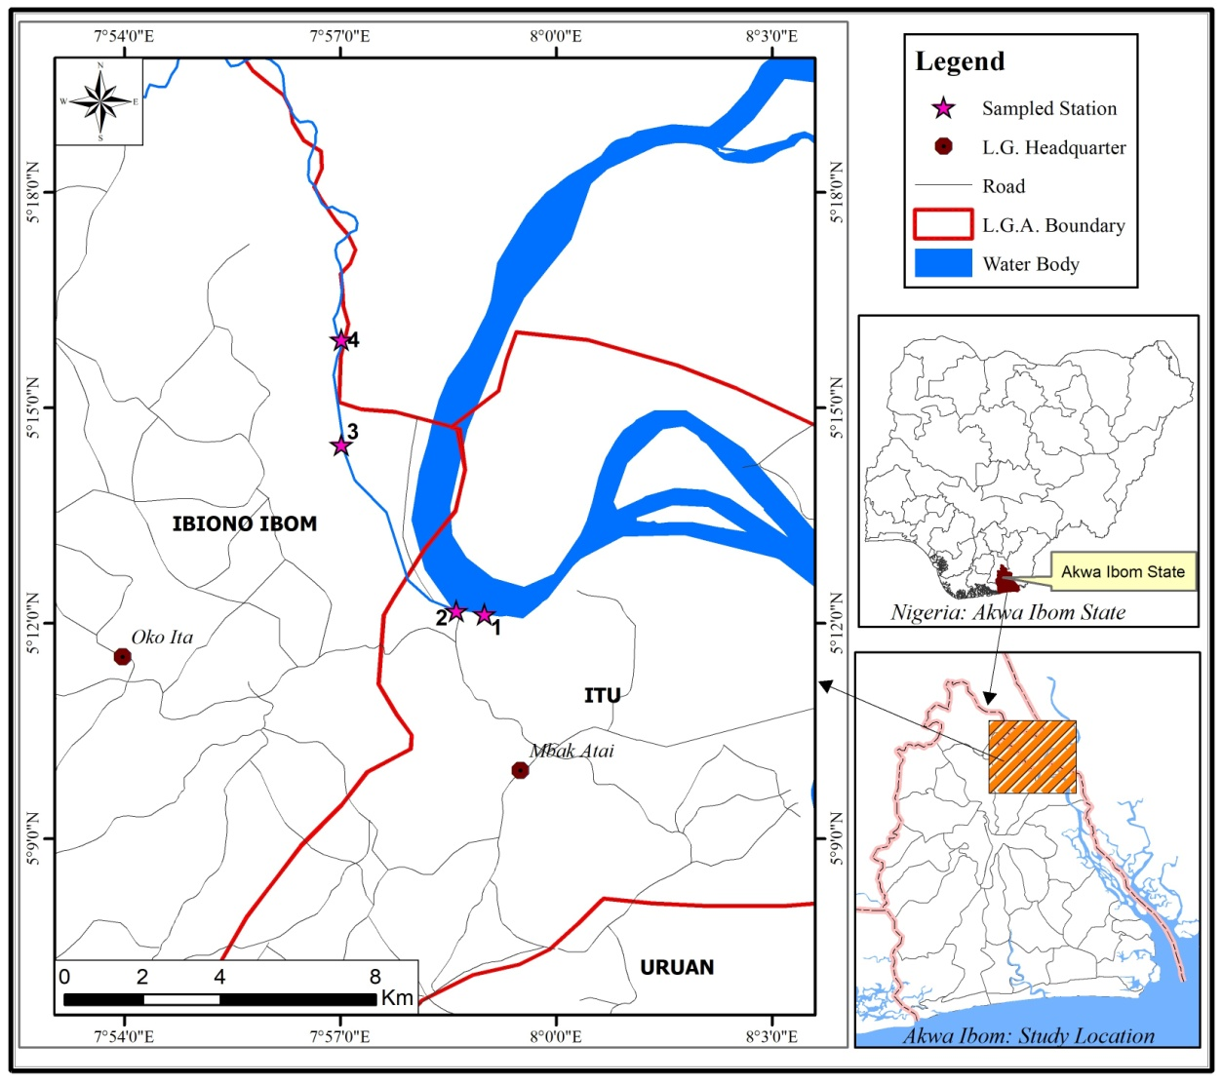
Fig. 1. Map of Eniong river showing sampling stations (source: Field data)

2.2 Sampling Design and Data Collection

A stratified random sampling design was employed to ensure comprehensive coverage of the river ecosystem. The river was divided into four zones (upper, middle, mid low and lower reaches) based on geomorphological characteristics and land use patterns for collection of periphytic algae and limnological data. Periphytic algae were collected manually four sampling times per season from four sampling Stations selected as representative of the entire river ecosystem. Station 1 and 4 were selected for comparison of species composition between river inlet and outlet, respectively. Station 2 was close to settlement area having higher exposure to anthropogenic activities whereas Station 3 was distant from settlements.Periphytic algae samples were collected from submerged surfaces of aquatic macrophytes, and woody debris, using a standardized scraping technique.The scraped material was preserved in Lugol’s iodine solution for subsequent analysis.In the laboratory, samples were homogenized, and aliquots were examined under a compound microscope at varying magnifications.Algae were identified to the lowest possible taxonomic level using identification keys and guides, such as those provided by Wehr and Sheath (2003). Limnological variables including water temperature (WT), pH, conductivity and dissolved oxygen (DO) were analysed in situ using HACH portable multimeter (Model HQ30d) and turbidity using EUTECH TN100 portable turbidimeter. Laboratory analysis of water alkalinity, Biological oxygen demand (BOD), nitrate NO₃-N, phosphate PO₄-P. total nitrogen (TN) and total Phosphorus (TP) was conducted based on standard methods as described in APHA (American Public Health Association (APHA), 2017; Hauer & Lamberti, 2017). Atomic Absorption Spectroscopy (AAS) was employed in solid sample digestion for heavy metal using standard methods as described in APHA (American Public Health Association (APHA), 2017; Hauer & Lamberti, 2017)
2.4 Data Analysis and Statistical Methods

Descriptive statistics were utilized to summarize physicochemical parameters and periphytic algae data. Spatial and temporal variations were assessed using Analysis of Variance (ANOVA), with significance set at p<0.05. Multivariate analyses such as Principal Component Analysis (PCA) were conducted to elucidate relationships between environmental variables and periphytic algae assemblages.

3. results and discussion

Table 1. Mean and standard error values of Surface water physicochemical parameters for four Stations
Water Parameter | Station 1(control) | Station 2 | Station 3 | Station 4 | WHO limits(2011) | NESREA limits
pH | 6.150±0.050 | 6.460±0.390 | 6.435±0.365 | 6.715±0.225 | 6.5–8.5 | 6.5–8.5
Temperature (ºC) | 26.250±1.750 | 26.050±1.950 | 26.050±2.050 | 26.250±2.150 | ≤30 | ≤30
Conductivity (mS/cm) | 34.50±2.500 | 34.50±7.500 | 35.00±4.00 | 35.50±2.500 | 1000 µS/cm | ≤250
Total Dissolved Solids (ppt) | 17.50 ±1.500 | 16.50± 3.500 | 18.50±2.500 | 17.50 ±1.500 | ≤500 | ≤500
Alkalinity (mg/L) | 0.770 ±0.730 | 0.990±0 .910 | 0.660±0.540 | 1.130±0 .950 | 200 | 20–200
Total Suspended Solids (mg/L) | 19.705±9.595 | 33.150±12.150 | 40.650±1.350 | 29.500±17.500 | 30 | ≤30
Total Hardness (mg/L) | 2.400±0 .600 | 4.550±1.450 | 5.300 ±4.000 | 6.150±1.332 | 500 | 100–500
DO (mg/L) | 13.210±10.290 | 13.100± 9.300 | 15.200±10.700 | 16.00±11.900 | ≥5 | ≥5
BOD (mg/L) | 0.550±0 .450 | 1.405 ±1.195 | 1.750 ±1.650 | 2.205±1.995 | ≤3 | ≤3
Magnesium Carbonate (mg/L) | 0.250±0.050 | 0.300±0 .260 | 0.890±0.010 | 1.975±1.425 | - | 30
Calcium Carbonate (mg/L) | 1.250±1.250 | 1.350 ± 1.350 | 1.100±1.100 | 2.350±2.350 | ≤100 | ≤100
Nitrate (mg/L) | 81.420±51.32 | 104.885±76.53 | 88.220±62.22 | 84.295±57.295 | ≤10 | ≤10
Phosphate (mg/L) | 0.760 ±0.590 | 1.320±0.700 | 0.760 ±0.320 | 0.830±0.720 | ≤0.5 | 0.03–0.5
Sulphate (mg/L) | 6.603±6.397 | 6.884 ±6.786 | 5.110± 4.890 | 6.533±6.466 | ≤250 | ≤200
Chromium (mg/L) | 0.174±0.128 | 0.061±0.045 | 0.063±0.047 | 0.066±0.040 | ≤0.05 | ≤0.05
Manganese (mg/L) | 0.079±0.010 | 0.0550±0.032 | 0.071±0.012 | 0.070±0.028 | ≤0.4 | ≤0.05
Lead (mg/L) | 0.242±0.221 | 0.232±0.21 | 0.192±0.176 | 0.246±0.220 | ≤0.01 | ≤0.01
Zinc (mg/L) | 0.025±0.009 | 0.014±0.011 | 0.030±0.007 | 0.021±0.008 | ≤3.0 | ≤3.0
Copper (mg/L) | 0.196±0.156 | 0.164±0.129 | 0.163±0.127 | 0.125±0.087 | ≤2.0 | ≤1.0
Magnesium (mg/L) | 0.167±0.033 | 0.030±0.010 | 0.464±0.435 | 1.724 ±1.675 | ≤50 | ≤50
Iron (mg/L) | 6.826±4.414 | 8.190±2.517 | 7.303±3.880 | 9.320± 9.320 | ≤0.3 | ≤0.3
Calcium (mg/L) | 4.372±1.872 | 2.390±0 .301 | 2.210±0.010 | 6.276 ±1.576 | ≤75 | ≤75
Nickel (mg/L) | 0.036±0.033 | 0.029±0.016 | 0.028±0.021 | 0.021±0.026 | ≤0.02 | ≤0.02
Cadmium (mg/L) | 0.229±0.204 | 0.228±0.203 | 0.173±0.148 | 0.195±0.178 | ≤0.003 | ≤0.003

The water quality of the Eniong River, as characterized by its physicochemical and biological parameters, provides clear evidence of a system under significant eutrophication and heavy metal stress. These environmental conditions play a critical role in structuring periphytic algal communities, which colonize submerged surfaces such as macrophytes (Pontederia crassipes, Pistia stratiotes, Ludwigia adscendens, Vossia cuspidata, Ceratophyllum submersum, and Ipomoea aquatica (Nkwoji et al., 2021).Elevated levels of nitrogen (N) and phosphorus (P), often driven by agricultural runoff, sewage discharge, and urban effluents, fuel algal blooms and shift community composition toward fast-growing, opportunistic species. Diatoms, while sensitive to water quality, can be early indicators of such eutrophication processes. Studies show that species such as Navicula malice, and Gomphonema parvulum tend to dominate under nutrient-rich, disturbed conditions due to their high tolerance for organic pollution and low dissolved oxygen (DO) concentrations (Taylor et al., 2007; Bellinger and Sigee, 2015). In the Eniong River, this nutrient loading likely promotes filamentous green algae and eutrophic-tolerant diatoms, while simultaneously suppressing more sensitive taxa like Fragilaria species that prefer oligotrophic to mesotrophic conditions (Kelly, 2003). Comparatively, the Ikot Ebak River in Akwa Ibom State, Nigeria, exhibits similar limnological determinants affecting periphytic algae assemblages. The presence of diatoms and Euglena indicates organic pollution, while Oscillatoria denotes nutrient enrichment (Denise,et al., 2022).
The pH values range from 6.15 to 6.715, which sit toward the lower end of the acceptable spectrum (WHO and NESREA limits: 6.5–8.5). Slightly acidic conditions can affect enzymatic activities and cellular processes in periphytic algae, often favouring species with robust acid-tolerance mechanisms. Studies have shown that diatoms and green algae with specialized membrane transporters are more likely to thrive under these conditions, while species requiring more neutral to alkaline conditions may be competitively excluded (Xu,et al., 2015).Water temperature remains consistently around 26 °C, a typical tropical value that supports rapid metabolic rates and growth. However, in the context of metal toxicity, higher temperatures can exacerbate the toxic effects by increasing metabolic uptake rates and accelerating biochemical reactions (Azim,et al., 2005). This constant thermal regime may therefore favour opportunistic periphytic algae that are capable of rapid growth under stress conditions.
The relatively low conductivity (34.50–35.50 mS/cm) and TDS (approximately 16.5–18.5 ppt) indicate that the water has a modest ionic strength. In such waters, even slight increases in the concentration of dissolved heavy metals or nutrients can impair osmoregulatory functions. For instance, studies have shown that exposure to these metals can decrease the blood osmotic concentration in marine and estuarine isopods, indicating disrupted osmoregulation and also increased bioavailability can lead to bioaccumulation and biomagnification of metals within the food web, posing risks to both aquatic organisms and higher trophic levels (Zhou, 2024).​ Moreover, the very low alkalinity (around 0.66–1.13 mg/L) coupled with low hardness (2.4–6.15 mg/L) suggests a minimal buffering capacity. Consequently, the system is more susceptible to pH fluctuations and heavy metal toxicity, conditions that can drastically affect algal community composition by favouring tolerant species (Prasanna et al., 2011).High DO levels (13.21–16.00 mg/L) indicate a well-oxygenated environment, supporting aerobic metabolism across periphytic communities. Low BOD values (0.55–2.205 mg/L) further imply that organic pollution is not currently imposing a significant oxygen demand. However, despite these favourable conditions for oxygen-dependent processes, the combined nutrient and metal stresses may override the benefits of high DO by selectively inhibiting sensitive algal taxa (Xiao et al., 2023).
Nitrate concentrations (81.42–104.885 mg/L) and phosphate levels (0.76–1.32 mg/L) far exceed the WHO and NESREA limits (≤10 mg/L for nitrate and ≤0.5 mg/L for phosphate). Such severe nutrient enrichment drives eutrophication, promoting the growth of opportunistic, fast-growing periphytic algae that can rapidly exploit available resources. This often results in algal blooms dominated by species with high nutrient uptake rates and short life cycles, which may outcompete more sensitive, slower-growing taxa (Rosales et al., 2022). The dominance of species such as Closterium moniliferum and Fragilaria javanica on macrophytes like Vossia cuspidata is indicative of a community adapted to high-nutrient, eutrophic conditions thereby causing homogenization of the periphytic community reducing its ecological value. A less diverse and functionally uniform community is less effective in supporting higher trophic levels, such as macro invertebrates and fish, which rely on a variety of algal species for food and habitat. Also a decline in diversity diminishes the resilience of the periphytic community to environmental changes and reduces the range of ecological functions performed.​
A striking aspect of the water quality is the high concentration of several heavy metals. Chromium (0.061–0.174 mg/L), lead (0.192–0.246 mg/L), iron (6.826–9.320 mg/L), nickel (0.021–0.036 mg/L), and cadmium (0.173–0.229 mg/L) all exceed the corresponding WHO and NESREA limits by several-fold.The presence of heavy metals introduces another layer of ecological filtering. These metals interfere with photosynthetic processes, enzymatic activity, and nutrient uptake in algae (Rzymski et al., 2015). Periphytic communities under such stress often exhibit reduced diversity and are dominated by metal-tolerant species. For example, Gomphonema species and filamentous green algae like Spirogyra majuscule are frequently recorded in habitats with elevated metal concentrations due to their robust cellular defenses and EPS (extracellular polymeric substance) production (Pandey et al., 2014).
Multivariate studies conducted in West African river systems, such as by Nkwoji et al. (2021), reveal that periphytic diatom composition is highly responsive to combined stress gradients, including conductivity, pH shifts, metal load, and nutrient pulses. These conditions produce distinct assemblages that serve as reliable bioindicators of ecological health. Nkwoji et al. (2021) observed that heavy eutrophication coupled with trace metal pollution led to dominance by a narrow group of taxa resilient to both stressors, while overall diversity decreased. This mirrors patterns likely observable in the Eniong River, where taxa with high ecological amplitude can persist, and others are excluded.Conversely, species not found on substrates like Vossia cuspidata, such as Cymbopleura inaequalis and Ulnaria amphirhynchus, may represent metal-sensitive taxa that are inhibited by the prevailing metal loads.(Xiao et al. 2023).
Furthermore Macrophytes provide a heterogeneous substrate that influences algal colonization. Differences in leaf surface texture, exudates, and positioning in the water column modulate microhabitatconditions (e.g., light exposure, flow rate, and nutrient microgradients), affecting which periphytic algae can thrive (Wetzel, 2001). For example, Pistia stratiotes and Eichhornia crassipes support dense epiphytic communities in polluted waters, but these communities differ markedly from those on submerged species like Ceratophyllum submersum, which experience different flow and light conditions (Søndergaard and Moss, 1998).

Periphytic algae composition

Table 2: checklist of periphytic algae species present in Eniong River during the study period
s/n | Periphytica Algae | Family
1 | Achnantheslongipes | Achnanthaceae
2 | Chroococcusturgidus (Kutz.) Lemm | Chroococcaceae
3 | Closteriummoniliferum | Closteriaceae
4 | Cosmarium botrytis | Desmidiaceae
5 | Cymbellacistula | Cymbellaceae
6 | Cymbopleurainaequalis. | Cymbellaceae
7 | Diadesmisconfervacea | Diadesmidaceae
8 | Encyonemaincurvatum | Cymbellaceae
9 | Epithemiaargus (Ehrenberg) Kützing | Rhopalodiaceae
10 | Epithemiaturgida | Rhopalodiaceae
11 | Euglena sp. | Euglenaceae
12 | Fragilaria javanica | Fragilariaceae
13 | Fragilaria rumpens | Fragilariaceae
14 | Gomphonema augur | Gomphonemataceae
15 | Gomphonemaclavatum | Gomphonemataceae
16 | Gomphonemahebridense | Gomphonemataceae
17 | Gomphonemaolivaceum | Gomphonemataceae
18 | Gomphonemaparvulum | Gomphonemataceae
19 | Gomphonemapseudoaugur | Gomphonemataceae
20 | Gomphonemasphaerophorum | Gomphonemataceae
21 | Gomphonematruncatum | Gomphonemataceae
22 | Gomphonematurris var. okamurae | Gomphonemataceae
23 | Gomphonema vibrio | Gomphonemataceae
24 | Gonium sp | Goniumaceae
25 | Licmophora sp. | Licmophoraceae
26 | MelosiranummuloidesAgardh | Melosiraceae
27 | Melosiravarians var. aequalis | Melosiraceae
28 | Micrasteriasmahabuleshwarensis | Micrasteriaceae
29 | Micrasterias sp. | Micrasteriaceae
30 | Navicula malice | Naviculaceae
31 | Pinnulariaacrosphaeria | Pinnulariaceae
32 | Pinnulariajoculata | Pinnulariaceae
33 | Pinnulariaviridis | Pinnulariaceae
34 | Pleurosigma elongatum Wm Smit | Pleurosigmataceae
35 | Rhopalodiagibba var. ventricosa | Rhopalodiaceae
36 | Spirogyra majuscule | Spirogyriaceae
37 | Stigeocloniumlubricum | Chaetophoraceae
38 | Surirella ovata Kutzing | Surirellaceae
39 | Surirellasublinearia | Surirellaceae
40 | Synedra acuta | Fragilariaceae
41 | Synedragracilis | Fragilariaceae
42 | Synedra ulna | Fragilariaceae
43 | Syrure sp | Syruraceae
44 | Tabellariaflocculosa | Tabellariaceae
45 | Thalasiothrixfraunfeldii Cleve and Grunow | Thalassionemataceae
46 | Ulnariaamphirhynchus. | Ulnariaceae
47 | Ulnariadelicatissima | Ulnariaceae
48 | Ulnaria ulna var. aequalis | Ulnariaceae

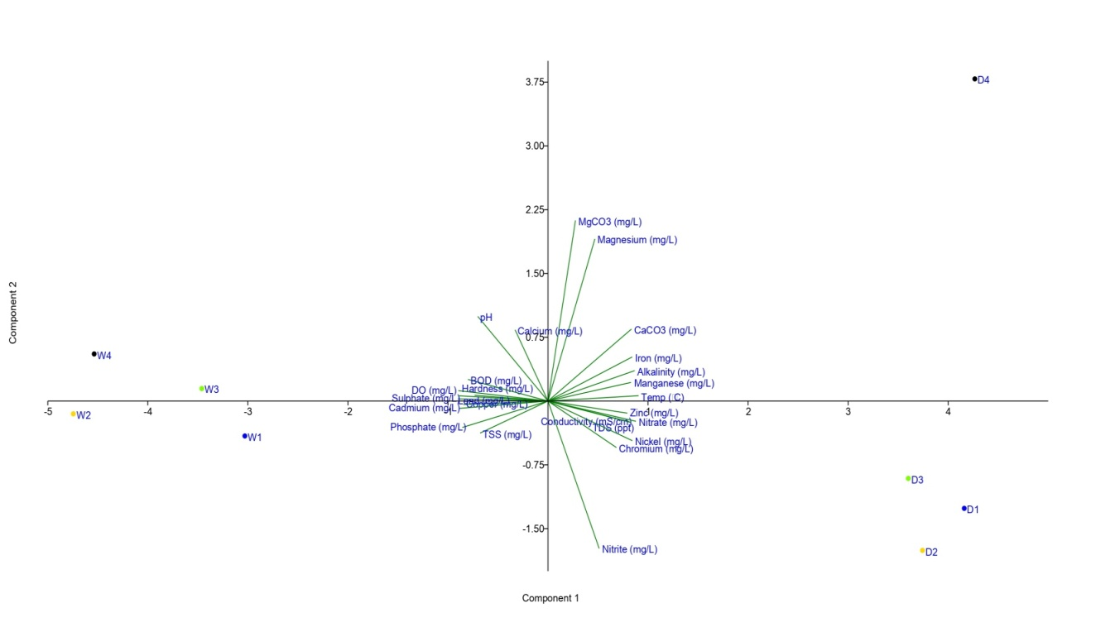

Fig 2: Principal component analysis biplot of limnological variables (surface water) at various sampling Stations

The results indicate that species such as Achnanthes longipes are more likely to thrive in conditions characterized by lower nutrient concentrations and reduced metal contamination, as suggested by their likely occurrence in stations with lower conductivity and trace metal loads. This finding is consistent with previous studies that report the sensitivity of certain diatom species to elevated metal levels and eutrophic conditions (Bubu-Davies et al., 2022). In contrast, taxa like Closterium moniliferum and Cosmarium botrytis appear to be more abundant in areas with oligotrophic to mesotrophic conditions, typically found in the left quadrant of the PCA where lower concentrations of nitrates and trace metals prevail. These species are often considered indicators of relatively unpolluted waters (Ugwumba and Esenowo, 2020). Species belonging to the Cymbellaceae, such as Cymbella cistula and Encyonema incurvatum, and those within the Rhopalodiaceae, such as Epithemia argus and Epithemia turgida, are distributed in regions corresponding to moderate nutrient conditions. Their occurrence in these transitional zones of the PCA suggests a tolerance to a range of water quality parameters but an absence in heavily contaminated or highly enriched waters. This aligns with observations in tropical river systems for instance; a study conducted in Southwest Ethiopia found that diatom community structures were influenced by environmental factors such as dissolved oxygen and nutrient concentrations, with certain species exhibiting tolerance to varying water quality parameters.However, these species were notably absent in heavily contaminated or highly enriched waters, indicating their preference for moderate nutrient environments.(Shibabaw et al., 2015). Diadesmis confervacea, a member of the Diadesmidaceae family, is commonly associated with mesotrophic environments that is water bodies characterized by moderate nutrient concentrations.Its positioning near the center of Principal Component Analysis (PCA) biplots in various studies suggests a moderate tolerance to environmental fluctuations, making it a reliable indicator of organic enrichment without severe disturbance.For instance, research in French rivers has documented the presence of D. confervacea in areas influenced by power plant discharges, indicating its resilience in moderately impacted habitats (Abonyi,et al., 2012). Additionally, studies have shown that diatom communities, including species like D. confervacea, respond predictably to varying nutrient levels, reinforcing their utility in monitoring mesotrophic conditions. (Burge, 2014)
In contrast, species within the Euglena genus, part of the Euglenaceae family, demonstrate a pronounced affinity for eutrophic conditions such as environments with high nutrient and organic matter levels.Their positive association with elevated conductivity and nutrient concentrations, often depicted on the right side of PCA biplots, underscores their role as bioindicators of organic pollution.For example, a study assessing the genotoxic potential of organic pollutants in Taihu Lake, China, utilized Euglena gracilis to detect DNA damage, highlighting its sensitivity to organic contaminants(Li, et al., 2014). Furthermore, research in the Niger Delta region of Nigeria identified Euglena species among other phytoplankton as indicators of polluted aquatic ecosystems, corroborating their association with nutrient-rich environments. (Denise et al.,2022)
Members of the Fragilariaceae family, such as Fragilaria javanica and Fragilaria rumpens, are known for their adaptability across a spectrum of environmental conditions. While specific studies on F. javanica are limited, research on related species like Fragilaria crotonensis indicates a broad ecological tolerance. For instance, a study by Dengg et al. (2022) demonstrated that F. crotonensis showed no significant growth response to elevated concentrations of trace metals, suggesting a level of resilience to varying metal concentrations. This adaptability underscores the importance of detailed taxonomic assessments when employing Fragilariaceae species as bioindicators, as their presence alone may not definitively indicate specific environmental conditions. In contrast, species within the Gomphonemataceae family, particularly Gomphonema parvulum, have been identified as reliable indicators of metal pollution. G. parvulum is frequently found in nutrient-enriched and metal-contaminated environments. Research by Ivorra et al., (2002) revealed that strains of G. parvulum from metal-polluted streams exhibited higher tolerance to zinc and cadmium compared to those from unpolluted streams. This metal-induced tolerance is likely a result of chronic exposure, leading to physiological adaptations that confer survival advantages in polluted conditions. Such findings highlight the potential of G. parvulum as a bioindicator for monitoring metal contamination in freshwater ecosystems (Gomes, 2021).

Similarly, G. pseudoaugur has been identified as dominant in periphytic diatom communities within heavy metal-contaminated water bodies. This species exhibits morphological and physiological changes, such as lipid body accumulation and frustule deformities, in response to heavy metal stress, making it a potential bioindicator for metal pollution. (Noga et al., 2018). In contrast, G. clavatum tends to inhabit less disturbed sites with specific ecological conditions. ​Research conducted in southeastern Poland has identified the presence of rare calciphilous diatoms, such as Gomphonema clavatum, in alkaline to neutral freshwater systems. These environments are characterized by moderate to low electrolytic conductivity and medium-to-high calcium ion concentrations. The occurrence of G. clavatum in these settings suggests a preference for unpolluted, calcium-rich stream beds, highlighting its potential as an indicator species for pristine aquatic habitats. (Noga et al., 2018).

4. Conclusion

The Eniong River exhibits significant ecological stress, primarily due to elevated nutrient and heavy metal concentrations. Such nutrient enrichment fosters eutrophication, leading to the proliferation of opportunistic periphytic algae species. Species like Navicula malice and Gomphonema parvulum dominate under these conditions, indicative of organic pollution and low dissolved oxygen environments while heavy metal disrupt photosynthetic processes and enzymatic activities in algae, leading to reduced diversity and dominance of metal-tolerant species such as Gomphonema parvulum and filamentous green algae like Spirogyra majuscule .​ Periphytic communities on macrophytes like Vossia cuspidata are dominated by species such as Closterium moniliferum and Fragilaria javanica, reflecting adaptation to high-nutrient, eutrophic conditions. This homogenization reduces the ecological value of the periphytic community, impairing its role in supporting higher trophic levels and diminishing its resilience to environmental changes.​ In contrast, stations with lower conductivity and trace metal loads, characterized by species like Achnanthes longipes, Closterium moniliferum, and Cosmarium botrytis, indicate relatively unpolluted conditions. Species such as Cymbella cistula, Encyonema incurvatum, Epithemia argus, and Epithemia turgida are associated with moderate nutrient conditions, suggesting a tolerance to a range of water quality parameters but an absence in heavily contaminated waters.​ Thefore Eniong River's periphytic algal communities reflect a gradient of ecological conditions, from heavily polluted to relatively pristine environments. The dominance of specific indicator species provides valuable insights into the river's ecological status, emphasizing the need for targeted management strategies to mitigate pollution and restore ecological balance

Competing interests

Declaration of competing interest should be placed here. All authors must disclose any financial and personal relationships with other people or organizations that could inappropriately influence (bias) their work. Examples of potential conflicts of interest include employment, consultancies, honoraria, paid expert testimony, patent applications/registrations, and grants or other funding. If no such declaration has been made by the authors, SDI reserves to assume and write this sentence: “Authors have declared that no competing interests exist.”.

Disclaimer (Artificial intelligence)
Author(s) hereby declare that NO generative AI technologies such as Large Language Models (ChatGPT, COPILOT, etc.) and text-to-image generators have been used during the writing or editing of this manuscript.

References

- Abonyi, A., Leitão, M., Lançon, A. M., &Padisák, J. (2012). Phytoplankton functional groups as indicators of human impacts along the River Loire (France). Hydrobiologia, 698(1), 233–249.

- Akpan, E. R., Obot, O. I., & Umoh, E. O. (2018). Physicochemical and bacteriological analyses of Eniong River water and sediment in Southern Nigeria. Environmental Monitoring and Assessment, 190(11), 1–12.

- American Public Health Association (APHA). (2017). Standard Methods for the Examination of Water and Wastewater (23rd ed.). APHA, AWWA, and WEF.

- Anyanwu, I. N., Ezema, C. A., Ebi, S., Nwajiuba, C. A., Nworie, O., &Anorue, C. O. (2021). Seasonal variation in water quality, plankton diversity and microbial load of tropical freshwater lakes in Nigeria. African Journal of Aquatic Science, 46(4), 414–427.

- Azim, M. E., Beveridge, M. C. M., van Dam, A. A., &Verdegem, M. C. J. (2005). Periphyton and aquatic production: An introduction. In M. E. Azim et al. (Eds.), Periphyton: Ecology, Exploitation and Management (pp. 1–13).

- Bellinger, E. G., &Sigee, D. C. (2015). Freshwater Algae: Identification and Use as Bioindicators. Wiley-Blackwell.

- Bubu-Davies, O. A., Ebini, M. V. C., &Anwuri, P. A. (2022). Assessment of Epiphytic Algae Community as Bioindicator of Organic Pollution: A Case Study of Orokubu Creek, Bille, Rivers State, Nigeria. Nigerian Journal of Technological Research, 17(1).

- Bubu-Davies, O. A., Teere, M. B., &Igilar, G. (2022). Evaluation of Epiphytic Algae Assemblage and Nutrient Status as Bioindicator of Organic Pollution in Alice Creek, Rivers State, Nigeria. Journal of Aquatic Sciences, 37(1).

- Burge, D. R. L. (2014). Relations of water quality, land use buffers, and diatom communities of connected depressions within the Cache River Watershed, Arkansas, USA (Master's thesis). Arkansas State University, Jonesboro, Arkansas.

- Crisman, T. L., Boateng, E., & Johnson, P. (2013). Tropical Wetlands: Ecology and Management. Springer.

- Denise, E. M., Okhator, O., Affah, G. P., & Anyadike, M. C. (2022). Physicochemical Properties and Periphytic Algae of Ikot Ebak River, Essien Udim LGA, Akwa Ibom State. FUDMA Journal of Sciences, 6(2), 18–23.

- Dengg, M., Stirling, C. H., Reid, M. R., Verburg, P., Armstrong, E., Kelly, L. T., & Wood, S. A. (2022). Growth at the limits: Comparing trace metal limitation of a freshwater cyanobacterium (Dolichospermumlemmermannii) and a freshwater diatom (Fragilaria crotonensis). Scientific Reports, 12, 467.

- Egbomuche, R. C., Ekwenye, U. N., Udofia, G. E., Anosike, I. K., Etang, U. E., Akpan, N. G., &Fatunla, O. K. (2024). Physicochemical and Bacteriological Analyses of Eniong River Water and Sediment in Southern Nigeria. Asian Journal of Environment & Ecology, 23(5), 48–63.

- Essien, I. I., Denise, E. M., &Anwana, E. D. (2025). Influence of Limnological Factors on Macrophytic Diversity and Distribution in the Humic Freshwater Ecosystem of Eniong River, Itu, Nigeria. Asian Journal of Research in Biology, 8(1), 65–77.

- Etuk, V. J., Ugbomeh, A., Akani, G. C., &Ugbomeh, L. I. (2020). The cichlids of Eniong and Cross Rivers, Niger Delta, Nigeria. Tropical Freshwater Biology, 29(1), 1–10.

- Gomes, M. P., Kochi, L. Y., Freitas, P. L., Figueredo, C. C., & Juneau, P. (2021). Periphytic algae and cyanobacteria from the Rio Doce Basin respond differently to metals and salinity, showing different potential for bioremediation. Plants, 10(11), 2349.

- Giri, T., Goutam, U., Arya, A., & Gautam, S. (2022). Effect of nutrients on diatom growth: A review. Trends in Sciences, 19(2), 1752.

- Hauer, F. R., & Lamberti, G. A. (2017). Methods in Stream Ecology (3rd ed.). Academic Press.

- Kelly, M. G. (2003). Short-term dynamics of diatoms in an upland stream and implications for monitoring eutrophication. Environmental Pollution, 125(1), 117–127.

- Li, M., Gao, X., Wu, B., Qian, X., Giesy, J. P., & Cui, Y. (2014). Microalga Euglena as a bioindicator for testing genotoxic potentials of organic pollutants in Taihu Lake, China. Ecotoxicology, 23(4), 633–640.

- Lobo, E. A., McCarthy, J., & Lee, S. (2012). Utilization of Diatoms for Monitoring Eutrophication in Rivers. Environmental Monitoring and Assessment, 184(7), 4393–4405.

- Mustapha, K. M. (2010). Seasonal influence of limnological variables in plankton dynamics of a small, shallow, tropical African reservoir. Asian Journal of Experimental Biological Science, 1(1), 60–79.

- Nezbrytska, I., Shamanskyi, S., Pavliukh, L., & Gorbunova, Z. (2022). Application of Euglena gracilis in wastewater treatment processes. BioTechnologia, 103(4), 321–329.

- Nkwoji, J. A., Ogbeibu, A. E., & Igbo, J. K. (2021). Influence of multiple stressors on periphytic diatoms in tropical riverine ecosystems. Tropical Freshwater Biology, 30(1), 35–52.

- Noga, T., Poradowska, A., Peszek, Ł., & Rybak, M. (2018). Rare calciphilous diatoms from the genus Gomphonema (Bacillariophyta) in lotic waters of SE Poland. Oceanological and Hydrobiological Studies, 47(1), 27–40.

- Onyema, I. C. (2007). The phytoplankton composition, abundance and temporal variation of a polluted estuarine creek in Lagos, Nigeria. Turkish Journal of Fisheries and Aquatic Sciences, 7, 89–96.
- Ogunmola, O. P., Adeniyi, I. F., Adesakin, T. A., Aduwo, A. I., Daisi, O., Akinpelu, O., &Aanuoluwa, I. (2020). Assessment of Periphyton Biomass and Water Quality by Chlorophyll Determination of Ifewara Reservoir, Osun State, Nigeria. African Journal of Environment and Natural Science Research, 3(4).

- Pandey, L. K., Singh, C. S., & Han, T. (2014). Diatom biofilms as indicators of heavy metal pollution in a riverine ecosystem. Ecological Indicators, 36, 272–279.

- Prasanna, R., Ratha, S. K., Rojas, C., & Bruns, M. A. (2011). Algal diversity in flowing waters at an acidic mine drainage "barrens" in central Pennsylvania, USA. Folia Microbiologica, 56(6), 491–496.

- Rosales, D., Ellett, A., Jacobs, J., Ozbay, G., Parveen, S., & Pitula, J. (2022). Investigating the Relationship between Nitrate, Total Dissolved Nitrogen, and Phosphate with Abundance of Pathogenic Vibrios and Harmful Algal Blooms in Rehoboth Bay, Delaware. Applied and Environmental Microbiology, 88(14), e00356-22.

- Rzymski, P., Niedzielski, P., Klimaszyk, P., &Poniedziałek, B. (2015). Bioaccumulation of selected trace elements in freshwater algae and macrophytes and their potential use for biomonitoring. Ecotoxicology and Environmental Safety, 118, 28–36.

- Salmaso, N., Montanari, A., & Ambrogi, C. (2016). Phytoplankton and Environmental Interactions in River Ecosystems. Aquatic Ecology, 50, 301–316.

- Sharma, A., &Anthal, R. (2016). Humic Substances in Aquatic Ecosystems: A Review. International Journal of Innovative Research in Science, Engineering and Technology, 5(10), 18462–18470.

- Shibabaw, T., Beyene, A., Awoke, A., Tirfie, M., Azage, M., & Triest, L. (2021). Diatom community structure in relation to environmental factors in human influenced rivers and streams in tropical Africa. Environmental Monitoring and Assessment, 193(2), Article 85.

- Søndergaard, M., & Moss, B. (1998). Impact of submerged macrophytes on phytoplankton in shallow freshwater lakes. Biological Reviews, 73(4), 445–472.

- Taylor, J. C., Harding, W. R., & Archibald, C. G. M. (2007). An illustrated guide to some common diatom species from South Africa. WRC Report TT 282/07.

- Ugwumba, A. A. A., &Esenowo, I. K. (2020). Anthropogenic impact on plankton and benthos assemblage in the Lagos Lagoon, Nigeria. Creation Journal of Fisheries, 78, 173–182.

- Wehr, J. D., & Sheath, R. G. (2003). Freshwater Algae of North America: Ecology and Classification. Elsevier Academic Press.

- Xiao, X., Li, W., Jin, M., Zhang, L., Qin, L., & Geng, W. (2023). Responses and tolerance mechanisms of microalgae to heavy metal stress: A review. Marine Environmental Research, 183, 105805.

- Xu, H., Paerl, H. W., Qin, B., Zhu, G., Hall, N. S., & Wu, Y. (2015). Determining critical nutrient thresholds needed to control harmful cyanobacterial blooms in eutrophic Lake Taihu, China. Environmental Science & Technology, 49(2), 1051–1059.

- Yusoff, F. M., Razak, R., & Hashim, R. (2020). Environmental Factors Shaping Phytoplankton Distribution in Tropical Lakes. Aquatic Ecology, 54, 189–202.

- Zhou, Y. (2024). Toxicological impacts of heavy metals on freshwater ecosystems: A case study approach. Journal of Ecology and Toxicology, 8(4), 1–7

