Evaluation of Different Bee Attractants for Apis florea and Their Effect on Seed Yield of Niger [Guizotia abyssinica (L.f.) Cass]

Abstract
An experiment was conducted during the Kharif season of 2022 at the experimental farm of the PC Unit S & N, College of Agriculture, JNKVV, Jabalpur, Madhya Pradesh, to investigate the impact of various bee attractants on the visitation rate of Apis florea and their subsequent influence on the seed yield of niger crops. The study employed a randomized block design comprising nine treatments with three replications. The results indicated that the greatest number of Apis florea visitors was observed at both the 10% and 50% flowering stages with the application of the 10% flower extract of Madhuca longifolia (14.67 bees/m²/5 min) and the 10% fruit extract of Phoenix dactylifera (14.00 bees/m²/5 min), respectively. These mixtures were followed by 10% rose water solution (13.75 bees/m²/5 min) and 10% sugar solution (13.67 bees/m²/5 min). In the control plots, bee visitation was lower, at 5.00 and 3.50 bees/m²/5 min during the 10% and 50% flowering stages, respectively. The water spray treatments resulted in slightly greater visitation than did the control, with 7.33 and 4.75 bees/m²/5 min. Notably, foliar sprays of Madhuca longifolia flower extract, rose water and Phoenix dactylifera fruit extract at 10% concentrations led to significantly greater seed yields, producing 6.96 q/ha, 6.42 q/ha and 6.90 q/ha respectively, than did the other treatments.
Keywords: Foliar spray, Apis florea, significantly superior, fruit extract of Phoenix dactylifera and 10% and 50% flowering stages.
1. Introduction
Niger (Guizotia abyssinica (L. f.) Cass.), a member of the Asteraceae (Compositae) family, originates from Tropical Africa and holds significant importance in the tribal agricultural systems of India. Often referred to as the "lifeline" of tribal farming and economy, it is typically cultivated by tribal communities on marginal to submarginal lands with minimal inputs, primarily under rainfed conditions (Ranganatha et al., 2009). In India, niger is cultivated over approximately 112.8 thousand hectares, yielding approximately 40.3 thousand tonnes, with an average productivity of 357.2 kg/ha. Madhya Pradesh contributes to this with approximately 16.0 thousand hectares under cultivation, producing nearly 4.9 thousand tonnes annually, and achieving an average yield of 308.8 kg/ha (Anonymous, 2021–22). Recognized as a minor oilseed crop, niger contributes approximately 3% of the country's total edible oil supply (Getinet and Sharma, 1996). The seeds contain 32–40% oil and 18–24% protein. Niger oil is light yellow in color, has a nutty flavour and emits a pleasant aroma (Dwarka et al., 2024a,b,c,d,e). It is free from toxins, and its taste is often compared to that of desi ghee.
Niger is a fully cross-pollinated crop and lacks the ability to self-fertilize (Dwarka et al., 2022). Insect-mediated pollination plays a vital role in improving seed yield, promoting uniform crop maturity, and facilitating earlier harvests in cross-pollinated crops such as niger. One effective yet straightforward approach to increase pollination is the strategic placement of bee colonies during the flowering phase (Dwarka et al., 2022). A well-organized national-level bee pollination strategy could address the country’s edible oil deficit significantly, even without increasing the amount of land under oilseed cultivation (Mohana Rao et al., 1981). Research on niger has demonstrated yield reductions ranging from 11% to 78% in the absence of honey bees and other natural pollinators. The incorporation of honey bee colonies alongside niger crops can lead to additional earnings, with estimates ranging from Rs. 252 to Rs. 2125 per hectare, averaging Rs. 1015/ha compared with open-pollinated plots (Anonymous, 2005). Honey bees are considered the most efficient pollinators because of their foraging behaviour and affinity for floral resources. Their effectiveness largely depends on their preference for the target crop over competing flora in the vicinity. To increase bee visitation, various attractants both commercial and traditional-have been employed in agricultural settings. These include products such as Bee Line, Bee Here, Bee Scent, Bee Scent Plus, Fruit Boost, Bee-Q, sugar solution, sugarcane juice, jaggery solution and molasses (Dwarka et al., 2022; 2023a,b,c). However, there is limited region-specific information on the use of these attractants within India. Given the growing concerns over pollinator conservation and sustainable agriculture, the present study aims to evaluate the effectiveness of different bee attractants in enhancing the visitation of Apis florea and their subsequent impact on seed yield in niger.
2. Methodology
Jabalpur, situated in the state of Madhya Pradesh, lies along the banks of the Narmada River. The city is positioned at an elevation of approximately 411.78 m above sea level, between latitudes 22°49'' and 24°8'' North and a longitude of 78°21'' East.
Table 1: List of attractants
Sl. No. | Treatments/attractants
1. | T₁- Flower extract of Madhuca longifolia 10%
2. | T₂ –Juice of Sachharum officinarum 10%
3. | T₃ -Jaggery solution 10%
4. | T₄ -Honey solution 10%
5. | T₅ -Fruit extract of Phoenix dactylifera 10%
6. | T₆-Sugar solution 10%
7. | T₇ -Rose water (Marketed) 10%
8. | T₈ -Water spray.
9. | T₉-Control
The bee attractants were applied twice once at the 10% flowering stage and again at 50% flowering. Standard agronomic practices were followed throughout the trial to ensure optimal crop health (Dwarka et al., 2025). Within each treatment plot, a one-square-meter area was randomly selected to record the number of Apis florea visiting the flowers during the blooming period. Observations were conducted a day before each application and subsequently on the 1st, 3rd, 5th, and 7th days following both the first and second applications. The seed yield data were also recorded accordingly. The identification of insect samples collected during the study was carried out with the support of the Regional Centre of the Zoological Survey of India (ZSI), located in Jabalpur, Madhya Pradesh.
3. Results and discussion
The findings of the present study indicated that all the bee attractants applied had significant effects on the foraging activities of Apis florea in niger crops and were superior to the indicated parameters in the control condition of unsprayed and nonpollinating plants.
The findings indicated that all the treatments significantly differed from one another in attracting Apis florea. At the 10% flowering stage, Apis florea was attracted to the 10% M. longifolia solution (14.67 bees/m²/5 min) followed by the fruit extract solution of P. dactylifera (14 bees/m²/5 min), rose water (13.75 bees/m²/5 min) and then the lowest on the control (5 bees/m²/5 min), followed by water (7.33 individual/m²/5 min) and 10% honey (10 bees/m²/5 min). At the 50% flowering stage the highest population of Apis florea was attracted to the flower extract of M. longifolia 10% solution (13.50 bees/m²/5 min), the fruit extract of P. dactylifera 10% solution (11.75 bees/m²/5 min), the rose water 10% solution (11.25 bees/m²/5 min) followed by the (10.25 bees/m²/5 min) juice of S. officinarum 10% solution while it was the lowest (3.50 bees/m²/5 min) in the control followed by the water spray (4.75 bees/m²/5 min) and the 10% jaggery solution spray (7.25 bees/m²/5 min). The present findings are also supported by the findings of Singh (2015) who reported that bees visiting the flowers of Apis florea. The present results are supported by those of other authors Manchare et al. (2019) reported that a honey solution with 10% flowering had the highest average capacity to attract Apis cerena indica, averaging 2.32 bees/m²/min, whereas common jaggery solution with 10% flowering (2.16 bees/m²/min) and molasses with 10% flowering (2.04 bees/m²/min) were the next two highest.
3.3. Seed yield (q/ha)
The analysis of the seed yield data revealed significant differences among the treatments. The highest yield was recorded with the application of a 10% foliar spray prepared from Phoenix dactylifera flower extract, which resulted in a yield of 6.96 q/ha. This was closely followed by the 10% rose water treatment, which produced 6.90 q/ha, and the 10% sugar solution treatment, which yielded 6.08 q/ha. The lowest seed yield was produced under the control conditions (3.25 q/ha) and in presence of water (5.16 q/ha). These findings align with the findings of Chandrashekhar and Sattigi (2009), who also reported that treatment with bee attractants, such as 10% cacambe and 10% jaggary solution, improved both the quantitative and qualitative characteristics of radish seeds. The same findings were reported by Dwarka et al. (2022), who reported that a 10% foliar spray treatment with Madhuca longifolia flower extract resulted in a maximum seed yield (6.90 q/ha) which also supported these findings. This is supported by Jayaramappa et al. (2011) and Dwarka et al. (2023^{a,b,c}).
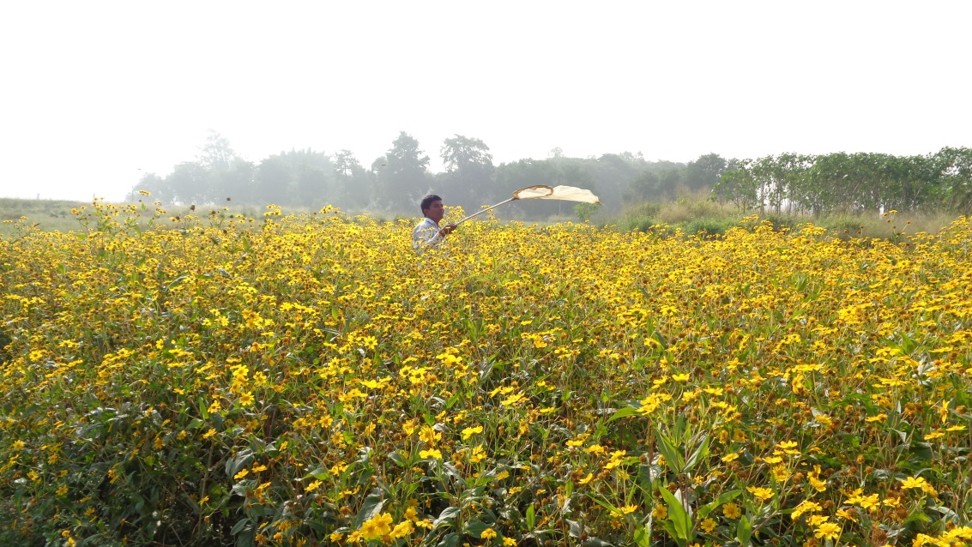
Plate: 1: View of the niger field
Source: Dwarka et al. (2025)
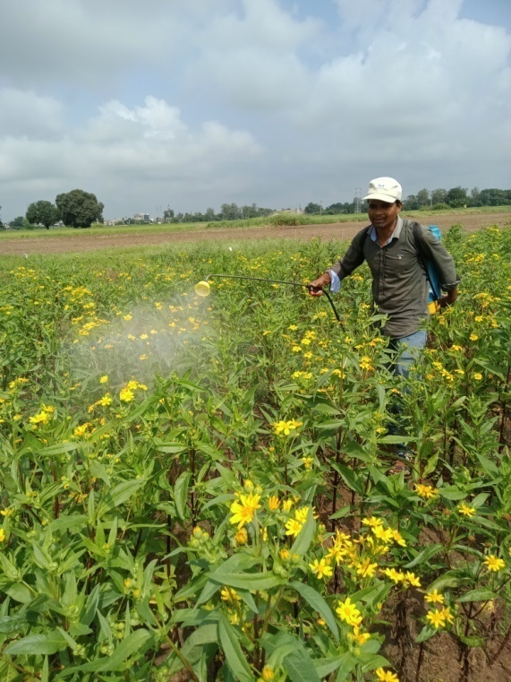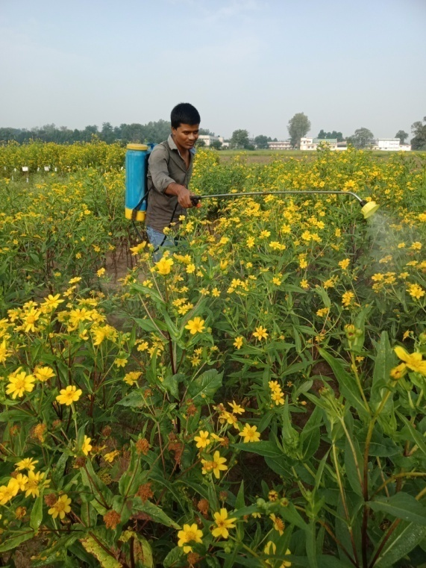
Plate: 2: 10% blooming Plate: 3: 50% blooming
Source: Dwarka et al. (2025) Source: Dwarka et al. (2025)

4. Conclusion
The best number of applications for Apis florea was obtained via the use of 10% flower extract of M. longifolia, 10% fruit extract of Phoenix dactylifera and 10% rose water, as the plants were attracted to these treatments, and the seed yield increased at the 10% and 50% flower spraying times.

Table 2: Influence of different attractants on Apis florea and the subsequent seed yield of niger crops during Kharif, 2022.
Treatments | Population of Apis florea/m²/5 minutes |  |  |  |  |  |  |  |  |  |  |  | Yield  (q/ha)
Treatments | 1st spray at 10% blooming |  |  |  |  |  | 2nd spray at 50% blooming |  |  |  |  |  | Yield  (q/ha)
Treatments | 1DBS | DAS |  |  |  | Mean | 1DBS | DAS |  |  |  | Mean | Yield  (q/ha)
Treatments | 1DBS | 1DAS | 3DAS | 5DAS | 7DAS | Mean | 1DBS | 1DAS | 3DAS | 5DAS | 7DAS | Mean | Yield  (q/ha)
T₁-Flower extract of M. longifolia 10% | 6.33  (2.61) | 13.33  (3.71) | 14.33  (3.76) | 20.33  (4.56) | 10.67  (3.34) | 14.67  (3.89) | 8.00  (2.86) | 11.00  (3.39) | 14.00  (3.81) | 14.67  (3.86) | 11.67  (3.48) | 13.50  (3.65) | 6.96  (2.73)
T₂-Juice of S. officinarum 10% | 4.33  (2.18) | 11.33  (3.41) | 11.00  (3.35) | 15.67  (3.98) | 8.67  (3.02) | 11.67  (3.49) | 6.33  (2.60) | 9.33  (3.09) | 10.33  (3.27) | 11.33  (3.44) | 9.33  (3.13) | 10.25  (3.25) | 6.00  (2.55)
T₃-Jaggery solution 10% | 3.33  (1.94) | 14.33  (3.84) | 15.00  (3.90) | 13.33  (3.70) | 9.67  (3.18) | 13.08  (3.68) | 5.67  (2.48) | 6.67  (2.62) | 9.67  (3.18) | 10.33  (3.28) | 8.67  (3.03) | 7.25  (3.05) | 4.50  (2.24)
T₄-Honey solution 10% | 2.67  (1.77) | 8.00  (2.90) | 11.67  (3.48) | 14.33  (3.84) | 7.00  (2.72) | 10.25  (3.28) | 5.00  (2.34) | 7.33  (2.76) | 8.67  (3.01) | 10.67  (3.33) | 6.67  (2.66) | 9.00  (2.97) | 5.55  (2.46)
T₅- Fruit extract of P. dactylifera 10% | 4.67  (2.27) | 11.67  (3.48) | 15.00  (3.91) | 17.00  (4.18) | 12.33  (3.58) | 14.00  (3.81) | 8.67  (3.02) | 10.00  (3.24) | 11.00  (3.38) | 14.00  (3.81) | 10.33  (3.29) | 11.75  (3.44) | 6.42  (2.63)
T₆-Sugar solution 10% | 5.33  (2.41) | 12.33  (3.57) | 12.00  (3.53) | 18.67  (4.37) | 11.67  (3.45) | 13.67  (3.76) | 5.67  (2.46) | 7.67  (2.86) | 9.33  (3.13) | 11.33  (3.43) | 7.67  (2.85) | 7.50  (3.08) | 6.08  (2.56)
T₇-Rose water 10% | 2.33  (1.68) | 10.33  (3.29) | 15.67  (4.02) | 19.33  (4.44) | 9.67  (3.18) | 13.75  (3.77) | 7.00  (2.73) | 8.00  (2.81) | 10.67  (3.34) | 13.00  (3.63) | 12.00  (3.53) | 11.25  (3.38) | 6.90  (2.72)
T₈-Water spray | 2.00  (1.58) | 7.00  (2.71) | 7.33  (2.78) | 11.00  (3.38) | 4.00  (2.11) | 7.33  (2.80) | 3.33  (1.95) | 4.00  (2.03) | 6.00  (2.54) | 7.00  (2.71) | 4.33  (2.20) | 4.75  (2.41) | 5.16  (2.38)
T₉-Control | 1.33  (1.34) | 4.33  (2.09) | 5.00  (2.34) | 7.00  (2.72) | 3.67  (2.02) | 5.00  (2.32) | 1.67  (1.44) | 3.00  (1.86) | 3.67  (2.00) | 4.00  (2.11) | 3.00  (1.86) | 3.50  (1.98) | 3.25  (1.92)
SEm± | 0.12 | 0.26 | 0.31 | 0.21 | 0.20 | 0.11 | 0.20 | 0.35 | 0.20 | 0.25 | 0.12 | 0.09 | 0.03
CD at 5% | 0.37 | 0.78 | 0.94 | 0.63 | 0.61 | 0.32 | 0.59 | 1.03 | 0.60 | 0.74 | 0.36 | 0.28 | 0.10
*Figures in parenthesis are square roots of √ x+0.5; DAS: Days before spray; DAS: Days after spray.

Disclaimer (Artificial intelligence)
Option 1:
Author(s) hereby declare that NO generative AI technologies such as Large Language Models (ChatGPT, COPILOT, etc.) and text-to-image generators have been used during the writing or editing of this manuscript.
Option 2:
Author(s) hereby declare that generative AI technologies such as Large Language Models, etc. have been used during the writing or editing of manuscripts. This explanation will include the name, version, model, and source of the generative AI technology and as well as all input prompts provided to the generative AI technology
Details of the AI usage are given below:
1.NO
2.NO
3.NO

5. References
Abrol DP. Foraging behavior of Apis florea F. an important pollinator of Allium cepa L. Journal of Apicultural Research. 2010;49(4):318-325.
Anonymous. 2005. observations made during “national seminar on strategies for enhancing production and export of sesame and niger” and “annual workshop of AICRP on sesame and niger research workers, 2005”.
Anonymous. 2020-21. 4th Advance Estimate, Agriculture Statistics Division, Directorate of Economics and statistics, New Delhi. Indian Journal of Natural Products and Resources, 2:221-226.
Dwarka, Chadar N, Katara VK , Thakur S, Shukla S, Parveen S, Maneesha and Ahirwar MK. Introduction to Insect Pests of Niger [Guizotia abyssinica (L.f.) Cass.] and Their Management: A Review. Journal of Experimental Agriculture International. 2024a;46(11): 835-841.
Dwarka, Ghugal SG, Patel GS, Kumar P, Chadar N, Panday AK and Tripathi SK. Introduction of Insect Pollinators Associated with Niger [Guizotia abyssinica (L. f.) Cass.] Crop: A Review. Journal of Biology and Nature. 17(1); 122-129.
Dwarka, Ghugal SG, Thakur S, Panday AK. Evaluation of Various Bee Attractants on the Foraging Behavior of Indian Honey Bee (Apis cerana indica) and their Impact on the Seed Yield of Niger [Guizotia abyssinica (L.f.) Cass]. Advances in Research. 2024b;25(6);528-534.
Dwarka, Panday AK , Thakur S , Katara VK , Patel DK and Kurmi JP. Impact of different bee attractants on the attraction of Indian honey bee, Apis cerana indica and their impact on seed yield of niger, Guizotia abyssinica (L.f.) Cass, crop. Plant Archives. 2024c;24(2); 255-258.
Dwarka, Panday AK , Thakur S and Katara VK. Study on the Effect of Bee Attractants on the Giant Honey Bee, Apis dorsata and their Effect on Niger [Guizotia abyssinica (L.f.) Cass] Seed Yield Journal of Experimental Agriculture International. 2024d;46(7); 903-908.
Dwarka, Panday AK and Saxena AK. To study the effect of bee attractants on the attraction of giant honey bees (Apis dorsata) and their impact on seed yield of Niger (Guizotia abyssinica) crop. The Pharma Innovation Journal. 2022;11(12): 866-868.
Dwarka, Panday AK, Saxena AK, Jain S, Marabi RS and Sahu R. Impact of different weather parameters on the population of pollinators visited on Niger flowers. The Pharma Innovation Journal. 2023a;12(7): 619-621.
Dwarka, Panday AK, Saxena AK, Jain S, Sahu R and Marabi RS. The relative abundance of insect pollinators/visitors in Niger (Guizotia abyssinica) crop. The Pharma Innovation Journal. 2023b;12(2): 3579-3581.
Dwarka, Panday AK, Tare S, Thakur S, Katara VK. Effect of Bee Attractants on the Attraction of Apis dorsata and their Impact on Seed Yield of Niger Guizotia abyssinica (L.f.) Cass Crop. Journal of Scientific Research and Reports. 2024e;30(6):420- 426.
Dwarka, Saxena AK, Panday AK, Jain A and Marabi RS. Succession of different insect pollinators on Niger flowers grown under different dates of sowing. The Pharma Innovation Journal. 2023c;12(7): 622-627.
Getinet A and Sharma SM. 1996. Niger, Guizotia abyssinica (L.f.) Cass. Promoting the conservation and use of underutilized and neglected crops. Institute of Plant Genetics and Crop Plant Research. International Plant Genetic Resources Institute, Rome.
Jayaramappa Kract V, Pattibhiramaiah M and Bhargava HR. Influence of bee attractants on yield parameters of Ridge gourd (Luffa acutangulus L.) (Cucurbitaceae).World Applied Science Journal. 2011;15(4);547-462.
Kalmath BS and Sattigi HN. Effect of different attractants on attracting the bees to onion (Alium cepa) crop. Indian Bee Journal. 2002;64(6): 68-71.
Manchare RR, Kulkarni SR and Chormale TS. Effect of bee attractants on foraging activities of Indian bees Apis cerena indica in bitter gourd (Momordica charantia L.). Journal of Entomology and Zoology Studies. 2019;7(5); 468-472.
Mohana Rao, GM, Lazar M and Suryanarayana MC. Foraging behaviour of honeybees in sesame (Sesamum indicum L.). Indian Bee Journal. 1981;43:97-100.
Ranganatha ARG, Tripathi A, Jyotishi A, Paroha S, Deshmukh MR and Shrivastava N. 2009. Strategies to enhance the productivity of sesame, linseed and niger. In: Proceedings of Platinum Jubilee Celebrations, UAS, Raichur.
Singh RS, Amrendra Pratap B, Singh Singh DV. Abundance and foraging activity of bee visitors to pigeonpea. Progressive Agriculture. 2015;15(1):116- 119.
Venkataramegowda S, Koragandahalli VJ, Menon A and Ruben MC. Use of Bee-attractants in Increasing Crop Productivity in Niger (Guizotia abyssinica. L). Braz. Arch. Biol. Technol. 2013;56(3):365-370.

Dwarka, S.G. Ghugal, Vijay Kumar Katara, Anand Kumar Panday, and Nisha Chadar. 2025. “Assessment of Various Bee Attractants on Apis Florea Fabricius and Their Influence on Seed Yield of Niger [Guizotia Abyssinica (L.F.) Cass]”. Annual Research & Review in Biology 40 (4):67-73. https://doi.org/10.9734/arrb/2025/v40i42222.

