Management of nitrate and nitrite toxicity in ruminants

Abstract:
The nitrate and nitrite toxicity among the ruminant is the most important field level problem. Nitrate level in feed and water is generally considered an undesirable compound induces methemoglobinaemia and causes sudden death. In an organized farm of Tamil Nadu, 5 cattle and 3 sheep and 5 goats died suddenly with the symptoms of gasping, difficult rapid breath, general weakness, trembling, hypersalivation, staggering gait, vomiting and diarrhoea. The clinical examination of affected animal revealed cyanotic appearance of eye, tongue, blue / chocolate coloured mucous membranes. The post mortem examination of affected animals revealed that bluish stripping of the rumen wall and intestinal linings, dark brown blood and pin-point haemorrhages in the all-visceral organs, congestion, haemorrhages and inflammation of heart, liver, spleen, kidney organs and brownish red discolouration of blood with poor clotting mechanism. The post mortem samples along with feed and water were collected from affected farms and submitted to toxicological laboratory for analysis of various toxicity. The toxicology analysis revealed that the level of nitrite and nitrate toxicity in feed (1300mg / kg), water (150mg/lit) rumen content and visceral organs shows at the level of (300mg / g), the samples were negative for organochlorine pesticide, organ phosphorous and organocarbomate pesticides. Proper feeding management and administration of methylene blue at the rate of 1-4 % intravenously with 5 % dextrose or 1 gram of methylene blue /100kg of body weight with repeated dose of 20-30 min will effectively control the nitrate toxicity in affected animals.
Key words: Nitrate toxicity, methhaemoglobinaemia, rapid breath, gasping, methylene blue
Introduction
Nitrate toxicity is one of the important field level problems in grazing animals. The accumulation of nitrate in plants is an important dangerous source of nitrate toxicity in grazing ruminants. The nitrates present in plants and feed causes inflammation of the gut epithelium when taken in large quantities and they are important source of nitrite toxicity. The accumulated nitrites in body system causes respiratory distress due to interference with oxygenation of blood leads to death in affected animals (Ayaş, 2024). Most of the plants absorb nitrogen from the soil in the form of nitrates and converted into proteins and other nitrogen-containing substances. “Usually plants contain small amounts of nitrate but during severe summer drought condition, the amount of nitrate in the soil can increased because of lack of leaching process and reduced uptake by plants followed by decomposition of organic matter. But immediately after summer rain fall, the level of nitrate uptake by plants may increased (Miranda et al., 2024). The high concentrations of nitrate are not toxic to plants but when the animals grazing on nitrate rich plants may suffer for nitrate toxicity. The major outbreaks of nitrate and nitrite poisoning among grazing animals may occurred during sudden rain after prolonged dry periods. The moisture stress, decreased light (cloudiness, short day length), low temperatures, use of nitrogenous fertilisers, spraying plants with hormone-type herbicides (such as 2,4-D) causes the nitrate poisoning. Some weeds, crop and pasture plants like capeweed, pigweed, barley, linseed, lucerne, maize, millet, oats, sorghum fodder, soybean are the major fodder plants and weeds causes nitrate toxicity among animals. The preserved fodders such as hay and silage can also contain high levels of nitrates and causes nitrate toxicity in animals. The soil water from soil containing high nitrogen levels is accessed by livestock also major source of acute nitrate toxicity. Generally nitrate is considered as a undesirable toxic compound in ruminant feeds causes methemoglobinaemia and carcinogenic effect among animals. The level of nitrate in feed reduces the vitamin A metabolism in ruminants animals leads to poor production and reproduction among the ruminant animals while consuming” (Murdock et al.,1972)
Materials and methods
The post mortem were performed with dead animals suspected for nitrate toxicity. The feed, water, visceral organs, urine, blood, peritoneal fluid, CSF were collected from suspected animals and quantitative toxicology analysis were performed in toxicology lab. The qualitative nitrate toxicity test were performed with diphenylamine reagents in field level. The 2 grams of grinded feed and rumen content were mixed with diphenylamine reagents. Based on the intensity of colour the approximate content of nitrate toxicity were identified (fig 7).
Results and discussion
The clinical examination of dead animals shows cyanotic appearance tongue, mucous membrane and eye (fig 1&2). The post mortem examination of affected animals showed severe congestion, bluish discolouration and haemorrhages on trachea, heart, lung, spleen, kidney, stomach and intestine (fig. 3,4,5 & 6). The liver enlarged, bluish discolouration of surface of liver with severe congestion and distended gall bladder with bluish discolouration of bile and unclotted bright red blood were noticed (fig 4). The qualitative invitro assay showed bluish discolouration of fodder and rumen content in diphenylamine reagents (fig. 7). The quantitative analysis of fodder, water and post mortem samples shows high content of nitrate and nitrite. The green fodder contain 850 mg / kg of nitrate and 5 mg / kg of nitrite and water contain 3 mg / lit of nitrate respectively.
The animal feeds like forage and green fodders contains nitrate as one form of nitrogen. The nitrate level in feed materials is generally negligible level in normal condition (Leng 2014) immediately summer rain, high amount of nitrate can accumulated in plants which is consumed by ruminants can cause acute nitrate toxicity and death among the animals. The growing stage of forage, maturity of plant, soil moisture conditions and application of nitrogenous fertilizers to soil are the important factors affecting nitrate concentration in feed and fodder (Leng et al.,2014). The level of nitrate in the feed and water, level of nitrate consumed by animals, incomplete form of nitrate and nitrite reduction to ammonia in the rumen and slow rumen passage rate of feed are the major factors causing nitrate toxicity among the ruminant animals.
The clinical symptoms of affected ruminant animal based on the level of nitrate content in the feed and amount of feed consumed by the animal. The affected animals shows the symptoms of decreased feed intake, reduced milk production, general emaciation, susceptibility to infection, reproductive failure, brownish discolouration of membrane, respiratory distress, coma, cyanosis and even death among the exposed animals (Lewicki, 1993&1998). The level nitrate poisoning and the level of blood methemoglobin in exposed animals are directly proportional, so the level of blood methemoglobin of exposed animals is a indicator of the degree of nitrate intoxication in affected animal (Leng 2008). “The Nitrate present in feed and fodder where ingested in rumen may reduced by rumen microbes in to ammonia via nitrite as an intermediate product and depending on the reduction rate of nitrate by rumen microbes, the nitrate and nitrite can accumulate in the rumen and absorbed into blood circulation through the rumen wall. The level of nitrate present in blood is not toxic but in the form of nitrite in blood is more toxic to the animals. The nitrate present in blood will be recycled back to the gut and excreted in urine through nitric oxide metabolism”. (Lewicki et al. 1998) but the level of nitrite content in blood may binds in to red blood cells and changes the ferrous (Fe2_) form of hemoglobin to the ferric (Fe3_) form of hemoglobin leads to methemoglobinaemia (Lundberg et al. 2008). “The methemoglobin is not able to carry oxygen to vital organs leads to hypoxia and sudden death among affected animals. The high levels of methemoglobin in blood of exposed animals will cause various clinical symptoms related to nitrate poisoning. The methemoglobin level was increased immediately after consuming nitrate rich fodder and the lethal level could be reached within 3 hr after feeding (approximately 10 - 15 g of nitrate per 100 lbs). The analysis of methemoglobin level in blood alone is not a reliable indicator of nitrate or nitrite toxicosis except in acute condition, because 50% of methemoglobin is converted back to normal haemoglobin within 2 hours and alternative forms of nonoxygenated haemoglobin that may be formed by reaction with nitrite are not detected via methemoglobin testing. The presence of nitrate and nitrite concentrations greater than 20 ppm and greater than 0.5 ppm in maternal and perinatal serum, plasma, ocular fluid and other similar biologic fluids are usually indicative of excessive nitrate or nitrite exposure in most of the domestic animal species but in case of poisoned ruminant livestock, nitrate and nitrite concentrations as high as 300 ppm and 25–50 ppm respectively. The nitrate concentrations of ocular fluid are relatively stable and remain diagnostically suitable up to 60 hours after death of exposed animals. The plasma serum and ocular fluid specimens collected from exposed animals have more stable for analysis of nitrate concentration for 1 week which is stored in refrigerator and 1 month at –20 °C”. (Li et al.,2012 & Lin et al.,2013)
“The normal nitrate and nitrite concentrations in laboratory diagnostic specimens are usually less than 10 ppm and less than 0.2 ppm respectively. The half-life of nitrate in cattle, sheep and ponies were 7.7, 4.2, and 4.8 hours respectively. The aqueous humor is actively secreted into the anterior chamber at a rate of 0.1 mL / hour and nitrate and nitrite are thought to enter the globe of the eye via this mechanism and equilibrium between aqueous and vitreous humor is by passive diffusion rather than by active secretion so the level of nitrate or nitrite present in vitreous humor comparatively lesser concentrations after acute exposure” (Hall JO et al., 2018).
“Feed Supplementary nitrate can be a source of nitric oxide and nitrate was initially considered an undesirable carcinogenic food residue as in ruminants (Sinderal and Milkowski 2012). Ruminants animals loses more than 5% of dietary energy through methane production in the rumen during feed fermentation and suppressing methane production in the rumen can increase efficiency of feed energy utilization for production and most of the in vitro and in vivo studies reported that consistent and persistent reductions in enteric methane emissions from ruminant animals which are fed with nitrate-based diet” (Hristov et al. 2013)
The field tests for nitrate toxicity are only qualitative level but the nitrate /nitrite toxicity should be confirmed by standard analytical methods at a well-qualified laboratory. The diphenylamine blue test (1% in concentrated sulfuric acid) is more suitable to determine the presence or absence of nitrate in suspected forages and feed in filed level. The nitrate test strips (dipsticks) are also effective for determining nitrate values in water supplies and can be used to evaluate nitrate and nitrite concentrations in serum, plasma, ocular fluid and urine samples of affected animals. The nitrate and nitrite toxicity were differentially diagnosed with other acute and chronic toxicosis like cyanide toxicity, urea toxicity, pesticides, toxic carbon monoxide, hydrogen sulfide gases and chlorates, aniline dyes, aminophenols, drugs and also differentially diagnosed with various infectious or noninfectious diseases of ruminant and poultry.
“The affected animals were treated with slow intra venous injection of 1%–2% methylene blue in isotonic (0.9% NaCl) saline solution at the concentration of 4–15 mg / kg. The lower dosages may be repeated in 20–30 minutes if the initial response is not satisfactory and lower dosages of methylene blue can be used in all species and ruminants can tolerate higher dosages also. If high toxic exposure or absorption occurs during therapy, treatment with methylene blue every 6–8 hours should be repeated. The intoxicated animals should be handled to minimize stress and animals should be removed from the source of excess nitrates and animal may be provided with other supportive care and management” (Lundberg et al.,2008).
“Animals may adapt to higher nitrate content in feeds, especially when grazing during summer annuals such as sorghum-sudan hybrids. Multiple time and small quantity of feedings help animals to adopt the level of nitrate. Supplementation of trace mineral and a balanced diet may help prevent nutritional or metabolic disorders associated with long-term excess dietary nitrate consumption and feeding grain with high-nitrate and forages may increase nitrite production. The forage nitrate concentrations greater than 1% of nitrate dry-weight basis (10,000 ppm) may cause acute toxicosis in unacclimated animals and forage nitrate concentrations less than 5,000 ppm (dry-weight basis) are recommended for pregnant cows but forage concentrations of 1,000 ppm dry-weight basis may considered as a lethal dose to hungry cows and engorging themselves in a single feeding within an hour” (Hall JO et al.,2018)
The high-nitrate concentration forages may also be harvested and stored as ensilage method rather than as dried hay or green chop may reduce the nitrate content in forages by up to 50%. The hay appears to be more hazardous than fresh green chop or pasture with similar nitrate content and heating may encourage bacterial conversion of nitrate to nitrite so feeding of hay, straw or fodder that has been damp or wet for several days may causes acute nitrate toxicity. The green-chopped forage should be avoided and water transported in improperly cleaned liquid fertilizer tanks may have an extremely high nitrate concentration and causes acute toxicity among the exposed animals (Hall JO et al.,2018)
Conclusion
The nitrate is an important feed additive component, used to reduce enteric methane emissions in ruminants. Feeding of nitrate rich fodder and water causes significant problem in animals production and reproduction. The toxicity of nitrate and nitrite can be reduced by adopting animals gradually to nitrate rich feed and fodder. The effects of nitrate on methane reduction in ruminant animals appear to be generally consistent from study to study and persistent over time. The nitrate appears to be a good source of NPN and thus act as a potential substitute for urea in ruminant diets. The utilization efficiency of nitrate is not well-understood compared with that of urea.
In this study the nitrate toxicity causes acute death among the ruminant animals with typical clinical signs and post mortem lesions, However, further indepth details study is needed for better understanding the metabolism and utilization of supplementary nitrate and nitrite in the diet of ruminant animals and pathophysiology of nitrate and nitrite toxicity in ruminant animals.

Picture associated with nitrate toxicity
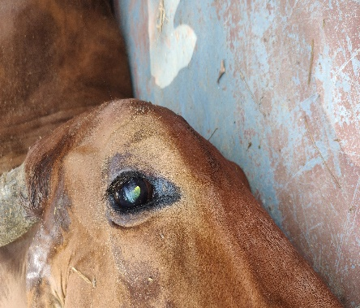  Fig : 1cyanotic appearance of eye | 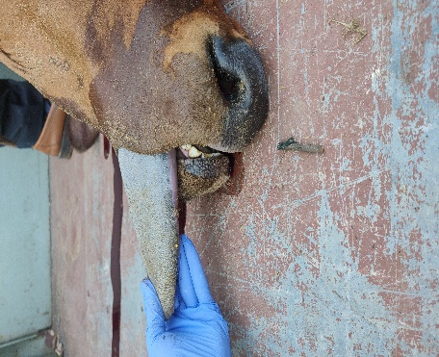  Fig 2: Bluish discolouration of tongue
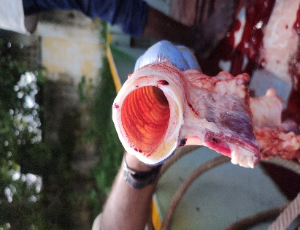  Fig 3: bright red colour appearance of tracheal wall | 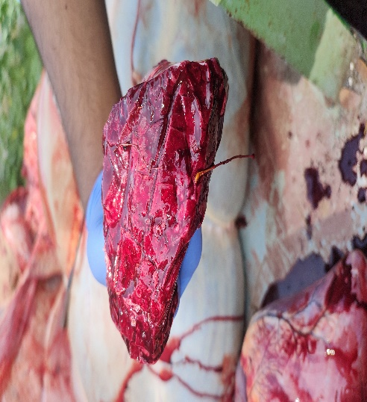  Fig 4: bright red coloured unclotted blood oozing out from cut edges of liver
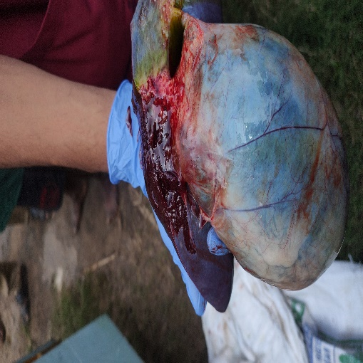  Fig 5: bluish discolouration of pericardial wall | 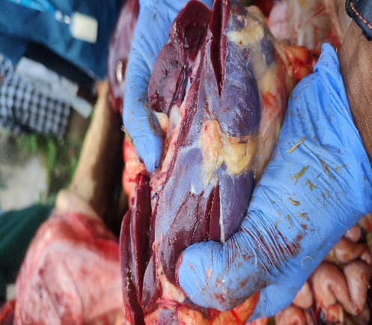  Fig 6: Bluish discolouration of kidney capsules
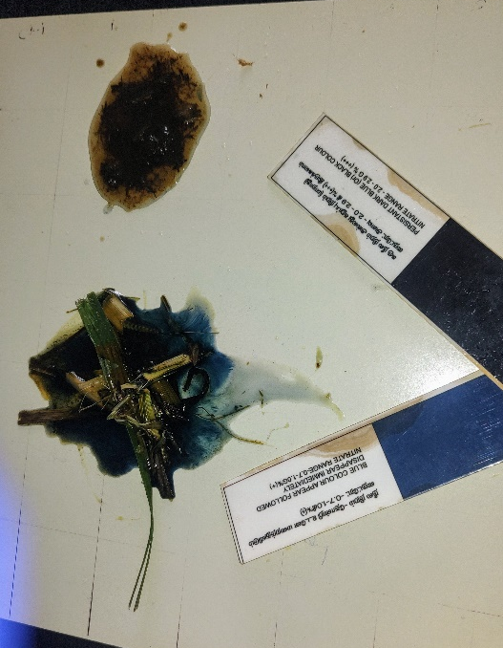

Fig 7: Qualitative invitro assay for detecting nitrate toxicity

Acknowledgement:
The author thankful to the Director, Centre for Animal Production Studies and The Director, Centre for Animal Health Studies , TANUVAS, Chennai for providing necessary facilities to carryout the study
Conflict of interest: Not interested
Disclaimer (Artificial intelligence)
Author(s) hereby declare that NO generative AI technologies such as Large Language Models (ChatGPT, COPILOT, etc.) and text-to-image generators have been used during the writing or editing of this manuscript.
References
- Hall JO. Nitrate- and Nitrite-Accumulating Plants. In: Gupta RC, ed. Veterinary Toxicology, 3rd Edition. Academic Press, 2018:941–946.
- Hristov, A. N., Oh, J., Firkins, J., Dijkstra, J., Kebreab, E., Waghorn, G., Makkar, H. P. S., Adesogan, A. T., Yang, W.,Lee, C., Gerber, P. J., Henderson, B. and Tricarico, J. M. 2013. Special topics _ Mitigation of methane and nitrous oxide emissions from animal operations: I. A review of enteric methane mitigation options. J. Anim. Sci. 91: 5045_5069.
- Leng, R. A. 2014. Interactions between microbial consortia in biofilms: a paradigm shift in rumen microbial ecology and enteric methane mitigation. Anim. Prod. Sci. 54: 519_543.
- Lewicki, J., Garwacki, S. and Wiechetek, M. 1994. Nitrate and nitrite kinetics after single intravenous dosage in sheep. Small Rumin. Res. 13: 141_146.
- Lewicki, J., Wiechetek, M., Souffrant, W. B., Karlik, W. and Garwacki, S. 1998. The fate of nitrogen from 15N-labeled nitrate after single intravenous administration of Na15NO3 in sheep. Can. J. Physiol. Pharmacol. 76: 850_857.
- Li, L., Davis, J., Nolan, J. and Hegarty, R. 2012. An initial investigation on rumen fermentation pattern and methane emission of sheep offered diets containing urea or nitrate as the nitrogen source. Anim. Prod. Sci. 52: 653_658
- Lin, M., Guo, W., Meng, Q., Stevenson, D. M., Weimer, P. J. and Schaefer, D. M. 2013. Changes in rumen bacterial community composition in steers in response to dietary nitrate. Appl. Microbiol. Biot. 97: 8719_8727.
- Lundberg, J. O., Weitzberg, E. and Gladwin, M. T. 2008. The nitrate_nitrite_nitric oxide pathway in physiology and therapeutics. Nat. Rev. Drug Discov. 7: 156_167.
- Murdock, F. R., Hudgson, A. S. and Baker, A. S. 1972. Utilization of nitrates by dairy cows. J. Dairy Sci. 55: 640-642.
- Sinderal, J. J. and Milkowski, A. L. 2012. Human safety controversies surrounding nitrate and nitrite in the diet. NitricOxide 26: 259_266.
- Ayaş, R. (2024). Nitrate Toxication in Ruminants. A Vıew of Agrıculture From an Academıc Perspectıve, 1, 143-156.
- Miranda, E. S., Boas, Y. R. V., da Silva Cabral, L., Arruda-Oliveira, J. C., Procópio, D. P., Lopes, M., ... & de Mattos Negrão, F. (2024). Urea and nitrate poisoning as a source of non-protein nitrogen in ruminant diets: a review. Caderno Pedagógico, 21(7), e5518-e5518.

