Distribution and Characterization of Microalgae from Chenab and Ravi River, Punjab Pakistan

ABSTRACT
This research explores the taxonomic investigation of algae in some selected habitats of the Chenab and Ravi Rivers of Punjab with respect to different environmental, biological and water quality parameters ascertained by using different laboratory instruments and chemicals. 35 freshwater algal species comprise 14 genera, 13 families, 13 orders, 3 classes, two Phylum Volvocophycota and Bacillariophycota; Volvocophycota contains 3 genera and 9 green algal species, Bacillariophycota contains 11 described Genera and 26 are diatoms were reported. The Phylum Bacillariophycota's high-density species (Nitzschia capitellata, N. palea, N. vermicularis, N. gandersheimiensis, and N. sigmoidea) and (Gomphonema dichotomum, G. parvulum, G. sphaerophorum, G. augur, G. lanceolatum, G. ghosea) were investigated. Other single genera belongs to species which explored were like Caloneis tenuis, Ctenophora pulchella, Frustulia rhomboids, Neidium affine var. amphirhynchus and Cyclotella comta. In this case, the most dominant out both phylum of Genus Cosmarium species were collected from samples of both rivers. Water quality tests were also performed to analyze the quantity of minerals affecting algal diversity. The aim of this current study is to establish the distribution and characterization on the diversity of algae in both freshwater habitats and determine the best growing conditions. It is the first algal taxonomy of Chenab River algae in the Gujrat district.
Key Words:
Taxonomy, Microalgae, Aquatic Algae, Physicochemical parameters, Ravi, Chenab, River
1. INTRODUCTION
Punjab is a Pakistani province, and it is situated in the northeaster region of Pakistan. It is the most populous province of Pakistan. Punjab, especially rural regions, is renowned for its rivers like the Indus River and rivers like the Jhelum, Chenab, Ravi, Beas, and Sutlej. Taxonomic study of fresh water algae was conducted on the Two Rivers, Chenab and Ravi, which are located in the cities of Gujrat and Lahore respectively in the state of Punjab. Gujrat is a very ancient city in Pakistan situated at the coordinates 32.571144 of latitude and 74.075005 of longitude. Lahore, which is the second largest city, is the capital city of Punjab. Its position is 31°32′59″ N latitude and 74°20′37 E longitude. Algae are thallophytes and are found in all kinds of environments from cold to warm and alkaline to acidic without any limitation. Chlorophyll-a is found in most algae, which makes them the primary producers and source of basic energy in terrestrial food webs (Roy et al., 2022) . Some physiologists have reported articles on various algal flora species in various areas of Pakistan. Previous studies, however, indicate that little has been done in the River Ravi and absolutely nothing in the River Chenab. The objective of the present study is to determine the algal flora of Chenab and Ravi Rivers at cellular level and close any lacuna in our information regarding the real number of species and their distribution. Investigation of reported and unreported freshwater algae species of Chenab and Ravi Rivers and Mineral analysis test of water samples to determine the richness of algae that affect the quality of water of these rivers.
1.1 Sampling Sites
Gujrat's Chenab River and Lahore's Ravi River were sampled for algae from December 2023 to January 2024 winters. The sampling map of both rivers is presented in map 1.
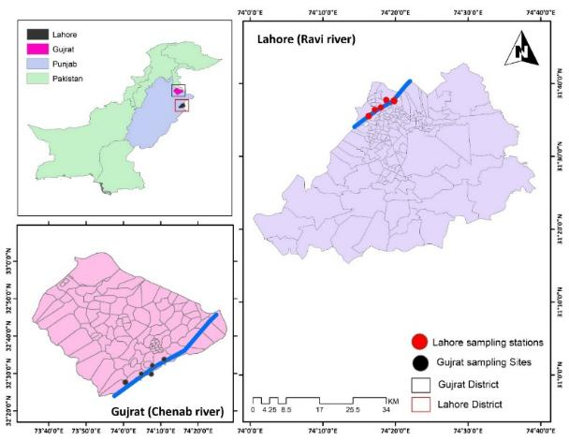
Map 1. Map of Algae collecting sites of Chenab and Ravi River
2. MATERIALS AND METHODS
2.1. Algal Sample Collection from Chenab and Ravi Rivers

The current research investigated a series of locations along Chenab and Ravi Rivers for algal collection (Photographs 1 and 2). Algal specimens, primarily filamentous and other attached algae, were collected with extreme care employing sterilized forceps in order to prevent structural damage. Filamentous algae were transferred to small, labbelled plastic bottles (Photographs 2, 3, and 4) for storage and further examination.

2.2. Preservation of Algal Samples

Freshly collected algae samples were cleaned in tap water several times to eliminate sediments, debris, and loosely adhering organisms. They were preserved by using Lugol's solution or formalin according to the traditional method mentioned by (Ghazala et al., 2009) to retain their pigment composition and morphology for a future identification process. These lots of preserved material were later off-loaded at Phycology Laboratory, Institute of Botany, University of the Punjab, Lahore, for taxonomic study.

2.3. Morphological and Microscopic Examination

The preserved algal samples were studied morphologically and cell-wise. A Trinocular OLYMPUS CH30 microscope was used at 4x, 10x, and 40x magnifications. Algal samples were iodine-stained to enhance visibility of the internal cell structures and facilitate identification.

2.4. Measurement of Physicochemical Parameters
In order to understand the environmental conditions favorable to algae growth, physicochemical parameters were investigated in each sample of water:
- Temperature: Measured using a digital thermometer.
- pH: Determined with a digital pH meter.
- Electrical Conductivity (EC): Measured using an EC meter.
- Total Dissolved Solids (TDS): Assessed using a TDS meter.
These parameters were recorded separately for all samples from both rivers (Tables 3 and 4).

2.5. On-Site Environmental Data Collection

Other environmental parameters such as latitude, longitude, temperature of air, temperature of water, and water clarity were also measured at each sampling station. This information brings the environmental conditions that support the growth of algae into context and aids in ecological correlation.

2.6. Nutrient Analysis of River Water Samples

Since nutrient availability is a requirement for the algae to grow, water samples from both rivers were taken for quantitative mineral analysis (Photograph 6). Analysis was for Sodium (Na), Potassium (K), and Phosphorus (P), and was conducted at the Metal and Mineral Analysis Laboratory, University of Veterinary & Animal Sciences, Lahore (Tables 1 and 2).

•Sodium and Potassium Analysis:

Performed by a Flame Photometer, standardized using standard solutions for precision. The process measures light intensity produced on the addition of the sample to the flame in relation to Na and K levels.

• Phosphorus Analysis:

Carried out in a UV-Visible Spectrophotometer through the molybdenum blue method. In this technique, phosphate interacts with ammonium molybdate in an acidic environment to produce a blue-colored complex. The complex was read at 880 nm absorbance and applied for precise quantitation of phosphorus levels.

2.7. Significance of Nutrient and Physicochemical Analysis
These analyses were required for obtaining a knowledge of the ecological parameters and nutrient dynamics of these rivers. Since algal biomass and species diversity directly depend on nutrient availability nominally higher nitrogen, phosphorus, and trace elements this step facilitated:
- Assess the trophic status of river water.
- Evaluate the likely eutrophication threats.
- Correlate nutrient concentration with algal abundance and richness.
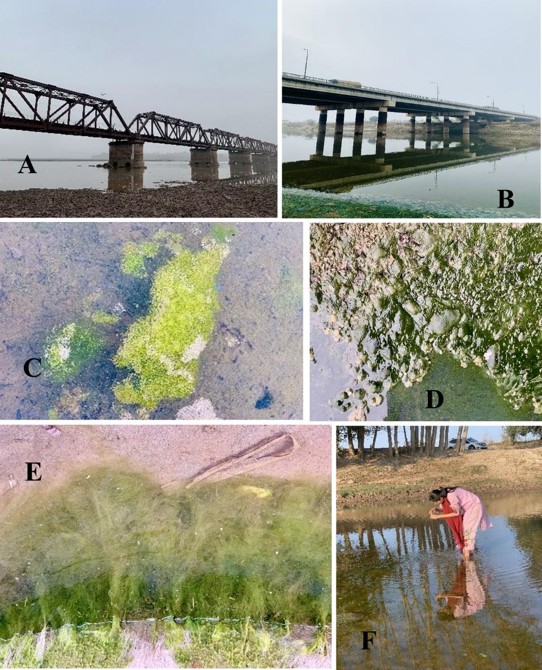
Image 1 . A-F: Photographs during sampling sites A. Algal Sampling site of Chenab River B.Algal Sampling site of Ravi River, Lahore C. Algal Patch floating on Chenab surface Algal diversity in the water of Ravi River Photo E.Growth of algal specimens at Chenab F. Collection of Water samples
Table 1: Minerals Tests of Algal Water Samples from Selected sites of Chenab River.
Serial No | Sample Name | Sodium  (mg/L) | Potassium  (mg/L) | Phosphorus  (mg/L)
1 | WN-01 | 55.0 | 15.0 | 0.11
2 | WN-02 | 45.0 | 13.4 | 1.82
3 | WN-03 | 40.0 | 12.8 | 0.09
4 | WN-04 | 39.0 | 13.2 | 2.34
5 | WN-05 | 54.0 | 14.5 | 1.72

Table 2: Minerals Tests of Algal Water Samples from Selected sites of Ravi River.
Serial No | Sample Name | Sodium  (mg/L) | Potassium  (mg/L) | Phosphorus  (mg/L)
6 | WN-06 | 24.0 | 16.1 | 0.15
7 | WN-07 | 20.0 | 12.6 | 0.12
8 | WN-08 | 17.0 | 13.8 | 0.08
9 | WN-09 | 12.0 | 14.4 | 0.09
10 | WN-10 | 28.0 | 13.7 | 0.11

Table 3: Physicochemical Parameters of Water Samples from Collected Sites of Chenab River.
Physicochemical Parameters of Water Samples from Collected Sites.
Sample number | GPS Location |  | Weather conditions | pH of Water | Water clarity | EC (µs/cm) | TDS (ppm) | Temperature º C
Sample number | Longitude | Latitude |  |  |  |  |  | Air | Water
01 | 32º  29’12.70248 | 74º 51’4.00424 | Foggy | 6.5 | Slightly muddy | 326 | 163 | 13.3 | 13.0
02 | 32º29’18.14812 | 74º 5’18.87136 | Foggy | 7.2 | Muddy  water | 366 | 183 | 12.9 | 11.9
03 | 32º  29’13.28496 | 74º 5’20.61672 | Windy | 8.5 | Extreme muddy | 418 | 209 | 12.3 | 11.4
04 | 32º  29’12.54516 | 74º 5’13.88832 | Clear | 7.5 | Greasy  water | 348 | 174 | 13.3 | 11.5
05 | 32º  29’19.56336 | 74º 5’51.46656 | Clear | 9.1 | Muddy  water | 496 | 248 | 13.2 | 11.2

Table 4: Physicochemical Parameters of Water Samples from Collected Sites of Chenab River.
Table 3: Physicochemical Parameters of Water Samples from Collected Sites.
Sample number | GPS Location |  | Weather conditions | pH of Water | Water clarity | EC (µs/cm) | TDS (ppm) | Temperature º C
Sample number | Longitude | Latitude |  |  |  |  |  | Air | Water
06 | 31º  32’54.92634 | 74º  14’38.1942 | Foggy | 7.0 | Muddy water | 700 | 350 | 11.0 | 11.4
07 | 31º  32’59.80476 | 74º  14’39.48086 | Foggy | 8.1 | Extreme muddy | 870 | 435 | 11.9 | 11.6
08 | 31º  32’58.68306 | 74º  14’39.49414 | Cloudy | 7.1 | Muddy  water | 546 | 273 | 12.0 | 12.2
09 | 31º  32’57.82192 | 74º14’35.1942 | Cloudy | 7.5 | extreme muddy | 942 | 471 | 12.2 | 11.9
10 | 31º  32’56.28472 | 74º14’38.65411 | Windy | 8.8 | Extreme muddy | 522 | 261 | 11.8 | 12.3

3. RESULTS
Blue-green algae were identified to the species level on the basis of cytological and morphological features. Distribution and species classification of algae species in the different Chenab and Ravi River stations is depicted in Table No. 6. Based on the newly developed taxonomy, the below 35 species come in a sequential order (Shameel, 2001; Shameel, 2012).
Identification keys are particularly useful for establishing differences among closely related and similar genera and species when numbers of similar things are large within groups. Therefore, Table No. 7 gives identification keys for familiarity at genus and species levels.
3.1. PHYLUM VOLVOCOPHYCOTA
These minute Coenobium algae are present either singly or in aggregates. They also have xanthophyll pigments lutein and neoxanthin together with chlorophyll a and b. The microscopical occurrence of the species of Phylum Volvocophycota from Chenab and Ravi River is presented in the table of Figures 1–9.
3.1.1. Genus Scenedesmus Meyen
Two, four, or more adjacent spindle-shaped or oblong cells cluster in a colony. A chloroplast is typically located along the cell wall of each cell, typically containing a single pyrenoid. While they are not typically seen, there are spines on certain cells, and the cell walls can be smooth. Zoospore and auto-colony formation will facilitate reproduction.
3.1.1.1. Scenedesmus longus var. naegelii (Brèbisson) G.M Smith (Prescott, 1962)
(Figure 1)
Taxonomic features: It consists of one row of two to four elongated cylindrical cells. There are one or two spines on each inner and outer end of the cells; the outer cells' spines are larger. The cells measure 8–12µ in length and 4-6µ in width.
Locality: Chenab River, Gujrat.
3.1.2. Genus Coelastrum Nӓgeli
It is a hollow, rounded, floating mass of a maximum of 128 cells. The cells are oval, spherical, or even pyramidal in shape, and are densely packed with short bridges connecting them, having pores. In these cells, the new colonies start to develop, so that they resemble babies within a parent. At times the new colonies get hidden under the walls of the parent cells, joining each other to form complex structures
3.1.2.2. Coelastrum microsporum Nӓgeli (Godar & Rai, 2018)
(Figure 2)
Taxonomic features: The colony is 8–64 cells in size and spherical in shape, with a diameter of around 43–47 µ. The cells range from 7 to 10µ in diameter and are oval or spherical. There are tiny spaces between the cells, and they are linked by short, thick, gel-like bodies.
Locality: Ravi River, Lahore.
3.1.3. Genus Cosmarium Corda
They are single cells with a morphology in which two half-cells are united to produce sinuses at an isthmus. The half-cells are sub-circular or oval in outline from above. The cell walls bear many types of designs including notched projections, spherical or triangular pits, or extremely fine spines. The middle and periphery of the cell wall can be made of various patterns. There are many pores distributed throughout, each having a slimy coating. Pyrenoids occur in all chloroplasts, either along the walls or in the center. The nucleus is housed in the isthmus. Sexual reproduction is by conjugation, but asexual reproduction gives rise to new semi-cells by cell division. Spiny and round, zygospores are formed by meiosis after nucleus fusion (karyogamy) during germination.
3.1.3.1. Cosmarium pyramidatum Brèbisson (Shyndanovina, 2020)
(Figure 3)
Taxonomic features: The flattened-end, oval-shaped frond pieces are covered in tiny dots and are whole, with no divisions or breaks. The cell form is more elliptical or rounded.
Locality: Chenab River, Gujrat.
3.1.3.2. Cosmarium granatum Ehrenberg (West, 1927) (Wasylik, 1961) (Hirano, 1964; Masud-ul-Hasan & Zeb-un-Nisa, 1986)
(Figure 4)
Taxonomic features: Flattened-end segments of the oval frond have minute spots, and are uninjured, unbroken and entire. Cell form is rounded or elliptical.
Locality: Chenab River, Gujrat.
3.1.3.3. Cosmarium bioculatum var. canadense Willi Krieger & Gerloff (Shyndanovina, 2020)
(Figure 5)
Taxonomic features: The semi-cells are truncated and pyramidal, and the cells are around 1.5 times longer than wide. The elliptical segments are connected by a more distinct isthmus than in other species, so that the notches on both sides are broader. Every semi-cell has a pyrenoid-bearing chloroplast. With an isthmus of 5-7µ, the cells measure around 26-28µ in length and 21-23µ in width.
Locality: Ravi River, Lahore.
3.1.3.4. Cosmarium lundellii Delponte (TK & Talwankar, 2018)
(Figure 6)
Taxonomic features: The isthmus is 6–6µ micrometers long, and the cells are 24-26µ wide and 29–33µ micrometers long. They have a deep constriction in the middle and are longer than broad. The apex is thin, somewhat notched, and has rounded corners, but the sinus exhibits narrow, linear undulations with subacute angles. The form of the semi-cells is elliptical. The cell wall is colorless and smooth. There is an axile chloroplast with a single pyrenoid inside every semi-cell.
Locality: Chenab River, Gujrat.
3.1.3.5. Cosmarium pygmaeum W. Archer (Patil & Kumawat, 2014)
(Figure 7)
Taxonomic features: The cell is 4µ isthmus long and about 11µ broad and 12µ long. It possesses a very small linear sinus in its cells. The semi-cells are oval and rhomoboic in nature. The axile chloroplast in the semi-cell is with a central pyrenoid, and the cell wall is colorless and smooth.
Locality: Ravi River, Lahore.
3.1.3.6. Cosmarium reniforme (Ralfs) Archer (Patil & Kumawat, 2014; TK & Talwankar, 2018)
(Figure 8)
Taxonomic features: It has a 14µ wide isthmus and is 50µ by 60µ in dimensions, which is medium in size. It is longer than wide. The sinus is linear and narrow but becomes much wider at the ends. Kidney-shaped semi-cells are what they are. The cell wall is made of granules that are very regular and ordered both horizontally and in weak vertical lines. Two pyrenoids and an axile chloroplast are present per semi-cell.
Locality: Ravi River, Lahore.
3.1.3.7. Cosmarium nitidulum De Notaris (Tiffany and Britton, 1971)
(Figure 9)
Taxonomic features: Cells are 16–22 micrometers thick and 23–33µ by 30-41µ long and wide, respectively. They are quite constricted and very slightly longer than wide. Apex is ever so slightly widened, sinus linearly narrowed, and the fronds are ellipse in form. Cell wall is even. Each semi-cell has one axial chromatophore.
Locality: Chenab River, Gujrat.

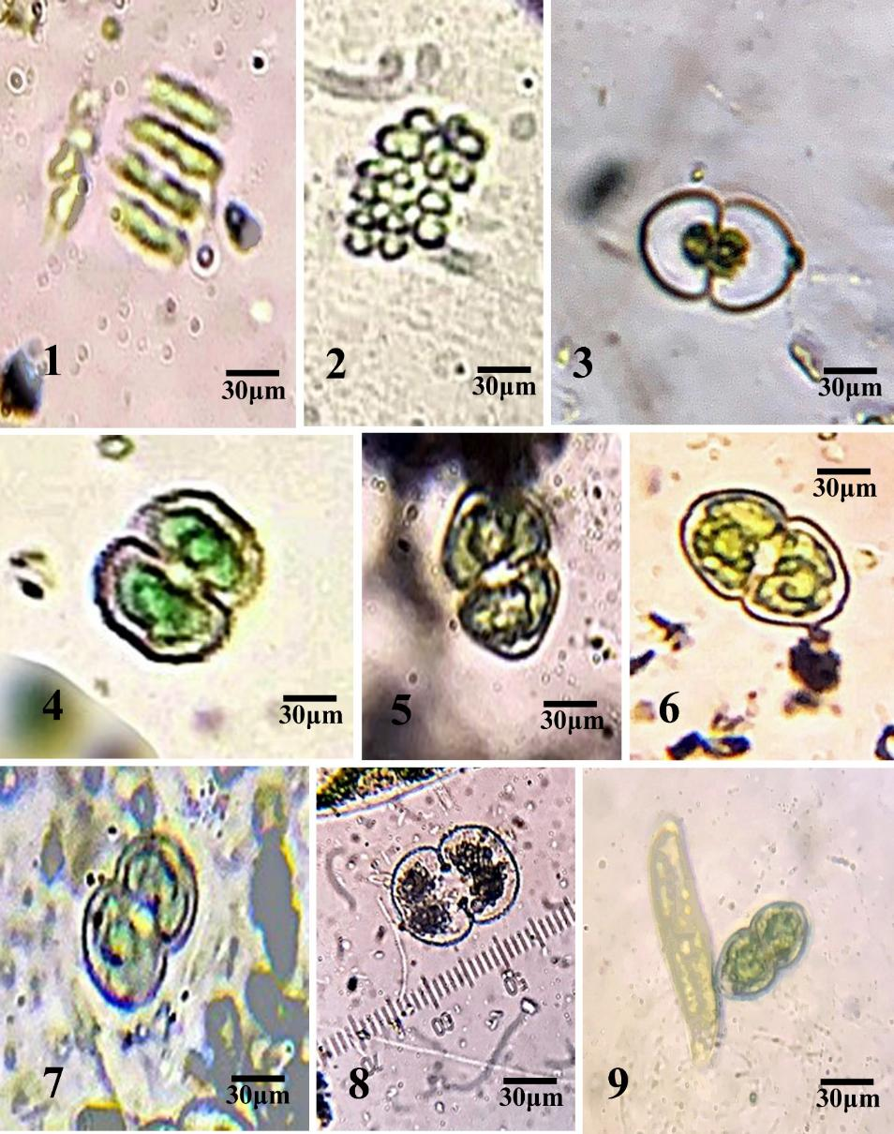
Plate 1. 1: Scenedesmus longus 2: Coalestrum microsporum 3: Cosmerium pyramidatum 4: C. granatum 5: C. bioculatum 6: C. lundellii 7: C. pygmaeum 8: C. reniforme 9: C. nitidulum.
3.2. PHYLUM BACILLAROPHYCOTA
Free-floating algae, the most striking members of this phylum that occur in both fresh and seawater ecosystems with commonality, have two valves filled with silica in their cell wall. In comparison to common algae, they do not undergo division using flagella for their movement but occur by fission. Overlapped opal or silica frustules exist in them. Distribution of species of Chenab and Ravi River of phylum Bacilariophycota viewed through a microscope is disclosed
in the figure table of 10-35.
3.2.1. Genus Cymbella C. A. Agardh
They occur singly or in colonies and possess asymmetrical frustules. They are free-floating or epiphytic, sessile or stalked, and typically enclosed in gelatinous tubes with subrectangular or straight girdles. The raphe curves around with polar and central nodules, and the valve typically tapers from the middle to the obtuse ends. There are striae, which vary from fine to coarse in fineness and punctate or radiating in appearance. Terminal fissures become either straight or curved when they near the dorsal margin. The axial zone is broad or narrow and usually dilated in the center, occasionally. There is one or more chromatophores, plate-shaped.
3.2.1.1. Cymbella aspera Agardh (Cox, 1996)
(Figure 10)
Taxonomic features: The cells are relatively large with moderately convex dorsal border and almost straight ventral border. They possess rostate tips and widely rounded apices. Their size is 20-48µ wide and 70-265µ long. Possessing large dot-like central terminals, the raphe practically assumes a central arc shape. The striae are observable; seven to ten punctate striae are observed in a 10-inch interval.
Locality: Chenab River, Gujrat.
3.2.1.2. Cymbella elginensis Krammer (Munir et al., 2012)
(Figure 11)
Taxonomic features: Valves of Cymbella elginensis are linear-lanceolate, typically 20 to 90 µm long and 5 to 7 µm wide, with a greater major axis than 70 µm. They are striae, parallel rows of puncta, and have a straight raphe, often close to one border.
Locality: Chenab River, Gujrat
3.2.1.3. Cymbella microcephala Grunow (Cox, 1996)
(Figure 12)
Taxonomic features: The small valves possess a straight ventral line, a weakly convex dorsal margin, and no rostate ends. They are 10–30 µm in length and 2-4 µm in breadth. Almost subcapitate apices occur. The ratio of length to breadth is less than four because cells tend to be longer and the valves are always wider (more than 6 µm) and usually proportionally broader. Axial main less than 70 micrometers.
Locality: Chenab River, Gujrat.
3.2.1.4. Cymbella minuta var. silesiaca (Bleisch) Reimer (Munir et al., 2012)
(Figure 13)
Taxonomic features: The cells are 18 to 40 µm in length and 10 to 20 µm in width. They possess a nearly parallel axial region to the ventral border and well-developed dorsi-ventral valves that are slightly rounded to a great extent.
Locality: Chenab River, Gujrat.
3.2.2. Genus Caloneis Cleve
With capitate, rounded, long ends, the cells are linear-lanceolate in shape, solitary, and free-floating. The cells contain radiating, parallel striae with a hyaline interruption. The cells possess two pyrenoids and two chromatophores per cell.
3.2.2.1. Caloneis tenuis (Gregory) Cleve (Munir et al., 2013)
(Figure 14)
Taxonomic features: Cells are 20 µm x 4 µm. They have 23 striae along 10 µm, parallel, radiating in the center, slightly convergent towards ends. Valve geometry is from linear to linear-elliptic. Core area is irregular, while axial area is variable.
Locality: Ravi River, Lahore.
3.2.3. Genus Ctenophora Ehrenberg
Valve and frustrule are lanceolate. Each rimoportula is bordered by an apical hyaline field, and the middle portion is buttressed internally. Its areolae possess internal hymenate occlusions as well as sieve-like closure plates externally. Each pole possesses a pseudoseptum, and in the common vegetative cells, the cingulum is girdle-banded.
3.2.3.1. Ctenophora pulchella (Ralfs ex Kützing) D. M. Williams & Round (Aboal et al., 2003; (Satpati et al., 2021)
(Figure 15)
Taxonomic features: 150-200 μm long and 5-7 μm wide, the frustules form ribbon-like colonies measuring 40-50 times longer than they are broad. The valves are lanceolate or linear in shape with rounded apices. But it is difficult to see the striae.
Locality: Chenab River, Gujrat.
3.2.4. Genus Naviculla Bory
Unbranched, isolated frustules with a platonic fusiform outline, lanceolate with capitation and rounded ends, are broad and elliptic in outline. The axial area is thin, and the raphe is straight with striations and polar nodules. In addition, two laminated chloroplasts occur usually.
3.2.4.1. Naviculla tripunctata (O.F Mull.) Bory (Cox, 1996.)
(Figure 16)
Taxonomic features: The valves are narrower than 10 µm and have straight, rather than cuneate, apices. The striae are parallel in very few instances, most noticeably in the region near the center of the cell.
Locality: Chenab River, Gujrat.
3.2.4.2. Naviculla leptostigma Ehrenberg (Cleve, 1894)
(Figure 17)
Taxonomic features: The elliptical valves have a single location in the middle. They are 0.015 to 0.02 mm in width and 0.038 to 0.048 mm in length. The core portion is big and orbicular, and the axial area is vague. Having approximately 22 puncta visible in 0.01 mm, alternating larger and smaller ones in the center, these striations are clearly punctate.
Locality: Chenab River, Gujrat.
3.2.5.1. Cyclotella comta Kützing (Kützing, 1844)
(Figure 18)
Taxonomic Features: The valves are radially symmetrical and have complex striae (lines or grooves). The outer part of the valve has radial striae, while the core part is often smooth or weakly ornamented. Marginal spines or processes on the valve margins are important for the identification of the species.
Locality: Ravi River, Lahore.
3.2.6. Genus Synedra Ehrenberg
If cells grow on a mucilage pad, they are radiating colonies and needle-like, free-living, or epiphytic. They have usually two long plastids that project into the girdles and overlap onto the valves to some extent but often disperse to appear like numerous discoid plastids. linear, sometimes capitate, or centrally inflated valves.
3.2.6.1. Synedra ulna var. amphirhynchus (Ehrenberg) Grunow. (Cox, 1996.)
(Figure 19)
Taxonomic features: They have a linear center, are 60 to 600 µ long and 5 to 9 µ wide, and carry thin to blunt sub-rostrate or rostrate apices.
Locality: Ravi River, Lahore.
3.2.6.2. Synedra acus Kützing (Cox, 1996)
(Figure 20)
Taxonomic features: The valves, which are usually 100-200 µm long and 4-5 µm wide, are lanceolate and gradually taper to narrowly subcapitate tips.
Locality: Ravi River, Lahore.
3.2.7. Genus Neidium Kützing
Neidium genus, while being universal in the world, is not highly sought after. Neidium is able to grow in quite acidic water. Linear or linear elliptical valves of neidium exist. Ends are rounded, capitate, rostrate, or elongated based on species. Internal canals on valve margins that form longitudinal lines exist. Striae consisting of isolated, round areolae are uniseriate. Two plastids of living cells are exposed to the girdle.
3.2.7.1. Neidium affine var. amphirhynchus (Ehrenberg) Cleve. (Hustedt, 1930)
(Figure 21)
Taxonomic features: Lanceolate valves approximately 7-8 times longer than the width, spacious central area and rounded tips, 50-70 μm long and 7-10 μm broad.
Locality: Chenab River, Gujrat.
3.2.8. Genus Gomphonema Agardh
Either directly fixed or on gelatinous stalks, the frustules are solitary or in groups. They have elongated valves, which may be tapered or rounded at the ends, and a girdle wedge-shaped. The striae may be punctate, linear, bead-like, or filamentous. In addition to a thin axial zone which is normally inflated in the middle and has one puncta, there is a straight raphe with central and polar nodules. The whole valve is covered by very lobed chromatophores.
3.2.8.1. Gomphonema ghosea Majeed (Inam et al., 1986) (Ghazala & Habib, 2011)
(Figure 22)
Taxonomic Features: The epiphytic frustules possess a clavate, attenuated base and a straight, cuneate girdle. The striae are punctate with a narrow axial area and measure 31–40 µm in length and 10–16 µm in width. There are typically 10–12 striae per 10 µm. There are two chromatophores as well, which are elongate and possess uneven lobes.
Locality: Ravi River, Lahore
3.2.8.2. Gomphonema sphaerophorum Ehrenberg (Venkataraman, 1939)
(Figure 23)
Taxonomic features: The elliptical valve club-shaped is rounded in base and has apex capitates. The axial area is linear and thin and has narrowed apex. The valve is 28-30 µm in length and 7-8 µm in width.
Locality: Ravi River, Lahore.
3.2.8.3. Gomphonema dichotomum Kützing, (Jena et al., 2006)
(Figure 24)
Taxonomic features: The valves are rectangular with wide center constrictions. They are rounded at the apices and have radiating striae, which are parallel rows of small puncta. There are clearly uniseriate striae along the margins.
Locality: Ravi River, Lahore.
3.2.8.4. Gomphonema parvulum (Kütz.) Grun. var. micropus(Kütz.)Cl.*(Cox, 1996)
(Figure 25)
Taxonomic features: With bluntly rounded but thin, sub-rostrate, or rostrate head poles, lanceolate valves at once become tapering to slender foot poles. They are typically 4-8 µ wide and 10-36 µ long. Cells typically contain a clearly spherical pyrenoid, but valve shape is rather variable. Striae are typically about 15 in 10 μ, but are hard to define in living material.
Locality: Ravi River, Lahore,
3.2.8.5. Gomphonema augur Ehrenberg (Cox, 1996)
(Figure 26)
Taxonomic features: The valves are clearly heteropolar, expanding toward the head pole which often carries bluntly rounded apical projection, and gradually tapering to the reasonably pointed foot pole. They are 8 to 20 µm wide and 17 to 130 µm long.
Locality: Ravi River, Lahore
3.2.8.6. Gomphonema lanceolatum Ehrenberg (Jena et al., 2006)
(Figure 27)
Taxonomic features: Lanceolate valves with a typical length of 20-100 µm and width of 4-10 µm are the features that distinguish the diatom species. The valves have closely spaced striae that consist of rows of parallel long puncta and a straight raphe along the ventral margin.
Locality: Ravi River, Lahore
3.2.9. Genus Frustulia Rabenhorst
Cells are found to bear two plate-form plastids having a pyrenoid-shaped central lenticular pyrenoid. The valves are lanceolate to rhomboidal and apically capitate ends occur rarely. The raphe slits filled with siliceous ribs become occasionally fused into the center nodule. Apical endings are like the terminal pencil propeller.
3.2.9.1. Frustulia rhomboids Ehrenberg (Cox, 1996) Hussain et al. 2011) (Saleem & Laghari, 2011)
(Figure 28)
Taxonomic features: The valves are lanceolate with dimensions of 30 µm by 160 µm, having apically sharply rounded tips.
Locality: Chenab River, Gujrat.
3.2.10. Genus Nitzschia Hassall
Frustules occur solitary and in clusters floating together or singly. The apices are truncate in morphology which can be elongate or sigmoid but the girdle is erect in form. The shape of the valve can be linear, broadly elliptical, or straight; it can become tapering to an acute or attenuated apex or subrostrate. Two valves possess carinal dots. Diagonally opposite to each other are the keels with raphe. Striae are fine or coarse punctae and are transverse in nature. Chromatophores are circular in shape with amorphous borders and are found in one to two in number.
3.2.10.1. Nitzschia capitellata Hustedt (Cox, 1996.)
(Figure 29)
Taxonomic features: The lanceolate-valved valves have broader subcapitate apices measuring about 2 µm. They are 20 to 70 µm in length and 3.5 to 6.5 µm in width.
Locality: Chenab River, Gujrat.
3.2.10.2. Nitzschia gandersheimiensis Krasske (Hustedt, 1959)
(Figure 30)
Taxonomic features: The algal cells are embedded in a plain gelatinous matrix. Attenuated poles are found in girdle view, and elongate to rectangular shape. Valves are endowed with a raphe along one margin and a keel along the other, and longitudinally asymmetric, straight, elliptic, or irregularly undulate. Single cells have 8–9 pores per 10μ on valves, and they are 60–70μ long and 4μ wide.
Locality: Chenab River, Gujrat.
3.2.10.3. Nitzschia palea (Kützing) W.Smith (Cox, 1996.)
(Figure 31)
Taxonomic features: Valves are straight in the center and under 4 µm wide, with narrowly cuneate apices that can be very slightly asymmetrical at times.
Locality: Ravi River, Lahore.
3.2.10.4. Nitzschia vermicularis (Kützing) Hantzsch (Tiffany and Britton 1952.)
(Figure 32)
Taxonomic features: The cell is sigmoid with parallel sides, girdle view; 5–7 μ diameter and 90–250 μ in length. The valve is capitate-poled with moderately naviculoid and selendric valves. Striations are 30–36 in 10μ. 8–12 is the punctae dimension in keel in 10μ.
Locality: Ravi River, Lahore.
3.2.10.5. Nitzschia sigmoidea (Nitzsch.) W.Smith (Tiffany & Britton, 1952.)
(Figure 33)
Taxonomic Characters: Cells are approximately linear and parallel-sided in girdle view, measuring 8-14 µm wide by 160-500 µm in length. They possess acute, cuneate poles that are very slightly recurved on their naviculoid valves. There is also an excentric keel with punctae 5-7 and striations 23-26 in 10μ.
Locality: Ravi River, Lahore.
3.2.11.1. Genus Gyrosigma Hassall
The frustules are lanceolate in shape, solitary and free-floating, with a linear, upright, regular oblong girdle. The sigmoid in shape valve is convex, with the apices tapering slowly and being broadly rounded or pointed. Except for curvature of raphe, which is apparent, and the polar and central nodules, two fine pairs of striae are noticed. Two or higher numbers of chromatophores may be seen.
3.2.11.2. Gyrosigma acuminatum (kuiitzing) Rabenhorst (Cox, 1996.)
(Figure 34)
Taxonomic features: Broad, 60-180 µ long, 11-18 µ wide, and regularly tapering to fairly obtuse, sigmoidally curved apices, the valves tend to possess minute striae in fresh material.
Locality: Chenab River, Gujrat.
3.2.11.3. Gyrosigma scalproides (Rabenhorst) Cleve (Jena et al., 2006) (Hof & Frémy, 1933)
(Figure 35)
Taxonomic features: Gyrosigma scalproides valves are lanceolate in form and typically 25-250 µm long and 3-8 µm wide. They possess a sigmoid raphe running the length of the valve, typical of the genus Gyrosigma. Parallel striae consist of puncta of different density and inter-punctum spacing.
.Locality: Chenab River, Gujrat.
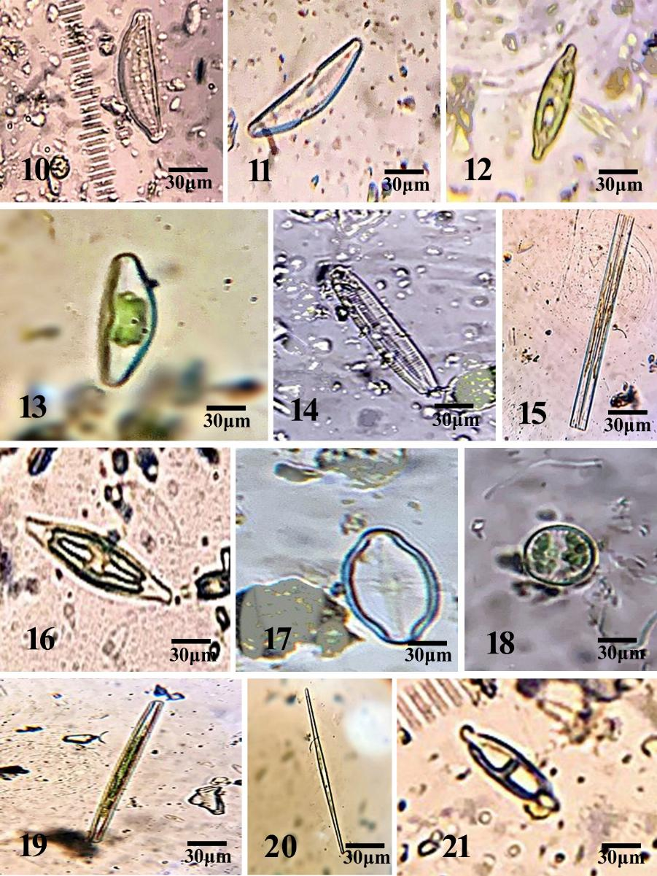
Plate 2. 10: Cymbella aspera 11: C. elginensis 12: C. microcephala 13: C. minuta 14: Caloneis tenuis 15: Ctenophora pulchella 16: Navicula tripunctata 17: N.leptostigma 18; Cyclotella comta 19: Synedra ulna 20: S. acus 21: Neidium affine.
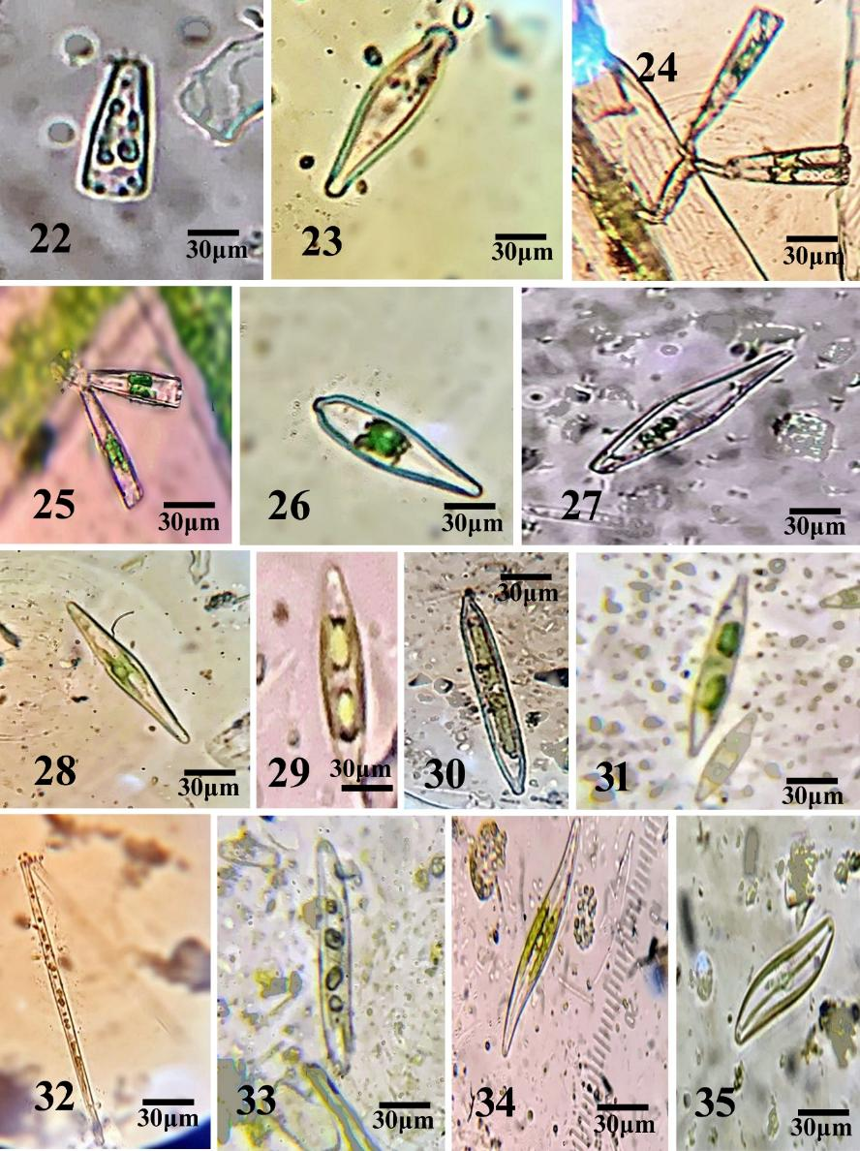
Plate 3. 22: Gomphonema ghosea 23: G. sphaerophorum 24: G. dichotomum 25: G. parvulum 26: G. augur 27: G. lanceolatum 28: Frustulia rhomboids 29: Nitzschia capitellata 30: N. gandersheimiensis 31: N. palea 32: Nitzschia vermicularis 33: N. sigmoidea 34: Gyrosigma acuminatum 35: G. scalproides.
Table 5: Distribution of Algal species in different localities of Chenab and Ravi River.
Species | Chenab River | River Ravi
- Scenedesmus longus var. naegelii (Brèbisson) G.M Smith | + | +
- Coalestrum microsporum Nӓgeli | _ | +
- Cosmerium pyramidatum Brèb. | + | _
- Cosmarium granatum Ehrenberg | + | _
- Cosmerium bioculatum var. canadense Willi Krieger & Gerloff | _ | +
- Cosmerium lundellii Delponte | + | _
- Cosmerium pygmaeum W. Archer | _ | +
- Cosmerium reniforme (Ralfs) Archer | _ | +
- Cosmarium nitidulum De Notaris | + | _
- Cymbella aspera Agardh | + | _
- Cymbella elginensis Krammer | + | _
- Cymbella. microcephala Grunow | + | _
- Cymbella minuta var. silesiaca (Bleisch) Reimer | + | _
- Caloneis tenuis (Gregory) Cleve | _ | +
- Ctenophora pulchella (Ralfs ex Kützing) D. M. Williams & Round | ₊ | _
- Naviculla tripunctata (O.F Mull.) Bory | + | _
- Naviculla leptostigma Ehrenberg | + | _
- Cyclotella comta Kützing | _ | +
- Synedra ulna var. amphirhynchus (Ehrenberg) Grunow. | _ | +
- Synedra acus Kützing | _ | +
- Neidium affine var. amphirhynchus (Ehrenberg) Cleve. | + | _
- Gomphonema ghosea Majeed | _ | +
- Gomphonema sphaerophorum Ehrenberg | _ | +
- Gomphonema dichotomum Kützing | _ | +
- Gomphonema parvulum (Kützing) | _ | +
- Gomphonema augur Ehrenberg | _ | +
- Gomphonema lanceolatum Ehrenberg | _ | +
- Frustulia rhomboids Ehrenberg | + | _
- N. capitellata Hustedt | + | _
- N. gandersheimiensis Krasske | + | _
- Nitzschia palea (Kützing) W.Smith | _ | +
- Nitzschia vermicularis (Kützing) Hantzsch | _ | +
- Nitzschia sigmoidea (Nitzsch.) W.Smith | _ | +
- Gyrosigma acuminatum (Küitzing) Rabenhorst | + | _
35. Gyrosigma scalproides (Rabenhorst) Cleve | + | _
+ Presence, - Absence

Table 6: Taxonomic Classification of Collected Micro Algal Species.
Species | Genera | Families | Orders | Classes
1. Scenedesmus longus var. naegelii | Scenedesmus | Scenedesmaceae | Sphaeropleales | Chlorophyceae
2. Coalestrum microsporum | Coalestrum | Scenedesmaceae | Sphaeropleales | Chlorophyceae
3. Cosmerium pyramidatum | Cosmerium | Desmidiaceae | Desmidales | Zygnematophyceae
4. Cosmarium granatum
5. Cosmerium bioculatum var. canadense
6. Cosmerium lundellii
7. Cosmerium pygmaeum
8. Cosmerium reniforme
9. Cosmarium nitidulum
10. Cymbella aspera | Cymbella | Cymbellaceae | Cymbellales | Bacillariophyceae
11. Cymbella elginensis
12. Cymbella microcephala
13. Cymbella minuta var. silesiaca
14. Caloneis tenuis | Caloneis | Naviculaceae | Naviculales | Bacillariophyceae
15. Ctenophora pulchella | Ctenophora | Beroidae | Beroida | Bacillariophyceae
16. Naviculla tripunctata | Naviculla | Naviculaceae | Naviculales | Bacillariophyceae
17. Naviculla leptostigma
18. Cyclotella comta | Cyclotella | Stephanodiscaceae | Thalassiosirales | Bacillariophyceae
19. Synedra ulna var. amphirhynchus | Synedra | Fragilariaceae | Fragilariales | Bacillariophyceae
20. Synedra acus
21. Neidium affine var. amphirhynchus | Neidium | Neidiaceae | Neidiales | Bacillariophyceae
22. Gomphonema ghosea | Gomphonema | Gomphonemataceae | Gomphonematales | Bacillariophyceae
23. Gomphonema sphaerophorum
24. Gomphonema dichotomum
25. Gomphonema parvulum
26. Gomphonema augur
27. Gomphonema lanceolatum
28. Frustulia rhomboids | Frustulia | Amphipleuraceae | Frustuliales | Bacillariophyceae
29. Nitzschia capitellata | Nitzschia | Nitzschiaceae | Naviculales | Bacillariophyceae
30. Nitzschia gandersheimiensis
31. Nitzschia palea
32. Nitzschia vermicularis
33. Nitzschia sigmoidea
34. Gyrosigma acuminatum | Gyrosigma | Pleurosigmataceae | Bacillariales | Bacillariophyceae
35. Gyrosigma scalproides
Total: 35 | 14 | 13 | 13 | 3

Table no. 7: Identification keys of Species and Genera of Phyla Volvocophycota and Bacilariophycota of both Chenab and Ravi river
Keys to species of Cosmarium
- Cells without a pronounced constriction 2
Cells with a pronounced constriction C. lundellii
- Cell length is less than 30µ 3
Cell length is more than 30µ 5
- Cells rhombic or oval in shape C. pygmaeum
Cells elliptical or cylindrical in shape 4
- Frond elliptical in shape C. nitidulum
Frond semi-circular in shape C. bioculatum
- Cells with a deep constriction at centre C. constrictum
Cells without a deep constriction at centre 6
- Cells with a reniform (kidney-shaped) outline C. reniforme
Cells with a different outline 7
- Cells with a more rounded or elliptical shape C. pyramidatum
Cells with a pyramidal or triangular shape 8
- Cell 26-28µ long C. granatum
Cells 112-114µ long C. ralfsii

Keys to genus of Cymbella, Caloneis, and Ctenophora.
- Valve tapers from the centre to obtuse ends Cymbella
Valve without tapering 2
- Valve linear or lanceolate Caloneis
Valve comb-like Ctenophora

Keys to species of Cymbella.
- Main axis more than 70µ C. elginensis
Main axis less than 70µ 2
- Valve width typically greater than 20 μ C. minuta
Valve width less than 20 μ 3
- Ends rostate C. aspera
Ends not rostate C. microcephala
Keys to genus of Navicula and Craticula.
- Frustules broad and elliptical Navicula
Frustules small and elliptic and areolae Craticula
Keys to species Gyrosigma.
- Valve tapering to blunt G. acuminatum
Valve lanceolate 2
- Valve less than 10 µ G. scalproides
Valve more than 10 µ G. eximium
Keys to species Naviculla.
- Ends capitate N. leptostigma
Ends cuneate N. tripunctata
Keys to species of Synedra.
- Valve more than 5µ S. ulna
Valve less than 5µ S. acus
Keys to species of Gomphonema.
- Valve width typically greater than 20 μ 2
Valve width less than 20 μ 5
- Valve face with a distinct longitudinal rib 3
Valve face without a distinct longitudinal 4
- Frustules straight G. augur
Frustules lanceolate G. lanceolatum
- Slight constriction at apex - G. sphaerophorum
No constriction at apex G. dichotomum
- Girdle sub-rostrate, or rostrate G. parvulum
Girdle cuneate and clavate G. ghosea
Keys to genus of Nitzschia and Gyrosigma.
- Girdle is erect in shape Nitzschia
Girdle sigmoid and convex form Gyrosigma

4. DISCUSSION
Chenab and Ravi Rivers, two of the prominent rivers of Punjab, Pakistan, possess a rich diversity of aquatic flora and fauna and a thick cover of algae vegetation. In order to know more about the diversity of algae, a systematic taxonomic study was pursued between the months of November 2023 to January 2024.Samples were collected from diverse locations on the rivers by using spatulas, forceps, and a plankton net of 30 μm mesh size. Physico-chemical characteristics of water were also studied to determine their role towards algae growth and occurrence. Ten algae samples were separately collected from each station in 50 ml plastic Bottles. The samples were preserved by adding 4% formalin solution. Algal samples were marked and taken to the laboratory. Algae samples were examined under a microscope and photo documented in the lab. Algal taxonomy was prepared based on the literature available. Water samples were also filled in sterile bottles simultaneously for physiochemical analysis. Ten points of Chenab and Ravi River were surveyed under this taxonomic results. All these sites proved to be unique in their physiochemical characteristics. Temperature was most significant in controlling the distribution of algal vegetation with diatoms possessing a relative preference for relatively low temperatures (Roka et al., 2022). The collection had been carried out during winter time thus there were diversities of diatoms. Previous studies done at the freshwater habitats of jilani park also reveals that dominance of Bacillariophyceae (50%) indicating that diatoms are the most prevalent freshwater algal group in Pakistan (ZAKRIA et al.). The survey resulted in a total count of 35 species of algae, spanning two phyla: Volvocophycota and Bacillariophycota. Among the number, the green algae were 9 species, and the diatoms made up the majority with 26 species. Volvocophycota with 3 genera being at 9 green algae species genera Scenedesmus (Scenedesmus longus var. naegelii and genera Coalestrum (Coalestrum microsporum) and seven species of genera Cosmarium (C. bioculatum var. canadense, C. lundellii, C. pygmaeum, C. nitidulum, C. reniforme, C. pyramidatum and C.granatum). Bacillariophycota with 11 genera described being at 26 species are diatoms. Dominant species of the Phyllum group Bacillariophycota (Nitzschia capitellata, N. palea, N. vermicularis, N. gandersheimiensis, and N. sigmoidea) and (Gomphonema dichotomum, G. parvulum var. micropus, G. sphaerophorum, G. augur, G. lanceolatum, G. ghosea). Similar studies were done by (Altaf et al., 2019) on Gulshan e Ravi drainage. He identified a total of 25 species 8 of them were from Ravi river with high biological oxygen demand. There are a number of environmental factors like temperature, pH, Electric conductivity, and dissolve solids and mineral content like potassium, phosphorous and sodium in water to find out their effect on algal diversity. These mineral nutrients play an important role in the growth of algae. An increase in the concentration of phosphorous by a little amount can increase the quantity of algae like cyanobacteria (Hanif et al.). The collected species were morphologically identified by cell shape and structure, and all the genera and species were categorized and classified according to the Shameelian system of classification. Shameelian system of classification relies on the Cell wall, Flagellation, Pigmentation, Classical systematics and Reserve food (Shameel, 2012). There were three genera in Phylum Volovocophycota, Scenedesmus Coelestrum and Cosmarium, Cosmarium species were abundant in both Chenab River and Ravi River and it is also the most numerous species of all the species present. Single species of Scenedesmus longus and Coelestrum microsporum were also present in Volvocophycota. Eleven different genus were abundantly discovered in Bacilariophycota they included Cymbella, Caloneis, Ctenophora, Naviculla, Cyclotella, Synedra, Neidium, Gomphonema, Frustulia, Nitzschia, and Gyrosigma. Gomphonema and Nitzschia. There were single species genera of Caloneis, Ctenophora, Cyclotella,Neidium and Frustulia.

DATA AVAILABILITY STATEMENT
The authors confirm that the information underlying the conclusions of this work is provided within the article.
DISCLAIMER (ARTIFICIAL INTELLIGENCE)
All Authors confirm that NO generative AI tools such as Large Language Models (ChatGPT, COPILOT, etc.) and text-to-image models have been employed in the writing or editing of this manuscript.

REFERENCES
Altaf, R., Ejaz, S. V., Umer, S., & Altaf, S. (2019). Identification of Algal Flora and evaluation of physicochemical status of sewage drain in Samanabad Lahore Pakistan. Environ. Contam. Rev, 2(1), 14-18. https://doi.org/http://doi.org/10.26480/ecr.01.2019.14.18
Aboal, M., Cambra-Sánchez, J., & Ector, L. 2003. Diatom Monographs. A.R.G. Gantner Verlag K.G, pp.1-657.
Cleve, P. T. (1894). Synopsis of the naviculoid diatoms (Vol. 26). PA Norstedt & söner.
Cox, E. J. (1996). Identification of freshwater diatoms from live material. (No Title).
Ghazala, B., & Habib, A. (2011). Distribution of family Fragilaraceae (Bacillarophycota) in the region of Multan, Pakistan. Pak. J. Bot, 43(1), 15-27.
Ghazala, B., Hena, L., Zarina, A., & Mustafa Shameel, M. S. (2009). Taxonomic survey of freshwater algae at the campus of BZ University of Multan, Pakistan. https://doi.org/20093197233
Godar, K., & Rai, S. K. (2018). Freshwater green algae from Raja-Rani wetland, Bhogateni-Letang, Morang, Nepal. Journal of Plant Resources, 16(1), 1-17. https://doi.org/http://www.dpr.gov.np/
Hanif, A., Shah, F. H., Mumtaz, A. S., Ullah, T., Azeem, M. A., Ahmad, M., & Shah, A. A. Taxonomic study of freshwater microalgal diversity and its optimum culturing condition of District Karak, Pakistan. https://doi.org/http://www.innspub.net/
Hirano, M. (1964). Freshwater algae of Afghanistan. Kyoto University.
Hof, T., & Frémy, P. (1933). On Myxophyceae living in strong brines. Recueil des travaux botaniques neerlandais, 30(1), 140-162.
Hustedt, F. (1930). Die Kieselalgen. Kryptogamen-Flora von Deutschland, Osterreich und der Schweiz, 7(1), 1-920.
Hustedt, F. (1959). Die Diatomeenflora des Neusiedler Sees im österreichischen Burgenland. Österreichische Botanische Zeitschrift, 106, 390-430. https://doi.org/https://doi.org/10.1007/BF01289320
Hussain, F., M.K. Leghari., H. Ahmad., Khushnud-ul-Rehman., A. Iqbal., M. Saleem and M.Y. Laghari. 2011. Taxonomic study of freshwater unicellular green algal species from Peshawar Valley. International Journal of Phycology and Phycochemistry, 7: 9-22
Inam, B., K. Nazir and M. K. Leghari. 1986. Some diatoms from Islamabad. Pakistan Journal of Botany, 10: 1-3
Jena, M., Ratha, S. K., & Adhikary, S. P. (2006). Diatoms (Bacillariophyceae) from Orissa state and neighbouring regions, India. Algae, 21(4), 377-392. https://doi.org/https://doi.org/10.4490/ALGAE.2006.21.4.377
Kützing, F. T. (1844). Die kieselschaligen bacillarien oder diatomeen. W. Köhne.
Masud-ul-Hasan, K., & Zeb-un-Nisa, M. (1986). Taxonomic studies of some fresh water algae from Azad Jammu and Kashmir. Biologia, 32, 229-256.
Munir, M., Qureshi, R., Arshad, M., Chaudhry, A. K., & Laghari, M. (2012). Taxonomic study of bacillariophyta from kallar kahar lake chakwal, punjab, pakistan. Pakistan J. Bot, 44(5), 1805-1814. https://doi.org/http://www.pakbs.org/pjbot/abstracts/44(5)/48.html
Munir, M., Qureshi, R., Laghari, M., Arshad, M., & Khaliq Ch, A. (2013). Taxonomy of some pennate diatoms from Kallar Kahar Lake, District Chakwal, Pakistan.
Patil, S., & Kumawat, D. (2014). Diversity of genus Cosmarium corda from Abhora dam of Jalgaon district, Maharashtra. International journal of geology, earth and Environmental sciences, 4(1), 109-114. https://doi.org/http://www.cibtech.org/jgee.htm
Prescott, G. (1962). Algae of western great lakes area. WMC. In: Brown Company Publishing, Iowa, USA.
Roka, D., Rai, S. K., & Ghimire, N. P. (2022). Seasonal variations of algal diversity in response to water quality at Beeshazari Lake, tropical lowland, Nepal. Pak. J. Bot, 54(4), 1445-1452.
Roy, A., Gogoi, N., Yasmin, F., & Farooq, M. (2022). The use of algae for environmental sustainability: trends and future prospects. Environmental Science and Pollution Research, 29(27), 40373-40383. https://doi.org/https://doi.org/10.1007/s11356-022-19636-7
Saleem, M., & Laghari, M. (2011). Taxonomic study of freshwater unicellular green algal species from Peshawar valley. Int. J. Phycol. Phycochem, 7(1), 9-22.
Satpati, G. G., Bose, R., & Pal, R. (2021). Taxonomic investigation of euplanktonic diatom communities as indicator of copper in the bank of the Subarnarekha river, Ghatshila, Jharkhand, India: Diatom as copper indicator. Journal of microbiology, biotechnology and food sciences, 11(1), e2827-e2827. https://doi.org/ https://doi.org/10.15414/jmbfs.2827
Shameel, M. (2001). Diversity exhibited by marine benthic algae inhabiting the coast of Balochistan. Pakistan Journal of Marine Sciences, 10(2), 87-103. https://doi.org/http://www.pakjmsuok.com/index.php/pjms/article/view/49
Shameel, M. (2012). Nomenclatural changes in the Shameelian classification of algae. International Journal of Phycology and Phycochemistry (Pakistan), 8(1).
Shyndanovina, I. (2020). Cosmarium tutum nom. nov. a new name for Cosmarium perforatum var. skujae (Charophyta, Desmidiaceae), a rare taxon newly found in Ukraine. Phytotaxa, 461(4), 243–253-243–253. https://doi.org/10.11646/phytotaxa.461.4.2
TK, M., & Talwankar, D. (2018). Occurrence of Cosmarium species in Khadakpurna reservoir, Buldana district–Maharashtra, India. https://doi.org/10.30574/gscbps.2018.5.3.0136
Tiffany, L.H. and M. E. Britton. 1971. The Algae of Illinois. Hafner Publishing Company, New York, pp.1-399.
Tiffany, L.H. and M.E. Britton. 1952. The Algae of Illinois. Hafner Publishing Company, New York. pp. 1-352.
Venkataraman, G. (1939). A systematic account of some south Indian diatoms. Proceedings/Indian Academy of Sciences,
Wasylik, K. (1961). The algae, especially the desmids of the raised peat-bogs in the Nowy Targ Basin, Polish Western Carpathians. Fregm. Flor. Geo. Bot, 7, 215-284.
West, G. S. (1927). A Treatise on the British Freshwater Algae: In which are Included All the Pigmented Protophyta Hitherto Found in British Freshwaters. The University Press.
ZAKRIA, A., BUTT, G., ZIAa, T., SAEED, Z., SAQIB, A., & MARIAM, A. Taxonomic Study of Freshwater Algae from Jilani Park, Lahore, Pakistan. https://doi.org/https://doi.org/10.56557/joban/2025/v17i19193

