Thermodynamic Studies and Physicochemical Properties of Polyphenol oxidase of African Bush Mango (Irvingia gabonensis) Fruit

Abstract
The study sought to investigate the catalytic effect of polyphenol oxidase (PPO) in adverse browning of African bush mango (I. gabonensis) fruit. PPO was isolated, purified and its physicochemical properties and thermodynamic stability were investigated. The pH and temperature optima of PPO were found at 7.0 and 50 °C respectively. However, the enzyme exhibited a higher activity at neutral pH 7.0, given a percentage activation of 90 %, while the enzyme inhibition was observed at the acidic region between pH 2.0 - 5.0. The presence of SDS at pH 2.0 - 5.0 was found to inhibit the activity of PPO. The average values of enthalpy (ΔH), entropy (ΔS), and Gibbs free energy (ΔG) obtained at 20 min of incubation and temperature 30 – 80 °C were respectively 39.93 KJ/mol, 431.57 J/K and -107.99 KJ/mol for peel PPO, and 37.92 KJ/mol, -442.51J/K, and -107.22 KJ/mol for pulp PPO. The information from this study suggests processing parameters for controlling PPO in potential industrial application of I. gabonensis fruit in order to prolong the shelf-life of this fruit for maximum utilization.

Keywords: Purification; enzyme activity; kinetic propertics; activation energy; adverse browning.
1. Introduction
The major problem of African bush mango (I. gabonensis) has been attributed to its postharvest deterioration and low storage ability, which greatly affects its economic impact [1, 2]. Postharvest deterioration and less storage ability of the fruit is a result of its ease to undergo browning reaction-an adverse reaction that limits the use and applicability of the fruit. Enzymatic browning is an economically important disorder that degrades organoleptic properties and prevents consumers from purchasing fresh fruit and vegetables [3-5]. Prevention and control of enzymatic browning in fruit and its product is imperative. African bush mango has three parts: the peel, the pulp, and the kernel, which is the peculiarity of most fruits [6, 2]. PPO, the agent of browning in fruits, is originally located at the thylakoid membrane of the chloroplast [7- 9]. However, damage to the tissues initiates rupturing at the location of PPO (either chloroplast, mitochondria, or microsomes), and the enzyme, in turn, reacts with phenolic compounds and, in consequence, leads to the browning of the fruit and vegetable [10-12].
The reaction involves the oxidation of a monophenol and/or an ortho-diphenol into their corresponding ortho-quinone derivatives and is catalyzed by PPO [7, 13-14] e o-quinones undergo further polymerization to yield undesirable brown pigments in the presence of
molecular oxygen. Enzymatic browning is associated with off-flavors and makes a significant contribution to loss in nutritional quality, leading to a decrease in the market value of the food and food products. Most importantly, the inhibition of enzymatic browning is a requirement in the food industry [15]. Thermal processes tend to be the most common techniques employed for enzyme inactivation through a systematic approach in varying temperatures.
Therefore, this study considers the parameters needed to characterize the thermal stability of a given enzyme. The information from this study suggests processing parameters for controlling PPO in potential industrial applications of I. gabonensis fruit in order to prolong the shelf-life of this fruit for maximum utilization.
2. Materials and Methods
The major chemicals and reagents used in this research include: Ascorbic acid, ammonium sulfate, di-sodium hydrogen phosphate, catechol, L-3, 4-dihydrophenylalanine (L-DOPA), Triton X-100, sulphanilamide, ethylenediamine tetraacetic acid, sodium dodecyl sulfate (SDS), sephadex DEAE A-50 and G-200 were the products of Pharmacia Chemicals (Sweden), molecular weights markers were purchased from Sigma-Aldrich, Mannheim (German).
2.1. Methods.
2.1.1. Effect of pH with and without SDS on polyphenol oxidase activity.
The enzyme pH with and without SDS was determined as described by Escribano et al. [16] and with a little modification according to Adeseko et al. [7] using various buffers at pH ranges from 2.0 - 9.0 at the concentration of 20 mM. The reaction mixture contained Glycine- NaOH buffer (pH 2.0 - 3.0), 20 mM sodium acetate buffer (pH 4.0 - 5.0), 20 mM potassium phosphate buffer (pH 6.0 - 7.0), and 20 mM Tris- HCI buffer (pH 8.0 - 9.0) in the presence and absence of 0.69 mM SDS. Enzymatic activity was determined according to the standard assay procedure.
2.1.2. Effect of temperature on polyphenol oxidase activity.
The effect of temperature on enzyme activity was carried out by varying the temperature conditions of the enzyme. The reacting mixture consisted of 0.1 mL of the purified enzyme solution and 2.9 mL of the substrate (catechol) solution. The reaction mixtures were incubated at temperatures ranging from 30 - 90°C at an interval of 10°C for 10 min. The enzyme activity was determined according to the standard assay procedure.
2.1.3. Effect of temperature on PPO stability.
Thermal stability of the PPO was determined by incubating purified enzyme at different temperature ranges of 30 – 90°C for 60 min. At 10-minute intervals, the residual activity was determined according to the standard assay procedure. Thermal inactivation was evaluated 30 – 80°C after 20 minutes of enzyme incubation [17]. The residual PPO activity (A) was determined according to the standard procedure described earlier. The data obtained were used to evaluate activation energy (Ea), enthalpy (ΔH), entropy (ΔS), and Gibbs free energy (ΔG) using Equation 1-9.
In the thermodynamic study, the percentage residual PPO activity is calculated by comparison to the initial enzyme activity (A0). The rate constant k for first-order inactivation was determined from the slopes of the inactivation time courses according to the following
equation:
$Log =(A/Ao) = k/2.30$ (1)
Where A0 is the initial enzyme activity (before heating where time t is zero), and A is the activity after heating for time t. A useful indication of the rate of a first-order chemical reaction is the half-life t_{1/2} of a substance, the time it takes for its concentration to fall to half the initial value. The time for [A] to decrease from [A0] to ½[A0] in a first-order reaction. The half-life of the enzyme (t_{1/2}) is calculated according to the following equation.
Therefore, $k = 2.303/t \log_{10} {[A]}_{o}/{[A]}_{1}$ (2)
The main point to observe about this result is that, for a first-order reaction, the half-life of a reactant is independent of its initial concentration. In addition, decimal reduction time (D-value) is defined as the time required to pre-incubate the enzyme at a given temperature to maintain 10 % residual activity or reduce the initial activity by 90 % [18-20] and was estimated from the relationship between k and D according to the Eq. 5.
$D = ln10/k$ (3)
The Z-value is the temperature increase required for one-log₁₀ reduction (90 % decrease) in D-value or the temperature needed to vary the D-value one log unit. It was determined from a plot of log D versus temperature (ºC). The slope of the graph is equal to - $1/Z$ [18].
The temperature of treatment and the rate constant (k) in a denaturation process were related according to the Arrhenius equation:
$k = A e^{-}E_{a}/RT$ (4)
Equation 4 can be transformed as in Eq. 7
$ln k = ln A - (E_{a}/T)$ (5)
$-R lnK = -R lnA + E_{a}/T$ (6)
where R is the universal gas constant (8.314 J.mol-1.K-1 ), k is the reaction rate constant value, A is the Arrhenius constant, Ea is the activation energy (energy required for the inactivation to occur), and T is the absolute temperature in Kelvin. Slopes were calculated using a linear equation $(y = mx + c)$. The energy of activation of denaturation (Ea) was calculated from the slopes of these Arrhenius plots, $(-R ln k)$ values versus reciprocal of absolute temperatures $(1/T)$ according to Eq. 7, and the ordinate intercept corresponds to –R $ln A$. The values of the activation energy (Ea) and Arrhenius constant $(A)$allowed the determination of different thermodynamic parameters such as variations in enthalpy (ΔH; Eq. 7), entrop,y$(ΔS; Eq. 8)$ and Gibbs free energy $(ΔG; Eq. 9)$, respectively [18], according to the following expressions.
$∆H* = Ea - RT$ (7)
$∆S* = (ln – ln (KB /h) – ln )$ (8)
$∆G* = ∆H* - T∆S*$ (9)

Where KB is the Boltzmann constant (1.38˟10 ⁻²³J/K), hP is the Planck constant (6.626 ˟ 10⁻³⁴ J.s), and T is the absolute temperature (K). All equations used here [1-9] were those of Anthon and Barret as modified by Fatoki and Sanni [17]
3. Results and Discussion
The purified enzyme exhibited a higher activity at neutral pH 7.0, given a percentage activation of 9 %, while the enzymatic inhibition was observed at the acidic region, pH 2.0 - 5.0. The presence of SDS was found to inhibit the activity of polyphenol oxidase from the peel and pulp of I. gabonensis, revealed in Table (1), as pH tends to be an acidic medium. However, an optimum temperature of 50°C was observed for polyphenol oxidase activity of both the peel and pulp of I. gabonensis fruit. A markedly high relative activity of 66.4 and 87.9% were also observed at 40°C while about (56.5 and 51.3 %) and (41.7 and 59.4 %) were recorded at 30 and 60°C, respectively. A gradual decrease in enzyme activity was observed after 50°C, as shown in figure (1c) for the peel and the pulp of I. gabonensis3.1. Physicochemical properties of PPO.
3.1. Effect pH with SDS and Without SDS.
The optimal pH of polyphenol oxidase activity in the presence and absence of 0.696 mM sodium dodecyl sulfate (SDS) was observed at pH 7.0, as shown in Figures (1a) and (1b). However, the enzyme was found to be active in all the pHs under investigation. There was a gradual increase in the activity of the polyphenol oxidase as the pH increased. However, the percentage inhibition of 14 % was measured at pH 2.0 while pH 9.0 gave the least inhibition of 3 % with the peel PPO, while 6 %, 6 %, and 3 % percentage inhibition were obtained with pH 2.0, 3.0, and 4.0 medium, respectively.

Table 1. Effect of pH with SDS and without SDS on PPO activity.
Sample | pH | Without SDS | With SDS | % Activation | % Inhibition
Peel | 2.0 | 0.21 | 0.18 | - | 14.3
Peel | 3.0 | 0.3 | 0.27 | - | 10
Peel | 4.0 | 0.36 | 0.33 | - | 8.3
Peel | 5.0 | 0.45 | 0.42 | - | 6.7
Peel | 6.0 | 0.39 | 0.42 | 7.7 | -
Peel | 7.0 | 0.45 | 0.54 | 9.0 | -
Peel | 8.0 | 0.36 | 0.45 | 9.0 | -
Peel | 9.0 | 0.36 | 0.36 | Nil | Nil
Pulp | 2.0 | 0.12 | 0.06 | - | 3.3
Pulp | 3.0 | 0.24 | 0.18 | - | 2.5
Pulp | 4.0 | 0.24 | 0.21 | - | 3.0
Pulp | 5.0 | 0.27 | 0.27 | Nil | Nil
Pulp | 6.0 | 0.30 | 0.36 | 6.0 | -
Pulp | 7.0 | 0.42 | 0.51 | 9.0 | -
Pulp | 8.0 | 0.33 | 0.33 | Nil | Nil
Pulp | 9.0 | 0.15 | 0.12 | - | 3.0

3.2. Effect of temperature on PPO activity.
An optimum temperature of 50°C was observed for polyphenol oxidase activity of both the peel and pulp of I. gabonensis fruit. A markedly high relative activity of 66.4 and 87.9% were also observed at 40°C while about (56.5 and 51.3 %) and (41.7 and 59.4 %) were recorded at 30 and 60°C, respectively. A gradual decrease in enzyme activity was observed after 50°C, as shown in figure (1c) for the peel and the pulp of I. gabonensis.
3.3. Thermal inactivation of PPO.
The thermal inactivation parameters for the African Bush Mango PPO are shown in Table 2. When the enzyme was exposed to 80°C for 30 min, only 30 % and 20 % of its original activity was retained with the peel and pulp extracts, respectively. Thermal inactivation of PPO from African Bush Mango exhibited a reduction in catalytic activity as the temperature and duration of heat inactivation increased in the presence of both extracts using catechol, reflected by an increment in k value. The half-life of PPO (t_{1/2}) decreased as the incubation temperature increased due to instability of the enzyme at high temperatures and was higher in the pulp than the peel. Both D and Z values decreased with increased temperature.

Table 2. Thermodynamic parameters of PPO from pulp and peel I. gabonnesis after 20 min of incubation.
Sample | Temperature  (°C) | Kinact (10⁻³  min⁻¹) | t1/2  (min) | D (min) | Z  (ºC) | Temperature  (K) | Ea (kJ/mol) | Ln A | ΔH# (kJ/mol) | ΔS#  (J/k) | ΔG# (kJ/mol)
Pulp | 30 | 8.4 | 84.518 | 274.117 | 47.619 | 303 | 36.95 | 10.080 | 34.430 | 432.219 | -96.531
Pulp | 40 | 13.1 | 52.912 | 175.77 | 47.619 | 313 | 36.95 | 10.080 | 34.347 | 431.949 | -100.852
Pulp | 50 | 38.7 | 17.911 | 59.498 | 47.619 | 323 | 36.95 | 10.080 | 34.264 | 431.688 | -105.171
Pulp | 60 | 47.8 | 14.501 | 48.171 | 47.619 | 333 | 36.95 | 10.080 | 34.181 | 431.434 | -109.486
Pulp | 70 | 58.9 | 11.768 | 39.093 | 47.619 | 343 | 36.95 | 10.080 | 34.098 | 431.188 | -113.799
Pulp | 80 | 73.3 | 9.456 | 31.413 | 47.619 | 353 | 36.95 | 10.080 | 34.015 | 430.949 | -118.110
Peel | 30 | 9.7 | 71.458 | 237.38 | 47.17 | 303 | 40.643 | 11.396 | 38.125 | 443.16 | -96.152
Peel | 40 | 13.4 | 51.727 | 171.835 | 47.17 | 313 | 40.643 | 11.396 | 38.042 | 442.89 | -100.583
Peel | 50 | 21.8 | 31.796 | 105.623 | 47.17 | 323 | 40.643 | 11.396 | 37.958 | 442.629 | -105.011
Peel | 60 | 37.7 | 18.386 | 61.077 | 47.17 | 333 | 40.643 | 11.396 | 37.875 | 442.375 | -109.436
Peel | 70 | 61.2 | 11.326 | 37.624 | 47.17 | 343 | 40.643 | 11.396 | 37.792 | 442.129 | -113.858
Peel | 80 | 107.0 | 6.478 | 21.519 | 47.17 | 353 | 40.643 | 11.396 | 37.709 | 441.89 | -118.278

PPO from I. gabonensis fruit pulp exhibited a reduction in catalytic activity as the temperature and duration of heat inactivation increased in the presence of catechol as substrate, reflected by an increment in k values (Table 2). The half-life of PPO (t_{1/2}) decreased as the incubation temperature increased due to the instability of the enzyme at high temperatures. Both D and Z values suggest that PPO showed a fair thermal stability in the presence of catechol with Ea value (36.95 kJ/mol). An inactivation curve of catechol indicated that more than 60 % of PPO activity was diminished after heating of PPO at 70°C for 30 min, and the activity was reduced to only 12.8 % when heated at 80°C for 60 min. Sharp decreases were observed in the half-life (t _{1/2}) and the decimal reduction time (D-value), which is defined as the time necessary for the activity to reduce by 90 % of the initial activity. Studies on PPO from fruit varieties from other sources, such as kirsmi grape [21], and violent eggplant [22]. Litchi apple [4]; banana [23]; PPO from I. gabonensis fruit was relatively thermally stable at the temperature range of 30 - 60; at high temperatures (60 – 80), the I. gabonensis PPO was more stable than the PPO from apricot [24], Anamur bananas [25] and was less stable than the PPO from Cape gooseberry [26, 27]. The t_{1/2} value of Yali pear PPO at 70°C was 6 min [28], with 8 min for avocado pear PPO [29, 30].
Bobo et al. [19] described the denaturation of sweet potato PPO as a first-order reaction with k values between 0.0075 and 0.0657 m⁻¹. The half-life (t_{1/2}) value of I. gabonensis peel and pulp PPOs in this study was between 71.46 - 6.48 min for I. gabonensis fruit peel PPO and 84.52 - 9.46 min for I.gabonensis fruit pulp PPO respectively. This value is higher compared to the reported 6.0 min Yali pear PPO at 70°C [31], 18.8 min at 60°C and 8.5 min at 70°C for mango kernel PPOs [32] and lower compared to white sorghum PPO 117.46 - 17.54 min at 70°C for white sorghum PPO, 770 - 25.20 min for yellow sorghum PPO [33] and 92 - 10 min for sweet potato PPO [19]. Z-value is the temperature increase needed for a 90% reduction in Dvalue, the Z-value of 47.17 and 47.62°C obtained for I. gabonensis peel and pulp PPO respectively is higher than 36.9°C and 20°C, obtained for white and yellow sorghum PPO [33], 14.1°C for sweet potato [19], 38.46°C of violent eggplant PPO [34], 21.5°C for pineapple PPO [35]. Generally, high Z-values indicate more sensitivity to the duration of heat treatment, and lower Z-values mean more sensitivity to increases in temperature [36]. Differences in the kinetics of heat activation of the peel and pulp PPOs might result from differences in their phenolic contents.
The results thus suggest that I. gabonensis fruit peel and pulp PPO is a relatively thermo-stable enzyme with the Ea of 36.95 and 40.64 KJ/mol, respectively, at 30 min incubation. High activation energy reflects a greater sensitivity of I. gabonensis fruit peel and pulp PPOs to temperature change [33, 35]. This suggests that the denaturation process requires a high energy input to the enzyme-substrate complex to initiate denaturation, probably due to a possible compact structure of enzymes and the strength of the thiol groups (SH) or disulfide bond at the active site [36, 40, 43]. This activation energy is lower compared to 51.84 kJ/mol for white sorghum [33], 52.93 KJ/mol for yam PPO [22], 82.8 kJ/mol for pineapple [35], 95 kJ/mol for sweet potato [19], 275 kJ/mol for grape [37-40], 116 kJ/mol for cranberry [14] but higher compared to 27.02 KJ/mol for Hibiscus sabdariffa PPO, 28.3 KJ/mol for apple PPO [38-42] and 33.67 kJ/mol for kiwifruit [39-41].
Thermal inactivation of PPO from I. gabonensis fruit peel and pulp in this study produce an average value of ΔH, ΔS, and ΔG of 37.917 kJ/ mol, 442.53 J/k, and 107.215 kJ/mol for peel and 34.22 kJ/ mol, 431 J/k, and - 107.32 kJ/mol for pulp PPO from I. gabonensis fruit at 30 min incubation and temperatures of 30 - 80. However, white and yellow sorghum as reported by [33, 43] that at temperatures of 50- 80, the average values of
ΔH, ΔS, and ΔG of 49.03 kJ/ mol, -129.52 J/k, and 92.81 kJ/mol for white sorghum PPO and 90.1 kJ/ mol, -9.29 J/k, and 93.37 kJ/mol for yellow sorghum PPO respectively. 50.20
kJ/ mol, -11.98 J/k, and 89.49 kJ/mol [44-46] for sweet potato [19, 44], 24.212 kJ/mol, -195.57 J/K, and 66.14 kJ/mol for Hibiscus sabdariffa PPO at 20 min incubation respectively, while ΔH and ΔS for potato PPO were 98.02 kJ/mol and 145 J/K [40, 45]. The high values of change in enthalpy obtained for the different treatment temperatures revealed that the enzyme undergoes a considerable change in conformation during denaturation. Positive values of ΔH of the PPO indicate the endothermic nature of the oxidation reactions. The negative values of entropy indicate that there are no significant processes of aggregation, otherwise, the values of entropy would be negative [33, 45, 47].
Concerning free energy (ΔG), is a measure of the spontaneity of the inactivation processes. The free energy of the PPO of the peel and pulp of I. gabonensis was negative, and it decreased with increasing temperature. The values were negative at all temperatures investigated, which showed that the inactivation processes were spontaneous.

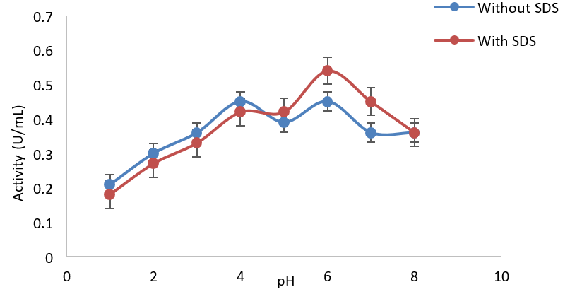 | 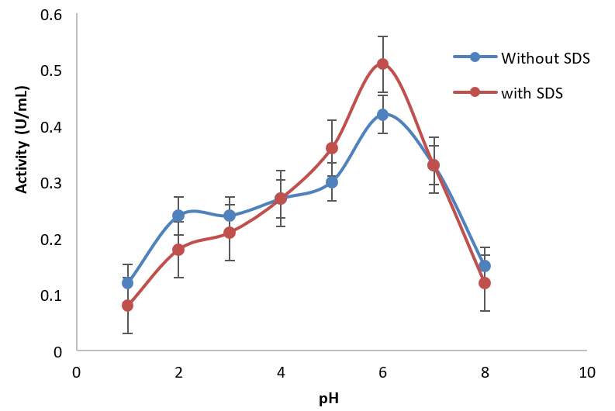
(a) | (b)
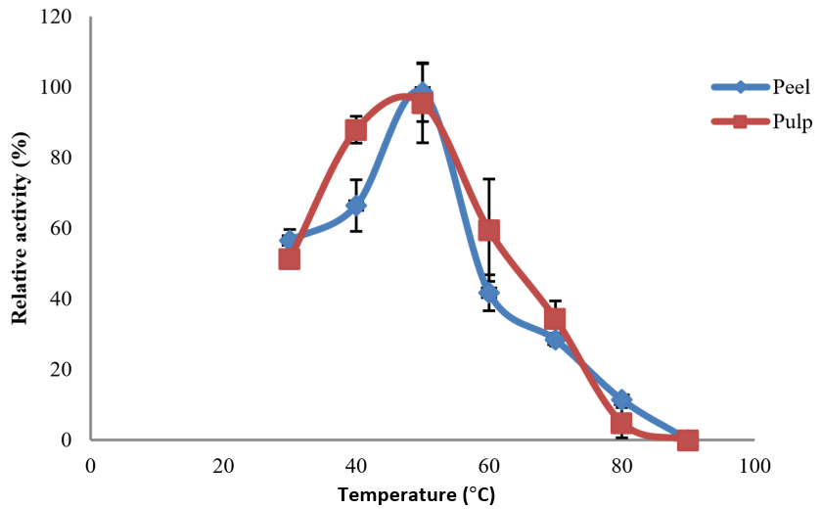 | 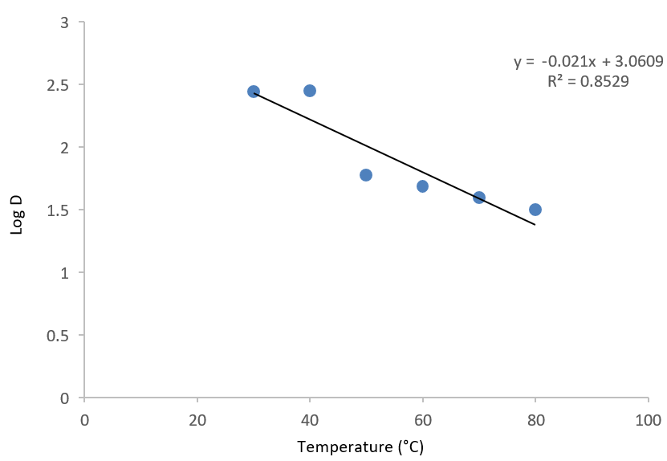
(c) | (d)
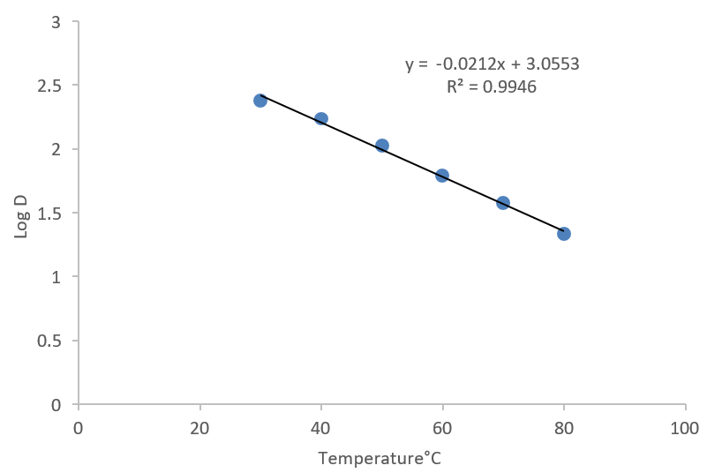 | 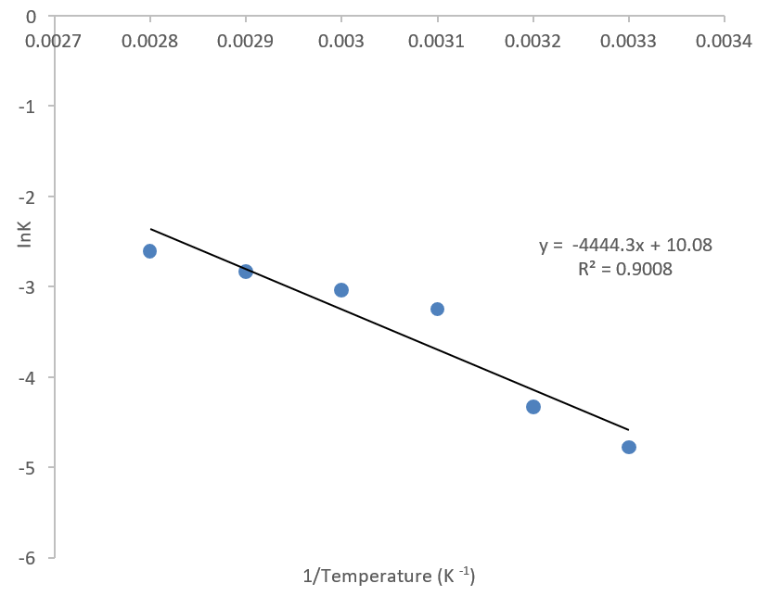
(e) | (f)
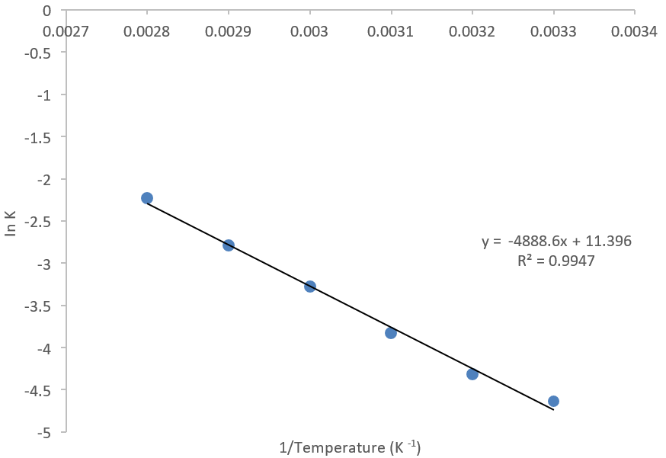
(g)
Figure 1. (a) Effect of pH with SDS and without SDS on African Bush Mango fruit peel PPO; (b) Effect of pH with SDS and without SDS on African Bush Mango fruit pulp PPO; (c) Effect of Temperature on African Bush Mango fruit Peel and Pulp PPO activity; (d) Z plot for PPO from African Bush Mango peel between 30 – 80 °C, at 20 min of incubation; (e) Z plot for PPO from African Bush Mango peel between 30 – 80 °C, at 20 min of incubation; (f) Arrhenius plot for PPO from African Bush Mango fruit peel between 30 – 80°C, at 20 min of incubation; (g) Arrhenius plot for PPO from African Bush Mango fruit pulp between 30 – 80 °C, at 20 min of incubation.
4. Conclusion
This study revealed thermal treatments that could be employed during postharvest storage and transportation of Irvingia gabonensis fruit to prolong the shelf-life of this fruit for maximum domestic and industrial utilization.
References
- Wang Z, Yuan J, Yang J, Dong Z, Yan X, Yuan C, Ren Y. Effects of Guankou grape polyphenol oxidase on enzymatic browning. J. Food Process. Preserv. 2022, 46, e16127, https://doi.org/10.1111/jfpp.16127.
- Adeseko CJ, Salawu SO, Sanni DM, Kade 1J. Nutritional Evaluation, Phenolic Constituents and Free-Radical Scavenging Activity of Peels and Pulp of African Bush Mango (Irvingia gabonensis) Fruit. J. Adv. Food Sci. Technol. 2022, 9, 35-44.
- Zawawi NAF, Hazmi NAM, How MS, Kantono K, Silva FVM, Sulaiman A. Thermal, High Pressure, and Ultrasound Inactivation of Various Fruit Cultivars’ Polyphenol Oxidase: Kinetic Inactivation Models and Estimation of Treatment Energy Requirement. Appl. Sci. 2022, 12, 1864, https://doi.org/10.3390/app12041864.
- Wei J, Zhang X, Zhong R, Liu B, Zhang X, Fang F, Zhang Z, Pang X. Laccase-Mediated Flavonoid Polymerization Leads to the Pericarp Browning of Litchi Fruit. J. Agric. Food Chem. 2021, 69, 15218–15230, https://doi.org/10.1021/acs.jafc.1c06043.
- Liu B, Zhou X, Guan H, Pang X, Zhang Z. Purification and Characterization of a Dark Red Skin Related Dimeric Polyphenol Oxidase from Huaniu Apples. Foods 2022, 11, 1790. https://doi.org/10.3390/ foods11121790.
- Umair M, Jabeen S, Ke Z, Jabbar S, Javed F, Abid M, Khan KUR, Ji Y, Korma SA, El-Saadony MT, Zhao L, Cacciotti I, Lima CMG, Conte-Junior CA. Thermal treatment alternatives for enzymes inactivation in fruit juices: Recent breakthroughs and advancements. Ultrason. Sonochem. 2022, 86, 105999, https://doi.org/10.1016/j.ultsonch.2022.105999.
- Adeseko CJ, Sanni DM, Lawal OT. Biochemical studies of enzyme-induced browning of African bush mango (Irvingia gabonensis) fruit pulp. Prep. Biochem. Biotechnol. 2021, 52, 835-844, https://doi.org/10.1080/10826068.2021.1998113.
- Yoruk R, Marshall MR. Physicochemical Properties and Function of Plant Polyphenol Oxidase: A Review. J. Food Biochem. 2003, 27, 361–422, https://doi.org/10.1111/j.1745-4514.2003.tb00289.x.
- Silva FVM, Sulaiman A. Control of Enzymatic Browning in Strawberry, Apple, and Pear by Physical Food Preservation Methods: Comparing Ultrasound and High-Pressure Inactivation of Polyphenoloxidase. Foods 2022, 11, 1942, https://doi.org/10.3390/foods11131942.
- Adeseko CJ, Sanni DM, Salawu SO, Kade IJ, Fatoki HT. HPLC-UV Standard Phenolic Constituents of African Bush Mango (Irvingia gabonensis) and Molecular Docking on Polyphenol Oxidases. J. Appl. Life Sci. Int. 2019, 22, 1-11, https://doi.org/10.9734/jalsi/2019/v22i130119.
- Sanni DM, Adeseko CJ, Bamidele SO. Purification and biochemical characterization of polyphenol oxidase from seeds of melon (Citrullus colocynthis). Nova Biotechnol. Chim. 2020, 19, 223-231, https://doi.org/10.36547/nbc.v19i2.777.
- Derardja A, Pretzler M, Kampatsikas L, Radovic M, Fabisikova A, Zehl M, Barkat M, Rompel A. Current Research in Food Science. CRFS 2022, 5, 196-206. https://doi.org/10.1016/j.fochx.2019.100053.
- Li J, Deng Zy, He Y, Fan Y, Dong H, Chen R, Liu R, Tsao R, Liu X. Differential specificities of polyphenol oxidase from lotus seeds (Nelumbo nucifera Gaertn.) toward stereoisomers, (–)-epicatechin and (+)-catechin: Insights from comparative molecular docking studies. LWT 2021, 148, 111728, https://doi.org/10.1016/j.lwt.2021.111728.
- AL-abbasy OY, Ali WI, Al-lehebe NI. Inhibition of enzymatic browning in fruits and vegetables, review. Samarra J. Pure Appl. Sci. 2021, 3, 56-73.
- Nogales-Delgado S. Polyphenoloxidase (PPO): Effect, Current Determination and Inhibition Treatments in Fresh-Cut Produce. Appl. Sci. 2021, 11, 7813, https://doi.org/10.3390/app11177813.
- Escribano J, Cabanes J, Garcia-Carmona F. Characterisation of Latent Polyphenol Oxidase in Table Beet: Effect of Sodium Dodecyl Sulphate. J. Food Sci. Agric. 1997, 73, 34-38, https://doi.org/10.1002/(SICI)1097-0010(199701)73:1<34::AID-JSFA689>3.0.CO;2-%23.
- Fatoki TH, Sanni DM. Physicochemical properties, kinetics and thermodynamic studies of polyphenol oxidase from sorghum (Sorghum bicolor (L.) Moench) for potential use in industry. Nova Biotechnol. Chim. 2019, 18, 102-117, https://doi.org/10.2478/nbec-2019-0013.
- Sant’Anna V, Cladera-Olivera F, Brandelli A. Kinetic and thermodynamic study of thermal inactivation of the antimicrobial peptide P34 in milk. Food Chem. 2012, 130, 84–89, https://doi.org/10.1016/j.foodchem.2011.07.001.
- Bobo G, Arroqui C, Virseda P. Natural plant extracts as inhibitors of potato polyphenol oxidase: The green tea case study. LWT. 2022, 153, 112467, https://doi.org/10.1016/j.lwt.2021.112467.
- Alja’afreh IY. Insight on Polyphenol Oxidase Enzyme And Its Chemical and Natural Inhibitors. J. Pharma Negat. Results 2022, 13, 3486-3493.
- Kaya ED, Bağci O. Purification and biochemical characterization of polyphenol oxidase extracted from Kirmizi Kismis grape (Vitis vinifera L.). J. Food Biochem. 2021, 45, e13627, https://doi.org/10.1111/jfbc.13627.
- Yapi JC, Ekissi GSE, Ya KC, Kouamé PL. Inactivation Kinetics and Thermodynamic Parameters of Polyphenol Oxidase and Peroxidase Activities in an Extract from of Violet Eggplant (Solanum melongena L.). 2021, 13, 83-92, https://doi.org/10.9734/EJNFS/2021/v13i330393.
- Wohlt D, Schwarz E, Schieber A, Bader-Mittermaier S. Effects of Extraction Conditions on Banana Peel Polyphenol Oxidase Activity and Insights into Inactivation Kinetics Using Thermal and Cold Plasma Treatment. Foods 2021, 10, 1022, https://doi.org/10.3390/foods10051022.
- Selvarajan E, Veens R, Manoj Kumar N, Singh J, Sharma D, Kumar G, Sharma N. Polyphenol Oxidase, Beyond Enzyme Browning. In Microbial Bioprospecting for Sustainable Development, Eds.; Springer, Singapore, 2018, 203-222, https://doi.org/10.1007/978-981-13-0053-0_10.
- Zhou CY, Cheng QW, Chen T, Meng LL, Sun TG, Hu B, Yang J, Zhang DY. Prediction of banana quality during storage by brown area. Acta Aliment. 2022, 51, 542-551, https://doi.org/10.1556/066.2022.00154.
- Bravo K, Osorio E. Characterization of polyphenol oxidase from Cape gooseberry (Physalis peruviana L.) fruit. Food Chem. 2016, 197, 185-190, https://doi.org/10.1016/j.foodchem.2015.10.126.
- Houška M, Silva FV, Evelyn M, Buckow R, Terefe NS, Tonello C. High Pressure Processing Applications in Plant Foods. Foods 2022, 11, 223, https://doi.org/10.3390/foods11020223.
- He J, Feng Y, Cheng Y, Karuppanapandian T, Wang J, Guan J. Changes in α-Farnesene and Phenolic Metabolism and the Expression of Associated Genes during the Development of Superficial Scald in Two Distinct Pear Cultivars. Inter. J. Mol. Sci. 2022, 23, 12088, https://doi.org/10.3390/ijms232012088.
- Guven RG, Guven K, Bekler FM, Acer O, Alkan H, Dogru M. Purification and characterization of polyphenol oxidase from purslane. Food Sci. Technol. 2017, 37, 356-362, https://doi.org/10.1590/1678-457X.03216.
- Chirinos R, Ramon K, Mendoza M, Figueroa-Merma A, Pacheco-Ávalos A, Campos D, Pedreschi R. Effect of Prolonged Cold Storage on the Dynamics of the Enzymatic and Non-Enzymatic Antioxidant System in the Mesocarp of Avocado (Persea americana) cv. Hass: Relationship with Oxidative Processes. Horticulturae 2022, 8, 880, https://doi.org/10.3390/horticulturae8100880.
- Zhou HW, Feng X. Polyphenol oxidase from yali pear (Pyrus bretschneideri). J. Sci. Food Agric. 1991, 57, 307−313, https://doi.org/10.1002/jsfa.2740570302.
- Arogba SS, Ajiboye OL, Ugboko LA. Essienette, S.Y.; Afolabi, P.O. Properties of polyphenol oxidase in mango (M. indica) kernel. J. Sci. Food Agric. 1998, 77, 459–462, https://doi.org/10.1002/(SICI)1097-0010(199808)77:4<459::AID-JSFA61>3.0.CO;2-O.
- Sanni DM, Fatoki TH. Evaluation of malting properties and activities of three enzymes from sorghum (Sorghum bicolor) during malting. Afr. J. Food Sci. Technol. 2017, 8, 090-098.
- Yapi JC, Gnangui SN, Ahi AP, Kouassi-Koffi JD, Kouamé LP. Thermal inactivation kinetics and thermodynamic analysis of the first isoform of polyphenol oxidase Purified from edible yam Dioscorea cayenensis-rotundata cv Kponan. Sky J. Food Biochem. Res. 2014, 3, 72–79.
- Chutintrasri B, Noomhorn A. Thermal inactivation of polyphenol oxidase in pineapple puree. LWT - Food Sci. Technol. 2006, 39, 492-495, https://doi.org/10.1016/j.lwt.2005.04.006.
- Çınar, F.; Aksay, S. Purification and characterization of polyphenol oxidase from myrtle berries (Myrtus communis L.). J. Food Meas. Charact. 2022, 16, 12282-2291, https://doi.org/10.1007/s11694-022-01350-0.
- Liu B, Zhu Q, Zhou X, Zhang X, Dang Z, Liang S, Li G, Zhang Z, Fang F, Pang X. Characterization of a pericarp browning related LACCASE 14-4 from longan fruit with a focus on (epi)catechin oxidative polymerization. Postharvest Biol. Technol. 2022, 185, 111802, https://doi.org/10.1016/j.postharvbio.2021.111802.
- Oktay M, Küfreviolu I, Kocaçalişkan I, Şaklrolu H. Polyphenoloxidase from Amasya Apple. J. Food Sci. 1995, 60, 494-496, https://doi.org/10.1111/j.1365-2621.1995.tb09810.x.
- Wang F, Zhou H, Cheng F, Niu H, Yuan L, Yi J, Zhou L. Comparison of the characterization and the temperature/pressure stability of soluble and membrane-bound polyphenol oxidase from ‘Lijiang’ snow peach. LWT-Food Sci. Technol. 2021, 146,
- Duangmal K, Apenten RKO. A comparative study of polyphenol oxidases from taro (Olocasia esculenta) and potato (Solanum tuberosum var. Romano). Food Chem. 1999, 64, 351–359. https://doi.org/10.1016/S0308-8146(98)00127-7.
- Kaya ED. Biochemical properties of polyphenol oxidase purified from Sarali plum (Prunus domestica), J.Food Meas Charact. 2024 18:6473–6484 https://doi.org/10.1007/s11694-024-02663-y
- Vivekanandhan K, Jeyasundar PJSA, Mani VM, Ayyappadas MP. Isolation and molecular identification of polyphenol oxidase and associated enzyme production from Bacillus spp.. J. Appl. Nat. Sci. 2024., 16(2), 663-673. https://doi.org/10.31018/jans.v16i2.5369
- Sarsenova A, Demir D, Ça ˘glayan K, Abiyev S, Darbayeva T, Eken C. Purification and Properties Polyphenol Oxidase of Dried Volvariella bombycina. Biol. 2023, 12, 53. https://doi.org/ 10.3390/12010053
- Demir D, Kabak S, Caglayen K. Purification and Characterization of Polyphenol Oxidase in the Fruits of Opuntia ficus-indica, Biol. (Basel), 2023 Oct; 12(10): 1339. Published online 2023 Oct 16. doi: 10.3390/biology12101339
- Yu K, He W, Ma X, Zhang Q, Chen C, Li P, Wu D. Purification and Biochemical Characterization of Polyphenol Oxidase Extracted from Wheat Bran (Wan grano), Mol. 2024, 29(6), 1334; https://doi.org/10.3390/mololecules29061334
- Zou C, Zhang X, Yongquan Xu, Yin J. Recent Advances Regarding Polyphenol Oxidase in Camellia sinensis: Extraction, Characterization, and Application, Foods 2024, 13(4), 545; https://doi.org/10.3390/foods13040545
- Sajjiad N, Ahmad MS, Mahmood RT, Tariq M, Asad MJ, Irum S, Andleeb A, Ahamed D. Purification and characterization of novel isoforms of the polyphenol oxidase from Malus domestica fruit pulp. NCBI, 2023; 18(8): e0276041 doi: 10.1371/journal.pone.0276041

