Comparative Study on the Extraction of Alpinia galanga (L.) Willd. Essential Oil for Evaluating Yield Efficiency

ABSTRACT
Aims: This study aims to evaluate the effectiveness of oil extraction through galangal rhizomes from various drying methods i.e. fresh, oven dried and shade dried rhizomes by using hydro distillation method.
Study Design: Experimental study comparing essential oil yields from three different samples of Alpinia galanga rhizomes.
Place and Duration of Study: Alpinia galanga rhizomes harvested from the Germplasm Conservatory cum Herbal Garden of Silviculture and Forest Management Division, at the Forest Research Institute, Dehradun. Further the oil extraction from rhizomes through hydro distillation has carried out in Non-Timber Forest Products laboratory, Forest Research Institute, Dehradun, from the time period between January 2023 to June 2024.
Methodology: Three types of Alpinia galanga rhizome samples (fresh, oven-dried, and shade-dried) were used. Each sample (400 grams) was immersed in 1000 ml of water in a boiling flask and subjected to hydro distillation for 4–5 hours. A Clevenger-type apparatus was used to separate the oil and water components. The oil-water mixture underwent multiple extractions using a separatory funnel to isolate the essential oil. The extracted oil was transferred to vials and allowed to evaporate completely in a well-ventilated area. The final oil content was weighed to determine extraction yield.
Results: The highest essential oil yield was obtained from the shade-dried rhizome sample, with a yield of 0.09%. Fresh and oven-dried samples yielded lower amounts of essential oil. Using these yield percentages, the estimated essential oil extraction from one kilogram (1 kg) of Alpinia galanga rhizome can be calculated.
Conclusion: Shade drying was found to be the most effective method for optimizing essential oil yield from Alpinia galanga rhizomes. This finding is significant for commercial production, as shade drying enhances oil recovery and could improve industrial-scale essential oil extraction efficiency.

Keywords: [Alpinia galanga, Essential oil, Rhizomes, Hydro distillation].
1. INTRODUCTION
Galangal, scientifically known as Alpinia galanga, is an herb frequently cultivated in Southeast Asia. Currently, China, Surinam, Bangladesh, India, and all other South-East Asian nations cultivate A. galanga [10]. It is a lesser-known medicinal plant grown in Asia, and its pharmaceutically bioactive ingredients are of industrial significance [3]. These medicinal benefits are due to galangal's secondary metabolites, which include flavonoids, terpenes, saponins, phenolic acids, and essential oils [1]. A. galangal rhizomes essential oil (AGREO) is an aromatic oily liquid obtained from fresh and dried A. galangal rhizomes, with a slightly spicy aroma. AGREO has gained global attention due to its great therapeutic potential, including insecticidal, antioxidant, anticancer, and anti-inflammatory properties. Rhizomes are harvested at about seven months old for essential oil extraction, however rhizomes are harvested after 15 months, when they turn fibrous, for use in ayurveda and other traditional medicinal formulations.[10]. Fresh rhizomes of galangal exhibit a refreshing, woody, minty, floral, and aromatic Odor, with a hot taste. Both fresh and dried rhizomes are extensively utilized as essential spices in various culinary preparations such as curry, soup, and seafood dishes across countries in Southeast Asia [6] used GC-FID, GC-MS, and olfactometry to investigate the essential oils of A. galanga leaves, stems, rhizomes, and roots from southern India. Many researchers have reported finding essential oil in the rhizome of A. galanga (greater galanga) [11],[4],[2],[9]. In contrast, certain studies have identified 1,8-cineole as the primary component of a 95% ethanol extract of galangal [8] as well as galangal essential oil that has been hydro distilled [8]. This study aims to find the extraction of oil from the fresh, oven dried and shade dried rhizomes of Alpinia galanga, by using hydro distillation procedure with specific equipment and processes. Further, to know the suitable type of rhizome with highest yield of oil extraction, thereby offers valuable insights for future agronomic research and potential commercial production of Alpinia galanga.
2. MATERIALS AND METHODS:
2.1 Study Area:
The Alpinia galanga rhizome were harvested from the Germplasm Conservatory Cum Herbal Garden, and oil extraction experimental analysis has carried out in the NTFP Discipline of Silviculture and Forest Management Division of Forest Research Institute Dehradun, located approximately 670 meters above sea level, positioned at coordinates 30°20'37''N and 78°0'11''E in the northwestern corner of Uttarakhand.
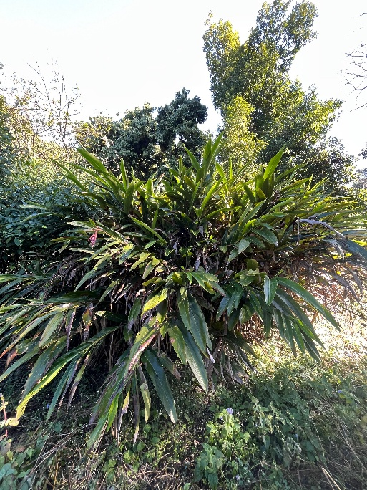
Figure 1: Patch of Alpinia galanga plantation in Germplasm Cum Herbal Garden
2.2 Samples:
The collected rhizome samples, was properly cleansed before chopping them into small pieces.
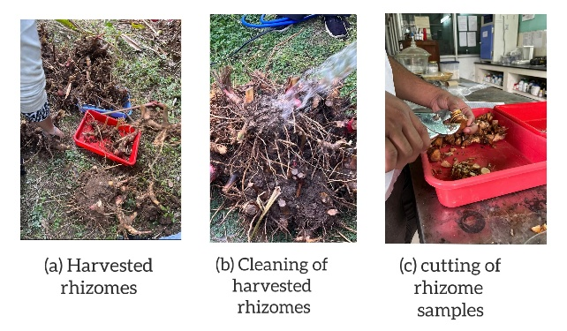
Figure 2: (a) Harvested rhizomes (b) Cleaning of harvested rhizomes (c) cutting of rhizome samples
Galangal oil was extracted from three types of samples i.e. fresh rhizomes, oven-dried rhizomes, and shade-dried rhizomes.
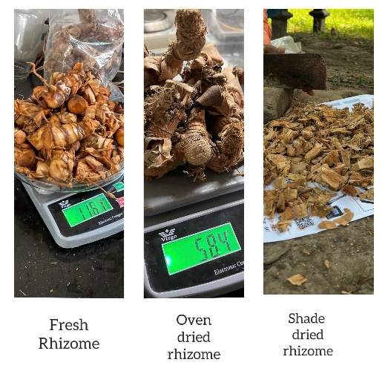
Figure 3: Different rhizome samples
The rhizomes were processed using a hydro distillation unit equipped with a condenser.
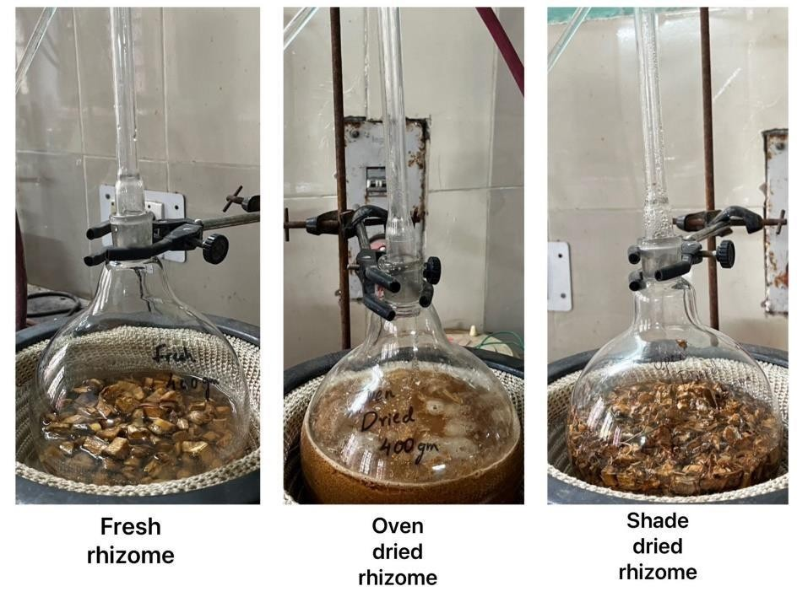
Figure 4: Samples of Fresh and Dried Rhizomes of Alpinia galanga
In the case of fresh rhizomes, 400 grams of rhizome samples were soaked in 1000 ml of water in a boiling flask. and heated for 4-5 hours to extract the essential oil completely. Oven-dried rhizomes were prepared by slicing and drying them in a 45°C oven for 15 days until a constant weight was achieved, with a moisture content of about 40%. These dried rhizomes were then processed into powder and 400 grams were used for extraction, which lasted 5-6 hours over 23 days. Similarly, shade-dried rhizomes, amounting to 400 grams, were finely sliced and airdried for five to six days at room temperature, resulting in a gradual reduction of water content by approximately 60%. The distillation process for all samples took about 5-6 hours to complete
2.3. Extraction: Hydro distillation was used as the technique for obtaining essential oils from galangal rhizomes.
Initially, the distillation unit that we adjusted by hand, along with an electronic steam boiler. To separate the oil from the condensate, the distillation equipment was outfitted with a customized condenser and a glass container. Preparation involved placing sliced rhizome samples in a 2000ml boiling flask filled with RO water, ensuring complete submersion. The flask was heated to its maximum temperature for 30 minutes to saturate the rhizome pieces fully. The distillation process commenced with a gradual increase in temperature to 60-70°C, facilitating the evaporation of volatile chemicals from the rhizome samples. Cooling water was circulated through the condenser to ensure efficient condensation of the evaporated oil, preventing its loss into the atmosphere.
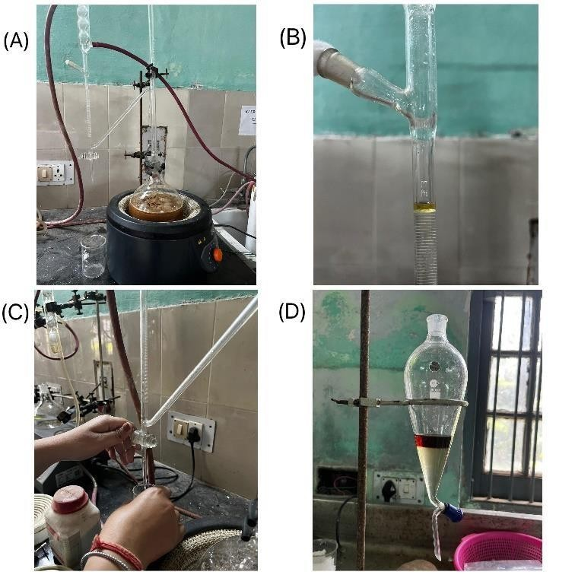
Fig 5: (A) Distillation Unit (B) Clevenger apparatus (C) Extraction of essential oil (D) Separating funnel.
2.4. Isolation of Essential oils:
The distillation lasted for 4 hours, with continuous water flow into the condenser. After distillation, a Clevenger-type apparatus was used to separate the oil and water components collected. The oil-water mixture underwent multiple separatory funnel extractions to isolate the essential oil. Subsequently, the oil was mixed with diethyl ether and placed in a water bath at 70°C for 5 minutes, followed by drying with anhydrous Na2SO4 to remove moisture. The resulting diethyl ether and essential oil mixture were transferred to vials and left in a well-ventilated area for complete evaporation of diethyl ether. Yield calculation was based on the initial weight of the rhizome samples, and the extracted oils were labelled and stored in sample containers at room temperature.

3. RESULTS AND DISCUSSION
The rhizome oils exhibited a strong aromatic profile and the extraction yields varied depending on the drying method applied.
Table 1: Essential oil yield from different rhizome samples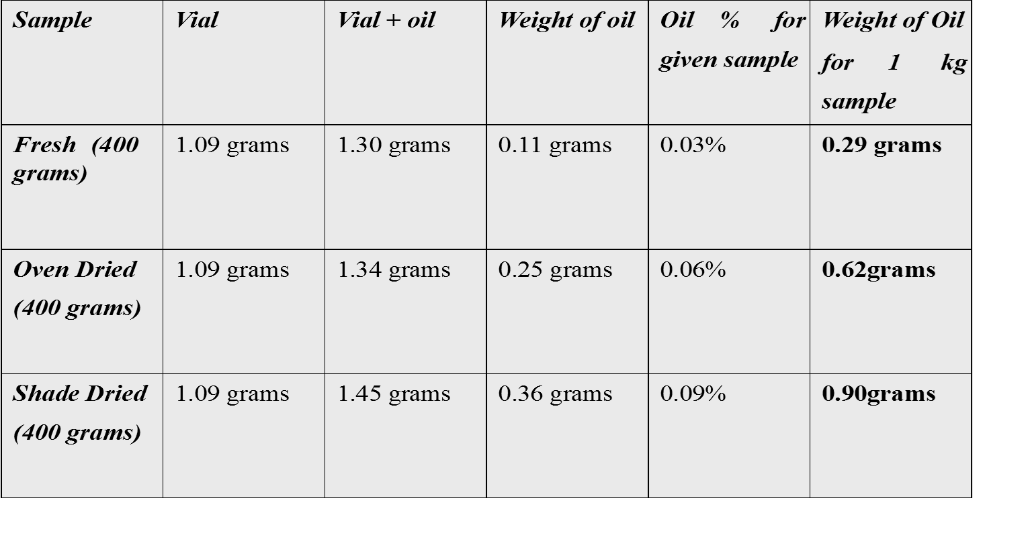
For a 400-gram sample of fresh rhizome, the oil yield was 0.03%. In contrast, for a 400-gram sample of oven-dried rhizome, the yield increased to 0.06%. The highest yield of 0.09% was obtained from a 400-gram sample of shade-dried rhizome. These results indicate that the shade drying method resulted in the highest extraction yield among the three tested samples. Using these yield percentages, we can estimate the weight of essential oil extracted from one kilogram (1 kg) of Alpinia rhizome samples. For a fresh one-kilogram sample, the estimated oil weight would be 0.29 grams. In the case of an oven-dried one-kilogram sample, the estimated oil weight would be 0.62 grams. Finally, for a shade-dried one-kilogram sample, the estimated oil weight would be 0.90 grams.
Variability in the Essential oil yield:
The Essential oil yields obtained after hydro distillation exhibit important variations, which may be explained by the harvest period selection in addition to the climate, geographic zone, plant genetics, degree of freshness, drying time, and extraction technique used [5]. These are the factors that may directly affect the Essential oil yield.
The fresh one-kilogram sample's estimated essential oil output was 0.29 grams, indicating that fresh rhizomes' high moisture content would make oil extraction less effective. High moisture content could slow the breakdown of cells that contain oil, hence decreasing the total output.
In oven dried one-kilogram sample’s oil output of 0.62 grams, was higher. By breaking cellular structures, oven drying's ability to remove moisture probably made it easier for essential oils to be released. The application of heat, however, might have prevented a more significant yield increase by partially degrading or evaporating volatile oil components.
In shade dried one-kilogram sample’s oil output of 0.90 grams per kilogram, showed the highest output of essential oils. This implies that by gradual lowering moisture content without overheating the sample, shade drying successfully maintains essential oil content. A higher yield could result from the delayed drying process' ability to preserve the structural strength of oil-bearing cells and stop the heat breakdown of volatile substances.
The results of the study align with previous studies on ginger essential oil, which showed that drying techniques had a major impact on the antioxidant qualities, chemical composition, and preservation of volatile compounds. This study showed that by limiting thermal degradation while retaining volatiles, shade drying efficiently increased the yield of essential oils in Alpinia galanga.
4. CONCLUSION
The estimated weights of essential oil per kilogram of rhizome samples provide measurable data on oil yield for each drying method. The open-dried sample yielded the highest amount of oil at 0.90 grams per kilogram, followed by the oven-dried sample at 0.62 grams per kilogram, and the fresh sample at 0.29 grams per kilogram. These results underscore the significant impact of the drying process of Alpinia galanga rhizomes on essential oil extraction yield. Compared to the fresh and oven-dried samples, the open drying method resulted in the highest output of essential oil. These findings emphasize the importance of selecting the appropriate drying method to maximize the extraction yield of essential oil from Alpinia galanga rhizomes. The open drying method, which involves drying the rhizomes at room temperature, appears to be the most effective in preserving the bioactive compounds responsible for the oil's aroma and medicinal properties. Given the limited production of galangal essential oil and its diverse range of biological effects, there is a pressing need to explore its application in various herbal formulations. Cultivating Alpinia galanga on a large scale is essential to prevent the risk of extinction and meet the growing demand for medicinal plants in health management.

REFERENCES
- Aziman, N., Abdullah, N., Noor, Z.M., Kamarudin, W.S.S.W., Zulkifli, K.S,. Phytochemical profiles and antimicrobial activity of aromatic malaysian herb extracts against food-borne pathogenic and food spoilage microorganisms. J. Food Sci. 2014; 79, M583–M592.
- Charles, D.J., Simon, J.E. and Singh, N.K. The essential oil of Alpinia galanga Willd. J. Essent. Oil Res.,1992; 4, 81–82.
- Chudiwal, A.K., Jain, D.P., Somani, R.S., Alpinia galanga Willd. - an overview on phyto-pharmacological properties. Indian J. Nat. Prod. 2010; Resour. 1, 143–149.
- De Pooter, H.L., Nor Omar, M., Coolsaet, A.B. and Schamp, N.M. The essential oil of greater galangal (Alpinia galanga) from Malaysia. Phytochemistry, 1985; 24, 93–96
- Kelen M. & Tepe B. Chemical composition, antioxidant and antimicrobial properties of the essential oils of three Salvia species from Turkish flora. Bioresource Technology, 2008; 99: 4096–4104.
- L. Jirovetz et al.: Analysis of the essential oils of the leaves, stems, rhizomes and roots of the medicinal plant Alpinia galanga from southern India, Acta Pharm. 53 2003; 73–81.
- Mallavarapu GR, Rao LM, Ramesh S, Dimri BP, Rao BRR, Kaul PN, et al. Composition of the volatile oils of Alpinia galanga rhizomes and leaves from India. J Essent Oil Res. 2002; 14:397– 399
- Mayachiew P and Devahastin S. Antimicrobial and antioxidant activities of Indian gooseberry and galangal extracts. LWT Food Sci Technol. 2008; 41:1153–1159
- Mori, H., Kubota, K. And Kobayashi, A. Potent aroma components of rhizomes from Alpinia galanga Willd. L. Nippon Shokuhin Kagaku Kogaku Kaishi. 1995; 42, 989–995
- SCHEFFER, J.J.C. and JANSEN, P.C.M.Alpinia galanga (L.) Willd. In: de Guzman, C.C. and Siemonsma, J.S. (eds) Plant Resources of South-East Asia No. 13, Spices. Backhyus Publishers, Leiden, the Netherlands. 1999; pp. 65–68.
- Scheffer, J.J.C., Gani, A. And Baerheim-Svendven, A. Mono-terpenes in the essential rhizome oil of Alpinia galanga (L.) Willd. Sci. Pharm.,1981; 49, 337–346

