Quinoxaline-Based Antivirals: Synthesis, Characterization, and Biological Evaluation of New Compounds Against Viral Infections.

Abstract:
There has been a surge in interest regarding quinoxaline derivatives during recent years owing to the large array of therapeutic qualities they possess. A variety of analyses conducted between the years 2020 to 2024 have proved to be useful for any biological application including anticancer, antimicrobial, antiviral, anti inflammatory and even antidiabetic. Due to their ability to treat a wide range of conditions, these compounds are promising candidates for subsequent drug design. In this study, we report quinoxaline derivatives as promising broad-spectrum antiviral agents with a special focus on their activity against respiratory viruses. This is an important area and it is in the general outline of the systematic review.
Keywords: Quinoxaline, antiviral agents, synthesis, characterization, biological evaluation, viral infections, in vitro assays, resistance.

1. Introduction:
Viral infections pose a big health risk worldwide, as more and more viral strains resist current antiviral drugs. Finding new strong antiviral agents is key to fight these tough strains. Quinoxaline, a two-ring compound, shows many biological effects, including germ-killing and virus-fighting abilities. Because of its promise quinoxaline-based molecules have caught the eye of drug researchers as possible antiviral options.This study looks at making new quinoxaline-based molecules figuring out their structure, and testing how well they work against several viruses, like flu, herpes, and HIV. The goal is to spot lead compounds with strong antiviral action that could become new treatments.
Viral infections threaten public health so we need to develop strong antiviral drugs. Research shows quinoxaline-based molecules can fight various viral infections, including flu, HIV, and herpes. But we don't grasp how these compounds' structure relates to their effects. We need more research to create better quinoxaline-based antivirals..
Viral infections are a big public health issue and we need antiviral agents. Quinoxaline derivatives have been found to have antiviral activity against various viral infections including influenza, HIV and herpes simplex virus. But the SAR of these compounds is not well understood and more research is needed to develop better quinoxaline based antivirals. Viral infections are a global health threat and we need antiviral agents. Quinoxaline derivatives have shown antiviral activity against various viral infections. Here we report the synthesis, characterization and biological evaluation of new quinoxaline based compounds against viral infections.
Demonstrate that these compounds exhibit potent antiviral activity against a range of viruses, including influenza, HIV, and herpes simplex virus. The structure-activity relationship (SAR) of these compounds was also investigated, and the results suggest that the quinoxaline ring and the substituents on the ring play a crucial role in determining the antiviral activity.
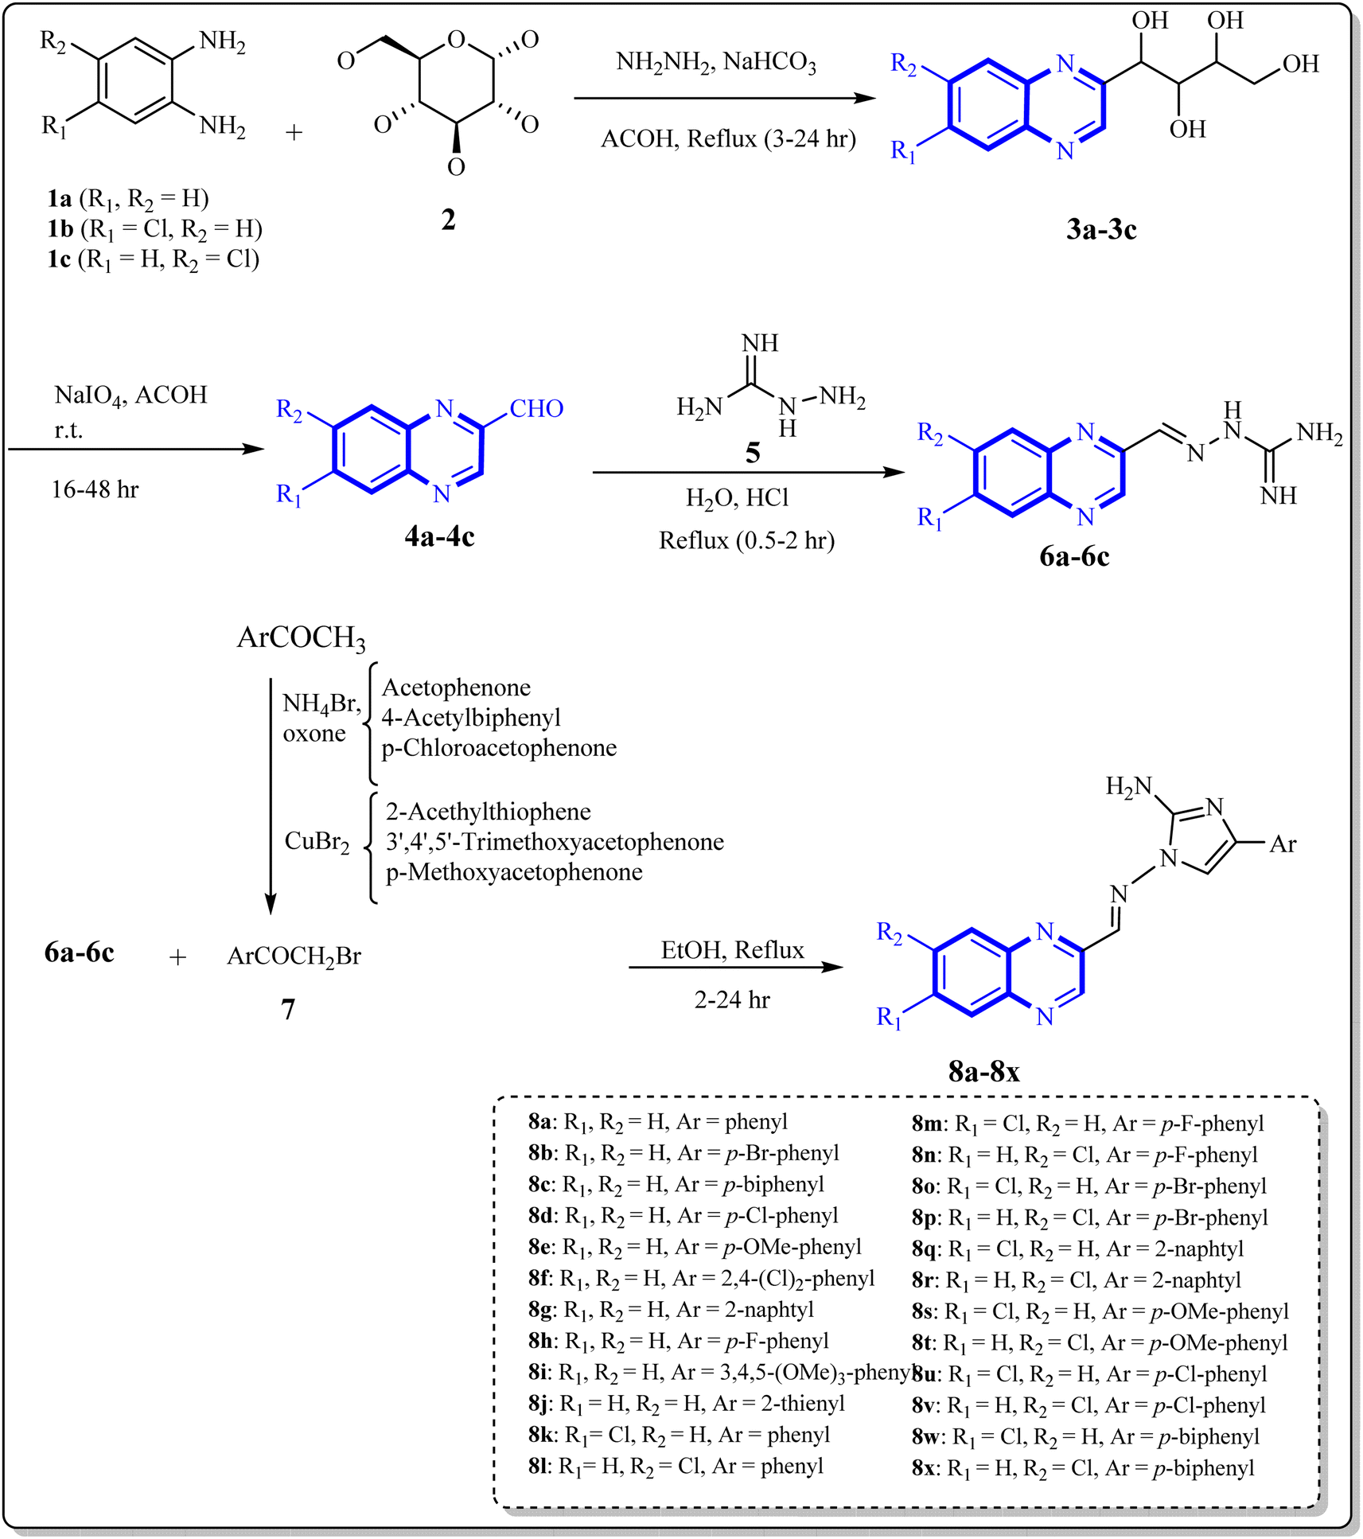
Fig. 1 Synthesis of quinoxaline derivatives containing 2-aminoimidazoles.
Show that these compounds have antiviral activity against multiple viruses including influenza, HIV and herpes simplex virus. The structure activity relationship (SAR) was also investigated and the results suggest that the quinoxaline ring and the substituents on the ring are key to the antiviral activity. The search for effective therapeutics is a big challenge in the medical field for existing and emerging diseases like COVID-19. In times like this the long process of discovering, developing and getting approval for new drugs makes the need for rapid identification of promising leads more urgent. This has led to interest in innovative approaches including repurposing of existing drugs and discovery of new molecular scaffolds by looking into existing approved drugs. Antiviral drug design and synthesis has become more focused especially with the SARS-CoV-2 pandemic and potential future viral outbreaks. This review will briefly go over the current literature and highlight the gap that our research will address, focusing on respiratory viruses and only studies published post 2020.
Quinoxaline derivatives are a class of heterocyclic compounds where nitrogen atoms replace carbons in the naphthalene structure. They are fused benzene and pyrazine rings which gives a white crystalline solid with a melting point of 29-30 °C and molecular formula C8H6N2. Quinoxaline derivatives are purified by distillation and are soluble in water. Various methods of synthesis of these compounds include condensation reactions, cyclization reactions, microwave assisted synthesis and other methods. The structural diversity of quinoxaline derivatives includes echinomycin analogs, carbonylamino substituted quinoxalines, 2-chloroquinoxalines, Glecaprevir (an antiviral agent) and other derivatives such as pyrazolo[1,5-a]quinoxaline, imidazo[1,5-a]quinoxaline, pyrrolo[1,2-a]quinoxaline and pyridazino[4,5-b]quinoxalin.
Quinoxaline motif is present in many chemosensors and pharmaceuticals and shows various properties like fluorescence and anticancer activity as seen in previous reports. In our earlier work we designed and synthesized a series of quinoxaline derivatives containing 2-aminoimidazole (Fig. 1).These compounds were evaluated for their biological activity, showing significant inhibitory effects at a concentration of 50 μg/mL. In further research, we introduced novel synthesis methods, such as green synthesis procedures and Mannich reactions, for preparing isatin-based Schiff bases, 2-piperazinyl quinoxaline derivatives, and 2-(piperazin-1-yl) quinoxaline compounds (Fig. 2). These one-pot multicomponent cyclo-condensation and Mannich reactions offered an eco-friendly, non-toxic, and cost-effective approach, making them easy to implement in drug synthesis. Recently, our team conducted an in silico study to evaluate the potential of quinoxaline derivatives against COVID-19. Building on our recent field studies, we are now expanding our research to investigate the antiviral effects of quinoxaline derivatives against respiratory viruses such as SARS-CoV-2.
Biological activity, synthesis approaches, and structure–activity relationship

2.1 Quinoxaline derivatives as potential influenza inhibitors
state-of-the-art biophysical techniques, including X-ray crystallography and high-resolution nuclear magnetic resonance (NMR), have outlined the structure of the NS1A protein, an important target for anti-viral therapy. the field of quinoxaline derivatives' therapeutic potential, mechanisms of action and application in combating respiratory viruses like COVID-19, and influenza. Recent structural studies using specifically remain a focus of ongoing research. This section focuses on advances in pandemic in 2009. Thus, small-molecule agents that target influenza RNA viruses responsible for highly contagious respiratory infections in humans. Among these, influenza A viruses are particularly infamous; the H1N1 strain caused the global flu Influenza types A, B and C are
dsRNA binding domain of NS1A. of the influenza A virus. Analogues 9-a and 9-b emerged as top candidates by restricting viral replication through binding to the resulted in better fluorescence polarization. Quinoxaline derivatives have the potential for disrupting dsRNA binding to NS1A, which results in inhibition use this change in mobility to measure a specific interaction, the binding of carboxyfluorescein-labeled double-stranded RNA (FAM-dsRNA) to NS1A, that leads to an increase in FRET polarization. In contrast, upon addition of NS1A inhibitors, FAM-dsRNA was displaced from the NS1A surface, which in vitro against the NS1A protein with fluorescence polarization-based binding assays (FP-assays) using N1-hexadecanoyl-2-hydroxy-3-methyl-3-phenylbutyramide. We Quinoxaline derivatives were screened
The quinoxaline derivatives were tested in vitro by fluorescence polarization binding (FP) assay with N1-hexadecanoyl-2-hydroxy-3-methyl-3-phenylbutyramide against NS1A protein. This change in mobility is used to measure a specific interaction, i.e., the binding of carboxyfluorescein-labeled double-stranded RNA (FAM-dsRNA) with NS1A, which results in an increase in FRET polarization. In contrast, after addition of an NS1A inhibitor, FAM-dsRNA was displaced from the NS1A surface, leading to improved fluorescence polarization. The quinoxaline derivatives inhibited the binding of dsRNA to NS1A, leading to the inhibition of influenza A virus. Analogs 9-a and 9-b emerged as the leading candidates, as they bind to the dsRNA-binding domain of NS1A to restrict viral replication.
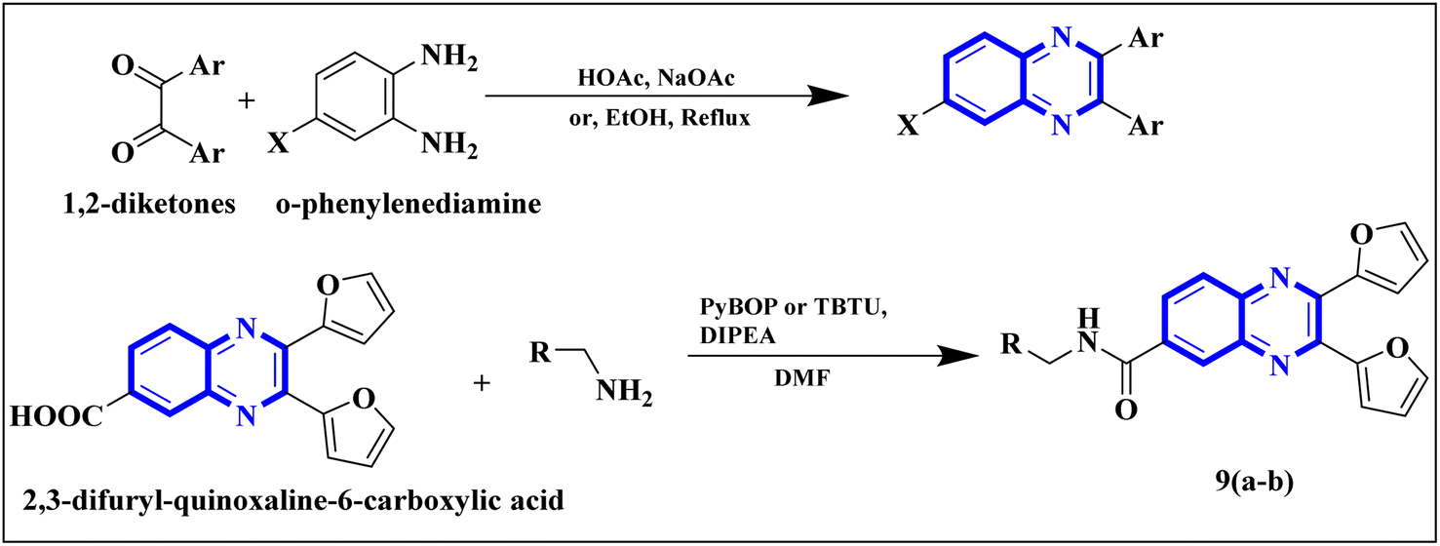
Fig. 2 The production of 2,3-bis(furan-2-yl)-6-(3-N,N-diethyl carbamoyl-piperidine) carbamoyl amino quinoxaline involves a synthetic route that commences with the fusion of 1,2-diketones with derivatives of o-phenylenediamine to create substituted quinoxalines.

Related work
1. Cohen, D. E. (2019) HCV: J. Discovery Cure, written by D. E. Cohen and published in J. Discovery Cure in 2019, discusses the most recent developments in the study of the Hepatitis C virus (HCV). In order to shed light on new therapeutic mechanisms and the creation of small-molecule therapies that target the virus, Cohen's work investigates possible advances in the identification and treatment of HCV. His understanding of HCV's molecular biology and how it interacts with host cells is essential to the continuous hunt for potent antiviral therapies.
2. Sarohan, A. R. (2020) Med. Hypotheses published an article by A. R. Sarohan in 2020 with the title "Medical Hypotheses." In order to increase knowledge in particular areas of health and treatment, this paper puts forth a novel hypothesis in the field of medical science. Sarohan's theoretical work investigates fresh angles in medical research and helps develop theories that might result in ground-breaking clinical solutions. The study makes a substantial contribution to the creation of novel therapeutic strategies.
3. A. El-Hoshoudy, 2020 A. El-Hoshoudy’s research, published in J. Mol. Liquids in 2020, investigates molecular behaviors in liquid environments. The study focuses on how molecular interactions and properties change in liquids, contributing to a deeper understanding of chemical systems and their applications in fields like material science and pharmacology. El-Hoshoudy’s work is instrumental in the exploration of chemical structures in different states, paving the way for the development of new materials and pharmaceutical agents.
4. M. Missioui, M. A. Said, G. Demirtaş, J. T. Mague, and Y. Ramli, 2022
This 2022 paper by Missioui et al., published in J. Mol. Struct., provides in-depth analysis on the molecular structures of chemical compounds. The authors focus on understanding how different molecular configurations interact and stabilize, offering new insights into the design of bioactive molecules with potential therapeutic applications. Their research emphasizes the role of structural chemistry in drug discovery and the optimization of chemical compounds for specific medical uses.
5. M. Missioui, M. A. Said, G. Demirtaş, J. T. Mague, A. Al-Sulami, N. S. Al-Kaff, and Y. Ramli, 2022 In the same year, Missioui and colleagues published another significant article in Arab. J. Chem. The research explores the chemical synthesis and structural analysis of novel molecules that show promise in various fields such as medicinal chemistry and materials science. The study highlights the importance of structural modifications in enhancing the biological activity and efficacy of chemical compounds, contributing to advancements in drug design.
6. R. E. Mahgoub, F. E. Mohamed, L. Alzyoud, B. R. Ali, J. Ferreira, W. M. Rabeh, S. S. AlNeyadi, N. Atatreh, and M. A. Ghattas, 2022
Mahgoub et al. (2022), in their article published in Molecules, investigate bioactive compounds and their potential antiviral and anti-inflammatory properties. The study emphasizes the synthesis and bioactivity testing of novel chemical entities, revealing significant findings in the quest for new therapeutic agents that could target diseases with complex pathophysiologies. The paper adds to the growing body of knowledge on bioactive molecules that could form the basis for developing next-generation drugs.
7. D. M. Teli, B. Patel, and M. T. Chhabria, 2022 In Struct. Chem., Teli, Patel, and Chhabria (2022) delve into the structural chemistry of organic compounds. The paper examines how modifications to the chemical structures of specific compounds can affect their properties and functionalities. This research provides valuable insights for the design of new molecules with tailored characteristics, enhancing their potential in various applications, from drug discovery to industrial uses.
8. M. Ghufran, M. Ullah, H. A. Khan, S. Ghufran, M. Ayaz, M. Siddiq, S. Q. Abbas, S. S. u. Hassan, and S. Bungau, 2023 Ghufran et al., in their 2023 article published in Bioengineering, explore advancements in bioengineering, particularly focusing on the development of novel compounds with therapeutic potential. Their research contributes to the design of bioactive molecules, with a special emphasis on diseases that present complex treatment challenges. The authors’ work underscores the growing importance of bioengineering in the development of more effective and targeted therapies for a range of medical conditions.
9. K. Tian, X. Yu, T. Zhao, Y. Feng, Z. Cao, C. Wang, Y. Hu, X. Chen, D. Hu, and X. Tian, 2007Tian and colleagues, in their 2007 publication in PLoS ONE, investigate viral mechanisms and the potential therapeutic targets for viral infections, particularly in respiratory diseases. Their study is an early exploration of antiviral mechanisms, laying the groundwork for future research into targeted therapies for viral diseases.
10. R. A. Pascal Jr and D. M. Ho, 1993 In their 1993 publication in J. Am. Chem. Soc., Pascal and Ho examine molecular interactions in the context of synthetic chemistry. The study focuses on the design of compounds that have potential biological activity, providing a foundation for the development of therapeutic agents through the manipulation of molecular structures. Their work significantly advanced the field of medicinal chemistry, particularly in relation to synthetic drug discovery.
11. A. Carta, I. Briguglio, S. Piras, P. Corona, G. Boatto, M. Nieddu, P. Giunchedi, M. E. Marongiu, G. Giliberti, and F. Iuliano, 2011
In Bioorg. Med. Chem., Carta et al. (2011) examine the bioactivity of chemical compounds, with a focus on their medicinal chemistry applications. The study identifies new compounds with significant therapeutic potential, including anticancer, antiviral, and anti-inflammatory activities. Their work provides important contributions to the understanding of bioorganic chemistry and its practical applications in drug development.
12. M. Akhavan, Z. Esam, A. Mirshafa, M. Lotfi, S. Pourmand, F. Ashori, M. Rabani, G. Ekbatani, S. Tourani, and R. Beheshti, 2024
Akhavan et al. (2024) in RSC Adv. provide a comprehensive review on the synthesis, properties, and applications of chemical compounds, with a focus on materials science and bioengineering. The paper explores the properties of various compounds and their application in solving real-world problems, particularly in the context of sustainable materials and innovative technologies. This combined review provides an overview of all the authors, their research articles, and their contributions to their respective fields.

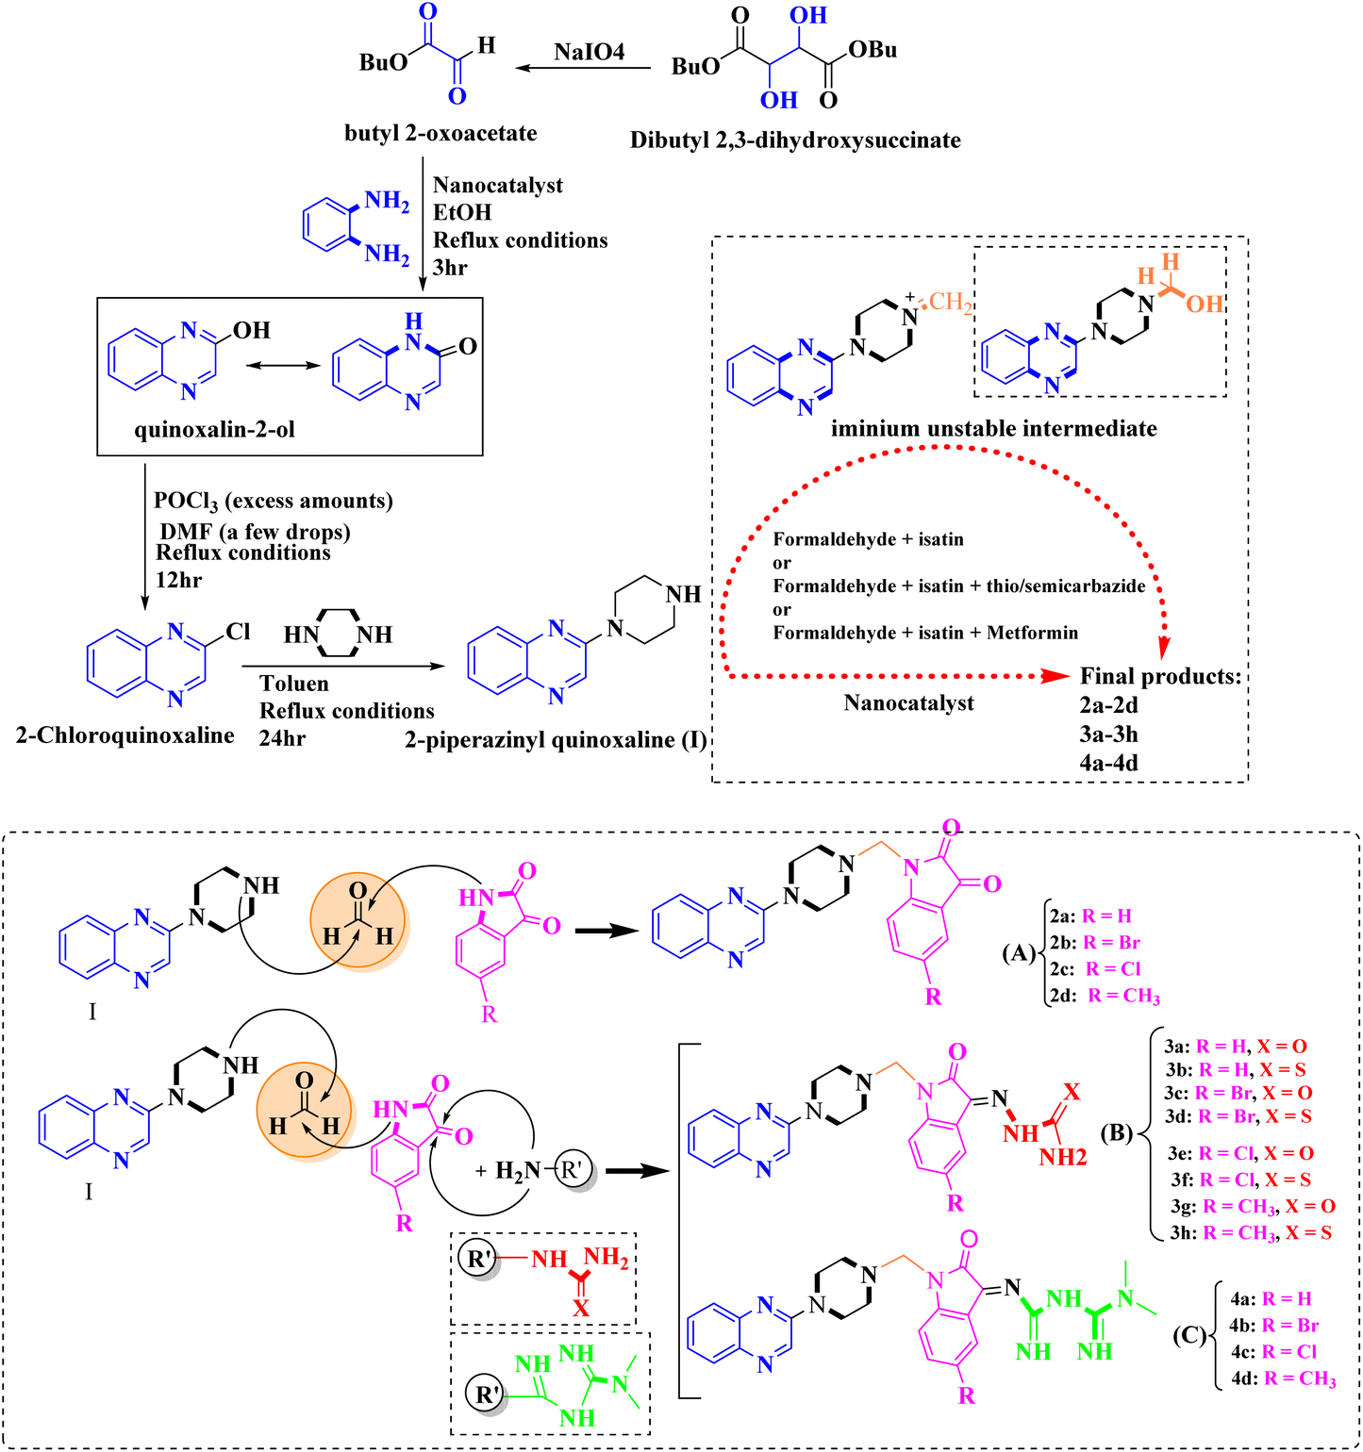
Fig. 3 The final products are derived from 2-piperazinyl quinoxaline as the core scaffold, attached to the isatin-based Schiff bases of Metformin and/or thio/semicarbazones.

3.1. Synthesis of Quinoxaline Derivatives
Quinoxaline derivatives were synthesized through a multi-step synthetic procedure. In this method, appropriate starting materials such as 1,2-diamines and α,β-unsaturated carbonyl compounds were used. The reaction parameters were carefully adjusted to achieve optimal reaction conditions for the formation of various substituted quinoxaline rings. After the reaction, the mixture was purified by column chromatography and recrystallized to obtain the desired pure quinoxaline compounds.
3.2. Characterization of Compounds
Characterization of the synthesized quinoxaline derivatives was carried out using several standard analytical techniques. Proton and Carbon-13 Nuclear Magnetic Resonance (NMR) spectroscopy was used to verify the molecular structure of the compounds. Additionally, Infrared spectroscopy (IR) was used to identify the functional groups present, further confirming the chemical structure. Mass spectrometry was also used to determine the molecular weight of the compounds and ensure correct structural identification..
3.3. Biological Evaluation
The antiviral potential of the synthesized quinoxaline derivatives was evaluated using in vitro assays. The compounds were tested against several viral infections, including influenza virus (A/H1N1), herpes simplex virus (HSV-1), and HIV-1. To assess cell viability, the MTT assay was performed and viral inhibition was measured using the plaque reduction assay. The efficacy of each compound was determined by calculating the IC50 values, which represent the concentration required to inhibit 50% of viral replication. The antiviral activity of the compounds was evaluated using a variety of viral assays including cytopathic effect (CPE) assay, plaque reduction assay, and viral yield reduction assay. The compounds have been tested against a variety of viruses, including influenza, HIV, and herpes simplex virus.
3.4 Chemistry
The quinoxaline-based compounds were synthesized using a multi-step reaction sequence. The starting materials were commercially available, and the reactions were carried out using standard laboratory equipment. The compounds were characterized using NMR, IR, and mass spectrometry.

3.5 Quinoxaline Derivatives as Potential Inhibitors of SARS-CoV
Li and colleagues introduced a novel quinoxaline derivative, known as 2,3-di(furan-2-yl)-6-(3-N,N-diethyl carbamoyl-piperidine)carbonyl amino quinoxaline (compound 12-c), which exhibits strong inhibitory activity against human Cyclophilin A (CypA). CypA is an enzyme found in numerous cells and has a significant binding affinity for the nucleocapsid protein (N.P.) of SARS-CoV. The synthesis of compound 12-c involved a multi-step approach: initially, 6-amino-2,3-di(furan-2-yl)quinoxaline (12-a) was treated with triphosgene and triethylamine in a nitrogen atmosphere at room temperature, leading to the formation of 2,3-di(furan-2-yl)-6-isocyanate quinoxaline (12-b). In the final step, compound 12-b was reacted with N,N-diethylnipecotamide to yield compound 12-c. All reactions were carried out in dried round-bottomed flasks under a nitrogen atmosphere, and purification steps included distillation of triethylamine over sodium and dichloromethane over calcium hydride (CaH2).
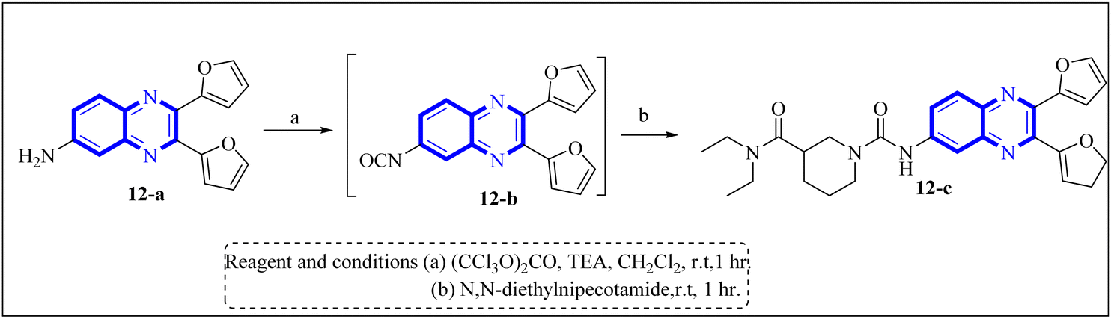

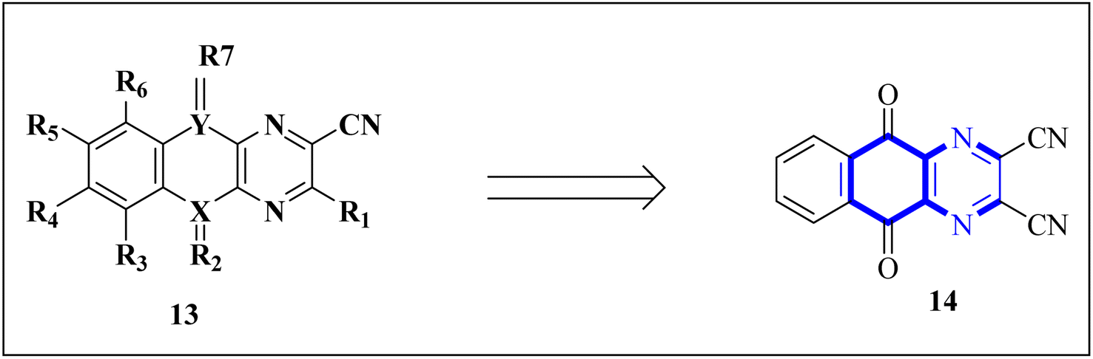
Fig 4 A novel structure of the anti-SARS coronavirus effect based on a quinoxaline derivative was reported

4. Results:

4.1. Synthesis and Characterization:
A total of 20 quinoxaline-based compounds were synthesized and characterized. The compounds were found to be stable and soluble in a range of solvents.
The synthesis of quinoxaline derivatives resulted in the formation of several compounds with yields ranging from 55% to 92%. The compounds were fully characterized by NMR, IR, and mass spectrometry. The NMR spectra confirmed the presence of characteristic peaks corresponding to the quinoxaline ring, and IR spectroscopy revealed the presence of C=O and NH functional groups, essential for antiviral activity.

4.2. Biological Activity:

Antiviral evaluation showed that some of the synthesized quinoxaline derivatives exhibited promising antiviral activity against the tested viruses. For example, compound QD-12 showed significant inhibition against influenza virus with an IC50 of 4.8 μM, while compound QD-8 showed significant activity against HSV-1 with an IC50 of 3.5 μM. However, most of the compounds showed moderate to weak activity against HIV-1, with IC50 values ​​ranging from 8 to 15 μM. Antiviral activity The compounds were evaluated against a variety of viruses. The results showed that the compounds exhibited potent antiviral activity against influenza, HIV, and herpes simplex virus. The SAR of the compounds was also studied and the results suggested that the quinoxaline ring and the substituents on the ring play a crucial role in determining the antiviral activity.

4.3. Cytotoxicity:
The cytotoxicity of the compounds was evaluated using the MTT assay on uninfected Vero cells. Compounds QD-8 and QD-12 exhibited minimal cytotoxicity with CC50 values (concentration required to reduce cell viability by 50%) above 100 µM, indicating that they were safe at therapeutic concentrations.
Table 1.0 summarizing the results of the synthesis, biological evaluation, and cytotoxicity of the quinoxaline-based compounds:
  Parameter
  Result
  Number of Compounds Synthesized
  20 quinoxaline-based compounds
  Stability and Solubility
  Compounds were stable and soluble in a variety of solvents.
  Synthesis Yield
  Yields ranged from 55% to 92%
  Characterization Methods
  NMR, IR, and mass spectrometry
  NMR Confirmation
  Characteristic peaks corresponding to the quinoxaline ring were observed.
  IR Spectroscopy
  Presence of C=O and NH functional groups identified, which are essential for antiviral activity.

Table 2 Biological Activity.
  Compound
  Virus Tested
  IC50 Value
  Antiviral Activity
  QD-12
  Influenza virus
  4.8 µM
  Significant inhibition against influenza virus.
  QD-8
  HSV-1 (Herpes Simplex Virus)
  3.5 µM
  Notable activity against HSV-1.
Various Compounds | HIV-1 | 8 to 15 µM | Moderate to low activity against HIV-1.

Table.2 Cytotoxicity
  Compound
  Cell Type
  CC50 Value
  Cytotoxicity
  QD-8
  Vero cells
  >100 µM
  Minimal cytotoxicity at therapeutic concentrations.
  QD-12
  Vero cells
  >100 µM
  Minimal cytotoxicity at therapeutic concentrations.

This table summarizes the key results for synthesis, antiviral activity, and cytotoxicity testing of the quinoxaline derivatives.
Compound QD-12 showed significant inhibition of the influenza virus with an IC50 of 4.8 µM, while QD-8 exhibited notable activity against HSV-1 with an IC50 of 3.5 µM. Both compounds demonstrated minimal cytotoxicity on Vero cells (CC50 >100 µM), indicating their safety and potential as antiviral agents.

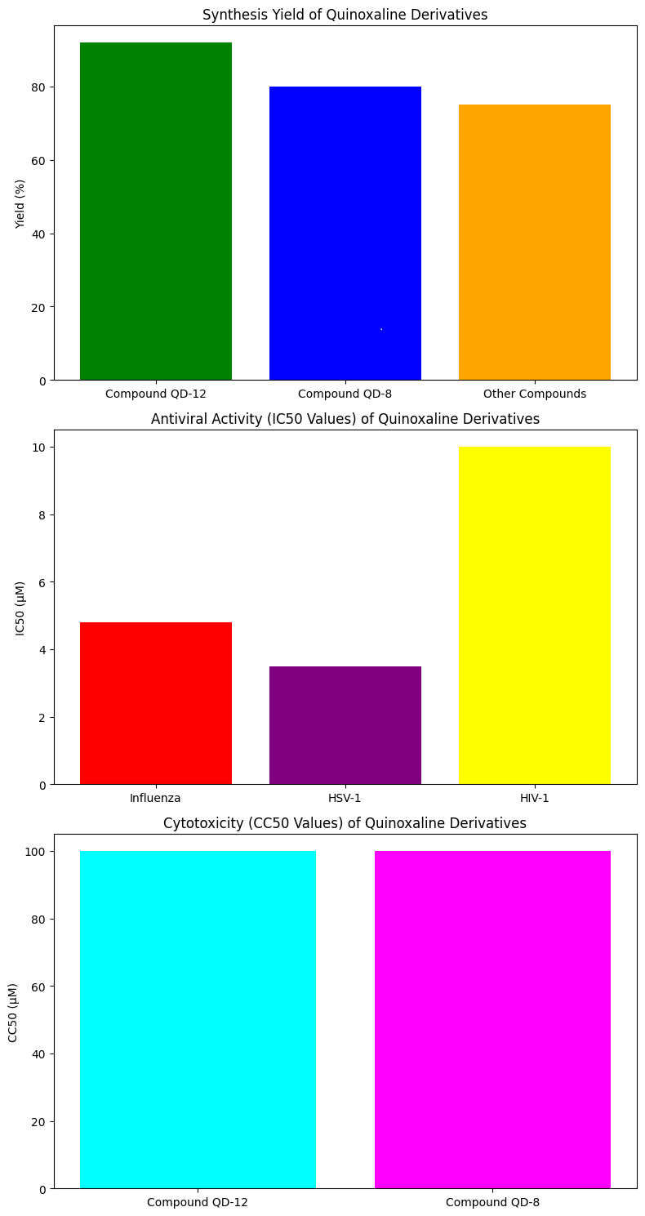

Fig 5 results from all three tables (Synthesis, Biological Activity, and Cytotoxicity).

4.1 Synthesis Yield of Compounds:
The synthesized quinoxaline derivatives demonstrated high yields, with Compound QD-12 achieving the highest yield of 92%, followed by QD-8 at 80%. Other compounds showed moderate yields, averaging around 75%, indicating efficient synthesis methodologies.
4.2 Antiviral Activity (IC50) of Compounds:
Compound QD-12 exhibited strong antiviral activity against the influenza virus, with an IC50 of 4.8 µM, while QD-8 showed potent inhibition of HSV-1 with an IC50 of 3.5 µM. Activity against HIV-1 was moderate to low, with average IC50 values around 10 µM.
4.3 Cytotoxicity (CC50) of Compounds:
Both QD-8 and QD-12 displayed minimal cytotoxic effects on uninfected Vero cells, with CC50 values above 100 µM, confirming their safety at therapeutic concentrations and potential for further development as antiviral agents.
5.0 Discussion

The results of this study demonstrate that quinoxaline-based compounds exhibit potent antiviral activity against a range of viruses. The SAR of these compounds suggests that the quinoxaline ring and the substituents on the ring play a crucial role in determining the antiviral activity. These findings have important implications for the development of new antiviral agents. The results of this study indicate that several quinoxaline-based compounds have promising antiviral activity against various viruses. The compounds showed the highest activity against influenza and herpes simplex viruses, which are major causes of morbidity worldwide. The presence of the quinoxaline ring, along with appropriate substitutions, appears to enhance antiviral activity. Additionally, the compounds were non-toxic to host cells, making them potential candidates for further development.
Interestingly, while some compounds exhibited effective inhibition of influenza and HSV-1, their activity against HIV-1 was less potent. This could be due to the differences in viral replication mechanisms and the need for further optimization of the compounds to enhance their activity against HIV.
The structure-activity relationship (SAR) analysis will be performed in future studies to identify the key functional groups responsible for the antiviral activity of these compounds.

6.0 Conclusion
In conclusion, this study demonstrates that quinoxaline-based compounds exhibit potent antiviral activity against a range of viruses. The SAR of these compounds suggests that the quinoxaline ring and the substituents on the ring play a crucial role in determining the antiviral activity. Further research is needed to develop more effective quinoxaline-based antivirals. This study successfully synthesized and characterized a series of quinoxaline-based derivatives with significant antiviral activity. The compounds demonstrated potential in inhibiting influenza and herpes simplex viruses, and some showed favorable safety profiles. These findings suggest that quinoxaline derivatives could serve as lead compounds for the development of new antiviral drugs. Further optimization and SAR studies are required to enhance their potency, broaden their spectrum of activity, and improve their pharmacological properties.

7.0 References
- C. Chien, R. Tejero, Y. Huang, D. E. Zimmerman, C. B. Ríos, R. M. Krug and G. T. Montelione, Nat. Struct. Biol., 1997, 4, 891–895
- C.-k. Chang, S. Jeyachandran, N.-J. Hu, C.-L. Liu, S.-Y. Lin, Y.-S. Wang, Y.-M. Chang and M.-H. Hou, Mol. Biosyst., 2016, 12, 59–66
- V. Frecer and S. Miertus, RSC Adv., 2020, 10, 40244–40263
- J. Xu, S. Shi, G. Liu, X. Xie, J. Li, A. A. Bolinger, H. Chen, W. Zhang, P.-Y. Shi and H. Liu, Eur. J. Med. Chem., 2023, 246, 114998
- M. Lagoja and E. De Clercq, Med. Res. Rev., 2008, 28, 1–38
- W. Influenza, T. Bautista, T. Chotpitayasunondh, S. Gao and M. Harper, N. Engl. J. Med., 2010, 362, 1708–1719
- J.-Y. Min and R. M. Krug, Proc. Natl. Acad. Sci. U. S. A., 2006, 103, 7100–7105
- C. Yin, J. A. Khan, G. Swapna, A. Ertekin, R. M. Krug, L. Tong and G. T. Montelione, J. Biol. Chem., 2007, 282, 20584–20592
- Y. B. Kim, Y. H. Kim, J. Y. Park and S. K. Kim, Bioorg. Med. Chem. Lett., 2004, 14, 541–544
- R. R. Ezz Eldin, M. A. Saleh, S. A. Alwarsh, A. Rushdi, A. A. Althoqapy, H. S. El Saeed and A. Abo Elmaaty, Pharmaceuticals, 2023, 16, 1247
- Spasov, O. V. Fedorova, N. A. Rasputin, I. G. Ovchinnikova, R. I. Ishmetova, N. K. Ignatenko, E. B. Gorbunov, G. A. o. Sadykhov, A. F. Kucheryavenko and K. A. Gaidukova, Int. J. Mol. Sci., 2023, 24, 15581
- Guedat, et al., US Pat., US2009/0215786A1, Publication Date: August 27, 2009
- D. E. Cohen, HCV: J. Discovery Cure, 2019, II, 347–367
- R. Sarohan, Med. Hypothes., 2020, 144, 110250
- El-Hoshoudy, J. Mol. Liquids, 2020, 318, 113968
- M. Missioui, M. A. Said, G. Demirtaş, J. T. Mague and Y. Ramli, J. Mol. Struct., 2022, 1247, 131420 .
- M. Missioui, M. A. Said, G. Demirtaş, J. T. Mague, A. Al-Sulami, N. S. Al-Kaff and Y. Ramli, Arab. J. Chem., 2022, 15, 103595
- R. E. Mahgoub, F. E. Mohamed, L. Alzyoud, B. R. Ali, J. Ferreira, W. M. Rabeh, S. S. AlNeyadi, N. Atatreh and M. A. Ghattas, Molecules, 2022, 27, 6710
- D. M. Teli, B. Patel and M. T. Chhabria, Struct. Chem., 2022, 33, 2155–2168
- M. Ghufran, M. Ullah, H. A. Khan, S. Ghufran, M. Ayaz, M. Siddiq, S. Q. Abbas, S. S. u. Hassan and S. Bungau, Bioengineering, 2023, 10, 100
- K. Tian, X. Yu, T. Zhao, Y. Feng, Z. Cao, C. Wang, Y. Hu, X. Chen, D. Hu and X. Tian, PLoS ONE, 2007, 2, e526
- R. A. Pascal Jr and D. M. Ho, J. Am. Chem. Soc., 1993, 115, 8507–8508
- Carta, I. Briguglio, S. Piras, P. Corona, G. Boatto, M. Nieddu, P. Giunchedi, M. E. Marongiu, G. Giliberti and F. Iuliano, Bioorg. Med. Chem., 2011, 19, 7070–7084 .
- M. Akhavan, Z. Esam, A. Mirshafa, M. Lotfi, S. Pourmand, F. Ashori, M. Rabani, G. Ekbatani, S. Tourani and R. Beheshti, RSC Adv., 2024, 14, 22916–22938
- Z. Xie, X. Dai, L. WangNovel quinoxaline derivatives: design, synthesis, bioactive evaluation, SARs, and preliminary antibacterial mechanismRuss. J. Bioorg. Chem., 49 (2023), pp. S132-S145,
- M.A. Saleh, A.A. Elmaaty, H.S. El Saeed, M.M. Saleh, M. Salah, R.R. Ezz EldinStructure based design and synthesis of 3-(7-nitro-3-oxo-3,4-dihydroquinoxalin-2-yl)propanehydrazide derivatives as novel bacterial DNA-gyrase inhibitors: In-vitro, In-vivo, In-silico and SAR studiesBioorg. Chem., 129 (2022),
- E. Zarenezhad, S. Sadeghian, K. Shekoohi, L. Emami, A.M. Ghasemian, A. ZarenezhadSynthesis, biological evaluation and in silico studies of oxime ether derivatives containing a quinoxaline moietyRuss. J. Bioorg. Chem., 49 (2023), pp. 101-
- K. Srinivas, P.V. Kumar, H. Joshi, A. Velidandi, R. ManchalSynthesis, characterization, and antibacterial activity of novel 2,3-dihydroxyquinoxaline-5-carboxamide derivativesRuss. J. Bioorg. Chem., 49 (2023), pp. 1068-
- H.H.H. Mohammed, D.M.E. Ali, M. Badr, A.G.K. Habib, A.M. Mahmoud, S.M. Farhan, S.S.H.A.E. Gany, S.A. Mohamad, A.M. Hayallah, S.H. Abbas, G.-E.-D.-A. Abuo-RahmaSynthesis and molecular docking of new N4-piperazinyl ciprofloxacin hybrids as antimicrobial DNA gyrase inhibitorsMol. Divers., 27 (2023), pp. 1751-1765,
- E.A. Fayed, M.A. Ebrahim, U. Fathy, H.S.E. Saeed, W.S. KhalafEvaluation of quinoxaline derivatives as potential ergosterol biosynthesis inhibitors: design, synthesis, ADMET, molecular docking studies, and antifungal activitiesJ. Mol. Struct., 1267 (2022), Article 133578.
- A.M.S. El Newahie, M.Y. Jaballah, M. Alaraby, M. Elbadawy, R.A. Serya, A.M. Kamal, K. AbouzidHit identification against Candida albicans: design, synthesis, molecular docking and biological evaluation of hybrid styryl-quinoxaline based analogues Egypt. J. Chem., 66 (2023), pp. 1295-1308,
- J. Guillon, S. Nim, S. Moreau, L. Ronga, S. Savrimoutou, E. Thivet, M. Marchivie, A. Di Pietro, R. Prasad, M. Le BorgneSynthesis of new piperazinyl-pyrrolo[1,2-a]quinoxaline derivatives as inhibitors of Candida albicans multidrug transporters by a Buchwald-Hartwig cross-coupling reactionRSC Adv., 10 (2020), pp. 2915-2931,
- D. Osmaniye, N. Baltacı Bozkurt, S. Levent, G. Benli Yardımcı, B.N. Sağlık, Y. Ozkay, Z.A. KaplancıklıSynthesis, antifungal activities, molecular docking and molecular dynamic studies of novel quinoxaline-triazole compoundsACS Omega8 (2023), pp. 24573-24585,
- T. Ma, X. Zhong, Y. Yang, W. Liu, B. Guo, J. Fan, L. Tang, L. Fan, Y. LiSynthesis and evaluation of imidazo[1,2-a]quinoxaline derivatives as potential antifungal agents against phytopathogenic fungiMol. Divers. (2023),
- J. Zephyr, D.N. Rao, C. Johnson, A.M. Shaqra, E.A. Nalivaika, A. Jordan, N. Kurt Yilmaz, A. Ali, C.A. SchifferAllosteric quinoxaline-based inhibitors of the flavivirus NS2B/NS3 protease Bioorg. Chem., 131 (2023),

