Short communication

DESIGN AND FABRICATION OF A POLYTETRAFLUOROETHYLENE (PTFE) ELECTROCHEMICAL CELL PROTOTYPE

Abstract:
Electrochemical cells have been widely used, however, when using strong acids, cells with high acid resistance must be used, so a new electrochemical cell design was created in SolidWorks using Teflon as the base material and machined with a conventional lathe and milling cutter. We went from a large and robust model to a small and versatile one, thus minimizing the use of materials such as silicon, HF (hydrofluoric acid), ethanol and Teflon. Simultaneously, functional tests were carried out to verify the correct operation of the electrochemical system, so P-type and N-type porous silicon samples were fabricated using the proposed electrochemical cell prototype.

Key Word: Design, Manufacturing, Prototype, Electrochemical Cell, Porous Silicon

- Introduction
Electrochemistry is a fundamental discipline in the development of technologies for energy storage, materials synthesis and chemical analysis [1]. Electrochemical cells are essential components in these processes, since they allow the study of oxidation-reduction reactions and electron transfer at conducting interfaces [2]. However, the design of these devices requires materials that guarantee chemical stability, corrosion resistance and adequate sealing to avoid interferences in the measurements [3].
Teflon (polytetrafluoroethylene, PTFE) has positioned itself as an ideal material for the fabrication of electrochemical cells due to its excellent resistance to acids, bases and organic solvents, in addition to its insulating properties and low reactivity [3][4]. Its use in electrochemical prototypes can improve the durability and precision of experiments, especially in applications that require aggressive conditions or high purity, such as electrocatalysis or corrosion studies [5] [6].
This work presents the design and fabrication of a Teflon-based electrochemical cell prototype, focused on optimizing its geometry, tightness and versatility for different experimental configurations. The material selection criteria, the manufacturing process and the preliminary functionality tests are detailed, with the objective of offering a robust and accessible alternative for research laboratories and industrial applications.

- Material And Methods
Design
Different designs were made in Solid Works software, where the three-dimensional prototype was also simulated, thus selecting the proposal that would optimize the material to be used in the manufacture of the cell, and that would also optimize the use of chemical reagents during the anodizing process (Figure 1).
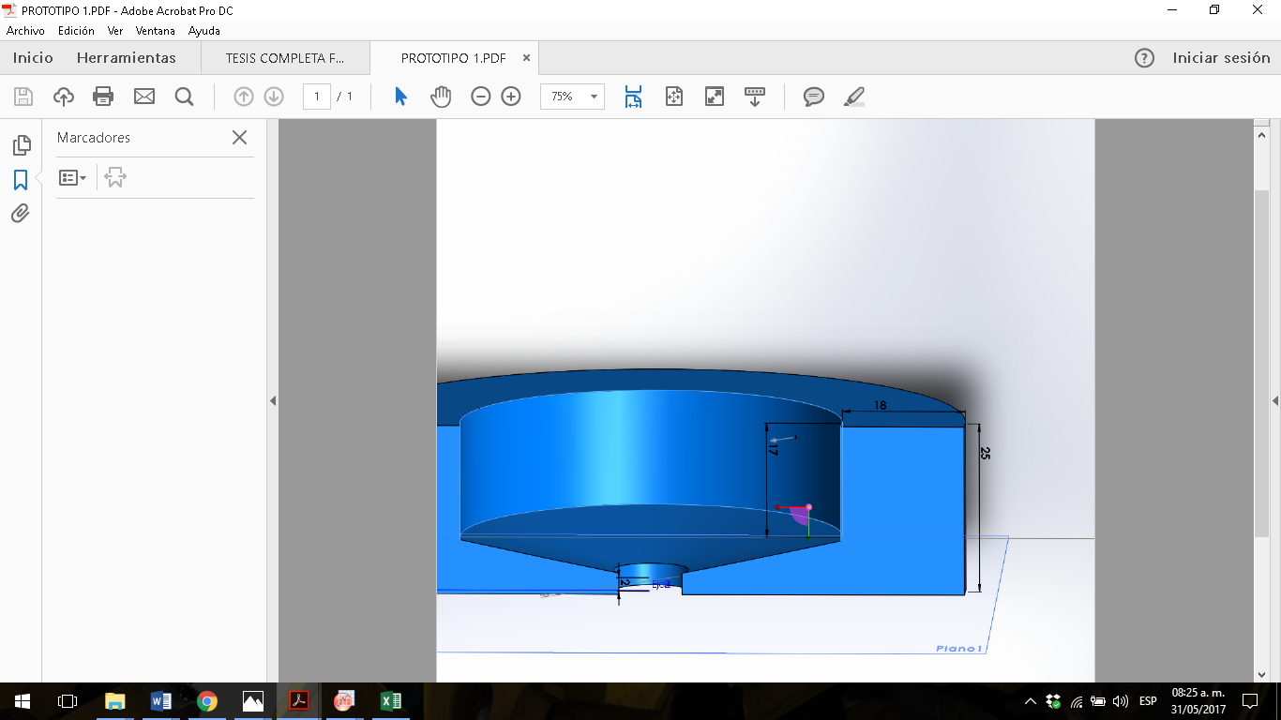  a) | 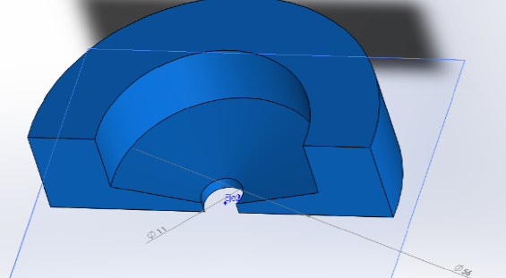  b)
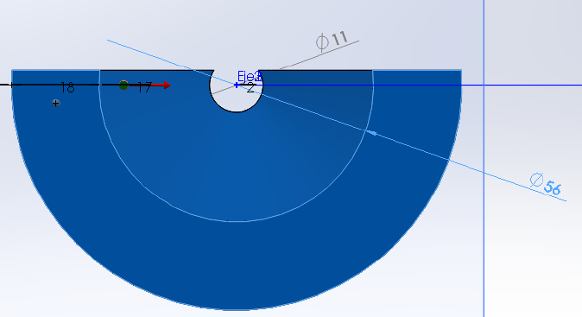  c) | 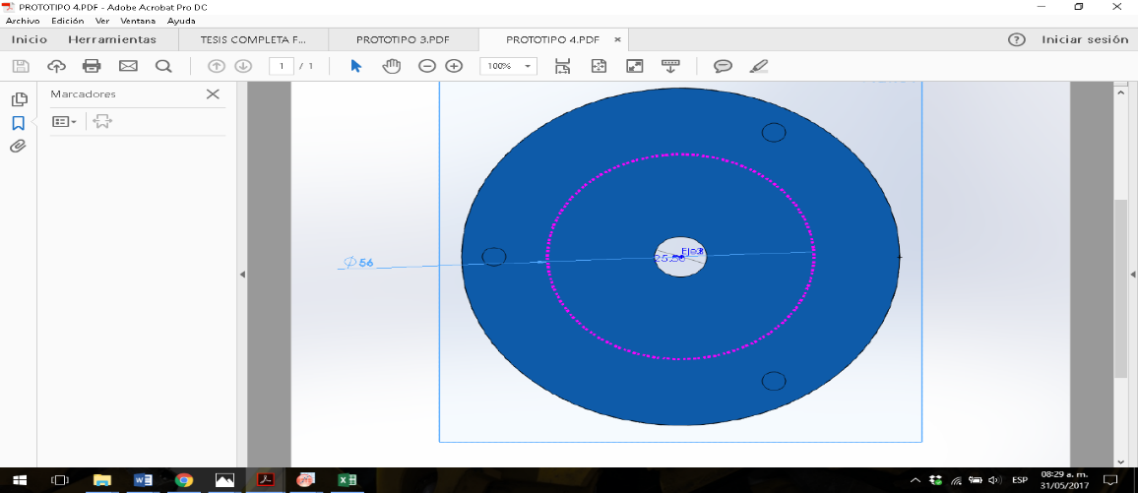  d)
Figure 1. Electrochemical cell design, a) three-dimensional view, b) top profile of the electrochemical cell design. c) top profile view of the electrochemical cell design and d) bottom profile view of the electrochemical cell design.

Manufacturing
After the design, simulation, digital optimization and selection of the ideal isometric, the prototype was manufactured using conventional lathe and milling machines; figure 2 shows the manufacturing process.
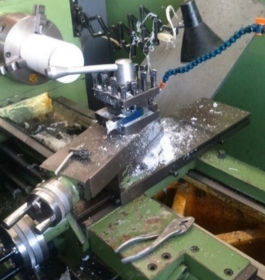  a) | 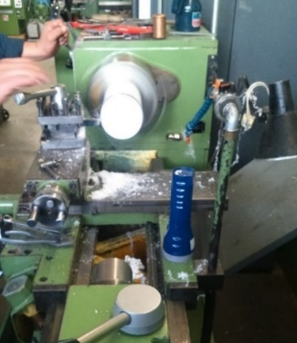  b)
Figure 2. Fabrication of the electrochemical cell, a) profile view and b) front view.
- Results
An extra improvement to the anodizing process was to place concentric O-rings which provide the concentration of the electrochemical attacks on the silicon (performing electrochemical attacks of basically any size).
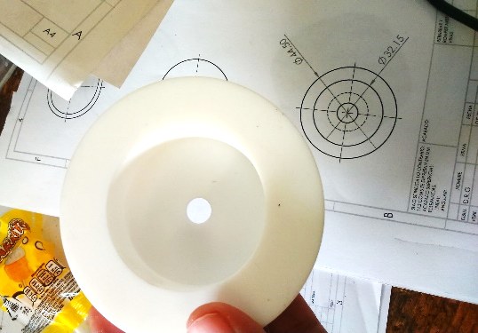  a) |   b)
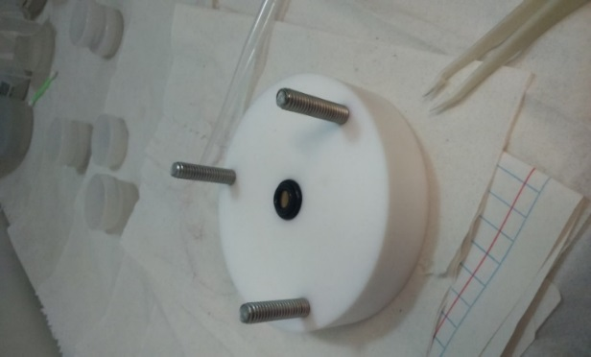  c) | 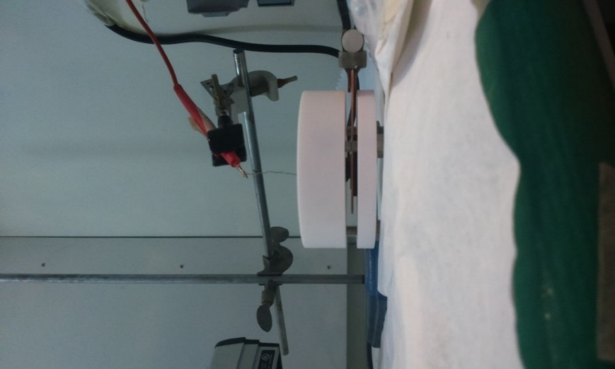  d)
Figure 3. a) top and bottom part after lathe work, b) finished model, c) electrochemical cell top and concentric O-ring and d) finished and assembled electrochemical cell.

Electrochemical cell in operation
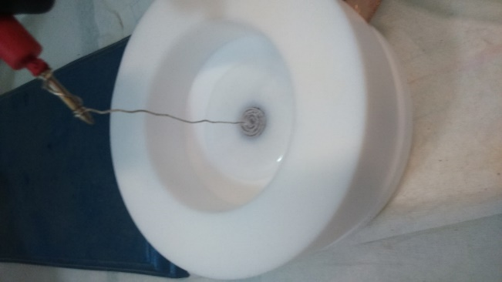  a) | 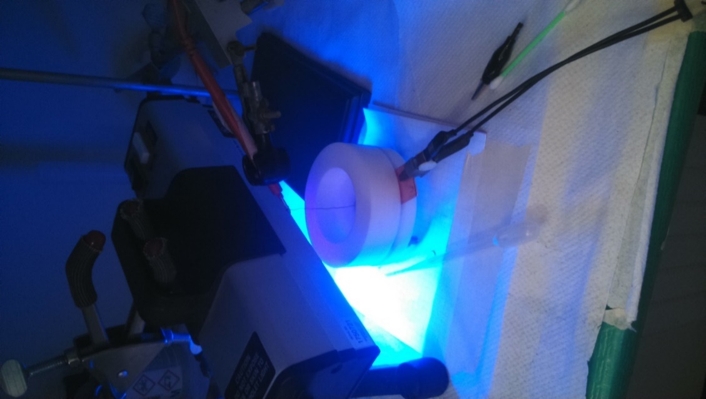  b)
Figure 4. Electrochemical cell anodizing a) p-type silicon and b) n-type silicon.
The procedure was performed in the same way for both type-p and type-n silicon, the difference being the use of the UV lamp and the absence of sunlight. It should be noted that this procedure was repeated on different types of silicon wafers to test their functionality (see Figure 4).

Attack speed
To perform the anodizing tests with a higher control, crystalline silicon type P doped with Boron, resistivity 0.01-0.02 Ωm, orientation (100), using a solution of HF and Ethanol (3:7), both sides polished.
In this way the attack speed is of utmost importance, because thanks to this we can determine the thickness d (table 1) of the porous silicon thin film created with certain conditions or parameters already known. This is the speed with which the electrochemical anodizing advances through the crystalline silicon. Then, the attack velocity equation is:
$V=\frac{d}{t}$ (1)
Table 1. Calculation of thicknesses according to the current and mass of each sample, with constant time and electrochemical solution.

 |  |  | Thickness
Current (mA) | m1  (gr) | m3  (gr) | cm | nm
1 | 0.2961 | 0.2956 | 0.000143123 | 1431.229426
5 | 0.3707 | 0.3693 | 0.000400744 | 4007.442393
10 | 0.4145 | 0.4124 | 0.000601116 | 6011.16359
20 | 0.406 | 0.4028 | 0.000915987 | 9159.868327
30 | 0.3948 | 0.3897 | 0.001459854 | 14598.54015
40 | 0.3689 | 0.3628 | 0.0017461 | 17460.999
50 | 0.4244 | 0.4166 | 0.002232718 | 22327.17905
Images of porous silicon
Figure 5 shows the porous silicon samples resulting from the electrochemical cell and the anodizing of the crystalline silicon, thus demonstrating the efficiency of the prototype and the concentric Orings for electrochemical etching.
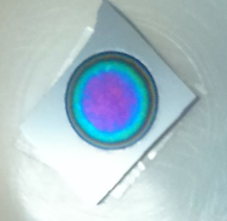  a) | 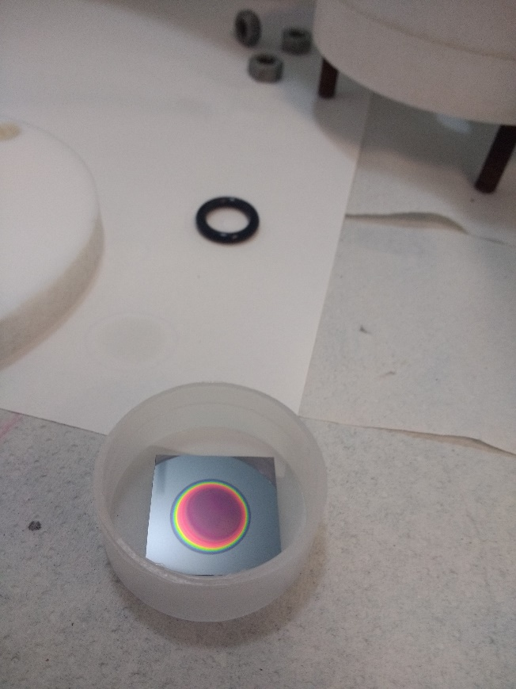  b)
Figure 5. Porous silicon multilayers a) n-type and b) p-type porous silicon.
- Discusión
Different electrochemical cells were analyzed to produce Table 2, which shows the results of the analysis.
Table 2. Comparative table of electrochemical cells
Cell Type | Typical Materials | Advantages | Limitations | Main Applications | References
Glass Cell | Glass, silicone gaskets | - Low cost  - Transparency for spectroelectrochemistry | - Fragile  - Reactivity with HF or alkalis | Electroanalysis, corrosion studies | [2,5]
PTFE (Teflon) Cell | PTFE, Viton® seals | - Extreme chemical resistance  - Leak-proof | - High cost  - Difficult machining | Electrosynthesis, acidic/alkaline media | [3,4]
Stainless Steel Cell | AISI 316, EPDM gaskets | - Robustness  - High pressure/temperature resistance | - Corrosion in halides  - Magnetic interference | Fuel cells, industrial electrolysis | [7]
Flow Cell | Graphite, polymers (PEEK) | - High performance  - Flow control | - Complexity  - Risk of clogging | Redox batteries, continuous synthesis | [8,9]
Microfluidic Cell | PDMS, glass/chemicals | - Miniaturization  - Low sample volume | - Leak sensitivity  - Limited scalability | Biosensors, lab-on-a-chip systems | [10,11]

Regarding resistance to strong acids and bases, PTFE (Teflon) cells stand out due to their exceptional chemical stability, particularly in corrosive media (concentrated acids, alkalis, and organic solvents) [3,4]. However, their high cost and difficult machining limit their use in budget-constrained laboratories. In contrast, glass cells are cost-effective and useful for electroanalysis, but their fragility and reactivity with fluorides (HF) or concentrated alkalis restrict their applicability [2,5].On the other hand, stainless steel cells (AISI 316) are ideal for industrial processes requiring high pressure and temperature, such as alkaline electrolysis or fuel cells [7]. Nevertheless, their susceptibility to chloride-induced corrosion (seawater, strong acids/bases) and potential magnetic interference in techniques like voltammetry limit their use in fundamental and applied research.

Regarding continuous flow cells (constructed with materials such as graphite or PEEK), they offer advantages for scalable electrochemical processes, including redox flow batteries or organic electrosynthesis [8,9]. However, their operational complexity (requiring pumps, flow sensors) and susceptibility to clogging in particle-containing systems render them less practical for laboratories lacking specialized infrastructure.
Microfluidic cells (PDMS/glass) represent a significant advancement in miniaturization, enabling analysis with minimal sample volumes [5]. These cells have been widely implemented in biosensors and lab-on-a-chip devices [11]. However, their limitations include scalability challenges and the potential for leaks or contamination in long-duration systems, which may compromise reproducibility

- Conclusions
A highly acid- and base-resistant prototype was developed, demonstrating both functionality and utility. The implementation of concentric O-rings enabled electrochemical attacks of varying sizes in highly specific areas, validating the cell's efficiency, reproducibility, and repeatability - crucial characteristics for both fundamental and applied research. However, in applications where cost or optical transparency are prioritized (e.g., spectroelectrochemistry), glass remains the material of choice. For industrial-scale applications, stainless steel and flow cells provide robust solutions, while microfluidic systems dominate high-sensitivity analytical applications. An emerging perspective involves the development of hybrid PTFE/graphene composite materials that could potentially enhance conductivity while reducing costs. Furthermore, optimized modular designs allowing component interchangeability based on reactive media may significantly improve electrochemical cell efficiency.

References
[1]. Awasthi S, Pandey SK, Pandey CP, Balani K. Progress in Electrochemical and Electrophoretic Deposition of Nickel with Carbonaceous Allotropes: A Review. Adv Mater Interfaces 2020;7. https://doi.org/10.1002/admi.201901096.
[2]. Compton RG., Laborda Eduardo, Ward KR. Understanding voltammetry : simulation of electrode processes. Imperial College Press; 2014.
[3]. Ebnesajjad Sina. Melt processible fluoropolymers : the definitive user’s guide and databook. Plastics Design Library; 2003.
[4]. Oh H, Kim GS, Hwang BU, Bang J, Kim J, Jeong KM. Development of a feasible and scalable manufacturing method for PTFE-based solvent-free lithium-ion battery electrodes. Chemical Engineering Journal 2024;491. https://doi.org/10.1016/j.cej.2024.151957.
[5]. Zhang H, Liu Y, Wang X, Feng K, Wang Q, Chen Z, et al. Research Progress in Ionic Liquid-Based Electrolytes for Electrochromic Devices. Molecules 2025;30:973. https://doi.org/10.3390/molecules30040973.
[6]. McCrory CCL, Jung S, Ferrer IM, Chatman SM, Peters JC, Jaramillo TF. Benchmarking Hydrogen Evolving Reaction and Oxygen Evolving Reaction Electrocatalysts for Solar Water Splitting Devices. J Am Chem Soc 2015;137:4347–57. https://doi.org/10.1021/ja510442p.
[7]. Elsherbini M, Wirth T. Electroorganic Synthesis under Flow Conditions. Acc Chem Res 2019;52:3287–96. https://doi.org/10.1021/acs.accounts.9b00497.
[8]. Ellamla HR, Staffell I, Bujlo P, Pollet BG, Pasupathi S. Current status of fuel cell based combined heat and power systems for residential sector. J Power Sources 2015;293:312–28. https://doi.org/10.1016/j.jpowsour.2015.05.050.
[9]. Cabana J, Alaan T, Crabtree GW, Huang PW, Jain A, Murphy M, et al. NGenE 2022: Electrochemistry for Decarbonization. ACS Energy Lett 2023;8:740–7. https://doi.org/10.1021/acsenergylett.2c02587.
[10]. Whitesides GM. The origins and the future of microfluidics. Nature 2006;442:368–73. https://doi.org/10.1038/nature05058.
[11]. Lerin-Morales KM, Olguín LF, Mateo-Martí E, Colín-García M. Prebiotic Chemistry Experiments Using Microfluidic Devices. Life 2022;12. https://doi.org/10.3390/life12101665.

