Impacts of Land use Dynamics on Montane Ecosystems in Ekiti State, Nigeria: Evidence from Satellite Images.
ABSTRACT
The study provided information on the NDVI and extent of land use/cover in the montane ecosystems in Ekiti State, Southwestern Nigeria which are generally lacking and this is critical for its proper functioning, sustainability and conservation. This study aimed at providing information on the impact of LUCC on the extent of the montane ecosystems which is crucial for policy makers and planners to conserving this disturbed ecosystem. The LUCC and NDVI were examined for a period of four decades (1986-2025) using Landsat Enhanced Thematic Mapper (ETM). Montane ecosystems were modelled using SPOT6 Digital Elevation Model (DEM) with a Ground Survey Distance (GSD) of 20m. There was steady increase in the NDVI values indicating the resilience of these ecosystems to anthropogenic activities. The dense vegetations were pronounced in altitudes above 700m and this covered 32% while low-lying ecosystems expanded to 62%. Rock-outcrops witnessed fluctuations and markedly a decline in 2001, 2006 and 2025 indicating they are being quarried for landscaping, constructions of roads and buildings. There was also increase in the extent covered by bare lands and built-up areas by 27%. The water body also recorded decline steadily over the periods examined. Concerted and timely interventions are crucial for policy making that will combat the human induced activities towards sustainability, conservations and proper functioning of these ecosystems.
Keywords: DEM, Ekiti State, LUCC, Montane Ecosystems, NDVI, Rock-outcrops
1. INTRODUCTION
Mountains occupy 24% of the global land surface and are habitat to 12% of the world’s populace (Schild, 2008). Tropical montane cloud forest ecosystems which contain some of the world's biodiversity hotspots for endemic species, and supports main biomes such as hyper arid hot deserts to polar ice caps; providing essential ecosystem services to including high quality freshwater and microclimate buffering against climate extremes (CBD, 2010; Abera et al., 2025). Due to the indispensability of mountains for the maintenance of biodiversity and ecosystem services, there are advancements in studies related to the processes that set their conservation at peril (Wang et al., 2018; Dunets et al., 2019). Satellite images are presently tools for policymaking in conservation through the mapping of the biotic and abiotic components of ecosystems: land-cover, land-use, ecological disruption, and plant phenology (Mihai et al., 2017; Borisade et al. 2021). The new methods permit assessing changes over time and the generation of ecological indicators at different spatial and temporal scales (Meresa & Gebrewhid, 2019; MohanRajan et al., 2020). The above gives the likelihood of the spatial and temporal tracking of the perceptible phenomena in environmental units and obtaining measurements on the spatial structure: fragmentation, distribution, abundance, and specificity (Espinoza-Guzman´ et al., 2023).
Unplanned land use practices, infrastructure development, unsustainable tourism, and climate change are all foremost to rapid modification in the montane ecosystems, with land cover change, precisely, one of the most significant chauffeurs (Maxwell et al. 2016; Chaudhary et al., 2017). The paucity of information on past and present land changes in vulnerable mountain landscapes is a challenge for ecological restorations (Balsiger and Debarbieux, 2015). This poses a noteworthy barrier to understanding and managing ecosystems sustainably and making effective decisions for conservation and sustainable development in inaccessible mountain regions.
Normalized Difference Vegetation indices (NDVI) is an indicator of vegetation health, because degradation of ecosystem vegetation, or a decrease in green, would be reflected in a decrease in NDVI value. Therefore, if a relationship between the quantity of an indicator – aerial biomass – in various forest ecosystems and the NDVI can be identified, processes of degradation can be monitored (Meneses-Tovar, 2011). NDVI is becoming a significant indicator to studying the spatial vegetation dynamics of regional ecological changes (Liu et al., 2015; Sun et al., 2021). The montane ecosystems in Ekiti State, Southwestern Nigeria offers ecosystem services such as providing habitat for endemic species, resources for establishment of quarry sites for construction of roads and houses, sacred places for religious purpose, cushioning the impact of climate changes, low lying forests for loggers to harvesting timber and provision of fodders for feeding livestock by herdsmen.
It has been reported that over the past few decades, there have been rapid modification and alterations in the land use change cover through anthropogenic activities such as residential and institutional activities in Ekiti State, Southwestern, Nigeria (NBS 2012). Some studies e.g. Owoeye & Ogunleye, 2016; Olorunfemi et al., 2018; Ajagbe et. al., 2021 exist on the impact of land use change in urban parts, and the Ekiti State ecosystems. These studies have not looked explicitly at the montane ecosystems in Ekiti State. Furthermore, information on the NDVI of montane ecosystems in Ekiti state, Southwestern Nigeria are generally lacking.
Therefore, this study aim is assessing the impact of land use change to affecting the extent of montane ecosystems in Ekiti State, Southwestern Nigeria over the last four decades 1986-2025. The montane ecosystems were also categorized based on elevations and NDVI were evaluated for the health and vitality of the montane ecosystems. This is much needed for ecological restorations and providing adequate information for policy makers towards conservation and sustainability of the montane ecosystems in Ekiti State, Southwestern Nigeria.
2. MATERIALS AND METHODS
2.1 Study Area
The study area, Ekiti State is located in the southwestern part of Nigeria (Fig 1). Ekiti State is located between Latitudes 7° 25′ to 8° 5′ N and Longitude 4° 45′ to 5° 45′ E and occupies a land area of about 5435 km² (NBS, 2012). The State is mainly an upland zone with elevation ranging from 250 to 540 m above mean sea level (a.m.s.l.) (Simon-Oke et al.,2012). The State lies on an area underlain by metamorphic rock and is potentially rich in mineral deposits, which include channockete, limestone, kaolin, columbite, phosphate, iron ore, aquamine, gemstone, barite, gold among many others, largely deposited in different villages and towns within the study area (Olorunfemi & Fasinmirin, 2017). Tropical climate exists in the State with two clear seasons which are rainy season between April–October and dry season between November–March (Olorunfemi & Fasinmirin, 2017). High humidity s being experienced in the state. Likewise, the mean air temperature ranges between 21 and 28 °C. Egbeda series and Iwo series are the dominant soils in Ekiti state (Smyth & Montgomery, 1962), which under the FAO/UNESCO classification are classified as Orthic and Plinthic Luvisols, respectively (FAO, 1998). Guinea forest vegetation with its attendant climate, fora, and fauna prevail in the state (Olorunfemi & Fasinmirin, 2017). Derived savannah predominates exists in the north peripheries, while tropical rainforest predominates in the south (logbaby.com). The study area captured all the montane ecosystems in Ekiti State, Southwestern Nigeria. Ekiti State has been experiencing a change in land use and land cover (LULC). The ever-increasing population which numbered 1.63 million in 1991 grew to 2.38 million in 2006 with a projected population of 3.17 million in 2015 (ekitistate.gov.ng).
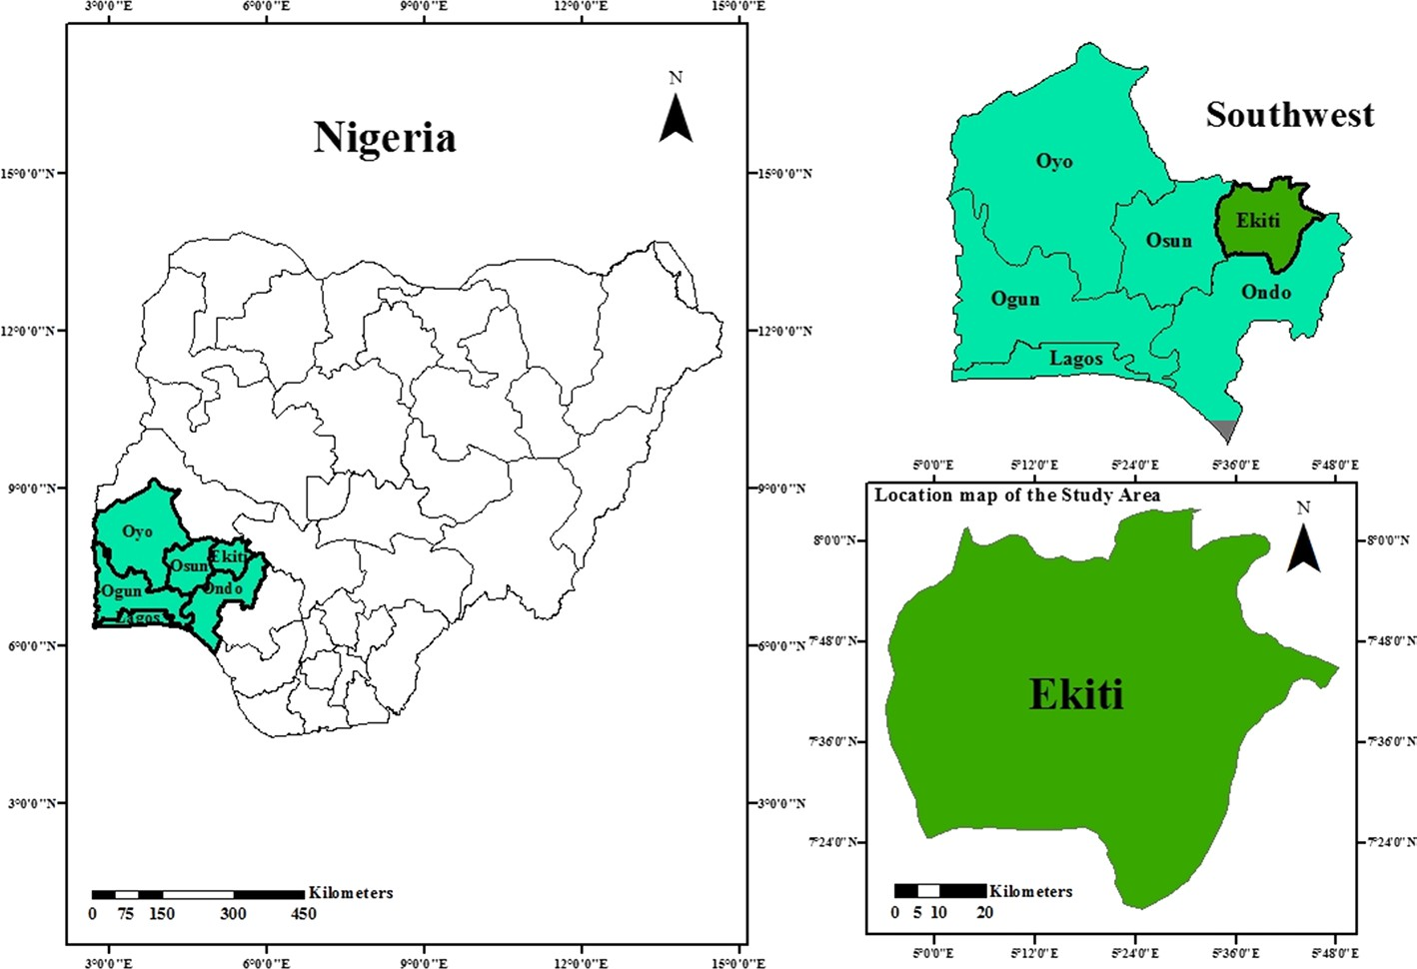

Figure 1: Location of study area in the maps of Nigeria and Southwestern geopolitical zone of Nigeria
2.2. Land use/land Cover Mapping and Vegetation Index Modeling
Landsat imageries for 1986, 2001, 2006, 2010, 2016, 2020, and 2025 were downloaded from the online archive of United States’ Geological Survey. Appropriate bands were combined for the land use/land cover and NDVI. The resultant composite images were subjected to supervised machine learning image classification procedure for land use/land cover classification. Whereas, the composite images were also subjected to the automated procedure of vegetation index computation using the image calculator algorithm on a GIS platform. The output classified images were subjected to mathematical computation to determine the area extents of each land use/land cover class. The equation for NDVI computation is presented as follows:
$$NDVI=\frac{(NIR− Red)}{(NIR+Red)} (1)$$
Where, NIR is Near Infrared Band, Red is the Red Band
2.3 Montane Ecosystem Modeling
We acquired SPOT6 Digital Elevation Model (DEM) with a Ground Survey Distance (GSD) of 20m. We classified the DEM based on British Geological Survey’s standard for montane ecosystem delineation. In this case, the study area was classified into three distinct types of ecosystems – the Low-lying Ecosystem, Montane Ecosystem > 500m and Montane Ecosystem > 700m. The outputs of these image classifications and analyses are presented in form of maps and the relevant attributes are presented in tabular form.
3. RESULTS
The classified land use and land cover maps for the seven epochs are presented in Figs. 2a – g, and the area extents of the land cover types and the corresponding percentages are presented in Tables 1 and 2. The study area has an area extent of 587,316 Km², been situated in the northwestern extreme of Southwestern Nigeria. In this study, we categorized, Built up area and Bare land as an interwoven entity. This is because, in medium resolution satellite imageries such as Landsat, ancient and recent mud houses are mostly classified as bare land. In addition, bare land is associated and interwoven with settlements in this part of the world, being predominantly rural.
Results showed that 56% of the montane ecosystems was covered by vegetation while human settlements and associated bare land occupy 11% and 16% respectively (Table 2). Analyses showed that 17% of the montane ecosystems comprised of rock outcrop while only 0.6% of the montane ecosystems is covered by water (Table 2). The highest extent of vegetation occurred in 2016 while the least was recorded for 1986 (Table 2). The health and vitality of vegetation of the study area has been rising significantly since year 2001. The NDVI maps of the study area for seven epochs between 1981 and 2025 are presented in Figs. 3a - g. In 1986, NDVI values ranged from -0.001 to 0.39. For 2001, NDVI values varied from -0.001 to 0.42. In 2006 and 2010, the ranges of NDVI values were -0.012 – 0.34 and -0.001 – 0.40 respectively. In 2015, NDVI values varied from -0.08 to 0.51. Whereas, NDVI values ranged from 0.024 to 0.41 and 0.011 to 0.42 in 2020 and 2025 respectively (Fig. 3)
The ecosystem of the study area is delineated into three – Low-lying Ecosystem, Montane Ecosystem > 500m, and Montane Ecosystem > 700m. The low-lying ecosystem covers 68% of the study area. Whereas, the remaining 32% of the study area is made up of montane ecosystem, with only 208 Km² occurring at the altitude of 700m and above (Fig. 4).

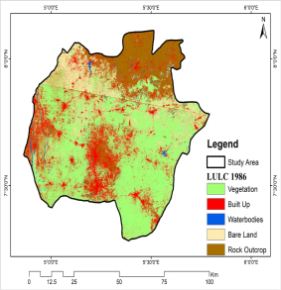
a
b
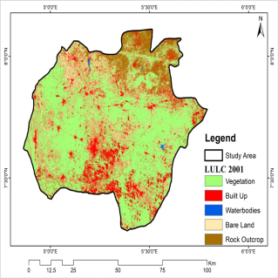
b
Figure 2. Land use/land cover maps of the study area for: a) 1986, b) 2001
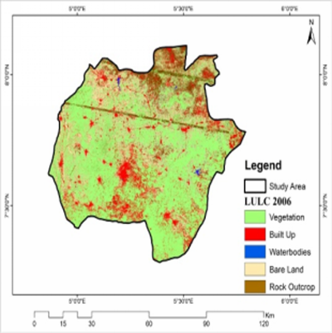
c
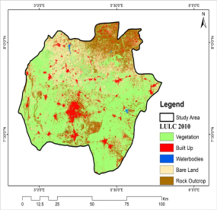
d
Figure 2. Land use/land cover maps of the study area for: c) 2006, d) 2010
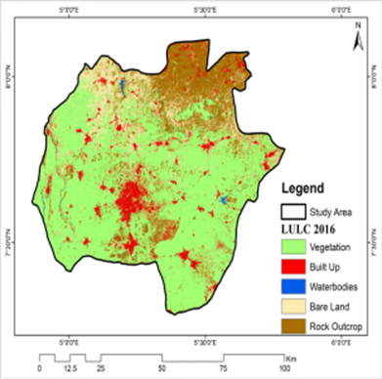
e
e
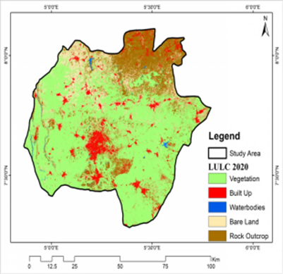
f
Figure 2. Land use/land cover maps of the study area for: e) 2015, f) 2020
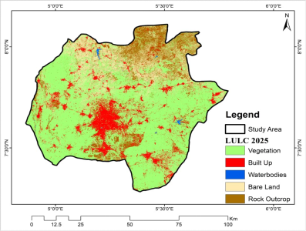
g
d
g
Figure 2. Land use/land cover maps of the study area for: g) 2025.

Table 1. The area extents of land use/land cover classes of the study area.
LULC | 1981 | 2001 | 2006 | 2010 | 2016 | 2020 | 2025
Vegetation | 299159 | 325018 | 319292 | 300375 | 348865 | 348473 | 343321
Built up | 99390 | 96023 | 71610 | 34878 | 37762 | 37889 | 58453
Waterbody | 8755 | 1098 | 5150 | 2273 | 3329 | 4085 | 1756
Bare land | 79151 | 94327 | 121152 | 128238 | 75399 | 79346 | 91770
Rock Outcrop | 100861 | 70849 | 70112 | 121552 | 121961 | 117522 | 92017

Table 2. The percentages of the area extents of land use/land cover classes of the study area.
LULC | 1981 | 2001 | 2006 | 2010 | 2015 | 2020 | 2025
Vegetation | 50.9 | 55.3 | 54.36 | 51.14 | 59.4 | 59.3 | 58.4
Built up | 16.9 | 16.3 | 12.19 | 5.94 | 6.4 | 6.5 | 10.0
Waterbody | 1.49 | 0.18 | 0.87 | 0.4 | 0.6 | 0.7 | 0.3
Bare land | 13.5 | 13.47 | 20.63 | 21.83 | 12.8 | 13.5 | 15.6
Rock Outcrop | 17.2 | 12.06 | 11.94 | 20.69 | 20.8 | 20.0 | 15.7
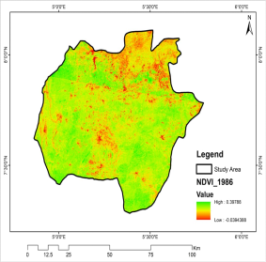
a
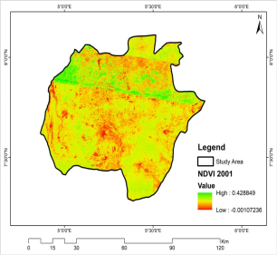
b
Figure 3. NDVI maps of the study area for: a) 1986, b) 2001

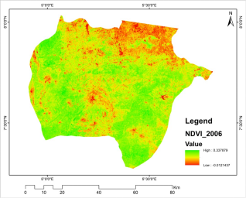
c
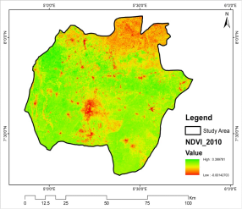
d
Figure 3. NDVI maps of the study area for: e) 2006, f) 2010

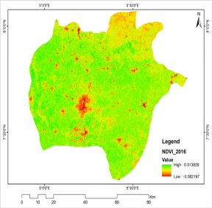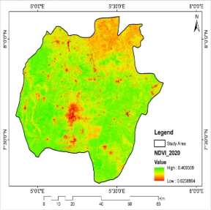
f
e
f
Figure 3. NDVI maps of the study area for: e) 2015, f) 2020

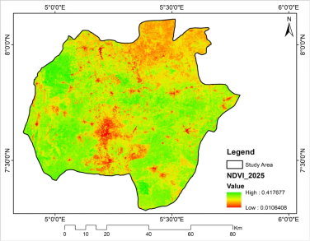
g
Figure 3. NDVI maps of the study area for: g) 2025.

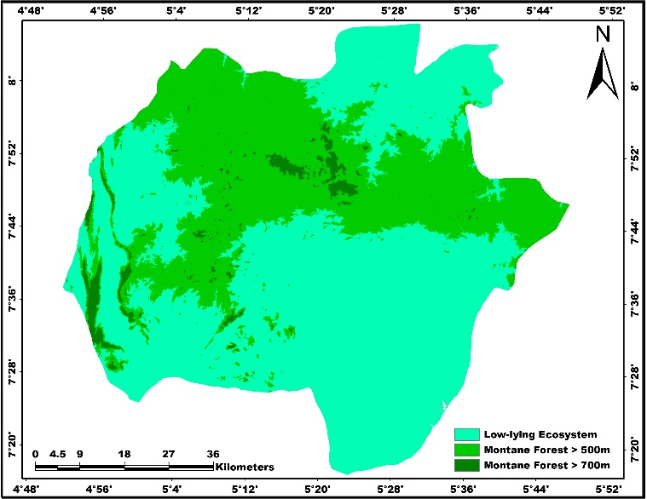
Figure 4. Ecosystem Map of the study area
4. DISCUSSION
The historical management practices of montane ecosystem in Nigeria are poorly documented and remain one of the most disturbed ecosystems in Southwestern Nigeria. Among the land use cover categorized, the extent in vegetation increased steadily from 1986 - 2020 and a little decline in 2025. This conforms with the findings of other workers e.g. Ajagbe et. al. (2021) who had categorized and reported an increasing extent in vegetation dynamics of the Ekiti state ecosystems, Southwestern Nigeria. The steady increase in the vegetation dynamics of the montane ecosystems could be attributed to inaccessibility to large portion of these vegetations especially at elevations ≥700m which posed as difficult terrain to encroach and security challenges, favorable climatic factors and steady increase in the NDVI values over the period of four decades.
The reduced human activities such as urban construction, mining, road and water infrastructure development could improve the greenness of the montane ecosystems and conspicuously as the elevation increases. The 32% of the areas covered by montane ecosystems with elevation of 500-700m being densely vegetated reiterate the impact of land use changes being intense in lower elevated areas, as low- lying ecosystems which covered 62% were sparsely vegetated. Research on mountain vegetation growth relies heavily on the NDVI, which is an important indicator for assessing the status of mountain vegetation growth, particularly during the growing season (Geng et al., 2019). The NDVI values reported in the study area falls within the range value reported by Olorunfemi et al., 2018 in same region but were lower than those from other regions (e.g. Muradyana et al., 2019; Zhu et al., 2021) who worked on mountainous ecosystems in Armenia and China respectively and this indicated that the level of anthropogenic activities ongoing in the study area were higher than what is obtainable in other regions. The spatial pattern of the NDVI distribution showing the vegetated areas to have high NDVI values relative to non-vegetated areas aligned with the findings of workers who have worked on montane ecosystems (Muradyana et al., 2019; Zhu et al., 2021).
The montane ecosystems have seen a fluctuation in terms of greenness within the study period, with increase since the year 2010. This development could partly be credited to relatively increase in annual rainfall over Nigeria (Ogunrinde et al., 2018), and the continuous efforts of the governments and international organizations to discourage bush burning, lumbering, fuel wood harvesting and unsustainable agricultural practices (Akinwumiju & Olorunfemi, 2023). The bare land extent was pronounced in 2006 and 2010 signaling a decrease in the NDVI values over the four decades considered. The built-up areas and bare lands exerted 27% on extent of the montane ecosystems. It was obvious that human population growth warranted urban expansions, rapid utilization of resources from the montane ecosystems, deforestation and degradation of vegetations for agriculture accounted for variations in bare lands and built-up areas in montane ecosystems in Ekiti State, Southwestern Nigeria. Similar observations have been made by workers who have assessed the impact of land use change cover on various African ecosystems (e.g. Obiahu et al., 2021; Gibtan et al., 2024).
The water body represented a small fraction in the extent covered in the montane ecosystem and witnessed a steady declined and this aligned with the findings of Abera et al. (2025) in their study on impacts of land use and climate change on montane ecosystems in Africa and noted that deforestation weakened the cloud water interception capacity of montane ecosystems in Africa. In the study area, the low-lying ecosystems have witnessed several anthropogenic activities notably deforestation and degradation and ultimately affected the water retention capacity of the montane ecosystems as it has not recorded increase more than in 1986.
The rock outcrops experienced fluctuations but was peak in 2015. The rock outcrop recorded a decline in 2001, 2006 and more recently 2025. The reason not far-fetched as the rocky outcrops in montane ecosystems in Ekiti State are quarried and used for landscaping, constructing buildings and roads and are also being damaged by livestock such as pigs and goats. The rock outcrops have been reported to play a crucial role in affecting hydrological and erosion process by serving as impermeable surfaces to increasing run off, providing preferential flow paths, and offering flow barriers to hill slopes and crucial habitats to harboring endemic species (Fitzsimons & Micheal, 2017; Zhang et al., 2024).
The study is one of the pioneer studies that provided information on the impact of land use change and NDVI in Montane ecosystems in Ekiti State, Nigeria. Human activities have greatly influenced the quality and extent these ecosystems which is evident by increase in bare surface and built-up areas and decline in water body and rock-outcrops. Concerted and timely management practices should be taken into consideration in order to sustain the ecological functions and services that these montane ecosystems offer. There is the need to assess the impact of climate change on the NDVI; extent and distributions of the montane forests ecosystems and also examine the impact of eco-hydrological drivers to influencing the proper functioning and resilience of the montane ecosystems in Ekiti State, Southwestern Nigeria.
CONCLUSION
The study clearly highlighted the impact of land use and identifies bare lands, built up and rocky outcrops extents in montane ecosystems as core factor responsible to affecting its extent and quality. The NDVI revealed a steady increase over the years examined indicating the resilience of the vegetation to providing and sustaining the health status and services offered by the ecosystems. The land use change also revealed a steady decline in water body which could have resulted from anthropogenic induced activities notably deforestation and degradation. Furthermore, there was an increase in low-lying montane ecosystems and decline in cover of montane ecosystems having elevations > 700m owing chiefly to urban expansions, quarried rock outcrops for landscaping, construction of roads and buildings.
DISCLAIMER (ARTIFICIAL INTELLIGENCE)
Author(s) hereby declares that NO generative AI technologies such as Large Language Models (ChatGPT, COPILOT, etc.) and text-to-image generators have been used during writing or editing of this manuscript.

ACKNOWLEDGEMENT
The authors of this research sincerely appreciate and acknowledge the Tetiary Education Fund (TetFund) for sponsoring this Institutional Based Research (IBR). Furthermore, the Vice Chancellor of Bamidele Olumilua University of Education, Science and Technology, Ikere-Ekiti, ensured the environment was research-friendly. At the same time, the TetFund Office, BOUESTI, Centre for Research and Development (CERAD), BOUESTI have been immensely committed to the eventual success of this research. We are grateful.
REFERENCES
Abera, T.A., Maeda, E., Heiskanen, J., Muhammed, M., Bhandari, N., Hailu, B., Pellikka, P., Nauss, T. & Zeuss, D. (2025). Impacts of land use and climate change on montane forest ecosystem services in Africa. EGU, 24, 2927. https://doi.org/10.5194/egusphere-egu24- 2927
Ajagbe, A.B., Oguntade. S.S. & Abiade, I. T. (2021). Land Use/Land Cover Changes of Ado-Ekiti LGA, Ekiti State, Nigeria Using Remote Sensing Techniques. Journal of Geography, Environment and Earth Science International, 25(8), 32-42
Akinwumiju, A.S. and Olorunfemi, M.O. (2023). Influence of geochemistry and topography on vegetation in tropical Nigeria: Geochemistry and soil thickness surpass topographic position. CATENA, 231, 107277
Balsiger, J. & Debarbieux, B. (2015). “Should Mountains (Really) Matter in Science and Policy?” Environmental Science & Policy,49, 1–7. Doi: 10.1016/j.envsci.2015.03.015
Balsiger, J. & Debarbieux, B. (2015). “Should Mountains (Really) Matter in Science and Policy?” Environmental Science & Policy,49, 1–7. Doi: 10.1016/j.envsci.2015.03.015
Borisade, T.V., Odiwe, A. I., Akinwumiju, A. S., Uwalaka, N.O., & Orimoogunje, O. I. (2021). Assessing the impacts of land use on riparian vegetation dynamics in Osun State, Nigeria. Trees, Forests and People, 5 (2021), 100099. https://doi.org/10.016/j.tfp.2021.100099
Chaudhary, S., Tshering, D., Phuntsho, T., Uddin, K., Shakya, B., & Chettri, N. (2017). Impact of land cover change on a mountain ecosystem and its services: case study from the Phobjikha valley, Bhutan. Ecosystem Health and Sustainability, 3:9,1393314. DOI: 10.1080/20964129.2017.1393314
CBD (2010). Programme of Work on Mountain Biodiversity. Montreal, Canada: Convention on Biological Diversity
Dunets, A.N., Vakhrushev, I.B., Sukhova, M.G., Sokolov, M.S., Utkina, K.M., & Shichiyakh, R.A. (2019). Selection of strategic priorities for sustainable development of tourism in a mountain region: concentration of tourist infrastructure or nature-oriented tourism. Entrepreneurship and Sustainability Issues, 7, 1217–1229. https:// doi.org/10.9770/jesi.2019.7.2(29.
Ekiti (State, Nigeria)—Population Statistics, Charts, Map and Location. (2018). Retrieved from http://www. citypopulation.de/php/nigeria-admin.php?adm1id=NGA013
Espinoza-Guzman´, M.A., Borrego, D.A. & Sahagún-Sanchez, F.J. (2023). Evaluation of recent land-use and land-cover change in a mountain region. Trees, Forests and People , 11 (2023), 100370
FAO (1998). World reference base for soil resources, by ISSS–ISRIC–FAO. World Soil Resources Report No. 84. Rom
Fitzsimons, J.A. & Micheal, D. R. (2017). Rocky outcrops: A hard road in the Conservation of Critical habitats. Biological Conservation, 211, 36-44. https://doi.org/10.1016/j.biocon.2016.11.019
Geng, L., Wang, X. & Wang, H. (2019). Detecting Spatiotemporal Changes in Vegetation with the BFAST Model in the Qilian Mountain Region during 2000- 2017. Remote Sensing, 11 (2), 103. doi:10.3390/rs11020103
Gibtan A., Abera W., Delelegn M., Maru M. & Emiru A. (2024). Land use/cover dynamics and its implication on the sustainability of urban agriculture in selected urban centers of Ethiopia. Ekológia (Bratislava) 43 (1): 91–98. DOI:10.2478/eko-2024-0009.
Liu, Y.; Li, Y.; Li, S.C.& Motesharrei, S. (2015). Spatial and Temporal Patterns of Global NDVI Trends: Correlations with Climate and Human Factors. Remote Sens., 7, 13233–13250.
Maxwell, S. L., Fuller, R. A., Brooks, T. M., & Watson, J. E. (2016). “Biodiversity: The Ravages of Gungs, Nets and Bulldozers.” Nature, 536, 143–145. doi:10.1038/536143a.
Meneses-Tovar, C.L. (2011). NDVI as indicator of degradation. Unasylva, 238, 62
Meresa, E. & Gebrewhid Y. (2019). Application of GIS and Remote Sensing to Analyse Land Use Land Cover Change Detection and Vegetation Dynamics Using Multi-temporal Satellite Images; The Case of Mariamdehan Kebele, Tigray Region, Northern Ethiopia. Asian J. Geo. Res., 10, 2(2),1-11
MohanRajan, S.N., Loganathan, A. & Manoharan, P. (2020). Survey on Land Use/Land Cover (LU/LC) change analysis in remote sensing and GIS environment: techniques and Challenges. Environmental Science Pollution Research, 27: 29900–29926. https://doi.org/10.1007/s11356-020-09091-7.
Mihai, B., S˘ Avulescu, I., Rujoiu-Mare, M., & Nistor, C. (2017). Recent forest cover changes (2002–2015) in the Southern Carpathians: a case study of the Iezer Mountains. Romania. Science of The Total Environment, 599–600, 2166–2174. https://doi.org/ 10.1016/j.scitotenv.2017.04.226.
Muradyana, V., Tepanosyana, G., Asmaryana, S., Saghatelyanb, A., & Dell'Acquac, F. (2019). Relationships between NDVI and climatic factors in mountain ecosystems: A case study of Armenia. Remote Sensing Applications: Society and Environment, 14 (2019), 158-169.
National Bureau of Statistics (NBS). (2012). Annual abstract of statistics. Federal Republic of Nigeria. https://www.nigerianstat.gov.ng. Accessed March 4, 2025.
Obiahu, O.H., Yan, Z. & Uchenna, U. B. (2021). Spatiotemporal analysis of land use land cover changes and built-up expansion projection in predominantly dystric nitosol of Ebonyi state, Southeastern, Nigeria. Environmental Challenges, 4 (2021), 100145. https://doi.org/10.1016/j.envc.2021.100145
Ogunrinde, A.T., Oguntunde, P.G., Akinwumiju, A.S. and Fasinmirin, J.T. (2019). Analysis of recent changes in rainfall and drought indices in Nigeria, 1981–2015, Hydrological Sciences Journal, DOI: 10.1080/02626667.2019.1673396.
Olorunfemi, I. E., & Fasinmirin, J. T. (2017). Land use management effects on soil hydrophobicity and hydraulic properties in Ekiti State, forest vegetative zone of Nigeria. CATENA, 155, 170–182
Olorunfemi, I.E., Fasinmirin, J.T., Olufayo, A.A., & Komolafe, A.A (2018). GIS and remote sensing-based analysis of the impacts of land use/land cover change (LULCC) on the environmental sustainability of Ekiti State, southwestern Nigeria. Environment, Development and Sustainability https://doi.org/10.1007/s10668-018-0214-z
Owoeye J.O.1. & Ogunleye O.S. (2016). Urban Development and Land Use Changes around the Ekiti State University (Eksu), Ado-Ekiti Nigeria. International Journal of Physical and Human Geography, 4 (1), 20-33

Schild, A. (2008). “ICIMOD’s Position on Climate Change and Mountain Systems.” Mountain Research and Development, 28, 328–331. doi:10.1659/mrd.mp009.
Simon-Oke, O., Jegede, O., & Osamede, A. (2012). Spatial distribution of micro finance institutions and agricultural development in Ekiti State, Nigeria. AFRREV IJAH: An International Journal of Arts and Humanities, 1(3), 258–269.
Smyth, A. J., & Montgomery, R. F. (1962). Soil and Land use in central Western Nigeria (p. 265). Ibadan: Govt. Printer
Sun, Z.H., Mao, Z.G., Yang, L.Y., Liu, Z., Han, J.C., Wanag, H.Y., & He, W. (2021). Impacts of Climate Change and Afforestation on Vegetation Dynamic in the Mu Us Desert, China. Ecol. Indic., 129, 108020
Wang, Y., Dai, E., Yin, L.& Ma, L. (2018). Land use/land cover change and the effects on ecosystem services in the Hengduan Mountain region. China. Ecosystem Services, 34, 55– 67. https://doi.org/10.1016/j.ecoser.2018.09.008
Zhang, S., Ma, Q., Qihua, K., Zhang, K., & Tong, Z (2024). Effects of rock outcrops on runoff and erosion from karst slopes under simulated rainfall. Land Degradation and Development , 35(3), 949-967. Doi: 10.1002/idr.4963.
Zhu, M., Zhang, J. & Zhu, L. (2021). Variations in Growing Season NDVI and Its Sensitivity to Climate Change Responses to Green Development in Mountainous Areas. Front. Environ. Sci., 9, 678450. doi: 10.3389/fenvs.2021.678450

