Assessment of Amino Acid profile and Vitamin content of three branded Poly-herbal mixtures

ABSTRACT
Poly-herbal bitters are composed of numerous chemical compounds extracted from plants. This study assessed the amino acid profile and vitamin content (B1, B2, B3, B9, C, and K) of three poly-herbal mixtures using UV spectrophotometer for Vitamins and HPLC for Amino acids. The findings revealed both low and moderate levels of B vitamins. Vitamin C concentrations ranged from 58.7 ± 7.1 to 60.4 ± 10.1 mg/kg, while Vitamin K ranged from 3.30 ± 2.1 to 3.41 ± 0.3 mg/L. The highest vitamin concentrations were observed for Vitamin K and Vitamin B3 (Niacin), suggesting a more significant contribution to daily nutritional needs. In contrast, Vitamin B1, B2, and B9 levels were relatively low across all samples, indicating that the tested mixtures are not highly concentrated sources of these vitamins. Amino acid profile analysis showed that Samples A and B contained 18 amino acids, while Sample C contained 16 amino acids, with total concentrations of 159.64 ppm, 171.03 ppm, and 128.48 ppm, respectively, including both essential and non-essential amino acids. The dominant amino acids were isoleucine, threonine, and alanine in Sample A; isoleucine, proline, and threonine in Sample B; and valine, serine, and isoleucine in Sample C. Conclusively, the low levels of some vitamins highlight the need to consider serving size to accurately assess the mixtures' vitamin contributions. The samples provided key amino acids supporting critical functions such as muscle maintenance, cardiovascular health, immune function, and protein synthesis, making them valuable for general nutrition and specific health benefits. However, the relatively lower levels of lysine and leucine suggest that dietary supplementation with lysine- or leucine-rich foods may be required to achieve a complete amino acid profile.

Keywords: Poly-herbal mixtures, Vitamins, Amino Acids, Essential and non-essential amino acids, Isoleucine.

INTRODUCTION
Poly-herbal mixtures are blends of multiple herbs or formulations containing multiple plant extracts that enhances Nutritional and medicinal effects through synergism. They are composed of different Plant constituents (Ogbonnia et al., 2018) such as Vernonia amygdalina, Cajanus cajan, Zingiber officinale, Allium sativum, Saccharum officinarum, Moringa oleifera, Magnifera indica, Citrus aurantifolia, Caramel, etc.
Vitamins are important nutrients that may be found in diet (Ahmed et al., 2021). They are essential for preserving good health as they carry out specialized and important tasks in a number of different physiological systems. Water-soluble vitamins and fat-soluble vitamins are the two distinct categories of vitamins. Vitamins A, D, E, and K are examples of fat-soluble vitamins that dissolve in fat prior to being absorbed in the bloodstream to perform their activities. These vitamins do not need to be consumed daily since excesses are stored in the liver. Water-soluble vitamins on the other hand, dissolve in water and are not retained by the body (Al-Masri & Habib, 2020). Due to the fact that they are excreted in urine, they must consumed on a regular basis. Vitamin B-complex and vitamin C are examples of water-soluble vitamins (Christopher et al., 2022). Analyzing the vitamin content in poly-herbal mixtures is crucial for understanding their nutritional and medicinal properties.
Amino acids play an essential role in enhancing the pharmacological properties of poly-herbal mixtures and contribute to cellular repair, enzymatic activity, and immune modulation, making their quantification crucial for understanding the therapeutic efficacy and quality of such formulations (Chandrasekaran et al., 2017). They provide essential nutrients that aid in metabolic processes. Poly-herbal mixtures containing amino acids are particularly valued for their role in immune function and tissue repair, future research continues to explore their therapeutic potential in treating metabolic and neurological disorders (Voet et al., 2016).
The National Agency for Food and Drug Administration and control (NAFDAC), a food and Drug Law Enforcement Agency in Nigeria, is yet to provide a confirmed generated information publicly on the Nutritional composition of the branded Poly-herbal mixtures that are being consumed. This research aims to quantify the Amino acid profile and Vitamin content in three branded poly-herbal mixtures.

MATERIALS AND METHOD
Study Area
Rivers State, Nigeria.
Sample Collection
Three samples of Poly-herbal mixtures were purchased from a vendor in Port Harcourt Metropolis.
Determination of Vitamin content
Vitamins B1, B2 and C were analyzed by Spectrophotometric method measured at 261nm, 242nm and 540 nm respectively. Vitamin K was determined by UV spectrophotometer at 260 nm. Vitamins B3 and B9 were determined via Titration.
Amino Acid Analysis
Amino acid was analyzed using chromatographic techniques using HPLC
Data analysis
Means ± standard deviation of triplicate determination were used to analyze data, which were compared with Analysis of Variance using the IBM Statistical Package of Biological and Social Sciences (SPSS).

RESULTS
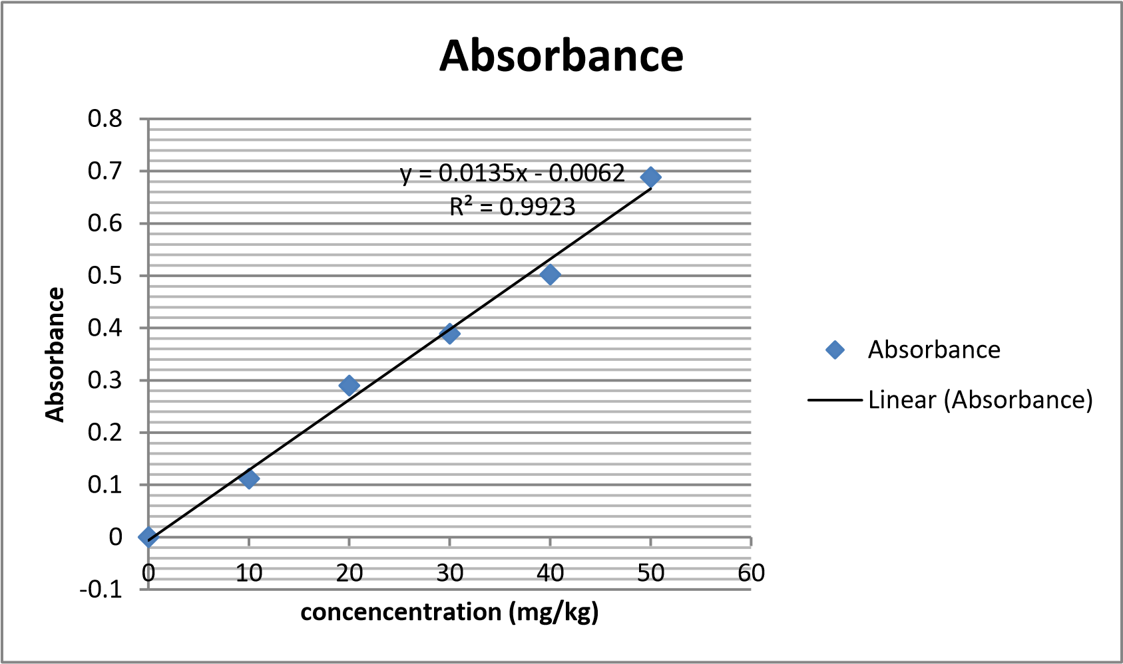
Fig 1: A graph showing the Calibration curve for Vitamin C

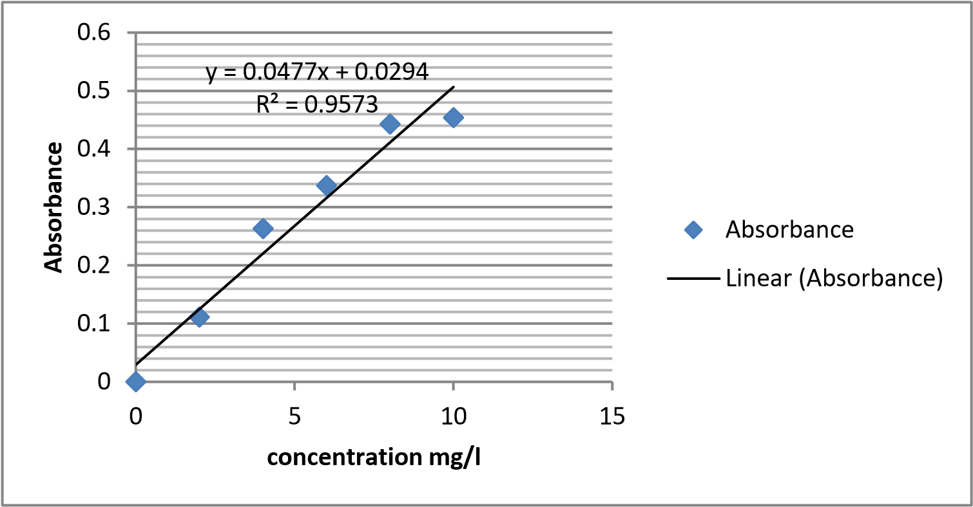

Fig 2: A graph showing the Calibration curve of Vitamin K

Fig 3: A graph showing the Concentration of B-Complex Vitamins across three samples specified as A, B, C.

Table 1: Amino Acid profile of Sample A
Amino Acid | Retention Time (min) | Peak Identification | Peak Area (p A*s) | Concentration (ppm)
Glycine | 2.959 | BV | 1.088 | 0.28±0.01
Alanine | 4.104 | BV | 81.828 | 22.55±8.25
Serine | 5.316 | VV | 45.407 | 12.50±2.57
Proline | 6.360 | VV | 40.846 | 11.25±4.02
Valine | 7.358 | VV | 19.584 | 5.38±0.21
Threonine | 8.311 | VV | 47.760 | 13.16±3.2
Isoleucine | 9.147 | VV | 106.727 | 29.42±0.71
Leucine | 10.024 | VV | 9.237 | 2.53±0.5
Aspartate | 10.821 | VV | 7.283 | 11.99±3.53
Lysine | 11.539 | VV | 10.883 | 12.95±2.8
Methionine | 12.135 | BV | 3.010 | 0.81±0.02
Glutamate | 12.247 | VV | 10.373 | 2.84±0.1
Phenylalanine | 12.880 | VB | 7.603 | 2.07±0.03
Histidine | 13.603 | BB | 3.494 | 0.94±0.01
Arginine | 14.064 | BB | 27.242 | 7.49±141
Tyrosine | 14.685 | VV | 2.437 | 0.62±0.02
Tryptophan | 15.223 | VB | 4.745 | 11.28±6.36
Cysteine | 15.723 | VV | 5.815 | 11.58±6.24
Mean Total |  |  |  | 159.64

Table 2: Amino Acid Analysis of Sample B
Amino Acid | Retention Time (min) | Peak Identification | Peak Area (pA*s) | Concentration (ppm)
Glycine | 2.954 | BV | 1.01 | 1.10±0.03
Alanine | 4.075 | VV | 33.38 | 9.19±2.19
Serine | 5.264 | VV | 12.29 | 3.37±0.31
Proline | 6.388 | VV | 72.77 | 20.05±5.34
Valine | 7.369 | VV | 37.38 | 10.29±3.11
Threonine | 8.313 | VV | 67.80 | 18.69±7.61
Isoleucine | 9.130 | VB | 138.50 | 38.19±10.21
Leucine | 10.030 | VV | 6.67 | 1.82±0.05
Aspartate | 10.813 | VV | 7.77 | 2.12±1.21
Lysine | 11.538 | VV | 17.96 | 4.91±2.13
Methionine | 12.149 | BV | 4.35 | 1.18±0.7
Glutamate | 12.244 | VV | 20.51 | 5.64±3.4
Phenylalanine | 12.874 | VB | 15.34 | 4.21±2.48
Histidine | 13.591 | BV | 7.60 | 2.07±0.2
Arginine | 14.030 | VB | 67.62 | 18.64±9.61
Tyrosine | 14.697 | VV | 20.32 | 5.54±2.32
Tryptophan | 15.201 | VV | 26.98 | 7.42±4.21
Cysteine | 15.870 | VV | 60.25 | 16.60±5.41
Mean Total |  |  |  | 171.03

Table 3: Amino Acid Evaluation of Sample C
Amino Acid | Retention Time (min) | Peak Identification | Peak Area (pA*s) | Concentration (ppm)
Glycine | 2.89 | BV | 1.01 | 1.20±0.1
Alanine | 4.204 | BV | 21.83 | 0.75±0.2
Serine | 4.216 | VV | 35.41 | 15.44±2.88
Proline | 5.330 | VV | 40.86 | 9.28±3.42
Valine | 6.823 | VV | 21.58 | 15.48±6.08
Threonine | 7.210 | BV | 58.56 | 15.16±3.28
Isoleucine | 8.140 | BV | 102.77 | 12.42±8.01
Leucine | 9.123 | VV | 8.24 | 9.23±3.27
Aspartate | 10.821 | VV | 7.23 | 9.29±4.01
Lysine | 11.230 | VV | 20.94 | 10.50±6.21
Methionine | 12.124 | BV | 3.10 | 7.11±0.01
Glutamate | 12.129 | VV | 9.33 | 5.22±2.11
Histidine | 13.301 | BB | 5.44 | 10.23±3.29
Arginine | 14.126 | BB | 18.34 | 1.49±0.11
Tryptophan | 15.312 | VV | 8.44 | 5.10±0.42
Cysteine | 15.823 | VB | 6.25 | 0.58±0.02
Mean Total |  |  |  | 128.48

DISCUSSION
The calibration curves in Figures 1 and 2 demonstrate strong linearity between absorbance and concentration, ensuring reliable quantification of Vitamins C and K.
The concentration of Vitamin C, as shown in Figure 1, ranged from 58.7 ± 7.1 to 60.4 ± 10.1 mg/kg. A study by Savych et al. (2021) reported higher Vitamin C levels (210–390 mg/kg) in various herbal mixtures, indicating that the tested poly-herbal mixtures in this study contain lower Vitamin C concentrations. Since Vitamin C is a potent antioxidant that protects cells from oxidative damage, its lower concentration could influence the antioxidant capacity of the tested mixtures.
The concentration of Vitamin K, as depicted in Figure 2, ranged from 3.30 ± 2.1 to 3.41 ± 0.3 mg/L. This result aligns with findings by Palla et al. (2021), who emphasized the antioxidant and cardiovascular support functions of Vitamin K.
B-complex vitamins play essential roles as coenzymes in energy metabolism and are vital for maintaining healthy skin, vision, neurological functions, and red blood cell formation. As shown in Figure 3, the concentrations of Vitamins B1, B2, B3, and B9 ranged from 0.019 ± 0.01 to 0.02 ± 0.00 mg/100g, 0.018 ± 0.01 to 0.019 ± 0.00 mg/100g, 0.610 ± 0.21 to 0.659 ± 0.12 mg/100g, and 0.234 ± 0.03 to 0.247± 0.01 mg/100g, respectively. These values are consistent with those reported by Lee et al. (2012), indicating moderate B-vitamin levels in poly-herbal products and supporting their role in metabolic and neurological health.
The amino acid profiles of the three branded poly-herbal mixtures, as summarized in Tables 1, 2, and 3, reveal variations in retention time, peak identification, chromatographic peak area, and concentration. Samples A and B contained 18 amino acids, while Sample C contained 16, with total concentrations of 159.64 ppm, 171.03 ppm, and 128.48 ppm, respectively. All three samples contained both essential and non-essential amino acids, emphasizing their nutritional potential for protein synthesis, immune function, and metabolic support.
In Sample A, isoleucine, threonine, and alanine were the most abundant amino acids, indicating a diverse profile that includes all nine essential amino acids, making it a potentially high-quality protein source. These findings align with Slobodianiuk et al. (2021), who reported a similar amino acid distribution in poly-herbal products.
Sample B showed a distinct amino acid profile, with isoleucine, proline, and threonine as the dominant amino acids. These amino acids are essential for muscle growth, tissue repair, neurotransmitter production, and immune health. The amino acid balance suggests a nutritionally beneficial profile, similar to the findings of Aja et al. (2019).
The amino acid profile of Sample C demonstrated high concentrations of valine, serine, and isoleucine. These essential amino acids play significant roles in protein synthesis, muscle health, and immune function. The results are consistent with Ambrogelly et al. (2021), who highlighted the importance of amino acid profiling for nutritional value assessment in herbal formulations.

CONCLUSION
Poly-herbal mixtures are gaining popularity due to their nutritional and therapeutic benefits. This study provides valuable insights into the vitamin and amino acid profiles of three branded poly-herbal mixtures. The results indicate that the mixtures contain modest levels of essential vitamins, with the highest concentrations observed for Vitamin K and Vitamin B3 (Niacin), which contribute significantly to daily nutritional needs. However, the levels of Vitamins B1, B2, and B9 were relatively low, suggesting that these mixtures are not highly concentrated sources of these vitamins. Variations in Vitamin C levels may be attributed to differences in herbal composition, preparation methods, or storage conditions.
The samples also contains varying amounts of both essential and non-essential amino acids. The total value of Amino acid is important in assessing the protein concentration or density of the samples, indicating that they contain a significant quantity of amino acids and could be a high-protein product. The samples provides key amino acids that support various critical functions, including muscle maintenance, cardiovascular health, immune function, and protein synthesis, making it a valuable source for both general nutrition and specific health benefits. However, the relatively lower levels of lysine and leucine suggest that dietary supplementation with lysine- or leucine-rich foods may be required to achieve a complete amino acid profile.
While these poly-herbal mixtures have the potential to supplement nutritional and therapeutic needs, their low levels of certain vitamins highlight the importance of considering serving sizes to optimize their contributions. Additionally, incorporating them into a balanced diet alongside lysine- and leucine-rich foods can enhance their overall nutritional value. Future research should focus on analyzing additional components and exploring their synergistic health benefits to provide more comprehensive recommendations for consumers.

Disclaimer (Artificial intelligence)
Author(s) hereby declare that NO generative AI technologies such as Large Language Models (ChatGPT, COPILOT, etc) and text-to-image generators have been used during writing or editing of manuscripts.

REFERENCES
Ahmed, R., Singh, P., & Kaur, M. (2021). Analysis of vitamin content in poly-herbal formulations using ICP-MS. Journal of Herbal Medicine, 25(2), 105–113.
Aja, P. M., Ekpono, E. U., Obasi, N. A., Obasi, D. C., & Nwaeke, J. (2019). Comparative amino acid compositions of Uvaria chamae stem bark and Ruzu bitters (a poly-herbal mixture). Earthline Journal of Chemical Sciences, 2(1), 79–95.
Al-Masri, H. T., & Habib, R. M. (2020). Optimization of extraction and analysis of water-soluble vitamins in complex plant matrices. International Journal of Analytical Chemistry, 2(20), 12-34.
Ambrogelly, A., Zhao, X., & Nakonechna, A. (2021). Amino acids in herbal plants: Their roles in stress physiology and potential therapeutic applications. Plant Physiology & Biochemistry, 128(1), 37–49.
Chandrasekaran, C. V., Sundarajan, K., & Rajan, S. (2017). Amino acid profiling of poly-herbal wound-healing formulations: A biochemical approach. Journal of Ethnopharmacology, 19(8), 92–98.
Christopher W., Karsten K., Peter P., & Lindy C. (2022). The Role of Vitamins in the Optimal Functioning of the Immune System. Nutrients, 14(3), 644.
Lee, H. S., Zeng, K. W., Yang, Z. (2012). Poly-herbal formulation concept for synergic action: A review. Journal of Drug Delivery and Therapeutics, 2(6), 123–130.
Ogbonnia, S. O., Mbaka, G. O., Igbokwe, N. H., & Nwakakwa, N. (2018). Antimicrobial evaluation, acute and subchronic toxicity studies of Leone Bitters: A Nigerian poly-herbal formulation. Journal of Agriculture and Biology, 1(3), 366-376.
Palla, A. H., Amin, F., Fatima, B., Shafiq, A., Urehman, N., & Gilani, A. U. H. (2021). Systematic review of poly-herbal combinations used in metabolic syndrome. Frontiers in Pharmacology, 12, Article 752926.
Savych, A., Marchyshyn, S., Mosula, L., & Kryskiw, L. (2021). Spectrophotometric determination of L-ascorbic acid in the herbal antidiabetic mixtures. Pharmacologyonline, 3(3), 118-128.
Slobodianiuk, A., Nakonechna, A., & Savych, I. (2021). Analysis of amino acids content in the plant components of the antidiabetic herbal mixture by GC-MS. Pharmacia, 69(1), 69–76.
Voet, D., Voet, J. G., & Pratt, C. W. (2016). Fundamentals of Biochemistry: Life at the Molecular Level (5th ed.). Hoboken, NJ: Wiley. (pp. 67–110).

