TAXONOMIC STUDY OF FRESHWATER ALGAE FROM JILANI PARK, LAHORE, PAKISTAN

Abstract
Freshwater algae are crucial components of aquatic ecosystems, contributing significantly to primary production and serving as bioindicators of environmental health. This study documented the taxonomy of freshwater algae in Jilani Park, Lahore, Pakistan, providing a comprehensive assessment of their diversity and distribution. Samples were collected from six different sites within the park during November 2023 to January 2024. Standard taxonomic procedures were used to identify and classify algal species, while measuring environmental parameters like pH, temperature, latitude, and longitude. A total of 30 algal species were identified, belonging to three kingdoms: Monera, Protista and Protoctista. The kingdom Monera included two classes within Phylum Cyanophycota; Chroocophyceae & Nostocophyceae with 13.4% and 6.6% respectively. The kingdom Protista had most % of species including Volvocophycota (Desmidiophyceae 6.6%); Euglenophycota (Euglenophyceae 3.4%) & Bacillariophycota (Bacillariophyceae 50%). The kingdom Protoctista included four classes (Chlorophyceae, Ulvophyceae, Zygnemophyceae, & Siphonocladophyceae) within Phylum Chlorophycota accounting for 20% of species. Frequently encountered genus included Gomphonema Ehrenberg, Nitzschia Hassall, and Pinnularia (Ehrenb.) Ehrenberg. The diversity measures indicated moderate to high species diversity across different sites, with environmental factors like pH and temperature shaping the algal communities, providing baseline data for future ecological monitoring and conservation efforts in Jilani Park.
Keywords: Taxonomy; identification; freshwater algae; Jilani park; algal distribution; aquatic; study
Introduction
Jilani Park, formerly known as Race Course Park, stands as a prominent urban oasis in Lahore, Punjab, Pakistan. Spanning 88 acres (0.36 km²) and established on October 3, 1985, under the governance of Governor Ghulam Jilani Khan, this park is a cherished destination for residents and visitors alike. Situated on Jail Road, opposite the Services Hospital, Jilani Park attracts tourists with its yearly horse race, artificial waterfall, and flower exhibits. Its beautiful foliage and lake in the shape of Pakistan demonstrate Lahore's commitment to public green areas. These features make it an ideal location for studying freshwater algae. The park’s urban setting provides a unique opportunity to study how environmental factors are associated with urbanization affect algal diversity and distribution (Nawaz et al., 2011).
Algae are complex, photosynthetic organisms that are essential to ecosystems around the world as primary producers. From tiny phytoplankton to enormous seaweeds, they can be found in freshwater, marine, terrestrial, and harsh habitats. Adaptable in both lotic (rivers) and lentic (lakes, ponds) systems, they can exist independently or in symbiosis (Yerima and Fidi, 2018; Gao et al., 2021; Minhas et al., 2023).
Algae, abundant throughout the year in damp environments like moist soil, are a diverse group found in various habitats including aquatic, terrestrial, aerophytic, cryptophytic, thermophilic, halophytic, epilithic, epizoic, epiphytic, endozoic, and symbiotic settings (Hussain et al., 2016). Freshwater algae, in particular, have garnered significant attention due to their potential applications. Aga et al., (2018) discovered 248 taxa in Kachhi, Balochistan, dominated by Bacillarophycota, Cyanophycota, and Volvophycota. Imtiaz et al., (2018) identified 30 species from Peshawar among six algal groups. Ullah et al., (2019) collected 52 species from Chitral, with Mougeotia, Spirogyra, and Zygnema being common. Ullah et al., (2021) identified 55 Chlorophyta species in District Mardan, with Spirogyra dominating. Ullah et al., (2022) used light and scanning electron microscopy to identify 21 species of Euglenophycota from Gujranwala, Gujarat, Narowal, and Sialkot. Javed et al., (2022) identified 28 algal species from Chishtian, including 16 genera, 11 families, seven orders, and four phyla. Zia et al., (2022) surveyed Halloki village in Lahore, identifying 34 algal species from five phyla. Minhas et al., (2023) studied 30 green algal species from Gujar Khan in Rawalpindi, identifying four orders, 11 families, and 14 genera, including three new records for Pakistan. Nazir et al., (2024) identified 94 algal taxa from 137 samples in Kohat and Hangu, covering 39 genera, 31 families, 18 orders, and seven classes. Recent taxonomic studies on freshwater algae in Pakistan have found remarkable species diversity. Hanif et al., (2024) discovered 33 microalgal strains in District Karak, including 10 orders, 12 families, and 17 genera across four classes.
Despite comprehensive global research, freshwater algae in Lahore, particularly in Jilani Park, remain little studied. Limited localized taxonomic data and old identification techniques prevent precise research and ecological evaluation. Incorporating molecular approaches is also crucial for enhancing environmental monitoring and management (Manoylov, 2014). These gaps highlight the necessity for enhanced training, funding, and infrastructure development in algal taxonomic studies.
The background and the purpose of the present study is to identify the freshwater algae species from Jilani Park and to assess the abundance, distribution and document of different algal taxa within the park's aquatic habitats. The benefit of this research is to provide the proof information in inventory or checklist of algal species collected from some sites in Pakistan for further research studies.
Materials and Methods
Site Selection
Jilani Park, an 88-acre urban green space in Lahore with a lake and waterfall, was selected as the study site to investigate freshwater algal diversity in an urban environment. From November 2023 to January 2024, Jilani Park aquatic habitats were sampled for freshwater algae. Waterfalls, lakes, and waterways were chosen for sampling.
Sample Collection
Water samples were gently collected from multiple locations within each habitat using plastic water sampling bottles during daylight hours. Planktonic algae were obtained from free floating water, epipelic algae were collected from sediments, epilithic algae were scraped from submerged rocks and bricks. After collection, the samples were transported to laboratory for processing and preservation according to established protocols. Different parameters such as temperature, pH, latitude, and longitude were also determined using thermometer, pH meter and Global Positioning System (GPS) (Table 1).
Preservation in lab
The collected water samples were washed with water to remove any dust or debris and preserved using formalin, a commonly used fixative in biological specimen preservation. Upon collection, 1 to 2 ml of 4% formalin was added to the samples for the intervals of 30 days. The preserved samples were placed in opaque, airtight containers to protect them from light and air exposure, which could cause degradation over time. These containers were labeled with pertinent information such as sample ID, collection date, and sampling location. The samples were kept in the Phycology Research Lab., Institute of Botany, University of the Punjab, Lahore.
Microscopy
The samples collected were examined taxonomically under a light microscope, utilizing various magnifications such as 10X, 40X, and 100X. Algae specimens were mounted on glass slides using either a dropper and covered with a slip, while distilled water was added to prevent dehydration. Photographs of each specimen were taken for documentation purposes. Species identification was conducted by consulting authoritative literature sources, including works by (Prescott, 1962; Desikacheri, 1951; Naz et al., 2023; Shahida et al., 2005; John et al., 2011; Cooke 1882 [48]; Osório et al., 2018; Masud-ul-Hasan and Zeb-un-Nisa 1986; Barsanti and Gualtieri, 2020; Ghazala and Arifa, 2011; Martins et al, 2013; Wazir, 2002; Noga et al.,2014; Masud-ul-Hasan and Yunus, 1978b; Cox, 1996; Smith, 1953; Nizamuddin, 1984 and Tangen et al., 1978).
Results
Algae samples were collected from Jilani Park in Lahore, Pakistan, to identify and classify them based on their taxonomic features and characteristics. The taxonomic study was conducted using phenotypic and cellular traits to identify the algae to the species level (Shameel, 2008; 2012). Through this investigation, 30 freshwater algal species were identified from Jilani Park, Lahore, Pakistan:
KINGDOM MONERA
1. PHYLUM CYANOPHYCOTA
1. Class Chroocophyceae
1. Order Chroococcales
1. Family Chroococcaceae Nägeli
1. Chroococcus Nägeli
1. C. limneticus Lemmermann
2. C. minutus (Kütz.) Nägeli
2. Merismopedia Meyen
3. M. elegans var. major G. M. Smith
2. Family Aphanothecaceae
3. Aphanothece Nägeli
4. A. bullosa Rabenhorst
2. Class Nostocophyceae
2. Order Nostocales Geitler
3. Family Oscillatoriaceae
4. Oscillatoria Vaucher
5. O. limosa C. Agardh
6. O. subbrevis Schmidle
KINGDOM PROTISTA
2. PHYLUM VOLVOCOPHYCOTA
3. Class Desmidiophyceae
3. Order Desmidiales
4. Family Desmidiaceae
5. Cosmarium Corda
7. C. contractum var. contractum Kirchner
8. C. pachydermum Lund
- PHYLUM EUGLENOPHYCOTA
4. Class Euglenophyceae
4. Order Euglenales
5. Family Euglenaceae
6. Euglena Ehrenberg
9. E. gracilis Klebs
4. PHYLUM BACILLARIOPHYCOTA
5. Class Bacillariophyceae
5. Order Bacillariales
6. Family Fragilariaceae
7. Synedra Ehrenberg
10. S. ulna Grun Majeed
7. Family Gomphonemataceae
8. Gomphonema Ehrenberg
11. G. affine Kützing
12. G. olivaceum var. obtusum (Lyngbye) Desmazieres
13. G. micropus Kützing
14. G. venusta Passy, Kociolek & Lowe
8. Family Naviculaceae
9. Navicula Bory
15. N. kotschyi Grunow
9. Family Diploneidaceae
10. Diploneis Ehrenberg ex Cleve
16. D. subovalis Cleve
10. Family Nitzschiaceae
11. Nitzschia Hassall
17. N. capitellata Hustedt
18. N. fonticola (Grunow) Grunow in Van Heurck
19. N. sigma (Kützing) W. Smith
20. N. sigmoidea (Nitzsch) W. Smith
21. N. vermicularis (Kützing) Majeed
11. Family Pinnulariaceae
12. Pinnularia (Ehrenb.) Ehrenberg
22. P. biceps Gregory
23. P. subdentica Hilse
24. P. viridis (Nitzsch) Ehrenberg
KINGDOM PROTOCTISTA
5. PHYLUM CHLOROPHYCOTA
6. Class Chlorophyceae
6. Order Tetrasporales
12. Family Sphaerocystidaceae
13. Sphaerocystis Chod.
25. S. schroeteri Chod.
7. Class Ulvophyceae
7. Order Ulotrichales
13. Family Ulotrichaceae
14. Ulothrix Kützing
26. U. tenuissima Kütz.
27. U. variabilis Kütz.
8. Class Zygnemophyceae
8. Order Oedogoniales
14. Family Oedogoniaceae
15. Oedogonium Link
28. O. pluviale Nord
9. Class Siphonocladophyceae
9. Order Cladophorales
15. Family Cladophoraceae
16. Rhizoclonium Kützing
29. R. casparyi Harv
30. R. hierglyphicum (C. Agardh) Kützing
KINGDOM MONERA
Individuals of this kingdom have prokaryotic cellular organization.
Phylum Cyanophycota
Cyanophycota, or blue-green algae, are prokaryotic, lack chromoplastids, have chlorophyll a and phycocyanin, and may have phycoerythrin. They synthesize glycogen and glycoproteins, not starch. Reproduction occurs by fission, fragmentation or by akinetes.
Class Chroocophyceae
Proliferation via cell division, endospore and exospore creation, and unicellular colonial or palmelloid forms.
Order Chroococcales
Cells are loosely bounded into gelatinous, irregular and simple colonies; there is no differentiation of cells. Reproduction occurs by endospores or cell division.
Family Chroococcaceae
Cells mainly ellipsoidal, seldom spindle-shaped, mostly spherical, single or in colonies, thick membrane, mucilaginous, typically lamellated, amorphous. Colonial or unicellular, floating or adhering to substrates. Pseudo filaments are absent.
Chroococcus Nägeli
Spherical, hemispherical, or ovate cells, solitary or in small colonies of 4, 8, 16 or more cells, or mixed with other blue-green algae to form crusts on wet rocks; generally colorless but sometimes bright blue-green, olive-green yellowish; cell contents granular.
Key to Specimen
Cells ovate ……………........ C. limneticus
Cells spherical ...…………... C. minutus
- C. limneticus Lemmermann (Fig. 2-1)
General Description: It is a free-floating alga commonly found in lentic water bodies such as lakes, ponds and slow-moving waterways. It has ovate or spherical colony; 4 to 32 closely arranged cells; hyaline, mucilaginous envelope; dull to bright blue-green contents; no sheath.
Locality: Waterway 1
References: (Prescott, 1962).
- C. minutus (Kützing) Nägeli (Fig. 2-2)
General description: This species flourishes in nutrient-rich waters with moderate light availability. Cells are spherical or oblong, single or in groups of 2-4, bright blue-green or dark green, 11-12 µm sheath diameter, 6-7 um without sheath, non-lamellated.
Locality: Waterway 2
References: (Desikachary, 1959; Naz et al., 2003; Shahida et al., 2005).
Merismopedia Meyen
Tabular colonies have four or more free-floating, circular, oblong before cell division, and subspherical after division cells. Mucilage is homogenous; cells are blue-green; multiplication by division in two directions.
- M. elegans var. major G. M. Smith (Fig. 2-3)
General Description: This is a variety of original species commonly found in fresh calm waters; having larger cells, usually 10-11 µm in diameter and 12-14 µm and sometimes 17 um in length.
Locality: Waterway 2
References: (Prescott, 1962).
Family Aphenothecaceae
Individual or small colonies of spherical or ovoid cells exist. They photosynthesize with chlorophyll a and phycobiliproteins. These pigments give greenish-blue color. They reproduce asexually through binary fission and live-in freshwater phytoplankton communities.
Aphanothece Nägeli
Elliptical or cylindrical cells might be straight or somewhat curved. These cells are in an enlarged, undefined thallus. The thallus' slimy mucilage is homogeneous and may have multilayer coatings. It has nanocysts and gelatinization. Transverse cell division occurs.
- A. bullosa Rabenhorst (Fig. 2-4)
General Description: It is usually found in unpolluted waters and mangrove soil surface. The thallus is round with irregular lobes and can reach 15 cm in diameter. It is delicate and greenish-yellow. Approximately 3.5-5 µm in width, the cells are cylindrical and elongated. Blue-green or olive-green cells; may or may not have coverings.
Locality: Waterway 3
Reference: (Desikachary, 1959).
Class Nostocophyceae
Filamentous algae with trichomes, usually unbranched.
Order Nostocales Geitler
Filamentous algae with trichomes, possess hormogones, akinetes, hormocysts for reproduction; filaments with false branching may exist.
Family Oscillatoriaceae
Unbranched trichomes with a single row of similar and uniformly broad cells, sometimes tapering at the ends, sheath firm, filaments straight or regularly or irregularly spirally coiled, growth intercalary and apical, many rotating along the longitudinal axis, and sometimes several trichomes in a sheath.
Oscillatoria Vaucher
Trichomes single or forming a flat or spongy free-floating thallus, sheath absent; filaments motile; end of trichomes distinctly marked, pointed or coiled.
Key to Specimen
Cells 11-22 µm ….……......... O. limosa
Cells 5-6 µm……………....... O. subbrevis
- O. limosa C. Agardh (Fig. 2-5)
General Description: Occurs in freshwater habitat; stagnant, free or slow-floating forming dark blue-green to brown mats. Trichome more or less straight, blue-green, brown or olive-green. Cells 11-13-16 -22 µm wide, 2-5 µm long; cross walls not or only slightly narrowed; end cell rounded, with slightly thickened membrane.
Locality: Lake
References: (John et al., 2011)
- O. subbrevis Schmidle (Fig. 2-6)
General Description: Freshwater, marine, brackish species. Trichomes single, more or less straight, not attenuated towards the apex. Cells 5-6 µm wide, 1-2 µm long; cross walls without granules; end cell rounded.
Locality: Water fall
References: (Cooke, 1882).
KINGDOM PROTISTA
Eukaryotic cells with solitary or colonial unicellular organization.
Phylum Volvophycota
Green microalgae that can be unicellular or colonial; typically include lutein and neoxanthin as well as the chlorophyll a and b.
Class Desmidiophyceae
Unicellular or sometimes filamentous without fragmentation, sexually reproduce by conjugation.
Order Desmidiales
Porous cell wall; new semi-cells formed by cell division.
Family Desmidiaceae
Unicellular, cell separation occurs at mid region with formation of daughter cells.
Cosmarium Corda
Solitary cells, 2 semicells unit by isthmus, sinuses; Round, reniform, pyramidate, quadrate semicells; cell wall may have central and marginal ornamentation, pores with distributed mucilaginous sheath, chloroplasts vary in number per half-cell, each contain pyrenoids, and nucleus in isthmus. Asexual reproduction by cell division, karyokinesis and cytokinesis at isthmus; sexual reproduction by conjugation, zygospore spherical with spines.
Key to Specimen
Cells wall smooth ......... C. contractum var. contractum
Cells wall thick …....... C. pachydermum
- C. contractum var. contractum Kirchner (Fig. 2-7)
General Description: Freshwater habitat; Cells 1.4–1.8 times longer than broad; smooth cell wall; median constriction deep, sinus opening, broad, isthmus slightly extended; each semi-cell has a single central pyrenoid on the axial side of the chloroplast. Length: 24–32 µm, Width: 15.5-17.5 µm.
Locality: Water fall
References: (Osório et al., 2018).
- C. pachydermum Lund (Fig. 2-8)
General Description: Oval, semi-hemispherical cells with two chloroplasts and prominent pyrenoids; 2.5-3 µm thick wall; 75 μm length, 60 μm breadth; 20-24 µm isthmus width. Commonly found in acidic, oligotrophic, aquatic environments, such as bogs and lakes.
Locality: Waterway 4
Reference: (Masud-ul-Hasan and Zeb-un-Nisa 1986).
Phylum Euglenophycota
Pigmentation is provided by chlorophylls a and b; two basal bodies and one or two emerging apical flagella. Proteinaceous pellicle in strips under plasma membrane; monokaryotic nucleus, unique cell-division, no sexual reproduction; paramylon storage product.
Class Euglenophyceae
Freshwater, stationary or motile by 1-2 µm powerful flagella; chloroplast and pyrenoids present.
Order Euglenales
Possess a stockpile of food that resembles starch and reproduce by cell division along one axis.
Family Euglenaceae
Few individuals are biflagellate; most are uniflagellate. Pyrenoids found on chloroplasts with disc- or ribbon-shaped sellars.
Euglena Ehrenberg
Elongated, fusiform, almost cylindrical, spherical, or somewhat flattened cells with oval plates, infrequently scattered, or ribbon-like chloroplasts.
- E. gracilis Klebs (Fig. 2-9)
General Description: Typically found in freshwater habitats, particularly in nutrient-rich environments like ponds and ditches. Their pellicle, a collection of proteinaceous strips beneath the outer membrane, characterizes them. Under a scanning electron microscope, euglenoid cells' pellicle appears striped and helps them move with flagella.
Locality: Waterway 2
Reference: (Barsanti and Gualtieri, 2020).
Phylum Bacillarophycota
Photosynthesis, freshwater and marine; phytoplankton major components; cell walls are two valves with silica. Reproduction fission; primarily diatoms (plankton) without flagella; overlapping opaline silica frustules.
Class Bacillarophyceae
Mostly diatoms, freshwater and marine algae, flagellum on sperm only; cell wall in bipartite frustules, outer epitheca and inner hypotheca.
Order Bacillariales
Pennate ornamentation; one or two chloroplasts; raphe may present; no flagellated spermatozoids, sexual reproduction by conjugation.
Family Fragilariaceae
Frustules have long girdles and truncate apices. They live isolated or in colonies and are perhaps epiphytic. Girdles may overlap or be separated by one-to-many intercalary bands. Two plate-shaped chromatophores run down the valve margins.
Synedra Ehrenberg
Fan or ribbon-shaped colonies without adhering cells. Apical axes contain linear or linear-lanceolate valves, and pseudoraphes. Valve surfaces may have striations throughout.
- S. ulna Grun Majeed (Fig. 2-10)
General Description: Solitary cells have linear to linear-lanceolate valves without a center area, prominent striae, narrow pseudoraphe with attenuated ends. Pole diameter is 3 um. Cells measure 50-350 µm long and 5-9 um wide; striae are delicate and punctate. Generally found in freshwater and slightly brackish environments.
Locality: Waterway 3
References: (Ghazala and Arifa, 2011; Kant and Gupta, 1998).
Family Gomphonemataceae
Straight, lanceolate, or club-shaped valve with capitates; single chromatophore with lanceolate, clavate, or plain cells.
Gomphonema Ehrenberg
Epiphytic cells grow on dichotomously branching gelatinous stalks; sometimes sessile; valves and girdles show transversely asymmetrical cells; straight, lanceolate, or clavate cells. Intercalary bands are absent; raphe is central and straight with prominent polar nodules. Striations are transverse or somewhat radial; chromatophore one lobed.
Key to Specimen
1. Valves club shaped ………….…. G. affine
Valves ovoid-clavate…......... G. olivaceum var. obtusum
2. Valves lanceolate ...………… G. micropus
Valves linear lanceolate ……… G. venusta
- G. affine Kützing (Fig. 2-11)
General Description: Freshwater diatom. Heteropolar, club-shaped valves with blunt and sharp apices. Valve surface has depressions. Axial area linear narrows towards apices. Shorter central striae. Raphe lateral, tiny, rounded proximal endings, comma-shaped distal endings. Striae are radial throughout.
Locality: Waterway 2
Reference: (Martins et al., 2013).
- G. olivaceum var. obtusum (Lyngbye) Desmazieres (Fig. 2-12)
General description: Freshwater diatom commonly found in lentic and lotic environments, including lakes, ponds and slow-moving streams. Ovoid-clavate valves with broadly rounded apex and abruptly rounded base; narrow, linear axial area, transversely enlarged middle area without dots. Have fewer, thicker, stronger striae. 22.5 µm long and 8-10 µm wide.
Locality: Waterway 4
References: (Wazir, 2002).
- G. micropus Kützing (Fig. 3-13)
General Description: Occurs in fresh and brackish waters. Lanceolate, heteropolar valves; 18.8-47.2 µm long and 6.8-9.2 µm broad Striae exhibit 8-10 µm of modest radiation.
Locality: Waterfall
Reference: (Wojtal, 2003)
- G. venusta Passy, Kociolek & Lowe (Fig. 3-14)
General Description: Usually thrives in benthic habitats. Valves weakly heteropolar, linear lanceolate, clavate. Head pole acutely to narrowly rounded. The raphe is lateral, the proximal endings are enlarged and teardrop-shaped.
Locality: Lake
Reference: (Martins et al., 2013).
Family Naviculaceae
Free floating; cells solitary; valves elliptic, lanceolate; raphe with distinct central and polar nodules; two laminate chromatophores.
Navicula Bory
Tiny particles that float alone, in groups, or capitate, rounded, or rostrate; straight, rectangular girdle; linear, lanceolate, or fusiform valves; raphe straight with polar and central nodules; tiny, linear axial region; two laminate chromatophores on opposite sides of the valve, occasionally with many little spherical granules.
- N. kotschyi Grunow (Fig. 3-15)
General Description: A freshwater species with valve lanceolate to elliptical with linear axial area, central area elliptic. Cell dimensions: 21 µm in 6 μm × 18 in 10 μm; striae radiating.
Locality: Waterway 3
Reference: (Noga et al., 2014).
Family Diploneidaceae
Possess an armored covering made of cellulose plates, which encase the cell and provide structural support and protection.
Diploneis Ehrenberg ex Cleve
Valve elliptical, ends may be rounded; having large central nodule, narrow furrows which follows central nodule.
- D. subovalis Cleve (Fig. 3-16)
General Description: Valves distinctly elliptical, apices rounded, 25 µm long, 15 μm broad; median nodule large and round; striae are strong, 8-10 in 10 μm. alternating with double row of alveoli. It is present both in freshwater and marine environments.
Locality: Waterway 1
Reference: (Masud-ul-Hasan and Yunus, 1978b).
Family Nitzschiaceae
Cells solitary, free floating or epiphytic; valves straight or sigmoid, transversely symmetric and longitudinally asymmetric; raphe on one lateral margin in each valve; two chromatophores separated at girdle.
Nitzschia Hassall
Solitary cells float or cluster in unbranched gelatinous tubes. They are lengthy and diverse, with attenuated poles. Valves are longitudinally asymmetrical. One valve has keeled margin and another unkeeled. In the keel, the raphe has small central and polar nodules. Transverse striae. Two axial chromatophores on girdle face.
Key to Specimen
1. Valves lance shaped ……………………………………………............. N. capitellata
Valves lanceolate ……………………………………………................. N. fonticola
Valves linear lanceolate ……………………………………………....... N. sigma
Valves sigmoid……………………………………………...................... 2
2. Valves structure robust ………………………………………................. robust
Valves structure punctate………………………..................................... N. vermicularis
- N. capitellata Hustedt (Fig. 3-17)
General Description: Typically lives in freshwater environments like lakes, streams and river. Valves are lance-shaped with slight constriction and pointed tips, 12-16 fibulae present; a central nodule and faint striae observed.
Locality: Waterway 1
References: (Noga et al., 2014).
- N. fonticola (Grunow) Grunow in Van Heurck (Fig. 3-18)
General Description: Lanceolate to linear-lanceolate valves with subcapitate apices, 10-65 µm long, 2.5-5 µm wide, dot-like fibulae, 9-16 in 10 µm long, more widely spaced at center. Widely distributed in freshwater bodies, particularly in rivers that are relatively high in specific conductance and fine sediments.
Locality: Waterfall
References: (Cox, 1996).
- N. sigma (Kützing) W. Smith (Fig. 3-19)
General description: Typically occurs inland aquatic systems. Solitary cells with bilaterally symmetrical, isopolar, sigmoid, and pole-tapering frustules at the valve and girdle ends. Strongly sigmoid, linear-lanceolate, or lanceolate valves taper evenly from centre to poles. Poles subrostrate or subcapitate. Transverse lines. The raphe system is marginal and not diverted across the centre valve. Every cell has two chloroplasts: one at each pole.
Locality: Waterway 2
References: (Smith, 1853).
- N. sigmoidea (Nitzsch) W. Smith (Fig. 3-20)
General description: Generally present in both brackish and freshwater environments. Frustules are bilaterally symmetrical, isopolar, straight in valve view but sigmoid in girdle view. Cells are solitary. Frustule sigmoidity is entirely due to valve margin and girdle shape. Unfinished central raphe. Cells have two chloroplasts, one at each pole.
Locality: Waterfall
References: (Smith, 1853).
- N. vermicularis (Kützing) Majeed (Fig. 3-21)
General Description: The girdle is sigmoid with truncated ends and has separate frustules. Sigmoid and linear, the valves narrow at the ends. The valve keel is punctate. The valve measures 67.2 µm long and 9.6 µm broad. It is frequently present in freshwater and marine environments, including those with colder temperatures and associated with sea ice.
Locality: Lake
References: (Nizamuddin, 1984).
Family Pinnulariaceae
Single, floating frustules; girdle linear, rectangular, or widely elliptical; valve lanceolate or linear; raphe straight; transverse, punctate, radiating, or parallel striae; pyrenoids on many chromatophores.
Pinnularia Ehrenberg
Single, living cells having two plate-like chloroplasts on the girdle sides and no pyrenoids. Chloroplast margins may be whole or lobed and extend under valve face. Valve is straight and bluntly rounded. Raphe central, complex, often in a large hyaline area; hooked polar fissures, expanded central fissures.
Key to Specimen:
1. Valves 42 - 45 µm long …...……........... 2
Valves 52 - 55 µm long ….... P. subdentica
2. Valves 23 - 30 µm width ……...... P. viridis
Valves 9 - 10 µm broad …........... P. biceps
- P. biceps Gregory (Fig. 3-22)
General description: Found in freshwater habitats, particularly in soft water conditions such as ponds, streams and lakes. Valve measures 42-45 µm length and 9-10 um wide, sublinear with slightly convex and constricted capitate ends. Raphe narrow, straight, unilaterally bent. Small axial size, wide central region, rhomboid sides, radial ends.
Locality: Waterway 3
References: (Tangen et al., 1978).
- P. subdentica Hilse (Fig. 3-23)
General description: Usually occurs in ponds and lakes. Valves are 52-55 µm long and 10 to 13 µm broad; chloroplasts two, having pyrenoids in them.
Locality: Waterway 2
References: (Cox, 1996).
- P. viridis (Nitzsch) Ehrenberg (Fig. 3-24)
General description: Length: 119-183 µm, width: 23-30 µm, striae per 10 µm: 7-8. The species is found in single cells in most watercourses, on stones, sand, and mud. Cosmopolitan, abundant, circumneutral, oligo- to mesotrophic, moderate electrolyte water.
Locality: Waterway 4
References: (Noga et al., 2014).
KINGDOM PROTOCTISTA
The kingdom, Protoctista includes a wide group of eukaryotic microorganisms such as algae, protozoa, slime moulds, and other unicellular or multicellular creatures. They have different nutrition, reproduction, and cell organization.
Phylum Cholrophycota
Chlorophyll a and b, 2-4 flagella terminal, isokontic, whiplash; cell wall cellulose. Filamentous, siphonacious, thalloid green algae. Ulvophyceae thalloid or filamentous algae; normal cell division; isogamous, anisogamous, or oogamous sexual reproduction.
Class Chlorophyceae
Contains chlorophylls a and b. Flagella: typically present, 2-4 flagella, whiplash type. Contains cellulose. Diverse habitats.
Order Tetrasporales
Non-motile, mostly unicellular or colonial. Reproduction: mainly through autospores or zoospores. Often spherical or ellipsoidal.
Family Sphaerocystidaceae
Spherical colonies of cells. Matrix: cells embedded in a mucilaginous envelope. Asexual reproduction through autospores.
Sphaerocystis Chod.
Colony structure: spherical colonies. Matrix: cells embedded in a gelatinous matrix. Freshwater environments.
- S. schroeteri Chod. (Fig. 4-25)
General Description: It is a plankton in freshwater habitats. Forms spherical colonies with many cells evenly dispersed in a mucilaginous sheath. Cells are circular to oval and have cellulose cell walls.
Locality: Waterfall
Reference: (Prescott, 1962).
Class Ulvophyceae
This class has one flattened chloroplast with many spiral or parallel chloroplasts. They range from simple branched filaments to large multicellular formations. Some species live free, while others are symbiotic with plants and fungus.
Order Ulotrichales
Thallus filamentous; filaments unbranched, uniserate; cells uninucleated, with parietal chloroplast.
Family Ulotrichaceae
Most members of this family have cylindrical, evenly formed cells. Some have gelatinous sheaths. Chloroplasts are parietal plates or bands that vary in cell wall encirclement. Some species generate a holdfast cell at the filament base. Vegetative proliferation, palmella phases, and isogametes reproduction.
Ulothrix Kützing
This genus has single, unbranched filaments with holdfast bases. The protoplast is surrounded by a single girdle-shaped chloroplast with one or more pyrenoids. Cell division happens diffusely. Fragmentation allows vegetative multiplication, while two forms of zoospores allow asexual reproduction. Sexual reproduction occurs through isogamy.
Key to Specimen
Cells cylindrical & elongate...... U. tenuissima
Cells short & broad ………......... U. variabilis
- U. tenuissima Kütz. (Fig. 4-26)
General Description: The filaments are fragile, and unbranched and uniform in appearance. Cells are cylindrical. Each cell has one parietal, girdle-shaped chloroplast with a conspicuous pyrenoid. It often occurs in freshwater settings such as standing and moving waterways, as well as moist soil.
Locality: Waterway 3
Reference: (Cooke, 1882).
- U. variabilis Kütz. (Fig. 4-27)
General Description: Thrives in nutrient-rich freshwater settings and is more prevalent in colder waters. Thin, unbranched filaments of cylindrical cells. A single, parietal, girdle-shaped chloroplast with a pyrenoid is seen in the short, broad cells. The filaments are homogeneous, but cells vary in size and shape, hence the species' name "variabilis".
Locality: Waterfall
Reference: (Cooke, 1882).
Class Zygnemophyceae
Their thallus has branching or unbranched filaments. Conjugation or cap cell creation are sexual reproduction methods.
Order Oedogoniales
These have cap cells for cell division, oogamous sexual reproduction, and stephanokontic reproductive bodies.
Family Oedogoniaceae
This family has filaments with or without branching. Polar filaments have cylindrical vegetative cells with rounded ends and parietal chloroplasts with several pyrenoids. Caps form during cell division. Oogamous sexual reproduction produces huge eggs in expanded oogonia, whereas box-like antheridia contain stephanokontic antherozoids.
Oedogonium Link
This magnificent genus of filamentous, unbranched chlorophytes has a holdfast and apical cell and is typically uniseriate. These green algae stick to substrates rather than float. Cylindrical vegetative cells have one nucleus and parietal chloroplasts with pyrenoids. Cap cells exist. Zoosporangia create zoospores, to reproduce asexually and sexually.
- O. pluviale Nord (Fig. 4-28)
General Description: Freshwater species. Cell-end-capped, unbranched cylindrical filaments. The anchoring holdfast cells have a single, reticulate chloroplast. Parietal chloroplasts contain carbon-fixing pyrenoids.
Locality: Lake
Reference: (Cooke, 1882).
Class Siphonocladophyceae
Coenocytic or siphonaceous. Possibly thalloid or filamentous.
Order Cladophorales
The chloroplasts have a net-like pattern, and the reproductive organs open through uncomplicated pores.
Family Cladophoraceae
Some species have no branches, while others have regular or irregular branches. Filamentous thallus branches out with a base and tip. Some species can release it following attachment. Alternate, dichotomous, or trichotomous branching patterns have smaller branches or taper towards the tips. Sometimes cylindrical or expanding cells have thin but strong walls. Chloroplasts form a reticulate pattern on cell walls that can break into several dises. Chloroplasts have pyrenoids.
Rhizoclonium Kützing
Filamentous algae are coarse. They form floating carpets or aquatic plant tangles. Filaments can be unbranched or have tiny rhizoidal branches. Sometimes multiple cells generate lengthy branches with no base or apex. Full epiphytic diatom and blue-green algae cover these walls. Like numerous irregularly shaped ovate chloroplasts with pyrenoid.
Key to Specimen
Filaments occasional branching… R. casparyi
Filaments unbranching ....... R. hierglyphicum
- R. casparyi Harv (Fig. 4-29)
General Description: It is primarily a freshwater species, though it can also occur in brackish environments, forming dense mats in slow-moving waters. Cells are slightly larger and may branch. The cells are robust than others, giving them a unique structure. Filament branching enhances complexity, allowing aquatic ecosystems to develop more complicated networks.
Locality: Waterfall
Reference: (Cooke, 1882).
- R. hierglyphicum (C. Agardh) Kützing (Fig. 4-30)
General Description: Thread-like filaments with cylindrical, long-chain cells. Filaments can create dense mats in freshwater, affecting biodiversity and water quality. Unique structural patterns and mat development distinguish this cyanobacterium and influence its ecology.
Locality: Waterfall
Reference: (Prescott, 1962).
Table 1. Physiochemical parameters of water from various sampling sites in Jilani Park, Lahore, Pakistan.
Sr. | Sampling sites | Latitude | Longitude | Temperature (°C) |  | pH | Water Clarity | Weather | Occurrence
 |  |  |  | Air | Water
1 | Lake | 31.54727 | 74.3336 | 24 | 20 | 8.30 | Clear | Clear and sunny | Bricks
2 | Waterway 1 | 31.54718 | 74.33531 | 23 | 21 | 8.40 | Clear | Clear skies | Surface
3 | Waterway 2 | 31.54618 | 74.33375 | 23 | 20 | 8.43 | Clear | Clear skies | Free floating
4 | Waterfall | 31.54816 | 74.33424 | 20 | 16 | 7.90 | Clear | Clear and sunny | Mud
5 | Waterway 3 | 31.54635 | 74.33586 | 18 | 15 | 8.10 | Clear | Clear and sunny | Free floating
6 | Waterway 4 | 31.54794 | 74.33326 | 17 | 12 | 7.67 | Turbid | Clear skies | Sediments

Table 2. Distribution in Different Localities of Jilani Park, Lahore, Pakistan.
Sr. No. | Specimen | Site 1 | Site 2 | Site 3 | Site 4 | Site 5 | Site 6 | Abundance Category
1 | Chroococcus limneticus Lemmermann | - | + | - | - | - | + | F
2 | C. minutus(Kütz.) Nägeli | - | - | + | - | + | - | O
3 | Merismopedia elegans var. major G. M. Smith | - | - | + | - | - | - | R
4 | Aphanothece bullosa Rabenhorst | - | - | - | - | + | - | R
5 | Oscillatoria limosa C. Agardh | + | - | + | - | + | - | D
6 | O. subbrevis Schmidle | - | + | - | + | - | - | C
7 | Cosmarium contractum var. contractum Kirchner | + | - | - | + | - | - | O
8 | C. pachydermum Lund | - | - | + | - | - | + | O
9 | Euglena gracilis Klebs | - | - | + | - | - | - | R
10 | Synedra ulna Grun Majeed | - | + | - | - | + | - | C
11 | Gomphonema affine Kützing | - | - | + | + | - | - | O
12 | G. olivaceum var. obtusum (Lyngbye) Desmazieres | + | - | - | - | + | + | F
13 | G. micropus Kützing | - | + | - | + | - | - | C
14 | G. venusta Passy, Kociolek & Lowe | + | - | - | + | - | - | C
15 | Navicula kotschyi Grunow | - | + | - | - | + | - | C
16 | Diploneis subovalis Cleve | - | + | - | - | - | - | O
17 | Nitzschia capitellata Hustedt | - | + | - | + | - | - | C
18 | N. fonticola (Grunow) Grunow in Van Heurck | - | - | - | + | - | - | O
19 | N. sigma (Kützing) W. Smith | - | - | + | - | - | + | R
20 | N. sigmoidea (Kützing) W. Smith | - | + | - | + | - | - | C
21 | N. vermicularis (Kützing) Majeed | + | - | + | - | + | - | D
22 | Pinnularia biceps Gregory | + | - | - | - | + | - | F
23 | P. subdentica Hilse | - | - | + | - | - | - | R
24 | P. viridis (Nitzsch) Ehrenberg | - | - | - | - | - | + | R
25 | Sphaerocystis schroeteri Chod. | - | - | - | + | - | - | R
26 | Ulothrix tenuissima Kütz | + | - | - | - | + | - | F
27 | U. variabilis Kütz | - | - | - | + | - | + | R
28 | Oedogonium pluviale Nord | + | - | - | + | - | - | F
29 | Rhizoclonium casparyi Harv | - | + | - | + | - | - | C
30 | R. hierglyphicum (C. Agardh) Kützing | - | - | - | + | - | + | O
D. Dominant F. Frequent C. Common O. Occasional R. Rare (+) Present (-) Absent
Table 3. Percentage distribution of species at selected areas of Jilani Park, Lahore, Pakistan.
Kingdom | Phylum | Class | O | F | G | Spp. | %
Monera | Cyanophycota | Chroocophyceae | 1 | 2 | 3 | 4 | 13.4
Monera | Cyanophycota | Nostocophyceae | 1 | 1 | 1 | 2 | 6.6
Protista | Volvocophycota | Desmidiophyceae | 1 | 1 | 1 | 2 | 6.6
Protista | Euglenophycota | Euglenophyceae | 1 | 1 | 1 | 1 | 3.4
Protista | Bacillariophycota | Bacillariophyceae | 1 | 6 | 6 | 15 | 50
Protoctista | Chlorophycota | Chlorophyceae | 1 | 1 | 1 | 1 | 3.4
Protoctista | Chlorophycota | Ulvophyceaea | 1 | 1 | 1 | 2 | 6.6
Protoctista | Chlorophycota | Zygnemophyceae | 1 | 1 | 1 | 1 | 3.4
Protoctista | Chlorophycota | Siphonocladophyceae | 1 | 1 | 1 | 2 | 6.6
Total. 3 | 5 | 9 | 9 | 15 | 16 | 30 | 100
O. Order F. Family G. Genus Spp. Species %. Percentage

Fig. 1. Graph showing relative percentage of classes.
Discussion
Altogether 30 algal species were identified belonging to three kingdoms, five phyla, nine classes, nine orders, fifteen families and sixteen genera across six different sites, in Jilani Park during November 2023 to January 2024. Kingdom Monera included one phylum, two classes, two orders, three families, four genera and six species. The percentage species distribution of classes; Chroocophyceae and Nostocophyceae, under the Phylum Cyanophycota, accounted for 13.4% and 6.6% of the total species, respectively. Chroococcus Nägeli, Merismopedia Meyen, Aphanothece Nägeli, and Oscillatoria Vaucher were the genera identified.
Kingdom Protista was the most diverse, encompassing three phyla, three classes, three orders, eight families, eight genera, and 18 species. It included species from Volvocophycota (Desmidiophyceae, 6.6%), Euglenophycota (Euglenophyceae, 3.4%), and Bacillariophycota (Bacillariophyceae, 50%). Identified genera were Cosmarium Corda, Euglena Ehrenberg, Synedra Ehrenberg, Gomphonema Ehrenberg, Navicula Bory, Deploneis Ehrenberg ex Cleve, Nitzschia Hassall, and Pinnularia (Ehrenb.) Ehrenberg.
Kingdom Protoctista comprised one phylum, four classes, four orders, four families, four genera, and six species in which Phylum Chlorophycota included classes Chlorophyceae, Ulvophyceae, Zygnemophyceae, and Siphonocladophyceae, making up 20% of the total species. Genera identified were Sphaerocystis Chod., Ulothrix Kützing, Oedogonium Link and Rhizoclonium Kützing. The maximum percentage species distribution was of Bacillariophyceae and minimum was of Euglenophyceae (Table 3).
The species identified during the study exhibited multiple morphological forms such as unicellular, filamentous and pseudo-filamentous. Water temperature has a tremendous effect on the growth of algae as lower temperatures may inhibit the growth of some algal species. In the winter, the temperature was lower, with clear skies, less sunlight, and stable water conditions with a pH of 7.3 to 8.4; these factors altered algae abundance and distribution. The dominant species were N. vermicularis and O. limosa while the frequent were C. limneticus Lemmermann, G. olivaceum var. obtusum (Lyngbye) Desmazieres, P. biceps Gregory, U. tenuissima Kütz and O. pluviale Nord (Table 2) in Jilani Park. Cold-tolerant species, particularly diatoms such as Nitzschia Hassall, Gomphonema Ehrenberg, and Pinnularia (Ehrenb.) Ehrenberg, predominated, flourishing in both planktonic and epipelic environments, showing their dominance during the winter season (Roka et al., 2022).
Comparing the algal diversity in Jilani Park with previous studies reveals both similarities and differences. The dominance of Bacillariophyceae (50%) aligns with previous studies indicating that diatoms are the most prevalent freshwater algal group in Pakistan (Javed et al., 2022). Similar results were observed by Zia et al. (2022) in Lahore’s Halloki Village, where Bacillariophyceae represented the majority of identified genera such as Synedra Ehrenberg, Navicula Bory, Nitzschia Hassall, Oscillatoria Vaucher, Euglena Ehrenberg and Cosmarium Corda. However, compared to studies in rural freshwater bodies, urban water systems such as Jilani Park exhibit higher proportions of Bacillariophyceae and Chroocophyceae, likely due to anthropogenic influences as human activities affect the water quality ultimately affecting algal diversity (Chen et al., 2020).
Algal distribution in Jilani Park was influenced by several environmental parameters, including pH and temperature (Table 1). Seasonal variations also play a crucial role in algal dynamics, with lower temperatures in winter months supporting diatom growth, a pattern observed in other freshwater ecosystems (Minhas et al., 2023; Hanif et al., 2024).
The presence of species such as O. limosa, N. palea, Synedra ulna, N. capitellata, G. affine and P. bicep indicates nutrient-rich conditions as they are recognized as pollution-tolerant species and are indicators of pollution (Ajuzie, 2016). This is a first comprehensive taxonomical study from Jilani Park. These findings will help future scientists explore and learn more about the freshwater algae of Jilani Park and its surrounding areas.
Conclusions
In conclusion, the taxonomic study of Jilani Park's freshwater algae highlights a rich diversity, with 30 species identified across Monera, Protista, and Protoctista. Cyanobacteria indicate nutrient-rich conditions and potential nitrogen fixation, while diatoms emphasize their role as primary producers. This documentation underscores algae's critical contributions to ecological balance, oxygen production, and nutrient cycling, providing a valuable foundation for future research, conservation, and water quality management efforts.
Data availability statement
The authors confirm that the data supporting the findings of this study are available within the article.
Disclaimer (Artificial intelligence)
All Authors hereby declare that NO generative AI technologies such as Large Language Models (ChatGPT, COPILOT, etc.) and text-to-image generators have been used during the writing or editing of this manuscript.
References
Aga, Q., Sumalani, M. A., Asrar, M., & Leghari, S. K. (2018). The ecology of algae from and around Bolan River, Balochistan. Pakistan Journal of Botanical Sciences, 7(2), 49-60.
Ajuzie, C. C. (2016). Epilithic diatoms of urban River Dilimi, Jos, Nigeria. Nature and Science, 14(8), 88-97. https://doi.org/10.7537/marsnsj14081613
Barsanti, L., Gualtieri, P. (2020). Anatomy of Euglena gracilis: Handbook of Algal Science, Technology and Medicine, Academic Press United States.
Chen, S., He, H., Zong, R., Liu, K., Yan, M., Xu, L., & Miao, Y. (2020). Geographical patterns of algal communities associated with different urban lakes in China. International Journal of Environmental Research and public Health, 17(3), 1009. https://doi.org/10.3390/ijerph17031009
Cooke, M. C. (1882). British fresh-water algae. Exclusive of Desmidieae and Diatomaceae volume 1, Williams and Norgate, United Kingdom.
Cox, E. J. (1996). Identification of freshwater diatoms from live material. London: Chapman and Hall, United Kingdom.
Desikachary, T. V. (1959). Cyanophyta ICAR monograph on blue green algae, New Delhi. American Journal of Plant Sciences, 6(18), 1-686.
Gao, G., Zhao, X., Jin, P., Gao, K., & Beardall, J. (2021). Current understanding and challenges for aquatic primary producers in a world with rising micro-and nano-plastic levels. Journal of Hazardous materials, 406(1), 124685. https://doi.org/10.1016/j.jhazmat.2020.124685
Ghazala B., Arifa, H. (2011). Distribution of family Fragilaraceae (Bacillarophycota) in the region of Multan, Pakistan. Pakistan Journal of Botany, 43(1), 15-27.
Hanif, A., Shah, F. H., Mumtaz, A., Ullah, T., Azeem, M. A., Ahmad, M., & Shah, A. (2024). Taxonomic study of freshwater microalgal diversity and its optimum culturing condition of District Karak, Pakistan. Journal of Biodiversity and Environmental Sciences, 24(1), 97-116.
Hussain, F., Shah, S. Z., & Hussain, Z. (2016). Indexing the cyanobacterial communities of different ecological habitats of Malakand Pakistan. Pakistan Journal of weed science research, 22(1), 37-47.
Imtiaz, H., Afridi, M. S., Hussain, Z., Shah, M., Shuaib, M., & Hussain, F. (2018). Community assembly and ecology of microalgae of Peshawar Khyber Pakhtunkhwa Pakistan. Pakistan Journal of weed Science and Research, 24(3), 295-300.
Jaffer, M., Rehman, A., & Gauhar, S. (2018). Study of diversity of freshwater algae in some areas of Lahore city. The International Organization of Scientific research Journal of engineering, 8(5), 61-79.
Javed, M., Fareed, A., Zahra, S. R., Bashir, U., & Naeem, A. (2022). Taxonomic studies of freshwater algae from Chishtian City, District Bhawalnagar. Plant Cell Biotechnology and Molecular Biology, 23(34), 42-57. https://doi.org/10.56557/pcbmb/2022/v23i33-347830
Javed, M., Fareed, A., Zahra, S. R., Bashir, U., & Naeem, A. (2022). Taxonomic studies of freshwater algae from Chishtian City, District Bhawalnagar. Plant Cell Biotechnology and Molecular Biology, 23(33–34), 42–57. https://doi.org/10.56557/pcbmb/2022/v23i33-347830
John, D. M., Whitton, B. A., & Brook, A. J. (2011) (Eds.). The freshwater algal flora of the British Isles: An identification guide to freshwater and terrestrial algae. Cambridge University Press, UK.
Kant, S., & Gupta, P. (1998). Algal flora of Ladakh. Scientific Publishers, India.
Leghari, M. K., Shah, M., & Leghari, M. Y. (2005). Ecological study of blue-green algae from Rawal Dam Water, Islamabad. International Journal of phycology and phycochemistry, 1(1), 5-12.
Manoylov, K. M. (2014). Taxonomic identification of algae (morphological and molecular): species concepts, methodologies, and their implications for ecological bioassessment. Journal of phycology, 50(3), 409-424. https://doi.org/10.1111/jpy.12183
Martins, S., Kennedy, M., Lowe, S., Lang, P., Briggs, J., Dallas, H., Taylor, J., Bertolli, L., Gibbins, C., Day, J., Sichingabula, H., Saili, K., Kapungwe, E., Willems, F., Mbulwe, F., Murphy, K. (2013). SAFRASS Guide to Common Diatoms, 1(1), 117-127.
Masud-ul-Hasan, K., & Yunus, A. (1978b). A contribution to the freshwater algae of the Punjab-II. Biologia, 24(1), 87-96.
Masud-ul-Hasan, K., & Zeb-un-Nisa, M. (1986). Taxonomic studies of some fresh water algae from Azad Jammu and Kashmir. Biologia, 32(1), 229-256.
Minhas, L., Mumtaz, A., Kaleem, M., Waqar, R., & Annum, J. (2023). A Prospective Study on Morphological Identification and Characterization of Freshwater Green Algae Based on the Microscopic Technique in District Rawalpindi. Pakistan Journal of Agriculture Research, 36(1), 20-35. https://dx.doi.org/10.17582/journal.pjar/2023/36.1.20.35
Minhas, L., Mumtaz, A., Kaleem, M., Waqar, R., & Annum, J. (2023). A prospective study on morphological identification and characterization of freshwater green algae based on the microscopic technique in District Rawalpindi. Pakistan Journal of Agriculture research, 36(1), 20-35. https://dx.doi.org/10.17582/journal.pjar/2023/36.1.20.35
Nawaz, M. I., Zafar, A. M., Shahid, Q. U. A., Rehman, A., & Ejaz, A. (2011). The Jilani Park, Lahore Internship Report. Unpublished internship report, Institute of Environmental Engineering & Research, UET, Lahore. (In press).
Naz, S., Shameel, M., Masud-Ul-Hasan., & Shafique-Ur-Rehman (2003). Survey of freshwater Cyanophyta from certain areas of northern region of Pakistan and Azad Kashmir. Pakistan Journal of Botany, 35(5), 31-741.
Nazir, R., Sarim, F. M., Hussain, F., Hamayun, M., Moon, Y., Ali, S., Alrefaei, A. F., & Azmat, R. (2024). Effect of water quality on the algal diversity; a case study from Tanda Dam and selected streams of District Kohat and Hangu, Pakistan. Pakistan Journal of Botany, 56(2), 741-749. http://dx.doi.org/10.30848/PJB2024-2(23)
Nizamuddin, M. (1984). Diatoms of Libya. Al-Insha Printing Press, Syria.
Noga, T., Peszek, Ł., Stanek-Tarkowska, J., & Pajączek, A. (2014). The Pinnularia genus in south-eastern Poland with consideration of rare and new taxa to Poland. Oceanological and Hydrobiological Studies, 43(1), 7–99.
Osório, N. C., Polinario, A. M., Dunck, B., Adame, K. L., Carapunarla, L., Junqueira, M. G., Fernandes, U., & Rodrigues, L. (2018). Periphytic Cosmarium (Zygnematophyceae, Desmidiaceae) in lentic environments of the Upper Paraná River floodplain: Taxonomy and ecological aspects. Acta Limnologica Brasiliensia, 30(1), 1-203. http://doi.org/10.1590/s2179-975x4717
Prescott, G.W. (1962). Algae of the Western Great Lakes Area (2nd ed.). William C. Brown Company, United States.
Roka, D., Rai, S. K., & Ghimire, N. P. (2022). Seasonal variations of algal diversity in response to water quality at Beeshazari Lake, tropical lowland, Nepal. Pakistan Journal of Botany, 54(4), 1445-1452. http://dx.doi.org/10.30848/PJB2022-4(19)
Shahida, B., Zarina, A., & Shameel, M. (2005). Taxonomic study of Cyanophyta from Rabwah and Sargodha, Pakistan. International journal of Phycology and Phycochemistry, 1(1), 43-64.
Shameel, M. (2008). Change of divisional nomenclature in the Shameelian Classification of algae. International Journal of Phycology and Phycochemistry, 4(2), 225-232.
Shameel, M. (2012). Nomenclature changes in Shameelian Classification of algae in 2012. International Journal of Phycology and Phycochemistry, 8(1), 07-22.
Smith, W. (1853). Synopsis of British Diatomaceae (Vol. 1). John Van Voorst, United Kingdom.
Tangen, K., Haworth, E.Y., Brettum, P., Müller, C. (1978). An annotated check list of microalgae from Øvre Heimdalsvatn and its tributaries. Ecography, 1(23), 155-166. https://doi.org/10.1111/j.1600-0587.1978.tb00951.x
Ullah, N., Butt, G. Y., Jaffer, M., & Ain, Q. (2022). Morpho‐anatomical characterization of some members of Euglenophycota (Algae) of North‐East Punjab, Pakistan based on light microscopy (LM) and scanning electron microscopy (SEM). Microscopy Research and Techniques, 85(2), 748-754. https://doi.org/10.1002/jemt.23946
Ullah, N., Sartaj, M., Nawaz, A., Muhammad, I., Jan, F., Hussain, F., Shah, M. M., Jang, N., & Shuaib, M. (2019). Diversity of freshwater algae from some important habitats of District Chitral, Pakistan. Pure and Applied Biology, 8(2), 1943-1949. https://dx.doi.org/10.19045/bspab.2019.80138
Ullah, S., Salam, U., Khan, Y., Akbar, N., & Rehman, K. U. (2021). Variation and distribution of freshwater algae (Chlorophyta) of District Mardan, Khyber Pakhtunkhwa, Pakistan. Pure and Applied Biology, 10(3), 640-650. https://dx.doi.org/10.19045/bspab.2021.100066
Wazir, S. M. (2002). Diatoms of Saif-ul-Malook Lake Kaghan Valley. Pakistan. Journal of Research Sciences, 13(1), 45-51.
Wojtal, A. (2003). Diatoms of the genus Gomphonema Ehr. Bacillariophyceae from a karstic stream in the Krakowsko-Czestochowska Upland. Acta Societatis Botanicorum Poloniae, 72(3):213-220.
Yerima, I., & Fidi, L. Y. (2018). The Potentials of Algae from Waste and Fresh Water as a Source of Biodiesel. Asian Journal of Environment & Ecology, 7(4), 1–8. https://doi.org/10.9734/AJEE/2018/44758
Zia, T., Butt, G. Y., Arif, F., Nawaz, H., Zafar, S., & Fareed, A. (2022). Taxonomic study of freshwater algae from water bodies in Halloki Village, Lahore, Pakistan. Plant Cell Biotechnology and Molecular Biology, 23(35&36), 64-85. https://doi.org/10.56557/pcbmb/2022/v23i35-367878

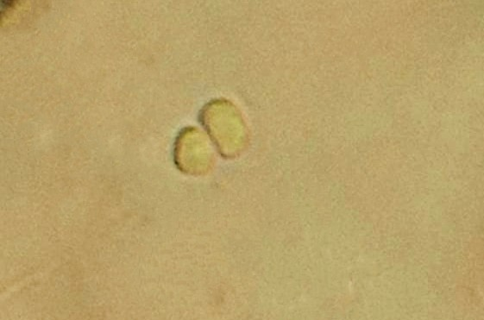
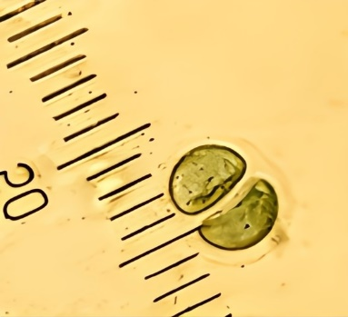
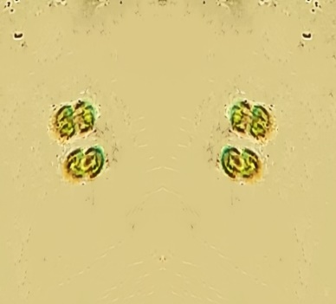
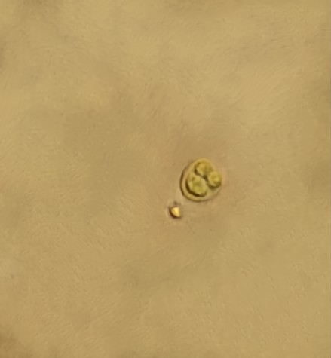
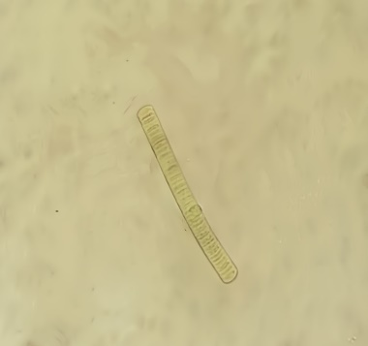
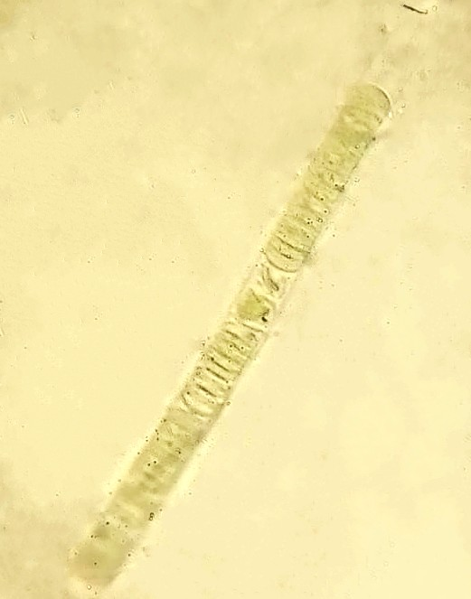
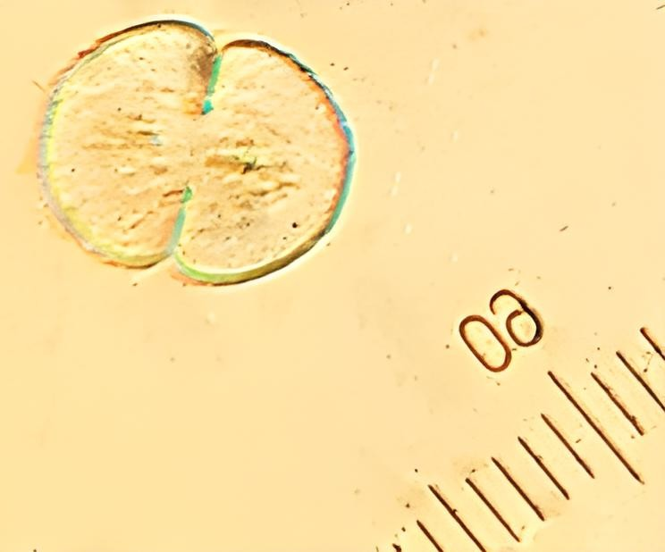
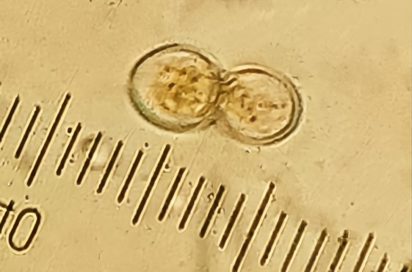
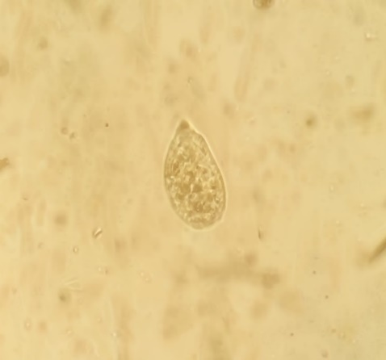
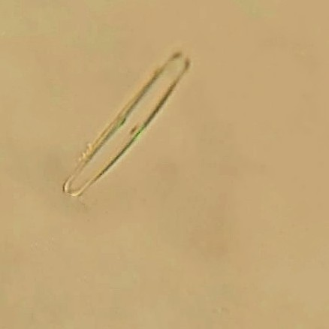
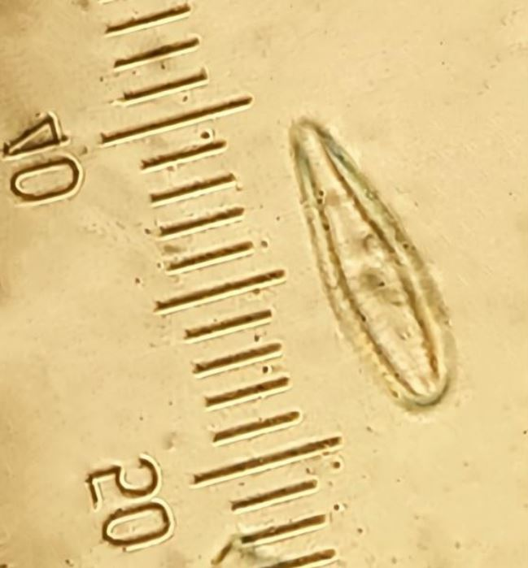
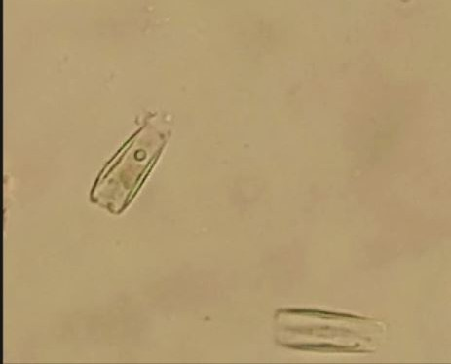
1
2
3
4
5
6
7
8
9
10
11
12

Fig. 2. Algal species collected from Jilani Park: 1. C. limneticus Lemmermann, 2. C. minutus (Kütz.) Nägeli, 3. M. elegans var. major G. M. Smith, 4. A. bullosa Rabenhorst, 5. O. limosa C. Agardh, 6. O. subbrevis Schmidle, 7. C. contractum var. contractum Kirchner, 8. C. pachydermum Lund, 9. E. gracilis Klebs, 10. S. ulna Grun Majeed, 11. G. affine Kützing, 12. G. olivaceum var. obtusum (Lyngbye) Desmazieres.

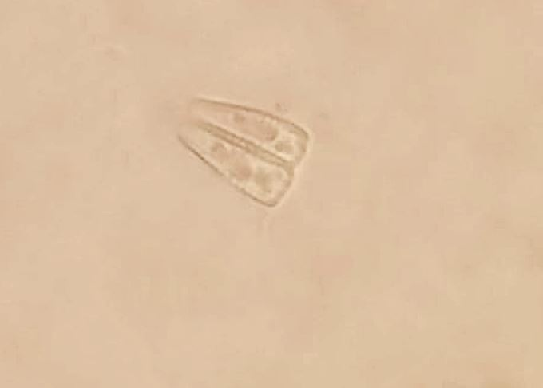
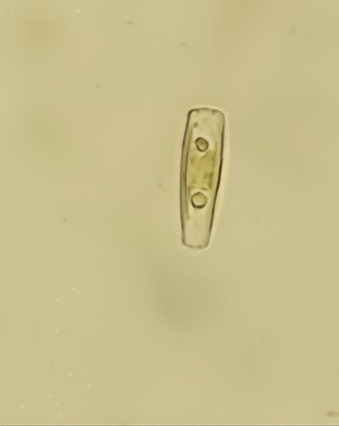
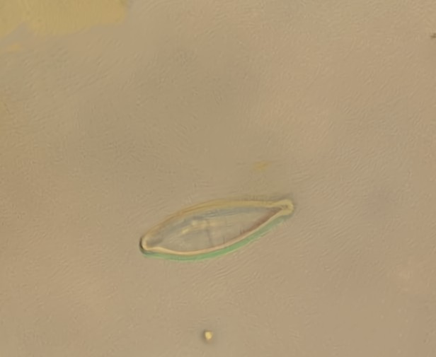
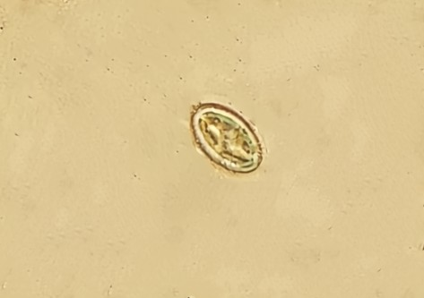
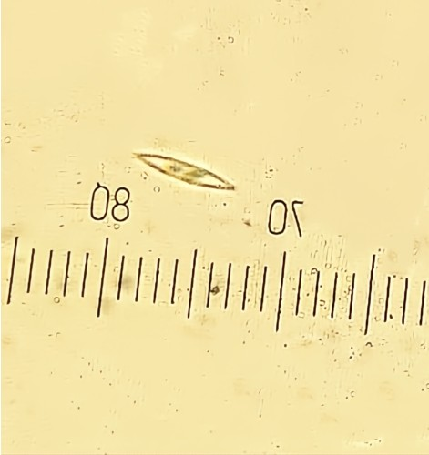
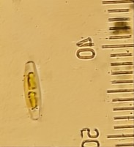
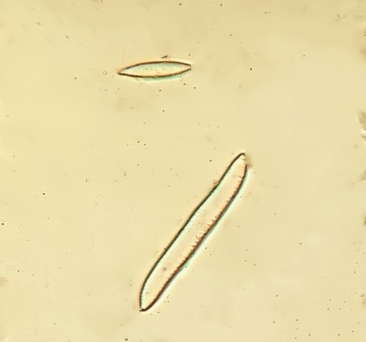
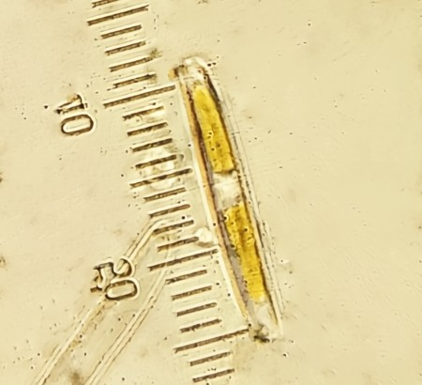
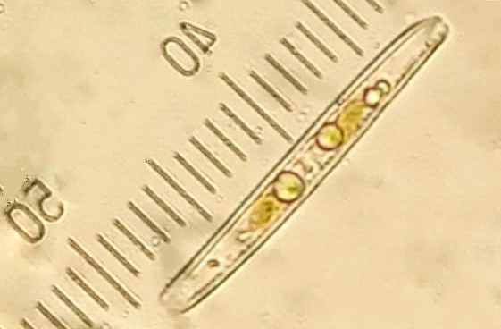
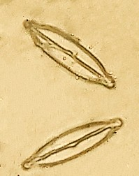
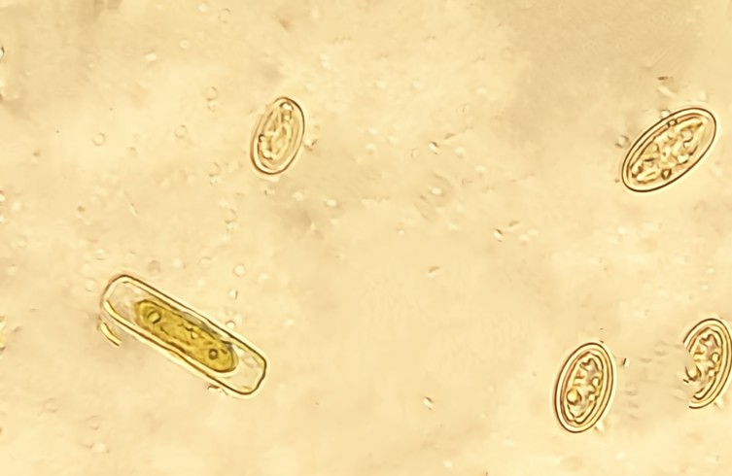
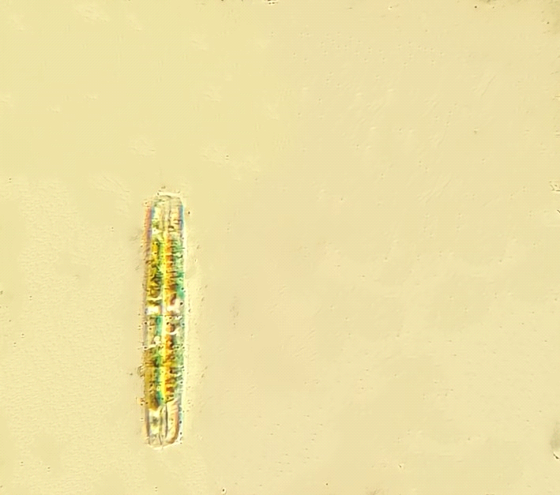
13
14
15
16
17
18
20
19
22
23
24

21

Fig. 3. Algal diatoms identified: 13. G. micropus Kützing, 14, G. venusta Passy, Kociolek & Lowe, 15. N. kotschyi Grunow, 16. D. subovalis Cleve, 17. N. capitellata Hustedt, 18. N. fonticola (Grunow) Grunow in Van Heurck, 19. N. sigma (Kützing) W. Smith, 20. N. sigmoidea (Nitzsch) W. Smith, 21. N. vermicularis (Kützing) Majeed, 22. P. biceps Gregory, 23. P. subdentica Hilse, 24. P. viridis (Nitzsch) Ehrenberg.

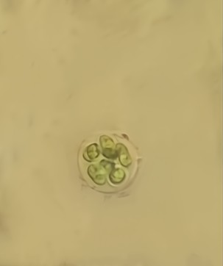
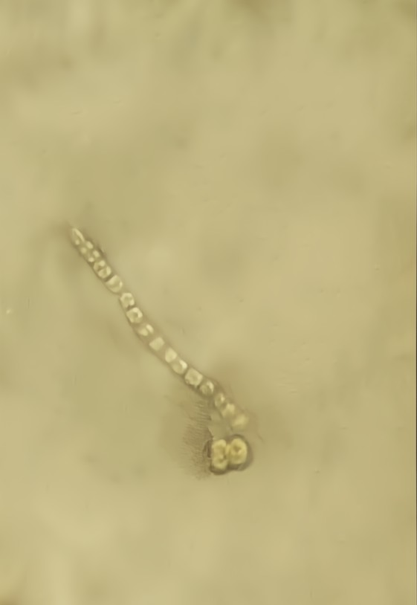
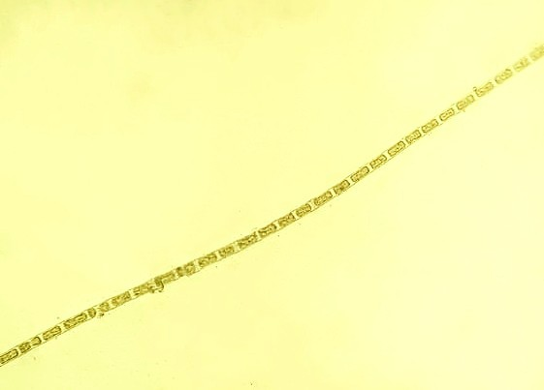
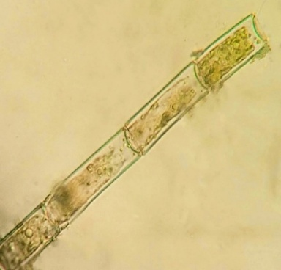
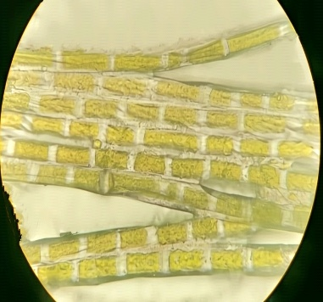
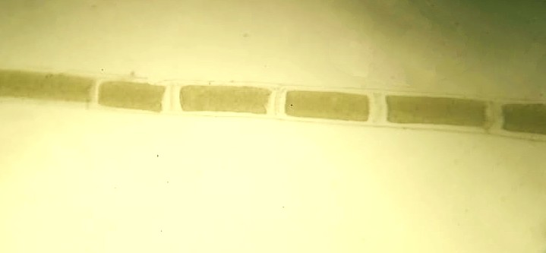
25
26
27
28
29
30

Fig. 4. Colonial and filamentous algae from Jilani Park: 25. S. schroeteri Chod., 26. U. tenuissima Kütz, 27. U. variabilis Kütz., 28. O. pluviale Nord, 29. R. casparyi Harv, 30. R. hierglyphicum (C. Agardh) Kützing

