Removal of Heavy Metals from Spent Automobile Engine Oil Using Oil Palm Biomass Adsorbents: A Sustainable Approach

Abstract: This research study examines the efficiency of Oil Palm Biomass in the removal of metal contaminants from spent automotive oils. A sedan with Four-cylinder engine specification was loaded with fresh automobile lubricating oil and allowed to operate for three months. The used automotive oil was drained from the car and sampled for this study. The fresh and the used oils were assessed quantitatively for the Zn and Fe alongside some performance parameters of lubricating oil such as density, particulate counts, Total Acid Number (TAN) and Total Base Number (TBN). Four different samples of Oil Palm Biomass (Oil Palm Trunk, Mesocarp Fibers, Palm Kernel Shell and Palm Kernel Cake) were collected from a local Palm Kernel Processing Facility. The Biomass samples were assessed to determine their absorbent properties such as SEM, FTIR, Bulk Density and Porosity, after which each of the biomass samples was used in the recycling of the spent automotive oil samples. The efficiency of the biomass was assessed by testing for heavy metals and performance parameters of the automotive oil, and the results compared with those of the spent and fresh automotive oils. The results suggest that the oil recovered after treatment with the oil palm biomass, exhibited better lubricating properties, and is recommendable as good base oil for automotive oil formulation

Index Terms: accumulation, metals, spent oils

- Introduction
A couple of decades ago, it was personally fascinating using spent automobile oils to lubricate and minimize squeaky sounds from rusty door hinges as much as it was also a puzzle when I wondered why green grass could not grow on portions of ground where spent automobile oils were discarded in nearby mechanic workshops. Even some neighbors employed similar practice to kill and disperse soldier ants around their homes. Though I could not figure out the phenomenon, I always knew that something about the spent lube oil was abhorrent to nature and did not support life forms.

Automobile oils are formulated from base oil by incorporating additives that improve the oil’s lubricating properties, making it more useful as lubricants. These additives ensure that while within the compartments of automobile engine, the oil helps to achieve the following: minimizes friction by preventing direct surface contact between the metallic components of the engine, facilitates engine temperature stabilization by transferring heat from the engine to the oil cooler and removes dirt by conveying debris and combustion products formed in the engine to the oil filter. This activity destroys and depletes the additives in the oil. As the additive’s potency weakens, the metal components of the engine commence gradual but increasing frequency of metal-to-metal contact as the engine operation continues (Tsamo et al., 2023). Most automobile engine components are made of alloys of different metals such as Fe, Zn, Mg and Al and at the instance of each direct metal-to-metal contact, particles of these metallic components are dislodged due to friction and entrained within the oil. When combined with the initial metal content of the fresh oil (Irwin, 1997), more metals are awaiting disposal (Aminuddin et al., 2023). This activity continues thereby weakening the potency of the additives and overtime rendering the automobile oil blend unfit to sustain lubrication and the oil due for change. Unlike fresh oil, which was a blend of base oil and additives, spent automobile oil being removed is a mix of base oil and numerous metal particles alongside other contaminants.

Waste engine oil is a high pollutant material that requires responsible management (Ihsan et al., 2013). Poor management of these spent automobile oils would result in indiscriminate disposal of the oil into the environment. According to Ekpo and Eghwere (2024), the increasing number of automobiles in the world has also contributed to a geometric increase in the amount of lubricating oil demand globally. Current statistics of number of registered vehicles in Nigeria shows 1747000, 3210000, 37500000 and 11700000 in 2005, 2010, 2015 and 2020 respectively (Nigeria Registered Motor Vehicle, 2020). New record was published during the West African automotive Council as 11869800 in 2023 (National Automotive Design and development Council, 2023). Estimating that each of these vehicles releases 4–6 liters of spent oil every 3-4 month, the sheer imagination of the quantity of used oils that could be generated from these vehicles gives a vivid picture of the heightened quantity of metals in the environment, considering the cumulative improper disposal of the used oils. This really poses severe risks to the environment, aquatic and terrestrial alike. High concentrations of toxic heavy metals in the soil may inhibit the metabolism and growth of most plant species, and this may have a detrimental effect on the food chain (Morkunas et al., 2018). Used oil poured onto soil surface can be washed into surface water by rain, or it can seep through the soil into groundwater to contaminate the water sources (Ali et al., 1996), as each volume of it can largely pollute not less than two hundred and fifty thousand volumes of water (Udonne, 2011). Studies by Wenten et al., (2018) suggest that metal contents in automobile spent oils either as additives (antioxidants, anti-wear, and de-foaming agents) or wear metals (components of degraded engine parts) contribute to the hazardous nature of the oils and influence their toxicity when released into the environment.

These realities become even much worse in areas where best practices on management of automotive oils are not adhered to. Non-adherence to best practices as exhibited in irresponsible disposal of spent automobile oil is partly due to the attendant cost of disposal. However, it is a much heavier price to pay when the environment is exposed to these harmful substances.

In a recent study, Qasim et al., (2016) stated that the management and disposal of the used lubricating oil has become a major challenge as large amounts of engine oil are recorded as being used annually. Poor management manifests as indiscriminate discharge of the used oil in the immediate terrestrial and aquatic environment (Bamiro and Osibanjo, 2004). The negative effects owing to the improper management of used oil on the environment and on human health, as reported by Botas et al. (2017), make inevitable the exploration of viable options for regenerating these oils with the intent of producing new lubricants and other petroleum derived products. Hence, recycling.

Recycling of spent lube oil is an important issue that has gained research attention in recent years. The practice provides various processes in which the used oil is passed through a cycle of changes that restores it to good condition by removing entrained impurities and providing products or materials for re-use. According to Szyszlak-Bargłowicz et al. (2021), the recycling of used lubricating oils involves subjecting them to a series of processes that lead to the elimination of most impurities, including water, oxidation products, and additives; thus, restoring the original properties of the base oil. Spent lube oil recycling would be beneficial in reducing engine oil costs besides having a significant positive impact on the environment (Boughton et al., 2004). As confirmation, Yanhong et al. (2016) found out that spent lube oils can achieve 70%~75% (by weight) base oil regeneration rate after removal of impurities and metamorphous materials.

As of 2014, Xiaong et al. (2014) noted that regeneration methods for waste engine oil worldwide were mainly as follows: re-purging, re-purification, refinement, among which the former is the prerequisite and basis of the latter. Recent advancements in lube oil recycling have focused on improving the efficiency of the process while reducing its environmental impact. One such advancement is the use of adsorption technology. Nabil, M. A et al. (2010) and Udonne (2011). have independently studied the treatment of used automobile oils using acid/clay treatment, and the results show that acid-treated clay gave the highest adsorption capacity of the metals.

Oil Palm Biomass are classified as lignocellulosic residues that typically contain cellulose, hemicellulose, and lignin in their cell wall that can be converted into fine chemicals (Noorshamsiana et al., 2017). Over a few decades now, there have been studies that report the important adsorptive properties of oil palm biomass in the purification of substances. These properties are attributed to their inherent content of lignocellulosic compounds which also play important roles in food, chemicals and pharmaceuticals. According to Ma (2002) and Chuah et al., (2005) several studies were initiated to utilize palm kernel shell as crude material for activated carbon, and it was reported that a good quality product could be obtained. This discovery, coupled with the inexpensive and near-pollution availability of oil palm biomass, makes it even more attractive and promising for full scale investigation as per its application to other areas of research.

While oil palm biomass can boast of having ready application in dye removal this research is investigating the suitability of Oil Palm Biomass as absorbents for the removal of heavy metals from spent automobile oil.

- Materials and Method
2.1 Materials
In this study, four Oil Palm Biomass were used. These include Oil Palm Trunk (OPT), Mesocarp Fibers (MF), Palm Kernel Shells (PKS) and Palm Kernel Cake (PKC). To verify the efficacy of the biomass, samples of fresh automobile oil and used automobile oil were also used. Also used are the necessary reagents and instrumentation for the determination of the FTIR, SEM, metal content, bulk density, porosity alongside performance parameters (TAN, TBN, Particle Count) of the oil.

  - Methods
    - Sampling Collection and Preparation
2.2.1.1 Lubricating Oil
Fresh Lube Oil was procured from an authorized dealer at a lube oil shop in Nigeria. A portion of the fresh/unused lube oil was poured into a container, labelled as FLO (Fresh Lube Oil) and preserved to be used for baseline property assessment while the rest of the oil was poured into a sedan with a 4-cylinder gasoline engine. The vehicle allowed to operate for a period of three months at the end of which the oil was evacuated from the engine and poured into four different containers labelled as SLO_{A}, SLO_{B}, SLO_{C} and SLO_{D} (NB: SLO: - Spent Lube Oil) to be used as Spent Automobile Engine Oil. The oil samples were well preserved in a cool and dry place pending laboratory experiment.

Plate 1: Images of Fresh and Spent Oil Sample
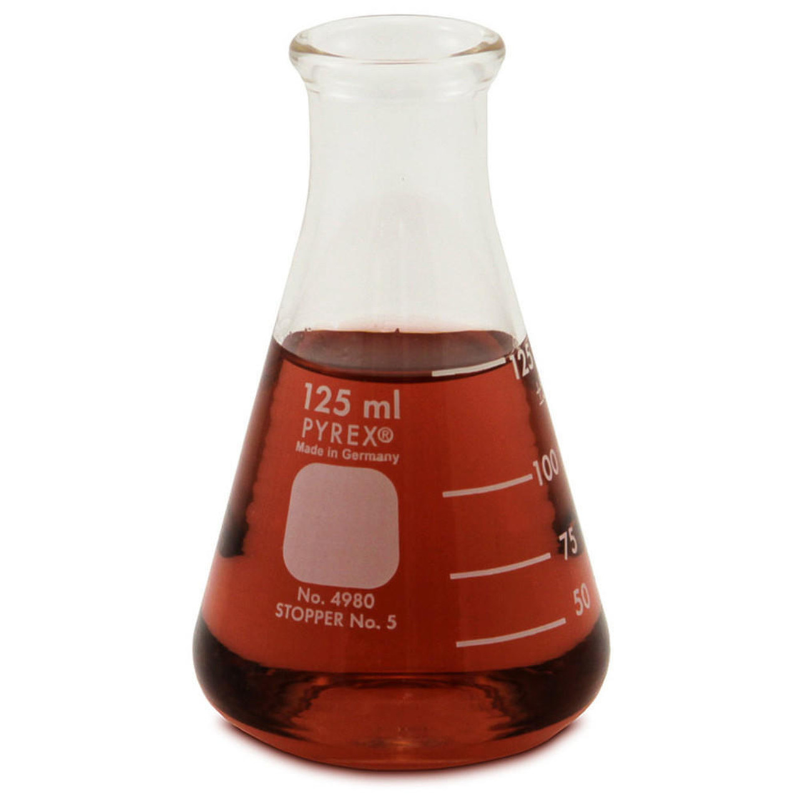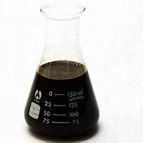

- Fresh Lube Oil (FLO)
(b) Spent Lube Oil (SLO)

2.2.1.2 Oil Palm Biomass
The Oil Palm Biomass samples: Oil Palm Trunk (OPT), Mesocarp Fibers (MF), Palm Kernel Shell (PKS) and Palm Kernel Cake (PKC) were collected from a local Palm Plantation in Agbokim Waterfalls area of Etung Local Government of Cross River State, Nigeria. The biomass samples were washed in de-ionized water and later sun-dried to eradicate dust and dirt particles. The dried samples were pulverized in accordance with ASTM D2862 (2016).
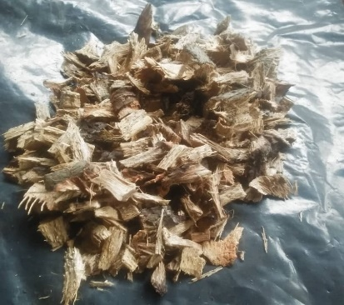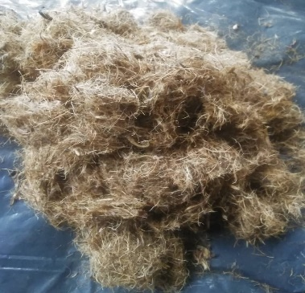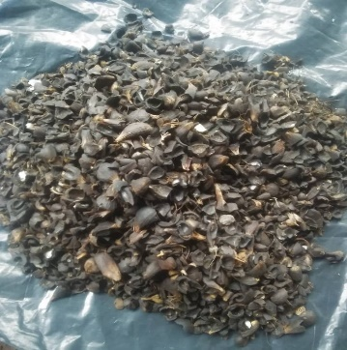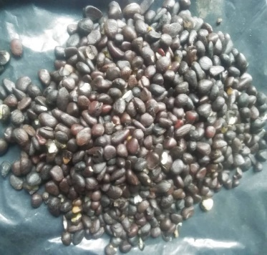

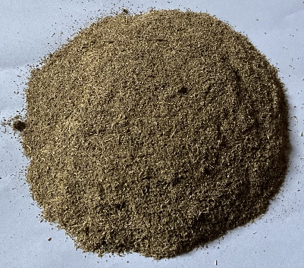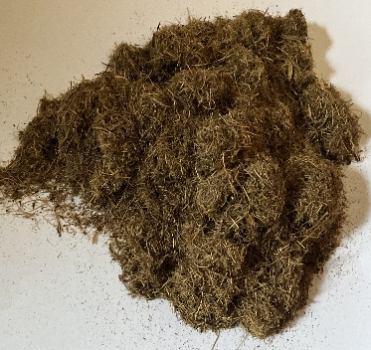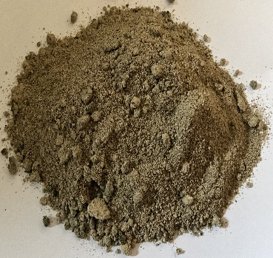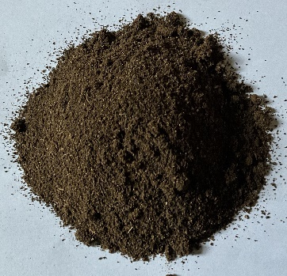Oil Palm trunk (OPT) Mesocarp Fibers (MF) Palm Kernel Shell (PKS) Oil Palm Kernel (OPK )
Plate 2: Images of Oil Palm Biomass samples as collected natural and blended.
BLENDING

    - Determination of Heavy Metal Content in Lube Oil Samples
The lube oil to be analyzed was reduced to ashes using a crucible, 50 ml aqua regia solution (1:3 volume HNO3 and HCl) was added to it using a 250 ml volumetric flask. The mixture was subjected to heat on a hot plate until the volume reduced to half. Distilled water was added to make up the displaced volume; this process was repeated three times. The concentration of six heavy metals (Mg, Al, Sn, Fe, Zn and V) were detected from the extracted sample solutions using a BUCK Scientific Model 210VGP Atomic Absorption Spectrometer (AAS) as has been done by Ekpo and Obi, (2017) and Shihab et al., (2019). The reference analytical method employed for this purpose conforms with ASTM D6598.

    - Total Acid Number Analysis
According to the procedure in ASTM D664, TAN determines the sum of total acid compounds that are present in petrochemical samples, using the principle of acid-base titration, the result expressed in mg of KOH per mass (g) of sample. In this study, 0.1 eq/L KOH was used as titrant; a mixture of 5 ml water in 495 ml of isopropyl alcohol and 500 ml chloroform would serve as the solvent.

A mixture of chloroform and isopropyl alcohol was used to dilute the samples when required. The indicator was prepared with 200 ml of toluene and 2 ml of water as solvent, then 0.5g of phenolphthalein was dissolved in 10 ml of the solution of toluene.

5.0 ± 0.5 g of the engine oil mixed with 3 drops of indicator was equally added and was titrated with the prepared KOH standard solution. At the end point, the color changed from colorless to pink as expected. The titer value (V_{titrant}) was noted and the TAN calculated as shown in Equ. 2.1 and 2.2 (ASTM D664, 2023).
Calculations:

TAN (mgKOH/g) = [C_{titrant} (eq/L) × 0.1N × V_{titrant} (ml) x MKOH (g/mol)] / n_{e-titrant} x m_{sample}(g)………………..(2.1)
= [0.1 (eq/L) × 0.1N × V_{titrant} (ml) x 56.11 g/mol (2.6)] / 1 x 5 g……………………………..(2.2)

    - Total Base Number Analysis
60 mL of titration solvent (glacial acetic acid chlorobenzene in a volume ratio of 1:2) was mixed with 2.5g of oil sample and was contained in a 150mls beaker. 0.1 eq/L Sodium acetate in acetic acid (5.3g of anhydrous Na₂CO₃ in 300 mL of glacial acetic acid, then diluted to 1 L) would serve as the titrant. A Back titration was carried out by taking 4 mL of 0.1 eq/L HClO₄ excess in a pipette to be titrated with the titrant. At the end of the titration. TBN was calculated in mg of KOH per g of sample as shown in Equ. 2.3 and 2.4 (ASTM D2896-11, 2015).
Calculations:

TBN (mgKOH⁄g) =
=[C_{back titrant} (eq/L) × V_{back titrant} - C_{titrant} (eq/L) × V_{titrant} (mL)×MKOH (g/mol)] / m_{sample}(g)……………………(2.3)
= [0.1 (eq⁄L) × 4 (mL) - 0.1 (eq/L) × V_{titrant} (mL) × 56.11 (g/mol)] / 2.5 g……………………………………….(2.4)

    - Density Measurement
API thermohydrometer was used to measure the API gravities of both the Fresh Oil, Spent Oil and Recycled Oil at ambient conditions, while correction table was used to correct the API gravity data from the ambient conditions to 60⁰F. further evaluations were implemented to arrive at specific gravity and density values as shown in Equ. 2.5

Calculations:

API Gravity at 60⁰F = (141.3/Specific Gravity at 60⁰F)-131.1…………………………………………………….(2.5)
Specific Gravity at 600F = density of Oil at 60⁰F/Density of Equal Volume of Water at 60⁰F………………(2.6)

    - Particle Count Measurement
The Particle Count was measured in accordance with ASTM D7647. 20ml of properly agitated oil sample was added to 50 ml of reagent grade kerosene was added to the sample and mixed properly. The mixture was filtered using vacuum filtration apparatus and dry filter paper of 10 microns. The analysis was carried out in triplicate and the particle count calculated as shown in Equ. 2.7 (ASTM D7647,2010; Quesnel & Geach, 2023)
Calculations:

Particulate count (particles/ml) = particles / volume of samples (ml)……………………………….(2.7)

    - Recycling of Spent Lube Oil using the Oil Palm Biomass Samples
150ml of the Spent Automobile engine oil was poured into four different 250ml conical flasks and labelled as SLO_{A}, SLO_{B}, SLO_{C} and SLO_{D}. The unmodified oil palm substrates (Oil Palm Trunk (OPT), Mesocarp Fibers (MF), Palm Kernel Shell (PKS) and Palm Kernel Cake (PKC)) were sieved with electric test sieve machines to a sieve size of 500 micrometers each. 2.5 g of each sieved substrate was mixed with any one of the four beakers containing the SLOs and placed inside an electric water bath with a heating temperature of 60⁰C. The mixture was steadily stirred with a magnetic stirrer for 30min followed by vacuum filtration using Whatman 63 filter paper (pore size 3) mounted upon a vacuum filtration pump to recover the recycled oil samples (Kurniawan et al., 2006)

- Results and Discussion
Considering the six metals studied, the fresh lube oil (FLO) contains a significant amount of only Sn (Table 1). This may be attributed to the use of Sn as part of the ingredients of detergent and dispersant additive which facilitates the suspension of particulate matters within the oil matrix. Zn and Sn having densities of 7.133 and 7.310 g/cm3 respectively are used as anti-wear, antioxidant, and corrosion inhibitory additives. The other analyzed metals Al and V might not have had useful applications in the fresh oils (Negash, 2016). The result shows that there was a significant increase in concentration of metals in the SLO as compared to FLO. This is from the engine components due to the tear and wear that would have occurred in the engine during the service life of the lube oil.

Table 1: Metal Contents (ppm) in the Oil Samples: Fresh Lube Oil (FLO), Spent Lube Oil (SLO) and Recycled
Lube Oils (RLOs)
 | FLO | SLO | RLO_{OPK} | RLO_{OPT} | RLO_{PKS} | RLO_{MF}
Al (ppm) | 0.009 | 2.11 | 1.11 | 0.51 | 1.17 | 1.47
Fe (ppm) | 0.009 | 13.16 | 6.75 | 4.1 | 8.3 | 10.1
Mg (ppm) | 0.18 | 2.37 | 1.18 | 0.78 | 1.39 | 1.81
Sn (ppm) | 1.64 | 1.5 | 0.1 | 0.1 | 0.1 | 0.1
V (ppm) | 0.12 | 0.14 | 0.12 | 0.12 | 0.12 | 0.12
Zn (ppm) | 0.009 | 7.28 | 3.72 | 2.19 | 4.44 | 5.41
Data was taken with analysis carried out in triplicate; standard deviation was calculated with P-value = 0.05

Figure 1: Amounts of Metals (ppm) in Oil Samples

Ekpo and Eghwere (2024) provided a decreasing order arrangement for the relative amounts of metals extracted into the spent oil as follows: Fe > Zn > Al > Mg > Sn > V, with Iron being the most extracted. This agrees with the findings of Nagash (2016) that in consideration that most part of the engine e.g. engine cylinders, camshafts and oil pumps, are made from Iron, it then follows Iron is the most dominantly extracted metal into the engine oil. These findings explain why the trendlines in Fig 1 shows Iron as the metal with the highest abundance in the SLO.

While the amounts of other metals increased in SLO relative to FLO, Sn appears to show the opposite trend. According to Nagash (2016), Sn is used as part of anti-wear, antioxidant and corrosion inhibitory additives. Most additive packages in the oil are designed to be sacrificial, as such, the decrease in the amount of the metal Sn proves adequate performance of its role as an additive.

According to Fig. 1, the amounts of metals in the RLO, as treated with the biomass, are quite lower relative to those of the SLO. This shows that the substrates were effective in treating SLOs. Besides the substrates being effective in removing the metals, the metal adsorption processes showed similar trends for all the metals. This can be explained as being dependent upon the relative abundance of the metals in SLO with the most abundant being the moved removed. Further examination of the results shows that among the four biomass samples used in this work, Oil Palm Trunk (OPT) showed best efficiency in the metal adsorption.

Table 2: Total Acid Number (TAN) of Oil Samples
Sample | FLO | SLO | RLOOPK | RLOOPT | RLOPKS | RLOMF
TAN | 0.4875 | 2.41 | 0.91 | 1.05 | 0.832 | 0.85

Acid anhydrides are formed during the combustion process that occurs in the engine. These anhydrides react with water, from either leakage in water cooling system or vapor from fuel combustion, to form acids. Continuous operation of the engine, alongside formation of these acidic substances, increases the acidity of the lube oil. This explains the increase in total acid number (TAN) from the unused oil samples to the used oil samples as shown on Fig. 2. The total acid number from the unused oil samples increased in the used oil samples by about 500% (Fig. 2). This may cause the engine block to be prone to corrosion via chemical attack. To adjust the effects of acids generated in the engine block, the lube oils are formulated to contain acid neutralizing substances as additives. The technical specification of TBN in automobile lube oils designed to make for acid produced is 10.8 mgKOH/g. Comparing Fig. 2 and Fig. 3, it is noticeable that an increase in TAN in the SLO caused a similar collapse in TBN. This can be attributed to the fact that formation in acidic substances in the engine resulted in a proportional depletion in the TBN properties. The value of TBN in the used oil sample was about 5 mg KOH/g as shown on Table. 3; this is an indication that the engine oils were due to be drained from the engine block and replaced as the amounts were below the technical specification for TBN in automobile engines (Papadopoulos, 2016; REPSOL, 2018).

Further observation also showed that there were improvements in TBN of some of the treated oil samples. The oil sample treated with OPT (Oil Palm Trunk) showed the best improvements.

Figure 2: Total Acid Number (TAN) of Oil Samples

Table 3: Total Base Number (TBN) of Oil Samples
Sample | FLO | SLO | RLOOPK | RLOOPT | RLOPKS | RLOMF
TBN | 6.2225 | 5.555 | 5.621 | 5.64 | 5.4 | 5.55

Figure 3: Total Base Number (TBN) of Oil Samples

Based on the classification by Society of Automobile Engineers (SAE), the Fresh Lube Oil used in this work are identified as SAE 20W-50; 20 describes the flow behavior of the oil at cold condition in a way that at low temperature conditions efficient lubrication is still obtainable with the oil; this shows that at low conditions the oil can retain its liquid state more than another oil with a higher number at this position. The number after W “Winter” describes the Kinematic viscosity rating of the oil at 100⁰C; here the higher the number, the more resistance the oil exerts to withstand loads (ADINOL, 2023). The standard specification of SAE 20W-50 lubricating oils for density at 15 ⁰C is 889 kg/m3 and the unused oil for this work has its density value as 883.8kg/m3 (Fig. 4); this signifies that the fresh oils attained the standard specification for density for this category of engine oils (Ettefaghi et al., 2013; REPSOL, 2018). Fig.4 also shows that the used oil samples were denser than the unused oil samples. This is attributed to adequate performance of engine oil functions of cleaning the engine block preventing it from malfunctioning, alongside its primary function of providing lubrication to minimize friction in the engine block

Table 4: Densities of Oil Samples: Fresh Lube Oil (FLO), Spent Lube Oil (SLO) and Recycled
Lube Oils (RLOs)
Sample | FLO | SLO | RLOOPK | RLOOPT | RLOPKS | RLOMF
DENSITY | 0.89385 | 0.91625 | 0.8834 | 0.8826 | 0.8831 | 0.8837

Figure 4: Densities (mg KHO/g) of Oil Samples

However, there is a significand decrease in the density of the lube oil after treatment with the biomass. This is attributed to the removal of the numerous impurities that were accumulated and entrained in the SLO during its service life in the engine compartment. Further, FLO is obtained when a base oil has been formulated with various ingredients to improve its performance efficiency. The process consequently makes the density of the FLO higher than that of the base oil. From Fig. 4, it is observable that the densities of the treated oil samples are lower than the density of the FLO. This can be attributed to the fact that the biomass removed the impurities so much that it practically restored the lube oil to its base oil.

- Conclusion
Reducing the frictional forces exerted during the operation of mechanical systems tends to minimize the harsh effects imparted on the mechanical components associated with such operations, which underscores the importance of engine oils. However, the same oil of tremendous importance during engine operation endangers the environment upon its inevitable accumulation accompanied by indiscriminate disposal. A major contributor to these harmful effects is the heightened presence of metals in the spent oil. Recycling the spent lube oil has proven to be the safest approach to effective management of spent lube oil and, by extension, its environmental hazards. Prior to now, most of the recognition accorded to the oil palm was based on its Plam Oil value while its biomass, especially the Tree Trunk, was treated more like a waste than a resource. This research has projected the further importance of the Oil palm in environmental protection and industrial revolution by revealing its biomass as effective substrate in facilitating an efficient spent automobile engine oil recycling process.

Disclaimer (Artificial intelligence)
Option 1:
Author(s) hereby declare that NO generative AI technologies such as Large Language Models (ChatGPT, COPILOT, etc.) and text-to-image generators have been used during the writing or editing of this manuscript.
Option 2:
Author(s) hereby declare that generative AI technologies such as Large Language Models, etc. have been used during the writing or editing of manuscripts. This explanation will include the name, version, model, and source of the generative AI technology and as well as all input prompts provided to the generative AI technology
Details of the AI usage are given below:
1.
2.

REFERENCES
Ali MF, Rahman F, and Hamdan AJ (1996): Techno-economic evaluation of waste lube oil Re-refining. Int J Prod Econ 42: 263-273.
Bamiro AO, Osibanjo O (2004): Pilot study of used oils in Nigeria. Int J Math Comp Sci 15: 100-165.
Chuah T. G, M.M. Nourouzi, Thomas S.Y. Choong (2009): Journal of Environmental Engineering
Ettefaghi, E., Ahmadi, H., Rashidi, A. and Mohtasebi, S., S. (2013): Experimental evaluation of engine oil properties containing copper oxide nanoparticles as a nano additive. International Journal of Industrial Chemistry, 4 (28): 1-6.
Idongesit I. E, and Obi, C. (2017): Chemical speciation dynamics and bio-availability quantification of trace metals distribution in non-detrital sediments phase of Cross River Estuary. Nigeria. International Journal of Chemical Studies, 5(2): 8-13
Idongesit E. Ekpo, and Kenneth E. Eghwere (2024): Assessment of Metals Accumulation in The Environment from Automobile Spent Oils in Nigeria 2024 IJCRT | Volume 12, Issue 2 February 2024 | ISSN: 2320-2882 www.ijcrt.org
Ihsan Hamawand, Talal Yusaf, and Sardasht Rafat (2013): Recycling of Waste Engine Oils Using a New Washing Agent Energies 2013, 6, 1023-1049; doi:10.3390/en6021023 ISSN 1996-1073 www.mdpi.com/journal/energies

Irwin, R. J (1997): Environmental Contaminants Encyclopaedia oil used motor oil entry. National Park Service Water Resources Division, Water Operation Branch, 1201, Oakridge drive, suite 250 port Collins Colorado. 80525.

Kurniawan, T.A., Chan, G.Y.S., Lo, W.H., and Babel, S. (2006): Comparison of Low-Cost for Treating Wastewaters Laden with Heavy Metals. Science of The Total Environment, 366(2-3), 409-206.
Morkunas, I., Woźniak, A., Mai, V. C., Rucińska-Sobkowiak, R. and Jeandet, P (2018): The Role of Heavy Metals in Plant Response to Biotic Stress. Molecules, 23(9), DOI: 10.3390/ molecules23092320.
Nabil M. Abdel-Jabbar, Essam A.H. Al Zubaidy, and Mehrab Mehrvar (2010): Waste Lubricating Oil Treatment by Adsorption Process Using Different Adsorbents. International Journal of Chemical and Biological Engineering 3:2 2010

Nagash T. (2016): Refining of Used Motor Oil Using Solvent Extraction. A Thesis Submitted to the Graduate Studies of Addis Ababa University in Partial Fulfilment of the Degree of Master of Science in Chemical Engineering (Process Engineering)

National Automotive Design and development Council (2023):
11869800 by national automotive design and development council
Nigeria Registered motor vehicles (2020). International Organization of Motor Vehicle Manufacturers 2005-2020.
https://www.ceicdata.com/en/indicator/nigeria/motorvehicleregistered#:~:text=Key%20information%20about%20Nigeria%20Registered, Unit%20th%20for%20Dec%202015.

Shihab, E. A. W. Hassan, K. H and Abd, A. N. (2019): Determination of carbon
Noorshamsiana A. W, Nur Eliyanti A.O, Fathian I and Astimar A. A. (2017): A Review on Extraction Processes of Lignocellulosic chemicals from Oil Palm Biomass. Journal of Oil Palm Research Vol. 29 (4) p. 512-527 DOI: hppts://doi.org/10.21894/jopr.2017.00016
Udonne J, (2011): A Comparative Study of Recycling of Used Lubrication Oils Using Distillation, Acid and Activated Charcoal with Clay Methods. Petroleum and Gas Engineering, 2, 12-19
Quesnel, W. A. and Geach, A. (2023): Particle counting of heavy contaminated oil samples. https://cinrg.com/docs/OilDoc.CINRGParticle_Counting_of_Heavily_ContaminatedOil_Samples.pdf [Retrieved: 12-11-2023]
Tsamo C, Zangue AH, Herbaud EE, Nchang ST. Investigating the potential of using tannery process solid hair waste for spent engine and vegetable oils removal from water and toxicity assessment using maize. Case Studies in Chemical and Environmental Engineering. 2023 Dec 1;8:100412.
Aminuddin IH, Taufik SH, Puasa NA, Radziff SB, Zamree ND, Shaharudddin NA, Che Abdullah CA, Rahman MF, Azmi AA, Ahmad SA. Biosorption of Engine Oil Using Rice Husk in a Filtration System. Sustainability. 2023 Oct 9;15(19):14599.

