OIL PALM BIOMASS AS SUITABLE ADSORBENT FOR THE REMOVAL OF HEAVY METALS IN SPENT AUTOMOBILE OIL

Abstract: This research investigated the suitability of Oil Palm Biomass as an adsorbent for recycling spent automobile engine oil. Four different samples of Oil Palm Biomass (Oil Palm Trunk[OPT], Palm Mesocarp Fibers [PMF], Palm Kernel Shell [PKS] and Oil Palm Kernel [OPK]) were selected from a local oil palm processing facility. Each of the biomass samples were analyzed for their adsorbent properties such as SEM, Bulk and Density preserved for the study. A portion of fresh lube oil was loaded on a sedan with four-cylinder engine specification. After three months of regular operation, the spent automobile engine oil was drained and subsampled for purpose of this study. The Fresh lube oil and spent lube oil samples were quantitatively assessed for their metal contents). Each of the biomass was used in the treatment of the spent lube oil. The suitability of the oil palm biomass was assessed by testing for heavy metals and some other performance parameters of the automotive oil, and the results were compared with those of the spent and fresh automotive oils. The treated oil showed an improvement in its lubricating properties which suggests that the biomass can be recommendable as a good suitable adsorbent for recycling spent lube oil.

Index Terms: oil palm biomass, adsorbent, automobile, spent oils

- Introduction
Over the past five decades or so, there has been a phenomenal cultivation of oil palms throughout the tropical regions such that palm oil is now a major commodity of world trade and the oil palm a leading source of vegetable oil (Henson, 2012). Besides the vegetable oil benefits of Oil Palm, advancements in science and technology have facilitated the discovery of many other applications of Oil Palm. Research studies have reported the observable adsorptive properties of oil palm biomass in the purification of substances. These properties are attributed to the biomass inherent content of lignocellulosic compounds. Oil palm biomass is classified as lignocellulosic residues that typically contain cellulose, hemicellulose, and lignin in their cell wall that can be converted into fine chemicals (Noorshamsiana et al., 2017). Vakili et al., (2014) made further findings and reported that among many alternatives, oil palm biomass have shown promise as effective adsorbents for removing heavy metals. Bhardwaj (2025), in his studies, confirmed that lignocellulose is highly effective at adsorbing metals, and in the words of Vakili et al., (2014), these low-cost agricultural wastes, in both their raw and modified form, exhibit the potential for eliminating heavy metals. Furthermore, increase in the demand and consumption of palm produce has led to expansion of oil palm industry in recent years, and this is creating an increasing build-up of the biomass – regarded as wastes. Considering this increasing inexpensive abundance and attendant underutilization, Said et al., (2021) remarked that this biomass output of the oil palm has piqued the interest of researchers and positions the oil palm as a potential major source of adsorbent.

Lubricating oil (or engine lubricant oil), a product derived from petroleum refining, is a mixture of essential oils (either virgin or processed, mineral or synthetic) and additives (Carlos et al, 2021). The activities that occur during engine operations deplete and destroy these additives and their lubrication potential respectively consequently exposing the metal components of the engine to friction and its effects. Most automobile engine components are made of alloys of different metals such as Fe, Zn, Mg and Al and at the instance of each direct metal-to-metal contact, particles of these metallic components are dislodged due to friction, tear and wear. Other contaminants such as dirt, water, metal particles from wear and tear of the engine being lubricated (Chung et al., 2007) can build-up in the oil during operation and consequently influence the rate of lubricant degradation. This oil and other fallouts, during repair services ranging from complex engine rebuilding to auto body repair; electrical, welding and spraying services; are disposal off indiscriminately on the mechanic workshops soil (Orji et al., 2018). In a recent study, Qasim et al., (2016) stated that the management and disposal of the used lubricating oil has become a major challenge as large amounts of engine oil are recorded as being used annually. A record published during the West African automotive Council stated that there were over eleven million (11,869,800) registered vehicles Nigeria as of 2023 (National Automotive Design and development Council, 2023). Estimating that each of these vehicles releases 4–6 liters of spent oil every 3-4 month, the sheer imagination of the quantity of used oils that could be generated from these vehicles paints a vivid but mind-boggling picture of the heightened quantity of metals released into the environment, considering the cumulative improper disposal of the used oils. Spent lubricating oils are generally toxic and not readily biodegradable (Joanna et al., 2021). High concentrations of toxic heavy metals may inhibit the metabolism and growth of most plant species, and this may have a detrimental effect on the food chain (Morkunas et al., 2018). Studies by Wenten et al., (2018) suggest that metal contents in automobile spent oils either as additives (antioxidants, anti-wear, and de-foaming agents) or wear metals (components of degraded engine parts) contribute to the hazardous nature of the oils and influence their toxicity when released into the environment. Owing to their toxicity and persistence in the environment, the presence of these metal contaminants in the soil are the major causes of soil pollution (Uchimiya et al., 2020). Considering they have the potential to harm crop health and production if they are present in the soil at high concentrations, they are safely regarded as agricultural soil pollutants (Shahid et al., 2015) (Rashid A et al., 2023). In the aquatic environment, several cases of high mortality of juvenile fish and reduced breeding potential of the adults after long term exposure to heavy metals (Olojo et al, 2005) have been reported. Aquatic animals, e.g. fish, bear significant amounts of omega-3 and protein that the human body needs to maintain healthy functioning, potentially dangerous heavy metals are absorbed into the body tissues of fish and are transferred to humans on consumption of the affected fish. The presence of these metals in the human body, at large-than-needed amounts, can be toxic enough to lower energy levels and adversely affect the functioning of vital organs of the body. These negative effects of the improper management of used oil, on the environment and on human health, as reported by Botas et al. (2017), make inevitable the exploration of viable options for regenerating these oils with the intent of producing new lubricants and other petroleum derived products. Hence, recycling.

The oil molecules are not degraded, but the presence of contaminants numerous to mention makes it necessary for replacement in automobile engines (Owolabi et al, 2017). Several methods for recycling of spent lubricating oil have been studied. One such advancement is the use of adsorption technology. Nabil, M. A et al. (2010) and Udonne (2011) have independently studied the treatment of used automobile oils using acid/clay treatment, and the results show that acid-treated clay gave the highest adsorption capacity of the metals. Atsar et al (2013) also studied cleaning of heavy metals from spent lube oil by adsorption process using acid-modified clay, the sulfuric acid-modified clay (SAMC) effectively adsorbed heavy metals from the used automotive oil. Recycling used lubricating oil using untreated, activated and calcined clay methods, the result that the three methods used removed the volatile contaminants from the used lubricating oil and returned the oil to a quality essentially equivalent to fresh lube oils, and that the most effective of the recycling methods were the activated clay and calcined methods (Udonne et al, 2016). While oil palm biomass can boast of having ready application in dye removal, this research is investigating the properties of the Oil Palm Biomass that renders it as suitable absorbents for the removal of heavy metals from spent automobile oil.

- Materials and Methods
2.1 Materials
In this study, four Oil Palm Biomass - Palm Trunk (OPT), Mesocarp Fibers (MF), Palm Kernel Shells (PKS) and Palm Kernel Cake (PKC)) were used. To verify the efficacy of the biomass, samples of fresh automobile oil and used automobile oil were also used. Also used are the necessary reagents and instrumentation for the determination of the SEM, metal content, bulk density, alongside performance parameters (TAN, TBN, Particle Count) of the oil.

  - Methods
    - Sampling Collection and Preparation
2.2.1.1 Lubricating Oil
Fresh Lube Oil was procured from an authorized dealer at a local lube oil shop in Port Harcourt, River State, Nigeria. A portion of the fresh/unused lube oil was poured into a container, labelled as FLO (Fresh Lube Oil) and preserved to be used for baseline property assessment while the rest of the oil was poured into a sedan with a 4-cylinder gasoline engine. The vehicle allowed to operate for a period of three months at the end of which the oil was evacuated from the engine and poured into four different containers labelled as SLO_{A}, SLO_{B}, SLO_{C} and SLO_{D} (NB: SLO: - Spent Lube Oil) to be used as Spent Automobile Engine Oil. The oil samples were well preserved in a cool and dry place pending laboratory experiment.
2.2.1.2 Oil Palm Biomass
The Oil Palm Biomass samples: Oil Palm Trunk (OPT), Mesocarp Fibers (MF), Palm Kernel Shell (PKS) and Palm Kernel Cake (PKC) were sourced from a Palm Plantation in Agbokim Waterfalls area of Etung Local Government of Cross River State, Nigeria. The biomass samples were washed in de-ionized water and later sun-dried to eradicate dust and dirt particles. The dried samples were pulverized in accordance with ASTM D2862 (2016).
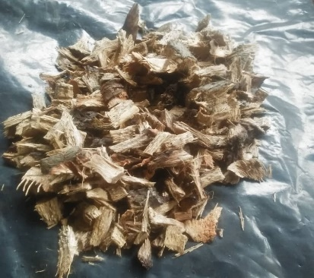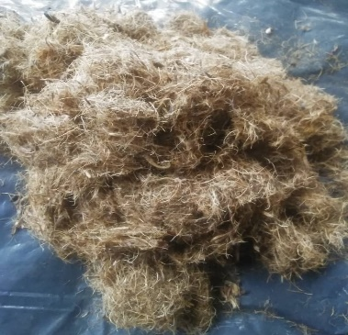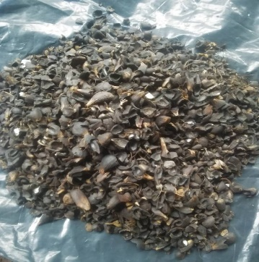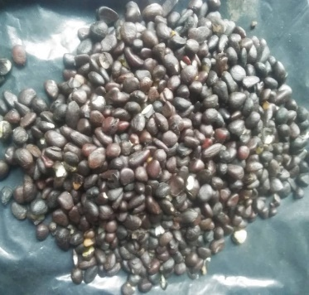

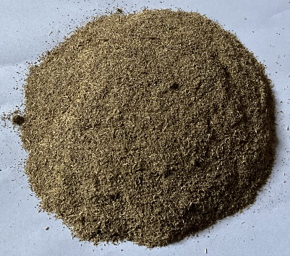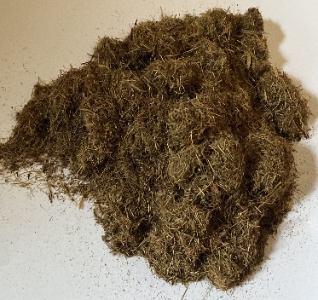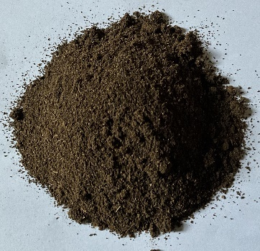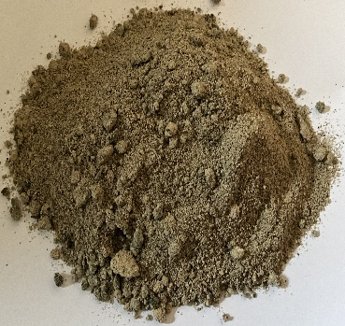Oil Palm trunk (OPT) Mesocarp Fibers (MF) Palm Kernel Shell (PKS) Oil Palm Kernel (OPK )
Plate 1: Images of Oil Palm Biomass samples as collected natural and blended.
BLENDING

    - Analysis of the Bulk Density of the Adsorbents
The bulk density test is used to determine the bulk density of powder or soil sample. It is determined by measuring the volume of a known weight of a powder sample into a graduated cylinder. This conforms to standard test method ASTM D6683-19.
Basically, the procedure involves:
- measuring the mass of a graduated cylinder, M_{Cyl}
- fill the graduated cylinder with sample to overflow and record the volume, V_{Cyl}
- level the surface
- record the mass of the cylinder and the sample, M_{(Cyl + Smp)}

Calculations:
Bulk Density (BD) = (M_{(Cyl + Smp)} - M_{Cyl} ] / V_{Cyl}……………………………………………………………………..…..(2.1)

where:
BD: bulk density of Sample, g/c m³,
M_{(Cyl + Smp)}: Mass of sample + graduated cylinder, g,
M_{Cyl}: mass of graduated cylinder, g,
V_{Cyl}: volume of graduated cylinder, cm³

    - Determination of Heavy Metal Content in Lube Oil Samples
The lube oil to be analyzed was reduced to ashes using a crucible, 50 ml aqua regia solution (1:3 volume HNO3 and HCl) was added to it using a 250 ml volumetric flask. The mixture was subjected to heat on a hot plate until the volume reduced to half. Distilled water was added to make up the displaced volume; this process was repeated three times. The concentration of six heavy metals (Mg, Al, Sn, Fe, Zn and V) were detected from the extracted sample solutions using a BUCK Scientific Model 210VGP Atomic Absorption Spectrometer (AAS) as has been done by Ekpo and Obi, (2017) and Shihab et al., (2019). The reference analytical method employed for this purpose conforms with ASTM D6598.

    - SEM Analysis of Biomass Samples
The microstructural characteristics of these substrates were analyzed by Scanning Electron Microscopy (SEM). HITACHI HD 2000 SEM Equipment was employed for this purpose. A portion of each of the ground sample was placed on the sample grid and scanned between 500 to 1500 magnification. The surface images of the biomass were captured and examined for adsorptive property.

    - Recycling of Spent Lube Oil using the Oil Palm Biomass Samples
Four different 250ml conical flasks containing 150ml of the Spent Automobile engine oil were labelled as SLO_{A}, SLO_{B}, SLO_{C} and SLO. The oil palm substrates (Oil Palm Trunk (OPT), Mesocarp Fibers (MF), Palm Kernel Shell (PKS) and Palm Kernel Cake (PKC)) were sieved with electric test sieve machines to a sieve size of 500 micrometers each. 2.5 g of each sieved substrate was added and mixed with any one of the four beakers containing the SLOs and placed inside an electric water bath with a heating temperature of 60⁰C. The mixture was steadily stirred with a magnetic stirrer for 30min followed by vacuum filtration using Whatman 63 filter paper (pore size 3) mounted upon a vacuum filtration pump to recover the recycled oil samples (Kurniawan et al., 2006)

- Results and Discussion
Considering the six metals studied, the fresh lube oil (FLO) contains a significant amount of only Sn (Table 1). This may be attributed to the use of Sn as part of the ingredients of detergent and dispersant additive which facilitates the suspension of particulate matters within the oil matrix. Zn and Sn having densities of 7.133 and 7.310 g/cm3 respectively are used as anti-wear, antioxidant, and corrosion inhibitory additives. The other analyzed metals Al and V might not have had useful applications in the fresh oils (Negash, 2016). The result shows that there was a significant increase in concentration of metals in the SLO as compared to FLO. This is from the engine components due to the tear and wear that would have occurred in the engine during the service life of the lube oil.

Table 1: Bulk Density (gcm³) of the Biomass
 | Oil Palm Trunk (OPT) | Oil Palm Kernel (OPK) | Palm kernel Shell (PKS) | Mesocarp Fibers (MF)
Bulk Density | 0.4579 | 0.4143 | 0.7867 | 0.1561

From the bulk density results, oil palm kernel shell has the highest bulk density while the least is the mesocarp fibers. The palm kernel shell is the hardest and most compact while the mesocarp fibers are loose and light weigh. The oil palm kernel had been stripped of its oil content resulting in less dense, soft and less heavy granules. The Oil palm trunk may have been fragmented but much of the structure of the vascular bundles is yet retained. Fig 1. shows an overlap of the bulk densities of the different biomass and their respective effect on the amounts of metals in the oil samples. The bar graphs represent the amounts of metals in the oil samples as seen in Fig. 2, while the curve represents the corresponding bulk densities of the biomass.

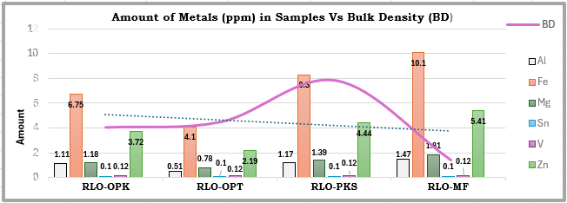
Figure 1: Overlap of Amounts of Metals (ppm) in Oil Samples Vs Bulk Density of Adsorbent [BD]

Due to the compact nature of the palm kernel shell granules, there were less intergranular spaces for the oil matrix to permeate and interact with the biomass, this could make the metal removal minimal. Mesocarp fibers had the least bulk density and showed minimal metal removal. This can be attributed to insufficient biomass granules per volume of the oil sample for adequate oil-substrate interaction. The oil palm kernel, though of similar bulk density with the oil palm trunk exhibited low metal removal. This can be attributed to the kernel’s poorer adsorptive potential compared to oil palm trunk. Oil palm trunk exhibited the best metal removal from the lube oil. The grinding fragmented the biomass and exposed the hemicellulose, cellulose and lignin of the vascular bundles thereby facilitating metal removal.

Table.2: Metal Contents (ppm) in the Oil Samples: Fresh Lube Oil (FLO), Spent Lube Oil (SLO) and Recycled
Lube Oils (RLOs)
 | FLO | SLO | RLO_{OPK} | RLO_{OPT} | RLO_{PKS} | RLO_{MF}
Al (ppm) | 0.009 | 2.11 | 1.11 | 0.51 | 1.17 | 1.47
Fe (ppm) | 0.009 | 13.16 | 6.75 | 4.1 | 8.3 | 10.1
Mg (ppm) | 0.18 | 2.37 | 1.18 | 0.78 | 1.39 | 1.81
Sn (ppm) | 1.64 | 1.5 | 0.1 | 0.1 | 0.1 | 0.1
V (ppm) | 0.12 | 0.14 | 0.12 | 0.12 | 0.12 | 0.12
Zn (ppm) | 0.009 | 7.28 | 3.72 | 2.19 | 4.44 | 5.41

Figure 2: Amounts of Metals (ppm) in Oil Samples

Ekpo and Eghwere (2024) provided a decreasing order arrangement for the relative amounts of metals extracted into the spent oil as follows: Fe > Zn > Al > Mg > Sn > V, with Iron being the most extracted. This agrees with the findings of Nagash (2016) that in consideration that most part of the engine e.g. engine cylinders, camshafts and oil pumps, are made from Iron, it then follows Iron is the most dominantly extracted metal into the engine oil. These findings explain why the trendlines in Fig.1 shows Iron as the metal with the highest abundance in the SLO.

While the amounts of other metals increased in SLO relative to FLO, Sn appears to show the opposite trend. According to Nagesh (2016), Sn is used as part of anti-wear, antioxidant and corrosion inhibitory additives. Most additive packages in the oil are designed to be sacrificial, as such, the decrease in the amount of the metal Sn proves adequate performance of its role as an additive.

According to Fig. 1, the amounts of metals in the RLO, as treated with the biomass, are quite lower relative to those of the SLO. This shows that the substrates were effective in treating SLOs. Besides the substrates being effective in removing the metals, the metal adsorption processes showed similar trends for all the metals. This can be explained as being dependent upon the relative abundance of the metals in SLO with the most abundant being the moved removed. Further examination of the results shows that among the four biomass samples used in this work, Oil Palm Trunk (OPT) showed best efficiency in the metal adsorption.

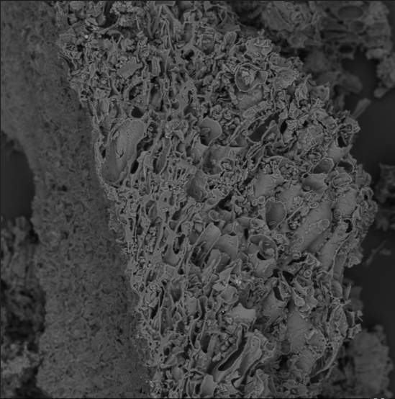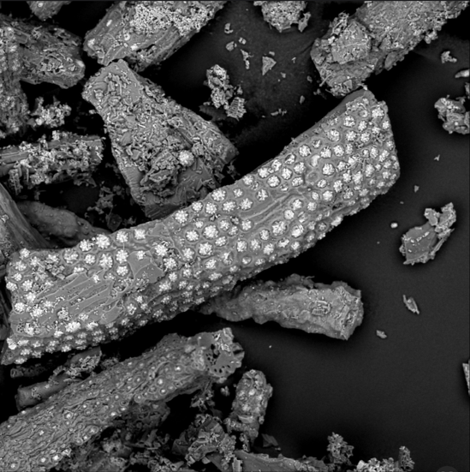
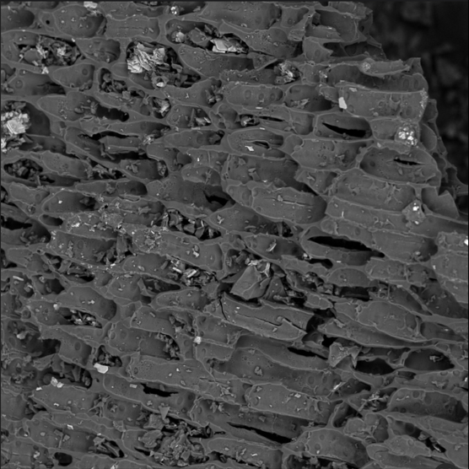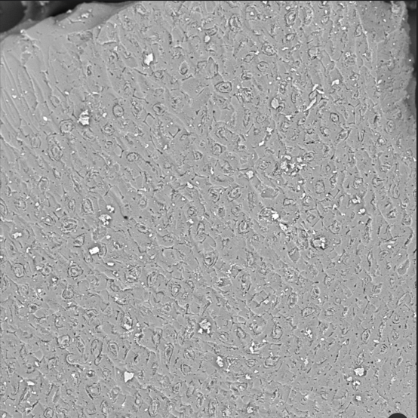
Plate 2: SEM Image of the Four Oil Palm Biomass samples (500x)
Top Left: Oil Palm Trunk, Top Right: Mesocarp Fibers, Bottom Left: Palm Kernel Shell, Bottom Right: Oil Palm Kernel

Plate 2 is a merging of SEM scan images of the four different oil palm biomasses. On the top left is the Oil Palm trunk magnified to 500 times. The image shows numerous openings on the surface of the substrate which could create sufficient surface area for adsorption. The least pored surface is the palm kernel (bottom right), it has smooth and homogenous surface with no observable pore openings at 500x magnification. Palm Kernel Shell (bottom right) shows a significant number of pores on its surface but not as much as the trunk. There are not many pores on the surface of the strands of the mesocarp fibers, besides, the stranded nature of the biomass leaves enough rooms for uncontacted spent lube oil to remain untreated resulting in an inefficient removal of metals.

- Conclusion
The properties of oil palm biomass were investigated to determine their adsorptive efficiency for the removal of metals in spent automobile oil. the result shows that the oil palm trunk exhibited the most efficient removal of metals from the spent lube oil. Oil palm trunk gave similar bulk density values with oil palm kernel and shows best metal removal efficiencies among the four biomass samples. Palm kernel shell biomass has high bulk density and poor surface area. The increased surface area on the oil palm trunk contributes to its most-preferrable adsorptive tendency. In previous studies, carbonization and activation of biomass adsorbents have been observed to improve their efficiency. This study is limited to natural and unmodified oil palm biomass, future studies can be extended to modified oil palm biomass.

Disclaimer (Artificial intelligence)
Author(s) hereby declare that NO generative AI technologies such as Large Language Models (ChatGPT, COPILOT, etc.) and text-to-image generators have been used during the writing or editing of this manuscript.

COMPETING INTERESTS
Authors have declared that no competing financial interests exist that could have appeared to influence the work reported in this paper.

REFERENCES
Atsar, Felix & Kukwa, Donald & Tyohemba, Raymond & Wuana, Raymond. (2013). Cleaning of heavy metals from Spent Lubrication Oil (SLO) by adsorption process using acid modified clay. 71-75.
Carlos Sánchez-Alvarracín *, Jessica Criollo-Bravo, Daniela Albuja-Arias, Fernando García-Ávila and M.RaúlPelaez-Samaniego. (2021) Characterization of Used Lubricant Oil in a Latin-American. Medium-Size City and Analysis of Options for Its Regeneration. Faculty of Chemical Sciences, University of Cuenca, Av. 12 de Abril and Av. Loja, Cuenca 10202,
Chung .M.K., R. Hu .K.C. Cheung and Wong. M.H., (2007): Pollutants in Hong Kong soils: Polycyclic aromatic hydrocarbons. Chemosphere. 67: 464-473.
Ian Henson (2012): A Brief History of Oil Palm. Palm Oil: Production, Processing, Characterization, and Uses. AOCS Press, 2012, Pages 1-29, ISBN 9780981893693, https://doi.org/10.1016/B978-0-9818936-9-3.50004-6. (https://www.sciencedirect.com/science/article/pii/B9780981893693500046).
Idongesit I. E, and Obi, C. (2017): Chemical speciation dynamics and bio-availability quantification of trace metals distribution in non-detrital sediments phase of Cross River Estuary. Nigeria. International Journal of Chemical Studies, 5(2): 8-13
Idongesit E. Ekpo, and Kenneth E. Eghwere (2024): Assessment of Metals Accumulation in The Environment from Automobile Spent Oils in Nigeria 2024 IJCRT | Volume 12, Issue 2 February 2024 | ISSN: 2320-2882 www.ijcrt.org
JD. Udonne, V.E. Efeovbokhan, A Ayoola, D.E. Babatunde, Ajalo Ifeoluwa and .J Ajalo (2016) Recycling Used Lubricating Oil Using Untreated, Activated and Calcined Clay Methods. Journal of Engineering and Applied Sciences 11 (6): 1396-1401,2016 ISSN: 1816-949X © Medwell Journals, 2016
Joanna Szyszlak-Bargłowicz, Grzegorz Zając, Artur Wolak (2021); Heavy metal content in used engine oils depending on engine type and oil change interval. University of Life Sciences in Lublin
Joseph, Udonne & Efevbokhan, V. & Ayoola, A. & Babatunde, D. & Ifeoluwa, Ajalo & Ajalo,. (2016). Recycling Used Lubricating Oil Using Untreated, Activated and Calcined Clay Methods. Journal of Engineering and Applied Sciences. 11. 1396-1401.
Kurniawan, T.A., Chan, G.Y.S., Lo, W.H., and Babel, S. (2006): Comparison of Low-Cost for Treating Wastewaters Laden with Heavy Metals. Science of The Total Environment, 366(2-3), 409-206.

Mohammadtaghi Vakili 1, Mohd Rafatullah, Mahamad Hakimi Ibrahim, Ahmad Zuhairi Abdullah, Babak Salamatinia, Zahra Gholami (2014): Oil palm biomass as an adsorbent for heavy metals. Rev Environ Contam Toxicol. 2014; 232:61-88. DOI: 10.1007/978-3-319-06746-9_3. PMID: 24984835.
Morkunas, I., Woźniak, A., Mai, V. C., Rucińska-Sobkowiak, R. & Jeandet, P. (2018). The Role of Heavy Metals in Plant Response to Biotic Stress. Molecules, 23(9), DOI: 10.3390/ molecules23092320

Nabil M. Abdel-Jabbar, Essam A.H. Al Zubaidy, and Mehrab Mehrvar (2010): Waste Lubricating Oil Treatment by Adsorption Process Using Different Adsorbents. International Journal of Chemical and Biological Engineering 3:2 2010

Nagash T. (2016): Refining of Used Motor Oil Using Solvent Extraction. A Thesis Submitted to the Graduate Studies of Addis Ababa University in Partial Fulfilment of the Degree of Master of Science in Chemical Engineering (Process Engineering)

National Automotive Design and development Council (2023). 11869800 by national automotive design and development council

Nigeria Registered motor vehicles (2020). International Organization of Motor Vehicle Manufacturers 2005-2020.
https://www.ceicdata.com/en/indicator/nigeria/motorvehicleregistered#:~:text=Key%20information%20about%20Nigeria%20Registered, Unit%20th%20for%20Dec%202015.

Noorshamsiana A. W, Nur Eliyanti A.O, Fathian I and Astimar A. A. (2017): A Review on Extraction Processes of Lignocellulosic chemicals from Oil Palm Biomass. Journal of Oil Palm Research Vol. 29 (4) p. 512-527 DOI: hppts://doi.org/10.21894/jopr.2017.00016
Nna Orji C, Abdulrahman FW, Rosemary Isu N. (2018) Pollution Status of Heavy Metals in Spent Oil-Contaminated Soil in Gwagwalada. Asian J. Appl. Chem. Res. [Internet]. Available from: https://journalajacr.com/index.php/AJACR/article/view/2
Rashid A., Schutte B.J., Ulery A., Deyholos M.K., Sanogo S., Lehnhoff E.A., and Beck L. (2023): Heavy metal contamination in agricultural soil: environmental pollutants affecting crop health. Agronomy.;13(6):1521.
Shahid M., Khalid S., Abbas G., Shahid N., Nadeem M., Sabir M., and Dumat C., (2015): Heavy metal stress and crop productivity. Crop production and global environmental issues:1–25.
Shihab, E. A. W. Hassan, K. H and Abd, A. N. (2019): Determination of carbon Residue. Ash Content, and Concentration of Heavy Metals in virgin and Spent Iraqi Lubricating Oils. Journal of Biochemical Technology, 4. 65-68
Olojo, E.A.A., Olurin, K.B., Mbaka G. and Oluwemimo A.D., (2005): Histopathology of gill and liver tissue of the African catfish Clarias gariepinus exposed to lead. African J. Biotechnology. 4(1) 117-122.
Owolabi, Rasheed, Akinola, A.., Oyelana, O., Amosa, Mutiu. (2017). Some Physico-Chemical and Adsorptive Reclamation Strategies of Spent Automobile Engine Lubricating Oil. Journal of Engineering Research. 22.
Udonne J, (2011): A Comparative Study of Recycling of Used Lubrication Oils Using Distillation, Acid and Activated Charcoal with Clay Methods. Petroleum and Gas Engineering, 2, 12-19
Department of Chemical and Polymer Engineering, Lagos State University, Lagos, Nigeria 'Department of Chemical Engineering, Covenant University, Otta, Ogun State, Nigeria
Journal of Engineering and Applied Sciences 11 (6): 1396-1401,2016 ISSN: 1816-949X © Medwell Journals, 2016
Uchimiya M., Bannon D., Nakanishi H., McBride M.B., Williams M.A., and Yoshihara T. (2020): Chemical speciation, plant uptake, and toxicity of heavy metals in agricultural soils. J. Agric. Food Chem.;68(46):12856–12869. DOI: 10.1021/acs.jafc.0c00183.

