Integrating Digital Applications with Occupational Therapy: A Case Study on Behavioral Changes in Children with ASD

Abstract
Mental disorders affect an individual's behavioural patterns, emotional expressions, and perception. Diagnosable disorders included are depression, anxiety, autism, ADHD, bipolar, etc. Therapy sessions are the only known treatment for mental health issues. Nowadays, digital solutions are also utilised as a potential option in facilitating therapy sessions for mental disorders. The present study aims to monitor the impact of digital applications on the behavioural changes and attention span of children with autism. The digital application helps provide personalised interventions, including interactive exercises, feedback mechanisms, and real-time progress tracking, allowing children with ASD to develop habit formation and skill development. Four children with mild to severe autism with anxiety and ADHD were taken, and a digital application was integrated with occupational therapy as an intervention program to monitor the performance of the child. This collaboration of occupational therapy and digital solutions was monitored for 3-4 weeks. Results concluded that digital application plays a significant role in fostering therapeutic processes in improving attention span, enhanced fine motor skills, and increased social interactions facilitated over a month. This case study enables the expanding role of technology in multidisciplinary approaches to treating autism through telehealth, early intervention programs, and personalised home-based therapy, making therapy more accessible and scalable.
Keywords: Mental health, Developmental disorder, Autism spectrum disorder, Digital solutions, Technology, Therapy sessions.
- Introduction
Mental disorders are clinical conditions that affect an individual's emotions, behaviour, and thinking process. Some of the diagnosable disorders involve anxiety, bipolar disorder, borderline personality disorder (BPD), clinical depression, Schizophrenia, ADHD, ASD, etc. In India, among 14.3% of the total population, 197.3 million people had mental disorders in 2017, with 4.7% of the total DALYs (Disability-adjusted life years), which was 2.5% in 1990 [2] [9]. During the year 2017, mental disorders emerged as the primary contributor of YLDs (Years lost due to disability) within the context of India, accounting for a significant 14.5% of the aggregate YLDs recorded in that year. DALYs caused by mental disorders were derived from a range of psychiatric conditions, including depression, anxiety, schizophrenia, bipolar, and conduct disorders. Depressive and eating disorders were highly present in females as compared to males, whereas autism and ADHD were present in males more than females. The contribution of autism spectrum disorder was 0.36% of total DALYs (0.24%-0.5%) with 1.45 annual per cent of change [2]. These statistics show the critical impact that mental health issues have on the overall health landscape in India, showing the urgent need for strategies to mitigate mental health issues in the population.
Autism spectrum disorder is a neuro-developmental disorder with poor communication skills, impaired social interaction, lack of eye contact, and repetitive patterns of behaviour. These symptoms can be visible during the developmental phase of the children [1]. Firstly, the child shows mild behavioural change other than developmental milestones; if unattended, it may shift to more complex behaviour, which defines the wide range of the spectrum. Due to the spectrum of autism, it is tough to understand the requirements of the child because of two reasons: (a) it varies between individuals and (b) lack of interaction [4]. It is inadequate to fulfil the needs of the children with autism as per the definition; instead, daily activities and interventions must be designed or modified explicitly to the unique characteristics of individuals with autism. This will encompass their distinct personality traits, narratives of their life experiences, particular interests, and the trajectories of their personal development, all of which are crucial for their holistic development [13].
Digital solutions, such as smartwatches, video games, mobile applications, websites, augmented reality (AR) [11] [14], and virtual reality (VR) [10], hold immense potential to create an engaging environment for children with ASD. Given the challenges in communication and social interaction, individuals with ASD often show a natural inclination toward technology [12]. This inclination can be harnessed as a powerful tool to enhance communication capabilities and open new socialisation pathways. The recent advancements in technology offer significantly new mediums of human-computer interaction and describe improved approaches to carry out therapy sessions for individuals with ASD.
2. Methodology
2.1 Participants
The study was conducted at Lakshya, a school for unique children in Rajasthan, India, having 50+ children in the age range of 3 to 15 years with autism and other developmental disabilities. Lakshya offers speech therapy, occupational therapy, and counselling sessions and organises social gatherings for the students to enhance social interaction and communication skills among these children. The primary objective of Lakshya School is to make children self-dependent by teaching them soft skills to open prospects for them.
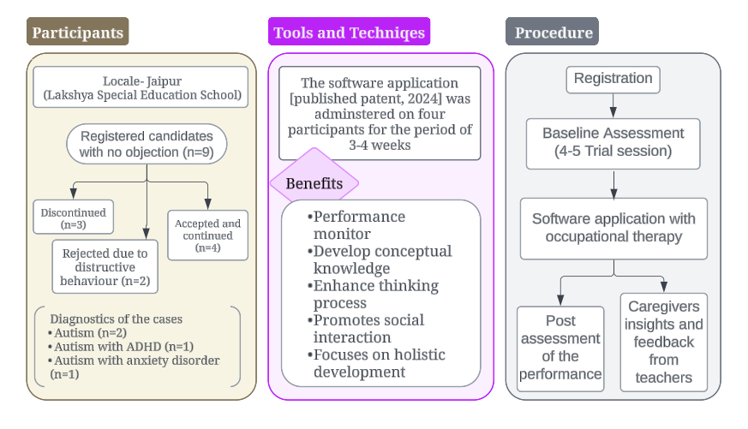
Four participants (two girls and two boys, between 3 and 5 years) were selected for this Respondents study. The selection process was based on the parents' no objection certificate (NOC) and the child's specific requirements. The NOC also included the parents' consent for their child's exposure to technology. Nine NOCs were received; three could not continue, and two were rejected based on their highly severe conditions, such as breaking items and fits in regular intervals. This resulted in a group of four individuals having autism as a common disorder with other developmental disorders such as anxiety disorder and ADHD (see Fig. 1).
Fig 1: Research Methodology
2.2 Tools and Techniques
To conduct this study, a software application (published patent, 2024) focuses on the holistic development of children with ASD. The application helps monitor the child's performance to study the growth ratio, strengths, and weaknesses. It is valuable for children with ASD as it develops conceptual knowledge, enhances thinking, and facilitates social interaction through engaging activities in all development sectors (see Fig. 1).
2.3 Procedure
Lakshya School provides occupational and speech therapy to children with ASD; within this framework, the inclusion of the application was strategically administered during occupational therapy sessions. The objective of occupational therapy revolves around designing intervention programs aligned with the individual's contextual events in daily life, thus ensuring a personalised therapeutic approach. This will foster overall health, well-being, and the ability to participate in the activities, facilitated by the inherent familiarity and meaningfulness of the tasks. Consequently, the approach addresses immediate therapeutic needs and contributes to developing skills and abilities.
The application needs four to five practice sessions to understand the basic functioning and overview. It is recommended to complete a usage period of a month to draw conclusions based upon the performance, as changes in growth ratio can only emerge within 3-4 weeks [6]. The frequency of utilisation of the software application is decided based on the time allocated to occupational therapy. Before and after each session, the researcher and the school teachers made observations. Regular updates were taken during the session, and at the end, a feedback form from parents was also filled out, mentioning the changes they observed in their children. Later, the observations are concluded with the results and findings (see Fig. 1).
2.4 Data collection
During the research period, participants performed activities per the application in a scheduled time slot paired with occupational therapy. This schedule remained the same for a month so the children could adapt to new technology and gain desired insights. The researcher wrote regular observations and continuous discussions with parents, which helped gain valuable insights regarding the children's behavioural changes. These insights are also utilised to make changes in the application for smooth functioning in the future.
3. Description of the respondents
Names used in the descriptions below are pseudonyms. Children are already diagnosed with the disorders, and a description is based on the observations of the researchers, teachers, parents, and caregivers.
3.1 Respondent 1: Autism and Behavioral Disorders
Priyal, aged five years, has autism with anxiety disorder, is very calm and composed in a classroom, and sits quietly in the corner chair daily. He is very protective of his things, so he usually throws a tantrum when the corner chair is taken. He sometimes gets mild anxiety attacks when his belongings go missing for a long time. These attacks are less frequent, but when they occur, resulting in difficulty falling asleep at night. A significant challenge for Priyal is communicating his thoughts, leading to complete social isolation. He uses a single word to express his needs to his family or mainly points out the object. His attention span is 4-5 minutes at a time. After that, he focuses on the moving fan or cutouts placed on the classroom wall for 10-15 minutes.
Priyal participated in the session (with parents' no objection certificate) and introduced a software application to monitor the child's performance in several areas. Activities in the software application helped to (a) enhance attention span, (b) build concepts, and (c) facilitate falling asleep through motor activities. Priyal performed the application activities 2-3 times daily as per his interest and continued them for a month.
3.2 Respondent 2: Autism
Liesel is a 3-year-old girl with autism. She lies on the moderate level of the spectrum and shows various symptoms of autism, such as avoiding eye contact and poor communication skills. She usually closes any attempt at social interaction and returns to her familiar environment, i.e., her parents. She got easily frustrated and was unable to switch between two activities. Her attention span is 1-2 minutes maximum, and she goes back to her parents if they are in the room, or she starts crying if they are not visible. Due to their low attention span, her knowledge of concepts is minimal, and she cannot understand direct instructions as she is unfamiliar with the terminologies.
The primary objective of providing the session containing software application to Liesel was to (a) improve the knowledge and concepts of surroundings, (b) enhance attention span, and (c) initiate and retain communication. At first, it was difficult for Liesel to sit and explore the application, but after performing one activity, she started gaining interest in other activities. She continued conducting the activities for a month, performing one daily activity.
3.3 Respondent 3: Autism
Sarah, a 3-year-old girl with severe autism, has been undergoing occupational therapy and speech therapy for the past four months. She is afraid of crowded places and used to cover her ears, scream her loudest, and throw herself down. She is unable to control her environment and shows these symptoms when more than six people gather in a classroom. She uses gestures to communicate and mostly tries to avoid communication. The only option left with her parents is to force her to talk, and they speak very elaborately so that she can listen and understand the surroundings.
The application is introduced to Sarah to (a) enhance engagement time and create a distraction from the surroundings, (b) understand their growth and developmental level, and (c) control her emotions.
3.4 Respondent 4: Autism and ADHD
Rudra is a 4-year-old boy with autism and attention deficit hyperactivity disorder. He lies on the severe spectrum of autism and is very hyperactive. He is having difficulty sitting even for a minute; due to hyperactivity, he usually starts running in a pattern and repeats it until he gets distracted again. He also shows escape behaviour and returns to an item of interest of the day, which he finds when he enters the classroom. Rudra lacks vocal skills and knows only a few sounds to express acceptance and rejection of items, activities, or toys. Rudra came from a Marwari background, so it was difficult for him to understand other languages, which was also a significant reason why he did not follow instructions. The application can help Rudra (a) channel his motor skills, (b) build conceptual knowledge, and (c) enhance his attention span. As Rudra comes from a local background where communication was held only in Marwari, the class teacher assessed him using the language to avoid confusion.
4. Results and findings
The results of all four respondents were recorded, and pre and post-intervention data was calculated through JASP (version 0.18.3), where the statistical analysis was conducted to study the impact of digital technology on children with ASD across different tests. The lowest mean of 14.50 ± 1.29 and the highest mean of 14.50 ± 1.29 were recorded in the pre-intervention of tests C and E. Whereas, for post-intervention, the lowest mean of 43.25 ± 9.06 and the highest mean of 50.75 ± 2.21 were recorded in tests A and C, respectively (see Table 1).

Tests | Pre-intervention  (Mean ± SD) | Post-intervention  (Mean ± SD) | t-value | p-value | Cohen’s d  (effect size) | Interpretation
A | 14.59 ± 2.16 | 42.42 ± 7.85 | 7.55 | 0.005 | 3.77 | Large effect
B | 15.45 ± 1.11 | 44.79 ± 4.18 | 14.31 | < .001* | 7.15 | Extremely large effect
C | 19.69 ± 1.47 | 50.71 ± 1.92 | 22.89 | < .001* | 11.44 | Extremely large effect
D | 14.45 ± 1.11 | 44.83 ± 3.93 | 18.39 | < .001* | 9.19 | Extremely large effect
E | 16.22 ± 0.82 | 46.61 ± 3.56 | 18.39 | < .001* | 9.19 | Extremely large effect
*Significant at (p < 0.05)
Table 1: Pre- and post-intervention data of different tests
The mean value of all tests has increased significantly in post-intervention, suggesting the improvement in skills and abilities of children with ASD. The data showcase a very high t-value, ranging from 7.55 to 22.89. A higher t-value indicates a more significant difference between pre-and post-intervention means relative to variability due to the smaller sample size. But, p-value < 0.001, meaning the differences are statistically significant. Cohan’s d values in the results are extremely high, ranging from 3.77 to 11.44, suggesting the considerable practical significance of the intervention. Still, the effect is also significant in real-world terms.
The mean change for test A was 14.59 to 42.42, i.e., 190.7% and the SD change was 2.16 to 7.85, i.e., 263%. For test B, the mean change was 15.45 to 44.79, i.e., 189.9% and the SD change was 1.11 to 4.18, i.e., 276%. Test C highlights a mean change of 19.69 to 50.71, i.e., 157.5% and an SD change of 1.47 to 1.92, i.e., 30.6%. Test D showcases a mean change of 14.45 to 44.83, i.e., 210.3% and SD change was 1.11 to 3.93, i.e., 254%, and test E highlights a mean change of 16.22 to 46.61, i.e., 187.4% and SD change was 0.82 to 3.56, i.e., 334%. Post-intervention means an increase of 150% to 210% across all tests, indicating the effectiveness of the intervention program in improving the performance of children with ASD. Considerable effect size (Cohen’s d > 3.5 in all tests) suggests the practical impact of the intervention, and test C (d = 11.44) had the most significant effect size, implying the most substantial influence of all.
The intervention was highly effective, with all tests showing significant increases in mean performance. However, variability increased, indicating that the intervention affected individuals differently. The high effect sizes suggest that the intervention had real-world significance, making it an effective method for improvement. Further analysis is required to investigate the effect of the intervention on a large sample. The participant's performance (see Fig. 2) is recorded over one month based on their test scores calculated while performing activities in five different tests. Findings are recorded based on the experiences and changes the teachers and caregivers observed during a month.
4.1 Respondent 1: Autism and Behavioral Disorders
Priyal was excited when he saw the laptop and immediately imitated his father. He showed excitement by laughing and touching the keyboard. He needed assistance initially, but after the sixth session, he started waiting to perform the activity himself. At the end of the month, he sat until he finished all the activities, which took him 20 mins. He started conversing in two-word sentences, for instance, “give me that”, “eat food”, and “do again”. He also started labelling 40-50 items, which he began by labelling “fan” and communicating “round fan” to the teacher. His mother recorded his stable sleeping hours as he revises motor activities at home with his mother.
4.2 Respondent 2: Autism
Liesel was not very positive towards the application at first. She started exploring the application when her mother showed it to her. In the first session, she didn’t even touch the laptop, and it took her three days to begin touching the computer. Sitting with the teacher and marking the correct answers took six days. She achieved an attention span of 9-10 mins, 1-2 mins at the beginning. She performed one activity per day at the start of the month and shifted it to three activities per day by the end. As the instructions on the application were direct, it also helped her apply and follow those in real life. For instance, her mother said she started saying “red light-STOP” every time the traffic signal turned red. She also began initiating conversations and created multiple communication circles. Although she could only have a conversation lasting 1-2 minutes, she then moved to other people.
4.3 Respondent 3: Autism
Sarah showed selective interest in exploring the application. Some days, she is highly excited and wants to attempt more and more activities, and then there are some days when she refuses to function. During her functional days, she could cover 5-6 activities without distractions for 10 minutes, and the frequency of non-functional days was less than that of functional days. By the end of the month, she could start engaging in front of the laptop and learning motor activities, which she began performing in a crowded place when recalled by the teacher. The application helped construct her growth ratio (see Fig. 2). Her parents shared that she approached her neighbour, told him her name, and returned to the house, which she usually avoids.
4.4 Respondent 4: Autism and ADHD
Rudra showed extreme involvement in the application and has been interested since the first session. During the first week, he didn’t communicate and used non-verbal gestures. The teacher constantly communicated in simple sentences in his regional language, which he understood and started responding to. He started narrating all the answers when he learned to perform the activity during the second week. Last week, he started using three-syllable words and labelling items in his regional language, reaching up to 50 monthly labels. With the help of motor activities, we can also channel his energy. He also gained confidence when he started narrating and performing correct answers. Through this, he could also make friends and was always around people. He repeats everything new he learned and narrates it to everyone he meets while going back home.
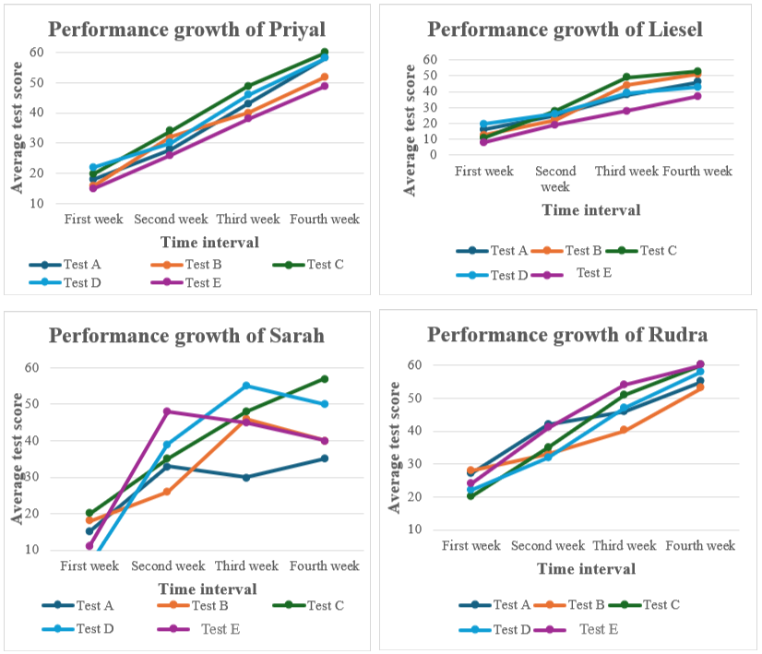
Fig. 2. Weekly performance growth of all the participants during a month.
The present study aimed to examine the potential of digital applications in enhancing attention span and other behavioural changes among children with ASD along with anxiety disorder and ADHD. The primary objective of the application is (a) to provide holistic development for the child by exploring all the areas of development, such as cognitive, physical, speech, language, social, emotional, gross, and fine motor skills; (b) to enhance attention span and (c) to generate a growth ratio of each individual. The application was introduced strategically between usual therapy sessions as per the unique requirement of the child. Although this study was conducted for one month, parents were asked to continue using it for their children to assess their growth ratio in real-time.
The application, which adopts a holistic approach, effectively utilises motor activities to channel the children's physical strength into a more productive learning experience by incorporating playing activities. Furthermore, the application also facilitates enhancement in the attention span of its young users, as it is an entirely new realm of learning filled with limitless possibilities that stimulate curiosity and eagerness to discover. The parents of many participants expressed the desire to continue using the application as it caters to the children's developmental needs and the parents' informational needs. Additionally, the application is paired with occupational therapy, which fosters children’s growth over time, equipping them with conceptual knowledge [16]. The digital application enhances children's attention span through an interactive environment with clear and direct instructions, facilitating a more focused and engaging learning experience. It was observed after a month that children can apply the knowledge they acquire to real-time scenarios [15].
The research findings show significant changes in the mental health and well-being of the individual. The research also demonstrates the potential of technologies in the therapeutic process of children with ASD. As it is a portable application, it makes it effortless to access the overall and daily performance anywhere. The application contains daily activities that enable the child to participate actively in the sessions. Hence, it is vital to bridge the physical and virtual interaction gap. Integrating technology in therapeutics facilitates the active participation of children, therapists, and parents [7]. This integration facilitates therapists to monitor the client's performance, incorporate necessary changes, and plan a treatment accordingly. However, face-to-face interaction is also essential for enhancing the social development of children [5]. Therefore, the inclusion of technology should be limited to the child's needs rather than keeping them engaged longer. Moreover, this study promotes the children's unique requirements. Therefore, customisation and designing a child-centric learning approach are necessary to meet the children's demands [3] [8].
All participants who attended these sessions experienced fluctuating intensity levels of the symptoms observed, which enhanced the excessive requirement for the personalised learning method. According to the requirements of the children, individual goals and needs are set to achieve the best of their abilities. The research displays a collaborative approach and child-centric therapy sessions, which work on the strengths and weaknesses of the child. The application shows the items' correctness and the child's performance, which helps build confidence among them.
5. Conclusion
The present study shows the potential of digital solutions in the treatment of autism spectrum disorder with other behavioural disorders such as anxiety and ADHD. It also shows how technology can help enhance children's conceptual knowledge and attention span. For prospects, it is recommended that this application be used for a more extended period based on the positive feedback of the participant's parents. This research highlights the necessity of customisation and the unique preferences of the children during therapeutic sessions. The inclusion of technology facilitates children with autism to understand their surroundings better and enhances their confidence in initiating communication. Moreover, direct instructions are crucial for the child to initiate social interaction. Technology in therapy sessions presents significant potential for improving mental health and therapeutic methodologies.
Funding
This research work received no specific grant from any funding agency in the public, commercial, or not-for-profit sectors.
Conflict of interest
The authors listed above certify that they have affiliations with every organisation or entity for financial or non-financial interest in the subject matter or materials discussed in this manuscript.
Ethical considerations
Authors are responsible for the correctness of the statements provided in the manuscript.
Disclaimer (Artificial Intelligence)
Authors hereby declare that generative AI technologies were used during the writing or editing of the manuscript. Details of the AI usage are given below:
SciSpace (version 1.4.12) https://typeset.io/ was utilised to enhance the conclusions drawn by entering the input prompt- “Autism Spectrum Disorder”, “Occupational Therapy”.

REFERENCES
- American Psychiatric Association. Diagnostic and statistical manual of mental disorders (5th ed.). American Psychiatric Publishing, Washington, DC (2013).

- Indian Council of Medical Research, Public Health Foundation of India, Institute for Health Metrics and Evaluation. GBD India Compare Data Visualization. http://vizhub.healthdata.org/gbd-compare/india (2024).

- Grover, S., Fitzpatrick, A., Azim, F.T., Ariza-Vega, P., Bellwood, P., Burns, J. et al.: Defining and implementing patient-centred care: An umbrella review, Patient Education and Counseling, 105 (7), 1679-1688 (2022).

- Jones, E. J. H., Gliga, T., Bedford, R., Charman, T., Johnson, M. H.: Developmental Pathways to Autism: A Review of Prospective Studies of Infants at Risk. Neuroscience & Biobehavioral Reviews 39, 1–33 (2014).

- Karnezi H, & Tierney K.: Cognitive Behavior Drama: An Innovative Intervention Model that Combines Established Psychological Methods with the Art Form of Drama to Provide Young Children on the Autism Spectrum with the Motivation and Confidence to Overcome Their Fears. 2(7):393-408. Doi: https://journalair.com/index.php/AIR/article/view/520 (2025).

- Lin, I. M., Chen, T. C., Tsai, H. Y., Fan, S. Y.: Four Sessions of Combining Wearable Devices and Heart Rate Variability (HRV) Biofeedback are Needed to Increase HRV Indices and Decrease Breathing Rates. Applied psychophysiology and biofeedback 48(1), 83–95 (2023).

- Munson, J., Pasqual, P.: Using technology in autism research: the promise and the perils. Computer 45(6), 89-91 (2012).

- Pleumeekers, E., Honinx, E., Lieten, H., Jacobs, N., Broes, S., Ross, V.: Examining the Potential of a Breath Pacer as an Adjuvant in Cognitive Behavioral Therapy: Respondents Studies in Digital Health for Mental Well-being. Journal of evidence-based psychotherapies 24(1), 43-62 (2024).

- Sagar, R., Dandona, R., Gururaj, G., Dhaliwal, R. S., Singh, A., Ferrari, A., et al.: The burden of mental disorders across the states of India: the Global Burden of Disease Study 1990-2017. The Lancet. Psychiatry 7(2), 148–161 (2020).

- Sanku, B. S., Li, Y. J., Jung, S., Mei, C., & He, J.: Enhancing attention in autism spectrum disorder: comparative analysis of virtual reality-based training programs using physiological data. doi: 10.3389/fcomp.2023.1250652 (2023).

- Taufiq, M., Suhartono, B. F. K., Sabanari, H. F., Musyaddad, M. N., Rofiq, D. A.: Augmented Reality Mobile Application for Autism Spectrum Disorder Rehabilitation. Doi: 10.18860/mat.v16i1.23409 (2024).

- Toma, M. V., Turcu, C. E., Turcu, C. O., Vlad, S., Tiliute, D. E., Pascu, P.: Extended Reality-Based Mobile App Solutions for the Therapy of Children With Autism Spectrum Disorders: Systematic Literature Review. JMIR serious games 12, e49906 (2024).

- Uljarević, M., Baranek, G., Vivanti, G., Hedley, D., Hudry, K., Lane, A.: Heterogeneity of Sensory Features in Autism Spectrum Disorder: Challenges and Perspectives for Future Research. Autism Research 10 (5), 703–710 (2017).

- Wang, R., Newton, S., & Lowe, R.: Experiential Learning Styles in the Age of a Virtual Surrogate. International Journal of Architectural Research: Archnet-IJAR, 9(3):93-110. doi: 10.26687/ARCHNET-IJAR.V9I3.715 (2015).

- Wert, B. Y., & Neisworth, J. T.: Effects of video self-modelling on spontaneous requesting in children with autism. Journal of Positive Behaviour Interventions, 5, 30-34 (2003).

- Williams, C., Wright, B., Callaghan, G., & Coughlan, B.: Do children with autism learn to read more readily by computer assisted instruction or traditional book methods? Autism, 6, 71-91 (2002).

