
Evaluation of turmeric-based Unani formulation for Respiratory tract infection: Physicochemical Analysis, HPTLC Fingerprint Screening and Microbiological studies.

Abstract:

Respiratory tract infection is a significant non-communicable disease (NCD) that outcomes to significant impairment and fatility on a global scale. The highest number of fatalities occurs in poor and middle-income nations, including Oceania, South and Southeast Asia, the Middle East, and Africa. The World Health Organization (WHO) recognizes and values the significance of medicinal plants in public healthcare in developing countries. The Unani classical literature has several formulas for treating respiratory diseases. Sufoof Dama Haldi Wala is a specific formulation in the unani system using turmeric-based material. However, the quality criteria of this formulation have not been assessed yet. Hence, this work aimed to establish a standardized turmeric-based unani formulation by evaluating its physicochemical properties and doing HPTLC fingerprint screening. The quality requirements have been established by thorough physico-chemical examination. The microbial load test, aflatoxin, and In-vitro antioxidant activity were all within acceptable limits, and no microbes were detected in the produced turmeric based Unani formulation. The elemental analysis has also shown intriguing findings. Standardization of herbal drugs is crucial for ensuring quality control. It enhancing the safety and efficacy of drugs is crucial for delivering optimal treatment to the society. Obtained data for turmeric-based Unani formulation will serve as valuable benchmarks for ensuring the standards and quality control of formulation.

Graphical Abstract:

Key words: Sufoof Dama Haldi Wala, Dama (Asthma), turmeric-based Unani formulation, Respiratory tract infection

- Introduction:
Respiratory tract infections (RTIs) are the most prevalent and potentially grave infections managed by healthcare professionals. Lower respiratory tract infections, including influenza, are the leading cause of infectious deaths in the United States. Factors that increase the likelihood of developing pneumonia and other respiratory tract infections include being in the very young or old age groups, smoking, drinking, weakened immune system, and having other medical disorders at the same time. The microbiological etiology of respiratory tract infections (RTIs) differs according on the kind of infection, such as acute bacterial sinusitis, acquired in the community infections, nosocomial infections, and other contributing variables. [1] They were responsible for 19% of all deaths in children younger than five years old, 8.2% of all injuries, and early deaths. RTIs killed 1.9 million children around the world in 2000, with 70% of those deaths happening in Africa and Southeast Asia (95% CI: 1.6 to 2.2 million) [2]. The disease’s prevalence has been reported to vary from 3% to 38% in children and from 2% to 12% in adults, making it the most frequent chronic disease among children [3]. The highest number of fatalities occurs in poor and middle-income nations, including Oceania, South and Southeast Asia, the Middle East, and Africa. [4]
Evaluating the quality of herbal formulations is crucial to determine their suitability in modern medicine.[5] An inherent challenge in the herbal sector is the lack of stringent quality control methods for herbal medications and their formulations. The World Health Organization (WHO) recognizes and values the significance of medicinal plants in public healthcare in developing countries. Indian traditional medicine, particularly the Unani system of medicine (USM), has a significant role and wide range of opportunities for developing standardized and therapeutically effective formulations. It is necessary to investigate the plants that have therapeutic value and the ways in which they might be used. [6-14]

Safoof Dama Haldi Wala is a one of the type of turmeric-based polyherbal powder formulation that has been utilized in the Unani System of Medicine for centuries for dealing with respiratory tract infections.
Comment [h1]: Sufoof containing sometimes allergen which causes allergic rhinitis .
This formulation is documented in the National Formulary of Unani Medicine
[15] the physicochemical, phytochemical standardization, HPTLC, heavy metals, and microbiological activities of this formulation have not been investigated yet, as shown by the literature review. With the aim of establishing quality control criteria for turmeric-based Unani formulation, this study was conducted using scientific analytical techniques.
- Materials and Methods:
The constituents of Sufoof Dama Haldi Wala include Triticum aestivum L. (common wheat) and Curcuma longa L. (turmeric/haldi). The formulation was created in accordance with the guidelines outlined in Bayaze Kabir Vol. II.The user's text is enclosed in tags. The prepared formulation underwent analysis based on organoleptic parameters, as well as several physico- chemical parameters including powder characterization, pH, loss on drying, ash values, and extractive values. The total microbial count (TMC) was determined using the plate method to assess microbial load and to detect the presence or absence of specific micro-organisms such as
S. aureus, P. aeruginosa, Salmonella sp, and, E. coli. Aflatoxin levels were also measured. Furthermore, the in-vitro antioxidant activity was assessed by measuring its ability to scavenge radicals. In addition, qualitative analysis of numerous phytochemical constituents and HPTLC was conducted. The fingerprint analysis was conducted on the ethanol extract and chloroform extract, and the quantitative measurement of various components was performed using Atomic Absorption Spectrophotometry (AAS).

  - Ingredients of the formulation of turmeric-based Unani formulation (Sufoof Dama Haldi Wala):
The Sufoof Dama Haldi Wala formulation consists of two components, as indicated in Table no.1.
Table No. 1: Ingredients of turmeric-based Unani formulation (Sufoof Dama Haldi Wala).

S. No. | Name of drugs | Parts Used
1. | Gundum sokhta* (Triticum aestivum Linn.) | Seeds
2. | Haldi or Turmeric (Curcuma longa Linn.) | Rhizome
*sokhta means burnt or charred

  - Drugs collection:
Comment [h2]: The voucher specimen number is missing in favor of respective ingredients in the survey of medicinal plant unit, Chennai.
The ingredients of turmeric-based Unani formulation are Triticum aestivum (Gundum) and
Curcuma longa (Haldi) which were obtained from R.B.Sabari & Co, a market in Chennai. These ingredients were authenticated by Dr. Venkatesan. K, Assistant Research Officer (Botany) at the Survey of Medicinal Plants Unit, Chennai. The specimen samples are displayed in Figure 1.
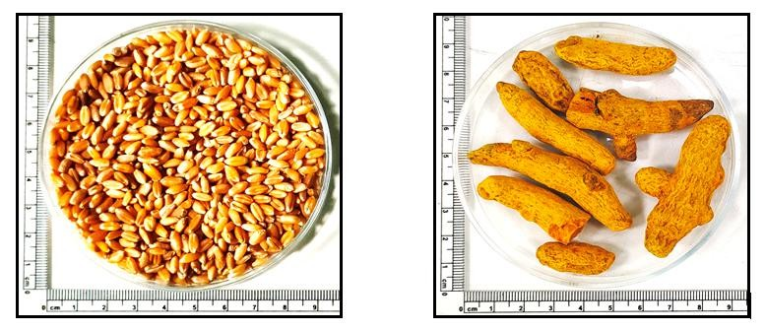
Figure No. 1: Ingredients of the Sufoof Dama Haldi Wala formulation
Triticum aestivum (Gundum)
Curcuma longa (Haldi)
  - Preparation of Formulation:
Both incident drugs underwent a cleaning process in which earthy impurities and foreign matter were eliminated, followed by drying.
    - Preparation of Gundum Sokhta:
Sokhta means "burned" or "charred." During this step, the drug is burned until it turns black, like coal. Gundum Sokhta was made using the traditional method that had been used in other studies as a standard. [16] Both materials were individually pulverized and then sifted through sieve no.
80. The resulting powder was combined in a 2:1 ratio (two parts of Gundum Sokhta and one part
of Hald). [17-18] The mixture was then completely blended using a mixer.
3.
Standardization of turmeric based Unani formulation (Sufoof Dama Haldi Wala)
Comment [h4]: The standard testing procedure is not clearly explained.
Comment [h3]: Shade drying or oven drying (mentioned it) .
  - Organoleptic characterization
The synthesized product was evaluated using organoleptic analysis to assess several criteria including appearance, color, odor, taste, and texture. [19] (Table 2)
Comment [h5]: Which type of microscope have been used . mentioned it.
  - Powder Microscope:

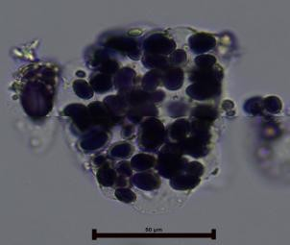
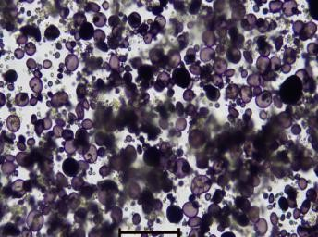

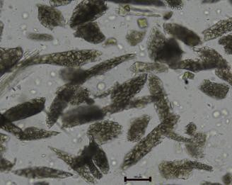
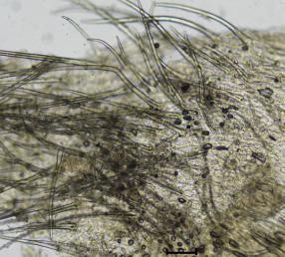
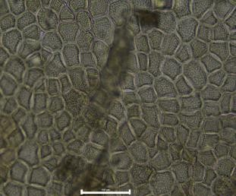
The Endosperm is numerous composed and abundant of thick walled polygonal or isolated parenchyma cells filled with numerous starch grains; there are many isolated endosperm parenchyma cells filled with starch grains; Starch grains numerous and simple; Starch grains of two distinct sizes, smaller circular, oval upto 15μ and large oval or sub-reniform upto 50μ, central hilum with concentric striations; Aleurone layer consisting parenchyma cells filled with
of thick walled that are packed with aleurone grains and oil globules; Some of the epidermal cells with long thick walled hairs from the apex (Gandum Sokhta); Cork cells in surface view; cortical parenchyma cells have filled with starch grains (gelatinized); Numerous parenchyma cells filled with yellowish orange globules of oleo resin (curcumin); Vessels with reticulate
thickening upto 50µ.(Shown S1).
Image 1 : Sufoof Dama Haldi Wala
S1. Sufoof Dama Haldi Wala
Endosperm cells
Epidermal hairs
Thick walled Aleurone layer filled with aleurone grains
100µ
100µ
100µ
Isolated endosperm cells filled with starch grains Numerous Starch grains
50µ
100µ
HALDI
GANDUM SOKHTA


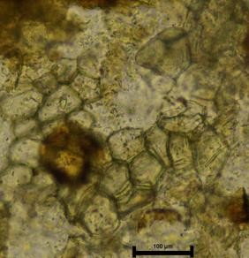
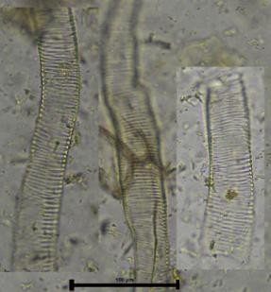
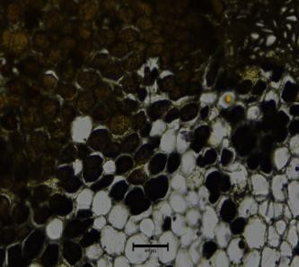
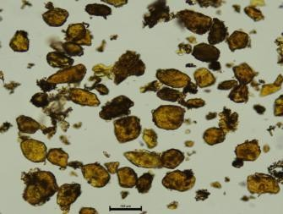
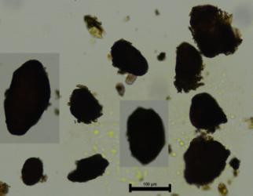
Reticulate Vessels Cortical parenchyma cells filled Cork cells
with gelatinized starch grains

Isolated cortical parenchyma cells filled with gelatinized starch grains

Yellowish orange oleo resin cells
100

100µ

100µ
  - Qualitative phytochemical analysis
The produced product underwent organoleptic examination to evaluate several parameters such as appearance, color, odor, taste, and texture.
  - Physico-chemical evaluation
The physicochemical parameters of turmeric based Unani formulation, including moisture content/Loss on drying at 105 °C, extractive values, total ash value, acid-insoluble ash value, and pH, were assessed using established protocols.[20].
  - Elemental or Heavy Metal Analysis
The test sample underwent evaluation for four heavy metals, namely arsenic (As), cadmium (Cd), mercury (Hg), and lead (Pb), utilizing an atomic absorption spectrophotometer (Thermo Scientific, iCE 3300, Germany) with the aid of SOLAAR, AA Software, Version 11.10.
    - Sample Preparation for AAS


The heavy metal analysis sample was produced using the techniques outlined [21-23] with minimal adaptations. Precisely 0.6 grams of the plant material, together with 6 mL of concentrated nitric acid (HNO₃), was loaded into a 50 mL TFM-PTFE microwave digestion tube. The sample was subjected to the hot digestion procedure utilizing the Anton Paar microwave digestion equipment (Multiwave GO Plus) at temperatures ranging from 0°C to 200°C for duration of 30 minutes. The pressure was gradually removed from the TFM digesting tube, allowing for the release of nitric acid fumes. Two 5 ml portions of deionized water were introduced to the tube. The processed sample was filtered with Whatman filter paper No.1 into a 100 ml volumetric flask, and the sample was diluted to a volume of 100 ml by adding deionized water.
  - HPTLC (High-Performance Thin Layer Chromatography)
An ethanolic extract of Sufoof Dama Haldi Wala was analyzed using a CAMAG HPTLC from Switzerland and a precoated silica gel 60F₂₅₄ HPTLC plate (5 × 10 cm) from Merck, Germany to determine its HPTLC fingerprint profile. The CAMAG ATS4 sample applicator was used to apply a volume of five micro liters of the sample onto the Silica-aluminum plate. The mobile phase consisted of a mixture of toluene, ethyl acetate, and formic acid at a ratio (v/v) of 7.0:3.0:0.01. The plates were extended to a maximum distance of 8 cm at room temperature using a CAMAG twin-through glass chamber of 10 × 10 cm. The duration of saturation was 20 minutes. Following the completion of the sample development, the plates were air-dried at ambient temperature. The bands that were formed on the plates were analyzed using the CAMAG UV Visualizer 2 at wavelengths of 254nm and 366 nm. The chromatogram depicts were scanned utilize a CAMAG TLC scanner. The finger print data and Rf values were documented utilizing the WINCATS planar chromatography management program.[24]
Comment [h6]: The solvent system has newly developed or cited other articles other solvent ( not cleared)
  - Microbial Load Determination
The microbiological harmony of commercially available and handmade herbal remedies was evaluated using The Unani Pharmacopoeia (2016) [25] and the World Health Organization (WHO) guidelines (2007) [26]. Experiments were carried out to ascertain the aerobic proliferation of bacteria and fungus in a 1 gram specimen. The samples were mixed and added to a peptone broth. They were subsequently diluted many times until the appropriate concentration was attained. The microbiological tests were performed three times, using the pour plate

technique to evaluate the survival of bacteria and determine the types of fungi present. The CFU/g count was assessed and compared to the guidelines established by the World Health Organization (WHO). Any samples with a bacterial count over 10⁵ CFU per gram of medical product were considered unsuitable for evaluation.
    - Identification of Bacteria
In order to differentiate and confirm the identity of bacteria, the samples were diluted in peptone water and subsequently agitated rigorously to achieve uniformity. The culture mediums utilized for examining Escherichia coli, Salmonella spp., Pseudomonas aeruginosa, and Staphylococcus aureus were MacConkey agar, cetrimide agar, EMB agar, and Mannitol salt agar. Following the incubation period, the pathogenic bacteria were initially identified by observing the morphology of the colonies, employing Gram staining, and conducting biochemical assays to assess oxidase, gas, and catalase production.
    - Aflatoxin test using afla-test fluorometer:

Aflatoxins are a category of naturally occurring toxins produced by two ubiquitous mould species, Aspergillus flavus and Aspergillus parasiticus. AflaTest is a quantitative method for the detection of aflatoxin in B1, B2, G1, G2, M1, and M2. This technique mixes one gram of unani formulation and 0.4 g of sodium chloride with methanol, 2% Tween 20, or phosphate buffer. The extract is filtered and diluted with 20 mL pure water. The diluted extract is run down an AflaTest WB column and rinsed with 2% Tween 20, filtered water, and 100% HPLC-grade methanol. Mix AflaTest Developer with the eluate in a sterile VICAM cuvette and insert in a fluorometer (VICAM fluorometer-sereies 4EX). The fluorometer reads concentration after 60 seconds.
    - Antioxidant Activity
      - DPPH (Diphenyl-1-picrylhydrazyl) /Radical Scavenging activity
The free radical scavenging capacity of turmeric-based Unani formulation was measured using a modified method from Brand-Williams et al (1995). The mixture of DPPH solution in methanol and Unani formulation solution was mixed in different concentrations (25, 50, 75 and 100 μg/ml), and absorbance was measured at 517 nm utilizing a UV-Vis-spectrophotometer [27]. The inhibition percentage was calculated using a formula.

% of inhibition = (A0 - A1 / A0) × 100.

A0 = The Absorbance of control reaction and A1 = The Absorbance in presence of test or standard sample.
      - ABTS assay
The ABTS radical cation decolorization test was employed to assess the antioxidant capacity of the turmeric-based Unani formulation. The ABTS + cation radical was generated by combining 7 mM ABTS in water with 2.45 mM potassium persulfate. The measurement of absorbance was conducted at a wavelength of 734 nm subsequent to the addition of the unani formulation. The percentage inhibition of absorbance was determined by applying the formula: ABTS+ scavenging effect (%) = ((AB–AA)/ AB) ×100, where AB represents the absorbance of the control sample and AA represents the absorbance of the sample being tested. Trolox was used as the reference drug. [28]
- Results & Discussions:
  - Physico-chemical Standardization for turmeric-based Unani formulation (Sufoof Dama Haldi Wala)
The organoleptic evaluation of the whole plant of turmeric based Unani formulation revealed that it was shiny, Light yellowish Black, tasteless, and had a characteristic odour is burn smell (Table 2).
Table No. 2: Organoleptic characteristics of turmeric-based Unani formulation(Sufoof Dama Haldi Wala)
S.NO | Parameters | Results
1 | Appearance | Shiny
2 | Colour | Light yellowish Black
3 | Odour | Burnt smell
4 | Taste | Tasteless
5 | Texture | Fine powder

The turmeric based unani formulations exhibited a loss on drying at 105 °C was found to be

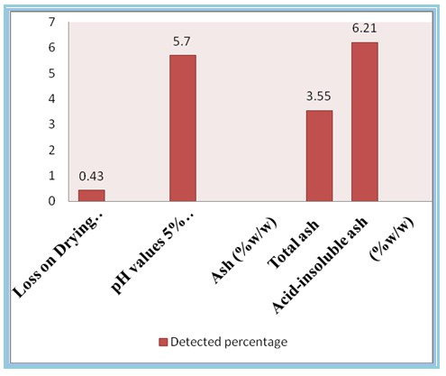
0.43%. The ash value is a crucial metric used to detect adulterants in a plant [29]. The turmeric based Unani formulation exhibited total ash and acid-insoluble ash values were found to be 3.55% and 6.21%, respectively. The hexane, ethanol, and water extractive values were found to be 3.52%, 7.88% & 2.66% respectively. The pH of the turmeric based Unani formulation was found to be 5.7 (graph -1 3, entry 1-5) [30]. The presence of heavy toxic metals in plants may significance serious health issues in humans [31]. According to heavy metal analysis of turmeric based Unani formulation, the values of lead, cadmium, arsenic, and mercury were found to be below the permitted limits were founded (Table 3) [11]. The entire turmeric based Unani formulation physicochemical constituents were all within acceptable limits according to the Indian Unani Pharmacopoeia, 2007.[32]

Graph 1: Physicochemical analysis of turmeric based Unani formulation

Table 3: Heavy metal analysis of turmeric based Unani formulation

S. No | Name of Element | Standard limit^{11,31*} | Result Obtained

1 | Arsenic (As) | 3 ppm | 0.0021 ppb
2 | Cadmium (Cd) | 0.3 ppm | 0.0025 ppm
3 | Lead (Pb) | 10 ppm | 0.2350 ppm
4 | Mercury (Hg) | 1 ppm | 0.0002 ppb

^{11,} ^{31*} Anonymous, 2016, UPI 2007
  - HPTLC Fingerprint Profile of turmeric based Unani formulation (Sufoof Dama Haldi Wala) :
HPTLC is a vital method to determine the quality and purity of herbs by developing their fingerprints of the phyto-chemical constituents. In the present study, to investigate the HPTLC analysis of two batches (tracks A and B) of ethanolic extract of turmeric based Unani formulation exhibited indistinguishable fingerprint profiles (Fig. 2). The Ethanol extract (8 µl each) on TLC plate was applied. Develop the TLC plate utilizing Toluene: Ethyl acetate: Formic acid (7: 3: 0.01) (v/v) as mobile phase. After development process allows the plate to dry in air and examined under UV wavelength at 254 nm & 366 nm. Immerse the plate in vanillin- sulphuric acid reagent followed by heating at 135°C about 5 min and observe under visible light, the plate shows major significant spots have been observed. The significant spots (06) were detected at Rf 0.87, 0.75, 0.65, 0.58, 0.29, and 0.15 under UV 254 nm on absorbance mode,
while the significant spots (05) were found at Rf 0.41, 0.28, 0.20, 0.14 and 0.08 under 366 nm on fluorescence mode. HPTLC chromatogram revealed 06 peaks at 254 nm and 5 peaks at 366 nm There was a commonality in Rf and band colour found, which indicates that the phyto- constituents of the two batches may be the same (Figure. 2 - 11).

Figure 2 : HPTLC photo documentation of turmeric based Unani formulation in Ethanol extract

 | 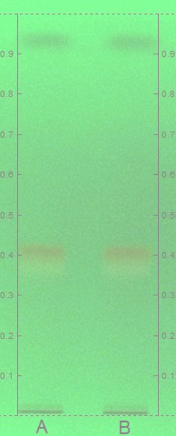 |  |  | 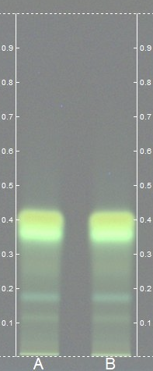 |  | 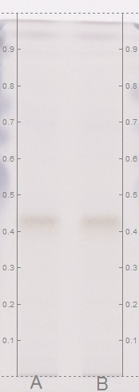
UV – 254 nm |  |  | UV – 366 nm |  | V - S Reagent
Solvent System: Toluene : Ethyl acetate : Formic acid (7.0: 3.0: 0.01) 8 µl Track 1: Batch - I; Track 2: Batch - II

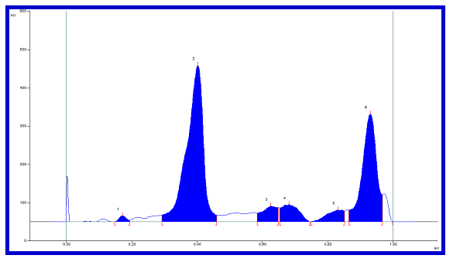
TLC plate was developed using Toluene: Ethyl acetate: Formic acid (7.0: 3.0: 0.01) as mobile phase. After development allow the plate to dry in air, record the finger print and densitometric chromatogram of the two batch samples of the single compound scanned at 254 and 366 nm.

Fig 3: HPTLC finger print of Sufoof Dama Haldi walain alcohol extract at 254 nm

(Absorbance mode)

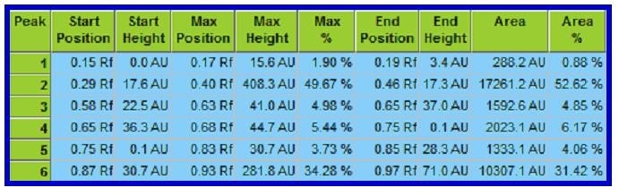
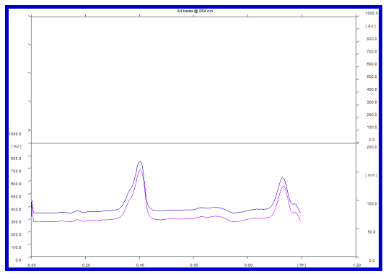
Fig 4: R_{f} values of Sufoof Dama Haldi walain alcohol extract at 254 nm (Absorbance mode)

Fig 5: Densitometric chromatogram in alcohol extract at 254 nm (Absorbance mode)

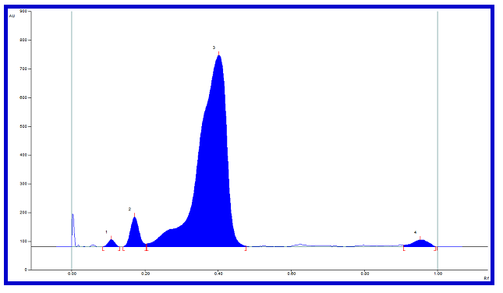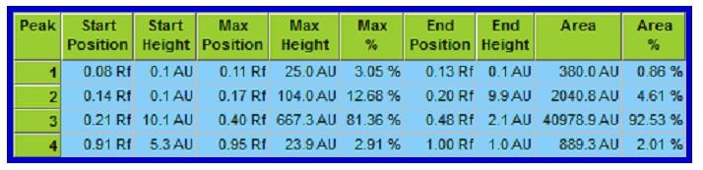
Fig 6: HPTLC finger print of Sufoof Dama Haldi wala in alcohol extract at 366 nm
(Absorbance mode)
Fig 7: R_{f} values of Sufoof Dama Haldi walain alcohol extract at 366 nm (Absorbance mode)

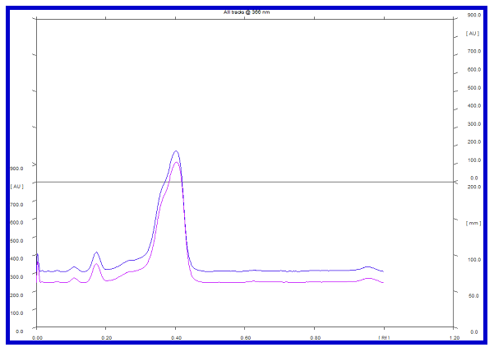

Fig 8: Densitometric chromatogram of Sufoof Dama Haldi wala in alcohol extract at 366 nm (Absorbance mode)

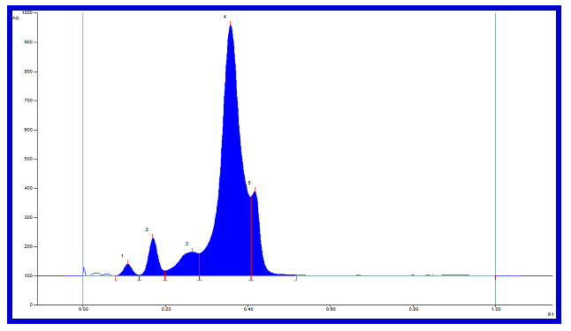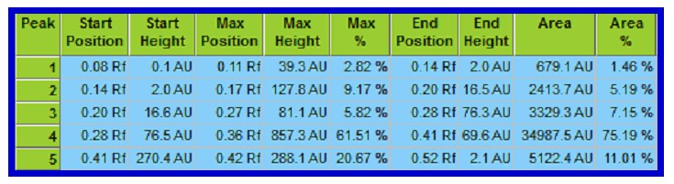
Fig 9: HPTLC finger print of Sufoof Dama Haldi walain alcohol extract at 366 nm
(Fluorescence mode)
Fig 10: R_{f} values of Sufoof Dama Haldi walain alcohol extract at 366 nm (Fluorescence
mode)

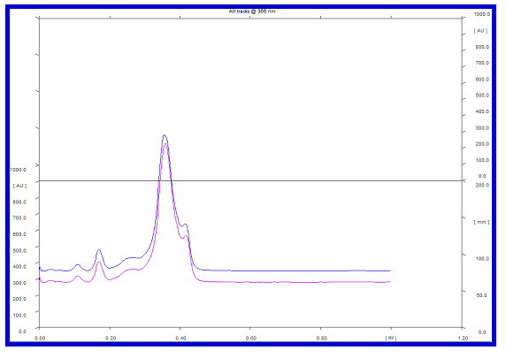
Fig 11: Densitometric chromatogram of Sufoof Dama Haldi walain alcohol extract at 366 nm (Fluorescence mode)
  - Microbial load
Table 4 represents the results of an investigation into the microbial load of turmeric-based Unani formulation. The number of microbes and fungi is below the permissible threshold. There is a lack of empirical evidence supporting the existence of harmful microbes, therefore making it a viable option for internal conception.

Table 4: Total bacteria, mould, and yeast count of turmeric-based Unani formulation

S. No. | Parameters | Results | Remarks
1 | Total Bacterial Count (TBC) | 1 x10⁴cfu/gram | Within permissible limits
2 | Total Fungal Count (TFC) | Less than 1 cfu/gram | Within permissible limits
3 | Enterobacteriaceae | Absent | Within permissible limits
4 | Escherichia coli | Absent | Within permissible limits
5 | Salmonella Spp | Absent | Within permissible limits

6 | Staphylococcus aureus | Absent
7 | Pseudomonas aeruginosa | Absent

    - Aflatoxin
The results of this test indicate that the amount of aflatoxin present in the turmeric based Unani formulation sample is below the detection level recommended by the World Health Organisation (2018) as shown in Table 5. Therefore, it can be concluded that the formulation is devoid of aflatoxin and may be considered safe for consumption.
Table 5: Quantification of aflatoxin using Afla-test fluorometer

S.No. | Parameters | Method / Reference | Results
1. | Total Aflatoxin  B1+B2+G1+G2 | Vicam Aflatest Fluorome  Instruction Manual | Below detection limit  1ppb

    - In-vitro antioxidant activity for turmeric based Unani formulation :
In the current study, evaluation of antioxidant activities of the turmeric based Unani formulation was done by using DPPH and ABTS assays. The DPPH radical scavenging activity of Sufoof Dama Haldi Wala was done in comparison to that of the synthetic antioxidant standard L- ascorbic acid. In this maximum inhibition was obtained in 100 mg/ml concentration and the percentage of inhibition is 72.54 were expressed in Table 6, with the IC 50 value of 64.14 mg/ml concentration. The same way in ABTS scavenging activity of the formulation at different concentrations from 50 to 150 mg/ml showed promising results at higher concentration (100 µg/ml ) with the 69.72 percentage of inhibition was showed in Table 7, with the IC 50 value of
57.74 mg/ml.
Table 6: DPPH assay of turmeric-based Unani formulation (Sufoof Dama
Haldi Wala)

Antioxidant assay | Concentration | % of inhibition | IC 50
DPPH | (S) 25 | 40.69 | 43.15
DPPH | (S) 50 | 53.93 | 43.15
DPPH | (S) 75 | 65.45 | 43.15
DPPH | (S) 100 | 81.56 | 43.15

 | (T) 25 | 28.3 | 64.14
 | (T) 50 | 40.76 | 64.14
 | (T) 75 | 54.57 | 64.14
 | (T) 100 | 72.54 | 64.14
(S)-Standard- L-ascorbic acid (1mg/ml); (T)- Test- Safoof Dama Haldi Wala (100mg/ml)

Table 7: ABTS assay of turmeric based Unani formulation

Antioxidant assay | Concentration | % of inhibition | IC 50
ABTS | (S) 25 | 43.73 | 40.86
ABTS | (S) 50 | 53.4 | 40.86
ABTS | (S) 75 | 64.31 | 40.86
ABTS | (S) 100 | 77.55 | 40.86
ABTS | (T) 25 | 36.72 | 57.74
ABTS | (T) 50 | 44.55 | 57.74
ABTS | (T) 75 | 57.55 | 57.74
ABTS | (T) 100 | 69.72 | 57.74
(S)-Standard- L-ascorbic acid (1mg/ml); (T)- Test- Safoof Dama Haldi Wala (100mg/ml)

The results indicate that the turmeric based Unani formulation was a tasteless, pale yellowish black, glossy fine powder. The quality criteria have been formulated based on comprehensive physico-chemical examination. The microbial load assay yielded results that were within the acceptable range, and no microbes were detected in the produced formulation. The elemental analysis has revels fascinating discoveries.

- Conclusion:
Evaluating the quality of herbal formulations is crucial to determine their suitability in modern medicine. The increasing acceptability of Unani medicine among the general population might be attributed to its holistic approach in treatment of diseases and the minimal occurrence of adverse effects associated with Unani herbal treatment. The evaluation was conducted based on a range of physico-chemical, qualitative, and
quantitative
Comment [h7]: Physicho-chemical and fingerprinting has been established but quantitative chemical data has not been established.
criteria. The results of this study can

serve as a definitive reference for the turmeric based Unani formulation and will undoubtedly guide future research in pharmacology, pharmaceuticals, and clinical investigations related to this formulation.

Ethical approval
As the work is purely an in-vitro study, ethical clearance is not re quired.
Declaration of Competing Interest
The authors declare no conflict of interest.
References:
[1]. File TM*., The epidemiology of respiratory tract infections. (2000), 15(3):184-194 https://doi.org/10.1053/srin.2000.18059 PMID: 11052419 ;Review
[2]. Del-Rio-Navarro, B. E., Espinosa-Rosales, F. J., Flenady, V., & Sienra-Monge, J. J. (2012). Cochrane Review: Immunostimulants for preventing respiratory tract infection in children. Evidence-Based Child Health: A Cochrane Review Journal, 7(2), 629 717. doi:10.1002/ebch.1833
[2]. Fanta CH. Asthma: N Engl J Med 2009; 360: 1002-14.
[3]. Cavkaytar O, Sekerel BE. Baseline management of asthma control. Allergol Immunopathol (Madr) 2014; 42: 162–8.
[4]. Burney P, Jarvis D, Perez Padilla R. The global burden of chronic respiratory disease in adults. Int J Tuberc Lung Dis 2015; 19: 10–20.
[5]. Satheesh NV, Kumud U, Asha B. Phytochemical screening and standardization of poly herbal formulation for Dyslipidemia. International Journal of Pharmacy and Pharmceutical Science 2011;3(3):235-38.
[6]. Fazmiya MJA, Sultana A, Heyat MBB, Parveen S, Rahman K, Akhtar F, Khan AA,
Alanazi AM, Ahmed Z, Díez IdlT, Ballester JB and Saripalli TSK (2024), Efficacy of a vaginal suppository formulation prepared with Acacia arabica (Lam.) Willd. gum and Cinnamomum camphora (L.) J. Presl. in heavy menstrual bleeding analyzed using a machine learning technique. Front. Pharmacol. 15:1331622. doi: 10.3389/fphar.2024.1331622.
[7]. Razi Z. Kitab Al Hawi, Part- IV, Matba Dairatul Muarif, Usmania Hyderabad; 1957. p. 1-2.

[8]. Tabri R. Firdaus al-Hikmat fit Tibb (Tasheeh was Takhreej), Dr. Zubair Ahmad Siddiqui, Matba Aftab Barlin; 1928. p 204-5.
[9]. Majusi A. Kamil-us-Sana, Vol-1, (Urdu Translation) Idara Kitab Alshifa, Dariya Ganj, Delhi; 2010. p. 490-92.
[10]. Khan MA. Akseer-e-Azam, Matba Nizami Kanpur; 1289H. p. 126-28. 23. Khan MA.
Haziq, Siddiqui Kitab Ghar, Lahore; 1978. p. 137-39.
[11]. Anonymous. Standard Unani treatment guidelines for common diseases. Central Council for Research in Unani Medicine. Volume II; 2016. p. 42-44. ISBN: 81-87748-42-7.
[12]. S. Tirumala santhosh kumar, J John Christopher1, S.A Wasim Akram, S.Mageswari, A. Jaculin Raiza, Rampratap Meena, N.Zaheer Ahmed*, P.Meera Devi Sri R. Selva Rani, Pharmacognostical and HPTLC Fingerprint analysis of Pterocarpus santalinus Linn.- Heart Wood in in Chloroform extract, 2022 JETIR February 2022, Volume 9, Issue 2 www.jetir.org (ISSN-2349-5162).
[13]. De La Sante OM. Quality control methods for medicinal plant materials, 559, rev.1, Original English, World Health Organisation.1992:159.
[14]. Sriwastava NK, et al. Standardization of Ajmodadi churna, a polyherbal formulation. Pharmacognosy Research. 2010;2(2):98-101.
[15]. Anonymous, National Fromulary of Unani Medicine, Government of India, Ministry of Health and Family Welfare (Department of AYUSH), New Delhi. 2011:105.
[16]. Kabiruddin, M. n.d. Bayaz-e-Kabir (Urdu). Vol 2nd. New Delhi: Aijaz Publishing House. pp.71.
[17]. Madhav, N.S., Upadhyaya, K. and Bisht, A.S.H.A., 2011. Phytochemical screening and standardization of polyherbal formulation for dyslipidemia. International Journal of Pharmacy and Pharmaceutical Sciences, 3(3), pp.235- 238
[18]. Raghubanshi. 2020. Scientific validation and standardization of Amal-e-Ehraq- A Unani
pharmaceutical process. M.D.- Unani Thesis. University of Delhi.
[19]. Rather, G.J., Ikram, M., Fatima, S. and Naquibuddin, M.D., 2018. Physicochemical Standardization of Polyherbal Powder Formulation: Safoof-e Makhana. Pharmacognosy Journal, 10(5).
[20]. Anonymous, 2007. The Ayurvedic Pharmacopoeia of India. Part 2, 1st ed. Ministry of Health and Family Welfare, Department of AYUSH, Government of India, New Delhi, pp. 141.

[21]. ABM, H.U., Reem, S.K., Mohamed, A., Abdulrahman, M.A., Abdulrazak, K., Abbas, S.A., 2016. Comparative study of three digestion methods for elemental analysis in tra ditional medicine products using atomic absorption spectrometry. J. Anal. Sci. Technol. 7, 6–13.
[22]. Anna, T., Kinga, W., Wojciech, M.W., 2019. Digestion procedure and determination of heavy metals in sewage sludge—an analytical problem. Sustainability 11, 1753.
[23]. Barbara, B.K., 2003. Preparation of Samples for Metals Analysis, Chapter 5.
[24]. Mahesh Kancherla, Mary Shamya A, Athar Parvez A, Zaheer Ahmed N, Rampratap Meena, Mohammed Younis Dar., Physicochemical, Heavy Metal Analysis, HPTLC, Gas Chromatography-Mass Spectrometry, Antibacterial, and Antioxidant Activity of an Ethanol Extract of Viola pilosa Blume Whole Plant Journal of Herbal Medicine 42 (2023) 100812, https://doi.org/10.1016/j.hermed.2023.100812.
[25]. The Unani Pharmacopoeia of India, 2016. Part – II, Volume - III (Formulations) 5 th Ed. [26]. World Health Organization (WHO), 2007. WHO guidelines for assessing quality of herbal medicines with reference to contaminants and residues, Geneva, Switzerland.
[27]. Srinivasan RM, Chandrasekar MJ, Nanjan MJ, Suresh B (2007) Antioxidant activity of Caesalpinia digyna root. J. Ethnopharmacol 113(2):284-91. https://doi.org/10.1016/j.jep.2007.06.006.
[28]. Prior, R. L., Wu, X. & Schaich, K. Standardized methods for the determination of antioxidant capacity and phenolics in foods and dietary supplements. J. Agric. Food Chem. 53, 4290–4302 (2005).
[29]. Ali, W., Shaikh, H., Ansari, A., Khanam, S., 2016. Standardization of Unani antidiabetic tablet - Qurse Tabasheer. Pharmacogn. Res. 8 (2), 147–152.
[30] Physicochemical standardization of Unani formulations. Part IV. New Delhi; CCRUM, Ministry of Health and Family Welfare, Govt. of India. 2006;142- 145,157-160.
[31]. Sangeeta, M., Anindya, B., Purnendu, P., Rao, M.M., 2016. Pharmacognostic, physico
chemical and chromatographic characterization of Samasharkara Churna. J. Ayurveda. Integr.
Med. 7 (7), 88–99.
[32]. The Unani Pharmacopeia of India, 2007. GOI, Dept. of AYUSH, Ministry of Health and Family Welfare, New Delhi. pp. 15.

