PHYSICO-CHEMICAL STATUS OF SURFACE WATER AND SEDIMENTS OF BONNY RIVER AFTER FUSOKIRI-6 MANIFOLD SPILL IN THE NIGER DELTA

Abstract
Surface waterand sediments are important natural resources and their physical, chemical and biological characteristics vary over time as a result of contaminable alterations of their dynamic equilibrium, thus the need for systematic monitoring and evaluation, even long after an oil spill incident. Accordingly, samples were collected at different points of the Creeks affected by the Fusokiri manifold oil spill at Bonny in Niger Delta, and subjected to physicochemical evaluation. The acidic pH values of sedients (4.19 for the NLNG-SPDC sediment samples, 4.43 for the Fibiri creek and 4.39 for the Iwoama creek sediments) are not within the WHO (World health organization) and NURPC (Nigerian Upstream Petroleum Regulatory Commission) benchmark of 6,4-8.5. The dissolved oxygen (DO) and other physicochemical properties also exceeded the baseline limits. The exceeded limits of WHO and NURPC for concentrations of heavy metals, especially the higher-than-normal concentration of Pb, pose major public health risks, such as lead poisoning. Therefore, there is need for periodic monitoring to determine the extent remediation action and restoration of water body, several months after the Fusokiri-6 oil spill, especially in view of the socio-economic and ecological significance of the Bonny River .

INTRODUCTION
The physicochemical properties of river water are important water quality parameters. Rivers are dynamic systems that respond to various physicochemical characteristics. Therefore, monitoring the physicochemical water quality plays a pivotal role in assessing the environment, ecosystem, hydrochemistry and ecology. Various factors like temperature, turbidity, nutrients, hardness, alkalinity, and dissolved oxygen play an important role for the growth of plants and animals or thein the water body. On the other hand, biological oxygen demand and chemical oxygen demand indicate the level of pollution of the water body. Aquatic organisms need a healthy environment to live and have adequate nutrients for their growth. The productivity depends on the physico-chemical characteristics of the water body (Onuigbo, 2025).
The maximum productivity obtained when the physical and chemical parameters are at the optimum level. Water quality plays an important role in decision making process for pollution control. Researches on the water quality aspects are of paramount significance in developing fresh water quality. Therefore, water quality is paramount factor in ecosystem productivity.
The Niger Delta region is mostly covered by the rain forest and the occupation of majority of the people in the region is fishing and farming. The region also produces and supplies abundant food made available for trade and consumption all year round. The rain forest in the Delta region is linked to the Atlantic Ocean and making the Niger Delta one of the most relevant wetlands with a rich, complex, but fragile, ecosystem. The petroleum industry began dominance in the economy of the nation and political arena from the first quarter of 1960s. Multinationals in the oil business entered oil and gas exploration in Nigeria and these firms include the Texaco Overseas Nigeria Petroleum Company Unlimited in 1961, Gulf Oil Company in 1961 (now Chevron), Société Africaine des Pétroles (SAFRAP) in 1962 (which later became Elf Nigeria Limited in 1974), Tennessee Nigeria Limited (Tenneco) in 1962, Azienda Generale Italiana Petroli (AGIP) in 1962, Multinational Oil Company (ENI) in 1964, Philips Oil Company in 1964 and Pan Ocean Oil Corporation in 1972. These multinational oil firm had significant level of success in crude oil exploitation and exploration in onshore and offshore fields in the Niger Delta. The Niger Delta oil prospects make Nigeria the biggest oil producer in Sub - Saharan Africa. Oil from this region is explored and exploited for the economic benefit of the country. During the exploration process, numerous waste is generated in varying quantity and are released into their immediate surroundings. For instance, during oil exploration, drill cuttings, mud and fluids are used for initiating production and hence contaminating the water bodies. Transportation of crude oil and other petroleum product during marketing, road accidents involving trucks carrying crude petroleum and tankers, pipeline rupture and sabotage generate oil spills and hydrocarbon emission that affects the soil, plant, animal and water resources (Onuigbo, 2025).
The Bonny River, consisting of several creeks, is one of oil spill prone areas of Niger Delta. The area located 25 miles (40 km) southeast of Port Harcourt in Rivers state of Nigeria, accounts for several spills that have had devastating effect on the river and adjoining mangroves. The area 217 illegal refineries and several oil facilities belonging the indigenous international oil companies (Omokheyeke, Omokheyeke et a., 2016)..
There have been repeated spills in the area primarily caused by illegal activities involving the tapping of transiting pipelines, extraction of crude oil using illegally installed valves and hoses to small and large vessels, transport to shore-based artisanal refineries, refining in steel drums heated by crude oil fire pits, and then refined product subsequently transported to Bodo in Ogoniland and other drop off locations on the mainland (Zabbey, and Uyi, 2014).
Oil spill has massive negative impact on the environment. These effects depend on factors such as the quantity and the type of spilled, the interaction of this spill on the aquatic environment. The prevailing weather conditions also affects the physical characteristics and its behaviour of the oil spill. This work looks at the remains of the impact of the Fusoliri-6 manifold spill on surface water and sediments six months after reported incidence of oil spillage in the area.

Materials and Methods
2.1 2.1 Study Area
The area of study is the Bonny creek in the south-eastern Niger Delta of Rivers State, Nigeria. The Bonny Estruary is an estruary on the coast of Rivers State, Nigeria. It is one of the network of creeks in the Niger Delta region that empties directly into the Atlantic Ocean at Bonny Island. It is tidal and thus receives a high influx of sea water most of the year (Dublin-Green, 1988). Large scale oil and gas production, industrialization and urbanization characterise the study location with reported impacts from oil spills, gas flares, industrial discharges, agricultural runoff and domestic effluents and leachates. The estuary also supports marine transportation by heavy vessels conveying goods and services to and from a petroleum tank farm, Port Harcourt wharf, cement and flour factories, among others, in addition to heavy traffic of fast speed boats for communal transportation. Despite these activities, artisanal fisheries in the estuary largely support the livelihood of its inhabitants who have little or no knowledge of the extent of contamination in the estuary. Fish remains an important part in the diet of Nigerians, especially for riverine communities such as the inhabitants of the study area, with seafood being served at almost every meal. In Nigeria, especially in rural and fishing communities, fish constitute approximately 75% of animal protein consumed. Fish is consumed either freshly prepared or smoked. Shellfish, especially the Tympanotonus species, are used largely as a condiment in most meals eaten in the Niger Delta (Gomna and Rana, 2007).
The area is dominated by mangrove swamp, similar in vegetation to the estuarine area of Niger Delta. The Bonny and Cross River estuaries are two major estuaries along the eastern coast of Nigeria. Ike the Cross River estuary, it is characterized by deep and shallow channels with semi-diurnal tides that generate tidal currents in phase with the tidal directions. The Bonny/New Calabar River Estuary system is vital to the people of Niger Delta and other surrounding regions. It is perhaps one of the largest arms of the River Niger discharging directly into the Atlantic Ocean. it is believed to also be the most environmentally stressed (Dublin-Green 1998). The Bonny estuary is vulnerable because it is exposed to multiple human activities such as petroleum industry operations. The present work seeks to evaluate status of hydrocarbons and heavy metals in water and sediments in the Bonny Estuary following a recent spill in the area. The consequence of unchecked exploitation is that the productivity of fisheries and important ecosystems, such as mangroves and coral reefs, reduces, which in turn affect the local community which depend on these resources for economic development.
2.2. The oil spill incidence
The oil spillage (cf: Figs 1-3), which turned out to be a major spill owing to perceived lapses at mitigating the cause of the failure of the oil-bearing equipment, occurred on Sunday the 4th of July 2021. The oil spill emanated through some of the oil pipelines criss-crossing the creeks of Bonny River, traceable to Fusokiri Ceek-6 manifolds and Adamakiri Creeks 5 & 6 manifolds, pipelines on the Right of Way to Bonny Export Terminal. Crude oil arising from the pipeline leakage eventually spread to several adjoining creeks from the points of leak.
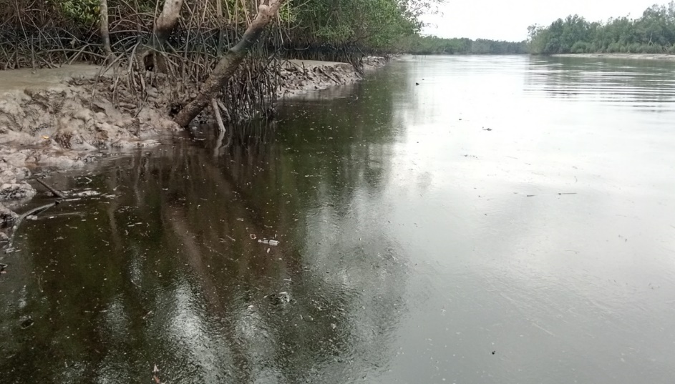

Fig. 1: A section of the Bonny River where oil spillage took place

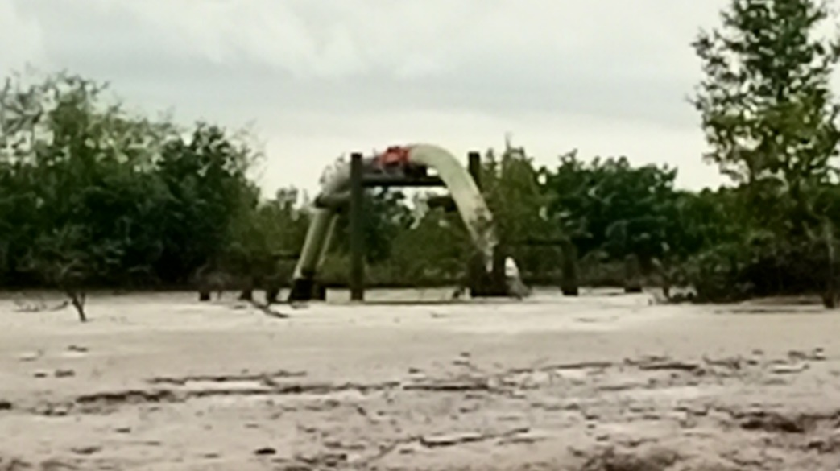
Fig. 2: A sectional vioew of Fusokiri-6 manifold pipeline
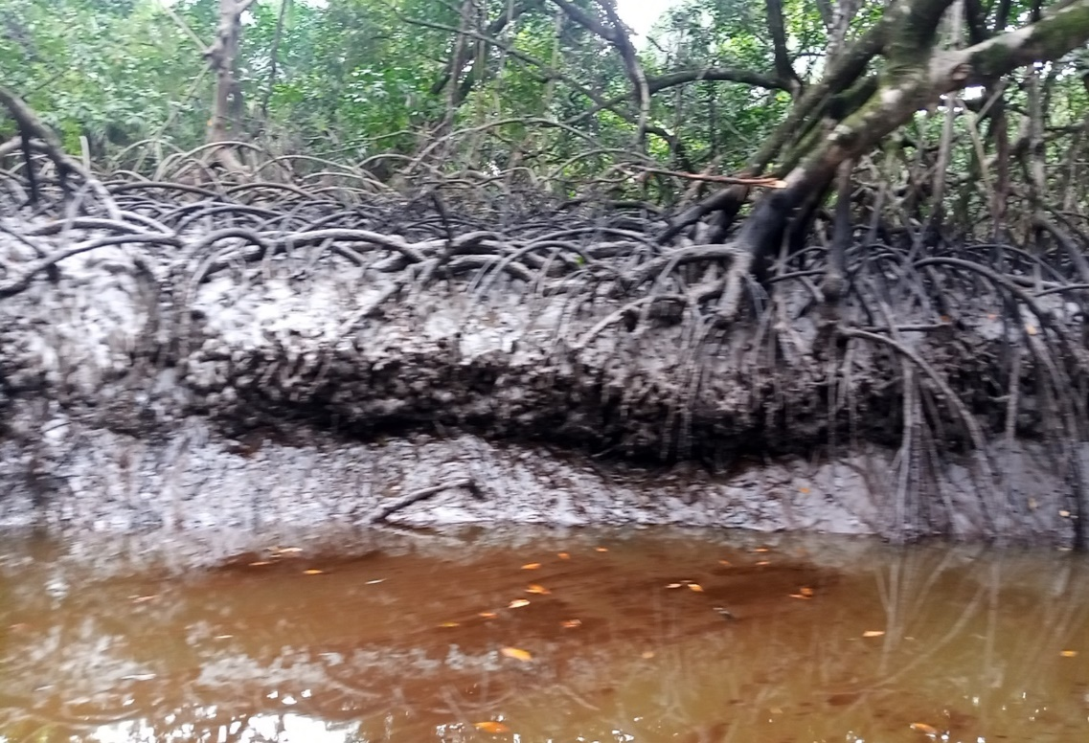
Fig. 3: Impacted site of Fusokiri-6 oil spill
Best practices in the oil and gas industry involve monitoring and evaluation of oil production facilities. Oil bearing pipelines or trunks, if not properly monitored and maintained by the operating company or companies, become susceptible to corrosion hacks, especially after a long period of time, as a result of salt intrusion which exacerbates the electrochemical process of rust and subsequent corrosion of the pipes. Corrosion and the resultant leak of crude oil would occur as a response to negligence, irrespective of who owns or inherits the facilities or laid pipelines.
The consequences of not cleaning up, until the time of our reconnaissance survey, several weeks after the recorded incidence of spill may have caused the impact observed. Several creeks such as FIBIRI Creek (on Longitude 04º 58.449’N and Latitude 007º 01.240’E), IWOAMA creek (Longitude 04º 28.718’N and Latitude 007º 06.603’E), and KALABIE (Longitude 04º 30.049’N and Latitude 007º 08.104’E) were heavily inundated by crude oil.
2.1 Description of the hydrogeology of study area
Bonny Island falls within the Beach ridges on-shore geomorphic sub-environment of the Delta. In the area, the hydrogeology is influenced to ferruginous sandy formation due to the vicinity surface aquifers' oxidation condition and dominant saline water intrusion (Ohwoghere-Asuma and Essi, 2017). The sand and clay form the principal aquifer and aquitard in the area, respectively. Also, the water table varies during the seasons. So that water table decreases in the dry season. By and large, the water table in the zone is dynamic and ranges between 0.1–3 m relying upon the season (Ohwoghere-Asuma et al., 2017). A few networks in Bonny Island are confronting an intense deficiency of consumable water because of high iron-water, saltwater interruption, and tidal impact. Thus, numerous boreholes have been surrendered in the territory (Nwankwoala and Udom, 2010).

2. 2 Data collection and procedure
The study collected surface water and sediment of four creeks/location along the Bonny River to examine the physicochemical characterization and molecular fingerprint distribution of oil spill in the environment. Details of the locations, and geographical coordinates of point of sample collections was presented in Table 1.
- Surface Water: Surface water samples were collected using the method of Ogbonna et al. (2021). Sterile 1.5 Litre bottles were used to aseptically collect the surface water. The samples were collected at four different locations in the direction of water flow. To collect the surface water, base of the sterilized sample container was held with one hand, plunged about 30 cm below the water surface with the mouth of the sample container positioned in an opposite direction to water flow. After collection, the samples were placed in a cooler containing ice blocks and transported immediately to the laboratory for analysis.
- Sediment: Sampling was carried out from 4 designated locations in the creeks and rivers. Surface sediment samples were collected at low tide by the grab method using Eckman grab sampler from 4 points at each location. The samples for trace metals were put in polythene bags previously washed in dilute HCl while those for organic matter were put in aluminium foils and stored in the laboratory by freezing.

Table 1: Locations and ggeographical coordinates of ppoint of sample ccollections

S/n | Location | Longitude | Latitude | SW | SD | Study Code | Study Code
1. | Fibiri Creek | 04º58.449’N | 007º01.240’E | Yes | Yes | FCSW | FCSD
2. | NLNG-SPDC | 04º29.656’N | 007º09.286’E | Yes | Yes | NSSW | NSSD
3 | Iwoama Creek | 04º28.718’N | 007º06.853’E | Yes | Yes | ICSW | ICSD
4. | Legakiri Creek | 04º29.118’N | 007º06.184’E | Yes | Yes | LCSW | LCSD
Key: Surface Water-SW, Sediment-SD

Sample analysis
Water temperature (Mercury-filled Celcius Thermometer), transparency (secchi disc method), turbidity (Nephelometric method, Systronic type No. 131), pH (Electronic digital instrument, model T-MS 30) and electrical conductivity (electrometric method) were estimated at the spot and rests of the parameters were determined in the laboratory within five hours of collection. Total suspended solids were measured by oven-dried method; total dissolved solids were estimated by filtration and oven dried method. Acidity was measured by titration method; dissolved oxygen (DO) was measured Winkler-azide modification method (APHA, 1985). Free carbon dioxide was measured titration method (APHA, 1985); Alkalinity was measured by titration method (Jenkins and Moore, 1977). Hardness was estimated by following EDTA titration method. Calcium and magnesium were measured by gravimetric method (Saxena and Saxena, 2013). Biochemical oxygen demand (BOD₅) was measured by five-day BOD test (APHA 1992). Chemical Oxygen Demand (COD) was measured by open reflux method. Sulfate was measured by gravimetric method with drying residue; phosphate was estimated by stannous chloride method (Saxena and Saxena, 2013). Nitrite was estimated by colorimetric method (APHA, 1985). Sodium and potassium were measured by using the Flame photometer (Burner unit 121, Digital FOPM-125) (Saxena and Saxena, 2013). Total iron was measured by Spectrophotometer (phototube 880 nm) phenanthroline method (APHA, 1985).
Results and Discussion
From Table 2, the physicochemical concentration of various parameters in surface water and sediment from four (4) locations in Bonny was presented. Concerning the surface water, the analysis indicated that the pH was 7.06 for FCSW, 7.03 for NSSW, 6.28 for ICSW and 6.74 for LCSW which ranged from 6.28-7.06 which is within the NUPR range of 6.5-8.5. The temperature of the sample ranged from 28.8˚C for NSSW to 29.7˚C for FCSW and all values are within the permissible limit of NUPR. The EC of surface water samples was 18280, 18380, 18250 and 18020 for FCSW, NSSW, ICSW and LCSW respectively. The TDS ranged from 9550.6 for LCSW to 9741.4 for NSSW and all the samples exceeded the NUPR limit for surface water at 5000mg/l. Similarly, the TSS of the samples ranged from 4.2 for LCSW to 0.6 for FCSW, however, all samples are within the permissible limit of NUPR. The turbidity of the samples are 0.4, 0.5, 2.3 and 2.8 for FCSW, NSSW, ICSW and LCSW respectively and within the NUPR limit while the DO showed that FCSW has the lowest concentration at 6.3 and LCSW has the highest concentration at 7.26 and all concentration exceeded the standard limit of NUPR. The COD of the surface water samples ranged from 114.4 for FCSW and ICSW to NSSW and LCSW and all within the standard permit for surface water. Similarly, the acidity and alkalinity of the surface water samples ranged from 32 and 70 for FCSW, 48 and 52 for NSSW, 38 and 88 for ICSW and 40 and 90 for LCSW respectively. The samples’ salt in form of Chloride showed that the concentration ranged from 6027 for FCSW to 9572 for LCSW and all sample exceeded the NUPR standard limit. The surface water showed that FCSW has 4.31mg/l and 0.26mg/l NO₃ and PO₄ concentration respectively while NSSW has 4.24mg/l NO₃ and 0.29mg/l PO₄, ICSW has 4.63mg/l NO₃ and 0.38mg/l PO₄, and LCSW has 4.48mg/l NO₃ and 0.33mg/l PO₄. All concentration of NO₃ are within the NUPR and WHO permissible limit for surface water.
For the sample’s sediments, the pH was 4.43 for FCSD, 4.19 for NSSD, 4.39 for ICSD and 5.59 for LCSD which ranged from 4.19-5.59 which is below the NUPR range of 6.5-8.5. The temperature of the sample ranged from 28.6˚C for NSSD to 28.8˚C for FCSW, LCSD, and all values are within the permissible limit of NUPR. The EC of surface water samples was 4800, 5580, 4569 and 4200 for FCSW, NSSW, ICSW and LCSW respectively. The samples’ salt in form of Chloride showed that the concentration ranged from 709 for NSSD to 1205 for LCSD and all sample are within the NUPR standard limit of 2000mg/kg. The sample sediments showed that the TOC concentration ranged from 1.52mg/kg for NSSD to 2.03mg/kg for LCSD. The surface water showed that FCSW has 3.28mg/kg and 0.86mg/kg NO₃ and PO₄ concentration respectively while NSSW has 3.43mg/kg NO₃ and 0.71mg/l PO₄, ICSW has 3.66mg/l NO₃ and 0.92mg/l PO₄, and LCSW has 3.18mg/l NO₃ and 0.65mg/l PO₄. All concentration of NO₃ are within the NUPR and WHO permissible limit for surface water.
Table 2: Physicochemical Parameters of Surface Water and Sediment from Study Area

 | Fibiri Creek |  | NLNG-SPDC |  | Iwoama Creek |  | Legakiri Creek
*Parameter | FCSW | FCSD | NSSW | NSSD | ICSW | ICSD | LCSW | LCSD | NUPR | WHO
pH | 7.06 | 4.43 | 7.03 | 4.19 | 6.28 | 4.39 | 6.74 | 5.59 | 6.5-8.5 | 6.5-8.5
Temp (˚C) | 29.7 | 28.8 | 28.9 | 28.6 | 29.6 | 28.7 | 29.4 | 28.8 | Ambient±2 | 27.8-30
EC | 18280 | 4800 | 18380 | 5580 | 18250 | 4569 | 18020 | 4200 | - | 1000µS/m
TDS | 9688.4 | NA | 9741.4 | NA | 9672.5 | NA | 9550.6 | NA | 5000mg/l | 2000
TSS | 0.6 | NA | 0.75 | NA | 3.45 | NA | 4.2 | NA | 50mg/l
Turbidity | 0.4 | NA | 0.5 | NA | 2.3 | NA | 2.8 | NA | 15NTU
DO | 6.3 | NA | 6.55 | NA | 7.14 | NA | 7.26 | NA | 5mg/l | 20
COD | 114.4 | NA | 121.2 | NA | 114.4 | NA | 121.2 | NA | 125mg/l
BOD  Acidity | 3.54  32 | NA  NA | 2.83  48 | NA  NA | 3.58  38 | NA  NA | 3.60  40 | NA  NA
Alkalinity | 70 | NA | 52 | NA | 88 | NA | 90 | NA
Chloride | 6027 | 852 | 7445 | 709 | 7090 | 780 | 9572 | 1205 | 2000mg/l | -
*TOC | NA | 1.95 | NA | 1.52 | NA | 1.68 | NA | 2.03
*NO₃ | 4.31 | 3.28 | 4.24 | 3.43 | 4.63 | 3.66 | 4.48 | 3.18 | 50mg/l | 50mg/l
*PO₄ | 0.26 | 0.86 | 0.29 | 0.71 | 0.38 | 0.92 | 0.33 | 0.65 |  | 5mg/l

*(mg/kg), SW= Surface Water, SD = Sediment, NUPR = Nigerian Upstream Petroleum Regulatory Commission; WHO = World Health Organization

Heavy metals
Assessment of heavy metals is essential in the evaluation of any environmental matrix. (Tiwar et al., 2010; Hameed et al., 2015; Pan et al., 2021; Uddin et al 2022). Table 3 presented the trace and heavy metal concentration of surface water and sediment from locations along bonny rivers. The surface water samples showed that the concentration of Na ranged from 29241.979mg/l for LCSW to 36428.591mg/l for FCSW, the K concentration ranged from 19933.555mg/l for LCSW to 28293.965mg/l for NSSW while the concentration Fe in the surface water sample ranged from 57.913mg/l for LCSW to 105.627mg/l for ICSW. The Ni concentration in the sample showed that FCSW has 43.883mg/l, NSSW has 44.099mg/l, and ICSW has 43.015mg/l while LCSW has concentration of 36.4mg/l. The Cd concentration in surface water ranged from 12.059mg/l in LCSW to 14.225mg/l in NSSW; however, all concentration exceeded the NUPR limit for Cd in surface water. The Se concentration in surface water ranged from 4.55mg/l in NSSW to 6.317mg/l in LCSW while the Zn concentration in surface water ranged from 5.653mg/l in LCSW to 9.658mg/l in FCSW and all concentration exceeded the NUPR limit of 5.0mg/l. The Pb in surface water showed that FCSW, NSSW, ICSW and LCSW has concentration of 61.296mg/l, 61.935mg/l, 60.0mg/l and 53.548mg/l and all concentration exceeded the NUPR limit of 5.0mg/l. The Cr concentration in surface water ranged from 73.684mg/l in LCSW to 91.228mg/l in FCSW while the Cu concentration in surface water ranged from 5.478mg/l in LCSW to 7.562mg/l in ICSW and all concentration of Cr and Cu exceeded the NUPR limit of 0.5.0mg/l and 1.5mg/l respectively.
The sediment samples showed that the concentration of Na ranged from 713.882mg/kg for LCSD to 837.323mg/kg for NSSD, the K concentration ranged from 1358.11mg/kg for LCSD to 2273.965mg/l for NSSD while the concentration Fe in the sediment sample ranged from 1526.612mg/kg for FCSD to 1557.444mg/kg for ICSD. The Ni concentration in the sample showed that FCSD has 47.786mg/kg, NSSD has 52.232mg/kg, and ICSD has 48.437mg/kg while LCSW has concentration of 60.04mg/kg. The Cd concentration in sediment ranged from 12.824mg/l in ICSD to 17.495mg/l in LCSD; however, all concentration exceeded the NUPR limit for Cd in sediment. The Se concentration in sediment ranged from 5.872mg/kg in LCSD to 6.966mg/kg in ICSD while the Zn concentration in surface water ranged from 29.12mg/kg in FCSD to 44.618mg/kg in LCSD and all concentration exceeded the NUPR limit of 5.0mg/l. The Pb in sediment showed that FCSW, NSSW, ICSW and LCSW has concentration of 52.903mg/kg, 57.484mg/kg, 54.929mg/kg and 65.148mg/kg and all concentration exceeded the NUPR limit of 5.0mg/kg. The Cr concentration in sediment ranged from 42.105mg/kg in FCSW to 60.04mg/kg in LCSW while the Cu concentration in sediment ranged from 7.176mg/kg in FCSW to 10.262mg/kg in ICSW and all concentration of Cr and Cu exceeded the NUPR limit of 0.5.0mg/kg and 1.5mg/kg respectively.

Table 3: Trace and Heavy Metals Concentration of Surface Water and Sediment

 | Fibiri Creek |  | NLNG-SPDC |  | Iwoama Creek |  | Legakiri Creek
TM/HM  (mg/l) | FCSW | FCSD | NSSW | NSSD | ICSW | ICSD | LCSW | LCSD | NUPR (mg/l)
Na | 36428.591 | 755.875 | 36268.095 | 837.323 | 35749.857 | 813.558 | 29241.979 | 713.882 | NL
K | 28074.915 | 2234.311 | 28293.965 | 2273.74 | 25592.348 | 1840.02 | 19933.555 | 1358.11 | NL
Fe | 60.258 | 1526.612 | 71.043 | 1539.859 | 105.627 | 1557.444 | 57.913 | 1549.355 | NL
Ni | 43.883 | 47.786 | 44.099 | 52.232 | 43.015 | 48.437 | 36.4 | 60.04 | NL
Cd | 13.503 | 14.225 | 14.395 | 13.503 | 13.333 | 12.824 | 12.059 | 17.495 | 1
Se | 5.56982 | 5.962 | 4.55 | 6.898 | 5.585 | 6.966 | 6.317 | 5.872
Zn | 9.658 | 29.12 | 8.74 | 42.72 | 9.408 | 36.024 | 5.653 | 44.618 | 5
Pb | 61.296 | 52.903 | 61.935 | 57.484 | 60 | 54.929 | 53.548 | 65.148 | 5
Cr | 91.228 | 42.105 | 83.088 | 52.232 | 87.719 | 48.437 | 73.684 | 60.04 | 0.5
Cu | 6.944 | 7.176 | 7.022 | 10.262 | 7.562 | 8.565 | 5.478 | 7.87 | 1.5
SW= Surface Water, SD = Sediment, NUPR = WHO = World Health Organization

Conclusion
The pH level in sediment with acidification is a pointer of heavy metals pollution in the environment. The TDS of all samples exceeded the permissible limit while the turbidity of the surface water are within the permissible limit for surface water quality. The DO of the surface water samples exceeded the NUPR limit while the COD concentration are within the permissible limit. The Cl (in form of salt) found in the surface water exceeded NUPR limit while that of the sediments are found within the permit. The concentration of Fe, Ni, Cd, Cu, Zn, Se, Pb and Cr reported exceeded the standard limit of NUPR and WHO for surface water and sediment across the studied locations (EGASPIN-NUPRC, 2022)..
The exceeded limits of WHO (World Health Organization) and NURPC (Nigerian Upstream Petroleum Regulatory Commission) for concentrations of heavy metals, especially the higher-than-normal concentration of Pb, pose major public health risks, such as lead poisoning. Therefore, there is need for periodic monitoring to determine the extent remediation action and restoration of water body, several months after the Fusokiri-6 oil spill, especially in view of the socio-economic and ecological significance of the Bonny River .

References
APHA (1985) Standard Method for the Examination of Water and Wastewater. 16th Edition, American Public Health Association, Washington DC.
APHA. (1992). Standard methods for the examination of water and wastewater. 18th ed. American Public Health Association, Washington, DC.
Dublin-Green, W. F. (1998). Future potential of Nigeria. AAPG Bull. 82 DOI: 10.1306/1D9BD745-172D-11D7-8645000102C1865D.
EGASPIN-NUPRC. (2022). Environmental Guidelines and Standards for the Petroleum Industry in Nigeria. Nigeran Upstream Petroleum Regulatory Commission.
Gomna, A. and Rana, K. (2007). Inter-household and intra-househpld patterns of fish and meat consumption in fishing communities in two states in Nigeria. British Journal of Nutrition 97 (1): 145-152.
Hameed, A., Alobaidy, M. J., Abid, H. S. and Maulood, B. K. (2010). Application of water quality index for assessment of Dokan Lake ecosystem, Kurdistan Region. Iraq Jurnal of Water Resources Protection, 2 (9): 792-798. DOI: 10.4236/jwarp.2010.29093
Jenkins, S.R., Moore, R.C. (1977). A Proposed Modification to the Classical Method of Calculating Alkalinity in Natural Waters. AWWA 69(1), 56-60. https://doi.org/10.1002/j. 1551-8833.1977.tb02544.x
Ogbonna, D.N., Anthony, E.M. and Kpormon, L.B. (2023). Physicochemistry and Microbiological Quality of Surface Water Body around Port Terminals in Southern Nigeria. Microbiol. Res, 33(2),.54-60.
Ohwoghere-Asuma, O., Iserhien-Emekeme, R., Aweto, K.E., Ofomola, M.O. (2020). Geophysical investigation of resistivity and groundwater quality in Ogbe-Ijoh coastal area of the western Niger Delta of Nigeria. Appl Water Sci 10, 70. https://doi.org/10.1007/s13201-020-1144-0
Omokheyeke, O, Onojake, M.C., Sikoki, F.D. (2016). Total hydrocarbon profile and trace metal level in sediments from the upper Bonny estuary in southern Nigeria. Bulletin of Earth Sciences of Thailand, 7(1), 57-68.
Pan, H., Zhou, G., Yang, R., Cheng, Z., Sun, B. (2022). Heavy metals and as in groundwater, surface water, and sediments of dexing giant Cu-polymetallic ore cluster, east China. Water, 14, 352. https://doi.org/10.3390/w14030352
Saxena, U. and Saxena, S. (2013). Statistical Assesment of ground water quality using physico-chemical parameters in Bassi Tehsil of Jaipur District, Rajasthan, India. Global Journal of Science Frontier Research, 13(3),.1.
Tiwari, M.K., Bajpai, S., Dewangan, U.K., Tamrakar, R.K. (2015). Assessment of heavy metal concentrations in surface water sources in an industrial region of central India. Karbala International Journal of Modern Science, 19e14
Uddin, Md.G., Nash, S., Obert, A. I. (2021). A review of water quality index models and their use for assessing surface water quality. Ecological Indicators 122, 107214.
Zabbey, N., Uyi, H. (2014). Impact of oil exploration and production activities on the Niger Delta Region of Nigeria. Journal of Ecology and the Natural Environment, 6(2), 39-50. https://doi.org/10.5897/jene2013.0459

