Genome-scale screening, characterization, and expression analysis of Sorghum bicolor Caffeoyl -Co-A Methyltransferase (CCoAOMT) gene family in response to drought and salinity stress

Abstract:
Sorghum bicolor is the world's fifth most widely farmed cereal crop and staple grain for millions of people, cultivated predominantly for seeds, fodder, sugar, fibre and biomass. Lignin is an essential cell wall element found in most terrestrial plant species, offering plant cells rigidity. Emerging research reveals that the composition and extent of lignification in distinct plant tissues are responsible for stress tolerance to abiotic and biotic stressors. The enzyme Caffeoyl coenzyme-A O-methyltransferase (CCoAOMT) methylates caffeoyl-CoA resulting in the production of feruloyl-CoA, which is essential for the biosynthesis of both G- and S-lignin. CCoAOMT is the most crucial enzyme and its role in abiotic stress is not yet completely explored in Sorghum. In the present research, the CCoAOMT gene family in Sorghum was comprehensively characterized in silico by examining its structural, functional, molecular and evolutionary characteristics, and expression trends in response to drought and salinity stress. A total of 7 CCoAOMT gene members have been discovered in the Sorghum genome. These gene family members exhibited high sequence and syntenic conservation with Maize and Oryza. Transcription factor and promoter analysis of the SbCCoAOMT gene family revealed that these genes may play important roles in lignin biosynthesis, defense and various abiotic stress responses. Furthermore, in silico expression analysis and expression profiling by RT-qPCR displayed significant changes in SbCCoAOMT transcripts under drought and salinity stress conditions. This study will serve as a foundation for altering lignin biosynthesis to improve the abiotic stress tolerance of this economically and industrially important crop.

Keywords: Sorghum bicolor, biomass, CCoAOMT gene, lignin, abiotic stress.

Introduction:
The C4 grass sorghum (Sorghum bicolor) is being developed for use as a feedstock for biofuel production. Due to its high levels of drought tolerance and potential for growth in low-nutrient environments, this crop can be cultivated sustainably on marginal soils. Sorghum is a suitable crop for bioenergy exploration due to its smaller diploid genome (730 Mb) and diverse genetic resources, including a highly efficient reference genome (Paterson et al., 2009). Sorghum has been cultivated as forage for hay and grazing in many semi-arid regions across the world, and it is just now being explored as a lignocellulosic feedstock for biofuel production. All sorghum species (sweet sorghum, forage sorghum, and Sudan grass (Sorghum bicolor var. sudanense)) and their hybrids have significant promise as key annual bioenergy crops. Optimizing biomass yields and composition is needed to foster the alternative use of lignocellulosic sources for petroleum-based chemical precursors (Sarath et al., 2008; Foley et al., 2011; Perlack et al., 2011).
The cell walls, composed of the three principal polymers cellulose, hemicellulose, and lignin, are an important target for improving the bioenergy conversion of sorghum biomass into biofuels and other renewable demands. Lignin is an aromatic phenolic polymer embedded in vascular plant cell walls that contributes to 18-35% of total plant biomass (Boerjan et al., 2003). Lignin and its associated metabolites serve vital functions in plant development as well as growth. Lignin, as a complex phenolic polymer, improves plant cell wall stiffness, hydrophobic characteristics, and mineral transport via the vascular bundles of plants (Schuetz et al., 2014). The principal lignin molecules that compose the cell wall are p-hydroxyphenyl (H), guaiacyl (G), and syringyl (S) units, which get polymerized from the corresponding monolignols, p-coumaryl, coniferyl, and sinapyl alcohols respectively. These aromatic monolignols are synthesized from phenylalanine and tyrosine through an array of processes that include deamination, hydroxylation, methylation, and reduction (Boerjan et al., 2003).
One of the principal enzymes responsible for the synthesis of lignin in plants is caffeoyl-CoA 3-O-methyltransferase (CCoAOMT) (Zhong et al., 1998; Chen et al., 2000). Caffeoyl-coenzyme A O-methyltransferase (CCoAOMT) is a crucial enzyme in monolignol production that influences lignification efficiency and lignin composition. Caffeoyl-coenzyme A 3-O-methyltransferase (CCoAOMT) is an O-methyltransferase that requires S-adenosyl methionine (SAM) to methylate the meta-hydroxyl group of caffeoyl-coenzyme A (CoA) in the monolignol biosynthesis pathway to yield feruloyl-CoA, an intermediate that is crucial to the biosynthesis of both G- and S-lignin. CCoAOMTs and CCoAOMT-like enzymes belong to the O-methyltransferases family, and they are distinguished by a molecular weight range of 26 to 29 kDa and the presence of divalent metal ions in the enzyme's active site (Ferrer et al., 2005; Joshi et al., 1998; Lee et al., 2008; Liu et al., 2016; Walker et al., 2016; Widiez., 2011). Despite their similarities, CCoAOMTs are substrate-specific and use one of two methyl acceptors, caffeoyl-coenzyme A or 5-hydroxy feruloyl-coenzyme A, whereas CCoAOMT-like enzymes use a wide range of compounds that include phenylpropanoids or alkaloids, flavonoids, anthocyanins. (Ibdah et al., 2003; Chen et al.,2000). CCoAOMTs provide the precursors for coniferyl and sinapyl alcohols, these are subsequently employed in the biosynthesis of lignin (Barros et al., 2015; Guo et al., 2001; Raes et al., 2003; Vanholme et al., 2010), and CCoAOMT-like enzymes, which catalyzes a wide range of substrates, are involved in various types of secondary metabolism pathways, which are often plant specific.
The function of CCoAOMT in lignin production was originally identified in Z. violacea and N. tabacum, where the enzyme was found across all lignified tissues (Maury et al., 1991; Ye et al., 1994; Zhong et al., 1998). Transgenic plants with altered CCoAOMT gene expression (Guo et al., 2001; Ye et al., 2001) provided direct proof of the role of CCoAOMT in lignin biosynthesis. Plants with a CCoAOMT gene knockout exhibited lower lignin content, which coincided with Vascular bundles that have collapsed, shorter height, lesser biomass, and delayed development (Do et al., 2007). Plants with downregulated CCoAOMT genes are displaying altered lignin monomer composition due to variations in the synthesis of syringyl and guaiacyl monolignols (Zhong et al., 1998; Chen et al., 2000; Pinçon et al., 2001; Li et al., 2013; Pang et al., 2014; Toraman et al., 2016;). Overexpression of CCoAOMT had the reverse impact, resulting in increased lignin content, height of plant, and silique length. (Zhang et al., 2014).
Several scientific reports suggest that CCoAOMT-like enzymes could play a role in monolignol production. Most CCoAOMT-like enzymes are related to species-specific activities (Ibdah et al., 2003; Kopycki et al., 2008; Widiezet al., 2011), although Walker et al (2016) proposed that sorghum enzymes from this family methylate a common substrate as substrate-specific CCoAOMTs. Recent findings reveal that the function of substrate-specific CCoAOMTs extends beyond secondary cell walls and lignin synthesis. The gene encoding CCoAOMT from petunia has been proven to play a role in the phenylpropene pathway, which leads to the production of volatile, aromatic attractants in petals (Tamagnone et al., 1998). AtCCoAOMT1 may enhance drought tolerance through Reactive oxygen species and ABA-dependent signaling pathways (Chun et al., 2021). Overexpression of the CCoAOMT gene from Paeonia ostii in tobacco, enhanced drought tolerance by increasing lignin quantity and reactive oxygen species (Zhao et al., 2021). In maize, ZmCCoAOMT2 associates with NLR Rp1 to regulate plant defense responses (Wang et al., 2016).
Due to its significance, the CCoAOMT gene family has undergone extensive research and analysis in numerous plants, including Arabidopsis and rice (Hamberger et al., 2007), citrus (Liu et al., 2016), switchgrass (Liu et al., 2016), dove tree (Wu et al., 2019), tea plant (Lin et al., 2021), and sorghum (Rakoczy et al., 2018) wheat (Yang et al., 2021) and D. farinosus (Wei et al., 2023).

Materials & Methods
Stress induction and plant material:
Sorghum bicolor High biomass variety is an agronomically essential inbred line and it is drought stress tolerant. The germplasm of the S. bicolor high biomass cultivar was obtained from IIMR Rajendra Nagar, Hyderabad, and planted in pots filled with black soil. Seedlings were grown in a glass house atmosphere at 28/200C day/night temperatures. Sixty-day-old plants were treated for 48 hours each with a 200 mM NaCl solution and a 200 mM mannitol solution. In parallel controls (no treatment and well-watered) were kept in identical environments. After 48 hours of exposure, leaves stems, and roots were removed from treated and control plants snap-frozen in liquid nitrogen and kept at -800 C for future use. Two biological and three technical duplicates are used for the qRT-PCR study.

In silico prediction and Characterization of SbCCoAOMT homologs:
To identify the CCoAOMT gene family in sorghum, the protein sequences of the sorghum genome were derived from the Phytozome v13 database to be utilized as the local protein database. A BLASTP search against the local protein database using the CCoAOMT genes from Arabidopsis was conducted with an E-value cut-off of >1e-5. To anticipate the conserved protein domain, the predicted sorghum CCoAOMT genes were then presented to SMART (http://smart.embl-heidelberg.de/) and NCBI CDD search, and those which comprised the entire CCoAOMT domain were retained as candidates.
Evolutionary divergence, Gene structure, Multiple sequence alignment, and Conserved Domain analysis of SbCCoAOMTs
Using ClustalW, multiple sequence alignment of SbCCoAOMT homologs was performed. The sequence similarity between the SbCCoAOMT gene family and orthologs in Arabidopsis, Oryza, and Z. mays was visualized by Circos (https://bat.infspire.org/circoletto/). The phylogenetic tree was built by employing the neighbor-joining method integrated with the MEGA-X program, with bootstrapping set to 1000. Exon/intron structure analysis for the SbCCoAOMT genes was executed by TB tools (https://github.com/CJ-Chen/TBtools) and GTF annotation files. MEME v5.2.0 with the default parameters was used to discover conserved motifs of SbCCoAOMT proteins. The motif patterns were visualized by TB tools software.
ProtParam analysis, Sub-Cellular localization, 2D and 3D Structures prediction, and PPI analysis of SbCCoAOMT homologs
The theoretical isoelectric point (pI) and molecular weight (Mw), amino acid composition, and GRAVY values of the potential SbCCoAOMT proteins were calculated using the ExPASy ProtParam tool. WOLFPSORTonline tool used for the prediction of Sub-Cellular localization of SbCCoAOMT homologs. The 2D & 3D structures of SbCCoAOMT homologs were modelled by using the SOPMA server (https://npsa-prabi.ibcp.fr/cgi-bin/npsa_automat.pl?page=/NPSA/npsa_sopma.html) and SWISS-MODEL server respectively and Ramachandran plots were calculated by PROCHECK server and additionally, these 3D structures stability was validated by online PSVS server. The Protein-Protein interactions of SbCCoAOMTs were examined by the STRING database.
Physical mapping, Synteny, and Ka/Ks analysis of SbCCoAOMT homologs
The predicted SbCCoAOMT homologs were mapped on the sorghum genome by using TBtools and GTF annotation files. MCScanX Software included in TB tools was used to analyse the collinearity of CCoAOMTs between Sorghum and Zea mays, Sorghum and Oryza, and Sorghum and Arabidopsis. The Ka/Ks Calculator by GLWL model was used to compute Ka, Ks, and the Ka/Ks ratio. As a result, a P-value of 0.05 was retained.
Promoter analysis of SbCCoAOMT genes
The regulatory elements in the promoter regions of the SbCCoAOMT genes (1500 bp upstream of the translation start sites) were discovered through the online program PlantCARE and visualized by TB tools software.
Transcription factor, miRNA prediction of SbCCoAOMT genes
The transcription factors that interact with SbCCoAOMT genes were predicted from the Plant Transcription Factor Database (Plant TFD), and miRNA binding sites were examined using the Plant psRNA prediction tool. The networks of TF and miRNA were visualized by the Cytoscape tool.
Gene Ontology and Co-expression Analysis of SbCCoAOMT genes:
Gene Ontology enrichment analysis of SbCCoAOMT homologs was done by ShinyGO online tool. The Co-expression analysis of SbCCoAOMT homologs was predicted from the Sorghum Functional Genomics Database (SbFDB) and the co-expression network is built with the Cytoscape tool.
In silico Expression analysis of SbCCoAOMT genes
Expression data of SbCCoAOMT homologs were downloaded from (SbFDB) which include FKPM values of SbCCoAOMT genes under diverse abiotic stress which comprises expression profiles under NaOH, ABA, PEG, and Drought conditions in various organs and tissues of Sorghum bicolor. Heat maps were built with TB tools.
Expression analysis of SbCCoAOMT genes by qRT PCR:
Total RNA was extracted from stress-induced and control samples using the Trizol reagent. An Eppendorf Bio Photometer was used to determine the purity of the RNA. According to the manufacturer's instructions, one microgram of RNA was utilized for first-strand cDNA synthesis using the Prime ScriptTM RT Reagent Kit (Takara, Japan). To calculate the relative gene expression levels of SbCCoAOMTs, a 2X SYBR Premix Ex Tag (Tli RNase H Plus, Takara, Japan) Master Mix with gene-specific primers was used (Table 3). Thermal cycling conditions of 95⁰C for 2 minutes, followed by 40 cycles of 95⁰C for 30 seconds, 56⁰C for 30 seconds, and 72⁰C for 30 seconds were set up in the ABI 7500 real-time PCR system (Applied Biosystems, Foster City, CA) for qRT-PCR analysis. SbCCoAOMT gene expression was normalized in both treatment and control samples using the EIF4a (Eukaryotic Initiation Factor 4A) reference gene. qRT-PCR was performed with three biological and three technical duplicates for each sample. The melting curve analysis of the amplicons confirmed the accuracy of the PCR reaction. The comparative 2^∆∆CT approach was used to calculate the relative quantities (Fold change) of each transcript.
Results
Identification and Characterization of the CCoAOMT gene family in Sorghum
To discover all potential members of the CCoAOMT gene family in sorghum, the previously described Arabidopsis CCoAOMT protein sequences were employed as query sequences in a BLASTp search against the sorghum genome database. Finally, a total of seven CCoAOMT genes were detected in the sorghum diploid genome and designated as SbCCoAOMT1-SbCCoAOMT7. All the characteristics of SbCCoAOMT genes were determined (Table 1). The length of the coding sequence of SbCCoAOMTs investigated varied from 921 bps (SbCCoAOMT3) to 435 bps (SbCCoAOMT6). The length of the proteins encoded by SbCCoAOMT homologs ranges from 307 amino acids (SbCCoAOMT3) and 145 amino acids (SbCCoAOMT6) (Table 2). Moreover, the molecular weight of 7 SbCCoAOMTs ranged between 15.905 kDa and 32.981 kDa, with SbCCoAOMT3 having the highest molecular weight and SbCCoAOMT6 having the smallest. The isoelectric points of all (Fig 1. h) predicted SbCCoAOMTs were analyzed and varied between 4.61(SbCCoAOMT6) and 9.09 (SbCCoAOMT3) and GRAVY values were also examined (Table 2). Additionally, we analyzed the amino acid composition of all SbCCoAOMT genes. We found that leucine and alanine are the major amino acids in all SbCCoAOMT proteins. Sub-cellular localization of SbCCoAOMTs was predicted. All the identified SbCCoAOMT proteins are located in cytosol except SbCCoAOMT3 which is found in Chloroplast.
Evolutionary analysis, Gene structure, Conserved Domains, and motif analysis of SbCCoAOMTs
The protein sequences of potential CCoAOMTs from Sorghum, Arabidopsis, Zea mays, and Oryza sativa were downloaded from the Phytozome database and aligned with ClustalW integrated in MEGA.10.0 tool (Fig1.f). Fully conserved residues of CCoAOMTs across above mentioned four species were highlighted. Sorghum CCoAOMT genes displayed 99% similarity with Oryza and Zea mays CCoAOMT genes and 50% similarity with Arabidopsis CCoAOMT genes (Fig 1. g). The phylogenetic tree was constructed with 7 protein sequences of Sorghum (Fig 1a). All these SbCCoAOMTs are grouped into four clades (I, II, III, and IV) based on evolutionary relationship analysis. The evolutionary tree was constructed using the full-length protein sequences 7 Sorghum bicolor CCoAOMTs, 7Arabidopsis thaliana CCoAOMTs, 5 Oryza sativa CCoAOMTs and 5 Zea mays CCoAOMTs (Fig 1e). According to our findings, the CCoAOMTs in these four species can be divided into four groups: I, II, III, and IV. Group I had 3 Zea mays CCoAOMTs, each from Arabidopsis and Oryza, Group II had 6 Arabidopsis thaliana CCoAOMTs and 1 Sorghum bicolor CCoAOMT and group III comprised 3 Sorghum bicolor CCoAOMTs, each from Zea mays and Oryza sativa CCoAOMTs respectively and group-IV harbours 3 Oryza sativa CCoAOMTs, 2 Sorghum bicolor CCoAOMTs and 1 Zea mays CCoAOMT. While AtCCoAOMT genes were primarily clustered in group II and there was only one gene (AtCCoAOMT1) in group I, SbCCoAOMT, ZmCCoAOMT, and OsCCoAOMT genes were scattered among all of the groups. In conclusion, the phylogenetic tree demonstrates the evolutionary consistency of CCoAOMTs across species.
The diversity of gene structure aids in the emergence of numerous gene families (Xu et al., 2012). The predicted gene structure illustrates notable variations in the diversity of SbCCoAOMTs gene architectures (Fig 1 b). In SbCCoAOMTs members of the same group had similar lengths in size and almost displayed the same intron/exon distribution. The majority of SbCCoAOMTs possess 2-5 exons. However, SbCCoAOMT2 comprises 2 exons and SbCCoAOMT3 consists of 9 exons. SbCCoAOMT3 is the longest gene and SbCCoAOMT6 is the shortest gene without any UTR sequence.
Subsequently, we used the MEME online tool (http://meme-suite.org/) to predict protein motifs and further examine the structural characteristics of SbCCoAOMT proteins. In the conserved motif analysis, a maximum of 10 conserved motifs in the SbCCoAOMT proteins have been discovered (Fig 1d) each of which was shown to be distinct motifs (motif 1 to motif 10). Members of the same clusters exhibited comparable motif compositions. All the predicted SbCCoAOMT proteins had motifs 1-7 except SbCCoAOMT6 which lacks motifs 2, 5, and 7. However, motif 10 is exclusively found in group-I SbCCoAOMTs. Moreover, motif 8 was detected only in group II and III SbCCoAOMTs.
Further examination of the conserved domains of Sorghum CCoAOMT proteins (Fig 1c) revealed that Methyltransf-3 (PF01596, O-methyltransferase) domains were found in all seven SbCCoAOMT genes. Additionally, Methyltransf_24(PF13578, Methyltransferase domain) was detected in all 7 predicted SbCCoAOMT genes. Most of the members of the SbCCoAOMT family have conserved motifs and domains that are comparable in composition and could potentially have similar biological activities.
2D & 3D structures modeling and PPI analysis of SbCCoAOMTs
The predicted 2D structures of all SbCCoAOMT homologs consist of more amount of helix followed by turns than sheets and coils (Fig 2.a&b). The 3D structures of all SbCCoAOMT homologs were predicted (Fig 2. c). All the predicted 3D structures showed significant similarity with corresponding templates ranging from 43%-100%. The PPI analysis of SbCCoAOMT homologs was analyzed (Fig 2.d). Among all SbCCoAOMT homologs, SbCCoAOMT1 and SbCCoAOMT7 displayed interactions. Furthermore, SbCCoAOMT1 exhibited interactions with 4-Coumarate-CoA-ligase and Cinnamoyl-CoA-reductase (Fig 2. e) the two major enzymes involved in lignin biosynthesis of sorghum.
Chromosomal location, Collinearity, and Ka/Ks analysis of SbCCoAOMTs
The locations of SbCCoAOMT genes on the 10 chromosomes of the sorghum genome were visualized using the TB tools software and GTF annotation files (Fig 3 a). All 7 SbCCoAOMT genes localized on chromosomes 2, 7, and 10 respectively, with no SbCCoAOMT genes found on the rest of the sorghum chromosomes. The majority of SbCCoAOMT genes (5 genes) are found on chromosome 7 and chromosomes 2 and 10 harbour each one SbCCoAOMT gene respectively. Findings from this study suggest that SbCCoAOMT genes are not evenly scattered across sorghum chromosomes, with around 85% positioned close to the bottom of the chromosomes and chromosome 7 being the hotspot for SbCCoAOMT homologs.
Furthermore, the collinearity of SbCCoAOMT genes is investigated by employing the MCScanX and TBtools software. Contrast analysis was executed among SbCCoAOMT proteins and homologs from the other three comparable plants, including Arabidopsis thaliana, Oryza sativa (Fig 3b), and Zea mays (Fig 3c), to further investigate the CCoAOMT gene family convergence among different species. The results displayed that there are four SbCCoAOMT proteins showing homology with both Oryza and Zea mays species and no homologs in Arabidopsis species. Therefore, the CCoAOMT gene family in sorghum displayed greater collinearity with monocots (Oryza and Zea mays) but no convergence with Eudicots (Arabidopsis), suggesting that the CCoAOMT gene family had experienced evolutionary divergence in Monocots. The Ka/Ks ratios of the homologous genes examined in the CCoAOMT gene subfamily were all less than 1, illustrating that the CCoAOMT gene family is subjected to purifying selection during evolution.
Promoter analysis of SbCCoAOMT homologs.
Numerous Cis-regulatory elements located in the promoter regions of SbCCoAOMTs genes:
To investigate the cis-acting elements found in the sorghum CCoAOMT gene family and their potential regulation, the PlantCare website was used to anticipate and explore the cis-regulatory elements of the 1500 bp nucleic acid sequences upstream of the SbCCoAOMTs genes transcriptional start site (Fig 4). The cis-acting elements located in the promoter region of SbCCoAOMTs genes can respond to diverse biotic and abiotic stimuli, thereby controlling the expression of downstream genes. The findings revealed that the cis-acting elements found in the SbCCoAOMT gene family's promoter region are primarily divided into four classes: development and growth, light-responsive, stress-responsive, and hormone-responsive cis-regulatory elements. The Methyl jasmonate responsive elements (MeJRE) in all SbCCoAOMTs (except SbCCoAOMT3) and Salicylic acid responsive elements (SARE) in SbCCoAOMT5,6&7 were detected, indicating that these genes may involve in plant defense responses. We also detected gibberellic acid (GARE SbCCoAOMT3,4,5,6&7) and auxin-responsive elements (AURE; SbCCoAOMT1) revealed their involvement in growth and development. The Abscisic acid-responsive element (ABARE) plays a vital role in drought stress response found in all SbCCoAOMTs except SbCCoAOMT1 indicating involvement of these genes in drought stress tolerance. Furthermore, we discovered various cis-regulatory elements located in promoter regions of SbCCoAOMTs including MYBHV1(SbCCoAOMT1,3,5,6&7) involved in lignin biosynthesis, MYB-Drought inducibility (SbCCoAOMT6 &7) MYB-BS (SbCCoAOMT2), MYB-Light (SbCCoAOMT6), Drought stress-responsive elements (DSRE SbCCoAOMT4), Low-temperature responsive (LTRE; SbCCoAOMT5) and Circadian responsive elements (CirRE; SbCCoAOMT2&5). These comprehensive results illustrate that a range of stressors or external stimuli may regulate SbCCoAOMT gene expression.
TF and miRNA prediction of SbCCoAOMT gene family:
The existence of many cis-elements in SbCCoAOMTs was observed (fig 5. a), which may serve as binding sites for transcription factors with important roles in lignin production. To explore this, Plant TFDB was used to discover transcription factors binding to regulatory elements of SbCCoAOMTs. This study revealed interactions of numerous transcription factors, majorly MYB, MYB-related, NAC, LFY, WRKY, bZIP, TALE, Trihelix, GRAS, and C2H2. Among all above mentioned TFs MYB, NAC transcription factors are interacting with all SbCCoAOMT homologs suggesting their participation in lignin biosynthesis and responses to various abiotic stresses. Further, we identified the miRNAs that could interact with SbCCoAOMTs to modulate their expression. Only SbCCoAOMT6 was found to be targeted by 2 miRNA targets (Fig 5. b) Sbi-MIR399d and Sbi-MIR399f. Transcription factor analysis along with miRNA prediction will provide insights into the regulation of expression of SbCCoAOMTs to engineer lignin biosynthesis in Sorghum bicolor.
Gene ontology and Co-expression study:
According to the results of the GO enrichment study, they were primarily enriched in terms related to Methylation, such as GO:0032259 (Methyl transferase activity, O-Methyl transferase activity) (Fig:6. a) and GO:0009809 (Lignin biosynthesis process). KEGG pathway analysis also found that SbCCoAOMT genes are involved in the Phenylpropanoid pathway, Lignin biosynthesis, flavonoid biosynthesis, and biosynthesis of various secondary metabolites (Fig:6. b). Co-expression analysis of SbCCoAOMT homologs found that several genes were co-expressed with these genes including myb domain protein 73, O-methyltransferase 1, several S-adenosyl-L-methionine-dependent methyltransferases superfamily proteins, expansin 11, PHE ammonia-lyase 1, laccase 17 and various transcription factors such as Basic HLH, E2F, MYB (Fig:6.c)
In silico Expression analysis of SbCCoAOMT homologs:
The expression patterns of SbCCoAOMTs have been explored using RNA-seq data from various tissues of sorghum as well as under ABA, PEG, and NaOH stress conditions. All of the discovered SbCCoAOMTs are expressed in various tissues, while some of the genes exhibit tissue-specific expression (Fig 7. a). Totally 2 genes (SbCCoAOMT1 & 2) were highly expressed in stem internodes and roots. SbCCoAOMT also exhibited a high level of expression in emerging inflorescence and early inflorescence. Meanwhile, SbCCoAOMT4 & 7 showed moderate expression patterns in early embryos 25 days after pollination.
We identified two genes, SbCCoAOMT2 and 4 showed the highest expression patterns specifically in root tissue when subjected to ABA, PEG, and NaOH (Fig 7. b) stress, and SbCCoAOMT3 exhibited low expression levels in root tissue under PEG stress conditions. Only SbCCoAOMT4 displayed a low level of expression patterns in shoot tissue under ABA stress conditions. We discovered 5 differently expressed SbCCoAOMTs under drought stress conditions in shoot and root tissue of sorghum, with SbCCoAOMT2, 6, and 7 exhibiting up-regulated expression and SbCCoAOMT1 and SbCCoAOMT5 displaying down-regulated expression. Under drought stress (Fig 7. c) the expression level of SbCCoAOMT6 is up-regulated in root tissues 21 days after drought, 35 days in root tissue and slightly decreased at 63 days after drought stress in root tissue. SbCCoAOMT7 is up-regulated after 77 days in shoot tissue and SbCCoAOMT2 is up-regulated after 42 days of drought stress in root tissue.
qRT PCR analysis of SbCCoAOMT genes:
SbCCoAOMT1 and 7 were chosen for qRT PCR analysis in sorghum bicolor tissues/organs under control, drought, and salinity stress conditions (Fig 7. d). SbCCoAOMT homologs displayed varied gene expression across tissues. When compared to drought stress, SbCCoAOMT1 expression was considerably higher during salt stress. Among the stress treatments, salt-stressed stems showed a considerable increase (33-fold increase) in SbCCoAOMT1 transcript levels, whereas leaves and roots showed a slight rise in SbCCoAOMT1 expression levels under salt stress. Except for drought-stressed roots, there is no substantial increase in SbCCoAOMT1 expression in other sorghum tissues under drought stress. Furthermore, SbCCoAOMT7 expression was observed to be higher under salt stress than under drought stress. SbCCoAOMT7 was highly expressed in salt-stressed roots. Under drought stress conditions, there was a 21-fold rise in SbCCoAOMT7 transcript levels in stem tissues of sorghum.
Discussion:
Due to the considerable lignification of the plant cell wall, which limits an immense quantity of cellulose and hemicelluloses from being accessible to hydrolytic enzymes, present technologies for the manufacture of second-generation biofuels are experiencing significant economic and energetic obstacles. The presence of lignin sterically hinders cellulases' accessibility to their substrate while also providing a surface for cellulolytic enzymes to adsorb irreversibly. As a result of this, high-energy thermochemical pre-treatments of plant biomass must be performed to eliminate or partly depolymerize the lignin (Agbor et al., 2011; Hernandez-Garcia et al., 2014; Leu et al., 2013). Furthermore, its pre-treatment by-products are the principal inhibitors of enzymatic reactions in the saccharification and fermentation processes (Kim., 2018; Jönsson et al., 2016). To overcome this hurdle, researchers tend to focus on altering the lignin content and composition of lignocellulosic feedstocks with the aid of genetic engineering technologies.
Lignin biosynthesis is a complicated process in which lignin monomers are derived from phenylalanine in the cytoplasm via a series of enzyme processes and then moved across the membrane to assist in the synthesis of cell walls. As a crucial enzyme in lignin synthesis, CCoAOMT catalyzes the methylation of caffeoyl-coenzyme A (caffeoyl-CoA) to feruloyl-coenzyme A (feruloyl-CoA), which promotes the synthesis of G-lignin monomers to S-lignin monomers, impacts the ratio of S/G lignin components (Wang et al., 2016). Here we explored the identification, characterization, and expression analysis of sorghum CCoAOMT genes involved in lignin biosynthesis, which play key roles in improving biomass quality and lignocellulosic biomass conversion.
In the present study, 7 CCoAOMT genes were discovered based on whole genome data of sorghum, which is equal to the number of genes in Arabidopsis (7 CCoAOMTs) and more than poplar (6 CCoAOMTs). According to the evolutionary tree analysis of Sorghum CCoAOMTs other species including Oryza, Arabidopsis, and Maize can be clustered into four groups. SbCCoAOMTs are scattered in all four groups. Proteins that are grouped in the same cluster typically display analogous properties. AtCCoAOMT1 has been identified as the true CCoAOMT1 gene, and it plays an important role in lignin production, implying that SbCCoAOMT3 in group II is also mostly involved in this biological function (Rakoczy et al., 2018). The results of the gene structure analysis revealed that the majority of SbCCoAOMTs genes have several introns. The SbCCoAOMTs in the same group have similar intron-exon structures. The number of introns in group III and IV SbCCoAOMTs is higher than the number of introns in groups I and II, which indicates that CCoAOMT genes with a high number of introns may have a greater selection advantage in evolution. Furthermore, gene structure affects protein conformation and protein structure defines function; genes that have identical protein structures typically have comparable activities. According to conserved motif analysis, all SbCCoAOMTs had motifs 1,3,4,5,6, these could represent the important structures in maintaining the functional conservation of the CCoAOMT gene family in sorghum. SbCCoAOMT6 lacks motif 5 which might result in a functional diversity of this gene. All the identified SbCCoAOMT genes comprise Methyltransf-3 indicating all the genes have similar biological functions.
Gene duplication has been considered to be a key driver of gene family expansion and functional diversity of genes. Based on chromosomal localization investigation of the S. bicolor 7 CCoAOMT genes, SbCCoAOMT genes are found to be densely dispersed on chromosome 7, exhibiting local proximal and tandem gene duplication; this is comparable to Arabidopsis (Kim et al., 2005) and Populus (Barakat et al., 2011) and it could be a result of gene evolution. The remaining two SbCCoAOMT genes were found on chromosomes 2 and 10. Collinearity analysis of SbCCoAOMT proteins with O. sativa and Z. mays and Arabidopsis genomes showed an equal number of homologs (4 homologs) with both the Oryza and maize genomes and there are no homologous blocks with Arabidopsis genome. This study suggests that the CCoAOMT genes have undergone evolutionary divergence in monocots and dicots. The Ka/Ks ratios of the paralogous genes assessed in the sorghum CCoAOMT gene, all showed values <1, revealing that the SbCCoAOMT gene family is subjected to purifying selection during evolution, which aids in understanding the evolutionary path of the Sorghum CCoAOMT gene family.
Cis-regulatory elements located in the promoter regions of the gene are essential for modulating gene expression trends and transcriptional regulation (Hernandez-Garcia et al., 2014). Diverse cis-acting elements usually symbolize genes that are involved in different biological functions. Previous studies revealed the presence of numerous cis-acting elements in promoter regions of lignin biosynthetic pathway genes and are essential for the regulation of lignin biosynthesis at the transcriptional level (Lacombe et al., 2000). The MYB-related motifs in the promoter regions of lignin biosynthesis genes control lignin synthesis by binding to P-box elements (Tamagnone et al., 1998). All the identified SbCCoAOMTs comprise MYB-related cis-regulatory elements except SbCCoAOMT4 suggests their involvement in lignin biosynthesis. We also found other MYB motifs such as MYB-drought and MYB-light (SbCCoAOMT6 and 7) indicate their involvement in drought stress responses and may influenced by light signals respectively. Moreover, several cis-acting elements were located in the promoter regions of SbCCoAOMT genes which are associated with ABA, auxin, Salicylic acid, MeJA, Gibberellic acid, drought stress-responsive and low-temperature responsive elements. These results are in harmony with the investigation of CCoAOMT genes in other species such as jute (Akhter et al., 2022) and D. farinosus (Wei et al., 2023). The strong connection between lignin production and environmental stress has been well established, and it may help plants guard against both mechanical injury and pathogenic bacterial infection. Drought conditions and wounding treatments rapidly enhanced the expression level of CCoAOMT in panicum (switchgrass) (Liu et al., 2016). In Arabidopsis, ABA controlled lignin production by phosphorylating NST1(Liu et al., 2021). Based on cis-regulatory elements analysis it could be presumed that these gene members play an important role in the deposition of lignin in various tissues to resist environmental perturbations and pathogen attack. However, further research is needed to determine how they coordinate environmental cues and lignin production.
Transcription factors (TFs) are key regulators of gene expression that are primarily involved in plant development, metabolism, and regulating stress responses. TFs directly interact with the genome by recognizing specific DNA sequences (Chowdhary et al., 2023). SbCCoAOMT genes were found to be interacting with numerous Tfs including majorly MYB, NAC, MYB-related, WRKY, LFY, and GRAS. MYB and NAC transcription factors interact with all identified SbCCoAOMT genes, known to play a role in regulating secondary cell wall biosynthesis, flavonoid biosynthesis, and hormone signaling pathways. They are also involved in the regulation of plant growth and development, as well as responses to biotic and abiotic stresses (Dubos et al., 2010; Cao et al., 2016; Nakashima et al., 2009; Nuruzzaman et al., 2010). WRKY transcription factors influence gene expression by binding the particular DNA sequences in the promoter regions of the targeted genes. They are involved in various physiological processes such as seed germination, root development, leaf senescence, and responses to pathogens and abiotic stresses such as drought, salinity, and cold (Chen et al., 2019; Guo et al., 2022). This study suggests that SbCCoAOMT genes play a vital role in the synthesis of various secondary metabolites including flavonoids and their involvement in various abiotic stress responses. MicroRNAs (miRNAs) are a small group of non-coding RNA molecules that regulate gene expression by binding to sequences that are complementary to target messenger RNAs (mRNAs) and trigger their breakdown or translational inhibition. SbCCoAOMT6 was found to be targeted by two miRNAs. These studies provide some insights into the regulation of SbCCoAOMTs to manipulate lignin biosynthesis in sorghum.
SbCCoAOMT genes displayed distinct expression patterns in tissues. SbCCoAOMT3/4/5/6/7 exhibited relatively very low expression levels in all tissues/organs and different growth stages, indicating that they didn't play a role in lignin biosynthesis during normal growth and development of sorghum. SbCCoAOMT1&2 were found to be moderately expressed in the inflorescence and shoots but highly expressed in the stem internodes and roots, indicating that they were primarily involved in the growth of these organs and the normal developmental process in sorghum. Under ABA, PEG, and NaOH stress conditions SbCCoAOMT2 & 4 exhibited a high level of expression patterns especially in roots than shoots suggesting these genes involved in lignification of root tissue under abiotic stress conditions to strengthen the roots. Under drought stress environment SbCCoAOMT1 & 5 are downregulated suggesting there is no involvement of these genes in drought stress response. Moreover, SbCCoAOMT2,6 & 7 displayed high expression patterns at different stages of growth in leaves and roots indicating these genes may play a vital role in the lignification of these organs under water-scarce conditions to prevent further water loss through areal parts and roots of sorghum. Apart from lignin biosynthesis, CCoAOMT genes are also involved in the production of various secondary metabolites in plants. For instance, VvCCoAOMT4 is important in the synthesis of flavonoids, particularly anthocyanins, as well as several other CCoAOMT genes from various plant species also reported their role in the synthesis of various compounds (Liu et al., 2020; Nakamura et al., 2015; Widiez et al., 2011).
Lignin is a complex aromatic polymer that plays a critical role in plant growth, defense, and morphology (Yan et al., 2018). Lignin biosynthesis is regulated by various environmental factors, including abiotic stresses such as drought and salinity. The role of lignin under drought stress conditions has been studied extensively. Lignin accumulation has been shown to increase under drought stress conditions, which may help to maintain cell wall integrity under drought stress (Bashir et al., 2021). There have been several previous studies on the effects of drought stress on lignin biosynthesis in plants. Some of the main findings are; that drought stress enhances cell wall lignification in various plant species, such as maize, wheat, soybean, and tomato, and lignin biosynthesis may play a role in drought tolerance by providing a physical barrier to limit water loss, enhancing antioxidant defense, and modulating abscisic acid levels (Malavasi et al., 2016; Yan et al., 2018; Choi et al., 2023; Gu et al., 2020), lignin biosynthesis genes are regulated by transcription factors, such as NAC and MYB, that respond to drought stress signals (Souza et al., 2023). Lignin can also help plants maintain their structural integrity under drought-stress conditions by providing mechanical support to the cell wall (Yadav et al., 2023). In addition, lignin can act as a barrier against pathogen attack and prevent water loss from the plant (Choi et al., 2023). Lignin biosynthesis genes play significant functions in plant tolerance to salt stress. Salt stress has a significant impact on root lignification as well as cell wall solidification in vascular and xylem tissues. (Zhao et al.,2021; Chun et al., 2019). In soybean roots, salt stress also retards primary xylem differentiation while accelerating secondary xylem development. (Yadav et al., 2023), in wheat roots, Salt stress resulted in significant thickening of cell walls in vascular tissues (Chun et al., 2019). Furthermore, Lignin biosynthesis genes play important functions in plant tolerance to salt stress by regulating plant growth, ion homeostasis, and antioxidant defense (Zhao et al., 2021).
Conclusions:
We discovered the existence of a total of 7 CCoAOMT genes in Sorghum bicolor. The phylogenetic study and multiple sequence alignment revealed that the amino acid sequences of CCoAOMTs are conserved across sorghum, Oryza, maize, and Arabidopsis. Gene structure study suggested that CCoAOMTs underwent gene rearrangement in sorghum under different evolutionary dynamics. In silico investigation of promoters uncovered that they consist of cis-elements for lignin biosynthesis which include MYB-related, numerous stress-related cis-elements such as ABRE, MYB-drought, and defense-related elements such as MeJR, Salicylic acid, indicating their function in diverse abiotic and biotic stress response. Transcription factor, miRNA prediction, and expression analysis revealed the link between abiotic stress response and lignin biosynthesis. Overall, this study will provide foundations for further engineering lignin biosynthetic pathways in sorghum for enhanced abiotic stress tolerance.

Acknowledgments
PB & PS would like to thank DST-FIST for providing Infrastructure in his lab.
Author contribution statement
Prashanth Bollempally: Writing – review & editing, Writing – original draft, Validation, Methodology, Investigation, Formal analysis, Data curation, Funding acquisition.
Vinod Kumar Anumandla: Review & editing, Formal analysis, Data curation, visualization.
Anjana priyadarshani Kanathala: Validation, Methodology, Investigation, Formal analysis, Software.
Anjana Wahengbam: Writing – review & editing, Formal analysis, Data curation
Prashant Singam: Writing – review & editing, Supervision, Project administration, Conceptualization.
Funding
This work was financially supported by CSIR (File no:09/132(0885)/2019-EMR-I)
Authors approval
All authors have read and approved it.
Declarations
Conflict of interest: The authors declare that they have no known competing financial interests or personal relationships that could have appeared to influence the work reported in this manuscript.

References

Agbor, V. B., Cicek, N., Sparling, R., Berlin, A., & Levin, D. B. (2011). Biomass pretreatment: fundamentals toward application. Biotechnology advances, 29(6), 675-685.
Akhter, S., Sami, A. A., Toma, T. I., Jahan, B., & Islam, T. (2022). Caffeoyl-CoA 3-O-methyltransferase gene family in jute: Genome-wide identification, evolutionary progression and transcript profiling under different quandaries. Frontiers in Plant Science, 13.
Barakat, A.; Choi, A.; Yassin, N.B.; Park, J.S.; Sun, Z.; Carlson, J.E. Comparative genomics and evolutionary analyses of the O-methyltransferase gene family in Populus. Gene 2011, 479, 37–46.
Barros, J., Serk, H., Granlund, I., & Pesquet, E. (2015). The cell biology of lignification in higher plants. Annals of botany, 115(7), 1053-1074.
Bashir, S. S., Hussain, A., Hussain, S. J., Wani, O. A., Zahid Nabi, S., Dar, N. A., ... & Mansoor, S. (2021). Plant drought stress tolerance: Understanding its physiological, biochemical and molecular mechanisms. Biotechnology & Biotechnological Equipment, 35(1), 1912-1925.
Boerjan, W., Ralph, J., & Baucher, M. (2003). Lignin biosynthesis. Annual review of plant biology, 54(1), 519-546.
Cao, Y., Han, Y., Li, D., Lin, Y., & Cai, Y. (2016). MYB transcription factors in Chinese pear (Pyrus bretschneider i Rehd.): Genome-wide identification, classification, and expression profiling during fruit development. Frontiers in plant science, 7, 577.
Chen, C., Meyermans, H., Burggraeve, B., De Rycke, R. M., Inoue, K., De Vleesschauwer, V., ... & Boerjan, W. A. (2000). Cell-specific and conditional expression of caffeoyl-coenzyme A-3-O-methyltransferase in poplar. Plant Physiology, 123(3), 853-868.
Chen, X., Li, C., Wang, H., & Guo, Z. (2019). WRKY transcription factors: evolution, binding, and action. Phytopathology Research, 1(1), 1-15.
Choi, S. J., Lee, Z., Kim, S., Jeong, E., & Shim, J. S. (2023). Modulation of lignin biosynthesis for drought tolerance in plants. Frontiers in Plant Science, 14.
Chowdhary, A. A., Mishra, S., Mehrotra, S., Upadhyay, S. K., Bagal, D., & Srivastava, V. (2023). Plant transcription factors: an overview of their role in plant life. Plant Transcription Factors, 3-20.
Chun, H. J., Baek, D., Cho, H. M., Lee, S. H., Jin, B. J., Yun, D. J., ... & Kim, M. C. (2019). Lignin biosynthesis genes play critical roles in the adaptation of Arabidopsis plants to high-salt stress. Plant signaling & behavior, 14(8), 1625697.Yadav, S., & Chattopadhyay, D. (2023). Lignin: the Building Block of Defense Responses to Stress in Plants. Journal of Plant Growth Regulation, 1-15.
Chun, H.J.; Lim, L.H.; Cheong, M.S.; Baek, D.; Park, M.S.; Cho, H.M.; Lee, S.H.; Jin, B.J.; No, D.H.; Cha, Y.J.; et al. Arabidopsis CCoAOMT1 Plays a Role in Drought Stress Response via ROS- and ABA-Dependent Manners. Plants 2021, 10, 831.
Do, C. T., Pollet, B., Thévenin, J., Sibout, R., Denoue, D., Barrière, Y., ... & Jouanin, L. (2007). Both caffeoyl Coenzyme A 3-O-methyltransferase 1 and caffeic acid O-methyltransferase 1 are involved in redundant functions for lignin, flavonoids and sinapoyl malate biosynthesis in Arabidopsis. Planta, 226, 1117-1129.
Dubos, C., Stracke, R., Grotewold, E., Weisshaar, B., Martin, C., & Lepiniec, L. (2010). MYB transcription factors in Arabidopsis. Trends in plant science, 15(10), 573-581.
Ferrer, J. L., Zubieta, C., Dixon, R. A., & Noel, J. P. (2005). Crystal structures of alfalfa caffeoyl coenzyme A 3-O-methyltransferase. Plant physiology, 137(3), 1009-1017.
Foley JA, Ramankutty N, Brauman KA, Cassidy ES, Gerber JS, Johnston M, et al. Solutions for a cultivated planet. Nature. 2011; 478(7369):337–42.
Gu, H., Wang, Y., Xie, H., Qiu, C., Zhang, S., Xiao, J., ... & Ding, Z. (2020). Drought stress triggers proteomic changes involving lignin, flavonoids and fatty acids in tea plants. Scientific reports, 10(1), 1-11.
Guo, D., Chen, F., Wheeler, J., Winder, J., Selman, S., Peterson, M., & Dixon, R. A. (2001). Improvement of in-rumen digestibility of alfalfa forage by genetic manipulation of lignin O-methyltransferases. Transgenic research, 10, 457-464.
Guo, X., Ullah, A., Siuta, D., Kukfisz, B., & Iqbal, S. (2022). Role of WRKY Transcription Factors in Regulation of Abiotic Stress Responses in Cotton. Life, 12(9), 1410.
Hamberger B, Ellis M, Friedmann M, de Azevedo Souza C, Barbazuk B,
Douglas CJ: Genome-wide analyses of phenylpropanoid-related genes in
Populus trichocarpa, Arabidopsis thaliana, and Oryza sativa: the Populus
lignin toolbox and conservation and diversification of angiosperm gene
families. This article is one of a selection of papers published in the Special
Issue on Poplar Research in Canada. Canadian Journal of Botany 2007,
85(12):1182–1201.
Hernandez-Garcia, C.M.; Finer, J.J. Identification and validation of promoters and cis-acting regulatory elements. Plant Sci. 2014,
217–218, 109–119.
Hu, F., & Ragauskas, A. (2012). Pretreatment and lignocellulosic chemistry. Bioenergy Research, 5, 1043-1066.
Ibdah, M., Zhang, X. H., Schmidt, J., & Vogt, T. (2003). A novel Mg2+-dependent O-methyltransferase in the phenylpropanoid metabolism of Mesembryanthemum crystallinum. Journal of Biological Chemistry, 278(45), 43961-43972.
Jönsson LJ, Martín C. Pretreatment of lignocellulose: Formation of inhibi-
tory by-products and strategies for minimizing their effects. Bioresour
Technol. 2016; 199:103–12.
Joshi, C. P., & Chiang, V. L. (1998). Conserved sequence motifs in plant S-adenosyl-L-methionine-dependent methyltransferases. Plant molecular biology, 37, 663-674.
Kim D. Physico-chemical conversion of lignocellulose: inhibitor effects
and detoxification strategies: a mini review. Molecules. 2018;23(2):309.
Kim, B.G.; Kim, D.H.; Hur, H.G.; Lim, J.; Ahn, J.H. O-Methyltransferases from Arabidopsis thaliana. Agric. Chem. Biotechnol. 2005,48, 113–119.
Kopycki, J. G., Rauh, D., Chumanevich, A. A., Neumann, P., Vogt, T., & Stubbs, M. T. (2008). Biochemical and structural analysis of substrate promiscuity in plant Mg2+-dependent O-methyltransferases. Journal of molecular biology, 378(1), 154-164.
Lacombe, E.; Van Doorsselaere, J.; Boerjan, W.; Boudet, A.M.; Grima-Pettenati, J. Characterization of cis-elements required for vascular expression of the cinnamoyl CoA reductase gene and for protein-DNA complex formation. Plant J. Cell Mol. Biol. 2000, 23, 663–676. [CrossRef]
Lee, Y. J., Kim, B. G., Chong, Y., Lim, Y., & Ahn, J. H. (2008). Cation dependent O-methyltransferases from rice. Planta, 227, 641-647.
Leu, S. Y., & Zhu, J. Y. (2013). Substrate-related factors affecting enzymatic saccharification of lignocelluloses: our recent understanding. Bioenergy Research, 6, 405-415.
Li, X., Chen, W., Zhao, Y., Xiang, Y., Jiang, H., Zhu, S., & Cheng, B. (2013). Downregulation of caffeoyl-CoA O-methyltransferase (CCoAOMT) by RNA interference leads to reduced lignin production in maize straw. Genetics and molecular biology, 36, 540-546.
Lin SJ, Yang YZ, Teng RM, Liu H, Li H, Zhuang J: Identification and
expression analysis of caffeoyl-coenzyme A O-methyltransferase family
genes related to lignin biosynthesis in tea plant (Camellia sinensis).
Protoplasma 2021, 258(1):115–127.
Liu SJ, Huang YH, He CJ, Fang C, Zhang YW: Cloning, bioinformatics and
transcriptional analysis of caffeoyl-coenzyme A 3-O-methyltransferase in
switchgrass under abiotic stress. Journal of Integrative Agriculture 2016,
15(3):636–649.
Liu X, Luo Y, Wu H, Xi W, Yu J, Zhang Q, Zhou Z: Systematic analysis of O-
methyltransferase gene family and identification of potential members
involved in the formation of O-methylated flavonoids in Citrus. Gene 2016,
575(2 Pt 2):458–472.
Liu, C.; Yu, H.; Rao, X.; Li, L.; Dixon, R.A. Abscisic acid regulates secondary cell-wall formation and lignin deposition in Arabidopsis thaliana through phosphorylation of NST1. Proc. Natl. Acad. Sci. USA 2021, 118, e2010911118
Liu, S.J.; Huang, Y.H.; Chang-Jiu, H.E.; Fang, C.; Zhang, Y.W. Cloning, bioinformatics and transcriptional analysis of caffeoyl-coenzyme A 3-O-methyltransferase in switchgrass under abiotic stress. J. Integr. Agric. 2016, 15, 636–649. [CrossRef]
Liu, X.; Zhao, C.; Gong, Q.; Wang, Y.; Cao, J.; Li, X.; Grierson, D.; Sun, C. Characterization of a caffeoyl-CoA O-methyltransferase-like enzyme involved in biosynthesis of polymethoxylated flavones in Citrus reticulata. J. Exp. Bot. 2020, 71, 3066–3079.
Malavasi, U. C., Davis, A. S., & Malavasi, M. D. M. (2016). Lignin in woody plants under water stress: a review. Floresta e Ambiente, 23, 589-597.
Maury, S., Geoffroy, P., & Legrand, M. (1999). Tobacco O-methyltransferases involved in phenylpropanoid metabolism. The different caffeoyl-coenzyme A/5-hydroxyferuloyl-coenzyme A 3/5-O-methyltransferase and caffeic acid/5-hydroxyferulic acid 3/5-O-methyltransferase classes have distinct substrate specificities and expression patterns. Plant Physiology, 121(1), 215-224.
Nakamura, N.; Katsumoto, Y.; Brugliera, F.; Demelis, L.; Nakajima, D.; Suzuki, H.; Tanaka, Y. Flower color modification in Rosa hybrida by expressing the S-adenosylmethionine: Anthocyanin 3′, 5′-O-methyltransferase gene from Torenia hybrida. Plant Biotechnol. 2015, 32, 109–117. [CrossRef]
Nakashima, K., Ito, Y., & Yamaguchi-Shinozaki, K. (2009). Transcriptional regulatory networks in response to abiotic stresses in Arabidopsis and grasses. Plant physiology, 149(1), 88-95.
Nuruzzaman, M., Manimekalai, R., Sharoni, A. M., Satoh, K., Kondoh, H., Ooka, H., & Kikuchi, S. (2010). Genome-wide analysis of NAC transcription factor family in rice. Gene, 465(1-2), 30-44.
Pang, S. L., Ong, S. S., Lee, H. H., Zamri, Z., Kandasamy, K. I., Choong, C. Y., & Wickneswari, R. (2014). Isolation and characterization of CCoAOMT in interspecific hybrid of Acacia auriculiformis x Acacia mangium—a key gene in lignin biosynthesis. Genet Mol Res, 13(3), 7217-38.
Paterson AH, Bowers JE, Bruggmann R, Dubchak I, Grimwood J, Gundlach H, et al. The Sorghum bicolor genome and the diversification of grasses. Nature. 2009; 457(7229):551–6. https://doi.org/10. 1038/nature07723 PMID: 19189423
Perlack RD, Eaton LM, Turhollow Jr AF, Langholtz MH, Brandt CC, Downing ME, et al. US billion-ton update: biomass supply for a bioenergy and bioproducts industry. 2011.
Pinçon, G., Maury, S., Hoffmann, L., Geoffroy, P., Lapierre, C., Pollet, B., & Legrand, M. (2001). Repression of O-methyltransferase genes in transgenic tobacco affects lignin synthesis and plant growth. Phytochemistry, 57(7), 1167-1176.
Raes, J., Rohde, A., Christensen, J. H., Van de Peer, Y., & Boerjan, W. (2003). Genome-wide characterization of the lignification toolbox in Arabidopsis. Plant physiology, 133(3), 1051-1071.
Rakoczy M, Femiak I, Alejska M, Figlerowicz M, Podkowinski J: Sorghum
CCoAOMT and CCoAOMT-like gene evolution, structure, expression and the
role of conserved amino acids in protein activity. Mol Genet Genomics
2018, 293(5):1077–1089.
Sarath G, Mitchell RB, Sattler SE, Funnell D, Pedersen JF, Graybosch RA, et al. Opportunities and roadblocks in utilizing forages and small grains for liquid fuels. Journal of Industrial Microbiology & Bio- technology. 2008; 35(5):343–54. https://doi.org/10.1007/s10295-007-0296-3 PMID: 18205019
Schuetz, M.; Benske, A.; Smith, R.A.; Watanabe, Y.; Tobimatsu, Y.; Ralph, J.; Demura, T.; Ellis, B.; Samuels, A.L. Laccases direct lignification in the discrete secondary cell wall domains of protoxylem. Plant Physiol. 2014,
166, 798–807. [CrossRef
Shaipulah, N. F. M., Muhlemann, J. K., Woodworth, B. D., Van Moerkercke, A., Verdonk, J. C., Ramirez, A. A., ... & Schuurink, R. C. (2016). CCoAOMT down-regulation activates anthocyanin biosynthesis in petunia. Plant Physiology, 170(2), 717-731.
Souza, U. R., Portilla, J. P. L., Vicentini, R., & Mazzafera, P. (2023). Transcription factors of lignin biosynthesis respond to cold and drought in Eucalyptus urograndis. Theoretical and Experimental Plant Physiology, 35(1), 17-30.
Tamagnone, L.; Merida, A.; Parr, A.; Mackay, S.; Culianez-Macia, F.A.; Martin, R.C. The AmMYB308 and AmMYB330 Transcription Factors from Antirrhinum Regulate Phenylpropanoid and Lignin Biosynthesis in Transgenic Tobacco. Plant Cell 1998, 10, 135–154.
Toraman, H. E., Vanholme, R., Borén, E., Vanwonterghem, Y., Djokic, M. R., Yildiz, G., ... & Marin, G. B. (2016). Potential of genetically engineered hybrid poplar for pyrolytic production of bio-based phenolic compounds. Bioresource technology, 207, 229-236.
Vanholme, R., Demedts, B., Morreel, K., Ralph, J., & Boerjan, W. (2010). Lignin biosynthesis and structure. Plant physiology, 153(3), 895-905.
Walker, A. M., Sattler, S. A., Regner, M., Jones, J. P., Ralph, J., Vermerris, W., ... & Kang, C. (2016). The structure and catalytic mechanism of Sorghum bicolor caffeoyl-CoA O-methyltransferase. Plant Physiology, 172(1), 78-92.
Wang, G.F.; Balint-Kurti, P.J. Maize Homologs of CCoAOMT and HCT, Two Key Enzymes in Lignin Biosynthesis, Form Complexes with the NLR Rp1 Protein to Modulate the Defense Response. Plant Physiol. 2016, 171, 2166–2177
Wei, L., Zhao, X., Gu, X., Peng, J., Song, W., Deng, B., ... & Hu, S. (2023). Genome-Wide Identification and Expression Analysis of Dendrocalamus farinosus CCoAOMT Gene Family and the Role of DfCCoAOMT14 Involved in Lignin Synthesis. International Journal of Molecular Sciences, 24(10), 8965.
Widiez, T.; Hartman, T.G.; Dudai, N.; Yan, Q.; Lawton, M.; Havkin-Frenkel, D.; Belanger, F.C. Functional characterization of two new members of the caffeoyl CoA O-methyltransferase-like gene family from Vanilla planifolia reveals a new class of
plastid-localized O-methyltransferases. Plant Mol. Biol. 2011, 76, 475–488. [CrossRef]
Wu X, Yan Z, Dong X, Cao F, Peng J, Li M: Cloning and characterization of a
CCoAOMT gene involved in rapid lignification of endocarp in dove tree
(Davidia involucrata Baill.). Biotechnology & Biotechnological Equipment
2019, 32(6):1398–1406.
Xu, G.; Guo, C.; Shan, H.; Kong, H. Divergence of duplicate genes in exon-intron structure. Proc. Natl. Acad. Sci. USA 2012, 109,
1187–1192. [CrossRef]
Xu, Z.; Zhang, D.; Hu, J.; Zhou, X.; Ye, X.; Reichel, K.L.; Stewart, N.R.; Syrenne, R.D.; Yang, X.; Gao, P.; et al. Comparative genome
analysis of lignin biosynthesis gene families across the plant kingdom. BMC Bioinform. 2009, 10 (Suppl. S11), S3.
Yadav, S., & Chattopadhyay, D. (2023). Lignin: the Building Block of Defense Responses to Stress in Plants. Journal of Plant Growth Regulation, 1-15.
Yan, J., Aznar, A., Chalvin, C., Birdseye, D. S., Baidoo, E. E., Eudes, A., ... & Scheller, H. V. (2018). Increased drought tolerance in plants engineered for low lignin and low xylan content. Biotechnology for biofuels, 11, 1-11.
Yang, G., Pan, W., Zhang, R., Pan, Y., Guo, Q., Song, W., ... & Nie, X. (2021). Genome-wide identification and characterization of caffeoyl-coenzyme A O-methyltransferase genes related to the Fusarium head blight response in wheat. BMC genomics, 22, 1-16.
Ye, Z. H., Kneusel, R. E., Matern, U., & Varner, J. E. (1994). An alternative methylation pathway in lignin biosynthesis in Zinnia. The Plant Cell, 6(10), 1427-1439.
Ye, Z. H., Zhong, R., Morrison Iii, W. H., & Himmelsbach, D. S. (2001). Caffeoyl coenzyme A O-methyltransferase and lignin biosynthesis. Phytochemistry, 57(7), 1177-1185.
Zhang, G., Zhang, Y., Xu, J., Niu, X., Qi, J., Tao, A., ... & Su, J. (2014). The CCoAOMT1 gene from jute (Corchorus capsularis L.) is involved in lignin biosynthesis in Arabidopsis thaliana. Gene, 546(2), 398-402.
Zhao, D.; Luan, Y.; Shi, W.; Zhang, X.; Meng, J.; Tao, J. A Paeonia ostii caffeoyl-CoA O-methyltransferase confers drought stress tolerance by promoting lignin synthesis and ROS scavenging. Plant Sci. 2021, 303, 110765
Zhao, S., Zhang, Q., Liu, M., Zhou, H., Ma, C., & Wang, P. (2021). Regulation of plant responses to salt stress. International Journal of Molecular Sciences, 22(9), 4609.
Zhong, R., Morrison III, W. H., Negrel, J., & Ye, Z. H. (1998). Dual methylation pathways in lignin biosynthesis. The plant cell, 10(12), 2033-2045.

Table 1: Characteristics of SbCCoAOMT homologs
Gene Name | Transcript ID | Chromosome | Start | End | Strand | CDS (bp) | No of Intron/Exons
SbCCOAOMT1 | Sobic.010G052200.1 | 10 | 4071577 | 4073478 | forward | 786 | 04:05
SbCCOAOMT2 | Sobic.007G218800.1 | 7 | 64709896 | 64711491 | forward | 741 | 01:02
SbCCOAOMT3 | Sobic.007G043200.1 | 7 | 4324569 | 4328510 | forward | 921 | 08:09
SbCCOAOMT4 | Sobic.007G218500.1 | 7 | 64677321 | 64678679 | forward | 804 | 02:03
SbCCOAOMT5 | Sobic.007G218700.1 | 7 | 64689205 | 64692655 | forward | 753 | 02:03
SbCCOAOMT6 | Sobic.007G217200.1 | 7 | 64554560 | 64555105 | reverse | 435 | 02:03
SbCCOAOMT7 | Sobic.002G242300.1 | 2 | 63154946 | 63156519 | reverse | 726 | 04:05

Characteristics of Sorghum CCoAOMT genes; CDS-coding sequence(bp)

Table 2: ProtParam analysis of SbCCoAOMT homologs:
Gene Name | Protein length (A.A) | Molecular Weight (kDa) | pI | Sub-cellular Localization | GRAVY
SbCCOAOMT1 | 262 | 29.062 | 5.23 | Cytosol | -0.261
SbCCOAOMT2 | 247 | 27.224 | 5.06 | Cytosol | -0.107
SbCCOAOMT3 | 307 | 32.981 | 9.09 | Chloroplast | 0.103
SbCCOAOMT4 | 268 | 28.76 | 5.35 | Cytosol | 0.005
SbCCOAOMT5 | 251 | 27.356 | 5.37 | Cytosol | -0.155
SbCCOAOMT6 | 145 | 15.905 | 4.61 | Cytosol | 0.041

Analysis of protein parameters of Sorghum CCoAOMT genes; protein length (amino acids), pI- isoelectric point, Sub-cellular localization and GRAVY- grand average of hydropathicity
Table 3: Primers used for q-RT PCR analysis
NAME | SEQ | Length | GC | Tm
SbCCO1-FP | 5’-CGGAGGACGGCACGATCT-3’ | 18 | 66 | 61
SbCCO1-RP | 5’-CGAAGTCGAACGACCCGTG-3’ | 19 | 63 | 61
SbCCO7-FP | 5’-AGACCCTCCTCAAGAGCCAA-3’ | 20 | 55 | 60
SbCCO7-RP | 5’-GAGCATCTCGATCAGGAGCC-3’ | 20 | 60 | 60
SbEF-FP | 5’-AAGGTTCTTGAGGCTTCCCG-3’ | 20 | 55 | 59
SbEF-RP | 5’-TCCAAGTTTCACGTCGGAGC-3’ | 20 | 55 | 60

Primer sequences used for q-RT PCR analysis of SbCCoAOMT genes designed by NCBI-Primer blast

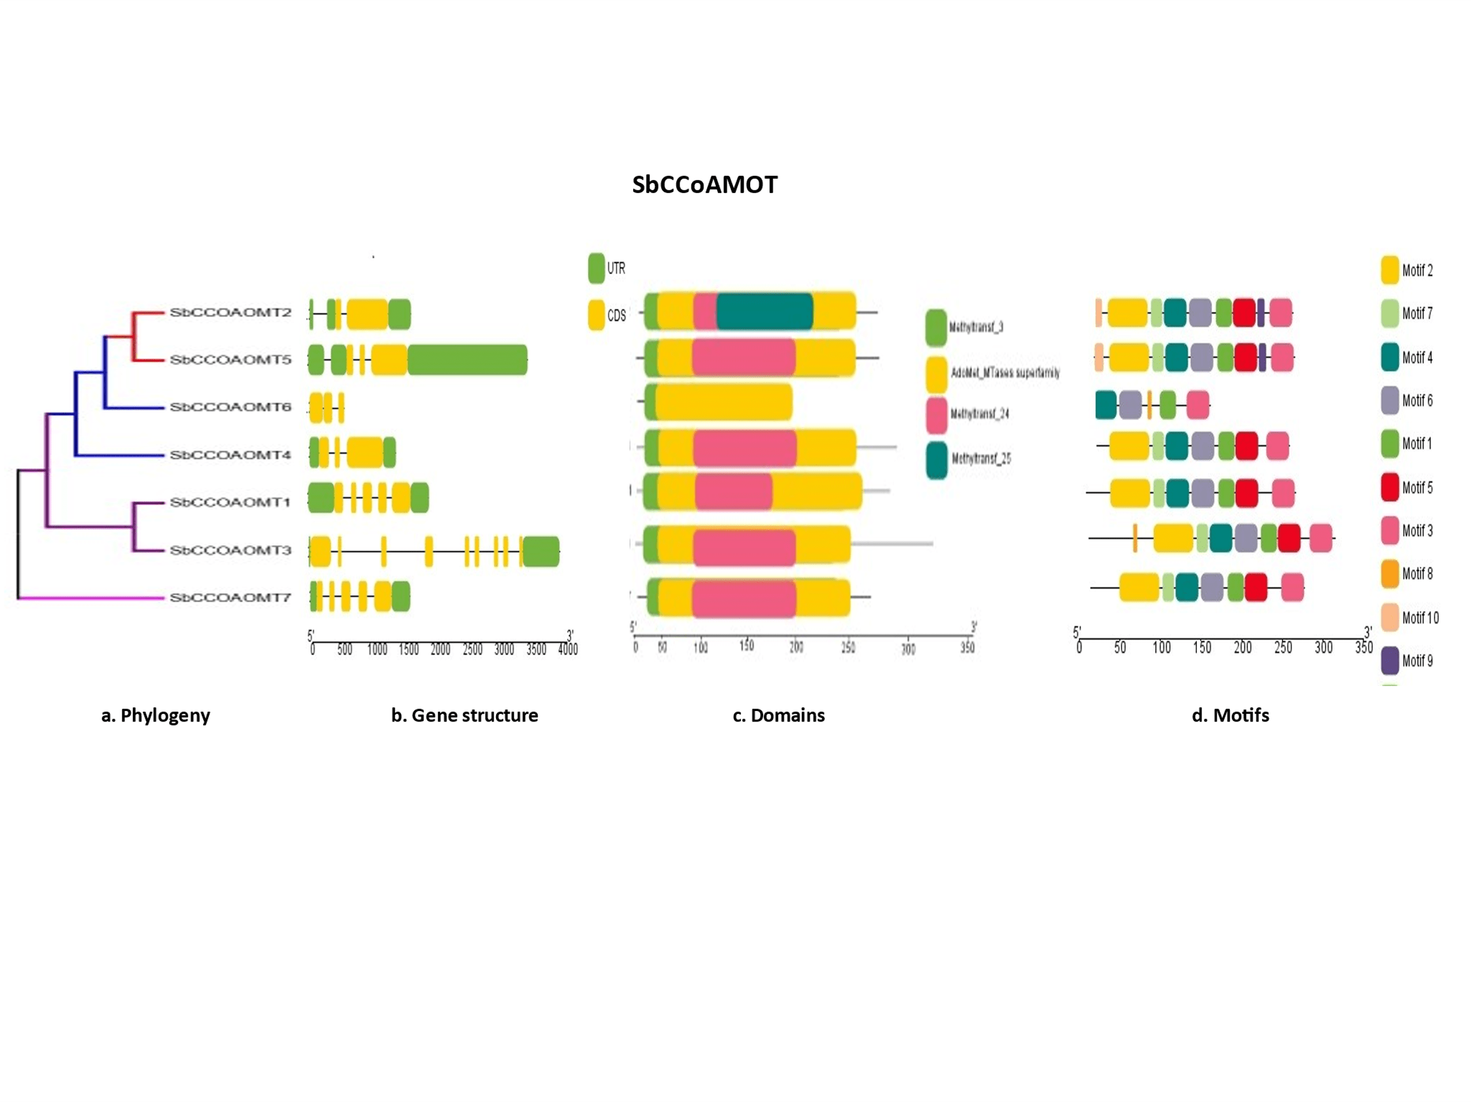

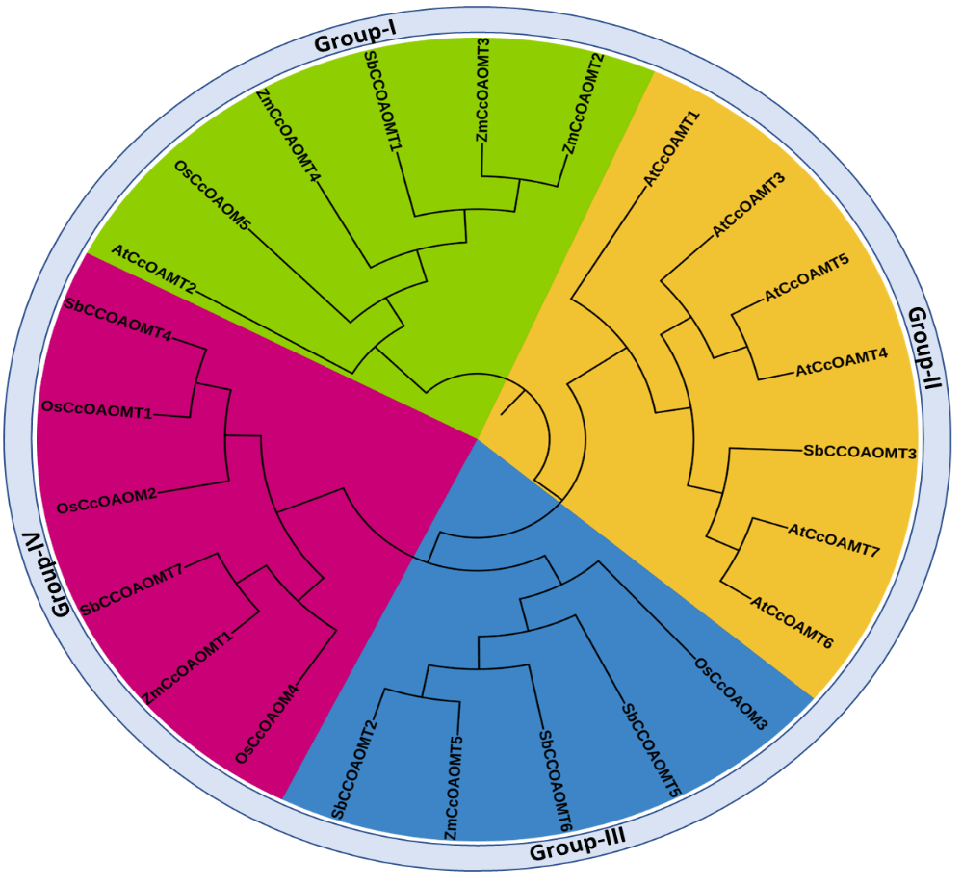
e. Evolutionary tree

f
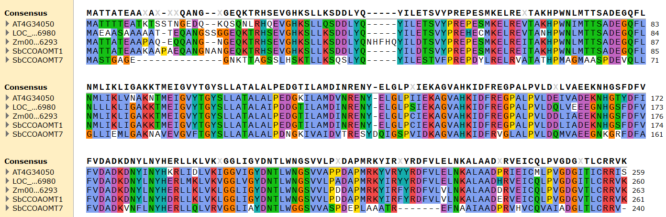

g h

Fig 1: a. Phylogenetic analysis of sorghum homologs, b. gene structure, c. conserved domains, d. Motif patterns of SbCCoAOMT homologs and e. Evolutionary analysis of SbCCoAOMT homologs with Arabidopsis (At), Oryza (Os) and Zea mays (Zm) CCoAOMT genes, f. Multiple sequence alignment of SbCCoAOMT1&7 genes with orthologs in Arabidopsis (At), Oryza (Os) and Zea mays (Zm), g. Amino acid composition of SbCCoAOMT proteins and h. Sequence similarity of SbCCoAOMT with Arabidopsis (At), Oryza (Os) and Zea mays (Zm) (blue<=50, green<=75, orange<=99.9999, red>99.9999).

2a: 2D structure prediction of SbCCoAOMT homologs
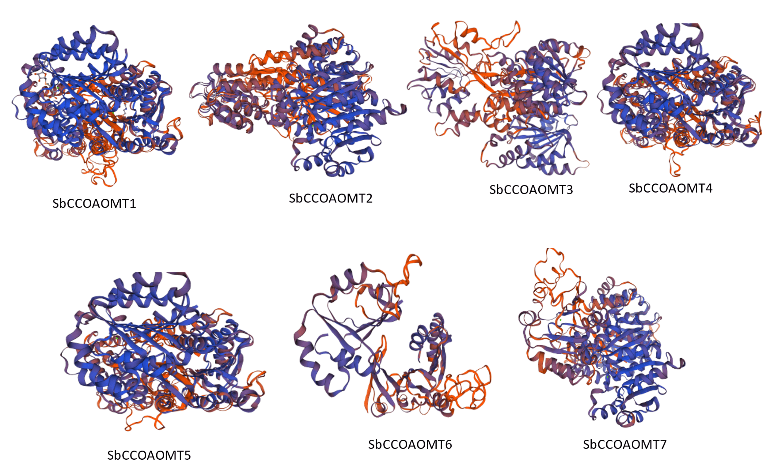
b: 3D structure modelling of SbCCoAOMT homologs

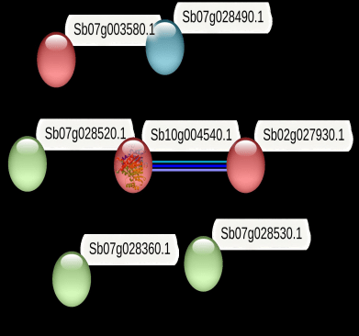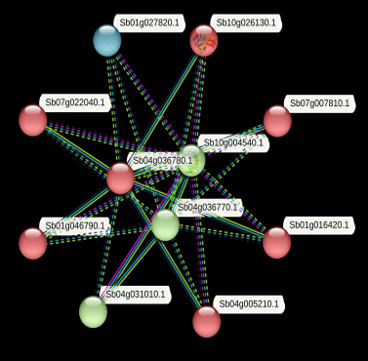
c. PPI analysis of SbCCoAOMT homologs d. PPI analysis of SbCCoAOMT1
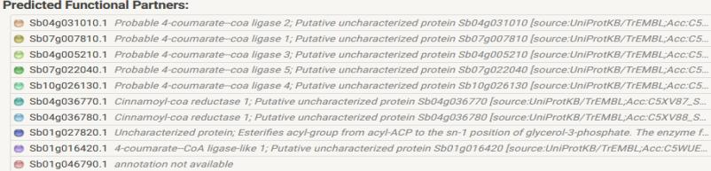
Fig 2: a.2D structure prediction, b. 3D structure modelling of SbCCoAOMT genes using SWISS model server and c & d. PPI analysis of SbCCoAOMT homologs using STRING data base.

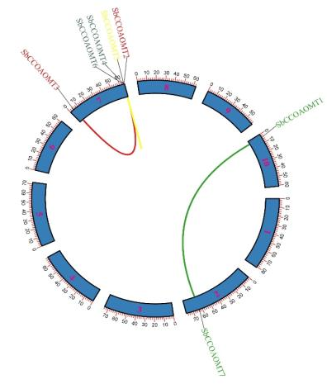
- Chromosomal location of SbCCoAOMT genes
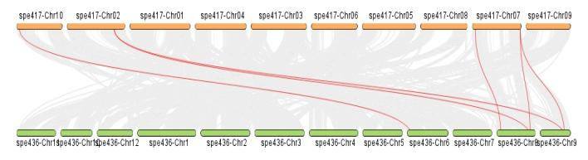
- Collinearity analysis of SbCCoAOMT genes in sorghum and Oryza sativa genome
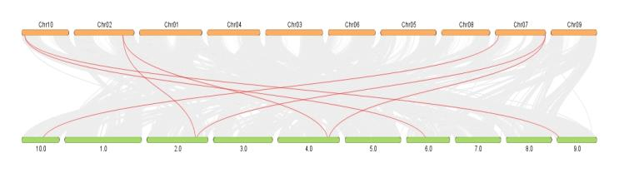
- Collinearity analysis of SbCCoAOMT genes in sorghum and Z. mays genome
Fig 3: a. Physical mapping of SbCCoAOMT genes on Sorghum genome, b & c Collinearity analysis of CCoAOMT genes between sorghum and Oryza and sorghum and Zea mays genome respectively

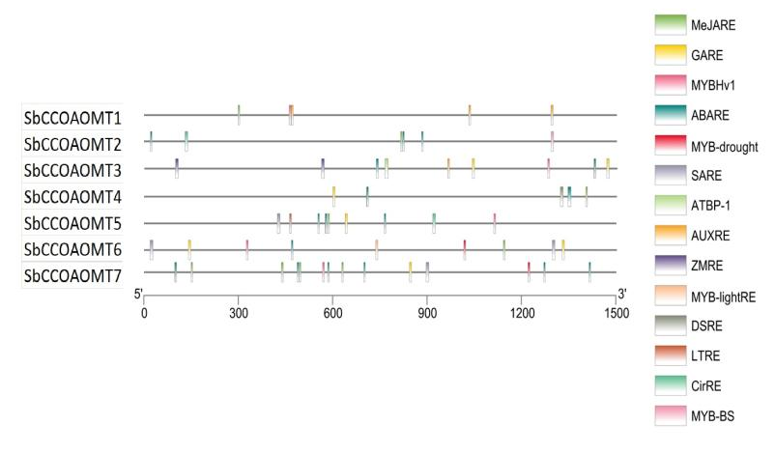
Fig 4: Promoter analysis of SbCCoAOMT genes
a
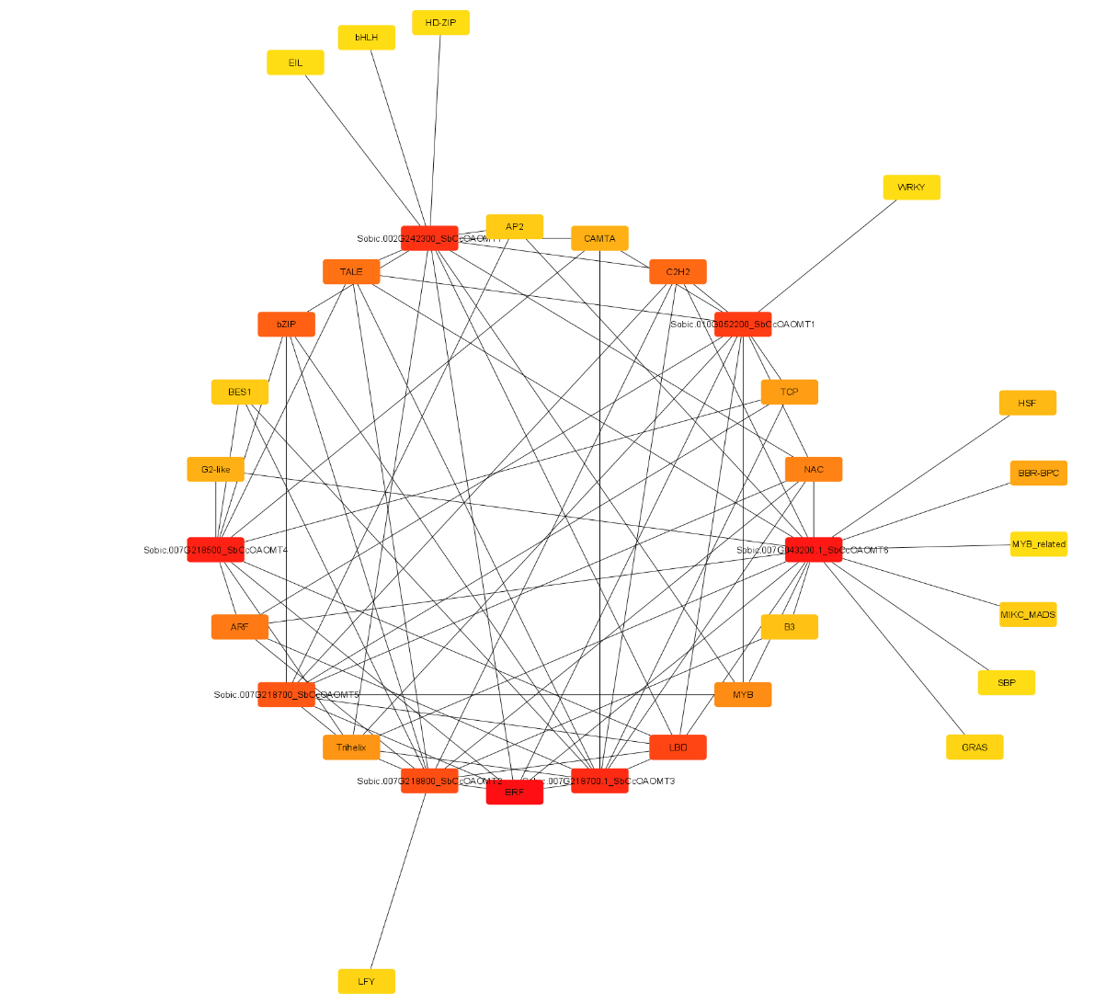

b
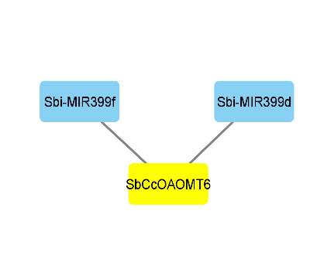
Fig 5: a. Transcription factor analysis and b. miRNA prediction of SbCCoAOMT genes
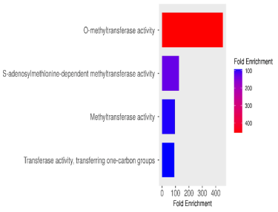
a b
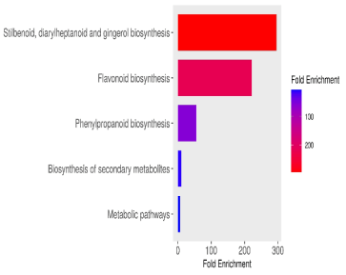

c
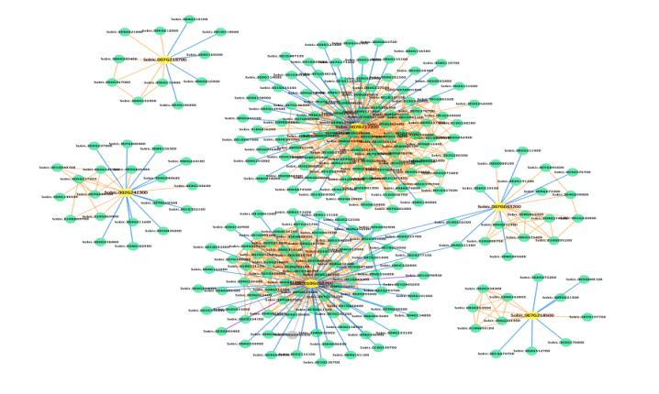

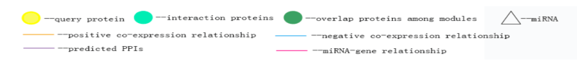
Fig 6: (a) Molecular function, (b) Pathway analysis, (c) Gene co-expression analysis of Sorghum CCoAOMT genes

a b
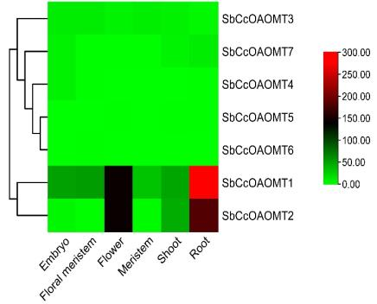
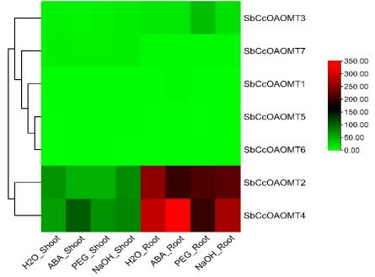
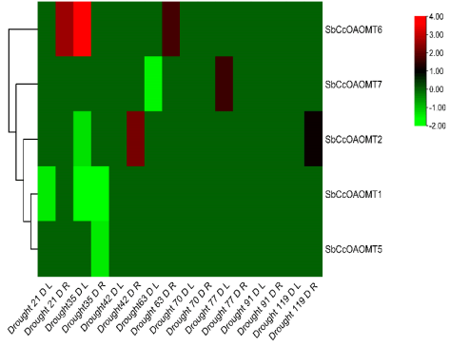
c d

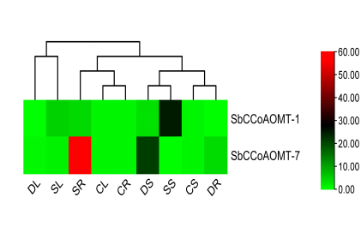
Fig 7: In silico expression analysis of SbCCoAOMT genes: (a) baseline, (b) under PEG, ABA and NaOH stress, (c) under drought and (scale bar represents FPKM) (d) q-RT PCR analysis under drought and salt stress conditions (CL-control leaf, CS-control stem, CR-control root, DL-drought leaf, DS-drought stem, DR-drought root, SL-salt leaf, SS-salt stem and SR-salt root and scale bar indicates average expression in fold change).

