Economic Value Potentials of the Niger Delta Mangrove Ecosystem, and decline in Rural Livelihood arising from Unsustainable Exploitations

Abstract
The Niger Delta mangrove is an extensive ecosystem that supplies various goods and provides ecological services. They are thus very important ecologically, economically, and socially as they harbour a wide range of aquatic and land-based flora and fauna, in addition to a number of ecosystem services that improve livelihood and the wellbeing of humans. The potential benefits derivable from these goods and services constitute the economic value potentials of the mangrove ecosystem. The Niger Delta mangrove ecosystem is a vital wetland area that encompasses diverse ecological zones, each with a unique stock of goods and services but has faced significant threats from anthropogenic activities, resulting in depletions that have created so many declines in livelihood activities, which beyond the economic considerations attached to the said various anthropogenic activities in the mangrove ecosystem, has led to the loss of economic values resulting from the attendant environmental degradation and therefore requires urgent attentions. Two zonal areas were selected for the study in Bayelsa State and Rivers State in the Nigeria’s Niger Delta. Investigations indicated a significant decline in the Rivers Zonal area than the Bayelsa State area because of the activities of illegal refining of crude petroleum in the Rivers State area. It is thus recommended by this study for the regular environmental audit through environmental valuations to initiate action plans for conservations.

Keywords: Niger Delta, mangrove ecosystem, flora and fauna, economic value

INTRODUCTION

Environmental goods and services generally constitute products and services that help in the protection of the environment and manage natural resources. They are therefore the environmental benefits resulting from physical, chemical, and biological functions of healthy ecosystem. They include market goods produced from ecosystems (e.g. food, fiber, fuel, fresh and clean water, genetic processes etc.), and also the benefits from ecosystem processes which may include nutrient cycling, climate regulation, water purification, waste treatment, pollination etc. [1]. Economic value potentials are latent economic qualities or abilities that may be developed and lead to future success or usefulness. The value that persons places on an economic good or service, based on the benefit they derive from it is what is referred to as Economic value [2].
The Niger Delta mangrove ecosystem encompasses diverse ecological zones which include coastal inland zone, middle mangrove swamp forests, fresh water swamps, and landward mangrove zones, covering an area of approximately 1900 km² wherein several biodiversity and essential ecosystem services are available for the sustenance of millions of people in the region [3]. In the face of the dependence upon the ecosystem by the inhabitants of the region, the ecosystem faces significant threats from anthropogenic activities such as oil exploration and exploitation, deforestation for other purposes, over harvesting of the component resources, and land use processes, all of which has resulted in the cumulative effect of significant depletion with an attendant loss of livelihoods of the coastal communities whose wellbeing had been generally dependent on the mangrove ecosystem.
Going by this description, the mangrove biome supports a wide range of communities that rely on it for their livelihoods [4]. Researchers have identified as much as 70 uses of mangroves in the Niger Delta to include fishing, firewood, building materials, flood protection, medicine, leisure, tourism, spiritual values etc. [5]. While these are available as the potentials for economic value in the Niger Delta regional mangrove, there is a continuous decline of the components of the ecosystem [6], reducing the said potentials and incapacitating the complexity of mangrove’s functional role as the mainstay of the people in the region, thereby calling for the prioritization of the implementation of conservation actions [7]. It is thus noted that there are factors that serve as drivers, as well as impacts of the said anthropogenic disturbances and they stem on deforestation and land use change, invasive species [3], and in recent development, illegal refining of crude petroleum which is associated with pipeline vandalization and careless spill of oil in the creeks and mangroves, giving rise to the said decline in rural livelihood, owing to damage on mangrove flora and fauna, upon which the wellbeing of the coastal community is dependent.
The economic impact of oil and gas related activities which is associated with illegal refining, has been widely reported but with a consideration of misplaced administrative strategy on the side of the Federal government who granted amnesty to those of the agitating militant youths of the region, who in the process, decided to drop their arms, leaving behind the non-violent ones who now resort to the idea of illegal refining of crude for their survival [8] & [9]. This development is without the consideration of the impact of the activity on rural livelihood and has thus created the need for this paper which is aimed at auditing the effects of unsustainable exploitation of the mangrove ecosystem upon the floristic and fauna composition as well as the economic value potentials of the Niger Delta mangrove ecosystem to beef up awareness over the need for action plans for sustainable use of the ecosystem.

LITERATURE REVIEW

Study Area

The Niger Delta is a geographical area that could be described with reference to its natural/geologic characteristics but in recent time, political and economic reasons have given rise to operational definitions for different purposes [10]. However, it could be best described as a geographic basin of the Niger River characterized by a fan-shaped flood plain that is defined by many tributaries and a host of attendant distributories forming the rivers and creeks and estuaries through which it opens into the Atlantic Ocean at the South most end of Nigeria, with the Nun River regarded as the direct continuation of the River Niger [11]. By this description, it is majorly made up of the whole of Rivers, Bayelsa, and Delta states but peripherally inclusive of few areas bordering the fan-shaped flood plain, stretching for nearly 150 miles (240km) from North to South and extending over an area of 14,000 square miles (36,000 sq. km) [12]. However, the area is noted to be a biodiversity hotspot that is rich in flora and fauna in addition to robust ecological processes upon which the economy of the local communities is dependent [11], thus characterizing the mangrove swamp and coastal vegetation of the region to be very high in biodiversity as well as dense human population.
The region is therefore noted to have had a mangrove reserve that is assessed to be the largest in Africa and third largest in the world, wherein about eight true mangrove species are available with a host of other minor components. This description covers the entire mangrove belt of Nigeria whilst the study’s scope is the geographic Niger Delta covering Rivers, Bayelsa, and Delta States covering a cumulative land area of 38,684 square kilometers (Rivers – 10,378, Bayelsa - 11,107, and Delta – 17, 163). It is to be noted however that these three states are biodiversity hotspot where exists both locally and globally endangered species of organisms in four major ecological zones namely: the coastal barrier islands, mangrove swamp forests, fresh water swamp, and lowland rain forests[13]. Of relevance to this paper is the mangrove swamp which interlocks with the coastal barrier islands, forming the rivers, creeks, and estuaries. This is as shown in the map in Fig.1 and 2:

Fig. 1: Map of the Niger Delta showing the three states of Rivers, Bayelsa, and Delta with the various rivers and tributaries opening into the Atlantic Ocean
Source: [13].

Fig. 2: Map of the Niger Delta showing the Mangrove Belt and the Various Rivers, including the River Nun which is a continuation of the Niger River. Source: ResearchGate (2024)
The Mangrove Belt of Nigeria
Mangroves in Nigeria generally extends from Badagry in the West to Calabar in the East, defined by a regular salt water inundation, and forming a vegetation band that is between 15 to 45 kilometers, parallel to the coast of the Atlantic Ocean and occupying a total land area of 10,000 square kilometers along the coast [14]. The Nigerian mangrove ecosystem is made up of fragmented deltaic discontinuous landform, occasioned by interruptions created by Beach Ridge Island forests which are characteristically of lowland rainforests within which communities are settled [15] The beach ridge forests typically contain lowland rainforest species. Some have large areas of high quality forests with high concentrations of biodiversity. This thus crates room for the survival both mangroves based, and non-mangroves based fauna organisms within the mangrove belt, thereby creating significant human economic dependence on the area.

The Importance of Mangroves

A report by the United Nations Environmental Program (UNEP) of 2023 described human attitude over mangroves as being ruled by ignorance as they perceive mangroves to be “dirty” or “death areas” and have consequently resorted to clearing them for sandy beaches, swanky resorts and other developments. The UNEP’s paper quoted from Leticia Carlvalho, Head of Marine and Fresh Water that mangrove on the contrary teems with life as more than 1500 plants and animal species depends on mangroves and they include fish and birds who uses the shallow water beneath the trees as nurseries and larger mammals such as monkeys, sloths, tigers, hyenas, and African wild dogs thus creating a diverse and remarkable ecosystem that works together with other marine ecosystem, not just for the ecological benefits alone but significantly for the wellbeing of humans. Mangroves thus stabilize the coastlines, protect water quality, reduce coastline flooding, provide habitat for fish, protect wildlife species, protect juvenile fish from predators, and serve as nesting areas, all culminating into economic benefits for human wellbeing [16].
The Niger Delta regional mangrove ecosystem provides a variety of services for human well-being in addition to several important ecological roles [17]. Functionally, mangroves contribution to rural (coastal) communities is likened to be what taxes are to national economies [18] such that in a well- organized utility of mangrove resources, there is an estimated economic value of mangrove resources to local community in the range of 27,264 to35, 921 US Dollars per hectare [19]. Mangroves thus provides local communities with several goods including fish, shrimps, crabs, firewood, electric poles, honey, boat building material, furniture, traditional medicine, and hunting amenity [18]. Ecologically, mangroves offer nine major services grouped under three broad functions of regulatory, reproductive and cultural [20]

Concept of Economic Value and Economic Valuation

‘Value’ as a concept is said to have differing meanings to those with different interests under any context. The environmentalist has therefore always made his assessment on the basis of desirability on moral, aesthetic and sustainability as certain types of environmental goods and services does not have market [21]. This fact makes environmental perspective about value to be very broad and have always been handled with principles of environmental economics. However, economic value describes the value placed on an economic good or service based on the benefits derivable from it [22; 17]. It is therefore a part of the quantitative measures of environmental benefits of natural resources which are majorly amenities that cannot be bought and sold in everyday markets. Ignorance of the assessment of these non-market environmental benefits creates bias in decision making to the detriment of the physical environment [23].
Environmental valuation itself is the assessment and determination of the monetary value of environmental impacts, some of which are non-market items. It involves the appraisal of the preferences of a given body of persons over an item and the trade-offs that can be willingly be accepted for it. Because there are no markets for some types of environmental goods and services, environmental economists has found it necessary to disaggregate any environmental impact into individual components of value. One of such approaches is the Total Economic Value (TEV) approach [22: 17], and so Economic Valuation involves the process of attaching monetary value or price to non-market environmental goods and services [24]. Total Economic Value (TEV) is thus achieved by the addition of the Use Value (UV) and Non Use Value of the goods and services which are arrived at by translating ecological complexities into a limited number of functions that provides the goods and services for human wellbeing and livelihood. These ecosystem functions are the capacity of natural process and components to provide goods and services for the satisfaction of human needs directly or indirectly. [25] recognize four major types which include regulation function, habitat function, production function, and information function. They provide ecological, socio-cultural and economic values, from which Total Economic Value is derivable. It is worthy to note that ignorance of the assessment of components of economic value creates bias in decision making to the detriment of the physical environment as well as human well-being.

METHODDOLOGY

Data Collection

A reconnaissance visit was made to some of the rural settlements along two locations - Rivers State and Bayelsa State, which are two of the three major states with extensive mangrove reserve in Nigeria. The Rivers State zonal area was the Ke River which runs in-between River Sombreiro and the New Calabar (Rio Real) River, flowing into the Atlantics while the Bayelsa State zonal Area is the famous St. Nicholas River, which also opens into the Atlantics. Selected communities were visited at a later trip with questionnaire designed from the observations during the reconnaissance tour, and were interviewer-administered. Photographs were also taken to capture the nature of the environment and a list of all available flora species compiled. However list of fauna species was a matter of a comprehensive qualitative analysis which also explained the relative economic value attached to each item in the ecosystem. The Taro Yamane formula was applied to determine the sample size for questionnaire administration from census records for quantitative data while qualitative data was also collected simultaneously through the convergent parallel mixed approach.

Data Analysis

Availability of macro plant and animal species endemic to the study area were investigated and identified in their species, family, and common names. There was therefore a computation of the economic value potentials of each of these items, and finally an inquiry into the occupational activities of the inhabitants of the area to measure decline in the livelihood of the inhabitants’ livelihood.

RESULTS AND DISCUSSIONS

Results

Results from the study as was computerized, analyzed, and interpreted are presented thus the following information were obtained:

- Floristic composition
The floristic composition of the two locations indicated a uniformity by the availability of 7 known species of plants that are composed of 9 families, out of which Rhizophoraceae, Avicenniaceae, and Cambretaceae are of ‘Major Mangroves Species’ while the rest are of ‘Minor Species’. There is indeed distributional variation in the both location but cumulatively, the composition is relatively the same. This is as presented in Table1:
Table 1: Availability and Distribution of Plant Species and Families in the Study Area

S/No | Plant Species | Families | Common Names | Species Density
 |  |  |  | Rivers | Bayelsa
1. | Rhizophoraceae | R. recemosa | Red mangrove (Tall) | 351  (46%) | 406  (42%)
2. | Rhizophoraceae | R. harrisonai | Red mangrove (moderate) | 153  (20%) | 173  (18%)
3. | Rhizophoraceae | R. mangle | Red mangrove (dwarf) | 191  (25%) | 314  (32%)
4. | Avicenniaceae | Avicennia germinans | Black mangrove | 39  (5.1%) | 50  (5%)
5. | Cambretaceae | Laguncularia recemosa | White mangrove | 11  (1.4%) | 13  (1%)
6. | Arecaceae | Nypa fructicans | Nypa Palm | 5  (0.7%) | 5  (0.5%)
7. | Arecaceae | Phoenix poludosa | Mangrove date palm | 6  (0.8%) | 7  (0.7%)
8. | Pteridoceae | Acrosticum aereum | Mangrove (leather fern) | 5  (0.7%) | 2  (0.2%)
9. | Malvaceae | Hibiscus tilanceous | Marine okra | 2  (0.3%) | 4  (0.4%)
10. | Unknown | Unknown | Marine sour sop | 0  (0%) | 1  (0.1%)

- Fauna Composition

Fauna composition was an item of qualitative information and from the narratives they are available in several categories with respect to mangroves’ natural function as a habitat, breeding, and foraging as follows:
- Mangrove as habitat for avi (birds) fauna
- Mangroves as a habitat for Reptiles
- Mangrove as a habitat for mammals
- Mangrove as habitat for fish, and
- Mangrove as habitat for invertebrates

- Exploring and Assessing Economic Value Potentials

The economic value potentials of the two locations were investigated, explored, and a comparison made of their availability status to ascertain their degree of importance to determine decline in environmental goods and services as well as livelihood in the area which were explained in qualitative data to bee as a result of several factors, most of which are anthropogenic. This is as presented in Table 2:

Table 2: Comparative Analysis of Degree of Importance of Economic Value Potential

Economic Value Potentials | Degree of Insignificance |  | Degree of Significance |  | RRI Ranking | Remarks
Economic Value Potentials | Rivers | Bayelsa | Rivers | Bayelsa
Aquaculture | 139(41%) | 130(38.6% | Nil | 26(7.7%) | 9th | 42(13%) responses were neutral
Fishing | Nil | Nil | 156  (46.3%) | 181  (53.7%) | 1st
Logging | Nil | Nil | 156  (46.3%) | 168  (50%) | 7th | 13(3.9%) responses were neutral
Haunting Amenity | Nil | Nil | 156  (46.3%) | 181  (53.7%) | 2nd
Local Crafts | Nil | Nil | 150  (44.5%) | 181  (53.7%) | 4th | 6(1.8%) responses were neutral
Fuel wood | Nil | Nil | 150  (44.5%) | 181  (53.7%) | 1st | 6(1.8%) responses were neutral
Building materials | Nil | Nil | 134  (39.8%) | 174  (51.6%) | 6th | 29(8.6%) responses were neutral
Shore Protection | Nil | Nil | 123 (36.5%) | 116 (34.4%) | 5th | 98 (29%) neutral
Ecological benefits | Nil | 7  (2.1%) | 139 (41.2%) | 129 (38.3%) | 3rd | 62 (18.4%) neutral
Traditional medicine | 17(5%) | 7(2%) | 139 (41%) | 141 (42%) | 8th | 33(10%) neutral responses

- Causes of Decline in Human Livelihood
Human livelihood refers to the means whereby one obtains income (finance) to earn a living. The two locations, though in the same geographical region, are of differing activities, each creating environmental impact unique to the prevailing circumstances. Accordingly, there is a significant operation of illegal refining of crude in the Rivers State zonal area of the study while the Bayelsa State Zonal area does not have such activities, hence deemed to have possessed a relatively normal environmental condition. This differential affects rate of decline in environmental resources as well as occupational activities. The computation of the investigation is as presented in Table 3: where it is indicated that the degree of significance of other activities are the same but that of illegal refining is significantly higher with its attendant impacts in the Rivers Stat zonal area of thee study.

Discussions

The results in Table 1 indicated the predominance of Rhizophoraceae (Red Mangrove) in the Niger Delta regional mangrove, appearing in three species of R. racimosa (Red Mangrove Tall), R. harrisonai (Red Mangrove Moderate), and R. mangle (Red Mangrove Dwarf) while others a scantily distributed. It is to be noted that the shady evergreen characteristic and the presence of tangle of prop roots creates room habitation, foraging, and breeding of various fauna components of the mangrove ecosystem. This justifies the assertion of [16] and the fact that there was no variation between the floral compositions of the two locations, is an indication of uniformity in the region. Red mangrove thrives well with the daily tidal effects which enable ecological activities to occur, thereby maintaining a food chain upon which human wellbeing and livelihood is dependent. The interlocking of the mangroves with barrier islands which are rainforest/fresh water environments creates hunting amenity as wildlife are attracted to these spots for their wellbeing. Fauna components such as mammals, birds, reptiles, and varieties of fishes, including gastropods are major components of the mangrove ecosystem. Thus there exist several economic activities such as fishing, hunting, logging, local crafts etc. attached to the mangrove ecosystem.
The benefit derivable from these resources of the ecosystem is a measure of the economic value which varies from one zone to the other. Accordingly, the study indicated a decline in livelihood of the rural dwellers whose economic lives are dependent on resources of the mangrove ecosystem. The reconnaissance survey of the study area revealed that due to the activities of illegal refining of crude oil in the Rivers zonal area, the mangroves in the area are significantly withered, resulting in deforestation, habitat loss, environmental pollution, and atmospheric changes while the Bayelsa zonal area is undisturbed by illegal refining. There is therefore a dearth of economic activities attached to the mangrove ecosystem in the Rivers area while almost all activities of economic concern are on-going in the Bayelsa area where the mangrove ecosystem is relatively undisturbed. Photograph taken during the reconnaissance survey is as shown in Figures 3 and 4:

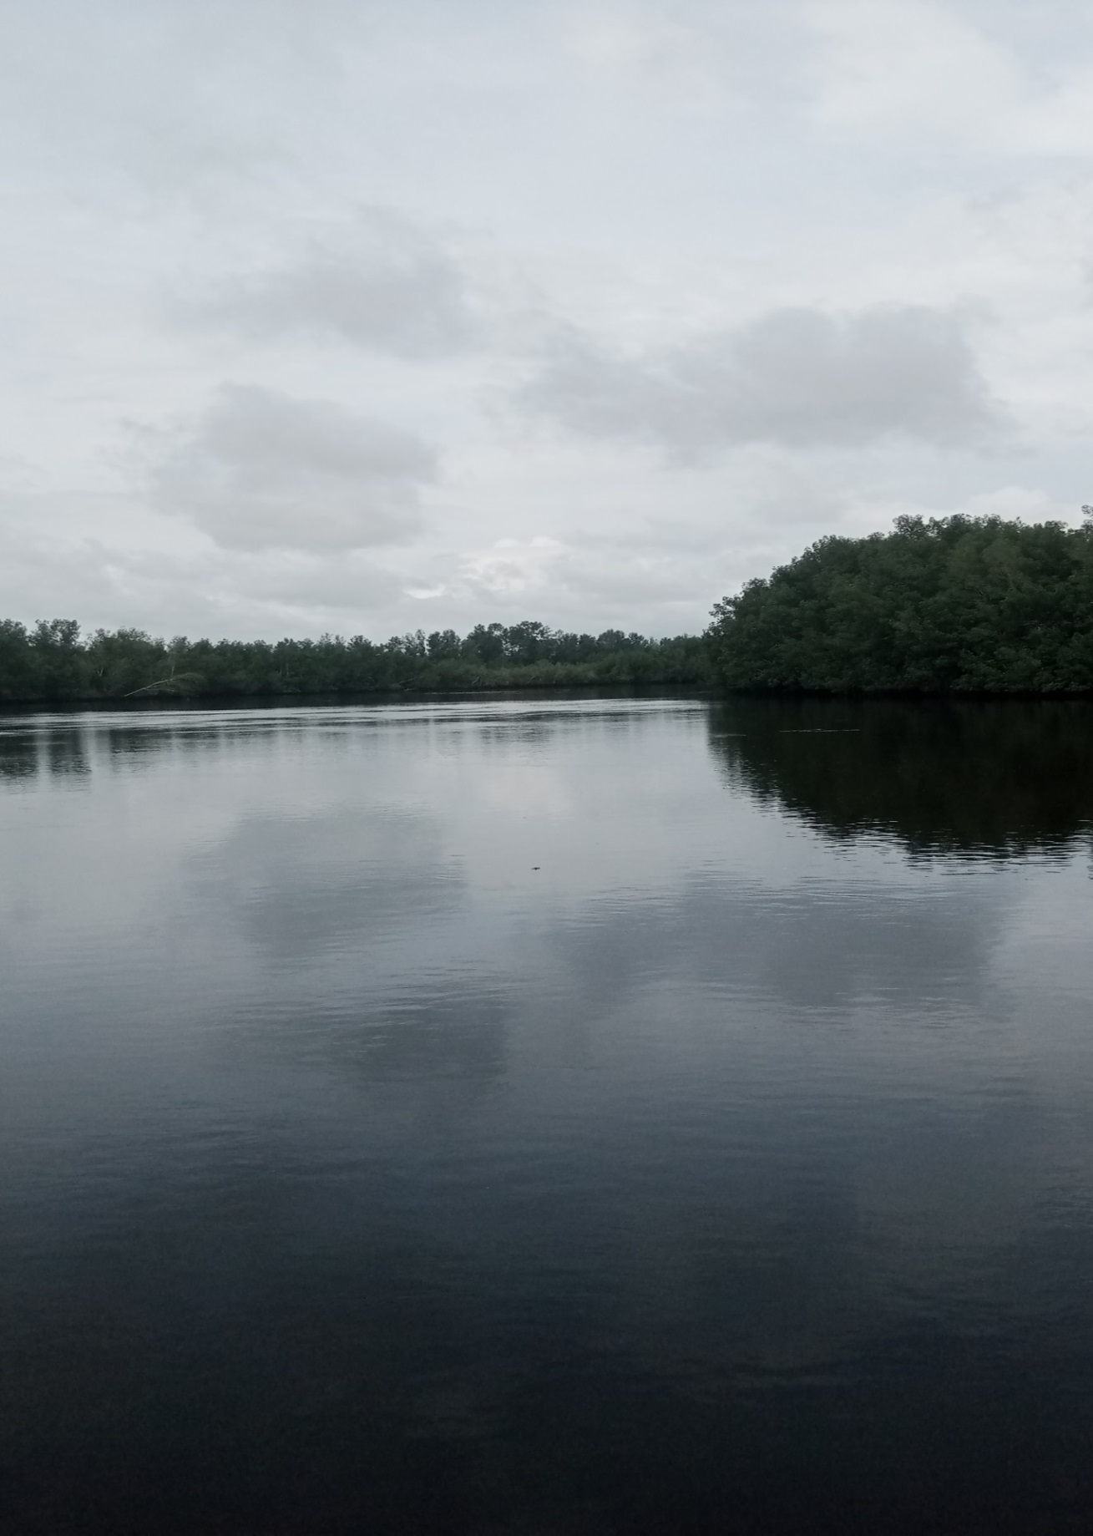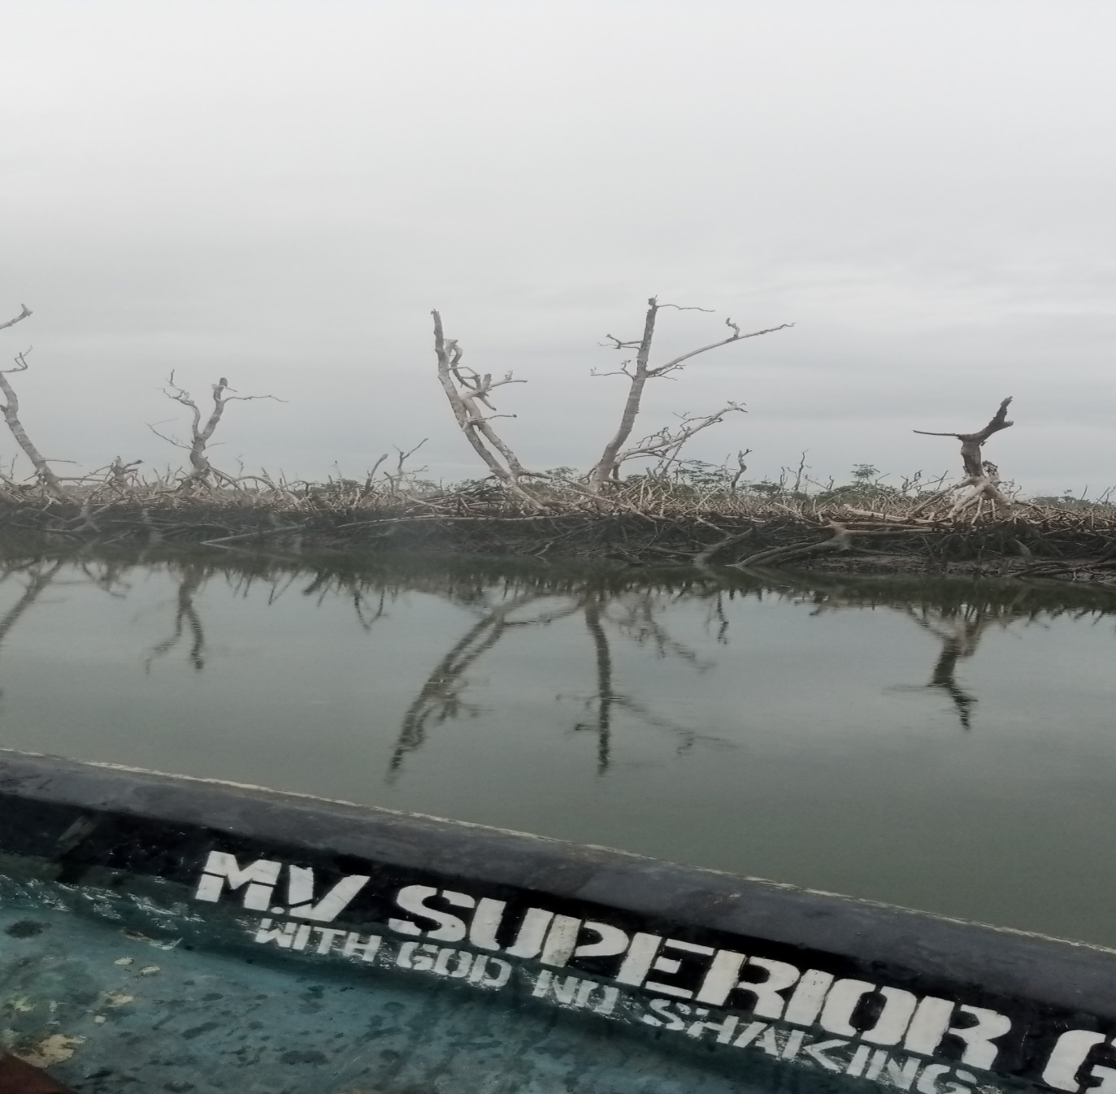
Figure 3: Undisturbed Mangrove Ticket at the Bayelsa Zonal Area
Figure 4: Withered Mangrove Environment in the creeks of the Rivers Zonal Area

Table 3: Intensity of Various causes of Depletion of Mangrove Ecosystem goods and services
Causes of Depletions | Very  Insignificant |  |  | insignificant |  | Neither Significant nor Insignificant |  | Significant |  | Very  Significant
FREQUENCY
 | Rivers | Bayelsa | Rivers |  | Bayelsa | Rivers | Bayelsa | Rivers | Bayelsa | Rivers | Bayelsa | Total Freq. | RRI Ranking
Tidal Effects | Nil | 13 (7%) | 11 (7%) |  | 7 (4%) | 23 (15%) | 45 (25%) | 111 (71%) | 91 (50%) | 11 (7%) | 25 (14%) | 337 | 0.74  (4th)
Bush Fire | 134 (86%) | 161 (89%) | Nil |  | Nil | Nil | Nil | 22 (14%) | 20 (11%) | Nil | Nil | 337 | 0.27  (7th)
Logging | Nil | Nil | Nil |  | 7 (4%) | 45 (29%) | 12 (7%) | 111 (71%) | 110 (61%) | Nil | 52 (29%) | 337 | 0.79  (3rd)
Oil Exploration | Nil | 13 (7%) | Nil |  | Nil | 11 (7%) | 7 (4%) | 11 (7%) | 38 (21%) | 134 (86%) | 123 (68%) | 337 | 0.92  (1st)
Biotechnology | 111 (71%) | 148 (82%) | 28 (18%) |  | Nil | 17 (11%) | 33 (18%) | Nil | Nil | Nil | Nil | 337 | 0.28  (6th)
Illicit Oil Refining | Nil | 13 (7%) | 6 (4%) |  | 13 (7%)) | 6 (4%) | 91 (50%) | 11 (7%) | 38 (21%) | 134 (86%) | 25 (14%) | 337 | 0.80  (2nd)
Chemical Fishing Techniques | Nil | 6 (3.5%) | Nil |  | 33 (18%) | 117 (75%) | 33 (18%) | 39 (25%) | 103 (57%) | Nil | 6 (3.5%) | 337 | 0.65  (5th)
Source: Researcher’s Field Records (2024)

It is therefore obvious that there is little or no much economic value ascribable to the withered environment in the assessment of economic value. There is therefore observable significant decline in livelihood from occupational activities, such as fishing, hunting, seafood harvesting/commercialization, logging and a host others attached to the mangrove ecosystem. This is explained in Table 2 where the various occupational activities thrives more in the Bayelsa State zonal area than the Rivers State zonal area. The mangrove ecosystem is noted for its provisioning services which are a major indicator of economic value potentials as several of them are major items for commercial activities but are extracted by ‘open access’. Environmental valuation therefore incorporates these benefits which are amenities that cannot be bought and sold in the open market to determine and assess the ecosystem functions and economic value.
Man’s daily dependence on the mangrove ecosystem is known to have created problems right from the beginning of creation but nature has always been able rehabilitate such issues through natural cycles but with increasing population of humans and the attendant utility pressure on the available resources, rural livelihood is discovered to have been negatively affected. The analysis of Table 3 also indicates that human-caused effect is more intense in the Rivers State area than in the Bayelsa Area.

CONCLUSION

Mangrove ecosystem is a very rich ecological system upon which the rural dwellers in the coastal communities of the Niger Delta region have been dependent. Sea food such as shrimps, oysters, periwinkles, whelks, conges, crabs and a variety of fishes breeds in the mangrove to set a food chain upon which livelihood is attained. It is therefore relevant for the mangrove ecosystem to be on a regular check against the action of man to avoid detrimental exploitation of the resources contained therein. There is therefore need for environmental valuation at regular intervals for action plans to curb the menace of man’s actions on the ecosystem.

REFERENCES

- Zhang, W., Rickets, T., Kremen, C., Carney, K., Swinton, S. (2007). Ecosystem services and dis-services to agriculture. Ecological Economics, 64: 253-260.
- Caroline Banton (2023). Economic Value: Definition, Examples, Ways to Estimate. Investopedia. Guide to economics.
- Aransiola et al (2024). The Niger Delta Mangrove Ecosystem: Biodiversity, past and present pollution, threat and mitigation. Science Direct. Regional Studies in Marine Science. 103568, ISSN 2352-4855, vol. 75
- Polidoro, B. A, Carpenter, K. E, Collins, L, and Duke, N. C (2010). The loss of species: mangrove extinction risk and geographic areas of global concern. PLoS ONE 5.
- Nababa et al (2020). Nababa, Land cover dynamics and mangrove degradation in the Niger Delta Region, Remote Sens., № 12, с. 3619 https://doi.org/10.3390/rs1221361
- Giri et al, (2011). "Status and distribution of mangrove forests of the world using earth observation satellite data: Status and distributions of global mangroves". Global Ecology and Biogeography. 20 (1): 154–159. doi:10.1111/j.1466-8238.2010.00584.x.
- Friess et al (2019). "The State of the World's Mangrove Forests: Past, Present, and Future". Annual Review of Environment and Resources. 44 (1): 89–115. doi:10.1146/annurev-environ-101718-033302
- Oredein, O. (2013) Shell Sees Rise in Crude Theft in Nigeria. Dow Jones News wire.www.businessfox.com/news/2013/3/4
- Asimiea, A, & Omokhuo (2013). Environmental Impact of Illegal Refineries on the Vegetation of the Niger Delta, Nigeria. Journal of Agriculture and Social Research, vol 13, No.2
- Imevbore & Gundiach (2017). The Niger Delta Environmental Survey, 1997: Vol. 1 – Environmental and Socio-Economic Characteristics. Researchgate.
- Ogbeibu A. E & Orihabor, B. J. (2023). Niger Delta Mangrove Ecosystem and its Conservation Challenges. Open Access Peer Reviewed Chapter of Mangrove Biology, Ecosystem, and Conservation. DOI: 10.5772/intechopen.112543
- Mobagunje, A. L (2024). Niger River. Encyclopedia Britannica. https://www.britannica.com/place/Niger-River
- Adegoke, J. O, Fageja, M, and Ologunerisa, T.E (2010). An assessment of the recent changes in the Niger Delta coastline using satellite imagery.
14. Ogbeibu, A. E, & Oribahbor, B. J (2023). The Niger Delta Mangrove Ecosystem and its Conservation Challenges. DOI: 10.5772/intechopen.11254
15. Abere, S. A, & Okeke, B. A (2011). The Nigerian Mangrove and Wildlife Development. Mediterranean Journal of Social Sciences. Vol. 2 (7).
- Florida Department of Environmental Protection (gov). – Benefits of Mangrove. https://floridadep.gov>sites>defaults>files> ben
- Akanni et al (2018). The Values of Mangrove Ecosystem Services in the Niger Delta Region of Nigeria. DOI: 10.1016/B978-0-12-809399-3.00025-2
- Zabbey et al (2010). Functional Roles of Mangroves of the Niger Delta to the Coastal Communities and National Economy. Paper presentation at the 25th annual international conference and exhibition at the Administrative Staff College of Nigeria (ASCON) Topo-Badagry, Lagos.
- Sathirathai, S. and Barbiar, E. B. (2001). Valuing mangrove conservation in Southern Thailand. Contemporary Economic Policy 19: 109 – 122
- Ronnback, P., Crona, B. And Ingwall, L. (2007). The return of of ecosystem goods and services in replanted mangrove forests: perspective from local communities in Kenya. Environmental Conservation. 34 (4): 313 – 324
- Olugbenga, O et.al, (2007). Monitoring and Modelling Techniques of Environmental Pollution. First Edition, His Mercy Publishers, Akure, Ondo State, Nigeria.
- Opara, Ukachukwu Eugene (2018). The Theoty and Practice of Environmental Valuation. First Edition, De-Emerald Publishers, Awka, Anambra State, Nigeria.
- De Groot, R. S, Wilson, M. A, & Boumans, R.M.J (2002). A Typology for the Classification, Description and Valuation of Ecosystem Functions, Goods and Services. Ecological Economics. Vol. 41, issue 6. P. 393 – 408.
- Rao, K. P. (2000). Sustainable Development – Economics and Policy. Blackwell Publishers. Oxford OX 41 JF Oxford.
- De Groot, R.S. (1992). Functions of Nature: Evaluation of Nature in Environmental Planning, Management, and Decision Making. Wolters-Noordhoff, Groningen.

