Review Article

Exploring Indoor Environmental Design Factors in Healthcare Settings Towards Users’ Well-being

ABSTRACT

This study explores environmental design factors that foster a healing and supportive healthcare indoor environment for staff and patients. In this comprehensive review, architectural as environmental design solutions are highlighted as a solution to improving patient outcomes, staff well-being and healthcare experiences. A thorough literature review highlights indoor design aspects that provide comfortable and healing healthcare environments. This finding can explore new architectural design notions for healthcare settings. This study's systematic methodology provides an in-depth analysis, offering a comprehending the connection between healthcare design factors and how it affects health outcomes. The original selection for this study included 360 peer-reviewed publications from different publishers. Out of these, 115 publications or articles that matched the topic of the study were vetted. 38 papers, book chapters and journals were finally selected for assessment and classification following a rigorous screening process. The review involves research questions, database searches, inclusion and exclusion criteria, data extraction, quality assessment, data synthesis and structured reporting. Key findings show that single-bed rooms minimise hospital-acquired infections and improve patient comfort. Acuity-adaptable room setups and ergonomic designs improve staff efficiency and patient care. Natural ventilation and daylight enhance interior air quality, minimise airborne contaminants and speed recovery. Biophilic design components like plants and views improve mental health and resilience. Visual arts and sensory aspects make patients feel welcome and less stressed. Evidence-based healthcare design creates environments that prioritise human health and well-being. Healthcare facilities may create healing and comfortable settings by prioritising environmental attributes.

Keywords: environmental design, design factors, indoor environment, healthcare settings well-being

INTRODUCTION
The discourse on healthcare design has advanced significantly, revealing its profound impact on patient outcomes, staff well-being and overall healthcare experiences. Several evidence-based design interventions, including single-bed rooms, adequate ventilation and natural lighting, have been shown to improve patient safety, outcomes and staff well-being according to Ulrich et al., (2008); Ulrich et al., (2010). Additionally, Ulrich et al. found that healthcare design interventions such as patient-centered designs, access to natural light and the presence of green spaces can lead to reduced stress levels, improved users' satisfaction and better outcomes for patients and staff. Later research has built upon these foundations, advocating for theory-based approaches to healthcare design and exploring the ethical implications of design decisions. According to Chi et al., (2020) and van Oel et al., (2021) integrating natural elements has multiple benefits, including improving patient experiences and enhancing healthcare workers' emotional resilience. Natural elements can help to reduce stress and anxiety, create a sense of comfort and wellbeing and provide a sense of connection to nature. Additionally, they can create a more aesthetically pleasing environment which can help reduce feelings of alienation and disconnection. These approaches are based on the idea that healthcare design should be focused on creating environments that are not only aesthetically pleasing but also promote positive health outcomes. Recent studies have also underscored the importance of biophilic design and the positive effects of incorporating visual and sensory elements into healthcare environments. According to studies, biophilic design can help reduce stress and anxiety, improve focus and increase job satisfaction. It can also create a sense of community and connection among healthcare workers. This comprehensive analysis reveals that evidence-based, theory-driven and stakeholder-engaged approaches are essential for creating healthcare environments that prioritise human health and well-being. Healthcare design has evolved a lot in recent years, with a growing body of research showing its impact on patient outcomes, staff well-being and overall healthcare experiences. Notable studies have revealed the importance of evidence-based design interventions in reducing hospital-acquired infections and improving patient safety and staff well-being. Subsequent research has built upon these findings, advocating for the integration of natural elements, ergonomic designs and biophilic principles to create healing environments that support both physical and psychological well-being. An increase in the number of such interventions has been linked to improvements in patient outcomes as well as reduced stress levels among healthcare workers in relation to the indoor environment. Thus, to improve the quality of indoor environment, healthcare setting should prioritise evidence-based design interventions. Identifying key factors in indoor environmental design that contribute to creating a supportive and healing healthcare environment for staff and patients is the primary objective of this research. This research aims to propose architectural design recommendations for healthcare settings that prioritise patient and staff well-being through a systematic literature review.

Process for Systematic Literature Reviews
PRISMA framework has been used in this systematic literature review. It comprises four fundamental steps: identification, screening, eligibility, and inclusion. The systematic literature review for this research involved several key steps: Defining Research Questions: Clearly articulating the research questions to guide the review process. For instance, the primary research question was: What are environmental design factors in healthcare settings or hospital wards to stimulate patients’ well-being? To ensure a focused and relevant search, this first step was essential. Identifying all relevant sources helped ensure a comprehensive literature review. Search strategy: Conducting a comprehensive search of academic databases, including PubMed, Scopus and Google Scholar, using relevant keywords like "healthcare design," "evidence-based design," "biophilic design," "patient outcomes," and "staff well-being." The databases that had the most relevant content allowed for a comprehensive search of academic literature. Furthermore, relevant keywords ensured that the search was focused on the most relevant sources. Inclusion and Exclusion Criteria: Establishing criteria to evaluate studies relevant to the research objectives, focusing on peer-reviewed articles, studies published in the last 15 years, and research conducted in diverse healthcare settings. Inclusion criteria involved selecting studies that specifically addressed the impact of environmental design factors on patient outcomes and staff well-being. Exclusion criteria ruled out non-peer-reviewed articles, studies conducted outside healthcare settings and research that did not directly relate to the specified design factors. Data Extraction: Systematically extracted data from selected studies, including study design, sample size, interventions, outcomes and key findings. This was done to ensure that only the most reliable and valid studies were included. In addition, the data extracted was relevant to the research question. Study designs without controls or inappropriate sample sizes, for example, were excluded. Quality Assessment: Evaluating the quality and rigor of the studies using standardised assessment tools to ensure reliability and validity of the findings. For instance, the quality of a study was judged based on the clarity of the research question, the validity of the methodology, and the reliability and accuracy of the results obtained. Data Synthesis: Synthesising the data to identify common themes, trends and gaps in the literature and to draw meaningful conclusions about the impact of healthcare design on patient and staff outcomes. For example, a synthesis of the literature might reveal that well-designed healthcare environments can reduce stress and anxiety for patients and staff and improve patient outcomes. Reporting Results: Presenting the findings in a structured format, highlighting the implications for healthcare design practice and future research directions. A synthesis might include a list of evidence-based design attributes for creating positive healthcare environments. This systematic approach will ensure a thorough and unbiased review of the existing literature. This will provide a robust foundation for understanding the relationship between healthcare design and health outcomes.
Figure 1
Process for systematic literature reviews

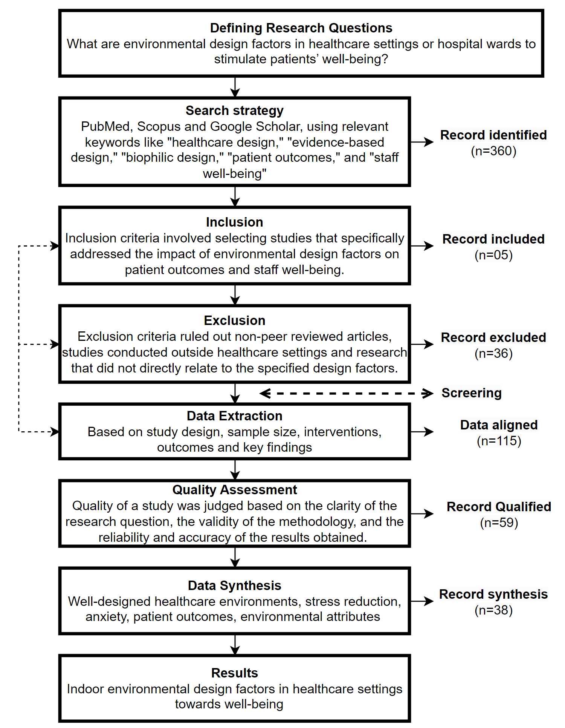
For this study, 391 peer-reviewed journals from various publishers were selected. From these, 115 papers or articles aligned with the study's theme were screened. After thorough screening, 38 articles, book chapters and journals were ultimately selected for review and categorization (see Figure 1).

Literature Review and Discussions
Recent years have seen significant attention paid to healthcare design. This is a result of numerous studies exploring how built environments influence the psychological, emotional and physical well-being of patients, healthcare providers and visitors. Healthcare settings are increasingly accepting evidence-based design, which is reflected in the growing body of literature on this topic. This critical review synthesises findings from numerous studies, focusing on design strategies that impact user engagement, safety, well-being and nature integration in healthcare environments. It emphasises the contributions, limitations and potential of each study in terms of their implications for healthcare design.
The impact of a choice-based design approach on family caregivers' use of green spaces at a tertiary care hospital in India is a notable study. Design strategies informed by behavioral economics can enhance well-being by promoting beneficial use of outdoor spaces. According to the results, the use of outdoor balconies has increased significantly. Though this is a positive outcome, stereotypical design elements raise questions about their long-term and cultural relevance. The study's consistent but static satisfaction outcomes suggest that increased engagement with the space may provide immediate psychological benefits. However, it is necessary to explore whether these effects are sustained over time. The reliance on perceived health benefits, even though promising, requires further examination to determine whether they are in line with actual health outcomes. Especially in settings where caregivers are under considerable stress, such investigations could provide valuable insights into the relationship between environmental factors and health outcomes.
Anesthesia workspace design guidelines address critical issues in operating rooms (ORs) to improve safety and efficiency (in a different context). In high-pressure environments, visibility, demarcation and standardisation are essential elements for improving situational awareness. A deeper exploration of the trade-off between ergonomic interventions and spatial constraints would be beneficial in healthcare settings. Due to the complexity and variety of OR layouts, further research is needed to determine how these guidelines can be adapted to different surgical practices. Additionally, the study fails to consider the psychological well-being of healthcare workers, an important issue when promoting a healthy work environment.
As well as lighting design for healthcare facilities, circadian synchronisation and task performance have been examined. As a result of the study on patient room lighting conditions Berglund et al., 2023, tailored lighting strategies improve both healthcare outcomes and staff performance. In order to ensure broader applicability, the findings could benefit from a more comprehensive cross-cultural validation, since lighting preferences and psychological effects may vary between cultures. Furthermore, while the study emphasises the importance of nighttime lighting for staff, it also acknowledges the potential disturbance to patients. This suggests a need for a more balanced approach that takes both patient comfort and staff needs into account.
The study on the moderating effects of individual traits on the association between nature and patient experiences in waiting areas highlights the complexity of cognitive thinking and connectedness to nature (Lee et al., 2024). It has been shown that plants can reduce anxiety and improve service quality, but the study relies on self-reported measures which can be biased. To strengthen the evidence, it would be valuable to include physiological metrics, such as cortisol levels. This could provide more objective insights into the impact of natural elements on patients’ stress levels. It may also be beneficial to examine waiting area design further to see what can be done to enhance patient experiences through nature integration. Architects could create actionable insights into relaxing and well-being spaces.
A more comprehensive approach to healthcare design is offered in the study that proposes a user-centered environmental sociology model, aiming to bridge medical sociology with environmental quality in hospitals (Ransolin et al., 2022). The framework integrates psychosocial and economic factors, reflecting a holistic understanding of health-promoting environments. However, the reliance on a systematic review without empirical validation leaves the framework's practical applicability uncertain. Future research should focus on testing the model across diverse healthcare contexts to establish its robustness and adaptability. This could facilitate the development of patient-centered and health-promoting environments.
In a broader context, the scoping review by Nieberler et al., (2023) on the influence of nature during inpatient hospital stays highlights the positive, although modest, effects nature has on psychological well-being. Despite presenting virtual reality as an innovative solution to extending nature's therapeutic benefits, technology may limit accessibility for certain demographics. This is particularly true in health care systems with limited resources. Additionally, the broad scope of the review dilutes the specificity of actionable design interventions. In the future, research could focus on the direct correlation between specific natural elements and health outcomes. This could include plants, water features and green spaces views. For designers looking to design healing environments in hospitals, this could provide more concrete guidelines.
Healthcare design is based on biophilic design which incorporates natural elements into built environments. Edwards, (2023) explores the connection between biophilic color choices and emotional well-being, specifically yellow which evokes hope. As a result of this finding, patient morale can be enhanced when uplifting spaces are created in healthcare settings. It may, however, be oversimplified to focus solely on color associations when discussing biophilic design. This encompasses sensory and spatial aspects as well. Providing a more nuanced understanding of how colors affect emotional well-being could be enhanced by exploring cultural and individual differences in color perception. Zhong et al., (2021) summaries the benefits of biophilic design for health, well-being and sustainability. Although the review emphasises the benefits of natural light, air quality and plant life, it does not address the specific challenges associated with implementing these elements in healthcare settings. The benefits of nature can be accessed by a wider range of healthcare facilities in the future through adaptive strategies for integrating biophilic design in resource-constrained environments.
Several studies have also explored the role of music in healthcare design to reduce patient anxiety in waiting rooms. Although they acknowledge the inconsistency in the existing evidence, Lai and Amaladoss, (2022) recognize music's therapeutic potential. As a result of their study's narrow scope, which only examines waiting rooms, music therapy does not have a broad application in healthcare. It could be beneficial to expand the research to cover other areas, such as patient rooms and recovery spaces, to gain a deeper understanding of how music affects emotional well-being.
Rossi et al., (2023) explore the role of the built environment in supporting physician well-being, who highlight design elements such as noise control, lighting and furnishings as essential factors. While the study offers a global perspective, it is limited by existing literature. This literature lacks longitudinal studies on the enduring impacts of these design interventions. Future research should address these gaps, particularly in terms of how design influences physician-patient relationships and care outcomes.
The growing body of research on healthcare design underscores the essential connection between the built environment and health outcomes for patients. This includes staff well-being and overall healthcare experience. Healthcare environments impact human health. Carefully selected design choices can enhance patient safety, comfort and healing, while also benefiting healthcare professionals and organizations. Ulrich et al., 2008 investigated design attributes by examining how specific elements, such as single-bed rooms, efficient ventilation and natural lighting can be used to reduce hospital-acquired infections and improve overall patient outcomes. The findings provided a scientific basis for the growing emphasis on evidence-based design (EBD) in healthcare settings, asserting that healthcare experiences are shaped by the environment. It has been shown that the integration of natural elements, such as daylight and greenery, as well as thoughtful considerations of acoustics and ergonomic layouts, improve patient and staff well-being. Ulrich's work paved the way for further healthcare design exploration. An expanded conceptual framework was developed in 2010 that identified nine categories of design variables, such as safety, support spaces and sustainability.
Since then, healthcare design has evolved to include a more holistic understanding of how physical spaces influence psychological and physiological outcomes. A significant shift in focus can be observed in Lundin, (2021). This group called for a more theoretical approach to healthcare design, emphasising the importance of evidence, practice and tacit knowledge. Lundin's framework recognises that healthcare environments are complex systems influenced by multiple factors and that theory-based approaches can help unravel these complexities. In order to transform tacit knowledge into explicit knowledge that guides design decisions, the study stresses dialogue and collaboration among stakeholders. In line with the broader discourse that advocates for a more integrated approach to healthcare design, this view looks at how emotional, ethical and cultural factors can be incorporated into the design process beyond isolated design interventions. Using this approach, healthcare environments are conceptualised and implemented in a multifaceted and iterative manner. This provides a theoretical basis for refining healthcare environments' design and implementation.
Furthermore, recent studies have introduced significant ethical and philosophical dimensions to healthcare design discourse. This is in addition to Ulrich et al's architectural and design principles. Hamilton, (2022) says architects need to consider the societal implications of their design decisions when addressing bioethics issues. A key responsibility of designers, Hamilton stressed, is to create environments that not only improve patient outcomes but also adhere to ethical standards. To ensure the health and safety of all users, it is essential to understand the legal implications of design choices and integrate evidence-based practices. Furthermore, Ransolin et al., (2022) advanced discussion on the dynamic nature of healthcare environments. They advocated for adaptable design strategies that respond to evolving healthcare delivery demands. Healthcare design includes resilience into account as a key attribute, as it can help patients both physically and psychologically recover. An emphasis on adaptable, informed design solutions reflects the shift towards a more integrated, research-driven approach to healthcare design that constantly adapts to the needs of patients, healthcare workers, and the broader community.
In addition to natural elements, healthcare design has also gained significant attention. Chi et al., (2020) outlined key themes such as nature's therapeutic effects and its influence on patient outcomes in a scoping review conducted on the role of natural environments (NE) in healthcare settings. They found that patients’ psychological and physical health can be improved when healthcare environments incorporate nature elements such as plants, outdoor garden spaces or natural materials. Patients and medical professionals prefer patient rooms with ample daylight and window orientation plays a crucial role in enhancing well-being according to van Oel et al., (2021). Creating therapeutic environments requires visual and sensory stimuli such as natural light and nature views. Tseung et al., (2022), examined the impact of outdoor spaces in post-acute care settings to further explore this idea. They concluded that these spaces aid healing by providing a distraction from illness and promoting a sense of connection to the outside world. Nature's role in fostering healing and enhancing overall patient experience is in line with a growing body of research.
Researchers have identified several strategies that bring nature into the built environment as a key concept emerging from their research into natural elements. According to Yan et al., 2024, a holistic healing environment is due to factors like air quality, natural light, plants and landscape views. Biophilic design supports sustainability goals and enhances creativity, spatial organization, and building quality. The authors of Tekin et al., (2023) support this view by identifying key biophilic design parameters for different user groups, including outpatients, inpatients and staff. Considering the unique needs of each group when implementing biophilic design features is critical to their findings. Healthcare environments can better support diverse users by tailoring biophilic design features to their specific needs. For example, fresh air and natural light for outpatients or privacy and security for inpatients.
Untaru et al., (2024) investigated the psychological impact of biophilic design in hospice care centers during the COVID-19 epidemic. In their study, it was found that the presence of natural elements, such as natural light and greenery, enhanced the emotional well-being of healthcare workers. A sense of connection and commitment to the healthcare environment can be enhanced by biophilic design. This not only supports their psychological resilience during a challenging time but also strengthens their attachment to their workplace. In addition, Lee and Yoon, (2024) found that plants in healthcare waiting areas could reduce patient anxiety and improve service quality perceptions. Both patients and healthcare professionals’ benefit from supportive, healing environments created by natural elements.
The integration of sensory stimuli, such as music and colour, has also been identified as a crucial aspect of healthcare design. Ullán and Belver, (2021) stressed the importance of the visual arts in healthcare. By creating a more positive, engaging environment, artistic interventions can improve the well-being of patients, their families and healthcare workers. As well, Lai and Amaladoss, (2022) discussed the importance of music to reduce patient anxiety in waiting rooms. The authors noted, though the evidence is mixed, that music can improve patient care. Edwards, (2023) explored the therapeutic effects of colour, particularly yellow, in healthcare environments. According to his study, yellow, especially at its maximum depth, can increase patients' and staff's emotional well-being by eliciting feelings of hope. As part of biophilic design, sensory interventions complement more traditional elements. In designing healthcare spaces, they stress the importance of considering users' emotional and psychological needs.

Figure 2
Design factors and spatial correlation

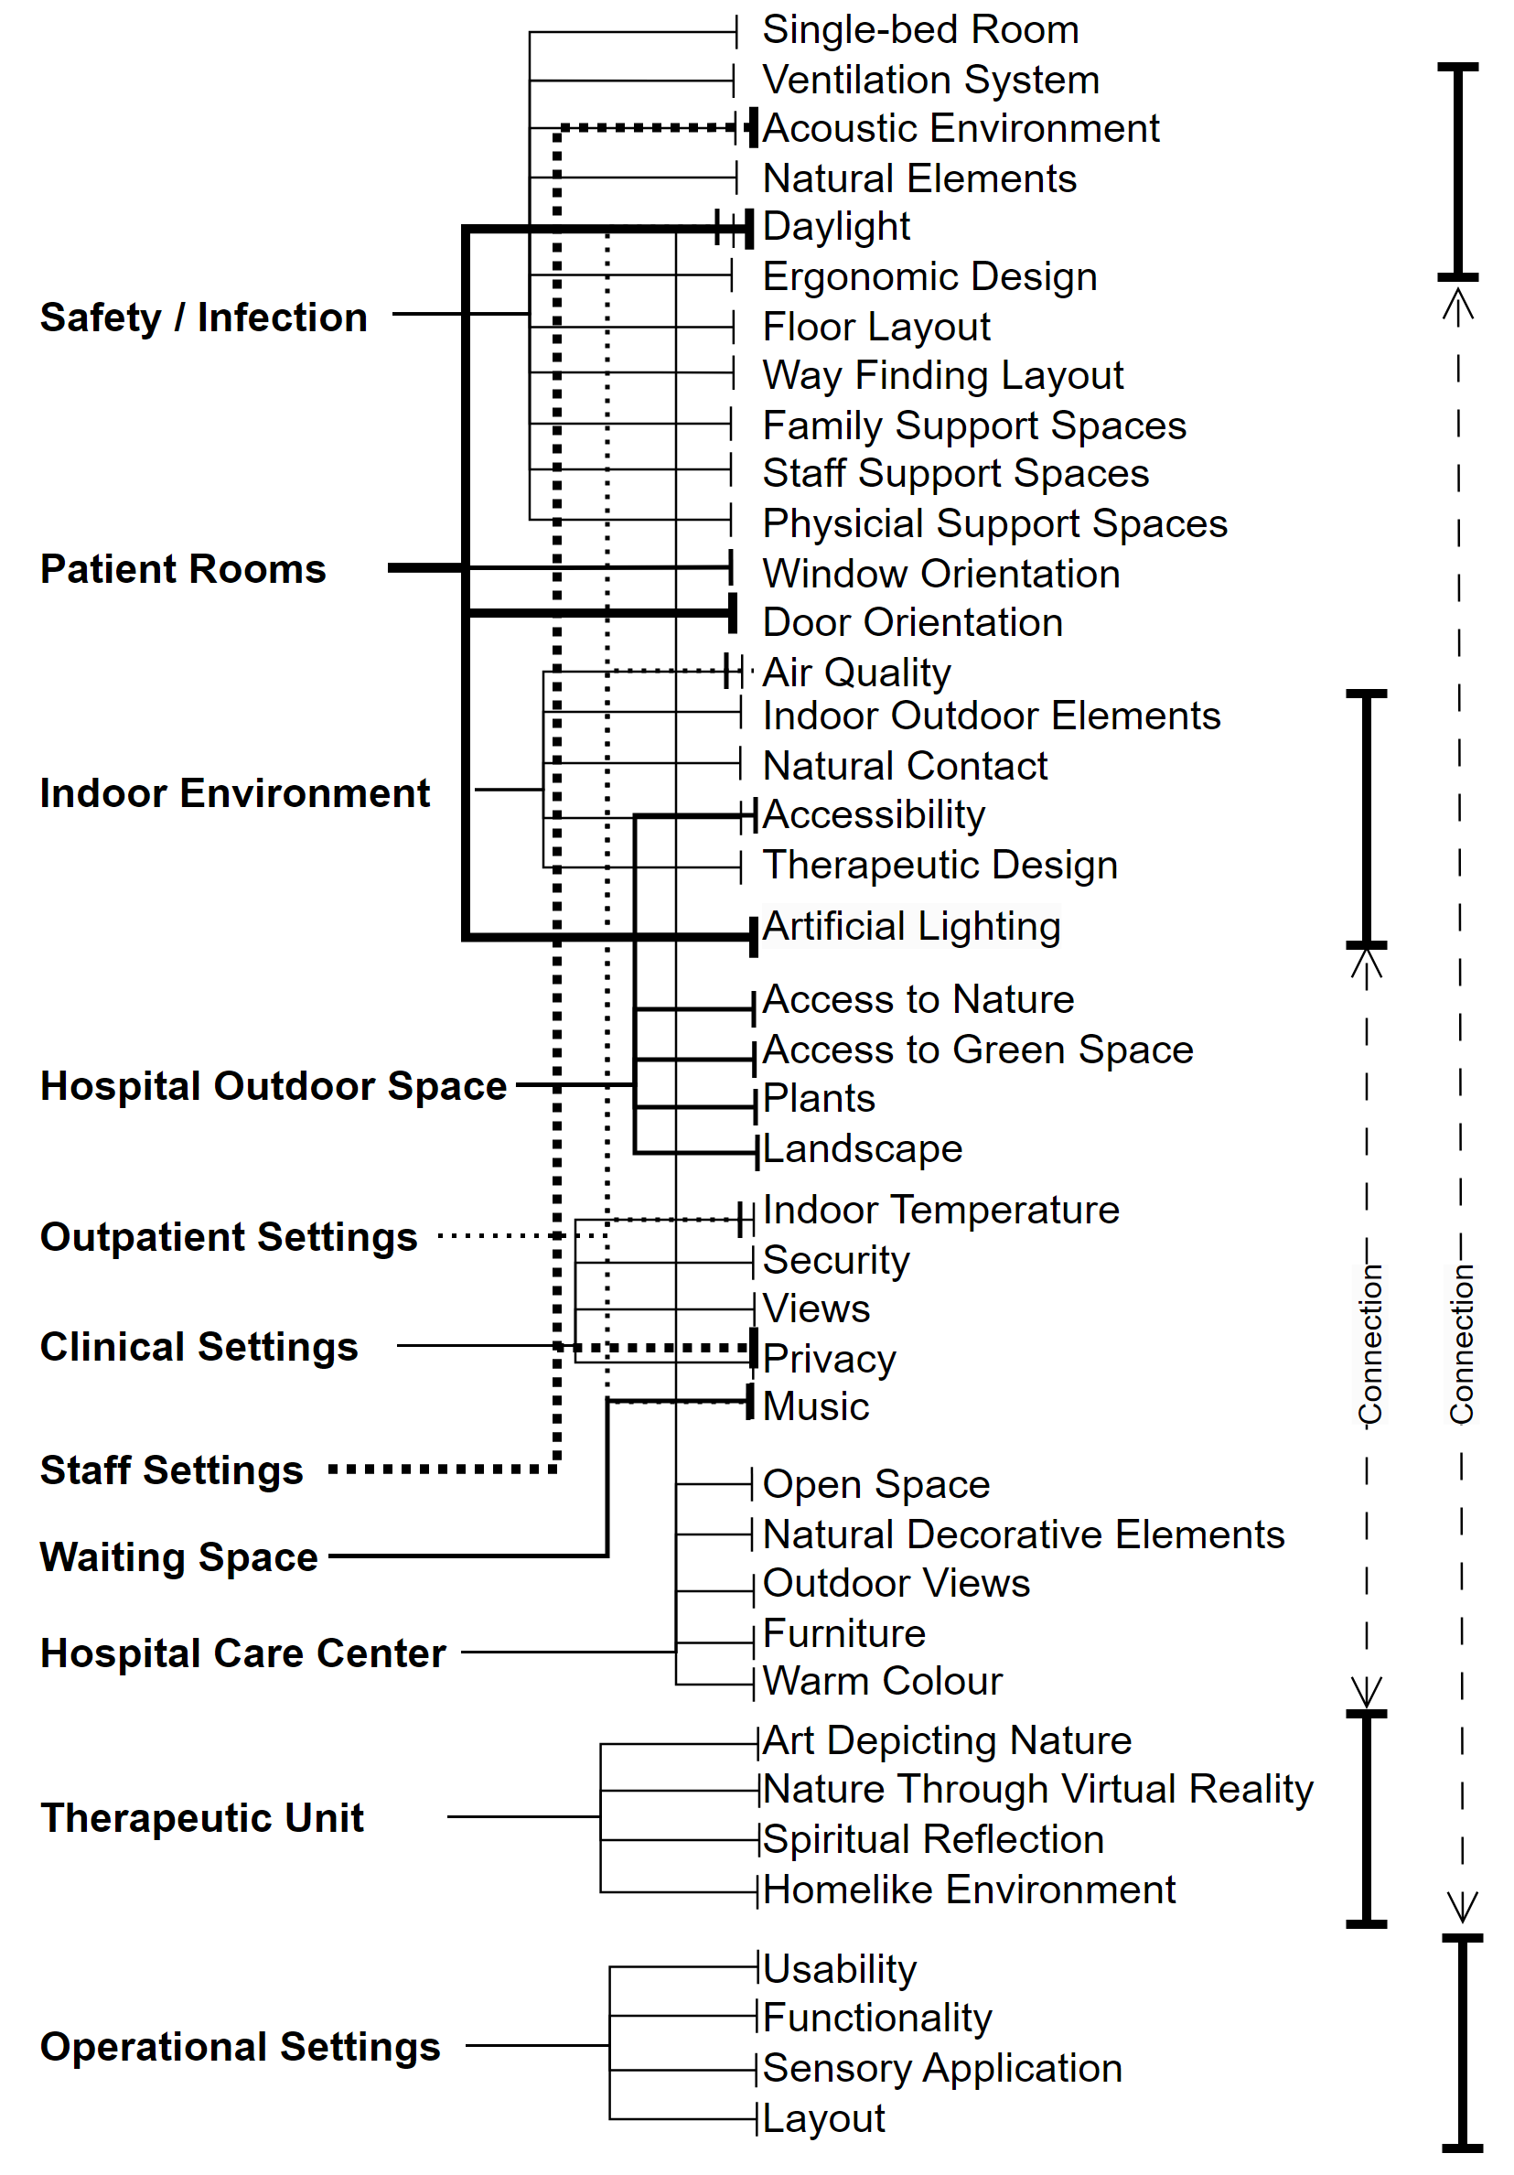

The studies reviewed here provide valuable insights into how healthcare environments can influence psychological, emotional and physical well-being of patients, staff and visitors. However, many studies face limitations such as reliance on self-reported measures, lack of longitudinal data and insufficient cross-cultural validation. Future research should focus on addressing these gaps, exploring the practical implementation of design guidelines and assessing the long-term impacts of design interventions on health outcomes. By integrating evidence-based design with user-centered approaches, architects and healthcare professionals can create environments that meet functional needs but also promote healing and well-being. Healthcare design research says it is imperative to create environments that support healthcare workers, improve patient outcomes and promote well-being. The research emphasises the multifaceted nature of healthcare environments and the need for a holistic approach to design by combining evidence-based design principles with natural elements and sensory stimuli (see Figure 2). As the field continues to evolve, there is growing recognition of the need for adaptable, evidence-driven design strategies that can respond to the changing demands of healthcare delivery. Healthcare design aims to create spaces that not only support physical health but also foster emotional resilience, healing and well-being for everyone. In light of this growing body of research, it is clear that the built environment can have a profound and lasting impact on healthcare experiences.

Design Interpretations
From the above analysis, it has been identified that evidence-based designs and biophilic designs in healthcare environments have a crucial role in enhancing patient well-being, safety and overall healthcare experiences (Ferrante and Villani, 2021, 2022; Hosseini et al., 2024; Cho, 2023) (see Table 1).

Table 1
Environmental Design factors for healthcare settings
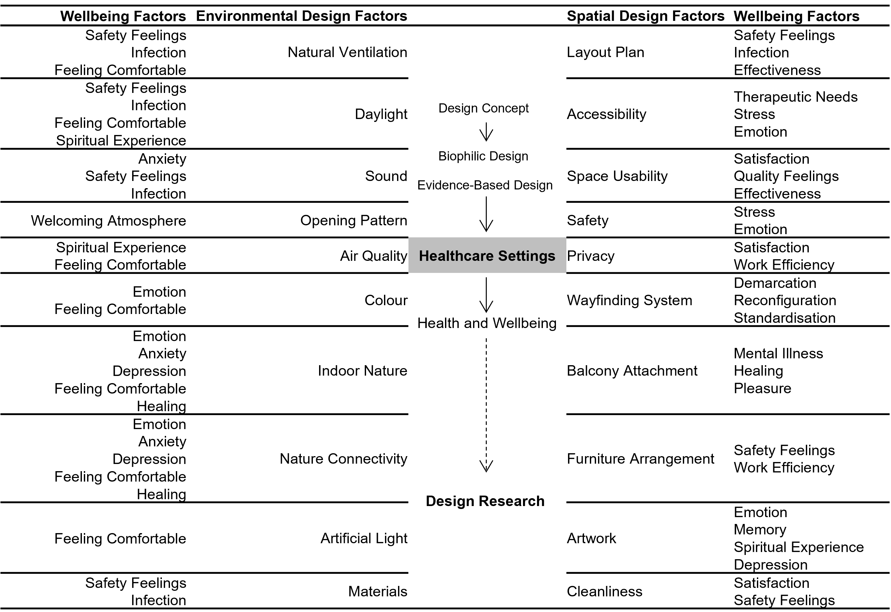

Evidence-based designs incorporate features that reduce medical errors and enhance infection control such as improved lighting and noise reduction. Biophilic designs introduce natural elements like plants and natural light which lower stress levels and promote faster recovery. Together, these approaches create a safer and healing environment for patients. Effective space articulation and utilisation play a crucial role in healthcare design for patients' safety and well-being (Miao et al., 2024; Shetty et al., 2024). Natural elements such as plants and natural light have been shown to lower stress levels by creating a calming atmosphere. Exposure to natural light helps regulate circadian rhythms, improving sleep quality and boosting mood. Additionally, the presence of plants can enhance air quality and provide a sense of tranquility, contributing to faster recovery times. According to the study above, patient rooms, specifically single-bed rooms, play a vital role in healthcare facility design by significantly reducing hospital-acquired infections and enhancing individual safety, privacy and comfort. Research suggests that single-bed rooms may lead to improved patient outcomes by minimising infection risks and providing a more personalised and relaxed environment. Related to this design factor, ergonomic designs and acuity-adaptable room setups may play a significant role in enhancing staff efficiency and patient care. If improved workspace and floor layouts are designed properly, they may support specific medical tasks, enhance workflow, reduce physical strain and increase safety. These design features suggest that healthcare centers can deliver more effective and comfortable service and care, ultimately benefiting both staff and patients.
The analysis suggests that incorporating natural air ventilation into healthcare facilities and patient rooms is consistently recognised as beneficial for patient health, comfort, well-being and safety. Natural ventilation, through the strategic design of windows, doors and architectural features, enhances indoor air quality by facilitating fresh air circulation. The review of related studies indicates that optimum airflow can help reduce and eliminate airborne pollutants, potentially leading to decreased respiratory problems and infections. In acute hospital settings, there is a relationship between therapeutic tools and natural ventilation through windows. Natural air may lead to physical and spiritual experiences in a healthcare center patient room. So, integrating natural ventilation into building design may make healthcare environments more refreshing and invigorating. This may promote quicker recovery times and improve patient satisfaction. This method offers an environmentally responsible option that reduces dependency on mechanical ventilation systems while fostering a more restorative and healthful interior atmosphere. It is in line with sustainable and biophilic architecture.
Integrating daylight access by maximising daylight in patient rooms is consistently highlighted in previous studies as beneficial for overall health. Natural light and nature views are associated with reduced anxiety, improved mood and faster recovery times. Proper lighting, particularly in patient rooms, regulates circadian rhythms and creates a soothing atmosphere conducive to healing. In post-occupation evaluations (POEs), vulnerable users' psychological needs may depend on indoor visual comfort. Also, natural light may impact patients' emotions in healthcare zones. Evidence-based design studies show that not only patients' healing but also physicians', family caregivers and staff's well-being depends on the built environment and lighting quality inside. Proper lighting in healthcare settings can significantly enhance staff performance by reducing eye strain and fatigue, leading to increased alertness and concentration. When healthcare professionals work in well-lit environments, they are more likely to maintain high levels of productivity and make fewer errors (Joshi et al., 2023). Additionally, exposure to natural light can improve mood and reduce stress, contributing to a more positive work atmosphere. In this case, window orientation, opening design and architectural features may work as therapeutic tools in healthcare settings. Lighting plays a crucial role in patient recovery by influencing sleep patterns and overall well-being. Exposure to natural light helps regulate melatonin production which is essential for maintaining healthy sleep cycles. Furthermore, well-lit environments promote a sense of comfort and safety, enhancing patients' ability to rest and recover effectively. Biophilic design, which incorporates elements like plants, natural light and landscape views through windows and openings, may contribute to emotional and psychological resilience and overall health outcomes. This is done by creating a soothing and healing healthcare setting.
To create a healing environment in healthcare settings, nature and biophilic design are crucial. By combining natural environments like plants, water and greenery, biophilic design principles establish a strong connection between the built environment and the natural world. The incorporation of plants and living walls into interior spaces directly brings nature into the space. Healthcare facilities that have access to outdoor spaces, such as gardens, courtyards and open terraces, offer patients, caregivers and staff an opportunity to spend time outdoors. As a result, patients can benefit from fresh air, sunlight and nature's therapeutic effects. Creating green spaces in healthcare waiting areas can enhance patients' experiences by connecting them to nature. It reduces boredom, increases visual comfort, and elicits positive psychological responses. The use of calming colors in biophilic design may instill hope in patients. Therefore, incorporating nature into healthcare design can support overall well-being. A hospital's outdoor space should seamlessly integrate access to nature and greenery with environmental design features in post-acute care settings and hospitals. Natural scenes, nature sounds, landscapes, and virtual reality can provide patients with a sense of connection to nature.
Effective acoustic conditions play a crucial role in evidence-based healthcare design, directly affecting patient well-being. Proper acoustic conditions can reduce stress and anxiety in patients by minimising noise levels which are often linked to increased heart rates and sleep disturbances. A quieter environment promotes rest and recovery, enabling patients to heal more effectively. Additionally, improved acoustics can enhance communication between healthcare providers and patients, ensuring clearer understanding and better overall care. Providing these conditions can reduce stress and noise-related disturbances, improving patient satisfaction and staff performance. Excessive noise has been shown to negatively affect both patients' physical condition and physicians' well-being. Virtual reality can serve as an effective tool in patient recovery by providing immersive experiences that distract from pain and discomfort. By simulating calming natural environments, it can help reduce stress and anxiety levels, promoting mental relaxation. Additionally, virtual reality therapy can be used in rehabilitation exercises, motivating patients to engage more actively in their recovery process. In healthcare settings, particularly in waiting rooms, music can reduce patients' anxiety. However, music choice should be carefully considered to promote relaxation and reduce mental stress. Indoor and outdoor acoustic environments are highlighted as significant design factors to evaluate and optimise in post-occupation evaluations.
It has been demonstrated that visual arts and other sensory elements enhance the well-being and experience of patients in healthcare environments. By enhancing patients' emotional states, visual arts can make hospitals more welcoming and less stressful. As an example, artwork depicting nature and landscapes can reduce stress levels by allowing patients to escape into the natural world temporarily. Interactive interventions can promote well-being through participatory, exploratory or diagnostic approaches. Sensory elements such as soothing sounds or calming scents, can create a more relaxing atmosphere that reduces anxiety and discomfort. These elements can also stimulate positive emotional responses which improve mood and promote faster healing. Additionally, engaging multiple senses can distract patients from pain and discomfort, contributing to an overall better recovery experience. Researchers have shown that colours affect human emotions. Specific colours such as yellow, are associated with emotions like hope. Lighting designs can create an uplifting and healing environment. Addressing emotional needs in hospital design is essential to patients' well-being. In addition to improving patient satisfaction, creating environments that offer privacy, versatile communal spaces, and connections to nature can significantly enhance therapeutic outcomes. As a result, a supportive and nurturing environment is created, which promotes both physical and psychological recovery. Healthcare outcomes, staff well-being and overall healthcare experiences can be significantly improved by integrating evidence-based design factors, theoretical approaches and stakeholder engagement. It is possible to create spaces that promote healing, comfort and positive experiences for all users by prioritising these elements.

Research Limitations
Despite significant advancements in healthcare design research, several limitations must be acknowledged. Firstly, the generalisability of findings may be constrained by the diversity of healthcare settings, patient populations, and cultural contexts in which the studies were conducted. Many studies focus on specific regions or types of healthcare facilities, which may limit their applicability to other settings. Secondly, while evidence-based design principles are widely advocated, there is a need for more longitudinal studies to assess the long-term effects of these design interventions on patient outcomes, and staff well-being. Short-term studies may not capture the full impact of design changes, and further research is needed to establish sustained benefits over time. Thirdly, the integration of natural elements, and biophilic design, although beneficial, often relies on qualitative measures, and subjective assessments. More quantitative research is needed to establish standardised metrics and objectively measure the impact of these design features on health outcomes (Karanikola et al., 2020; Ismaeil et al., 2022; Sun et al., 2023; Rasmussen et al., 2023). Additionally, the studies reviewed often highlight the importance of stakeholder engagement, and participatory experience design processes (Chowdhury et al., 2020-2023). However, there is limited exploration of the challenges, and barriers to effectively implementing these approaches in practice. Future research should address how to overcome these obstacles to ensure stakeholder perspectives are meaningfully integrated into healthcare design projects. Lastly, while the incorporation of visual arts, and sensory elements (Joseph et al., 2024) has shown promise, the variability in methodologies, and interventions used across studies makes it challenging to draw definitive conclusions. More rigorous, and consistent research designs are needed to validate the effectiveness of these interventions and understand their mechanisms of action. In conclusion, while the current body of research provides valuable insights into the impact of healthcare design on patient, and staff outcomes, further research is needed to address these limitations and enhance our understanding of effective design strategies in diverse healthcare settings.

Conclusions
According to research, there is a strong correlation between healthcare design and improving patient outcomes, staff well-being and overall healthcare experiences, according to research. Evidence-based design (EBD) interventions include single-bed rooms, efficient ventilation systems, natural light and biophilic elements. In addition to reducing hospital-acquired infections, these design elements also create healing and emotional environments. To enhance patient and staff experiences, it is critical to optimize space utilisation, incorporate ergonomic designs and provide effective acoustics. Natural ventilation and daylight improve indoor air quality and circadian rhythms are regulated. By enhancing psychological resilience and overall health outcomes, biophilic design elements such as plants and scenic views, are even more beneficial. Through the creation of a more welcoming, less stressful environment, visual arts and sensory elements have been shown to significantly improve patient experiences in healthcare settings. A combination of colors that promote hope and thoughtful lighting designs creates uplifting, healing spaces. By providing person-centered care and therapeutic design features such as privacy and flexible communal spaces, it can promote emotional and psychological healing for patients. By integrating nature into patient care, both physically and virtually, it supports patient well-being and complements biomedical healthcare systems. According to the evidence, a holistic approach to healthcare design that considers natural elements, optimal spatial arrangements and psychological and therapeutic needs, can significantly improve healthcare outcomes and health outcomes. Future research should explore these relationships and improve environmental design strategies.

References
Berglund, M., Westin, L., Svanström, R., & Sundler, A. (2012). Suffering caused by care—Patients’ experiences from hospital settings. International journal of qualitative studies on health and well-being, 7(1), 18688.

Bevere D, Faccilongo N. Shaping the Future of Healthcare: Integrating Ecology and Digital Innovation. Sustainability. 2024; 16(9):3835. https://doi.org/10.3390/su16093835

Chi, P., Gutberg, J., & Berta, W. (2020). The Conceptualization of the Natural Environment in Healthcare Facilities: A Scoping Review. HERD, 13(1), 30–47. https://doi.org/10.1177/1937586719845118

Cho M. Evaluating Therapeutic Healthcare Environmental Criteria: Architectural Designers’ Perspectives. International Journal of Environmental Research and Public Health. 2023; 20(2):1540. https://doi.org/10.3390/ijerph20021540

Chowdhury S, Noguchi M, Doloi H. Methodological Approach of Environmental Experience Design to Enhancing Occupants’ Well-Being, Bangladesh. Buildings. 2023; 13(2):542. https://doi.org/10.3390/buildings13020542

Chowdhury S, Noguchi M, Doloi H. Conceptual Parametric Relationship for Occupants’ Domestic Environmental Experience. Sustainability. 2021; 13(5):2982. https://doi.org/10.3390/su13052982

Chowdhury S, Noguchi M, Doloi H. Defining Domestic Environmental Experience for Occupants’ Mental Health and Wellbeing. Designs. 2020; 4(3):26. https://doi.org/10.3390/designs4030026

Edwards T. M. (2023). Designing for Hope: Biophilic Colour Associations, and Their Relevance to Clinical Settings. HERD, 16(4), 159–171. https://doi.org/10.1177/19375867231173410

Ferrante, T., & Villani, T. (2021). Environmental Physical, and Perceived Quality in Hospice. HERD, 14(4), 324–338. https://doi.org/10.1177/19375867211028160

Ferrante T, Villani T. Pre-Occupancy Evaluation in Hospital Rooms for Efficient Use of Natural Light—Improved Proposals. Buildings. 2022; 12(12):2145. https://doi.org/10.3390/buildings12122145

Hamilton D. K. (2022). Evidence, Bioethics, and Design for Health. HERD, 15(2), 13–21. https://doi.org/10.1177/19375867221082774

Hosseini SN, Walton JC, SheikhAnsari I, Kreidler N, Nelson RJ. An Architectural Solution to a Biological Problem: A Systematic Review of Lighting Designs in Healthcare Environments. Applied Sciences. 2024; 14(7):2945. https://doi.org/10.3390/app14072945

Ismaeil EMH, Sobaih AEE. Enhancing Healing Environment and Sustainable Finishing Materials in Healthcare Buildings. Buildings. 2022; 12(10):1676. https://doi.org/10.3390/buildings12101676

Joshi, R., Ossmann, M., & Joseph, A. (2023). Measuring potential visual exposure of physicians during shift-end handoffs and its impact on interruptions, privacy, and collaboration. HERD: Health Environments Research & Design Journal, 16(1), 175-199. https://doi.org/10.1177/19375867221131934

Joseph, A., Neyens, D., & Catchpole, K. (2024, June). Using Virtual Reality to Conduct Proactive Evaluation of Three Alternative Anesthesia Workspace Layouts in the Operating Room. In EDRA 55 Human-Centric Environments. EDRA.

Karanikola P, Andrea V, Tampakis S, Tsolakidou A. Indoor and Outdoor Design in Healthcare Environments: The Employees’ Views in the General University Hospital of Alexandroupolis, Greece. Environments. 2020; 7(8):61. https://doi.org/10.3390/environments7080061

Lundin S. (2021). A Consciously Applied, Design-Driven Dialogue Can Improve Healing Architecture. HERD, 14(1), 61–70. https://doi.org/10.1177/1937586720954931
Lai, J. C., & Amaladoss, N. (2022). Music in Waiting Rooms: A Literature Review. HERD, 15(2), 347–354. https://doi.org/10.1177/19375867211067542

Lee, J., & Yoon, S. Y. (2024). Moderating Effects of Individual Traits on the Association Between Nature and Patient Wait Experiences. HERD, 19375867241226601. Advance online publication. https://doi.org/10.1177/19375867241226601

Miao Y, Yu DSF, Tan W, Lau SSY, Lau SSY, Tao Y. Crafting Sustainable Healthcare Environments Using Green Building Ratings for Aging Societies. Sustainability. 2024; 16(5):1954. https://doi.org/10.3390/su16051954

Nieberler-Walker, K., Desha, C., Bosman, C., Roiko, A., & Caldera, S. (2023). Therapeutic hospital gardens: Literature review and working definition. HERD: Health Environments Research & Design Journal, 16(4), 260-295.

Ransolin, N., Saurin, T. A., Zani, C. M., Rapport, F., Formoso, C. T., & Clay-Williams, R. (2022). The Built Environment Influence on Resilient Healthcare: A Systematic Literature Review of Design Knowledge. HERD, 15(3), 329–350. https://doi.org/10.1177/19375867221077469

Rossi, A., Heyman, N. B., Rossi, M. O., Wolf, S., & White, T. (2023). Exploring the Association Between the Healthcare Design Elements, and Physician Well-Being: A Scoping Review. HERD, 16(3), 362–378. https://doi.org/10.1177/19375867231151687

Rasmussen B, Carrascal T, Secchi S. A Comparative Study of Acoustic Regulations for Hospital Bedrooms in Selected Countries in Europe. Buildings. 2023; 13(3):578. https://doi.org/10.3390/buildings13030578

Shannon, M. M., Nordin, S., Bernhardt, J., & Elf, M. (2020). Application of Theory in Studies of Healthcare Built Environment Research. HERD, 13(3), 154–170. https://doi.org/10.1177/1937586719901108

Sijm-Eeken M, Jaspers M, Peute L. Identifying Environmental Impact Factors for Sustainable Healthcare: A Scoping Review. International Journal of Environmental Research and Public Health. 2023; 20(18):6747. https://doi.org/10.3390/ijerph20186747

Shetty RS, Kamath GB, Rodrigues LLR, Nandineni RD, Shetty SR. The Impact of the Physical Environment on Staff in Healthcare Facilities: A Systematic Literature Review. Buildings. 2024; 14(9):2773. https://doi.org/10.3390/buildings14092773

Sadek, A. H., & Shepley, M. M. (2016). Space Syntax Analysis: Tools for Augmenting the Precision of Healthcare Facility Spatial Analysis. HERD, 10(1), 114–129. https://doi.org/10.1177/1937586715624225

Sun Y, Kojima S, Nakaohkubo K, Zhao J, Ni S. Analysis and Evaluation of Indoor Environment, Occupant Satisfaction, and Energy Consumption in General Hospital in China. Buildings. 2023; 13(7):1675. https://doi.org/10.3390/buildings13071675

Tekin, B. H., Corcoran, R., & Gutiérrez, R. U. (2023). A Systematic Review, and Conceptual Framework of Biophilic Design Parameters in Clinical Environments. HERD, 16(1), 233–250. https://doi.org/10.1177/19375867221118675

Tseung, V., Verweel, L., Harvey, M., Pauley, T., & Walker, J. (2022). Hospital Outdoor Spaces: User Experience, and Implications for Design. HERD, 15(1), 256–267. https://doi.org/10.1177/19375867211045403

Ulrich, R. S., Zimring, C., Zhu, X., DuBose, J., Seo, H. B., Choi, Y. S., Quan, X., & Joseph, A. (2008). A review of the research literature on evidence-based healthcare design. HERD, 1(3), 61–125. https://doi.org/10.1177/193758670800100306

Ulrich, R. S., Berry, L. L., Quan, X., & Parish, J. T. (2010). A conceptual framework for the domain of evidence-based design. HERD: Health Environments Research & Design Journal, 4(1), 95-114.

Untaru, E. N., Han, H., David, A., & Chi, X. (2024). Biophilic Design, and Its Effectiveness in Creating Emotional Well-Being, Green Satisfaction, and Workplace Attachment Among Healthcare Professionals: The Hospice Context. HERD, 17(1), 190–208. https://doi.org/10.1177/19375867231192087

Ullán, A. M., & Belver, M. H. (2021). Visual Arts in Children's Hospitals: Scoping Review. HERD, 14(4), 339–367. https://doi.org/10.1177/19375867211003494

van Oel, C. J., Mlihi, M., & Freeke, A. (2021). Design Models for Single Patient Rooms Tested for Patient Preferences. HERD, 14(1), 31–46. https://doi.org/10.1177/1937586720937995

Yan, S., Azmi, A., Mansor, N., Wang, Z., & Wang, Y. (2024). Healing Spaces as a Design Approach to Optimize Emotional Regulation for Patients with Mood Disorders. Buildings, 14(2), 472.

Zhong, W., Schröder, T., & Bekkering, J. (2022). Biophilic design in architecture, and its contributions to health, well-being, and sustainability: A critical review. Frontiers of Architectural Research, 11(1), 114-141.

