Hydrocarbon distribution at the Bonny Creek six months after the Fusokiri-6 manifold oil spill in the Niger Delta

Abstract
The distribution of petroleum hydrocarbon (PAH and TPH) was investigated at the Bonny Creek six months after the Fusokiri-6 manifold oil spillage in the Niger Delta region of Nigeria. PAHs reported for the study are the parental PAHs with rings ranging from 2-6. For the surface water and sediment of Fibiri Creek and NLNG-SPDC site, the total PAHs was <0.01. The PAHs of Iwoama Creek is dominated by Phenanthrene (3-Rings) for both surface water and sediment while the Legakiri Creek PAHs is dominated by Anthracene (3-Rings) in surface water and Phenanthrene (3-Rings) in sediment. The TPH of the range of C₈-C₄₀ as well as PAHs were found in all sampled locations. Results indicated that all locations were dominated 1-4-Alkylated-PAH of low molecular weight (2-3 Rings). Oiling was still evident on the water body as observed by the intense discolouration observed during the field reconnaissance survey of the spilled site and evident by the concentrations of TPH and PAHs.

Keywords: petroleum hydrocarbon; Bonny creek; Niger Delta; TPH; PAH; oil spill

Introduction
Petroleum hydrocarbons have environmental importance due to their toxicity to humans, plants and animal resources (Onianwa and Essien, 1999; Osuji and Onojake, 2005; Iwegbue, 2007). They are prominent among the organic pollutants which are frequently disposed into marine environment. Petroleum hydrocarbons consist majorly of three groups, namely the paraffins (n-alkanes), the naphthenes (cycloalkanes), and the aromatics (monocyclic and polycyclic aromatics). They also contain minor constituents of the heavy metals and nitrogen, suphur, oxygen (NSO) compounds (Wigger and Torkelson, 1997). Alkanes are the key components of many refined petroleum products (e.g. gasoline, diesel fuel, kerosene, jet fuel and heating oils) and can be generally subdivided into several classes which include the following: linear alkanes (n-alkanes), branched alkanes, cycloalkanes, isoprenoids (e.g., pristane, phytane, steranes and triterpanes), and unresolved complex mixtures (UCM), which are difficult to resolve by capillary column gas chromatography. The presence of UCM in chromatograms is usually an indication of petroleum degradation (Hutchenson et al., 1996).
Studies have shown that when oil spills in the aquatic environment, the petroleum hydrocarbons and heavy metals released also find their way even to the sediment base of the river. They are generally less soluble in water, but are readily adsorbed onto particulate matter and are subsequently scavenged to the bottom sediment which has become a reservoir for several hydrophobic contaminants. The danger in the sedimentation of these organic pollutants is their tendency to accumulate and bioconcentrate over time in aquatic organisms (Ali et al., 2015).
Creeks and composite rivers in the Niger Delta are prone to contamination of petroleum hydrocarbons and heavy metals from industrial activities associated with exploration and production operations. These operations are susceptible to oil spill which unleashes contaminants in the offshore aquatic medium. Oil spill is the uncontrolled release of crude oil into environment as a result of operational mishap, equipment failure and/or intentional damage to oil production facilities, otherwise known as sabotage (Osuji and Onojake. 2005).
Oil Spills usually occur during the development, production, transportation and storage of crude oil and available records show that oil spill incidents have occurred in many parts of Niger Delta. According to NUPR-EGASPIN (2022), a total of 4,835 incidents resulted in the spill of approximately 2,446,322 barrels of oil between 1976 and 1996. Of this quantity, an estimated 1,896,322 barrels (77%) of the oil spilled into the environment. A review of a number of existing post-impact assessment (PIA) reports on the Niger Delta have shown a range of impacts on predominantly mangrove ecosystem. Generally, the worldwide oil spill data show a good progress but there are still challenges for the industry, particularly the transportation industry. A recent study by the U.S National Resource Council and the National Academy of Sciences shows that oil and gas exploration and production is the fourth-biggest contributor to oil entering the global oceans, contributing 3% of the total (1% for U.S. waters). The highest contribution is from natural seeps (46%); followed by consumers of oil by way of sewers, storm drains, and water vehicles (37%); and by petroleum transportation (11%). The impacts range from localized effects on flora and fauna (usually considered as minor), to major impacts like high mortality of the mangrove trees and of the ecological species they support. The insidious impact of post-oil spill fires has also been evaluated and all of these point to severe depletion of oxygen and restriction of gaseous diffusion in soils. In the case of an offshore spill, some water-soluble fractions, particularly aromatic compounds, are toxic to aquatic animals and plants (Iwegbue et al., 2007; Ikhumetse et al., 2022; Jonah and Francis, 2022). The significant disposition of this area to eco-trade and commerce calls for periodic monitoring of the hydrocarbon content, especially after oil spillage in order to ascertain the water quality status of the creek
2. Materials and methods
2.1 Study Area
The area of study is the Bonny creek in the south-eastern Niger Delta of Rivers State, Nigeria. The Bonny Estruary is an estruary on the coast of Rivers State, Nigeria. It is one of the network of creeks in the Niger Delta region that empties directly into the Atlantic Ocean at Bonny Island. It is tidal and thus receives a high influx of sea water most of the year (Dublin-Green, 1988). Large scale oil and gas production, industrialization and urbanization characterise the study location with reported impacts from oil spills, gas flares, industrial discharges, agricultural runoff and domestic effluents and leachates. The estuary also supports marine transportation by heavy vessels conveying goods and services to and from a petroleum tank farm, Port Harcourt wharf, cement and flour factories, among others, in addition to heavy traffic of fast speed boats for communal transportation. Despite these activities, artisanal fisheries in the estuary largely support the livelihood of its inhabitants who have little or no knowledge of the extent of contamination in the estuary. Fish remains an important part in the diet of Nigerians, especially for riverine communities such as the inhabitants of the study area, with seafood being served at almost every meal. In Nigeria, especially in rural and fishing communities, fish constitute approximately 75% of animal protein consumed. Fish is consumed either freshly prepared or smoked. Shellfish, especially the Tympanotonusspecies, are used largely as a condiment in most meals eaten in the Niger Delta (Gomna and Rana, 2007).
The area is dominated by mangrove swamp, similar in vegetation to the estuarine area of Niger Delta. The Bonny and Cross River estuaries are two major estuaries along the eastern coast of Nigeria. Ike the Cross River estuary, it is characterized by deep and shallow channels with semi-diurnal tides that generate tidal currents in phase with the tidal directions. The Bonny/New Calabar River Estuary system is vital to the people of Niger Delta and other surrounding regions. It is perhaps one of the largest arms of the River Niger discharging directly into the Atlantic Ocean. it is believed to also be the most environmentally stressed (Dublin-Green 1998). The Bonny estuary is vulnerable because it is exposed to multiple human activities such as petroleum industry operations. The present work seeks to evaluate status of hydrocarbons and heavy metals in water and sediments in the Bonny Estuary following a recent spill in the area. The consequence of unchecked exploitation is that the productivity of fisheries and important ecosystems, such as mangroves and coral reefs, reduces, which in turn affect the local community which depend on these resources for economic development.
2.2. The oil spill incidence
The oil spillage which turned out to be a major spill owing to perceived lapses at mitigating the cause of the failure of the oil-bearing equipment, occurred on Sunday the 4th of July 2021. The oil spill emanated through some of the oil pipelines criss-crossing the creeks of Bonny River, traceable to Fusokiri Ceek-6 manifolds and Adamakiri Creeks 5 & 6 manifolds, pipelines on the Right of Way to Bonny Export Terminal. Crude oil arising from the pipeline leakage eventually spread to several adjoining creeks from the points of leak.
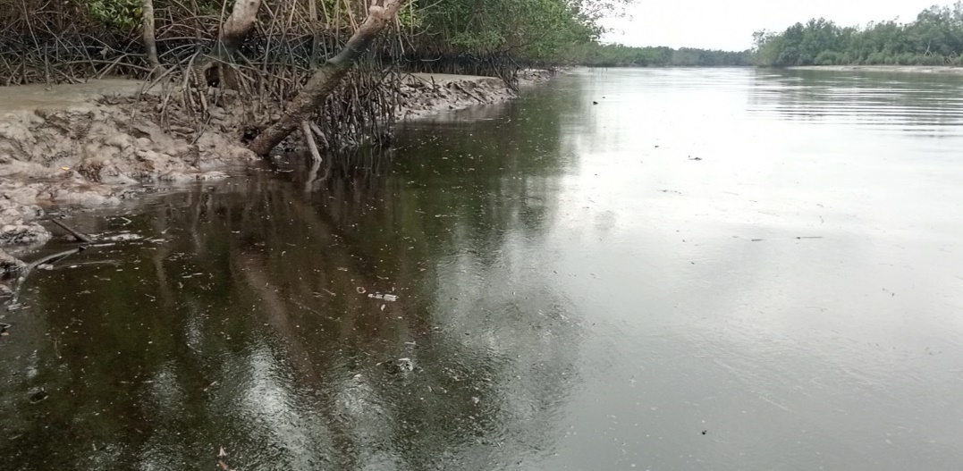

Fig. 1: A section of the Bonny River where oil spillage took place
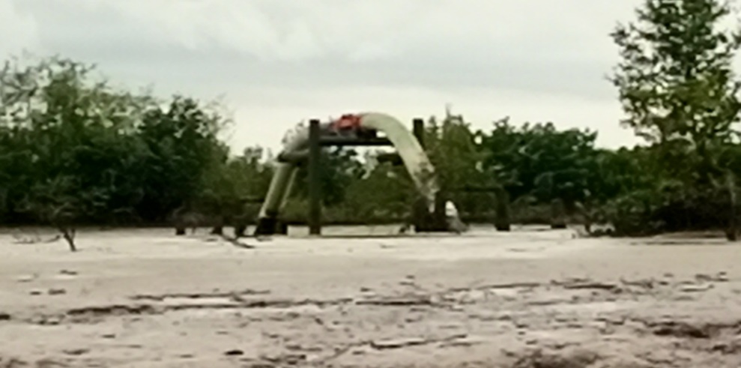
Fig. 2: A sectional vioew of Fusokiri-6 manifold pipeline
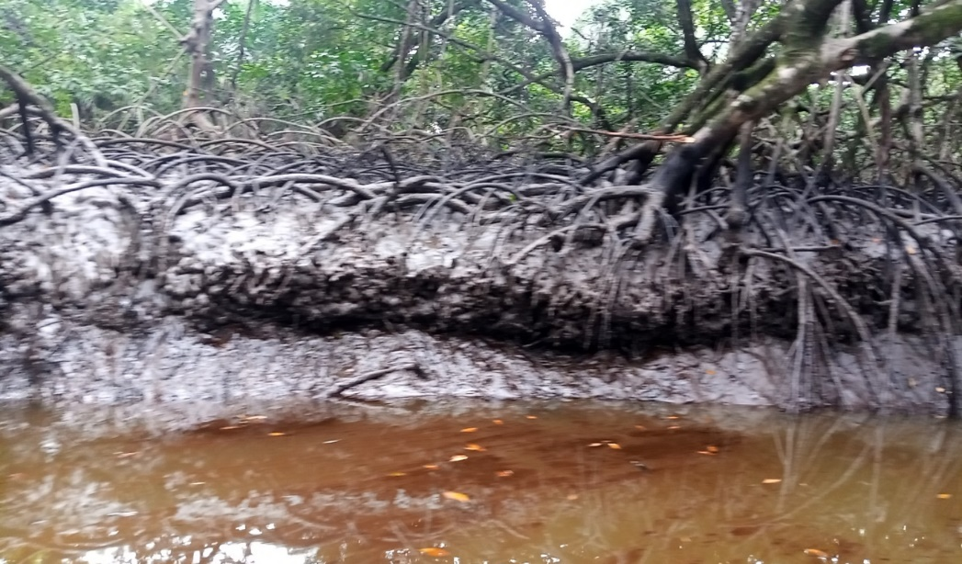
Fig. 3: Impacted site of Fusokiri-6 oil spill
Best practices in the oil and gas industry involve monitoring and evaluation of oil production facilities. Oil bearing pipelines or trunks, if not properly monitored and maintained by the operating company or companies, become susceptible to corrosion hacks, especially after a long period of time, as a result of salt intrusion which exacerbates the electrochemical process of rust and subsequent corrosion of the pipes. Corrosion and the resultant leak of crude oil would occur as a response to negligence, irrespective of who owns or inherits the facilities or laid pipelines.
The consequences of not cleaning up, until the time of our reconnaissance survey, several weeks after the recorded incidence of spill may have caused the impact observed. Several creeks such as FIBIRI Creek (on Longitude 04º 58.449’N and Latitude 007º 01.240’E), IWOAMA creek (Longitude 04º 28.718’N and Latitude 007º 06.603’E), and KALABIE (Longitude 04º 30.049’N and Latitude 007º 08.104’E) were heavily inundated by crude oil.
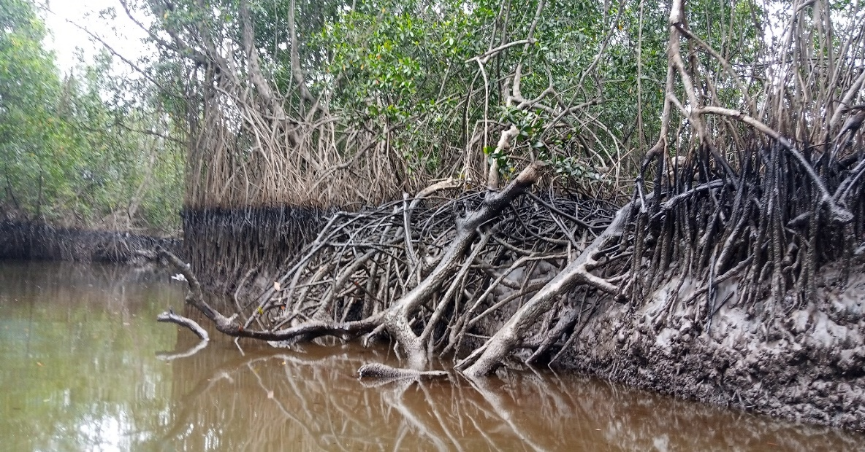
Fig. 4: Impacted vegetation of fusokiri-6 oil spill
2.3. Hydrocarbon analyses
Fifty milliliters (50ml) of water sample was measured with a measuring cylinder, into a separatory flask. 50ml of DCM was added in a ratio of 1:1. The sample was shaken vigorously and vent to remove excess pressure and allowed to settle for 2minutes. Solvent phase was extracted and the sample was dried by adding 5g of anhydrous sodium sulphate. The sample was concentrated into 2ml volume by passing through a gentle stream of Nitrogen gas or rotary evaporator, and fractionated into Aliphatic and Aromatic using column chromatography packed with glass wool and silica gel. The packed column was preconditioned with hexane. For Aliphatic (TPH), 2ml of the concentrate was introduced into the column and eluted with 10ml of hexane. The eluent was further concentrated into final 2ml volume. The final 2ml was introduced into a vial bottle and capped. The sample was ready to be run with GC. For Aromatics (PAH), to the same column, 10ml of DCM was introduced and eluted. The 10ml eluents was further concentrated into a final 2ml. The final 2ml was introduced into a vial bottle and capped. The sample was ready to be run with GC.
Quality Control
- The instrument was allowed to attain the set temperature for the method.
- The column was baked by pressing oven temperature on the GC, then the desired temperature was regulated not beyond oven temp limit. After baking for 1hr re-set oven temperature back to the initial state.
- The instrument was allowed to attain set temperature.
- A solvent blank was run for the method to be analyzed (PAH=DCM, TPH=hexane, BTEX=methanol).
- A standard was run and monitored to make sure the result obtained for the standard corresponds with the previous standard used to calibrate the instrument.
- Gas Chromatograph equipment calibration was performed within 6months or when there is a major maintenance which affects the hardware or software and when calibration material is different from the stored calibration.
- Standards 5.0mg/l (or 50mg/kg) for low range and 20mg/l (or 200mg/kg) for high range were chosen as quality control standard.
- For every batch of samples analyzed, one spike analysis was carried out, low or high depending on the concentration range of the sample analyzed.
Spiking: To a known weight of the sample e.g. 5g
A concentration of TPH or PAH was added which was at least 10 times the concentration of the MDL e.g. 0.5mg spiked sample was treated the same way as the sample.
Expected Concentration = 0.5mg /5g X 1000
= 100mg/kg
Percentage Recovery = (Spike sample result – Sample result) / Expected result X 100
- For every 10 samples or each batch of samples, whichever is less, one of the samples was analysed with low concentration or one sample with high concentration as a duplicate. The acceptable limit for low concentration samples is 75% to 125% while for high concentration samples (repeatability) is 90 to 110%. If the duplicate analysis exceeds the limit, the analysis was repeated.
Repeatability = [1 - (X₁ - X₂)/Mean] x 100%
Where:
Mean = (X₁ + X₂)/2, mg/kg
X₁ = TPH content in sample, mg/kg
X₂ = TPH content in duplicate sample, mg/kg
j] For every 10 samples or each batch of samples, whichever is less, a mid-point check standard or any other standard was analyzed to ensure that calibration has not drifted. If the mid-point check standard is outside 95 to 105% of the expected concentration, the analysis was repeat.
Results and Discussion
The TPHs compound in the surface water and sediment of various location at Bonny range from C₈-C₄₀ compounds which was presented in Table 1. For FCSW, the TPH-compound of C₈-C₁₆, C₁₇₊, C₁₈₊ and C₃₅-C₄₀ has concentration <0.01mg/l while the highest TPH-compound concentration was 0.04mg/l which was found with C₂₅-C₂₇, C₂₉ and C₃₁-C₃₂. The total concentration of TPHs in surface water of Fibiri Creek was 0.70232mg/l and is within the NUPR permissible limit of 10-500mg/l for surface water. For NSSW, the TPH-compound of C8-C16, C17+, C18+, C19-C22 and C33-C40 has concentration <0.01mg/l while the highest TPH-compound concentration was 0.22mg/l which was found with C₂₈. The total concentration of TPHs in surface water of NLNG-SPDC was 0.40769mg/l and is within the NUPR permissible limit of 10-500mg/l for surface water. For ICSW, the TPH-compound of C₈-C₁₁, and C₃₉-C₄₀ has concentration <0.01mg/l while the highest TPH-compound concentration was 55.73mg/l which was found with C₁₇. The total concentration of TPHs in surface water of Iwoama Creek was 614.898mg/l which exceeded the NUPR permissible limit of 10-500mg/l for surface water. For LCSW, the TPH-compound of C₈ and C₉ have concentration of <0.01mg/l while the highest TPH-compound concentration was 1503mg/l which was found with C₁₇. The total concentration of TPHs in surface water of Legakiri Creek was 16557mg/l which exceeded the NUPR permissible limit of 10-500mg/l for surface water.
For the sediment from various location, the FCSD concentration of TPH-compound of C₈-C₁₄ and C₃₇-C₄₀ was <0.01mg/kg while the highest TPH-compound concentration was 46.6mg/kg which was found with C₂₈. The total concentration of TPHs in sediment of Fibiri Creek was 431mg/kg and is within the NUPR permissible limit of 10-500mg/kg for sediment. For NSSW, the TPH-compound of C₈-C₁₄, and C37-C40 has concentration <0.01mg/kg while the highest TPH-compound concentration was 28.8mg/kg which was found with C₂₈. The total concentration of TPHs in sediment of NLNG-SPDC was 165.0mg/kg and is within the NUPR permissible limit of 10-500mg/kg for surface water. For ICSW, the TPH-compound of C₈-C13, and C₃₇-C₄₀ has concentration <0.01mg/kg while the highest TPH-compound concentration was 11.21mg/kg which was found with C31. The total concentration of TPHs in sediment of Iwoama Creek was 119.0mg/kg and it is within the NUPR permissible limit of 10-500mg/kg for sediment. For LCSW, the TPH-compound of C₈-C₁₀ and C₃₈-C₄₀ have concentration of <0.01mg/l while the highest TPH-compound concentration was 357.9mg/kg which was found with C₁₇. The total concentration of TPHs in sediment of Legakiri Creek was 4130mg/kg which exceeded the NUPR permissible limit of 10-500mg/kg for surface water.
Table 4.4: TPHs Concentration in Surface Water and Sediment

 | Fibiri Creek |  | NLNG-SPDC |  | Iwoama Creek |  | Legakiri Creek
Parameter | FCSW | FCSD | NSSW | NSSD | ICSW | ICSD | LCSW | LCSD | NUPR
C₈ | <0.01 | <0.01 | <0.01 | <0.01 | <0.01 | <0.01 | <0.01 | <0.01 | 10-5000mg/l
C₉ | <0.01 | <0.01 | <0.01 | <0.01 | <0.01 | <0.01 | <0.01 | <0.01 | 10-5000mg/l
C₁₀ | <0.01 | <0.01 | <0.01 | <0.01 | <0.01 | <0.01 | 2.98 | <0.01 | 10-5000mg/l
C₁₁ | <0.01 | <0.01 | <0.01 | <0.01 | <0.01 | <0.01 | 5.19 | 4.82 | 10-5000mg/l
C₁₂ | <0.01 | <0.01 | <0.01 | <0.01 | 0.58 | <0.01 | 59.92 | 7.35 | 10-5000mg/l
C₁₃ | <0.01 | <0.01 | <0.01 | <0.01 | 0.26 | <0.01 | 120.4 | 29.09 | 10-5000mg/l
C₁₄ | <0.01 | <0.01 | <0.01 | <0.01 | 3.26 | 0.04 | 274.4 | 48.74 | 10-5000mg/l
C₁₅ | <0.01 | 0.05 | <0.01 | 0.04 | 10.97 | 0.55 | 366.7 | 88.97 | 10-5000mg/l
C₁₆ | <0.01 | 0.48 | <0.01 | 1.58 | 15.28 | 1.14 | 563.4 | 114.4 | 10-5000mg/l
C₁₇ | 0.02 | 7.73 | 0.01 | 5.36 | 55.73 | 8.06 | 1503 | 357.9 | 10-5000mg/l
C₁₇₊ | <0.01 | 2.72 | <0.01 | 6.64 | 21.77 | 2.35 | 191 | 141.56 | 10-5000mg/l
C₁₈ | 0.01 | 10.9 | 0.01 | 2.99 | 33.09 | 5.75 | 471 | 204.6 | 10-5000mg/l
C₁₈₊ | <0.01 | 13.51 | <0.01 | 1.2 | 26.83 | 3.39 | 639 | 163.8 | 10-5000mg/l
C₁₉ | 0.01 | 13.4 | <0.01 | 6.53 | 23.74 | 4.95 | 1273 | 146 | 10-5000mg/l
C₂₀ | 0.01 | 24.9 | <0.01 | 6.84 | 40.32 | 7.27 | 807.7 | 243 | 10-5000mg/l
C₂₁ | 0.02 | 40.8 | <0.01 | 12.1 | 36.77 | 6.5 | 979 | 229 | 10-5000mg/l
C₂₂ | 0.02 | 25.4 | <0.01 | 10.4 | 30.92 | 5.9 | 772 | 179 | 10-5000mg/l
C₂₃ | 0.03 | 25.6 | 0.01 | 2.05 | 30.75 | 5.57 | 723 | 165 | 10-5000mg/l
C₂₄ | 0.03 | 32.2 | 0.01 | 2.59 | 33.39 | 6.98 | 841 | 220 | 10-5000mg/l
C₂₅ | 0.04 | 28.61 | 0.02 | 2.19 | 35.14 | 7.5 | 928 | 343 | 10-5000mg/l
C₂₆ | 0.04 | 37.9 | 0.02 | 4.22 | 26.12 | 6.09 | 774 | 180 | 10-5000mg/l
C₂₇ | 0.04 | 16.2 | 0.02 | 5.53 | 33.87 | 3.31 | 922 | 190 | 10-5000mg/l
C₂₈ | 0.02 | 46.6 | 0.22 | 28.8 | 28.48 | 8.63 | 605 | 180 | 10-5000mg/l
C₂₉ | 0.04 | 32.5 | 0.02 | 25.4 | 34.66 | 8.64 | 842 | 234 | 10-5000mg/l
C₃₀ | 0.03 | 21.9 | 0.02 | 11.63 | 24.24 | 4.61 | 495 | 182 | 10-5000mg/l
C₃₁ | 0.04 | 24.6 | 0.02 | 15.53 | 18.83 | 11.21 | 382 | 127 | 10-5000mg/l
C₃₂ | 0.04 | 7.76 | 0.02 | 5.77 | 24.54 | 5.62 | 550 | 173 | 10-5000mg/l
C₃₃ | 0.02 | 9.31 | <0.01 | 9.67 | 16.27 | 1.47 | 496 | 112 | 10-5000mg/l
C₃₄ | 0.02 | 4.8 | <0.01 | 1.88 | 1.99 | 2.22 | 237 | 38.23 | 10-5000mg/l
C₃₅ | <0.01 | 3.3 | <0.01 | 2.12 | 4.13 | 0.24 | 153 | 7.25 | 10-5000mg/l
C₃₆ | <0.01 | <0.1 | <0.01 | <0.01 | 0.66 | 0.63 | 138 | 5.7 | 10-5000mg/l
C₃₇ | <0.01 | <0.01 | <0.01 | <0.01 | 0.786 | <0.01 | 107 | 10.26 | 10-5000mg/l
C₃₈ | <0.01 | <0.01 | <0.01 | <0.01 | 1.39 | <0.01 | 159 | <0.01 | 10-5000mg/l
C₃₉ | <0.01 | <0.01 | <0.01 | <0.01 | <0.01 | <0.01 | 125 | <0.01 | 10-5000mg/l
C₄₀ | <0.01 | <0.01 | <0.01 | <0.01 | <0.01 | <0.01 | 46.86 | <0.01 | 10-5000mg/l
TPHs TOTAL | 0.70232 | 431 | 0.40769 | 165 | 614.898 | 119 | 16,557 | 4130 | 10-5000mg/l

The concentration PAHs in surface water and sediment of various locations in Bonny was presented in Table 2. The surface water of FCSW and NSSW showed <0.01 concentration to various parameters of PAHs and the total concentration of PAHs was <0.01 for both FCSW and NSSW. The surface water of ICSW showed <0.01 concentration to compounds of PAHs such as Naphthalene, and Indeno (1,2,3-cd) pyrene while the highest concentration of PAHs compound was 2.35 for Phenanthrene with total concentration of PAHs at 5.04 for ICSW. Sample from LCSW showed <0.01 concentration to compounds of PAHs such as Acenaphthylene, and Acenaphthene while the highest concentration of PAHs compound was 0.04 for Anthracene with total concentration of PAHs at 0.11 for LCSW.
The sediment of FCSD and NSSD showed <0.01 concentration to various parameters of PAHs and the total concentration of PAHs was <0.01 for both FCSD and NSSD. The sediment of ICSW showed <0.01 concentration to compounds of PAHs such as Acenaphthylene, and Benzo (ghi) Perylene while the highest concentration of PAHs compound was 0.23 for Phenanthrene with total concentration of PAHs at 0.65 for ICSW. Sample from LCSW showed <0.01 concentration to compounds of PAHs such as Acenaphthylene, and Acenaphthene while the highest concentration of PAHs compound was 0.13 for Phenanthrene with total concentration of PAHs at 0.35 for LCSW.

Table 2: PAHs Concentration in Surface Water and Sediment
 | Fibiri Creek |  | NLNG-SPDC |  | Iwoama Creek |  | Legakiri Creek
Parameters | FCSW | FCSD | NSSW | NSSD | ICSW | ICSD | LCSW | LCSD | NUPR
Naphthalene | <0.01 | <0.01 | <0.01 | <0.01 | <0.01 | <0.01 | <0.01 | <0.00
Acenaphthylene | <0.01 | <0.01 | <0.01 | <0.01 | 0.01 | 0.01 | <0.01 | <0.00
Acenaphthene | <0.01 | <0.01 | <0.01 | <0.01 | 0.12 | 0.03 | <0.01 | 0.01
Fluorene | <0.01 | <0.01 | <0.01 | <0.01 | 0.1 | 0.02 | <0.01 | 0.01
Anthracene | <0.01 | <0.01 | <0.01 | <0.01 | 1.66 | 0.2 | 0.04 | 0.01
Phenanthrene | <0.01 | <0.01 | <0.01 | <0.01 | 2.35 | 0.23 | 0.03 | 0.13
Fluoranthene | <0.01 | <0.01 | <0.01 | <0.01 | 0.01 | 0.02 | 0.01 | 0.02
Pyrene | <0.01 | <0.01 | <0.01 | <0.01 | 0.1 | 0.03 | 0.01 | 0.04
Benz(a)anthracene | <0.01 | <0.01 | <0.01 | <0.01 | <0.01 | 0.01 | <0.01 | 0.01
Chrysene | <0.01 | <0.01 | <0.01 | <0.01 | 0.4 | 0.01 | <0.01 | 0.01
Benzo(b)Fluoranthene | <0.01 | <0.01 | <0.01 | <0.01 | 0.13 | 0.02 | <0.01 | 0.04
Benzo(k)Fluoranthene | <0.01 | <0.01 | <0.01 | <0.01 | 0.09 | 0.03 | <0.01 | 0.01
Benzo(a) Pyrene | <0.01 | <0.01 | <0.01 | <0.01 | 0.06 | 0.02 | 0.01 | 0.04
Benzo(a,h)anthracene | <0.01 | <0.01 | <0.01 | <0.01 | 0.01 | 0.01 | <0.01 | 0.01
Indeno(1,2,3-cd) pyrene | <0.01 | <0.01 | <0.01 | <0.01 | <0.01 | 0.01 | 0.01 | 0.01
Benzo (ghi) Perylene | <0.01 | <0.01 | <0.01 | <0.01 | <0.01 | <0.01 | <0.01 | <0.01
PAH TOTAL | <0.01 | <0.01 | <0.01 | <0.01 | 5.04 | 0.65 | 0.11 | 0.35

The chromatograms from which the hydrocarbon data was derived are presented as figures 5 and 6.
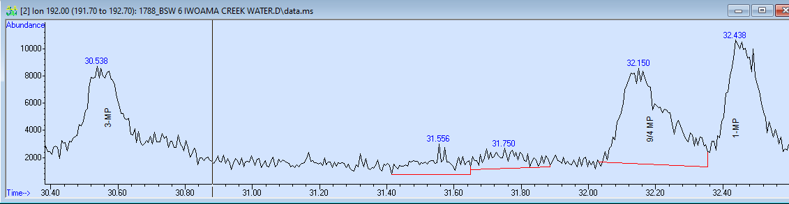
Fig. 5: IWOAMA CREEK Surface Water Methyl-Phenanthrenes ion Chromatogram

Fig. 6: TPH of the surface water sample

Conclusion
The results of the hydrocarbon anslyses of the Bonny Creek six months after the Fusokiri-6 oil spill provide substantial evidence of the presence of hydrocarbons long after contingency intervention at the site. The hydrocarbon distribution varied from location to location but generally points to severe contamination of the creek. For the surface water and sediment of Fibiri Creek and NLNG-SPDC site, the total PAHs was <0.01. The PAHs of Iwoama Creek was dominated by Phenanthrene (3-Rings) for both surface water and sediment while the Legakiri Creek PAHs was dominated by Anthracene (3-Rings) in surface water and Phenanthrene (3-Rings) in sediment. The environment is dominated by 3-Rings PAHs compounds.
For surface water, the concentration descended as LCSW > ICSW > FCSW > NSSW (by location; Legakiri Creek > Iwoama Creek > Fibiri Creek > NLNG-SPDC). For the sediment concentration of TPHs descended as LCSD > FCSD > NSSD > ICSD (by location; Legakiri Creek > Fibiri Creek > NLNG-SPDC > Iwoama Creek). The TPHs was dominated by C₁₇-Compound in surface water of all the sites and C8-Compound in sediment of Fibiri Creek and NLNG-SPDC sites, C₃₁-Compound at Iwoama Creek and C₁₇-Compound at Legakiri Creek.

References
Ali, F. M., Al-Khadrawi, R. M., Perzanowski, H., Halpern, H. J., 2002. Central Saudi Arabia crude oil: a geochemical Investigation. Petroleum Science and Technology 20, 633-654.

Dublin-Green, W. F., 1998. Future potential of Nigeria. AAPG Bull. 82 DOI: 10.1306/1D9BD745-172D-11D7-8645000102C1865D.

EGASPIN-NUPRC., 2022. Environmental Guidelines and Standards for the Petroleum Industry in Nigeria. Nigeran Upstream Petroleum Regulatory Commission.

Gomna, A. and Rana, K. (2007). Inter-household and intra-househpld patterns of fish and meatn consumption in fishing communities in two states in Nigeria. British Journal of Nutrition 97 (1): 145-152.

Hutchenson, M.S., Pederson, D., Anastas, N.D., Fitzgerald, J., Silverman, D., 1996. Beyond TPH: health-based evaluation of petroleum hydrocarbon exposures. Reg. Toxicol. Pharmacol. 24, 85-101.

Ikhumetse, A.A., Abioye, O.P., Ijah, U., Bankole, M.T. 2022. A critical review of Oil Spills in the Niger Delta aquatic environment: causes, impacts and bioremediation assessment. Environmental Monitoring and Assessment 194, 816. https://doi.org/10.1007/s10661-022-10424-x

Iwegbue, C.M.A., Nwajei, G.E., Arimoro, F.O., 2007. Characteristic levels of total petroleum hydrocarbons in soil, sediment and surface water of an oil impacted area in the Niger Delta. Parkistan Journal of Scientific and Industrial Research 50(4), 247-250.

Jonah, I.B., Francis, I.O., 2022. Physico-chemical analysis of oil spill in the Niger Delta. Global Scientific Journal 10 (12),73-107. https://doi.org/10.11216/gsj.2022.11.89487

Onianwa, P.C., Essien, C.A., 1999. Petroleum hydrocarbons levels in sediments of streams and river within Ibadan City, Nigeria. Bulletin of Chemical Society of Ethiopia 13, 83-85.

Osuji, L.C., Onojake, C.M., 2005. Field reconnaissance and estimation of petroleum hydrocarbon and heavy metal contents of soils affected by the Ebocha-8 oil spillage in Niger Delta, Nigeria. Journal of Environmental Management 79, 133-139. https://doi.org/10.1016/j.jenvman.2005.06.004

Wigger, P. E., Torkelson, B. E. (1997). Petroleum hydrocarbon fingerprinting: Numerical interpretation developments. Proceedings of the International Petroleum Environmental Conference, San Antonio, TX.

