Anti-ammonia Amendment Infusion in Fresh Chicken Dung Benefits for Coriander (Coriandrum sativum) Production

ABSTRACT
Ammonia from fresh chicken dung is detrimental to plant health. Thus, they are normally composted for more than a month prior to using it as fertilizer. A pot experiment was conducted to evaluate the effects of fresh chicken dung infused with various anti-ammonia amendments on the growth, biomass and phytochemical characteristics of Coriander (Coriandrum sativum). The study was laid out in Randomized Complete Block Design (RCBD) with six treatments: fresh chicken dung alone (50 g/pot) and fresh chicken dung infused with wood ash (50 g/pot at 1:1 ratio), fresh chicken dung infused with lime (50 g/pot at 1:1 ratio), fresh chicken dung infused with biochar (50 g/pot at 1:1 ratio), fresh chicken dung infused with zeolite (50 g/pot at 1:1 ratio), and fresh chicken dung infused with aluminum sulfate (50 g/pot at 1:1 ratio). Lime-infused chicken dung produced the tallest plants (20.63±0.49 cm), had the most branches (8.10±0.057), and resulted to heaviest fresh (323.33±1.90 g/plant) and dry (23.67±2.18 g/plant) weight, as well as longest roots (11.67±0.23 cm). Moreover, phytochemical analysis revealed that aluminum sulfate infusion in fresh chicken dung produced the highest chlorophyll a content (0.0055±0.0013 mg/g of tissue) and total chlorophyll (0.0105±0.0006 mg/g of tissue) content, as well as total soluble solids (4.23± 0.48 ºBrix). Nonetheless, infusion with wood ash resulted in the highest chlorophyll b content (0.0079± 0.0002 mg/g of tissue). Therefore, infusing lime to fresh chicken dung resulted to greatest growth and biomass, while aluminum sulfate and wood ash infusion resulted to better phytochemical characteristics of Coriander.
Keywords: anti-ammonia amendments, fresh chicken dung, coriander (Coriandrum sativum), phytochemical characteristics, horticultural characteristics

INTRODUCTION
Coriander (Coriandrum sativum) is a vital herb and spice plant belonging to the parsley family (Apiaceae). It's also commonly known as cilantro, Chinese parsley, or dahania. It is native to Southern Europe, Northern Africa, and Southwestern Asia [1]. It is an annual herb and a cool-season crop. It can be grown on different kinds of soil and prefers light, well-drained, moist, loamy soil. It can also grow on heavy black soil [2]. Coriander leaves are used as a parsley-like garnish with a fresh fragrance, that is vital in soups and meat dishes because these are rich in vitamins A, B2 (riboﬂavin), C, and dietary ﬁber. Salads are incredibly beneﬁcial for weight-conscious persons due to their lofty vitamins and ﬁber contents [3].
Direct application of chicken dung into agricultural soil may cause environmental problems such as foul odor and it may become a breeding ground for pests such as flies. Due to its high ammonia content, fresh chicken dung is hot and will damage or kill the plants. Ammonia, the most common odor substance, can reach as high as 4100 ppm in the compost area [4]. Thus, this is mitigated through the composting process. However, the biological transformation of chicken dung via composting technique has its disadvantages because the process may take months to complete [5].
Adding anti-ammonia to fresh chicken dung is necessary to reduce ammonia odor and the acidity of fresh chicken dung. Alesna et al. [6] reported that liming and chicken manure application significantly improved soil pH and decreased exchangeable Al and acidity of soil, which facilitates the availability of nutrients. Also, studies have shown that zeolite, when added to fresh chicken dung can significantly promote the formation of soil aggregates, increase the total soil porosity, loosen the soil and improve soil permeability [7-9], which plays an important role in improving soil nutrients and supplying plant growth [10-12]. A study by Agbede et al. [13] reported that combined applications of wood ash and chicken manure mostly improved soil fertility and increased the availability of nutrients which aided faster decomposition and release of nutrients of chicken dung. Moreover, aluminum sulfate is a unique chemical for chicken dung amendment as it not only reduces NH3 volatilization but also reduces P solubility and N loss [14]. Findings of Qasim et al. [15] reported that a combination of aluminum sulfate may be a useful amendment for reducing NH3 and CO₂ volatilizations, pH, and moisture content of chicken dung, which will help in improving poultry productivity, pollution control, and chicken dung fertilizer usage. Overall, these studies indicated the possibility of anti-ammonia amendments to improve composting efficiency and reduce the detrimental effects of excess ammonia from chicken dung to plants. Therefore, this study aims to evaluate the effects of fresh chicken dung infused with anti-ammonia amendments on the soil fertility and plant characteristics of Coriander.
MATERIALS AND METHODS
Experimental Site
A pot experiment was conducted in the screenhouse of Cebu Technological University – Barili Campus, Cagay, Barili, Cebu which was located about 10° 07’ 56.6” N latitude, 123° 32’ 44.8” E longitude.
Experimental Design and Treatment
The experiment was laid out in Randomized Complete Block Design with six treatments; fresh chicken dung alone (50 g/pot) and fresh chicken dung infused with wood ash (50 g/pot at 1:1 ratio), fresh chicken dung infused with lime (50 g/pot at 1:1 ratio), fresh chicken dung infused with biochar (50 g/pot at 1:1 ratio), fresh chicken dung infused with zeolite (50 g/pot at 1:1 ratio), and fresh chicken dung infused with aluminum sulfate (50 g/pot at 1:1 ratio). The ratio was based on the study of Xu et al. [16].
Preparation, Application and Cultural management
Various anti-ammonia fertilizers (wood ash, lime, biochar, zeolite, and aluminum sulfate) were procured, while fresh chicken dung was sourced from a local poultry farm in Barili, Cebu, Philippines. After purchase, the chicken dung was mixed in a clean container with the anti-ammonia fertilizers at a 1:1 ratio and allowed to ferment for two weeks in a cool, dry place before application to the crops. The coriander variety used in the study was OP Coriander Wansoy. A total of 180 pots, each measuring 20.32 cm in diameter and 25.4 cm in depth, were utilized for each sample plant. Coriander seeds were germinated in a nursery for two weeks, then transplanted into pots containing 4.950 kg of thoroughly mixed garden soil to ensure uniform soil quality across all treatments. Each pot received a basal application of 50g of the treatments, resulting in a total of 5 kg per pot. All treatments were watered uniformly, approximately 250ml per pot daily, throughout the study. Insect pests were managed through handpicking, and weeds were controlled by manual pulling as needed, before and during treatment application. Plants were harvested 45 days after sowing.
Data gathered
The following parameters were gathered in this study:
- Plant height (cm) - this was done by measuring the height of the sample plants from the ground to the tip of the plant.
- Number of branches - was counted in the whole plant.
- Fresh weight (g) - weight of harvested plant using a digital weighing scale.
- Dry weight (g) - plants after harvesting were air dried until weight constant.
- Root length (cm) - was done by using a ruler.
- Total soluble solids (ºBrix) - coriander paste was measured with a digital refractometer (Hanna HI96801).
- Extraction and Estimation of Chlorophyll (mg/g of tissue) - The chlorophyll content was estimated spectrophotometrically by the method of Sadasivan and Manicham [17]. Coriander foliages (1g) were macerated separately with the addition of 20 ml of 80 % acetone to a fine pulp in a mortar and pestle. The paste was centrifuged for 5 min at 5000 rpm. The supernatant was decanted, and the left residue was then ground with 20 ml of 80 % acetone, centrifuged for 5 min at 5000 rpm, and the supernatant was again decanted. The extraction was repeated 5-10 times until the residue was colourless. The extracts were collected in a beaker, filtered and made up to 100 ml with 80 % acetone in a volumetric flask. The absorbances of the extracted solutions were recorded using the UV–VIS spectrophotometer (Jinan Hanon Instrument) at 645 nm and 663 nm against the solvent (80 % acetone) blank. The amount of chlorophyll presents in extract i.e. mg of chlorophyll per gram of tissue on dry weight basis was calculated using the following equations:

Chlorophyll A'(mg/g of tissue) =[12.7∗X−2.69∗Y] ×v(1000×W)
Chlorophyll B'(mg/g of tissue) =[22.9∗Y−4.68∗X] ×v(1000×W)
Total Chlorophyll’ (mg/g of tissue) =[20.2∗Y+8.02∗X] ×v(1000×W)
Where, X = absorbance at 663 nm
Y = absorbance at 645 nm
W = weight of fresh tissue extracted (1 g)
V = final volume of extract in 80 % acetone (100 ml)
Statistical Analysis
Data was recorded, tabulated, consolidated and statistically analyzed through Analysis of Variance (ANOVA) for Randomized Complete Block Design (RCBD). Further testing was done through Duncan’s Multiple Range Test (DMRT) at 0.5% probability to determine the significant difference among treatment means.
RESULTS AND DISCUSSION
Growth
Infusing lime to fresh chicken dung consistently produced the tallest plants, measuring 20.63±0.49SE cm, and the most number of branches, averaging 8.10±0.057SE. Additionally, these plants achieved the heaviest fresh weight of 323.33±1.90SE g/plant and dry weight of 23.67±2.18SE g/plant, alongside the longest root of 11.67±0.23SE cm (Table 1). Overall, plants with fresh chicken dung alone yielded the shortest plants, lowest number of branches, lightest fresh and dry weight, and shortest roots. The current finding aligns with the results of Salim et al. [18] where it was found out that Ammonia (NH₃) emissions from poultry farming operations have become a crucial concern due to their potential adverse effects. Therefore, ammonia, a byproduct of microbial decomposition in chicken dung, can be harmful to crops if not properly managed. Moreover, the study concluded that infusing lime to chicken dung significantly enhances the plant height, number of branches, root length, fresh and dry weight of Coriandrum sativum more effectively than fresh chicken dung alone. The present finding agrees with the findings Pudjirahaju et al. [19] where it was found out that there is a reduction in the levels of ammonia gas from 1.67 to 0.78 ppm by spreading lime evenly over the chicken dung and stated that it was the most effective method that farmers could use to reduce ammonia. Furthermore, Drapanauskaitė et al. [20] reported that lime application improved soil pH, nutrient availability, and crop biomass, demonstrating the positive effects of lime on agricultural productivity.
Table1: Effect of infusing Anti-ammonia amendment on Fresh Chicken Dung and their interactions to the
Growth and Biomass of Coriandrum sativum.
 | Plant height (cm) |  |  |  | Branch number
Treatments |  | 2nd  week | 4th week | 6th  week  (at harvest) |  | 2nd week | 4th  week | 6th week (at harvest) |  | Fresh weight at harvest (g) | Dry weight at harvest | Root Length at harvest (cm)
T0- Fresh chicken dung alone |  | 3.53^{c} | 6.43^{b} | 4.80^{c} | 1.30^{c} |  | 2.27^{c} |  | 3.33e | 28.33^{d} | 2.33^{c} | 8.36^{c}
T1- Fresh chicken dung infused with wood ash  (50 g/pot at 1:1 ratio) |  | 4.43^{bc} | 7.87^{b} | 10.43^{bc} | 1.73^{bc} |  | 2.67^{c} |  | 4.27^{d} | 164.67^{c} | 12.33^{b} | 10.93^{ab}
T2- Fresh chicken dung infused with lime  (50 g/pot at 1:1 ratio) |  | 7.60^{ab} | 13.20ª | 20.63ª | 2.33^{ab} |  | 5.90ª |  | 8.10ª | 323.33ª | 23.67ª | 11.67ª
T3- Fresh chicken dung infused with biochar  (50 g/pot at 1:1 ratio) |  | 5.40^{abc} | 8.37^{b} | 11^{b} | 2.03^{ab} |  | 4.57^{b} |  | 7.33^{b} | 222.67^{bc} | 15.67^{ab} | 11.07^{ab}
T4- Fresh chicken dung infused with zeolite  (50 g/pot at 1:1 ratio) |  | 8.07ª | 11.37ª | 18.63ª | 2.67ª |  | 4.37^{b} |  | 6.80^{b} | 269^{ab} | 17.67^{ab} | 9.63^{bc}
T5- Fresh chicken dung infused with aluminum  sulfate (50 g/pot at 1:1 ratio) |  | 4.80^{bc} | 8.20^{b} | 10.97^{b} | 2.23^{ab} |  | 3.90^{b} |  | 5.53^{c} | 259.67^{ab} | 21.33^{ab} | 10.97^{ab}
CV% |  | 20.21 | 7.66 | 6.04 | 11.78 |  | 8.97 |  | 3.79 | 14.99 | 22.32 | 6.02
Although, infusing zeolite to fresh chicken dung is comparable to lime-infused chicken dung on several parameters in terms of plant height, fresh and dry weight, lime is cheaper (Php 16.00/kg) and more available in the market than zeolite (Php 55.00/kg).

Phytochemical Characteristic
Table 2 indicates that the infusing aluminum sulfate into fresh chicken dung resulted in the highest levels of chlorophyll a content 0.0055±0.0013SE mg/g of tissue and total chlorophyll 0.0105±0.0006SE mg/g of tissue, as well as total soluble solids content 4.23±0.48SE °Brix. These results conform to the findings of Jowkar et al. [21] where aluminum sulfate increased leaf chlorophyll content of Cherry brandy rose.
Conversely, infusing wood ash yielded the highest chlorophyll b content 0.0079±0.0002SE mg/g. This result corresponds to the study of Bonfim-Silva et al. [22] where it was found out that the application of wood ash with mineral fertilizers (organomineral) gave a significant and positive effect on the development of chlorophyll index of Arugula culture. It was again the treatment with fresh chicken dung alone that produced the lowest levels of chlorophyll and total soluble solids content.
Table 2: Phytochemical Response of Coriandrum sativum as affected by Anti-ammonia amendment infused in Fresh Chicken Dung.
Treatments | Chlorophyll a  (mg/g of tissue) | Chlorophyll b  (mg/g of tissue) | Total Chlorophyll (mg/g of tissue) | TSS
T0- Fresh chicken dung alone | 0.0016e | 0.0038^{c} | 0.0054^{c} | 2.73
T1- Fresh chicken dung infused with wood ash (50 g/pot at 1:1 ratio) | 0.0023^{d} | 0.0079ª | 0.0102ª | 2.93
T2- Fresh chicken dung infused with lime (50 g/pot at 1:1 ratio) | 0.0028^{c} | 0.0056^{b} | 0.0084^{b} | 3.83
T3- Fresh chicken dung infused with biochar (50 g/pot at 1:1 ratio) | 0.0043^{b} | 0.0054^{b} | 0.0097^{ab} | 3.53
T4- Fresh chicken dung infused with zeolite (50 g/pot at 1:1 ratio) | 0.0040^{b} | 0.0051^{bc} | 0.0092^{ab} | 3.40
T5- Fresh chicken dung infused with aluminum sulfate (50 g/pot at 1:1 ratio) | 0.0055ª | 0.0050^{bc} | 0.0105ª | 4.23
CV% | 3.12 | 9.05 | 6.32 | 20.72

CONCLUSION
Lime infusion in fresh chicken dung improves growth and increases the biomass of Coriander. Aluminum sulfate infusion, on the other hand, enhanced chlorophyll and TSS content. These infusions allow the use of fresh chicken dung which would otherwise be composted for a month prior to fertilization.

Disclaimer (Artificial intelligence)

The authors hereby declares that NO generative AI technologies such as Large Language Models
(ChatGPT, COPILOT, etc.) and text-to-image generators have been used during the writing or editing of
this manuscript.

REFERENCES
- Samuelsson, M. (2003). Aquavit: And the New Scandinavian Cuisine. Houghton Mifflin. Harcourt.P.12 (of 312).

- Bhat, S., Kaushal, P., Kaur, M., & Sharma, H. K. (2014). Coriander (Coriandrum sativum L.): Processing, nutritional and functional aspects. African Journal of plant science, 8(1), 25-33.

- Nadeem, M., Muhammad Anjum, F., Issa Khan, M., Tehseen, S., El‐Ghorab, A., & Iqbal Sultan, J. (2013). Nutritional and medicinal aspects of coriander (Coriandrum sativum L.) A review. British Food Journal, 115(5), 743-755.

- Arifin, B., Bono, A., & Janaun, J. (2006). The transformation of chicken manure into mineralized organic fertilizer. J. Sustain. Sci. Manag, 1(1), 58-63.

- Wang, Y. C., Han, M. F., Jia, T. P., Hu, X. R., Zhu, H. Q., Tong, Z., ... & Hsi, H. C. (2021). Emissions, measurement, and control of odor in livestock farms: A review. Science of the Total Environment, 776, 145735.

- Alesna, R. J. G., & Lina, S. B. (2022). Chicken manure application and liming enhanced the soil chemical properties of andisols. Journal of Agriculture and Technology Management (JATM), 25(1), 102-109.

- Zhang L., Zhao B. W. & Li R. R. (2012). Research Progress of Soil Amelioration with Zeolite[J]. Environment Science and Management, 37 (1): 39-43.

- Xu G. H. (2003). The mechanism of the improvement of soil with natural zeolite[J]. Conservation and Utilization of Mineral Resources, (5):18-20.

- Li C. H., Li H. X. & Zhang X. M. (2000). Effects of natural zeolite on soil properties and nutrient efficiency[J]. Soil and Environment, 9(2): 163-165.

- Kong X. Q., & Yuan J. (2005). Study on the role of natural zeolite in the improvement of greenhouse soil [J]. China Non-metallic Minerals Industry, 246: 31-37.

- Qi N., Sun X. Y., & Zhang T. T. (2011). Advances in the application of zeolite in soil improvement and pollution control[J]. Guizhou Agricultural Sciences, 39 (11): 133-135.

- Jiang X F, Sun X. Research progress of natural zeolite in soil improvement and fertilizer production [J]. Pratacultural Science, 2004, 21(4):48-51.

- Agbede, T. M., & Adekiya, A. O. (2012). Effect of wood ash, poultry manure and NPK fertilizer on soil and leaf nutrient composition, growth and yield of okra (Abelmoschus esculentus). Emir. J. Food Agric, 24(4):314-321.

- Moore Jr, P. A., Daniel, T., & Edwards, D. R. (2000). Reducing phosphorus runoff and inhibiting ammonia loss from poultry manure with aluminum sulfate. Journal of Environmental Quality, 29(1):37-49.

- Qasim, W., Moon, B. E., Phonsuwan, M., Jo, J. S., Lee, M. H., Nafees, M., &amp; Kim, H. T. (2018). Effects of an aluminum sulfate and ferric chloride blend on poultry litter characteristics in vitro. Journal of Applied Poultry Research, 27(1), 92-102.

- Xu, Y., Li, J., Guo, Z., & Hua, D. (2020, May). Effects of zeolite and chicken manure on the growth of soybean and rapeseed. In IOP Conference Series: Earth and Environmental Science, (514) 5: 052047. IOP Publishing.

- Sadasivan S. and Manicham A. (1991). Biochemical Methods. Wiley Eastern Limited, New Delhi.

- Salim, H. M., Patterson, P. H., Ricke, S. C., &amp; Kim, W. K. (2014). Enhancement of microbial nitrification to reduce ammonia emission from poultry manure: a review. World&#39;s Poultry Science Journal, 70(4):839- 856.

- Pudjirahaju, A. & Arsyad, M. (2019). Reducing ammonia gas from chicken manure with lime and soybean plants. Environmental Quality Management, 28(4), 49-56.

- Drapanauskaitė, D., Bunevičienė, K., Repšienė, R., Karčauskienė, D., Mažeika, R., &amp; Baltrusaitis, J. (2022). The effect of pelletized lime kiln dust combined with biomass combustion ash on soil properties and plant yield in a three-year field study. Land, 11(4), 521.

- Jowkar, M. M., Khalighi, A., Kafi, M., &amp; Hassanzadeh, N. (2012). Evaluation of aluminum sulfate as vase solution biocide on postharvest microbial and physiological properties of&#39;Cherry Brandy&#39;rose. In VII International Postharvest Symposium, 1012:615- 626.

- Bonfim-Silva, E., Oliveira, E., Bezerra, M., Castañon, T., Fenner, W., &amp; Silva, T. (2017). Application of wood ash, organomineral and mineral fertilizers to increase the growth of arugula (Eruca sativa Miller) at different base saturation on Oxisol. Journal of Experimental Agriculture International, 17(3), 1-6.

APPENDIX TABLE
Table 1. Plant Height (2nd week)
Source | df | SS | Mean of Squares | F Value | Pr (>F)
Block | 2 | 4.75 | 2.37 | 1.83 | 0.21
Treatment | 5 | 49.16 | 9.83 | 7.57 | 0.0035
Ex. Error | 10 | 12.98 | 1.29
Total | 17 | 66.90
CV = | 20.21%

Table 2. Plant Height (4th week)
Source | df | SS | Mean of Squares | F Value | Pr (>F)
Block | 2 | 0.80 | 0.40 | 0.80 | 0.47
Treatment | 5 | 95.43 | 19.08 | 38.16 | 0.00
Ex. Error | 10 | 5.00 | 0.50
Total | 17 | 101.24
CV = | 7.66%

Table 3. Plant Height (6th week)
Source | df | SS | Mean of Squares | F Value | Pr (>F)
Block | 2 | 4.88 | 2.44 | 3.76 | 0.06
Treatment | 5 | 372.57 | 74.51 | 114.60 | 0.00
Ex. Error | 10 | 6.50 | 0.65
Total | 17 | 383.96
CV = | 6.04%

Table 4. Branch Number (2nd week)
Source | df | SS | Mean of Squares | F Value | Pr (>F)
Block | 2 | 0.09 | 0.04 | 0.77 | 0.48
Treatment | 5 | 3.47 | 0.69 | 11.90 | 0.0006
Ex. Error | 10 | 0.58 | 0.05
Total | 17 | 4.14
CV = | 11.78%

Table 5. Branch Number (4th week)
Source | df | SS | Mean of Squares | F Value | Pr (>F)
Block | 2 | 0.31 | 0.15 | 1.26 | 0.32
Treatment | 5 | 26.51 | 5.30 | 42.35 | 0.00
Ex. Error | 10 | 1.25 | 0.12
Total | 17 | 28.08
CV = | 8.97%
Table 6. Branch Number (6th week)
Source | df | SS | Mean of Squares | F Value | Pr (>F)
Block | 2 | 0.0078 | 0.0039 | 0.08 | 0.92
Treatment | 5 | 51.28 | 10.25 | 205.59 | 0.00
Ex. Error | 10 | 0.49 | 0.04
Total | 17 | 51.78
CV = | 3.79%

Table 7. Fresh weight (at harvest)
Source | df | SS | Mean of Squares | F Value | Pr (>F)
Block | 2 | 1008.77 | 504.38 | 0.50 | 0.61
Treatment | 5 | 162002.27 | 32400.45 | 32.29 | 0.00
Ex. Error | 10 | 10034.55 | 1003.45
Total | 17 | 173045.61
CV = | 14.99%

Table 8. Dry Weight (at harvest)
Source | df | SS | Mean of Squares | F Value | Pr (>F)
Block | 2 | 34.33 | 17.16 | 1.43 | 0.28
Treatment | 5 | 866.50 | 173.30 | 14.48 | 0.0003
Ex. Error | 10 | 119.66 | 11.96
Total | 17 | 1020.50
CV = | 22.32%

Table 9. Root Length
Source | df | SS | Mean of Squares | F Value | Pr (>F)
Block | 2 | 0.82 | 0.41 | 1.04 | 0.39
Treatment | 5 | 18.96 | 3.79 | 9.54 | 0.0015
Ex. Error | 10 | 3.97 | 0.39
Total | 17 | 23.76
CV = | 6.02%

Table 10. Chlorophyll a
Source | df | SS | Mean of Squares | F Value | Pr (>F)
Block | 2 | 0.00 | 0.00 | 5.56 | 0.02
Treatment | 5 | 0.00 | 0.00 | 563.40 | 0.00
Ex. Error | 10 | 0.00 | 0.00
Total | 17 | 0.00
CV = | 3.12%

Table 11. Chlorophyll b
Source | df | SS | Mean of Squares | F Value | Pr (>F)
Block | 2 | 0.00 | 0.00 | 0.67 | 0.53
Treatment | 5 | 0.00 | 0.00 | 22.44 | 0.00
Ex. Error | 10 | 0.00 | 0.00
Total | 17 | 0.00
CV = | 9.05%

Table 12. Total Chlorophyll
Source | df | SS | Mean of Squares | F Value | Pr (>F)
Block | 2 | 0.00 | 0.00 | 1.22 | 0.33
Treatment | 5 | 0.0001 | 0.00 | 33.56 | 0.00
Ex. Error | 10 | 0.00 | 0.00
Total | 17 | 0.0001
CV = | 6.32%

Table 13. TSS
Source | df | SS | Mean of Squares | F Value | Pr (>F)
Block | 2 | 0.10 | 0.05 | 0.10 | 0.90
Treatment | 5 | 4.65 | 0.93 | 1.83 | 0.19
Ex. Error | 10 | 5.09 | 0.50
Total | 17 | 9.84
CV = | 20.72%

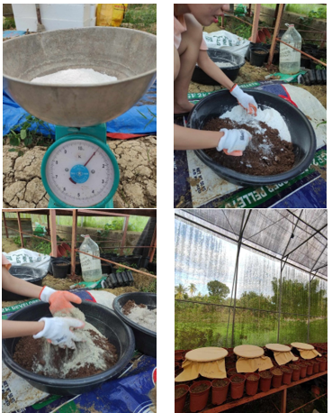
Figure 1: Fermentation of Fresh Chicken Dung infused in different Anti-ammonia Fertilizer

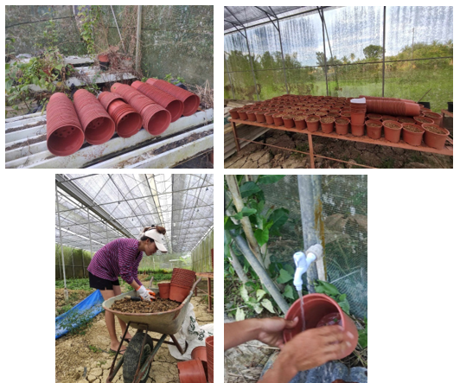

Figure 2: Soil Collection and Pots Preparation

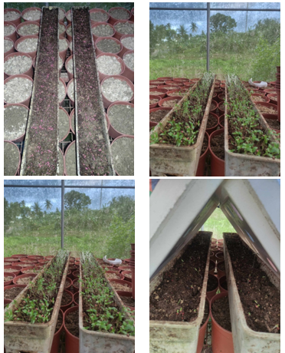
Figure 3: Sowing of seeds

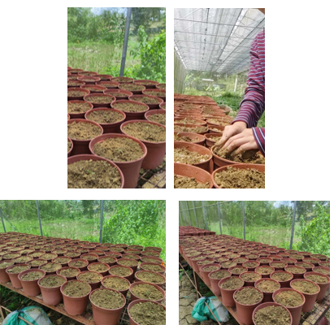
Figure 4: Transplanting

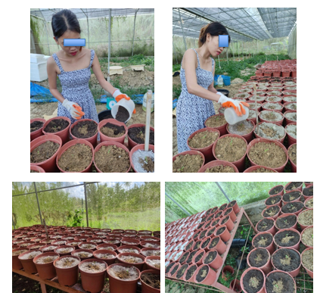
Figure 5: Treatment Application

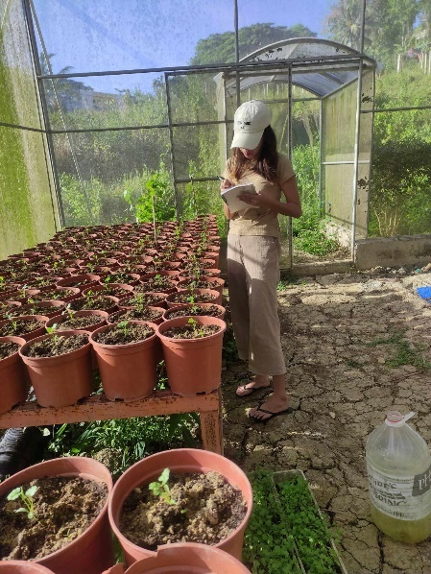 | 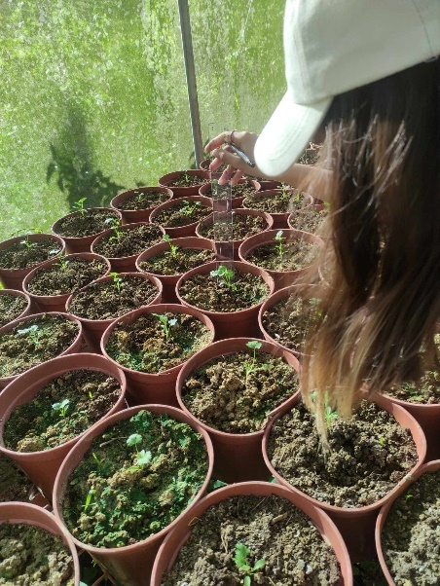
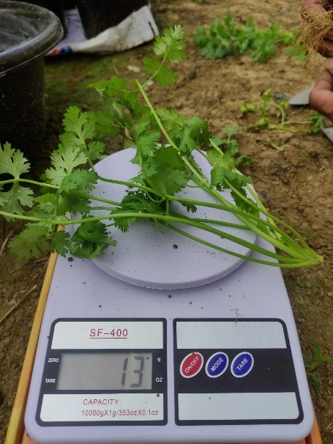 | 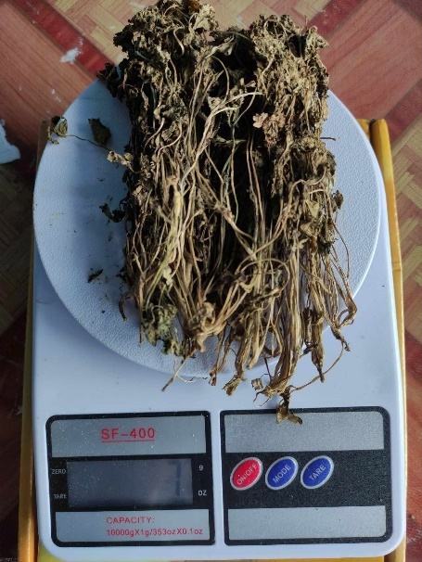
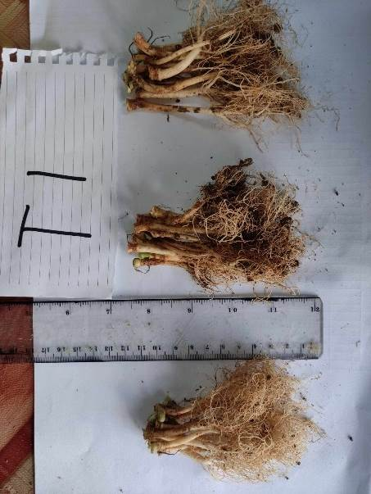 | 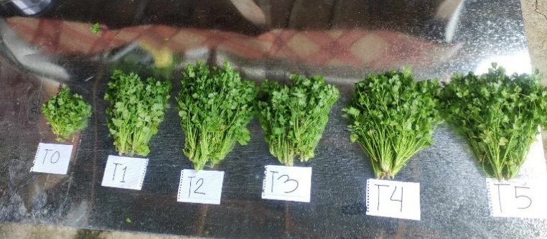
Figure 6: Data Gathering

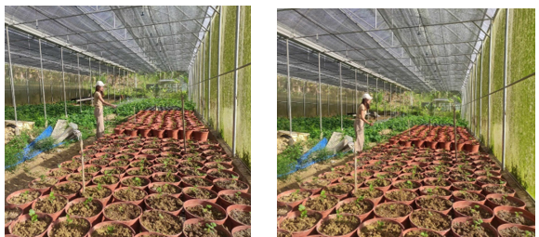
Figure 7: Two weeks after Transplanting as affected by treatments

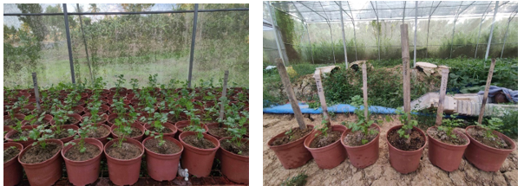
Figure 8: Four weeks after Transplanting as affected by treatments

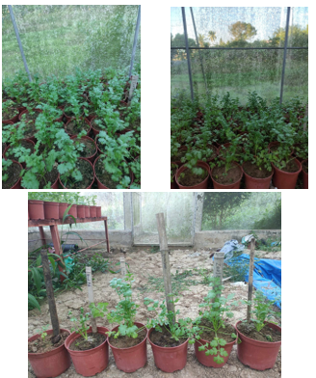
Figure 9: Six weeks after Transplanting as affected by treatments

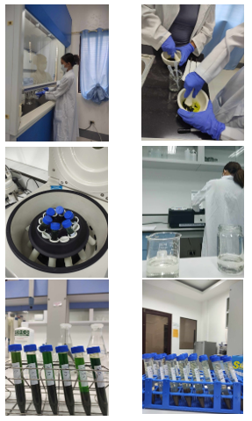

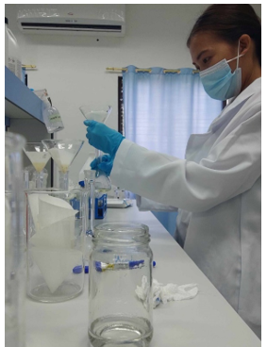 | 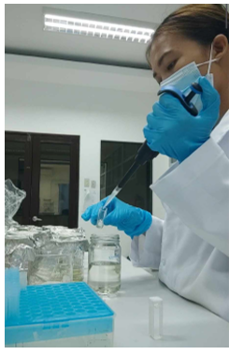
Figure 10: Laboratory for Phytochemical Response

