Differential Maltosazone Crystal Formation in Selected Packaged Food Products Using the Osazone Test

Abstract
This study explored the application of the osazone test for maltose detection. The osazone test is a qualitative method used to detect various sugars in food products. When performed with maltose, the osazone test led to the production of maltosazone. This study investigated the use of the osazone test for various readily available food products, primarily those found in grocery stores and used in bakery products suspected to contain maltose or maltodextrin. Maltose consumption can exacerbate diet-induced obesity and related health issues, particularly when combined with a high fat diet. Malt is utilized in chocolate-based products as a thickening agent, which correlates with its potential health impacts. Other detection methods used in industries, such as gas chromatography, HPLC, and enzymatic methods, are time-consuming and cost-ineffective. Five packaged food products were used in this study. Maltosazone crystals were observed in four of them. The presence and morphology of the crystals confirmed the presence of maltose. This study demonstrated the application of the osazone test for the detection of maltose.
Keywords: Osazone test; Maltose detection; Maltosazone

Introduction:
Maltose is a disaccharide composed of two glucose units and is commonly found in foods such as raw cereals, vegetables, and chicken [1]. It is a reducing sugar that can be rapidly hydrolyzed in the human body, releasing it quickly into the blood upon consumption [1].
The effects of maltose on health are complex and context dependent. In healthy individuals, maltose can moderate hunger sensations even at lower dosages, suggesting that it may play a role in appetite regulation [2]. However, its effect on blood sugar levels is less pronounced than that of glucose. In a study involving healthy subjects, intravenous maltose administration did not significantly influence blood sugar concentration [3].
Maltose metabolism differs between healthy individuals and individuals with certain health conditions. In insulin-dependent diabetic patients, maltose metabolism is reduced, with only 3% of maltose being oxidized and 51% excreted in the urine within 8 h [3]. This finding suggests that maltose may not be a suitable carbohydrate source for parenteral nutrition in these patients. Children with glucose-6-phosphatase deficiency and maltose feeding have been shown to have decreased blood lactate levels, in contrast to lactose and sucrose [4]. While maltose does not appear to have significant adverse effects on healthy individuals, its use as a sole substrate for parenteral nutrition is not recommended because of the high renal loss and difficulty in achieving constant blood concentrations [5].

Ready-to-eat food processing companies use maltose in food products for several reasons:
Maltose is a valuable ingredient in food processing owing to its unique properties and versatility. Maltose is a reducing sugar that can form an aldehyde group in solution, contributing to flavor development and browning reactions during food processing [1].

An interesting aspect of maltose is its rapid biological hydrolysis in humans. When consumed, maltose is quickly broken down into glucose, which appears rapidly in the bloodstream after a meal [1]. This property makes maltose an attractive ingredient for food processors to provide quick energy sources for their products.
We can infer that its natural occurrence in many food sources, its role in flavor development, and its rapid conversion to glucose in the human body make it a valuable ingredient in ready-to-eat food products. Additionally, the importance of maltose in various scientific disciplines, including the food industry, suggests its continued relevance in food-processing applications [6].

Effects of maltose on health:
Maltose consumption can exacerbate diet-induced obesity and related health issues, particularly when combined with a high fat diet. A study on male C57BL/6J mice found that adding 7.0% maltose to a high-fat diet (HFD + Mal) resulted in significantly higher weight gain than a high-fat diet alone after 6 weeks [7]. The HFD + Mal group also showed higher body mass index, relative liver weight, blood glucose levels, and plasma cholesterol levels than both the control and high-fat diet groups. Interestingly, the study noted that maltose content in raw sweet potatoes increased by 40 times upon baking, suggesting that consuming maltose-rich cooked sweet potatoes as part of a high-fat diet might worsen diet-induced overweight [7]. This finding contradicts the common perception that sweet potatoes are a healthy food choice, highlighting the importance of considering food preparation methods and overall dietary context.
Maltose itself may not be inherently hazardous, and its consumption in combination with a high-fat diet can lead to adverse health effects including increased obesity, elevated blood glucose and cholesterol levels, and potential liver issues.
Osazone test:
The osazone test is an important reaction in carbohydrate chemistry and is used to identify and characterize reducing sugars. It involves the reaction of reducing sugars with phenylhydrazine to form crystalline osazone compounds [8].

The mechanism of osazone formation has been the subject of several studies. Recent theoretical findings have helped explain the factors that direct the regiochemistry of osazone formation [8]. The reaction proceeds through several steps, including the initial formation of a phenylhydrazone, conversion to an N-glycoside, Amadori rearrangement to a 1-deoxy-1-amino-2-ketose derivative, and dehydrogenation and transamination to form the phenylosazone product [9].
The osazone reaction is analogous to that of other chemical systems. For example, the reaction of squaric acid with phenylhydrazine produces compounds analogous to intermediates in carbohydrate osazone formation [10]. The osazone test remains an important tool for sugar characterization and continues to be an area of mechanistic research in organic chemistry. Its inclusion in organic chemistry education helps fill gaps in the understanding of carbohydrate reactivity [8].
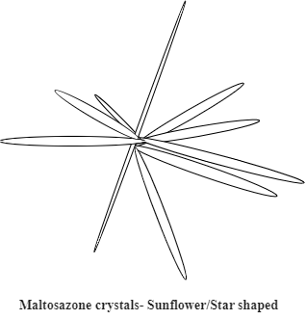
Figure 1: Illustration of the morphology of maltose crystals formed in the osazone test, referred to as maltosazone.
Accurate estimation of maltose is crucial for ensuring food safety and quality:
Accurate estimation of maltose is essential for food safety and quality because of its role in various food products. In quality control, accurate maltose measurement ensures consistent product quality and influences taste, texture, and nutritional value, which are integral to quality management and assurance in the agro-food industry. For process monitoring, maltose levels indicate the effectiveness of food-processing steps, such as fermentation or enzymatic reactions. While not a direct safety concern, maltose measurement contributes to broader safety protocols, as unexpected changes in its levels could indicate microbial activity or improper storage, potentially compromising food safety. Technological advancements, including the use of cutting-edge sensing methods, such as Aggregation-Induced Emission (AIE), offer improved sensitivity and accuracy in maltose detection [11], which supports food safety and quality assurance goals, forming a vital part of comprehensive quality management systems essential for producing safe and high-quality food products.
Other methods, such as gas chromatography (GC), have been used to analyze maltose in apple juice. This method involves forming silylated oxime derivatives in a two-stage reaction, which allows improved maltose analysis [12]. GC is known to have high sensitivity and specificity.

High-performance liquid chromatography (HPLC) is widely used for the determination of maltose in various food products. It offers advantages, such as simplicity, specificity, and reliability, over a wide range of sugar concentrations in different food matrices. Sample preparation typically involves water-ethanol extraction and mini-column cleanup. HPLC can separate and quantify multiple sugars, including maltose, in less than 45 minutes [13].
Enzymatic methods have also been developed for maltose analysis. These methods are more selective than the standard non-enzymatic procedures and can be applied to a broad range of food products. For instance, the Megazyme enzymatic method has shown good repeatability and reproducibility for the analysis of available carbohydrates, including maltose, in various food matrices [14].

In comparison, the osazone test is considerably more straightforward and effective than the aforementioned methods for qualitative estimation of maltose.
Although the osazone test is a reliable method for estimating maltose, there is limited research on its application in diverse food products. The aim of this study was to evaluate the efficacy of the osazone test for qualitative estimation of maltose in a variety of food products.
The objective of this study was to evaluate the efficacy of the osazone test as a potential tool for screening for maltose in various food products.

Materials and Methods:
Packed food products, both branded and unbranded, were categorized into solids (e.g., Chochalates, Coco powder) and liquids (e.g., juices, chochalate syrup). Solid samples were crushed and diluted to 10% (w/v), whereas the liquid samples were diluted 1:1 with distilled water. An osazone reagent comprising phenylhydrazine hydrochloride, sodium acetate, and glacial acetic acid was prepared. Each diluted sample was mixed with the reagent, heated in a boiling water bath for 10 min, and cooled to room temperature. The formation of maltosazone crystals was observed under an optical microscope and images were captured using mobile phones. The presence of crystals has been documented and compared across different food products.
Various food products were designated A, B, C, and D to maintain brand anonymity. The generic nomenclature of the products was used for product identification.

Results and Discussion:

Table 1: Morphometric variations of Maltosazone crystals in different food products

Sr. No. | Food Products | Generic  name | State | Dilution  Factor* | Morphometric observations of Maltosazone crystals
 |  |  |  |  | Colour | Crystal shapes | Crystal pattern | Inference  +/- | Intensity  (+/++/+++)
 | A | Choco syrup | Liquid | 1:1 | Yellow | Sunflower shaped | 5-6 tubular stellar structure | + | ++
 | B | Cold coco | Liquid | 1:1 | Brown | Long needle  Shaped | 5-6 tubular stellar structure | + | +++
 | C | Almond shake | Liquid | 1:1 | Black | Asymmetric shaped | Asymmetrical shape | - | +
 | D | Cold coffee | Solid | 1:10 | Peach yellow | Sunflower shaped | Fern like  Dendrites | + | ++
 | E | Coco powder | Solid | 1:10 | Brown | Sunflower shaped | 2-3 tubular Stellar crystals | + | +

{Note: *Dilution factor (Product: Distilled Water); Inference- + (matlosazone confirmed), - (matlosazone absent); Crystal Intensity- + (less dense crystals), ++ (more dense crystals), +++ (highest dense crystals)}

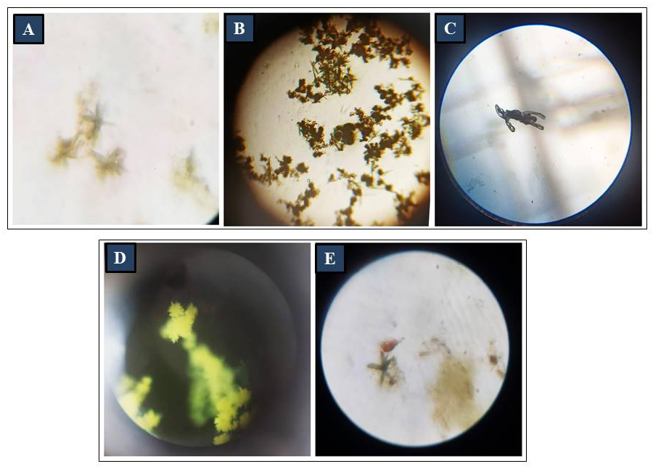

Figure 2: Microscopic observations of Maltosazone crystals in different food products
{Note: Maltosazone crystals observed in; A: Choco syrup, B: Cold coco, C: Almond shake, D: Cold coffee, E: Coco powder}

Significant variations in crystal formation were observed across the different food products analyzed in this study. Despite being categorized into liquid and solid forms, all the products consistently exhibited sunflower-shaped maltosazone crystals. However, the color of the crystals varied among the samples. Choco syrup formed yellow-colored crystals, cold coco produced brown crystals, almond shake yielded black crystals, cold coffee produced peach-colored crystals, and cocoa powder generated brown-colored crystals. These color variations are likely attributable to inherent differences in the color of the food products themselves.
Notable differences were also observed in the intensity of the crystal formation. The highest intensity was recorded for cold coco, followed by choco syrup, cold coffee, cocoa powder, and almond shake. Crystals in almond shakes were less defined, suggesting the possible absence of maltose in the sample.
Variations in the crystal shapes were evident across the samples. In choco syrup and cold coco, 5–6 stellar-shaped crystals were identified, likely indicating the presence of maltose owing to their similar composition. In contrast, almond shakes exhibited asymmetric, undefined crystal structures, further supporting the absence of maltose in this product. Cold coffee showed clustered fern-like dendrites, indicating the presence of maltose. The cocoa powder formed 2–3 tubular stellar crystals, which is also indicative of maltose.
Sugars exhibit similar properties, rendering the differentiation of various carbohydrate members difficult. Consequently, microscopic examination of the osazone test revealed distinct crystalline structures [15]. Acid hydrolysis of starchy products results in the formation of maltose crystals, demonstrating their extensive industrial applications [16]. The presence of maltose can also be detected effectively using the osazone technique in the presence of other sugars, such as dextrose [17]. Research conducted by Percival and Percival (1937) [18] demonstrated that crystalline maltosazone forms two distinct types of needles: elongated lemon-yellow needles and pointed yellow plates, which aligns with our observations. This technique also demonstrated applicability in the detection of sugar in urine for glycosuria and maltosuria [19].
Interestingly, while HPLC generally offers superior sensitivity, some studies have found comparable results between HPLC and other methods. For example, a statistical analysis comparing HPLC with conventional volumetric, distillation, and enzymatic methods for wine and grape must analysis showed good agreement in accuracy and precision [20]. This suggests that the choice of method may depend on specific application requirements and available resources.In terms of cost and speed, HPLC presents advantages over other techniques. HPLC methods often require minimal sample preparation, reducing overall analysis time and cost. However, it remains an expensive method to implement.

Osazone tests are potentially unreliable for analyzing mixtures of sugar samples, such as those found in plant cells. Additionally, these tests can result in various crystal aggregations owing to the combination of sugar crystals [21]. Consequently, further research is recommended to investigate the complex crystal formation that occurs in such scenarios.
These findings highlight the potential of maltosazone crystal morphology and color as qualitative indicators of maltose content in diverse food products.

Conclusion:
This study demonstrated significant variations in maltosazone crystal morphology, intensity, and coloration across different food products, reflecting their unique composition. While sunflower-shaped crystals are a common feature, differences in color and structure can be formed owing to the nature of the product and other compositions. Notably, cold coco and choco syrup exhibited the highest intensity and well-defined stellar crystals, confirming the presence of maltose, whereas the almond shake lacked definitive crystal structures, indicating its potential absence. The observed variations highlight the utility of maltosazone crystal analysis as a simple and effective method for qualitative estimation of maltose in diverse food products, highlighting the need for broader applications in food quality control and screening.
Data Availability Statement
This research did not involve any data processing.

Disclaimer (Artificial intelligence)
Author(s) hereby declare that NO generative AI technologies such as Large Language Models (ChatGPT, COPILOT, etc.) and text-to-image generators have been used during the writing or editing of this manuscript.

References
- Gaspar, E. M. S. M., Nunes, I. S., Gyamfi, D., & Lopes, J. F. (2012). CHAPTER 24. Food Sources and Analytical Approaches for Maltose Determination (pp. 405–424). royal society of chemistry. https://doi.org/10.1039/9781849734929-00405
- Poothullil, J. M. (1992). Maltose: The primary signal of hunger and satiation in human beings. Physiology & Behavior, 52(1), 27–31. https://doi.org/10.1016/0031-9384(92)90429-6
- Finke, C., & Reinauer, H. (1976). Über den Abbau von infundierter Maltose beim Menschen. Zeitschrift Für Ernährungswissenschaft, 15(2), 231–245. https://doi.org/10.1007/bf02018446
- Fernandes, J. (1974). The effect of disaccharides on the hyperlactacidaemia of glucose-6-phosphatase-deficient children. Acta Paediatrica, 63(5), 695–698. https://doi.org/10.1111/j.1651-2227.1974.tb16992.x
- Förster, H., Hoos, I., & Boecker, S. (1976). Tests with human volunteers on parenteral utilization of maltose. Zeitschrift Fur Ernahrungswissenschaft, 15(3), 284–293. https://doi.org/10.1007/bf02022005
- Crow, R. R., Varela, M. F., & Kumar, S. (2012). CHAPTER 7. Maltose Chemistry and Biochemistry (pp. 101–114). royal society of chemistry. https://doi.org/10.1039/9781849734929-00101
- Shibazaki, N., Matsuyama, H., Sakakibara, H., Yokoyama, D., Kubota, H., Ogawa, K., Suzuki, Y., & Tanaka, W. (2022). Maltose consumption exacerbates high-fat diet-induced overweight and related parameters in mice. Functional Foods in Health and Disease, 12(11), 680. https://doi.org/10.31989/ffhd.v12i11.997
- Sánchez-Viesca, F., & Gómez G, R. (2017). Reactivities Involved in the Regioselectivity of Osazone Formation. World Journal of Organic Chemistry, 5(1), 11–16. https://doi.org/10.12691/wjoc-5-1-3
- Micheel, F., & Dijong, I. (1963). ON THE MECHANISM OF THE OSAZONE REACTION. Experientia, 19(7), 338–339. https://doi.org/10.1007/bf02152304
- El Khadem, H. S., Shalaby, M. A., Coxon, B., & Fatiadi, A. J. (1993). The reaction of phenylhydrazine with squaric acid: a model for carbohydrate osazone formation. Carbohydrate Research, 239, 85–93. https://doi.org/10.1016/0008-6215(93)84205-k
- Huang, X., Guo, Q., Tang, B. Z., Lam, J. W. Y., Leng, Y., Xiong, Y., Zhang, R., & Zhao, Z. (2020). AIEgens: An emerging fluorescent sensing tool to aid food safety and quality control. Comprehensive Reviews in Food Science and Food Safety, 19(4), 2297–2329. https://doi.org/10.1111/1541-4337.12591
- Woźniak, Ł., Szczepańska, J., Roszko, M., & Skąpska, S. (2020). Occurrence of maltose in apple juices: Improved method of analysis, typical levels, and factors affecting it. LWT, 124, 109154. https://doi.org/10.1016/j.lwt.2020.109154
- Dunmire, D. L., & Otto, S. E. (1979). High Pressure Liquid Chromatographic Determination of Sugars in Various Food Products. Journal of AOAC INTERNATIONAL, 62(1), 176–185. https://doi.org/10.1093/jaoac/62.1.176
- Mcloughlin, C., Mccleary, B. V., & Mckie, V. A. (2022). Validation of the Test Method-Determination of Available Carbohydrates in Cereal and Cereal Products, Dairy Products, Vegetables, Fruit, and Related Food Products and Animal Feeds: Collaborative Study, Final Action 2020.07. Journal of AOAC International, 106(2), 370–383. https://doi.org/10.1093/jaoacint/qsac116
- Hassid, W., & McCready, R. (1942). Identification of Sugars by Microscopic Appearance of Crystalline Osazones. Industrial & Engineering Chemistry Analytical Edition, 14(8), 683–686. https://doi.org/10.1021/i560108a025
- Rolfe, Geo. W., & Haddock, I. T. (1903). THE PRESENCE OF MALTOSE IN ACID-HYDROLYZED STARCH PRODUCTS. Journal of the American Chemical Society, 25(10), 1015–1019. https://doi.org/10.1021/ja02012a002
- Baker, J. L., & Dick, W. D. (1905). The detection and estimation of small quantities of maltose in the presence of dextrose. Analyst, 30(348), 79–85. https://doi.org/10.1039/AN9053000079
- Percival, E. E., & Percival, E. G. v. (1937). 268. Sugar osazones and their anhydrides. Journal of the Chemical Society (Resumed), 0, 1320–1325. https://doi.org/10.1039/JR9370001320
- Herzfeld, E. (1932). Glycosuria and maltosuria.
- Frayne, R. F. (1986). Direct Analysis of the Major Organic Components in Grape Must and Wine Using High Performance Liquid Chromatography. American Journal of Enology and Viticulture, 37(4), 281–287. https://doi.org/10.5344/ajev.1986.37.4.281

- Jöroensen, I., & Stilbs, W. (1918). THE OSAZONE METHOD FOR DETECTING SUGARS IN PLANT TISSUES. New Phytologist, 17(1‐2), 45-45.

