Comparative Analysis of Chen-Type Distributions for Modelling Nigerian Stock Market: An Evaluation of Predictive Performance and Statistical Fit

Abstract
This study presents a comparative analysis of Chen-type distributions for modelling the behaviour of the All-Share Index (ASI) in Nigeria, utilizing both secondary data from the Nigerian Stock Exchange (January 2008–December 2021) and simulated datasets. The study evaluates the performance of three statistical distributions: Generalized Chen (GC), New Extended Chen (NEC), and Modified Generalized Chen (MGC) based on key model selection criteria, including Akaike Information Criterion (AIC), Bayesian Information Criterion (BIC), Mean Squared Error (MSE), and Likelihood Ratio Test (LRT). Descriptive statistics of the log-transformed ASI data indicate a mean of 10.33 and a standard deviation of 0.258, with a slight positive skewness (0.51) and a kurtosis value of -0.14, suggesting a near-normal distribution with moderate dispersion. The MGC distribution consistently demonstrates superior model performance, achieving the lowest AIC, BIC, and LRT values across various dataset sizes. Notably, at a dataset size of 1000, MGC records an LRT of 201,256.7, significantly lower than GC (276,903.2) and NEC (1,198,378), reinforcing its superior fit. Additionally, the NEC distribution exhibits extreme instability, with MSE values approaching infinity, making it unsuitable for predictive modelling. The probability density function (PDF) and cumulative distribution function (CDF) visualizations further confirm that MGC effectively captures the distributional properties of ASI data, while GC shows heavy-tailed behaviour, and NEC demonstrates numerical instability. These findings establish MGC as the most appropriate distribution for modelling ASI behaviour, balancing goodness-of-fit with predictive accuracy and offering a robust statistical framework for financial market analysis in Nigeria.
Keywords: Chen-type distributions; Modified Generalized Chen Distribution; Likelihood Ratio Test; Nigerian Stock Exchange; Statistical Properties
- Introduction

Financial markets, especially in emerging economies, are complex systems where the behaviour of stock indices can exhibit a range of patterns that are often challenging to model accurately. Stock market indices, such as the All-Share Index (ASI) of the Nigerian Stock Exchange (NSE), serve as critical indicators of a country's economic performance and investor sentiment. Given the volatility and inherent unpredictability of stock markets, developing accurate models to predict market behaviour is a fundamental task in both financial economics and econometrics. Among the numerous models employed in financial data analysis, statistical distributions play a crucial role in capturing the inherent uncertainties and variabilities in asset returns, prices, and other financial indicators. Over time, researchers have sought to extend the flexibility and applicability of traditional distributions to better model financial data, particularly with regard to skewness, heavy tails, and other irregularities observed in real-world data. In this context, the Chen distribution has emerged as a notable tool for modelling such financial data.

The Chen distribution is known for its versatility and ability to model various types of data with differing skewness and tail behaviours. However, despite its applicability, the Chen distribution, in its standard form, struggles to accommodate certain complexities in survival datasets and financial data, such as heavy tails and skewness. The ability of financial data to exhibit extreme events, such as market crashes or booms, demands more robust and flexible models that can capture these behaviours. Recent advancements have sought to address these challenges by modifying and extending the Chen distribution, leading to a variety of Chen-type models that offer greater flexibility and robustness for different applications, including financial market analysis. A wide range of modified Chen distributions has been introduced to overcome the limitations of the original Chen distribution. Researchers like Anafo et al. (2022), Joshi and Pandit (2018), and Reis et al. (2020) have expanded on the Chen distribution to better model data with skewness, heavy tails, and other irregularities. For instance, the Chen Pareto and Chen Pareto distributions, as explored by Awodutire (2020) and Zamani et al. (2022), provide more flexibility in modelling data with extreme values, which is a common feature in financial markets. Additionally, the Weibull-Chen and extended Chen-Poisson distributions, introduced by Tarvirdizade and Ahmadpour (2021) and Sousa-Ferreira et al. (2023), have proven useful in addressing more complex data structures, with their ability to model varying hazard functions being particularly useful in finance for capturing different market risk profiles.

The Chen distribution, introduced by Chen (1989), is a flexible distribution that has found widespread use in survival analysis and modelling. It is characterized by its ability to accommodate various forms of skewness and kurtosis, making it a valuable tool in fields that deal with complex data. However, despite its flexibility, the Chen distribution has limitations, particularly when it comes to accurately modelling data with extreme values or heavy tails, which are often encountered in financial markets. In the context of stock market indices, such as the ASI, the occurrence of extreme market movements, like sharp declines or surges, poses significant challenges for traditional models like the Chen distribution. In response to these limitations, researchers have proposed several modifications to the Chen distribution to enhance its ability to capture extreme values and skewness. For example, the Chen Pareto distribution, introduced by Awodutire (2020), combines the Chen distribution with the Pareto distribution to address the heavy-tailed nature of financial data. Similarly, the Weibull-Chen distribution, proposed by Tarvirdizade and Ahmadpour (2021), introduces the Weibull distribution's shape parameters into the Chen framework, allowing for greater flexibility in modelling different types of hazard rates. Other notable extensions, such as the extended Chen-Poisson distribution by Sousa-Ferreira et al. (2023), have combined the Chen distribution with the Poisson distribution to handle count data and rare events, further expanding the applicability of Chen-type models in financial modelling. The continuous evolution of Chen-type distributions reflects the growing demand for models that can better capture the complexities of financial data. Researchers have proposed various extensions to the Chen distribution to enhance its applicability in a wide range of domains, including finance. For example, Chaudhary et al. (2023) introduced the Half-Cauchy Chen distribution, a variant designed to better capture the heavy-tailed nature of financial data. Similarly, the Chen autoregressive moving average (CHARMA) model, introduced by Stone et al. (2023), integrates Chen distributions with time series models, providing a more accurate tool for modelling financial indices like the ASI.
In the context of stock market modelling, the introduction of these modified distributions has proven invaluable in improving the predictive accuracy and robustness of financial models. The Chen Pareto distribution, for example, has shown superior performance in modelling stock price movements, as demonstrated by Zamani et al. (2022) while Sarhan et al. (2024) proposed the bivariate Chen distribution (BCD), offering new avenues for analyzing intricate data sets. Ismael and AL-Bairmani (2024) introduced the [0, 1] Truncated Nadarajah-Haghighi Chen distribution, emphasizing its utility for data analysis through comprehensive testing. Al-Essa et al. (2024) explored bathtub-shaped failure rate functions using advanced statistical methods with the Chen distribution, demonstrating practical applications across various fields. Singh et al. (2024) examined the competing risks model with failure times following the Chen distribution, validating Bayesian and classical estimation techniques through simulations and real-life examples. Akpojaro and Aronu (2024) introduced the Modified Generalized Chen (MGC) distribution, evaluating its theoretical and empirical performance against other Chen distribution variants. The MGC consistently outperformed alternatives, demonstrating superior model fit, predictive accuracy, and interpretability, making it valuable for empirical analyses in econometrics and policy decision-making.

The Nigerian All-Share Index (ASI) is one of the key indicators of the Nigerian Stock Exchange's performance, reflecting the overall market sentiment and economic conditions. The behavior of the ASI is often subject to fluctuations due to both domestic and international economic factors. In recent years, the ASI has witnessed significant volatility, driven by factors such as inflation, oil price fluctuations, and political instability. Given the complex nature of the Nigerian economy, the ASI's behaviour is not easily captured by traditional statistical models.
The introduction of Chen-type distributions offers a promising avenue for modelling the behaviour of the ASI. By incorporating modifications to the Chen distribution, such as the Chen Pareto, Weibull-Chen, and extended Chen-Poisson distributions, this study aims to provide a more accurate and robust framework for analyzing the ASI. Through a comparative analysis of these models, the study seeks to identify the most suitable distribution for capturing the dynamics of the ASI and providing valuable insights for financial decision-making. The objectives of the study are: Evaluate the statistical properties of the ASI using descriptive statistics; Assess the suitability of Chen-type distributions (Generalized Chen, New Extended Chen, and Modified Generalized Chen) for modelling the ASI; Compare the performance of these distributions using AIC, BIC, MSE and LRT; and Identify the most appropriate distribution based on model fit, predictive accuracy, and numerical stability.

2. Methods

2.1 Source of Data collection for the study
This study uses secondary data and simulation. The secondary data was monthly All Share Index (ASI) data from the Nigerian Stock Exchange (January 2008-December 2021) which was employed to evaluate stock market performance and investor sentiment. The simulation involves analyzing the dataset of All-Share Index (ASI) values and generating synthetic data to model its behaviour. First, the mean and standard deviation of the observed ASI values were calculated. A simulation function, simulate_asi, was then defined to generate random observations from a normal distribution using the computed mean and standard deviation as parameters. To ensure reproducibility, a fixed random seed was set using set.seed(123). Subsequently, the function was employed to generate the various number of observations, effectively creating a synthetic dataset (x_values) that mirrors the statistical characteristics of the original ASI data. This approach enables studying ASI behaviour under hypothetical scenarios, facilitating statistical analysis and predictive modelling.

2.2 The Probability Density Functions of Variants of the Chen Distribution
Table 1 presents the Probability Density Functions of Variants of the Chen Distribution.
Table 1. Probability Density Functions of Variants of the Chen Distribution
S/No. | Distribution | PDF | Source
1. | Generalized Chen (GC) Distribution | $$\left(\frac{γ}{2β}\right){\left(\frac{x}{β}\right)}^{\left(α - 1\right)}e^{-{\left(\frac{x}{β}\right)}^{γ}},α∈R,β>0,γ>0,x≥0$$ | Singh et al. (2024)
2 | New Extended Chen (NEC) Distribution | $$bdx^{b-1}e^{\left[x^{b}e^{d\left(1-e^{x^{b}}\right)}+\overline{θ}\left(1-\left(1-e^{d\left(1-e^{x^{b}}\right)}\right)\right)\right]\left[1-\overline{θ}\left(1-e^{d\left(1-e^{x^{b}}\right)}\right)\right]},$$  $$b>0,d∈R,x≥0, 0≤θ≤1.$$ | Acquah et al. (2023)
3 | Modified Generalized Chen (MGC) distribution | $$\left(\frac{γ }{2βλ}\right) {\left(\frac{\left(x - δ\right)}{βλ}\right)}^{\left(α - 1\right)}e^{-{\left(\frac{x - δ}{βλ}\right)}^{γ}}$$ | Akpojaro and Aronu (2024)

Table 1 presents three probability distributions, each extending or modifying the classical Chen distribution. The Generalized Chen (GC) Distribution, introduced by Singh et al. (2024), incorporates three parameters $(α,β,γ)$ and is defined for non-negative x. The New Extended Chen (NEC) Distribution, proposed by Acquah et al. (2023), introduces additional parameters $(b,d,\overline{θ})$ that influence the flexibility of the model, particularly in survival analysis and reliability studies. Lastly, the Modified Generalized Chen (MGC) Distribution, developed by Akpojaro and Aronu (2024), further refines the GC model by introducing an additional location parameter (δ) and a scaling factor (λ), which enhances its adaptability to real-world data. Each distribution has a specific probability density function (PDF) and was introduced by different researchers, contributing to the ongoing evolution of Chen-type distributions in statistical modelling.
2.2.1 Parameter Estimation
Parameter estimates for each distribution were derived using the Maximum Likelihood Estimation (MLE) method, which maximizes the likelihood function $L(θ∣x)$ given by:
$$L\left(θ ∣ x\right)=\prod_{i=1}^{n}{f\left(x_{i};θ\right)} (1)$$
where $f\left(x_{i};θ\right)$represents the Probability Mass Function (PMF) of the distribution, θ is the vector of parameters, and $x_{i}$ are the observed data points (Casella and Berger, 2002). MLE implementation was performed in the R programming language (R Core Team, 2023).
2.2.2 Model Performance Measures of the distributions
The model performance was evaluated using the following criteria:
i. Akaike Information Criterion (AIC):
$$AIC=-2ln\left(L\right)+2k (2)$$
where L Where likelihood of the model, and k is the number of estimated parameters (Akaike, 1974).
ii. Bayesian Information Criterion (BIC):
$$BIC=-2ln\left(L\right)+kln\left(n\right) (3)$$
where n is the sample size (Schwarz, 1978).
iii. Mean Squared Error (MSE):
$$MSE=\frac{1}{n}\sum_{i=1}^{n}{{\left(y_{i}-{\hat{y}}_{i}\right)}^{2}} (4)$$
where $y_{i}$​ represents the observed values, and ${\hat{y}}_{i}$​ are the predicted values.
iv. The Likelihood Ratio Test (LRT) is a statistical hypothesis test used to compare the goodness of fit between two nested models: a more complex (unrestricted) model and a simpler (restricted) model. It evaluates whether additional parameters in the unrestricted model significantly improve the model's explanatory power (Casella & Berger, 2002). Given a parametric statistical model $f\left(x;θ\right)$, where $θ$ represents the parameter vector, the LRT is based on the likelihood function $L\left(θ;x\right)$ , which measures the probability of observing the given data under specific parameter values. The LRT statistic is formulated as (Wilks, 1938):
$$λ=\frac{{Sup}_{θ_{0}∈Θ_{0}}L\left(θ_{0};x\right)}{{Sup}_{θ∈Θ }L\left(θ;x\right)} (5)$$
Where:
$Θ_{0}$ represents the parameter space under the null hypothesis,
$Θ$ represents the parameter space under the alternative hypothesis,
Sup denotes the supremum (maximum likelihood estimate).
The test statistic presented in equation (5) can transforms into:
$$LRT=-2\log\left(λ\right)=2\left(l\left(\hat{θ}\right)-l\left({\hat{θ}}_{0}\right)\right) (6)$$
Where $l\left(\hat{θ}\right)$ and $l\left({\hat{θ}}_{0}\right)$ denote the log-likelihoods of the unrestricted and restricted models, respectively (Davidson & MacKinnon, 2004).
The LRT statistic follows a chi-square $χ^{2}$distribution with degrees of freedom equal to the difference in parameters between the unrestricted and restricted models.
$$p=P\left(χ_{df}^{2}>LRT\right) (7)$$
where df is the number of constraints imposed by the null hypothesis and p denotes the p-value associated with the test statistics (Greene, 2012).
These metrics were computed for the three distributions considered in the study across datasets, as shown in Table 3. To ensure a comprehensive evaluation, the average values of AIC, BIC, MSE and LRT for each distribution were also computed and summarized in Table 4.

3. Results
Table 2: Descriptive Statistics of dataset
Variable | Mean | StDev | Minimum | Median | Maximum | Skewness | Kurtosis
log(ASI) | 10.33 | 0.258 | 9.896 | 10.299 | 11.092 | 0.51 | -0.14

Table 2 presents the descriptive statistics for the logarithm of the All-Share Index (log(ASI)), summarizing its central tendency, dispersion, and distribution shape. The mean value of 10.33 suggests that, on average, the log-transformed ASI values cluster around this point. The standard deviation (StDev) of 0.258 indicates a moderate spread around the mean, reflecting the level of variation in the data. The minimum value of 9.896 and the maximum value of 11.092 define the range within which log(ASI) fluctuates, with the median value of 10.299 being close to the mean, suggesting a relatively symmetric distribution. The skewness value of 0.51 indicates a slight positive skew, meaning that the distribution has a longer right tail, implying a few higher-than-average values. The kurtosis value of -0.14 suggests that the distribution is slightly flatter than a normal distribution, indicating fewer extreme values. Overall, these statistics suggest a relatively normal distribution with mild asymmetry and moderate dispersion in log(ASI) values.
Table 3: Model Selection Criteria and Error Metrics for Different Distributions Applied to Various Dataset Sizes
Dataset | Distributions | Parameter estimates | AIC | BIC | MSE | LRT
10 | GC | $$α=3.41, β=0.00, γ =0.07$$ | 2755.99 | 2756.90 | 2.69 e+119 | 2768.82
10 | NEC | $$b=3.26, d=10.94,$$  $$θ=-12.88$$ | 12652.63 | 12653.53 | ∞ | 13499.57
10 | MGC | $$α=3.38, β=0.00, γ =0.06, δ=0.22, λ=0.92$$ | 1969.57 | 1971.08 | 1271.92 | 2012.62
20 | GC | $$α=3.42, β=0.00, γ =0.06$$ | 5506.00 | 5508.99 | 2.69 e+119 | 5537.92
20 | NEC | $$b=3.26, d=5.49,$$  $$θ=-5.10$$ | 25584.35 | 25587.34 | ∞ | 25699.91
20 | MGC | $$α=3.42, β=0.00, γ =0.02, δ=0.18, λ=0.95$$ | 3997.23 | 4002.21 | 384.03 | 4024.90
30 | GC | $$α=3.42, β=0.00, γ =0.07$$ | 8255.99 | 8260.19 | 2.69 e+119 | 8307.28
30 | NEC | $$b=3.25, d=0.00,$$  $$θ=-2.35$$ | 37625.67 | 37629.88 | ∞ | 37096.18
30 | MGC | $$α=3.43, β=0.00, γ =0.02, δ=0.18, λ=0.95$$ | 5990.23 | 5997.24 | 3764.66 | 6038.19
50 | GC | $$α=3.42, β=0.00, γ =0.07$$ | 13755.97 | 13761.71 | 2.69 e+119 | 13845.01
50 | NEC | $$b=3.26, d=4.92,$$  $$θ=-5.49$$ | 63180.93 | 63186.67 | ∞ | 61432.98
50 | MGC | $$α=3.35, β=0.00, γ =0.09, δ=0.24, λ=0.90$$ | 797.72 | 807.28 | 398.17 | 10062.56
100 | GC | $$α=3.42, β=0.00, γ =0.07$$ | 27505.99 | 27513.81 | 2.70 e+119 | 27689.94
100 | NEC | $$b=3.25, d=1.58,$$  $$θ=-1.49$$ | 125502.30 | 125510.10 | ∞ | 122858.00
100 | MGC | $$α=3.43, β=0.00, γ =0.02, δ=0.18, λ=0.95$$ | 19944.84 | 19957.87 | 379.32 | 20125.00
200 | GC | $$α=3.42, β=0.00, γ =0.06$$ | 55006.03 | 55015.92 | 2.69 e+119 | 55379.38
200 | NEC | $$b=3.24, d=44.95,$$  $$θ=-33.88$$ | 242915.80 | 242925.60 | ∞ | 244629.40
200 | MGC | $$α=3.42, β=0.00, γ =0.02, δ=0.18, λ=0.95$$ | 39882.10 | 39898.59 | 3.84 e+89 | 40247.69
500 | GC | $$α=3.42, β=0.00, γ =0.06$$ | 137506.12 | 137518.70 | 2.12 e+119 | 138451.90
500 | NEC | $$b=3.23, d=26.03,$$  $$θ=-20.47$$ | 598038.1 | 598050.7 | ∞ | 605689.70
500 | MGC | $$α=3.42, β=0.00, γ =0.02, δ=0.18, λ=0.95$$ | 99686.49 | 99707.56 | 3.81e+86 | 100627.70
1000 | GC | $$α=3.42, β=0.00, γ =0.06$$ | 275006.20 | 275020.90 | 2.34 e+119 | 276903.2
1000 | NEC | $$b=3.23, d=5.97,$$  $$θ=-4.98$$ | 1188366.00 | 1188381.00 | ∞ | 1198378
1000 | MGC | $$α=3.42, β=0.00, γ =0.02, δ=0.18, λ=0.95$$ | 199372.50 | 199397.00 | 3.85e+86 | 201256.7
Log(ASI) | GC | $$α=3.42, β=0.00, γ =0.06$$ | 46206.01 | 46215.38 | 2.69 e+119 | 46519.96
Log(ASI) | NEC | $$b=3.23, d=55.58,$$  $$θ=-43.19$$ | 203743.80 | 203753.10 | ∞ | 203959.10
Log(ASI) | MGC | $$α=3.42, β=0.00, γ =0.02, δ=0.18, λ=0.95$$ | 33501.22 | 33516.84 | 3.81 e+86 | 33811.18

Table 3 presents the Akaike Information Criterion (AIC), Bayesian Information Criterion (BIC), and Mean Squared Error (MSE) for three distributions (Generalized Chen (GC), New Extended Chen (NEC), and Modified Generalized Chen (MGC)) across different dataset sizes. The AIC and BIC values, which measure model fit while penalizing complexity, indicate that the MGC distribution consistently outperforms both GC and NEC distributions, as it has the lowest values across all dataset sizes. The GC distribution, while having relatively lower AIC and BIC values than NEC, exhibits an extremely large MSE (2.69e+119 or similar magnitudes across dataset sizes), indicating poor predictive accuracy. The NEC distribution has the highest AIC and BIC values among the three models, and its MSE is recorded as ∞ (infinity) across all dataset sizes, suggesting severe overfitting, numerical instability, or an inability to generalize to the data.
As dataset size increases, the MGC distribution consistently maintains lower MSE values, which remain within a reasonable range compared to the excessively large errors of the GC and NEC models. This pattern suggests that the MGC distribution provides the best balance between goodness-of-fit and predictive accuracy. Conversely, the GC model appears unsuitable due to its persistently large MSE values, while the NEC model demonstrates extreme instability. These findings indicate that MGC is the most appropriate distribution for modelling the given dataset, as it minimizes both model complexity penalties and predictive errors, making it the preferred choice for practical applications. In addition, the results of the Likelihood Ratio Test (LRT) indicate that the MGC distribution consistently achieves the lowest LRT values across various dataset sizes, suggesting it provides the best fit for ASI data. For instance, at dataset size 10, MGC has an LRT of 2012.62, compared to 2768.82 for GC and 13499.57 for NEC. Similarly, for dataset size 100, MGC records 20125.00, whereas GC and NEC have 27689.94 and 122858.00, respectively. This trend persists across larger datasets, with MGC maintaining lower LRT values (e.g., 201256.7 for size 1000 vs. 276903.2 for GC and 1198378 for NEC). The NEC distribution consistently has the highest LRT values, implying poor model fit. Additionally, for the log-transformed ASI data, MGC exhibits the lowest LRT (33811.18), reinforcing its superiority over GC (46519.96) and NEC (203959.10). This suggests that MGC is the most suitable distribution for modelling ASI data.
The Probability Density Function (PDF) of the Generalized Chen (GC) distribution for simulated data (n=1000) in Figure 1 exhibits a smooth increasing trend. This suggests that higher values of the random variable are associated with larger probabilities. The distribution’s shape indicates a right-skewed pattern, emphasizing heavy-tailed behaviour in the dataset. The Probability Density Function (PDF) of the NEC distribution for simulated data (n=1000) in Figure 2 appears nearly flat and close to zero, suggesting very low-density values. The Probability Density Function (PDF) of the MGC distribution for simulated data (n=1000) in Figure 3 shows a steady increase in density values. This suggests that higher values of the random variable are associated with larger probabilities.
Also, the Probability Density Function (PDF) of the GC distribution for ASI data in Figure 4 exhibits an increasing trend, with extremely high density values. The Probability Density Function (PDF) of the NEC distribution for ASI data in Figure 5 appears to be nearly flat, with density values close to zero or negative. The Probability Density Function (PDF) of the MGC distribution for ASI data in Figure 6 exhibits a consistently increasing trend, suggesting a right-skewed-like behaviour.
The Cumulative Distribution Function (CDF) of the GC distribution for simulated data (n=1000) in Figure 7 shows a steady, increasing trend, indicating a continuous accumulation of probability mass. The CDF of the NEC distribution for simulated data (n=1000) in Figure 8 exhibits an abrupt rise near the upper bound, suggesting a highly skewed distribution. The CDF of the MGC distribution for simulated data (n=1000) in Figure 9 exhibits a smooth, increasing pattern, indicating a well-distributed variable with continuous growth. The steepness suggests a rapid accumulation of probability mass, and the large values on the y-axis may indicate heavy-tailed behaviour.
Similarly, the CDF of the GC distribution for ASI data in Figure 10 shows a smooth, linear increase, indicating a stable cumulative probability function. The extremely large values suggest high-magnitude data and potentially heavy-tailed behaviour. The near-linear trend implies a consistent probability accumulation, reflecting a well-behaved distribution with minimal abrupt changes. The CDF of the NEC distribution for ASI data in Figure 11 exhibits a sharp increase near x≈11.1, indicating that most probability mass is concentrated in a narrow range. The initial flat portion suggests a low cumulative probability until a sudden rise, implying a highly skewed or heavy-tailed distribution. The CDF of the MGC distribution for ASI data in Figure 12 shows a nearly linear increase, indicating a smooth and continuous accumulation of probability. This suggests that the distribution is well-behaved without abrupt changes, implying a relatively uniform or normal-like spread of values over the observed range.
Table 4: Comparison of Average Model Selection Criteria and Error Metrics for Different Distributions
Distributions | Average  AIC | Average  BIC | Average  MSE | Average  LRT
GC | 21877.05 | 21881.24 | 2.58 e+119 | 63933.71
NEC | 286733.22 | 286740.60 | ∞ | 279249.20
MGC | 46455.085 | 46467.35375 | 1.09429E+86 | 46467.39

The result in Table 4 provides a comparative evaluation of three statistical distributions (Generalized Chen (GC), New Extended Chen (NEC), and Modified Generalized Chen (MGC)) using the average values of the Akaike Information Criterion (AIC), Bayesian Information Criterion (BIC), and Mean Squared Error (MSE). The AIC and BIC values indicate how well each distribution fits the data while penalizing model complexity. The NEC distribution exhibits the highest average AIC (286,733.22) and BIC (286,740.60), suggesting that it is the least optimal model in terms of fit and complexity. Additionally, its MSE is recorded as ∞ (infinity), implying numerical instability or an extreme lack of predictive accuracy. The GC distribution, while having significantly lower AIC (21,877.05) and BIC (21,881.24) compared to NEC, still demonstrates an extraordinarily large average MSE (2.58e+119), suggesting that while it fits the data better than NEC, its predictive power remains highly unreliable.
Among the three distributions, the MGC model shows a balance between model fit and predictive accuracy. Although its average AIC (46,455.09) and BIC (46,467.35) are higher than those of the GC model, they are significantly lower than those of the NEC model, indicating a reasonable trade-off between model complexity and fit. More importantly, the MSE for MGC (1.09e+86) is significantly smaller than that of the GC distribution, demonstrating superior predictive accuracy. This result suggests that the MGC model is the most stable and reliable among the three, making it the preferred choice for modelling the dataset. The findings highlight that while both the GC and NEC models suffer from extreme prediction errors, the MGC distribution provides a more balanced and effective approach to data modelling.
Further findings on the Average Likelihood Ratio Test (LRT) indicate that the MGC distribution provides the best overall fit for the ASI data, as it has the lowest average LRT value (46467.39). In contrast, the GC distribution has a higher average LRT (63933.71), while the NEC distribution exhibits the highest average LRT (279249.20), suggesting the poorest fit. The significant gap between NEC and the other distributions confirms its inefficiency in modelling ASI data. The lower LRT value for MGC indicates superior model performance and better goodness-of-fit across varying dataset sizes, reinforcing its suitability for ASI data modelling.

Figure 1. PDF of GC distribution for Simulated Data of n=1000
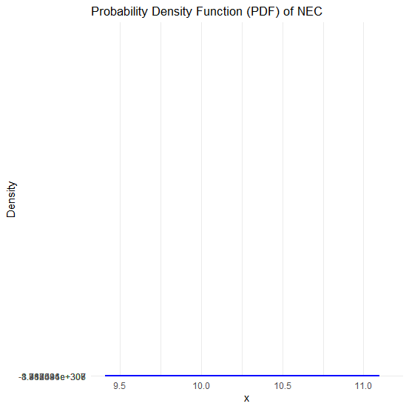
Figure 2. PDF of NEC distribution for Simulated Data of n=1000

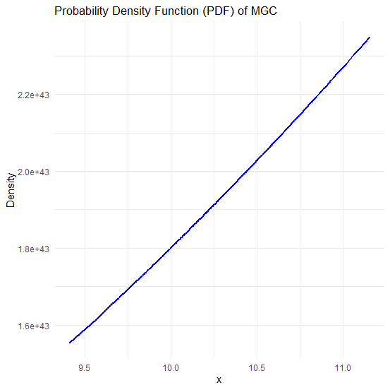
Figure 3. PDF of MGC distribution for Simulated Data of n=1000

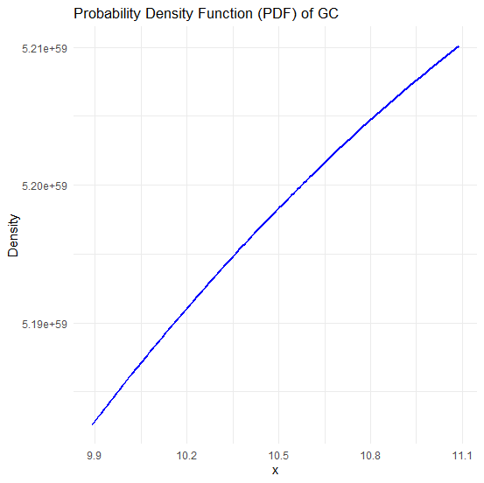
Figure 4. PDF of GC distribution for ASI Data
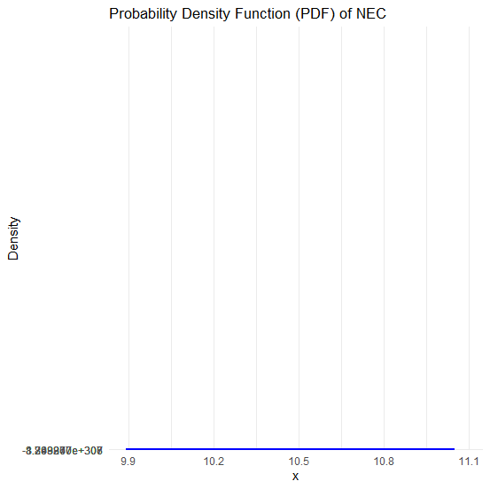
Figure 5. PDF of NEC distribution for ASI Data

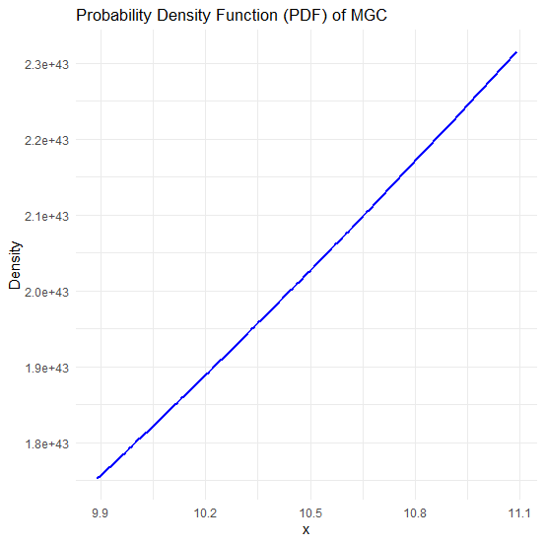
Figure 6. PDF of MGC distribution for ASI Data
Figure 7. CDF of GC distribution for Simulated Data of n=1000

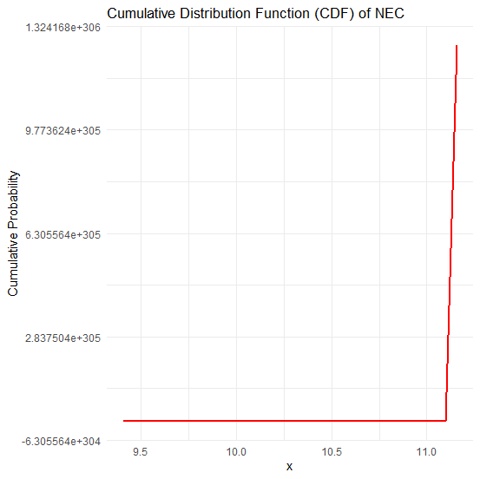
Figure 8. CDF of NEC distribution for Simulated Data of n=1000

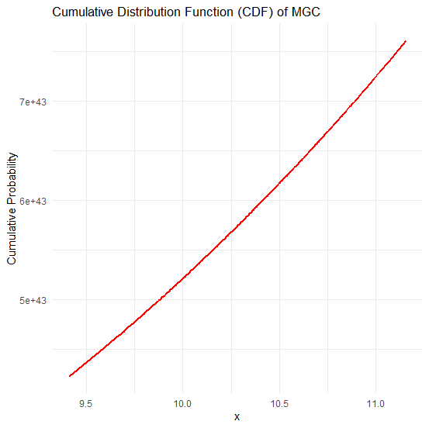
Figure 9. CDF of MGC distribution for Simulated Data of n=1000
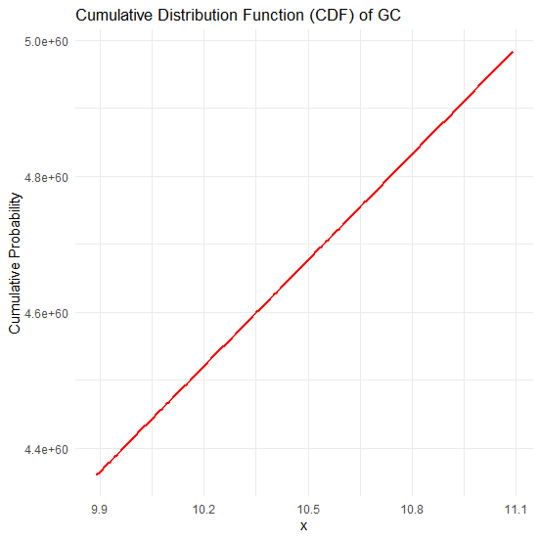
Figure 10. CDF of GC distribution for ASI Data

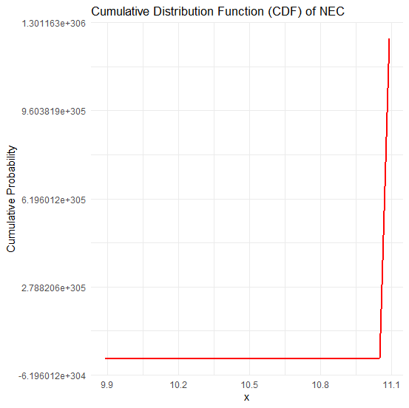
Figure 11. CDF of NEC distribution for ASI Data
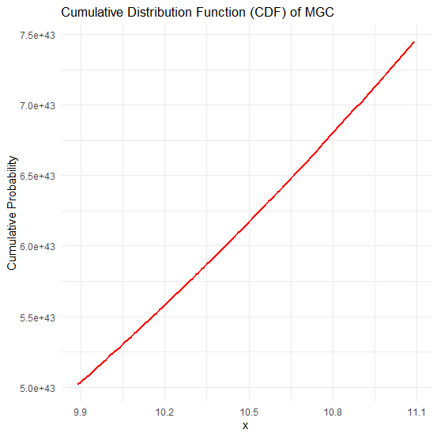
Figure 12. CDF of MGC distribution for ASI Data
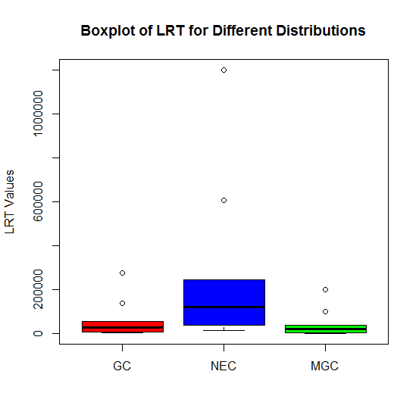
Figure 13. Boxplot of LRT for the Distributions considered in the study
Figure 13 presents the boxplot of the Likelihood Ratio Test (LRT) values for the three distributions considered in the study: GC, NEC, and MGC. The NEC distribution exhibits the highest median LRT value (~150,000) with a wide interquartile range (IQR), indicating high variability. Additionally, NEC has extreme outliers, with values exceeding 1,000,000. In contrast, the GC and MGC distributions have lower median LRT values (~50,000 and ~30,000, respectively) and more compact IQRs, suggesting relatively stable performance. The MGC distribution shows the lowest LRT values with minimal variability, indicating a better model fit compared to GC and NEC. Overall, NEC demonstrates the poorest model fit due to its high LRT values and variability, while MGC appears to be the most reliable.
- Conclusion
This study considered a comparative analysis of Chen-type distributions for modelling All-Share Index (ASI) behaviour in Nigeria providing valuable insights into the statistical properties and predictive performance of different distributional models. Using secondary data from the Nigerian Stock Exchange spanning January 2008 to December 2021, alongside simulated datasets, this study systematically evaluated the applicability of three variants of the Chen distribution (Generalized Chen (GC), New Extended Chen (NEC), and Modified Generalized Chen (MGC)). The findings indicate that while the NEC distribution exhibited extreme numerical instability and poor predictive accuracy, the GC distribution, though marginally better in terms of fit, demonstrated excessively high Mean Squared Error (MSE) values, rendering it unreliable for modelling ASI behaviour. In contrast, the MGC distribution consistently outperformed both alternatives, striking a balance between goodness-of-fit and predictive performance, as evidenced by its lower AIC, BIC, MSE and LRT values across dataset sizes.
These results underscore the importance of selecting appropriate statistical models for financial time series analysis, particularly in volatile markets such as the Nigerian Stock Exchange. The superior performance of the MGC distribution suggests that incorporating additional flexibility through a location parameter (δ) and a scaling factor (λ) enhances the robustness of the model, making it more suitable for capturing the complex dynamics of ASI fluctuations. The study contributes to the growing body of literature on the statistical modelling of financial indices and highlights the necessity of evaluating alternative probability distributions before concluding market behaviour. Future research could explore further modifications of the Chen distribution, incorporating additional market factors and expanding the scope of analysis to other stock exchanges, thereby improving predictive accuracy and model stability in financial econometrics.
Disclaimer (Artificial intelligence)
Author(s) hereby declare that NO generative AI technologies such as Large Language Models (ChatGPT, COPILOT, etc.) and text-to-image generators have been used during the writing or editing of this manuscript.
References
Aarset, M.V. (1987). How to identify a bathtub hazard rate. IEEE Trans. Reliab., 36: 106–108.
Abbas, U. F., Ahmed, A., & Mukhtar, U. (2022). Bayesian Estimation of Four Parameters Additive Chen-Weibull Distribution. Fudma. Journal of Sciences, 6(1): 181–190.
Abdulateef, E. A., Salman, A. N., & Luaibi, H. H. (2023). Employ Stress-Strength Reliability Technique in Case the Inverse Chen Distribution. Iraqi Journal of Science, 64(10): 5173–5181.
Abdulzeid, Y. A., Lewis, B., and Nasiru, S., (2022). The modified extended Chen distribution: properties and application to rainfall data. Applied Mathematics and Information Sciences, 16(5): 711–728.
Acquah, J., Odoi, B., Anafo, A. Y., & Senyea, B.-A. (2023). An Extension of the Chen Distribution: Properties, Simulation Study and Applications to Data. Asian Journal of Probability and Statistics, 23(4): 26–42.
Aﬁfy, A. Z., Altun, E., Alizadeh, M., Ozel, G., and Hamedani, G.G. (2017). The odd exponentiated half-logistic-G family: properties, characterizations and applications. Chilean Journal of Statistics, 8(2): 65-91.
Agiwal, V. (2023). Bayesian Estimation of Stress Strength Reliability from Inverse Chen Distribution with Application on Failure Time Data. Annals of Data Science, 10(2): 317–347.
Al-Essa, L. A., Soliman, A. A., Abd-Elmougod, G. A., & Alshanbari, H. M. (2024). Statistical inference of joint competing risks models from comparative bathtub shape distributions with hybrid censoring. Alexandria Engineering Journal, 86: 9–22.
Anafo, A.Y., Brew, L., and Nasiru, S. (2022). The Modiﬁed Extended Chen Distribution: Properties and Application to Rainfall Data. Appl. Math., 16(5): 711-728.
Awodutire, P. O. (2020). Chen Pareto Distribution: Properties and Application. Pakistan Journal of Statistics and Operation Research, 16(4): 812–820.
Awopeju, A.K., and Abiodun, A. A. (2023). Exponentially Generated Modified Chen Distribution with Applications to Lifetime Dataset. Journal of Probability and Statistics, 2023, 1–25.
Azimi, R., Esmailian, M., & Gallardo, D. I. (2023). The inverted exponentiated Chen distribution with application to cancer data. Japanese Journal of Statistics and Data Science, 6(1), 213–241.
Bebbington, M. C., Lai, D., and Zitikis, R. (2007). A flexible Weibull extension. Reliability Engineering & System Safety, 92(6): 719–726.
Casella, G. and Berger, R.L. (2002). Statistical Inference. 2nd Edition, Duxbury Press, Pacific Grove.
Chaubey, Y. P. and Zhang, R. (2015). An extension of Chen’s family of survival distributions with bathtub shape or increasing hazard rate function. Communications in Statistics-Theory and Methods, 44(19): 4049-4064.
Chaudhary, A. K., Yadav, R. S., & Kumar, V. (2023). Half-Cauchy Chen Distribution with Theories and Applications. Journal of Institute of Science and Technology, 28(1): 45–55.
Chen, Z. (2000). A new two-parameter lifetime distribution with bathtub shape or increasing failure rate function. Statistics & Probability Letters, 49(2): 155-61.
Cordeiro, G.M., Lemonte, A.J., Ortega, E.M. (2014). The Marshall-Olkin family of distributions: Mathematical properties and new models. Journal of Statistical Theory and Practice, 8: 343-66.
Davidson, R. and MacKinnon, J.G. (2004). Econometric Theory and Methods. Oxford University Press, New York.
Eghwerido, J.T., Oguntunde, P.E., Agu, F.I. (2021). The alpha power Marshall-Olkin-G distribution: properties, and applications. Sankhya A.: 1-26.
Greene, W. H. (2012). Econometric analysis (7th ed.). Pearson Education.
Hu, C., & Gui, W. (2023). Reliability Inference of Multicomponent Stress–Strength System Based on Chen Distribution Using Progressively Censored Data. Applied Sciences (Switzerland), 13(11).
Ismael, A. A., & AL-Bairmani, Z. A. A. (2024). New extension for Chen distribution based on [0, 1] Truncated Nadarajah-Haghighi-G family with two real data application. International Journal of Financial Management and Economics, 7(1): 46–57.
Joshi, R.K. and Kumar, V. (2021). Logistic Chen Distribution with Properties and Applications. International Journal of Mathematics Trends and Technology, 67(1):141-51.
Joshi, S., and Pandit, P.V. (2018). Estimation of stress strength reliability in s-out-of-k system for a two parameter inverse Chen distribution. Journal of Computer and Mathematical Sciences, 9(12): 1898-1906.
Khosa, S.K., Aﬁfy, A.Z., Ahmad, Z., Zichuan, M., Hussain, S., and Iftikhar, A. A (2020). New extended-f family: properties and applications to lifetime data. Journal of Mathematics, 2020: 1-9.
Kilany, N. M., & El-Qareb, F. G. (2023). Modelling bivariate failure time data via bivariate extended Chen distribution. Stochastic Environmental Research and Risk Assessment, 37(9): 3517–3525.
Korkmaz, M.C.¸, Cordeiro, G.M., Yousof, H.M., Pescim, R.R., Aﬁfy, A.Z., Nadarajah, S. (2019).The Weibull Marshall–Olkin family: Regression model and application to censored data. Communications in Statistics-Theory and Methods, 48(16): 4171-4194.
Meeker, W.Q., Escobar, L.A., and Pascual, F.G. (2021). Statistical Methods for Reliability Data. John Wiley & Sons: Hoboken, NJ, USA.
Méndez-González, L. C., Rodríguez-Picón, L. A., Pérez-Olguín, I. J. C., & Vidal Portilla, L. R. (2023a). An Additive Chen Distribution with Applications to Lifetime Data. Axioms, 12(2): 118.
Méndez-González, L. C., Rodríguez-Picón, L. A., Rodríguez Borbón, M. I., & Sohn, H. (2023b). The Chen–Perks Distribution: Properties and Reliability Applications. Mathematics, 11(13).
Nadarajah, S., Cordeiro, G. M., Ortega, E. M. (2012). General results for the Kumaraswamy-G distribution. Journal of Statistical Computation and Simulation, 82(7):951-79.
Nasiru, S. (2018). Extended odd Fr´echet-G family of distributions. Journal of Probability and Statistics, 2018: 1-2.
Nofal, Z.M., Aﬁfy, A.Z., Yousof, H.M., and Cordeiro, G.M. (2017). The generalized transmuted-G family of distributions. Communications in Statistics-Theory and Methods, 46(8): 4119-4136.
Otoo, H., Inkoom, J., & Wiah, E. N. (2023). Odd Chen Exponential Distribution: Properties and Applications. Asian Journal of Probability and Statistics, 25(1): 13–34.
Pappas, V., Adamidis, K., and Loukas, S. (2011). A three-parameter lifetime distribution. Adv. Applic. Statist., 20: 159–167.
Radwan, H. M. M., & Alenazi, A. (2023). Different estimation techniques for constant-partially accelerated life tests of Chen distribution using complete data. Scientific Reports, 13(1).
Reis, L.D., Cordeiro, G.M., and Lima, M.C. (2020). The Gamma-Chen distribution: a new family of distributions with applications. Spanish Journal of Statistics.,2(1): 23-40.
Reyad, H., Alizadeh, M., Jamal, F., Othman, S. (2018). The Topp Leone odd Lindley-G family of distributions: Properties and applications. Journal of Statistics and Management Systems, 21(7): 1273-297.
Sarhan, A. M., Apaloo, J., & Kundu, D. (2024). A new bivariate lifetime distribution: properties, estimations and its extension. Communications in Statistics: Simulation and Computation, 53(2): 879–896.
Singh, K., Kumar Mahto, A., & Mani Tripathi, Y. (2024). On partially observed competing risks model for Chen distribution under generalized progressive hybrid censoring. Statistica Neerlandica, 78(1): 105–135.
Sousa-Ferreira, I., Abreu, A. M., & Rocha, C. (2023). The Extended Chen–Poisson Lifetime Distribution. Revstat Statistical Journal, 21(2): 173–196.
Stone, R. F., Loose, L. H., Melo, M. S., & Bayer, F. M. (2023). The Chen Autoregressive Moving Average Model for Modeling Asymmetric Positive Continuous Time Series. Symmetry, 15(9).
Tarvirdizade, B., & Ahmadpour, M. (2021). A New Extension of Chen Distribution with Applications to Lifetime Data. Communications in Mathematics and Statistics, 9(1): 23–38.
Telee, L. B. S., & Kumar, V. (2023). Exponentiated Inverse Chen distribution: Properties and applications. Journal of Nepalese Management Academia, 1(1): 53–62.
Wang, F. (2020). A new model with bathtub-shaped failure rate using an additive Burr XII distribution. Reliab. Eng. Syst. Saf., 70: 305–312.
Wilks, S.S. (1938) The Large Distribution of the Likelihood Ratio for Testing Composite Hypotheses. Annals of Mathematical Statistics, 9, 60-62.http://dx.doi.org/10.1214/aoms/1177732360
Yousaf, F., Ali, S., Shah, I., & Riaz, S. (2023). Parameters Estimation of the Exponentiated Chen Distribution Based on Upper Record Values. Journal of Reliability and Statistical Studies, 16(1), 197–228.
Zamani, Z., Afshari, M., Karamikabir, H., Alizadeh, M., & Ali, M. M. (2022). Extended Exponentiated Chen Distribution: Mathematical Properties and Applications. Statistics, Optimization and Information Computing, 10(2): 606–626.
Zhang, T. and Xie, M. (2011). On the upper truncated Weibull distribution and its reliability implications. Reliability Engineering & System Safety, 96(1): 194–200.

