Neoliberalism and Gender Justice: Examining Economic Reforms and Feminist Responses in India
Abstract
The economic reforms introduced in India in 1991, marked by liberalisation, privatisation, and globalisation, have significantly shaped the country’s economic landscape but also deepened gender inequalities. This study examines the gendered consequences of these neoliberal policies, focusing on their impact on labour markets, access to resources, and social structures. The reforms led to the feminisation of informal and precarious work, reduced access to public services like healthcare and education, and reinforced intersectional disparities based on caste, class, and religion. These changes have disproportionately affected women and marginalised genders, exacerbating economic and social vulnerabilities. Simultaneously, the paper explores how feminist movements in India have responded to these challenges, adapting their strategies to address the evolving realities of a neoliberal economy.
Through an analysis of government reports, academic studies, archival records, and policy review, this research highlights the resilience and adaptability of feminist movements in advocating for gender justice. Case studies of organisations like the Self-Employed Women’s Association (SEWA) and campaigns such as #MeToo demonstrate how feminist activism has countered the adverse effects of economic reforms. However, challenges such as fragmentation within movements, co-optation by neoliberal agendas, and resistance from conservative forces persist. The study concludes with policy recommendations for fostering gender-sensitive economic frameworks, emphasising the need for sustained and intersectional feminist activism to achieve equitable outcomes in a neoliberal era.
Keywords: Economic Reforms, Gender Justice, Neoliberalism, Feminist Movements, India.
Introduction:
The economic reforms introduced in India in 1991 marked a pivotal shift in the country’s economic trajectory, transitioning from a state-led development model to a market-driven, neoliberal framework. Characterised by liberalisation, privatisation, and globalisation (LPG), these reforms aimed to integrate India into the global economy and foster rapid economic growth (Chakravarty, 2019). While the reforms achieved higher GDP growth rates and attracted foreign investment, they also exacerbated existing social inequalities, particularly along gender lines (Masumdar, 2007). This study critically examines the gendered consequences of India’s neoliberal policies, focusing on their impact on labour markets, access to resources, and social structures, while also analysing feminist responses to these challenges, particularly in how they have contested and adapted to the shifting economic realities through both grassroots mobilisation and policy engagement.
A key critique of neoliberalism is its impact on gender justice. Scholars argue that market-driven policies often reinforce patriarchal structures, disproportionately affecting women and marginalised genders (Fraser, 2013). In India, neoliberal reforms have led to the feminisation of informal and precarious work, reduced access to public services like healthcare and education, and reinforced intersectional disparities based on caste, class, and religion (Desai & Joshi, 2019). Rural women have been particularly affected by the decline in agricultural employment, while urban women face barriers to securing stable, well-paying jobs (Mehrotra & Parida, 2017). Additionally, the privatisation of public services has increased the burden of unpaid care work on women (Sen & Govender, 2015). These transformations raise critical questions about the extent to which neoliberal economic policies have altered gendered labour dynamics, deepened structural inequalities, and reshaped the avenues through which feminist movements negotiate economic justice within an increasingly globalised landscape.
In response to these challenges, feminist movements in India have sought to navigate the shifting terrain of neoliberalism through strategies that range from grassroots organising, as seen in the Self-Employed Women’s Association (SEWA), to digital activism exemplified by the #MeToo movement, both of which illuminate the resilience and adaptability of feminist interventions (Menon, 2018). However, despite these efforts, the capacity of feminist movements to challenge entrenched economic disparities remains constrained by ideological fragmentation, co-optation by neoliberal agendas, and resistance from conservative forces (Gangoli, 2023). The study thus interrogates the complex interplay between neoliberal policies and gender justice, examining how feminist activism has evolved to counter the socioeconomic challenges engendered by these reforms while also reflecting on the policy measures necessary to foster a more equitable and inclusive economic framework in India. Employing a qualitative case study approach, this research draws on government reports, academic studies, archival records, and policy reviews to illuminate the intricate connections between economic liberalisation and gender justice. By critically engaging with the ways in which neoliberalism has reshaped labour markets, access to resources, and socio-political structures, the study seeks to contribute to broader discussions on feminist praxis and economic justice in post-reform India, underscoring the imperative for sustained intersectional engagement to counteract the systemic inequities perpetuated by market-driven growth.
Neoliberal Economic Reforms in India: A Historical and Theoretical Overview:
The economic reforms introduced in India in 1991 marked a watershed moment in the country’s economic history. These reforms, often referred to as the Liberalisation, Privatisation, and Globalisation (LPG) model, were a response to a severe balance of payments crisis and aimed to integrate India into the global economy (Chakravarty, 2019). While the reforms succeeded in achieving higher economic growth rates and attracting foreign investment, they also fundamentally altered the country's socio-economic fabric, with significant implications for gender justice. This section provides a historical and theoretical overview of India’s neoliberal economic reforms, situating them within the broader context of global neoliberalism and examining their gendered consequences. The neoliberal economic reforms introduced in India in 1991 marked a significant departure from the state-led development model of the post-independence period. While these reforms achieved higher economic growth rates and integrated India into the global economy, they also had profound and far-reaching consequences for gender justice. The erosion of public services, the feminisation of informal and precarious work, and the reinforcement of intersectional inequalities are among the key gendered impacts of neoliberal policies in India.
The Genesis of the 1991 Reforms
The economic reforms of 1991 were born out of necessity. By the late 1980s, India was facing a severe economic crisis characterised by dwindling foreign exchange reserves, rising inflation, and a stagnant economy (Panagariya, 2008). The immediate trigger for the reforms was the balance of payments crisis in 1991, which forced the Indian government to seek a bailout from the International Monetary Fund (IMF) and the World Bank. In exchange for financial assistance, these institutions mandated structural adjustment programs (SAPs) that required India to liberalise its economy, reduce public spending, and open up to foreign investment (Nayar, 2001). The reforms introduced in 1991 included the dismantling of the License Raj, which had previously regulated industrial production and investment; the reduction of tariffs and trade barriers to promote global integration; and the privatisation of state-owned enterprises to improve efficiency and reduce fiscal deficits (Ahluwalia, 2002). These measures were aimed at transforming India from a state-led, inward-looking economy to a market-driven, globally integrated one. While the reforms succeeded in achieving higher GDP growth rates and attracting foreign direct investment (FDI), they also led to significant socio-economic disruptions, particularly for marginalised groups, including women (Masumdar, 2007).
Theoretical Framework: Neoliberalism and Gender
Neoliberalism, as an economic and political ideology, is rooted in the principles of free markets, deregulation, and reduced state intervention. Proponents of neoliberalism argue that market-driven growth leads to greater efficiency, innovation, and prosperity for all (Harvey, 2005). However, feminist scholars have critiqued neoliberalism for its adverse effects on gender justice, arguing that it exacerbates existing inequalities and reinforces patriarchal structures (Fraser, 2013). One of the key critiques of neoliberalism is its emphasis on commodification, which transforms social goods and services into marketable commodities. This process disproportionately affects women, who are often responsible for unpaid care work and rely on public services like healthcare and education (Benería, 2003). The erosion of public services under neoliberal policies burdens women, who must either pay for privatised services or compensate for their absence through unpaid labour (Sen & Govender, 2015). Another critique of neoliberalism is its focus on individualism and self-reliance, which undermines collective forms of social protection and solidarity. This shift disproportionately affects women and marginalised genders, who often rely on social safety nets and community support systems (Bakker, 2007). Furthermore, neoliberal policies tend to prioritise economic growth over social equity, leading to the marginalisation of gender justice issues in policy-making (Rai, 2002).

Fig 1: Female-to-male ratio of time devoted to unpaid care work, 2014
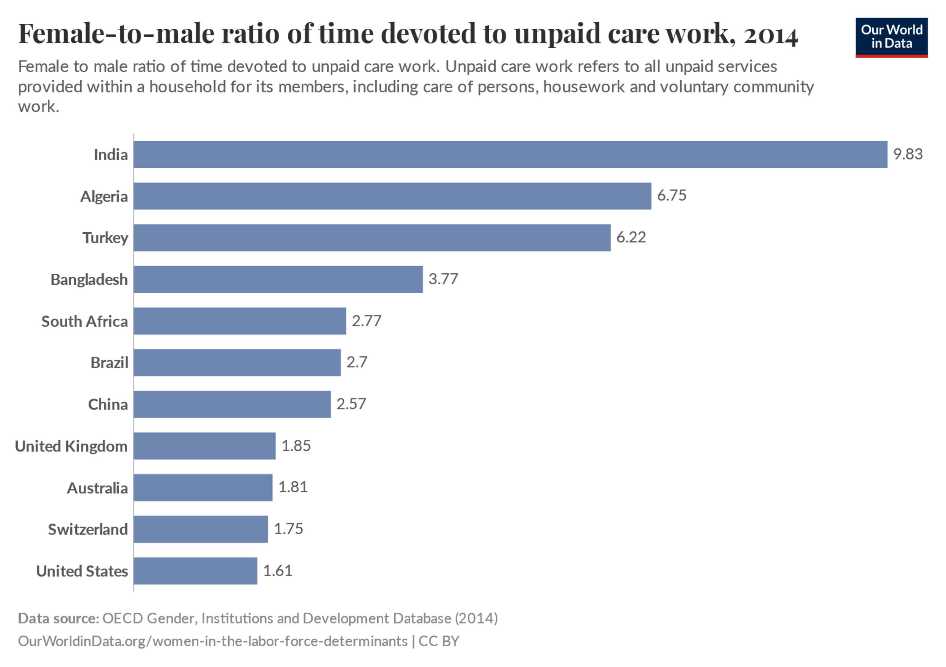
Source: OECD Gender, Institutions and Development Database OurWorldinData.org/women-in-the-labor-force-determinants

The Indian Context: From Welfare State to Market Economy
Prior to the 1991 reforms, India’s economic policies were characterised by a strong emphasis on state-led development and social welfare. The post-independence period saw the adoption of a mixed economy model, with the state playing a central role in industrialisation, poverty alleviation, and social welfare (Chakravarty, 2019). The public sector dominated key industries, and the government implemented a range of social welfare programs, including subsidised food distribution, public healthcare, and universal education (Nayar, 2001).
While these policies were not without their flaws, they provided a degree of social protection for marginalised groups, including women. For instance, the public distribution system (PDS) ensured access to subsidised food grains for low-income households, while public healthcare and education programs aimed to reduce disparities in access to essential services (Rao et al., 2017). However, the state-led development model also had its limitations, including inefficiencies, corruption, and a lack of focus on gender equity (Masumdar, 2007). The 1991 reforms marked a decisive shift away from the welfare state model towards a market-driven economy. The reduction of public spending, privatisation of state-owned enterprises, and deregulation of markets were central to this transition (Ahluwalia, 2002). While these measures were aimed at promoting economic growth and efficiency, they also led to the erosion of social welfare programs and public services, with significant implications for gender justice (Desai & Joshi, 2019).

The Global Context of Neoliberalism and Its Influence on India
The neoliberal economic reforms in India were part of a broader global trend towards market liberalisation and globalisation. The 1980s and 1990s saw the rise of neoliberalism as the dominant economic paradigm, driven by the policies of international financial institutions like the International Monetary Fund (IMF) and the World Bank (Harvey, 2005). Structural adjustment programs (SAPs) were imposed on developing countries as a condition for financial assistance, requiring them to liberalize their economies, reduce public spending, and open up to foreign investment (Benería, 2003). These policies were justified as necessary for economic stabilisation and growth but often led to increased inequalities and a decline in state-led welfare provisions, particularly impacting marginalized communities. India’s adoption of neoliberal policies was influenced by both external pressures and internal dynamics. The balance of payments crisis in 1991 provided the immediate impetus for economic reforms, but the shift towards neoliberalism was also driven by a growing consensus among Indian policymakers that market-driven growth was the key to economic prosperity (Panagariya, 2008). However, the implementation of neoliberal policies in India was marked by contradictions and tensions, as the government sought to balance the demands of global capital with the needs of a diverse and unequal society (Nayar, 2001).
India's experience with neoliberalism aligns with broader patterns observed in other parts of the Global South, where economic liberalization was introduced under similar pressures from international financial institutions. In Latin America, countries such as Chile and Argentina implemented neoliberal reforms, often under authoritarian regimes, which significantly reduced social spending and labour rights (Eisenstein, 2015). Chile’s neoliberal model, designed by economists trained under the Chicago School, led to economic growth but also entrenched income inequality and gender disparities in employment, with women largely concentrated in low-paid service sector jobs (Waylen, 2007). Similarly, Argentina’s adoption of neoliberalism resulted in increased job insecurity, with a rise in informal employment where women were disproportionately represented (Benería, 2003).
In Africa, SAPs imposed by the IMF and World Bank led to a decline in public sector employment and the erosion of social welfare systems, disproportionately affecting women who relied on state-provided services for healthcare, education, and child support (Razavi, 2007). Countries such as Ghana and Nigeria saw a contraction in government services, leading to a rise in informal sector employment, where women were often engaged in precarious and unregulated work (Tsikata, 2009). The rollback of state subsidies further exacerbated economic hardships, particularly for marginalised communities dependent on state support for basic needs. In Southeast Asia, neoliberal globalisation played a significant role in shaping labour markets. Countries such as Indonesia, Thailand, and the Philippines experienced a surge in low-wage, export-oriented manufacturing jobs, especially in industries such as textiles and electronics (Elson, 1999). While these jobs provided employment opportunities for women, they were often characterised by exploitative working conditions, wage discrimination, and a lack of job security. The expansion of special economic zones (SEZs) in countries like the Philippines mirrored India’s own SEZ policies, where women workers faced poor working conditions with limited labour rights protections (Seguino, 2010).
The global context of neoliberalism also shaped the gendered consequences of economic reforms in India. The emphasis on export-oriented growth and foreign investment led to the expansion of industries such as textiles, garments, and information technology, all of which relied heavily on female labour (Mehrotra & Parida, 2017). However, these jobs were often low-wage, informal, and precarious, reflecting a broader global trend where the feminization of labour under neoliberalism coincided with deteriorating labour protections (Bakker, 2007). The experience of Indian women workers in the neoliberal economy mirrors patterns seen elsewhere in the Global South. In Latin America, the proliferation of maquiladoras (export-processing factories) created jobs for women but reinforced gender hierarchies and exploitative working conditions (Seguino, 2010). Similarly, in Africa, SAP-induced public sector cutbacks pushed women into low-paid, informal employment (Razavi, 2007). In Southeast Asia, women’s participation in global production networks led to increased economic vulnerability due to casualisation and lack of labour protections (Elson, 1999). Thus, while neoliberal economic reforms expanded employment opportunities for women, they often did so at the cost of job security, fair wages, and social protection. The shift towards a market-driven economy exacerbated gender inequalities, as women workers faced double burdens of unpaid domestic labour and precarious employment, a pattern evident across various neoliberal economies.
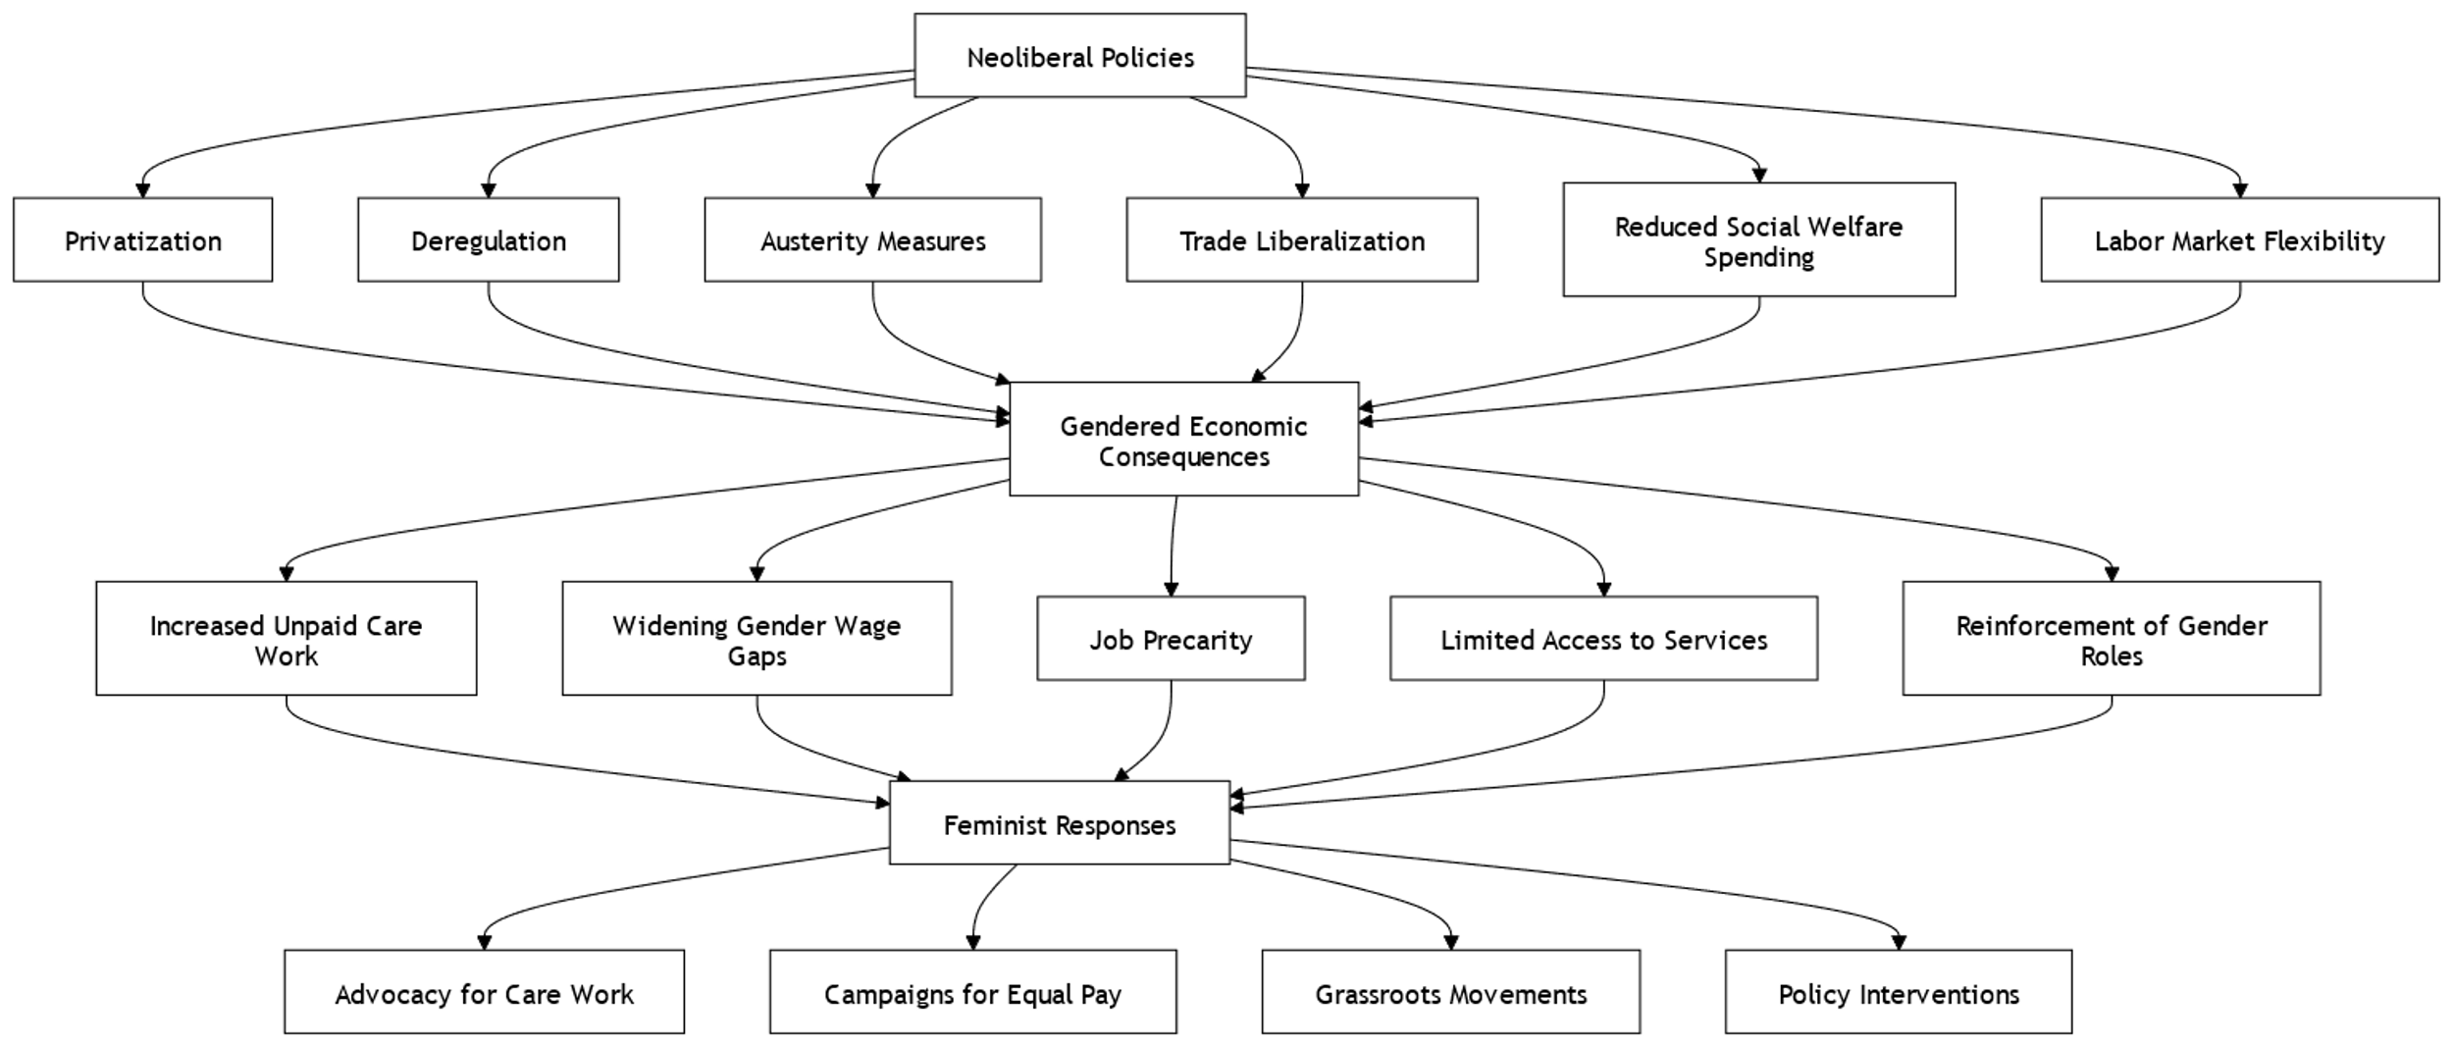
Fig 2:
Gendered Impacts of Neoliberal Policies in India
The neoliberal economic reforms introduced in India in 1991 have had profound and far-reaching consequences for gender justice. While these reforms were aimed at achieving higher economic growth and global integration, they also exacerbated existing gender inequalities and created new forms of marginalisation. This section examines the gendered impacts of neoliberal policies in India, focusing on three key areas: labour market transformations, access to resources and public services, and intersectional inequalities. Through an analysis of empirical data, case studies, and feminist critiques, this section highlights the disproportionate burden borne by women and marginalised genders under neoliberalism. The neoliberal economic reforms introduced in India in 1991 have had profound and far-reaching consequences for gender justice. The feminisation of informal and precarious work, the erosion of public services, and the reinforcement of intersectional inequalities are among the key gendered impacts of these policies. While neoliberal policies have created new opportunities for women in certain sectors, they have also exacerbated existing inequalities and created new forms of marginalisation.
Fig 3: Female employment -to-population ration, 1994 to 2023
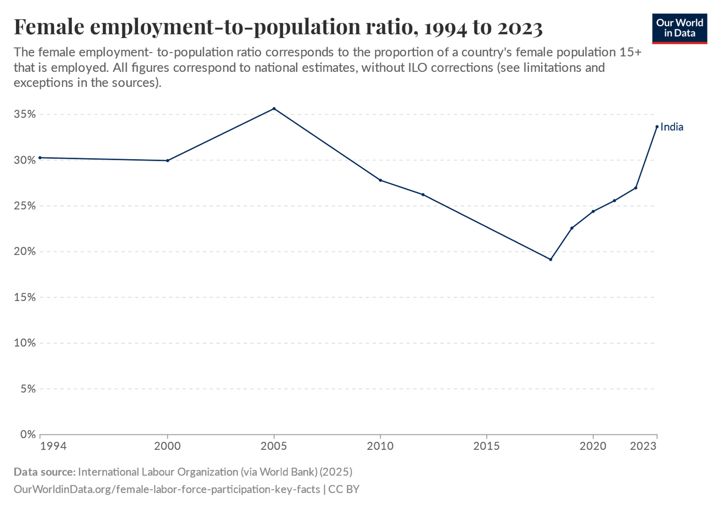
Source: Female employment-to-population ratio”. Our World in Data (2025). Data adapted from International Labour Organization (via World Bank). Retrieved from https://ourworldindata.org/grapher/female-employment-to-population-ratio[online resource]
Labour Market Transformations
The feminisation of Informal and Precarious Work
One of the most significant gendered impacts of neoliberal policies in India has been the feminisation of informal and precarious work. The shift from a state-led to a market-driven economy led to the decline of traditional industries like agriculture and the growth of informal and service sectors, which rely heavily on female labour (Mehrotra & Parida, 2017). According to the International Labour Organisation (ILO), over 81% of working women in India are employed in the informal sector, where they face low wages, poor working conditions, and a lack of social security (ILO, 2018). The garment and textile industries, which expanded significantly under neoliberal policies, are a case in point. These industries employ a large number of women, often in exploitative conditions characterised by long working hours, low wages, and lack of job security (Neetha, 2014). Similarly, the growth of the information technology (IT) sector has created new opportunities for women, but these jobs are often concentrated in low-skilled, low-paying roles such as data entry and customer service (Dutta Gupta et al., 2015).

Fig 4: Proportion of female employees by economic sector, India , 1991 to 2022
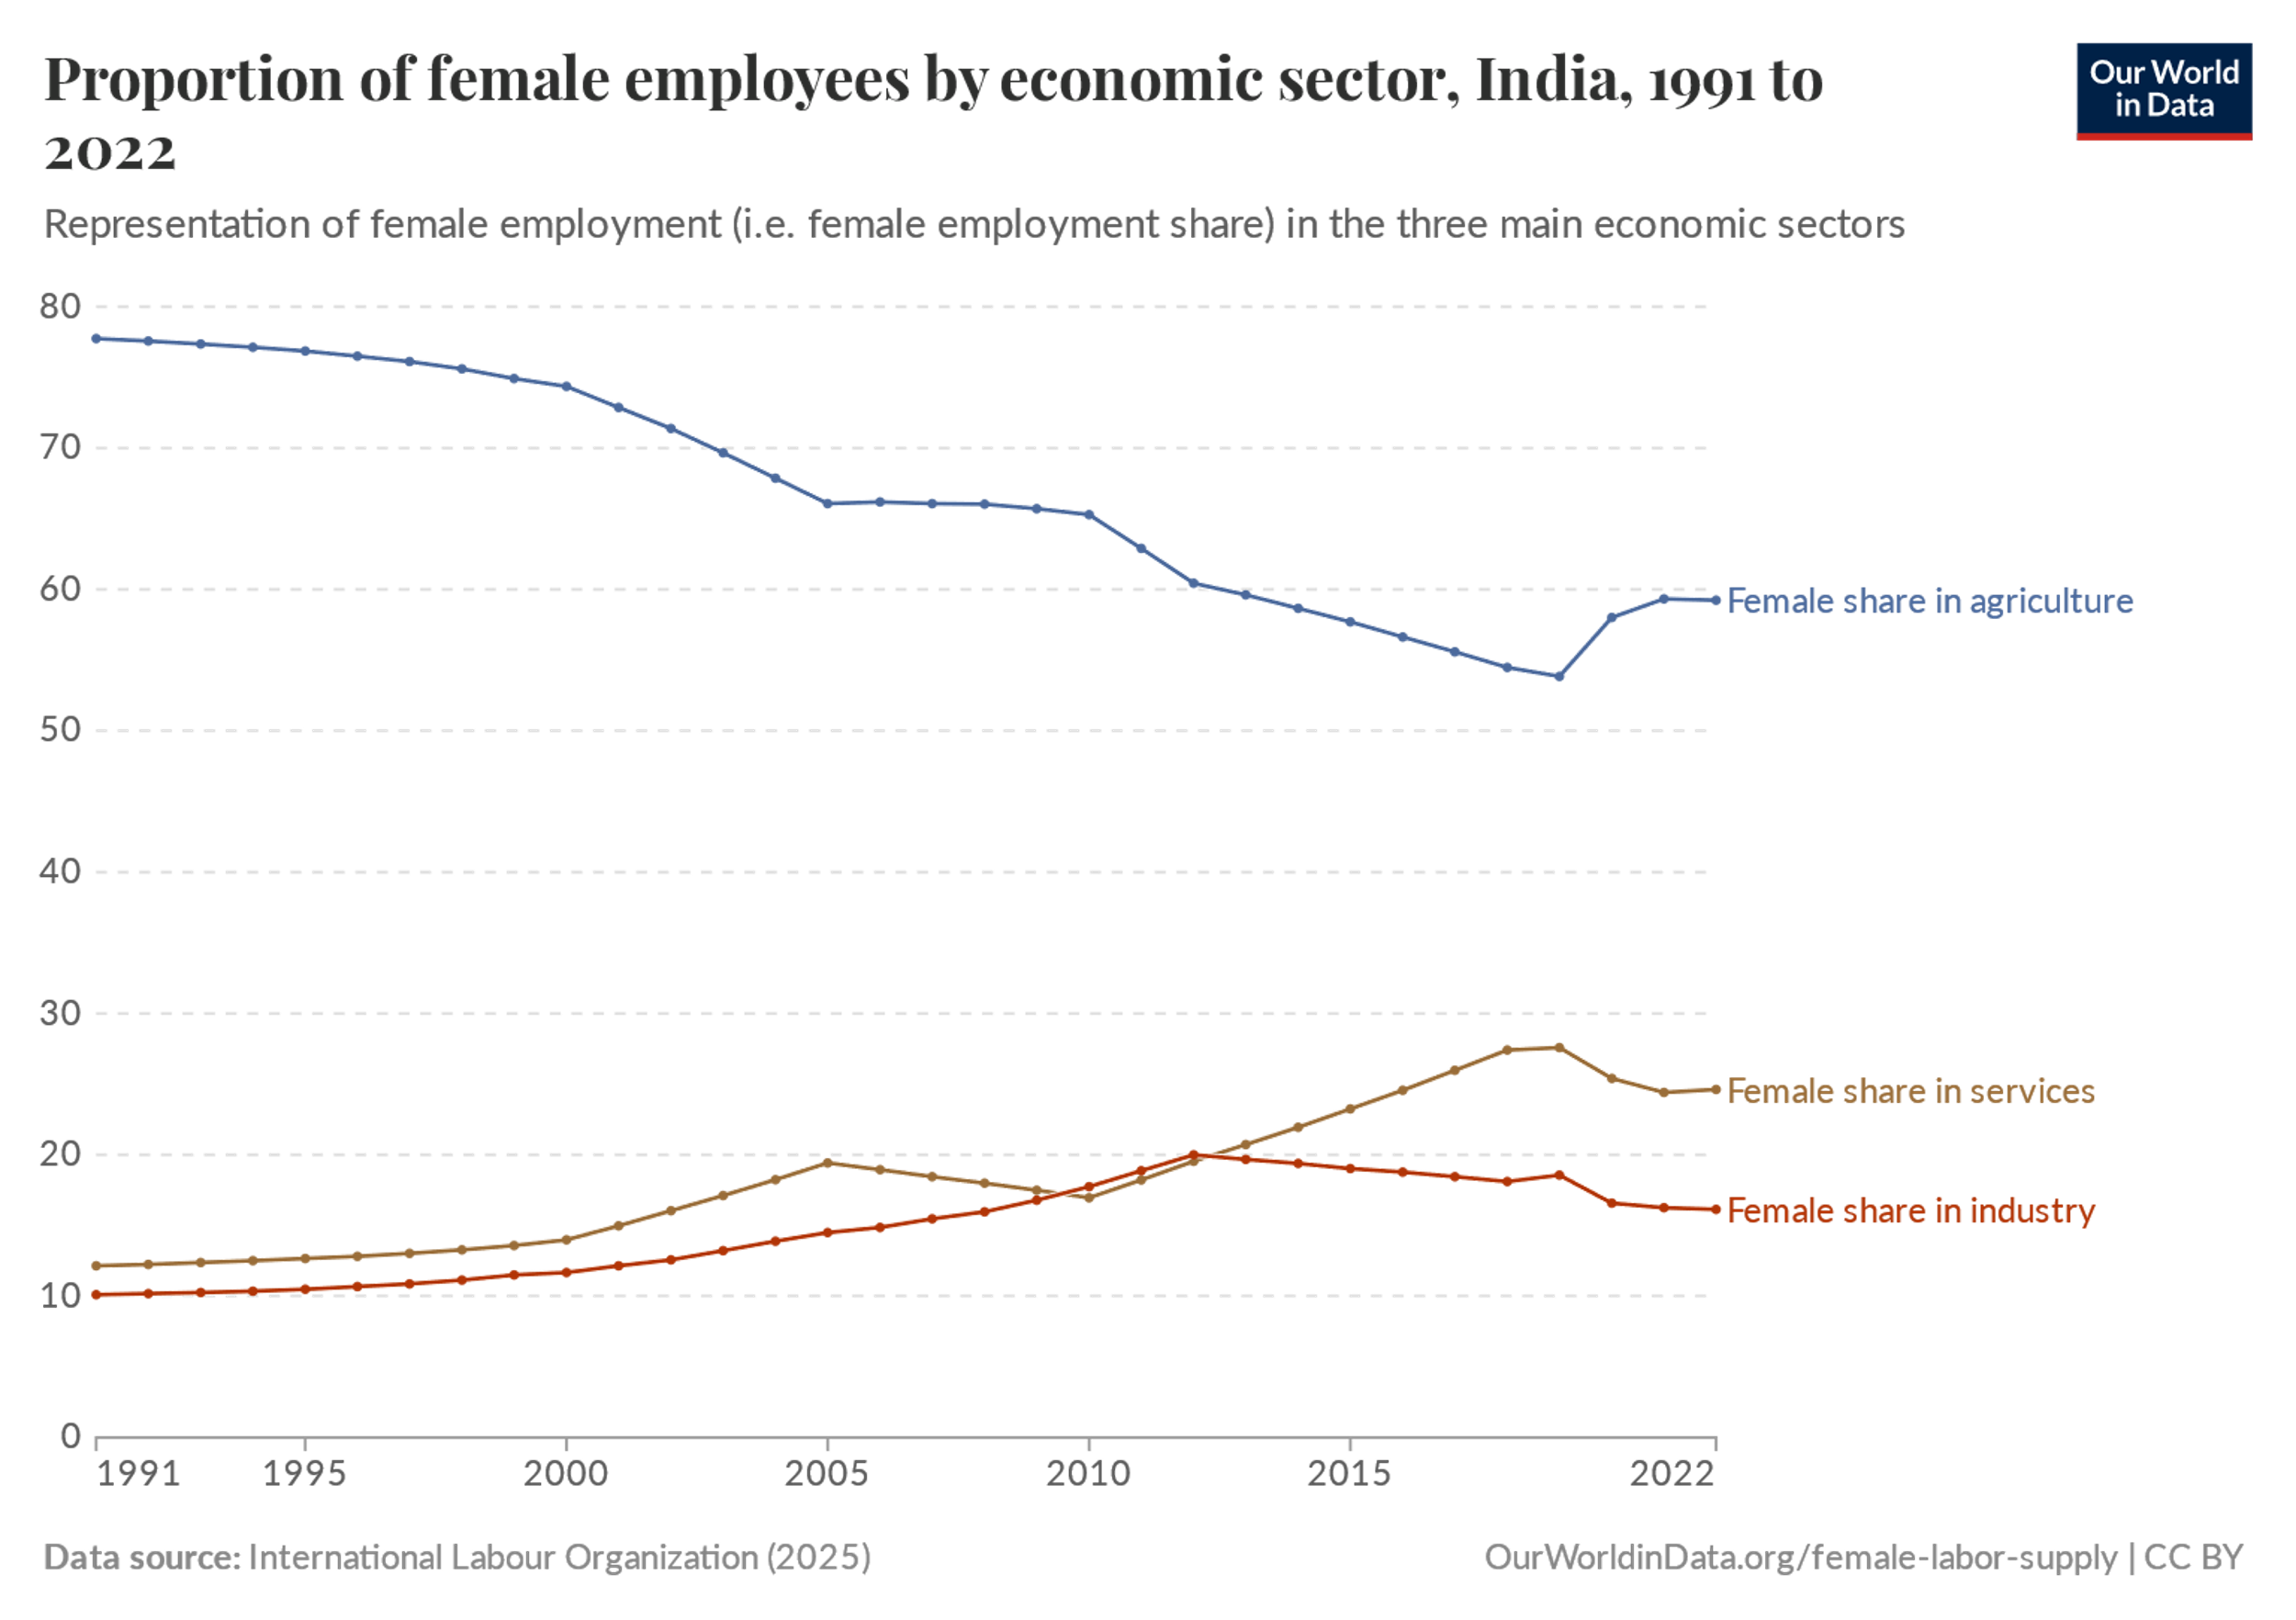
Source:https://ourworldindata.org/grapher/share-of-female-workers-by-sector?country=~IND
The informalisation of work under neoliberalism has also led to the rise of precarious forms of employment, such as contract labour, home-based work, and gig work. Women are overrepresented in these forms of work, which offer little to no job security, benefits, or legal protections (Desai & Joshi, 2019). For instance, home-based workers, who are predominantly women, often work long hours for meagre wages and are excluded from labour laws and social security schemes (Bhatt, 2020).
Wage Gaps and Occupational Segregation
Neoliberal policies have also reinforced gender-based wage gaps and occupational segregation in India. Despite the increase in female labour force participation in certain sectors, women continue to earn significantly less than men for the same work. According to a report by the World Economic Forum, India ranks a low 108th out of 153 countries in terms of the gender pay gap. This disparity is not only unfair, but it also has a significant impact on the economic stability and growth of the country. Occupational segregation, where women are concentrated in low-paying, low-status jobs, is another persistent issue. For example, women are overrepresented in sectors like domestic work, care work, and agriculture, which are often undervalued and underpaid (Masumdar, 2007). In contrast, men dominate higher-paying sectors like construction, manufacturing, and IT, where wages and working conditions are relatively better (Neetha, 2014). According to a report by the International Labour Organization (ILO), the gender pay gap in India stands at 27% as of 2023. This means that, on average, women in India earn 73% of what men earn for doing the same job. This gap is even wider in certain industries, such as the technology sector, where women earn just 60% of what men earn.“Women and Men in India 2022” by the National Statistical Office. The report states that the market-determined wages for women performing similar work are considerably lower than those of men. Moreover, the gender wage gap has widened in rural areas over the past decade, although it has narrowed in towns.The neoliberal emphasis on flexibility and cost-cutting has further exacerbated these disparities. Employers often prefer to hire women for low-paying, flexible jobs, citing their "docility" and willingness to accept poor working conditions (Dutta Gupta et al., 2015). This gendered division of labour not only reinforces economic inequalities but also perpetuates patriarchal norms that devalue women’s work.
Impact on Rural and Urban Economies
The gendered impacts of neoliberal policies vary significantly between rural and urban areas. In rural India, the decline of agriculture and the shift towards non-farm employment have disproportionately affected women, who constitute a large proportion of agricultural workers (Rao et al., 2017). The reduction of subsidies and public investment in agriculture has led to the feminisation of agrarian distress, with women bearing the brunt of declining incomes and increasing indebtedness (Rao, 2017). In urban areas, the growth of the informal and service sectors has created new opportunities for women, but these jobs are often low-paying and precarious. For instance, the expansion of the retail and hospitality sectors has led to an increase in female employment, but these jobs are characterised by low wages, long hours, and a lack of job security (Desai & Joshi, 2019). Additionally, the privatisation of public services has increased the burden of unpaid care work on women, who are often responsible for childcare, eldercare, and household chores (Sen & Govender, 2015).
Table 1: Employment in India: Total, Agricultural, and Non-Agricultural by Urban-Rural and Sex (2011-12 & 2017-18) (Millions and % in Parentheses)
Year | Area | All Workers | Women | Men | Agricultural Workers | Women | Men | Non-Agricultural Workers | Women | Men
2011-12 | All India | 467.72 (100.0%) | 126.77 (27.1%) | 340.95 (72.9%) | 223.41 (47.8%) | 78.55 (16.8%) | 144.86 (31.0%) | 244.31 (52.2%) | 48.22 (10.3%) | 196.09 (41.9%)
 | Urban | 135.39 (28.9%) | 27.02 (5.8%) | 108.37 (23.1%) | 9.10 (1.9%) | 2.93 (0.6%) | 6.17 (1.3%) | 126.29 (27.0%) | 24.09 (5.1%) | 102.20 (21.9%)
 | Rural | 332.33 (71.1%) | 99.75 (21.3%) | 232.58 (49.7%) | 214.31 (45.8%) | 75.62 (16.2%) | 138.69 (29.7%) | 118.02 (25.2%) | 24.13 (5.1%) | 93.89 (20.1%)
2017-18 | All India | 461.52 (100.0%) | 104.95 (22.7%) | 356.58 (77.3%) | 194.08 (42.1%) | 57.78 (12.5%) | 136.30 (29.5%) | 267.45 (57.9%) | 47.17 (10.2%) | 220.28 (47.7%)
 | Urban | 150.25 (32.6%) | 29.91 (6.5%) | 120.33 (26.1%) | 9.25 (2.0%) | 2.72 (0.6%) | 6.53 (1.4%) | 141.00 (30.6%) | 27.19 (5.9%) | 113.81 (24.7%)
 | Rural | 311.28 (67.4%) | 75.03 (16.3%) | 236.24 (51.1%) | 184.83 (40.0%) | 55.05 (11.9%) | 129.77 (28.1%) | 126.45 (27.4%) | 19.98 (4.3%) | 106.47 (23.1%)
Source : Informal Workers in India: A Statistical Profile(2020) Women in Informal Employment: Globalizing and Organizing(WIEGO).https://www.wiego.org/wp-content/uploads/2020/10/WIEGO_Statistical_Brief_N24_India.pdf
Access to Resources and Public Services
Erosion of Public Healthcare and Education
The neoliberal emphasis on reducing public spending and promoting privatisation has had a devastating impact on access to healthcare and education, particularly for women and marginalised groups. The reduction of public investment in healthcare has led to the proliferation of private hospitals and clinics, which are often unaffordable for low-income families (Hooda, 2020). As a result, women, who are often the primary caregivers in families, face significant barriers to accessing healthcare services.

Fig 5: Gender gap in primary, secondary and tertiary education, India

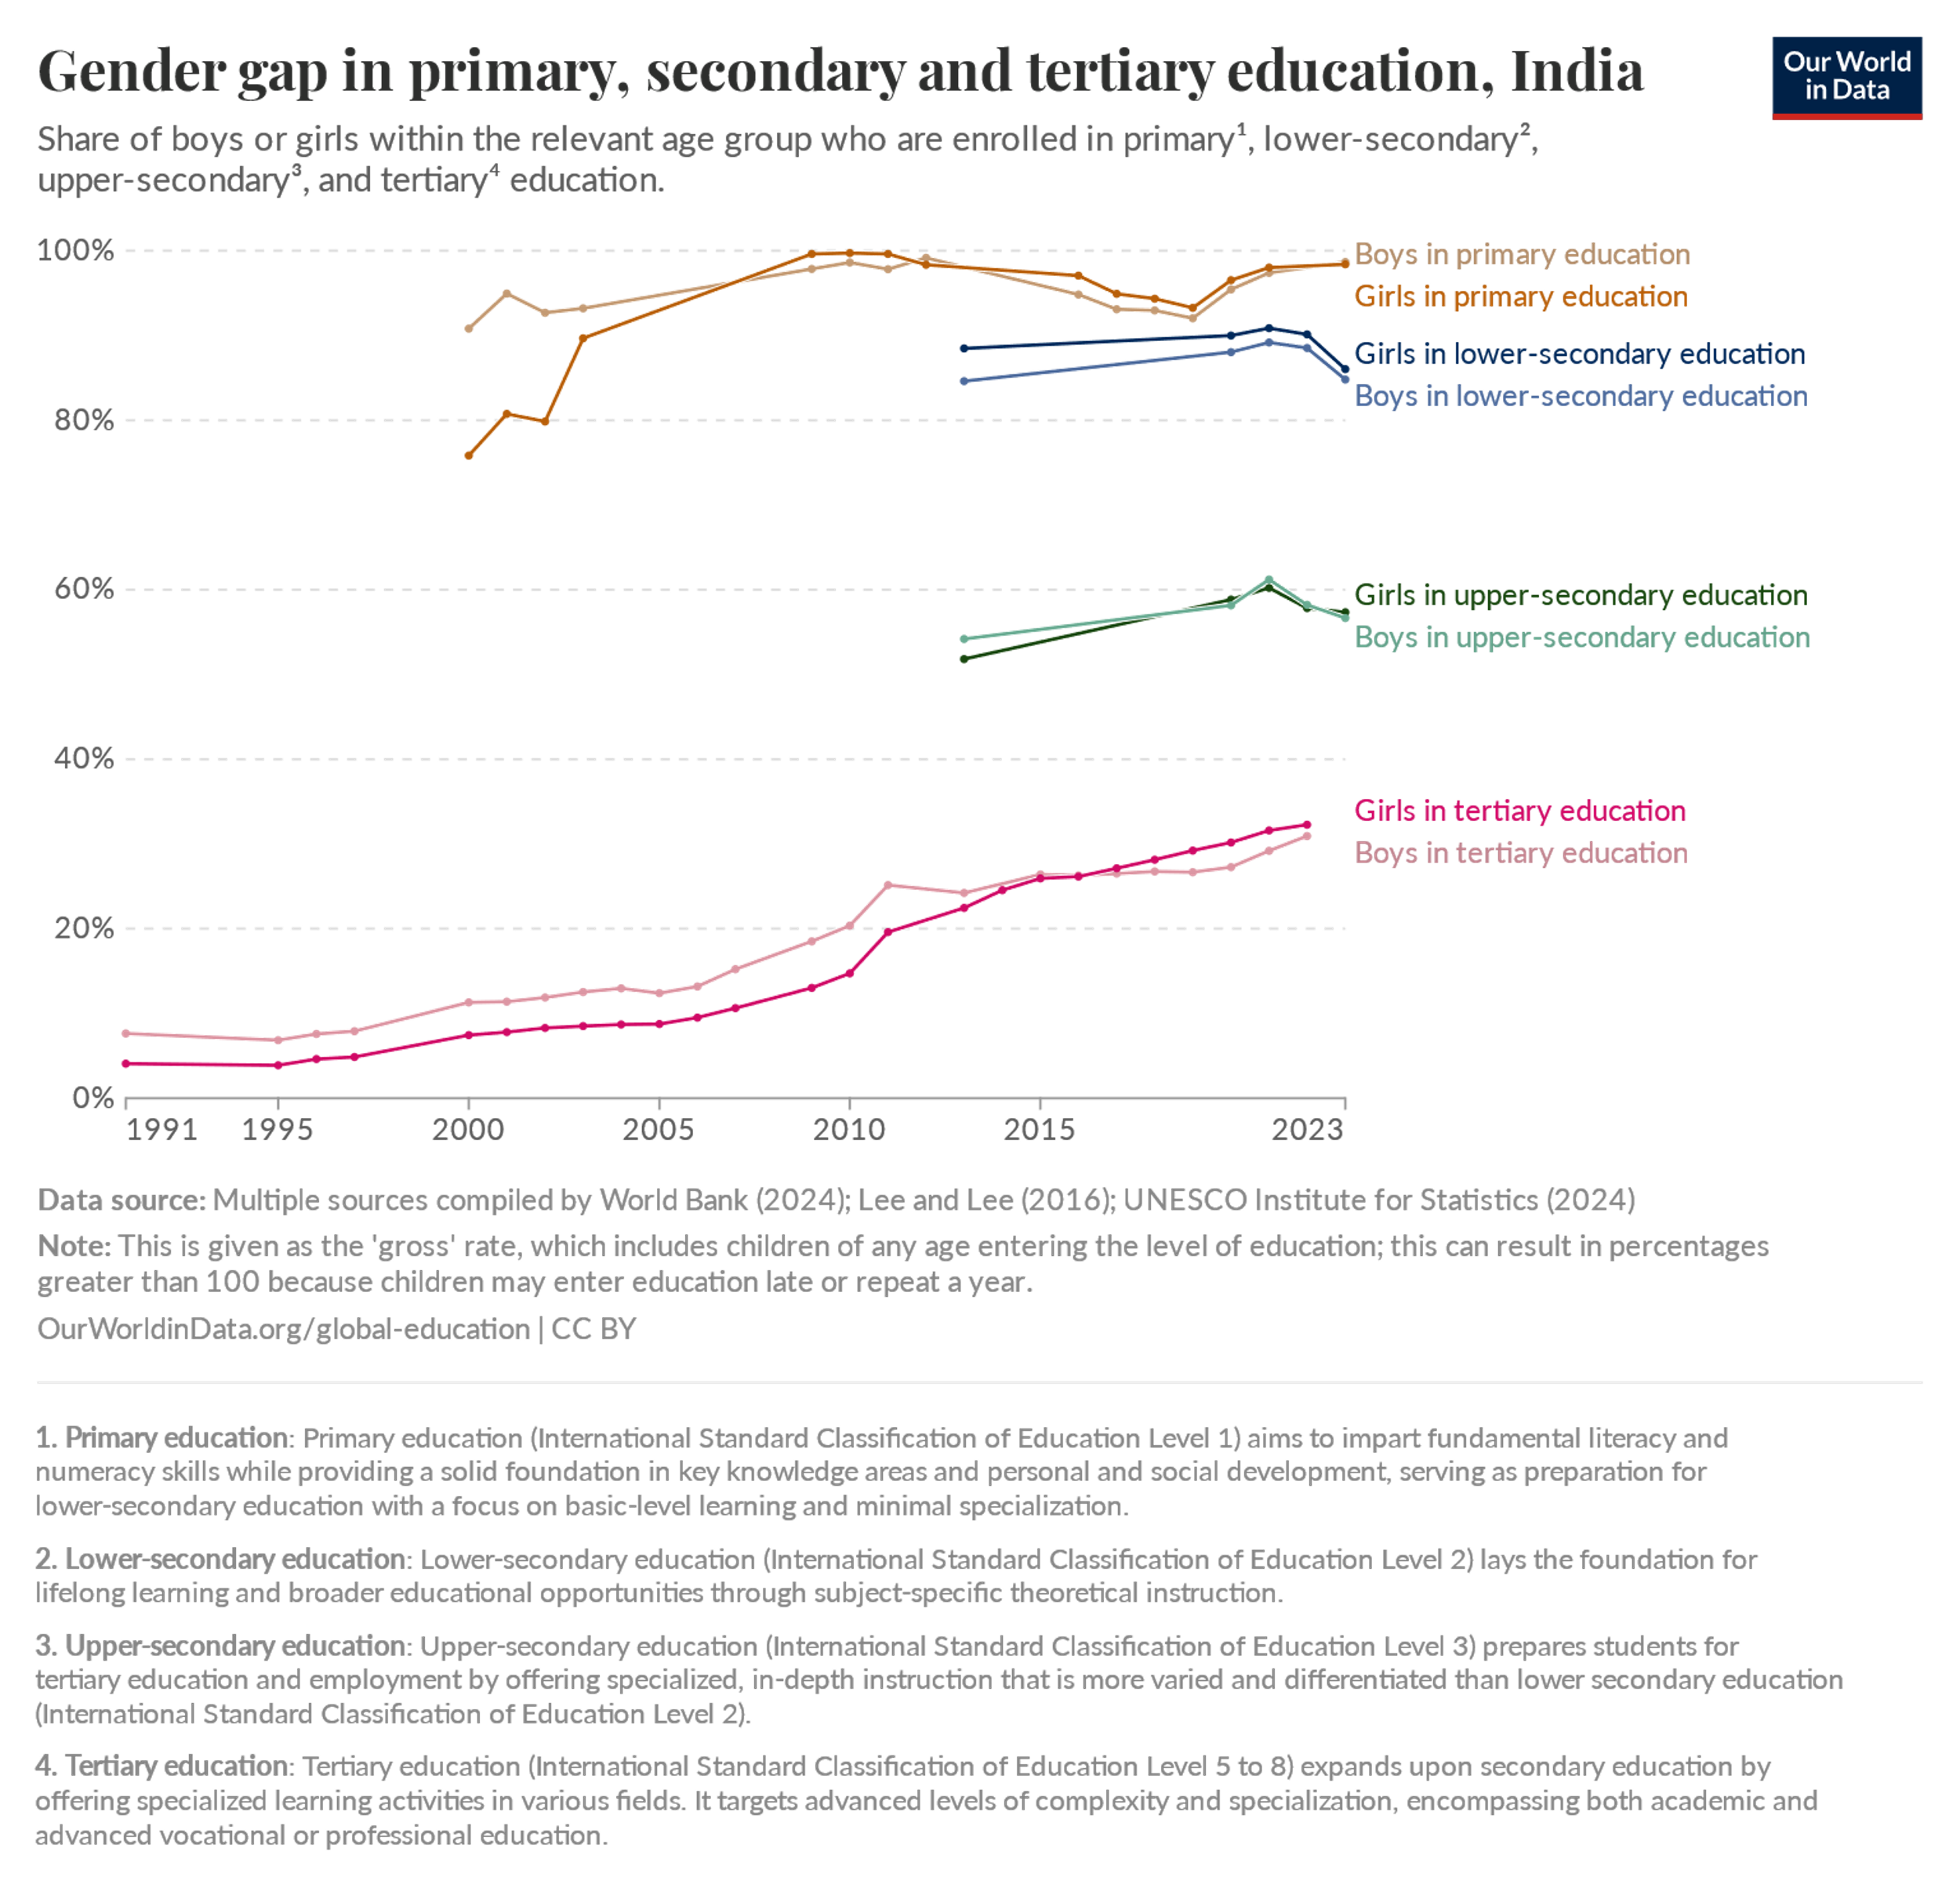
Source: UNESCO Institute for Statistics (2024) – processed by Our World in Data. “Boys in lower-secondary education” [dataset]. UNESCO Institute for Statistics, “UNESCO Institute for Statistics (UIS) - Enrolment Rates (OPRI)” [original data]. https://ourworldindata.org/grapher/gender-gap-education-levels?time=1991..latest&country=~IND
Similarly, the privatisation of education has exacerbated gender disparities in access to schooling. While the enrolment of girls in primary education has improved, the quality of education in public schools has declined due to underfunding and neglect (Tilak & Choudhury, 2021). Private schools, which offer better facilities and teaching quality, are often unaffordable for low-income families, particularly those with multiple children. This has led to a situation where girls from marginalised communities are more likely to drop out of school or receive a substandard education (Nambissan, 2016).
Privatisation and Its Disproportionate Impact on Women
The privatisation of essential services like water, electricity, and transportation has also had a disproportionate impact on women, who are often responsible for managing household resources. For instance, the privatisation of water supply has led to increased costs and reduced access, forcing women to travel long distances to fetch water or rely on unsafe sources (Bakker, 2007). Similarly, the privatisation of electricity has led to frequent power cuts and rising costs, which disproportionately affect women who rely on electricity for cooking, cleaning, and childcare (Sen & Govender, 2015).
Changes in Land and Property Rights
Neoliberal policies have also reinforced gender disparities in land and property rights. Despite legal reforms aimed at promoting gender equality in land ownership, women in India continue to face significant barriers to accessing and controlling land (Agarwal, 2003). The commodification of land under neoliberalism has led to the displacement of rural communities, particularly women, who are often excluded from decision-making processes and compensation schemes (Rao, 2017)
Fig 6: Land ownership, men vs. women , 2022, India

Source: World Bank - Women, Business and the Law (2024) OurWorldinData.org/economic-inequality-by-gender
Intersectional Inequalities
Caste, Class, and Gender: Compounding Vulnerabilities
The gendered impacts of neoliberal policies are further compounded by intersectional inequalities based on caste, class, and religion. Dalit women, for instance, face multiple forms of discrimination and marginalisation, which limit their access to education, employment, and healthcare (Rathnam, 2024). Similarly, Muslim women, who are often excluded from formal employment and social welfare schemes, face significant barriers to economic and social mobility (Hasan & Menon, 2004).
Religious Minorities and Marginalised Genders
The neoliberal emphasis on individualism and self-reliance has also marginalised religious minorities and LGBTQ+ communities, who often lack access to social protection and support systems (Narrain, 2018). For instance, transgender individuals in India face significant barriers to employment, healthcare, and housing, which are exacerbated by the lack of legal recognition and social acceptance.
Regional Disparities in the Impact of Reforms
The gendered impacts of neoliberal policies also vary significantly across regions. In states like Kerala and Tamil Nadu, where social welfare programs and public services are relatively robust, women have better access to education, healthcare, and employment (Heller, 2012). In contrast, states like Uttar Pradesh and Bihar, which have weak social infrastructure and high levels of poverty, have seen a decline in female labour force participation and access to essential services (Desai & Joshi, 2019).
Feminist Movements in India: Evolution and Responses
Feminist activism in India has a rich and diverse history, deeply rooted in the country’s struggle for independence and social reform. The pre-1991 era was marked by movements that focused on legal reforms, anti-dowry campaigns, and women’s rights. For instance, the 1970s and 1980s saw the rise of feminist groups like the Progressive Organisation of Women (POW) and the Forum Against Oppression of Women, which challenged patriarchal norms and advocated for gender equality (Kumar, 1993). These movements were instrumental in bringing issues such as domestic violence, dowry deaths, and workplace discrimination to the forefront of public discourse.
The post-1991 period, however, witnessed a significant shift in the focus and strategies of feminist activism. The introduction of neoliberal economic reforms brought about new challenges, such as the feminisation of informal labour, the erosion of public services, and the exacerbation of intersectional inequalities. Feminist movements in India responded to these challenges by adopting more intersectional approaches, addressing not only gender but also caste, class, religion, and regional disparities (John, 2013). This period also saw the emergence of new forms of activism, including digital campaigns and grassroots mobilisation, which enabled feminists to reach a wider audience and build solidarity across diverse communities.
Case Studies of Feminist Organisations and Campaigns
Self-Employed Women’s Association (SEWA): A Paradigm of Feminist Economic Resistance
The Self-Employed Women’s Association (SEWA), founded in 1972 by Ela Bhatt, stands as one of the most significant examples of feminist activism in India. SEWA is a trade union that organizes women working in the informal sector, including domestic workers, street vendors, agricultural labourers, and home-based workers. With a membership of over 2.5 million women as of 2023 (SEWA, 2023), the organization has become a powerful force in advocating for the rights and empowerment of some of the most marginalized workers in India. SEWA’s primary mission is to address the systemic inequalities faced by women in the informal economy by ensuring access to fair wages, social security, legal protections, and financial inclusion (Bhatt, 2006). Its work is particularly relevant in the context of neoliberal economic policies, which have exacerbated the precarity of low-wage, informal labour, disproportionately affecting women. Under neoliberalism, the informal sector in India has expanded significantly, with women constituting a substantial portion of this workforce. According to the International Labour Organization (ILO, 2018), approximately 81% of employed women in India work in the informal sector, often without job security, social protection, or fair wages. Neoliberal policies, such as deregulation, privatization, and austerity measures, have further eroded labour rights and deepened gender inequalities. SEWA’s efforts to organize informal women workers directly challenge these neoliberal trends by advocating for the recognition and formalization of informal labour. For instance, SEWA has successfully unionized over 1.5 million informal workers, enabling them to collectively bargain for better wages and working conditions (Chen, 2014). This organizing model not only empowers women economically but also disrupts the commodification of labour under neoliberalism.
SEWA’s impact extends beyond grassroots organising to influencing policy at both national and international levels. The organisation has been instrumental in promoting gender-responsive budgeting, a framework that ensures government budgets address the specific needs of women. For example, SEWA’s advocacy contributed to the inclusion of informal workers in India’s National Rural Employment Guarantee Act (NREGA), which guarantees 100 days of wage employment annually to rural households (SEWA, 2023). Additionally, SEWA has played a pivotal role in shaping international labour standards. In collaboration with the ILO, SEWA successfully advocated for the adoption of the Home Work Convention (C177) in 1996, which recognizes the rights of home-based workers, a predominantly female workforce (Chen, 2014). These policy interventions highlight SEWA’s ability to bridge grassroots activism with macro-level policy change. Furthermore, SEWA’s microfinance initiatives have provided over 1.2 million women with access to credit, enabling them to start or expand small businesses (SEWA, 2023). These economic gains have had a ripple effect, improved household well-being and reduced gender disparities in access to resources. For instance, SEWA’s health insurance program, VimoSEWA, has covered over 500,000 women, significantly improving their access to healthcare (Desai & Joshi, 2013).
Despite its successes, SEWA’s work also highlights the challenges of organizing in a neoliberal context. The informal sector remains highly fragmented, and many women workers continue to face exploitation and exclusion. However, SEWA’s model of combining economic empowerment with social mobilization offers a powerful alternative to neoliberal paradigms. By centring the voices of informal women workers, SEWA not only challenges the structural inequalities perpetuated by neoliberalism but also redefines feminist activism to include the most marginalized women. Its achievements demonstrate the potential of grassroots movements to create meaningful change, even in the face of entrenched systemic barriers.
#MeToo India
The #MeToo movement, which gained global traction in 2017, sparked an important conversation about workplace harassment and gendered violence in India. The movement created a platform for women to share their experiences, hold perpetrators accountable, and challenge entrenched patriarchal norms in professional spaces (Menon, 2018). In India, #MeToo gained significant momentum in sectors such as media, entertainment, and academia, leading to the exposure of high-profile individuals accused of sexual misconduct (Gangoli, 2023). However, while the movement made strides in bringing gender-based harassment to the forefront, its reach and impact remained largely confined to urban, upper-caste, and privileged women, raising critical concerns about inclusivity and intersectionality (Wilson et al., 2018)).
A key critique of the #MeToo movement in India is its failure to adequately address the experiences of Dalit women, informal sector workers, and those from marginalized communities. Dalit feminists and scholars have pointed out that the movement predominantly amplified the voices of elite, urban women while neglecting the structural violence and workplace exploitation that lower-caste and rural women endure (Rege, 2006). Women engaged in domestic work, agricultural labour, and factory employment often face systemic harassment, wage theft, and economic precarity, yet their struggles were largely absent from mainstream #MeToo narratives (Gopal, 2021). This exclusion reflects broader caste and class hierarchies within Indian feminism, where issues affecting marginalized women are often sidelined in favour of those concerning privileged groups (Kannabiran & Swaminathan, 2006). Additionally, the digital nature of the movement created accessibility barriers for women in informal and rural employment, where internet penetration and literacy rates are significantly lower than in urban areas (Bhatia, 2021). Unlike structured labour movements such as the Self-Employed Women’s Association (SEWA), which have successfully mobilized informal workers for decades, #MeToo did not effectively engage with grassroots organizations or integrate the concerns of labouring women (Chen, 2014). Consequently, while the movement led to policy discussions and legal scrutiny in professional and corporate environments, it had minimal impact on informal sector workplaces where gender-based violence remains rampant (Sen, 2023).
Despite these limitations, #MeToo India played a crucial role in challenging workplace impunity and initiating discussions on consent and power dynamics. However, its effectiveness as a transformative feminist movement remains contingent on its ability to expand beyond elite spaces and incorporate an intersectional lens that prioritizes the voices of marginalized women. Future feminist mobilization against gender-based violence must center the lived experiences of Dalit, Adivasi, and informal sector women to create a truly inclusive movement for justice (Narrain, 2018).
Other Notable Movements
Other feminist movements in India have focused on issues such as land rights, education, and healthcare. For example, the Right to Food Campaign, launched in 2001, has advocated for food security and the expansion of social safety nets, particularly for women and marginalised communities. The campaign has played a crucial role in challenging the neoliberal agenda of reducing public spending and privatising essential services (Drese & Sen, 2013). Similarly, feminist groups like the All-India Democratic Women’s Association (AIDWA) and the National Federation of Indian Women (NFIW) have campaigned for land rights and property ownership for women, particularly in rural areas. These movements have highlighted the intersection of gender, class, and caste in shaping access to resources and opportunities (Agarwal, 1994).
Strategies for Advocacy and Resistance
Legal and Policy Interventions
Feminist movements in India have increasingly turned to legal and policy interventions to challenge neoliberal policies and advocate for gender justice. For example, the passage of the Protection of Women from Domestic Violence Act (2005) and the Sexual Harassment of Women at Workplace (Prevention, Prohibition, and Redressal) Act (2013) were significant achievements of feminist activism (Agnes, 2011). These legal victories, however, have not always translated into effective implementation. Feminist organisations have continued to push for stronger enforcement mechanisms and greater accountability, particularly in cases involving marginalised women.
Grassroots Mobilisation
Grassroots mobilisation has been a key strategy for feminist movements in India, enabling them to build solidarity among women workers and marginalised communities. For example, SEWA’s success in organising informal women workers has been largely due to its grassroots approach, which involves working closely with local communities and addressing their specific needs (Bhatt, 2006). Similarly, feminist groups like the Gulabi Gang, a women’s vigilante group in Uttar Pradesh, have used grassroots mobilisation to challenge gender-based violence and advocate for women’s rights. The group’s use of direct action and community organising has made it a powerful force for change in rural India ((Richards, 2016).
Digital Activism
The rise of digital activism has provided feminist movements in India with new tools for advocacy and resistance. Social media platforms like Twitter, Facebook, and Instagram have been used to raise awareness about gender inequality, mobilise support for campaigns, and hold perpetrators of violence accountable. For example, the #MeToo movement in India relied heavily on social media to amplify women’s voices and challenge patriarchal norms. Digital activism has also enabled feminist groups to reach a wider audience and build transnational solidarity, as seen in campaigns like #PinjraTod (Break the Cage), which advocates for the rights of women students (Bhatia, 2021).
Challenges and Limitations of Feminist Movements
Feminist movements in India have made significant strides in addressing gender inequality and advocating for women’s rights. However, they continue to face numerous challenges and limitations that hinder their effectiveness in achieving gender justice. This section examines the key challenges faced by feminist movements in India, including fragmentation within the movement, co-optation by neoliberal agendas, resistance from conservative forces, and the difficulties of balancing intersectionality with unified advocacy.
Fragmentation within Feminist Activism
One of the most significant challenges faced by feminist movements in India is the fragmentation of activism along ideological, caste, class, and regional lines. While the diversity of perspectives within the movement can be a strength, it has also led to divisions and conflicts that weaken collective action. -For example, feminist groups in India often differ in their priorities and strategies. Urban, upper-caste feminists may focus on issues like workplace harassment and legal reforms, while rural, Dalit feminists may prioritise land rights, access to education, and caste-based discrimination (Rege, 2006). These differences can create tensions and hinder collaboration, particularly when resources and visibility are unevenly distributed.
Moreover, the rise of identity politics has further fragmented feminist activism. Movements led by Dalit women, Muslim women, and LGBTQ+ communities have highlighted the limitations of mainstream feminism in addressing intersectional inequalities. While these movements have enriched feminist discourse by bringing marginalised voices to the forefront, they have also exposed the challenges of building a cohesive and inclusive feminist movement (Menon, 2015).
Co-optation by Neoliberal Agendas
Another major challenge for feminist movements in India is the co-optation of their agendas by neoliberal forces. The rise of corporate social responsibility (CSR) initiatives and the NGO-isation of feminist activism have led to the dilution of radical feminist demands and the depoliticisation of gender justice struggles. For instance, many feminist organisations in India rely on funding from international donors and corporate entities, which often impose conditions that align with neoliberal priorities. This reliance on external funding can limit the autonomy of feminist groups and force them to focus on projects that are palatable to donors rather than addressing systemic issues (Mitra, 2011). Additionally, the emphasis on individual empowerment and entrepreneurship in neoliberal discourse has shifted the focus of feminist activism away from collective struggles for structural change. Programs that promote microfinance and self-help groups, for example, often frame women’s empowerment in terms of economic participation rather than challenging patriarchal norms and power structures (Kalpana, 2017).
Resistance from Conservative Forces
Feminist movements in India also face significant resistance from conservative forces, including patriarchal institutions, religious groups, and political parties. These forces often view feminism as a threat to traditional values and social hierarchies, leading to backlash against feminist demands. For example, campaigns for gender equality and women’s rights are frequently met with accusations of being “anti-family” or “anti-culture.” Conservative groups have mobilised against feminist initiatives such as the introduction of comprehensive sex education in schools, the criminalisation of triple talaq, and the expansion of reproductive rights (John, 2013). The rise of right-wing nationalism in India has further exacerbated this resistance. The Hindu nationalist ideology promoted by the ruling Bharatiya Janata Party (BJP) often conflates feminism with Westernisation and portrays it as a threat to Indian culture. This narrative has been used to justify attacks on feminist activists and organisations, particularly those advocating for the rights of religious minorities and marginalised communities (Basu, 2015).
Balancing Intersectionality with Unified Advocacy
While intersectionality has become a central tenet of feminist activism in India, it also presents challenges in terms of balancing diverse perspectives with unified advocacy. Intersectionality recognises that gender inequality is shaped by multiple axes of oppression, including caste, class, religion, and sexuality. However, addressing these intersecting inequalities can complicate efforts to build a cohesive feminist movement. For instance, Dalit feminists have criticised mainstream feminist movements for failing to adequately address caste-based discrimination and violence. Similarly, Muslim feminists have highlighted the marginalisation of their concerns within feminist discourse, particularly in the context of rising Islamophobia and communal violence (Kannabiran & Swaminathan, 2006). These tensions underscore the difficulty of creating a feminist movement that is both inclusive and effective. While intersectionality enriches feminist analysis and advocacy, it also requires feminist groups to navigate complex power dynamics and prioritise the needs of the most marginalised. This can be a daunting task, particularly in a context where resources and political support are limited.
The Role of Digital Activism and Its Limitations
The rise of digital activism has provided feminist movements in India with new tools for advocacy and mobilisation. Social media platforms like Twitter, Facebook, and Instagram have been used to raise awareness about gender inequality, amplify marginalised voices, and hold perpetrators of violence accountable. However, digital activism also has its limitations. The digital divide in India means that access to online platforms is often restricted to urban, educated, and privileged groups. This can exclude rural, low-income, and marginalised women from participating in digital feminist campaigns (Bhatia, 2021). Moreover, online spaces are not immune to the same hierarchies and power dynamics that exist offline. Women who speak out on social media often face harassment, trolling, and threats of violence, which can deter them from participating in digital activism. The anonymity of online platforms also makes it difficult to hold perpetrators accountable and ensure the safety of feminist activists (Phadke, 2018).
The Way Forward: Building Inclusive and Resilient Feminist Movements
Despite these challenges, feminist movements in India have demonstrated remarkable resilience and adaptability. By addressing the limitations of their strategies and building on their strengths, they can continue to play a crucial role in advancing gender justice in a neoliberal era. One key priority is to foster greater solidarity and collaboration among diverse feminist groups. This requires creating spaces for dialogue and mutual learning, as well as addressing power imbalances within the movement. Feminist organisations must also prioritise the needs of the most marginalised women and ensure that their voices are central to advocacy efforts. Another important strategy is to resist the co-optation of feminist agendas by neoliberal forces. This can be achieved by diversifying funding sources, strengthening grassroots mobilisation, and maintaining a focus on structural change rather than individual empowerment. Finally, feminist movements must continue to challenge conservative forces and push back against the backlash against gender equality. This requires building alliances with other social justice movements, leveraging legal and policy interventions, and using digital tools strategically to amplify their message.
Policy Recommendations for Gender-Sensitive Economic Frameworks
The gendered impacts of neoliberal policies in India underscore the urgent need for economic frameworks that prioritise gender justice. While feminist movements have played a crucial role in highlighting these issues, systemic change requires robust policy interventions. This section outlines actionable recommendations to address the structural inequalities neoliberalism exacerbated and create a more equitable economic system.The neoliberal economic reforms in India have had profound gendered impacts, exacerbating inequalities and marginalising women and other vulnerable groups. However, feminist movements have demonstrated remarkable resilience and adaptability in responding to these challenges. The policy recommendations outlined in this section provide a roadmap for creating a more gender-sensitive economic framework. By strengthening social safety nets, promoting gender-responsive budgeting, enhancing labour rights, addressing intersectional inequalities, and leveraging global solidarity, India can move towards a more equitable and just society. The path forward requires sustained commitment from policymakers, civil society, and the international community to ensure that economic growth does not come at the cost of gender justice.
Strengthening Social Safety Nets
One of the most significant consequences of neoliberal reforms has been the erosion of public services, disproportionately affecting women and marginalised groups. To counteract this, the government must prioritise the expansion and strengthening of social safety nets.
Healthcare and Education: Increased public investment in healthcare and education is essential to ensure universal access. Policies should focus on reducing out-of-pocket expenses for women, who often bear the brunt of caregiving responsibilities. For instance, expanding schemes like the National Health Mission (NHM) and integrating gender-sensitive components can improve maternal and child health outcomes. Similarly, initiatives like the Right to Education Act must be enforced rigorously to ensure girls’ access to quality education.
Public Distribution Systems (PDS): Revitalising the PDS to ensure food security for low-income households is critical. Women, who often manage household nutrition, benefit directly from such schemes. Introducing gender-sensitive measures, such as prioritising women as ration card holders, can enhance the effectiveness of these programs.
Promoting Gender-Responsive Budgeting
Gender-responsive budgeting (GRB) is a powerful tool to address systemic inequalities by ensuring that public resources are allocated equitably.
Institutionalising GRB: The government should institutionalise GRB across all ministries and departments. This involves conducting gender audits of existing policies and budgets to identify gaps and reallocating resources to address them. For example, increasing funding for women-centric schemes like the Beti Bachao Beti Padhao campaign can help bridge gender disparities in education and health.
Capacity Building: Training policymakers and bureaucrats in gender analysis and budgeting techniques is crucial for the successful implementation of GRB. This will ensure that gender considerations are integrated into all stages of policy formulation and implementation.
Enhancing Labour Rights and Protections
The feminisation of informal work under neoliberalism has left millions of women in precarious, low-wage jobs with little to no social protection. Addressing this requires comprehensive labour reforms.
Formalising Informal Work: Policies must focus on formalising informal work by extending labour protections, such as minimum wages, social security, and safe working conditions, to sectors dominated by women, such as domestic work, construction, and agriculture. The Code on Social Security, 2020, is a step in the right direction but needs stricter enforcement and broader coverage.
Equal Pay and Opportunities: Enforcing equal pay for equal work and addressing occupational segregation are critical to reducing wage gaps. Initiatives like the Mahatma Gandhi National Rural Employment Guarantee Act (MGNREGA) should be expanded to ensure equal participation and wages for women.
Addressing Intersectional Inequalities
Neoliberal policies have exacerbated existing hierarchies based on caste, class, religion, and region. A one-sise-fits-all approach to gender justice is insufficient; policies must address intersectional inequalities.
Caste and Gender: Dalit women face dual discrimination based on caste and gender. Policies must address their specific needs, such as access to land, education, and employment. For instance, expanding reservations for women in local governance (Panchayati Raj institutions) can empower Dalit women politically and economically.
Religious Minorities and LGBTQ+ Communities: Muslim women and LGBTQ+ individuals face unique challenges that require targeted interventions. For example, providing skill development programs for Muslim women in urban slums can enhance their economic opportunities. Similarly, legal recognition and protection for transgender individuals under the Transgender Persons (Protection of Rights) Act, 2019, must be enforced effectively.
Regional Disparities: Policies should address the uneven development across states by prioritising investments in underdeveloped regions. For instance, increasing funding for infrastructure and social services in states with low human development indices can reduce regional disparities.
Role of International Organisations and Global Solidarity
Global networks and international organisations play a crucial role in supporting local feminist movements and advocating for gender-sensitive policies.
Leveraging Global Platforms: Indian feminist organisations can collaborate with international bodies like UN Women and the International Labour Organisation (ILO) to advocate for gender justice. For example, the ILO’s Decent Work Agenda can be used to push for better labour protections for women in India.
Global Solidarity: Building alliances with feminist movements in other countries can amplify the voices of Indian women and create a collective front against neoliberal policies. Campaigns like the Global March for Women highlight the interconnectedness of gender justice struggles worldwide.
Monitoring and Evaluation
To ensure the effectiveness of these policy recommendations, robust monitoring and evaluation mechanisms are essential.
Data Collection and Analysis: Gender-disaggregated data must be collected and analysed regularly to assess the impact of policies. This will help identify gaps and inform evidence-based policymaking.
Accountability Mechanisms: Establishing accountability mechanisms, such as independent gender audits and citisen-led monitoring committees, can ensure that policies are implemented effectively and transparently.
Conclusion
The exploration of neoliberal economic reforms in India and their gendered impacts reveals a complex interplay between market-driven policies and gender justice. Since the 1991 liberalisation, privatisation, and globalisation (LPG) reforms, India has witnessed significant economic growth, but this progress has been uneven and deeply gendered. Women, particularly those from marginalised communities, have borne the brunt of these policies, facing increased precarity in the labour market, reduced access to public services, and heightened intersectional inequalities. Feminist movements in India have responded to these challenges with resilience and innovation, advocating for systemic change and pushing back against the neoliberal agenda. This article has examined these dynamics, offering a comprehensive analysis of the gendered impacts of neoliberalism and the strategies employed by feminist movements to counter them.
The study highlights several critical findings. First, neoliberal policies have led to the feminization of informal work, with women disproportionately represented in low-wage, precarious jobs in sectors like domestic work, agriculture, and construction (Kiran & R. Santhosh, 2024). This has exacerbated wage gaps and occupational segregation, limiting women’s economic mobility. Second, the erosion of public services, particularly in healthcare and education, has disproportionately affected women, who often rely on these services for their families and themselves (Michael et al., 2019). Third, intersectional inequalities based on caste, class, religion, and region have been further entrenched, with Dalit women, Muslim women, and LGBTQ+ communities facing compounded marginalisation (Sen, 2023).
Feminist movements in India have adapted to these challenges by adopting intersectional approaches and leveraging diverse strategies, from grassroots mobilisation to digital activism. Organisations like the Self-Employed Women’s Association (SEWA) have championed the rights of informal women workers, while campaigns like #MeToo India have challenged workplace harassment and patriarchal norms (Desai & Joshi, 2019). These movements have not only highlighted the gendered impacts of neoliberalism but also demonstrated the potential for collective action to drive change. The resilience of feminist movements in India is a testament to their ability to adapt to changing socio-economic contexts. Despite facing challenges such as fragmentation, co-optation by neoliberal agendas, and resistance from conservative forces, these movements have continued to advocate for gender justice. For instance, the Right to Food Campaign successfully pressured the government to address food insecurity, benefiting millions of women and their families (Rao et al., 2017). Similarly, digital activism has emerged as a powerful tool for mobilising support and raising awareness, as seen in the #MeToo movement. However, the limitations of these movements cannot be overlooked. Fragmentation along ideological, caste, and class lines has sometimes hindered unified advocacy, while the NGO-isation of feminist activism has risked diluting its radical potential (Mitra, 2011). Addressing these challenges requires a renewed commitment to intersectionality and solidarity, ensuring that feminist movements remain inclusive and representative of all marginalised voices.
The Path Forward
Achieving gender justice in a neoliberal era demands sustained and systemic change. The policy recommendations outlined in this article—strengthening social safety nets, promoting gender-responsive budgeting, enhancing labour rights, addressing intersectional inequalities, and leveraging global solidarity—provide a roadmap for creating a more equitable economic framework. These measures must be underpinned by robust monitoring and evaluation mechanisms to ensure their effectiveness and accountability.
Moreover, the role of feminist movements in driving this change cannot be overstated. Their ability to adapt, innovate, and mobilise offers hope for a more just and inclusive future. As Sen and Ghosh (2020) argue, “The struggle for gender justice is not just about challenging patriarchy but also about reimagining economic systems that prioritise equity and sustainability”. This reimagining requires collective action, both within India and globally, to challenge the structural inequalities perpetuated by neoliberalism. the gendered impacts of neoliberal policies in India underscore the urgent need for gender-sensitive economic frameworks. While feminist movements have made significant strides in advocating for change, systemic transformation requires the active involvement of policymakers, civil society, and the international community. Further studies should also examine the long-term impact of digital activism on policy changes and labour rights, particularly in informal sectors. By centring the voices of the most marginalized and challenging the hegemony of elite feminist discourse, a more equitable and transformative feminist movement can emerge in India, ensuring that neoliberalism’s impact on gender justice is met with sustained and effective resistance.By prioritising gender justice in economic policies and supporting feminist activism, India can move towards a more equitable and inclusive society. The path forward is challenging, but the resilience and adaptability of feminist movements offer a beacon of hope for a better future.

Disclaimer (Artificial intelligence)
Option 1:
Author(s) hereby declare that NO generative AI technologies such as Large Language Models (ChatGPT, COPILOT, etc.) and text-to-image generators have been used during the writing or editing of this manuscript.
Option 2:
Author(s) hereby declare that generative AI technologies such as Large Language Models, etc. have been used during the writing or editing of manuscripts. This explanation will include the name, version, model, and source of the generative AI technology and as well as all input prompts provided to the generative AI technology
Details of the AI usage are given below:
1.
2.
3.
References:
Agarwal, B. (1994). A field of one’s own: Gender and land rights in South Asia. Cambridge University Press.
Agarwal, B. (2003). Gender and land rights revisited: Exploring new prospects via the state, family, and market. Journal of Agrarian Change, 3(1-2), 184-224. https://doi.org/10.1111/1471-0366.00054
Agnes, F. (2011). Law and gender inequality: The politics of women’s rights in India. Oxford University Press.
Ahluwalia, M. S. (2002). Economic reforms in India since 1991: Has gradualism worked? Journal of Economic Perspectives, 16(3), 67-88. https://doi.org/10.1257/089533002760278721
Bakker, I. (2007). Social reproduction and the constitution of a gendered political economy. New Political Economy, 12(4), 541-556. https://doi.org/10.1080/13563460701661561
Bakker, I. (2007). Social reproduction and the constitution of a gendered political economy. New Political Economy, 12(4), 541–556. https://doi.org/10.1080/13563460701661561
Basu, A. (2015). Violent conjunctures in democratic India. Cambridge University Press.
Benería, L. (2003). Gender, development, and globalisation: Economics as if all people mattered. Routledge.
Bhatia, K. V. (2021). The revolution will wear burqas: feminist body politics and online activism in India. Social Movement Studies, 1–17. https://doi.org/10.1080/14742837.2021.1944850
Bhatt, E. (2006). We are poor but so many: The story of self-employed women in India. Oxford University Press.
Chakravarty, S. (2019). Development planning: The Indian experience. Oxford University Press.
Chen, M. A. (2014). Informal economy monitoring study: Sector report—Home-based workers. Women in Informal Employment: Globalising and Organising (WIEGO).
Chen, M. A. (2014). Informal economy monitoring study: Sector report—Home-based workers. Women in Informal Employment: Globalizing and Organizing (WIEGO).
Desai, S., & Joshi, O. (2019). The paradox of declining female labor force participation in India. Indian Journal of Labour Economics, 62(1), 55-71. https://doi.org/10.1007/s41027-019-00162-s
Drese, J., & Sen, A. (2013). An uncertain glory: India and its contradictions. Princeton University Press.
Dutta Gupta, S., Raychaudhuri, A., & Haldar, S. Kr. (2015). Information technology sector in India and gender inclusivity. Gender in Management: An International Journal, 30(2), 94–108. https://doi.org/10.1108/gm-04-2013-0046
Eisenstein, H. (2015). Feminism seduced: How global elites use women’s labor and ideas to exploit the world. Routledge.
Elson, D. (1999). Labor markets as gendered institutions: Equality, efficiency, and empowerment issues. World Development, 27(3), 611–627. https://doi.org/10.1016/S0305-750X(98)00147-8
Fraser, N. (2013). Fortunes of feminism: From state-managed capitalism to neoliberal crisis. Verso Books.
Gangoli, G (2023). The #metoo Movement in India: Emotions and (in)justice in feminist responses. Feminist Legal Studies, 32(2), 213–230. https://doi.org/10.1007/s10691-023-09540-x
Gopal, P. (2021). Insurgent empire: Anticolonial resistance and British dissent. Verso Books.
Harvey, D. (2005). A brief history of neoliberalism. Oxford University Press.
Hasan, S., & Menon, R. (2004). Unequal citisens: A study of Muslim women in India. Oxford University Press.
Heller, P. (2012). Democracy, participatory politics, and development: Some comparative lessons from Brasil, India, and South Africa. Polity, 44(4), 643-665. https://doi.org/10.1057/pol.2012.19
Hooda, S. K. (2020). Health System in Transition in India: Journey from State Provisioning to Privatization. World Review of Political Economy, 11(4), 506–532. https://doi.org/10.13169/worlrevipoliecon.11.4.0506
International Labour Organisation (ILO). (2018). Women and men in the informal economy: A statistical picture(3rd ed.). ILO.
John, M. E. (2013). Women’s studies in India: A reader. Penguin Books.
Kalpana, K. (2017). Women, microfinance, and the state in neo-liberal India. Feminist Economics, 23(4), 1–26. https://doi.org/10.4324/9781315543321
Kannabiran, K., & Swaminathan, P. (2006). Gender, caste, and the imagination of equality. Women Unlimited. .
Kiran, N., & R. Santhosh. (2024). Caste, Neoliberalism and Entrepreneurship in India: A Sociological Mapping. Sociological Bulletin. https://doi.org/10.1177/00380229241306088 .
Kumar, R. (1993). The history of doing: An illustrated account of movements for women’s rights and feminism in India, 1800–1990. Subaan.
Masumdar, I. (2007). Women workers and globalisation: Emergent contradictions in India. Stree.
Mehrotra, S., & Parida, J. (2017). India’s employment crisis: Rising education levels and falling non-agricultural job growth. Centre for Sustainable Employment, Asim Premji University.
Mehrotra, S., & Parida, J. K. (2017). India’s employment challenge: Creating jobs, helping workers. Oxford University Press.
Menon, N. (2018). Seeing like a feminist. Penguin Books.
Menon, N. (2018). Seeing like a feminist. Penguin Books.
Michael, K., Shrivastava, M. K., Hakhu, A., & Bajaj, K. (2019). A two-step approach to integrating gender justice into mitigation policy: examples from India. Climate Policy, 20(7), 800–814. https://doi.org/10.1080/14693062.2019.1676688
Mitra, A. (2011). Feminist organizing in India: A study of women in NGOs. Women’s Studies International Forum, 34(1), 66–75. https://doi.org/10.1016/j.wsif.2010.10.003
Nambissan, G. B. (2016). Low-Cost Private Schools for the Poor in India Some Reflections. Taylor & Francis, 84–93. https://doi.org/10.4324/9781315538914-10
Narrain, A. (2018). Vacillating between empathy and contempt: The Indian judiciary and LGBT rights. In N. Nicol et al. (Eds.), Envisioning global LGBT human rights: (Neo)colonialism, neoliberalism, resistance and hope (pp. 43–62). Human Rights Consortium, Institute of Commonwealth Studies.
Narrain.A (2018) ‘Vacillating between empathy and contempt: the Indian judiciary and LGBT rights’, in N. Nicol et al. (eds.) Envisioning Global LGBT Human Rights: (Neo)colonialism, Neoliberalism, Resistance and Hope (London: Human Rights Consortium, Institute of Commonwealth Studies), pp. 43–62.
Nayar, B. R. (2001). Globalisation and nationalism: The changing balance in India’s economic policy, 1950-2000. Sage Publications.
Neetha, N. (2014). Crisis in female employment: Analysis across social groups. Economic and Political Weekly, 49(47), 50-59.
Panagariya, A. (2008). India: The emerging giant. Oxford University Press.
Phadke, S. (2018). Unfriendly bodies, hostile cities: Reflections on loitering and gendered public space. Economic and Political Weekly, 53(42), 1–7.
Rai, S. M. (2002). Gender and the political economy of development: From nationalism to globalisation. Polity Press.
Rao, N., Pradhan, M., International Food Policy Research Institute, & Roy, D. (2017). Gender justice and food security in India [Review]. IFPRI Discussion Paper, IFPRI Discussion Paper 01600. https://www.researchgate.net/publication/320259060
RAO, S. (2017). Caste Discrimination and Agricultural Performance in India. Economic and Political Weekly, 52(25/26), 32–38. http://www.jstor.org/stable/26696038 .
Rathnam, R. (2024). Remapping the connections between feminism and secularism: A study of the women’s movements in India and their engagements with religion. Asian Journal of Women’s Studies, 30(3), 227–254. https://doi.org/10.1080/12259276.2024.2392945
Razavi, S. (2007). The political and social economy of care in a development context. United Nations Research Institute for Social Development (UNRISD).
Rege, S. (2006). Writing caste, writing gender: Reading Dalit women’s testimonies. Subaan.
Rege, S. (2006). Writing caste, writing gender: Reading Dalit women’s testimonies. Zubaan.
Richards, M. S. (2016). The Gulabi Gang, Violence, and the Articulation of Counterpublicity. Communication Culture and Critique, 9(4), 558–576. https://doi.org/10.1111/cccr.12139
Seguino, S. (2010). Gender, distribution, and balance of payments constrained growth in developing countries. Review of Political Economy, 22(2), 155–176. https://doi.org/10.1080/09538251003665501
‌Sen, G., & Govender, V. (2015). Sexual and reproductive health and rights in changing health systems. Global Public Health, 10(2), 228-242. https://doi.org/10.1080/17441692.2014.986161
Sen, R. (2023). Intersectional Feminist Activism and Practices of Transformation: Perspectives from Indian Feminisms. Journal of Women, Politics & Policy, 44(4), 422–431. https://doi.org/10.1080/1554477X.2023.2247630
Sharma, A. (2021). NGO-isation of feminism in India: A critical perspective. Journal of South Asian Development, 16(1), 7-28. https://doi.org/10.1177/09731741211003892
Tilak, J., & Choudhury, P. (2021). Inequality in Access to Higher Education in India between the Poor and the Rich: Empirical Evidence from NSSO Data. https://iariw.org/wp-content/uploads/2021/07/Pradeep_Paper.pdf
Tsikata, D. (2009). Informalization, the informal economy, and urban women’s livelihoods in sub-Saharan Africa. UNRISD Gender and Development Programme Paper, 16.
Waylen, G. (2007). Engendering transitions: Women's mobilization, institutions, and gender outcomes. Oxford University Press.
Wilson, K., Loh, J. U., & Purewal, N. (2018). Gender, Violence and the Neoliberal State in India. Feminist Review, 119(1), 1–6. https://doi.org/10.1057/s41305-018-0109-8
Wilson, K., Loh, J. U., & Purewal, N. (2018). Gender, violence, and the neoliberal state in India. Feminist Review, 119(1), 1–6. https://doi.org/10.1057/s41305-018-0109-8
World Economic Forum. (2021). Global Gender Gap Report 2021. World Economic Forum.

