Effect of Synthesis Temperature on Optical Properties of PolyanilineDodecylbenzenesulfonic Acid (PANI DBSA) for Optoelectronics.

ABSTRACT
This study investigates the effects of synthesis temperature on the optical properties of polyaniline (PANI) doped with dodecylbenzene sulfonic acid (DBSA) over a range of temperatures (-5°C to 40°C). The PANI DBSA a conducting polymer with potential applications in optoelectronic devices and sensors was synthesized by self-dispersed emulsion polymerization. The optical properties of PANI DBSA thin films were characterized using UV-Vis spectroscopy in the wavelength range of 230nm - 1099.77nm. Results show that the absorbance spectrum of PANI: DBSA thin films undergoes significant changes, with a redshift and intensity decrease at higher temperatures. Specifically, the absorbance peak wavelength shifts from 839.39 nm at -5°C to 792.31 nm at 40°C, accompanied by a reduction in intensity. The optical bandgap and optical conductivity of PANIDBSA were found to decrease with increasing temperature, indicating enhanced electronic delocalization and density. The band gap was 1.37 eV, 1.20 eV, and 1.07 eV. Materials with band gap energies as low as 1.07 eV have applications in thermoelectric devices or solar cells (Yao H et al.,, 2017).
KEYNOTE: PANI-DBSA, OPTICAL, ABSORSANCE, TEMPERATURE.

INTRODUCTION
Conducting polymers has received enormous interest over the last decade resulting in an explosion of publications. The research in this area has provided a fundamental understanding of the chemistry, physics, and material science of materials and has supported the industrial growth of conducting polymer products [1, 2]. Several kinds of intrinsically conducting polymers (ICPs) have been produced and are widely in use which include polypyrrole (PPy), polythiophene (PT), polyacetylene (PA), polyparaphenylene (PPP) and polyaniline (PANI) etc. [1].
Polyaniline (PANI) and its derivatives, such as polyaniline dodecylbenzenesulfonic acid (PANIDBSA), are conducting polymers that have garnered significant attention in recent years due to their unique optical and electrical properties. These properties make them suitable for various applications, including optoelectronic devices, sensors, and energy storage systems.
Temperature is a critical factor that influences the optical properties of PANIDBSA, which in turn affects its performance in various applications. Understanding the effects of temperature on the optical properties of PANIDBSA is crucial for optimizing its performance and stability in different environments. The temperature-dependent optical properties of PANI: DBSA have been studied previously, with reports indicating a significant impact of temperature on the material's absorbance spectrum (3, 4).
Zhang et al. (2010) observed a redshift in the absorbance peak wavelength of PANI: DBSA with increasing temperature, attributed to the formation of polarons (5). Similarly, Kumar et al. (2012) reported a decrease in absorbance intensity with increasing temperature, related to the thermal activation of polarons (6).
PANI: DBSA has been typically synthesized through chemical oxidation polymerization methods (5). However, these methods often result in aggregated particles and poor processability (6). Recently, self-dispersed emulsion polymerization has emerged as a promising method for preparing PANI: DBSA with improved optical and electrical properties (7,8).
In this study, we report the synthesis of PANI: DBSA by self-dispersed emulsion polymerization and investigate the temperature-dependent optical properties of the resulting thin films over a range of temperatures (-5°C to 40°C). Our results provide new insights into the material's optical behavior and its potential applications.
EXPERIMENTAL
Materials
Aniline (Sigma Aldrich), Ammonium Persulphate (JHD), HPLC grade Iso-propanol (Sigma Aldrich), Benzene (Riedel-de Haen), Distilled water, Ammonia Solution SG.088 (Griffin & George), Dodecylbenzene
Preparation of Stock Solutions
Solution A: Solution A was prepared by combining 1 ml of distilled aniline with 1M HCl to achieve a final volume of 60 ml. Solution B: A separate solution was created by blending 0.56g of ammonium persulfate with 1M HCl, resulting in a 20 ml solution.
Self-Dispersed Emulsion Polymerization of Aniline
The process commenced by mixing 6 ml of Solution A with 4 ml of benzene and 12 ml of isopropanol. Subsequently, the mixture underwent vigorous stirring for 10 minutes on a hot plate stirrer set at maximum speed. The resulting solution was then cooled on a solid-state chiller to a predetermined temperature of 100 degrees cent.. Polymerization initiation was achieved by adding 2 ml of Solution B dropwise over 30 minutes. The polymerization reaction was allowed to progress for 6 hours, yielding a dark green polyaniline emeraldine salt (PANI: HCl).
PANI: HCL Purification
The obtained product underwent purification through sequential cycles of centrifugation at 4000 RPM/10 min, decantation, and the gradual addition of distilled water until the supernatant attained a neutral pH.
Preparation of PANI Emeraldine Base
The polyaniline emeraldine salt was transformed into a dark blue polyaniline emeraldine base through the dedoping process with a 1M ammonium hydroxide solution over a one-hour duration. This was followed by alternating cycles involving the addition of distilled water, centrifugation, and decantation until the supernatant achieved a neutral pH. The resulting product underwent additional washing with methanol and subsequent overnight drying.
Preparation of PANI: DBSA
The next step involved the reaction of PANI Emeraldine base with an equal weight of DBSA at the temperature of -5◦C for one hour yielding PANI: DBSA. The product was subjected to sequential washing with propanol while suspended on a filter paper to eliminate any residual, unreacted DBSA. The remaining propanol was then solvent-exchanged with N, N-dimethylformamide. The content of the filter paper was carefully transferred to a mortar and dispersed with 0.5 ml of DMF by grinding with a pestle until a stable dispersion was attained.
The same experimental process, mentioned above was performed at different temperatures i.e. -10◦C, 29 ◦C, and 40 ◦C. The PANI-DBSA samples synthesized at these temperatures were labeled as, PANI DBSA - 5◦C, PANI DBSA -10◦C, PANI DBSA 29◦C and PANI DBSA 40◦C respectively.
Preparation of PANI: DBSA Samples
Samples of PANI: DBSA were fabricated on soda–lime glass slides through drop casting. Briefly, two drops of the PANI: DBSA dispersion were deposited onto soda lime glass substrates. The resulting sample was held for 30 minutes before being transferred to a desiccator for storage.
RESULTS AND DISCUSSION
Optical Analysis of PANI: DBSA samples
The optical characterization was carried out using a UV-Vis spectrophotometer. The machine analyzed the absorbance of the Samples in the spectra of wavelength ranging from 230nm to 1099.77nm.
Absorption Spectra
The absorption spectra of PANI: DBSA thin films are shown in Figure 1. It was observed that at -5 ̊ C, the measured absorbance (0.22878 a.u) was generally very high corresponding to the high infrared region(839.39nm ). At -10 ̊ C, the measured absorbance is relatively high in the infrared region of the electromagnetic spectrum. At 29 ̊ C, the measured absorbance (0.18381a.u) is high in the visible light region of the electromagnetic spectrum. It has many applications in wireless communication, radio frequency (RF), and light bulbs, it is also used as a film or a digital sensor to create photographs. Also, at 40 ̊ C, the increased absorbance (0.20089 a.u) has the corresponding wavelength (792.31nm) within the near-infrared region of the electromagnetic spectral. Therefore, as the temperature increases the wavelength decreases.
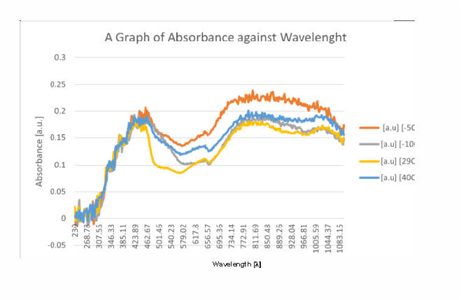

Figure 1: Graph of Absorbance against wavelength
Optical Transmission Spectra
Figure 2 below shows the transmittance spectrum of PANI: DBSA thin film samples as a function of wavelength. It was observed that the transmittance of all the samples, deposited at different temperatures (-5°C, -10°C, 29°C, and 40°C), begins at a value of 1, with the corresponding wavelengths primarily falling within the ultraviolet (UV) region of the electromagnetic spectrum.
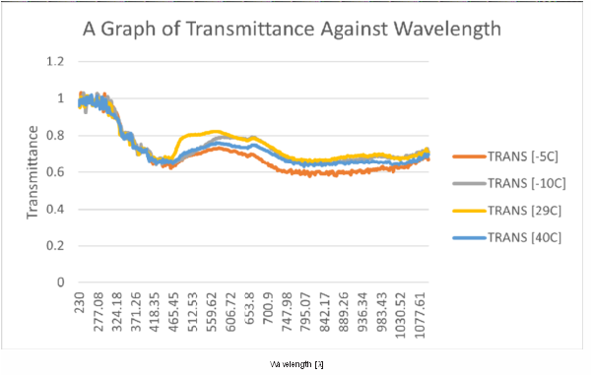
Figure 2: Graph of Transmittance against wavelength
Optical Reflection Spectra
Figure 3 displays the reflectance spectra of PANI: DBSA thin films at various temperatures, showing the relationship between reflectance and wavelength. At temperatures below room temperature (-5°C and -10°C), the samples exhibit elevated reflectance in the infrared region. Similarly, at temperatures above room temperature (29°C and 40°C), the reflectance remains high in the infrared portion of the electromagnetic spectrum..Such high reflectance in the infrared is of particular significance for applications in astronomy, space exploration, and the design of optical components for mid-infrared laser systems. Notably, the data reveals a clear trend: the reflectance increases as the temperature rises, indicating a temperature-dependent optical response in the infrared range.
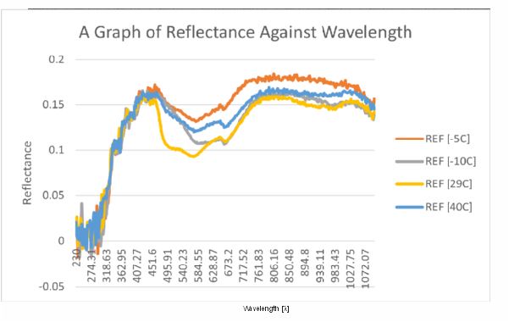
Figure 3: Graph of Reflectance against wavelength.
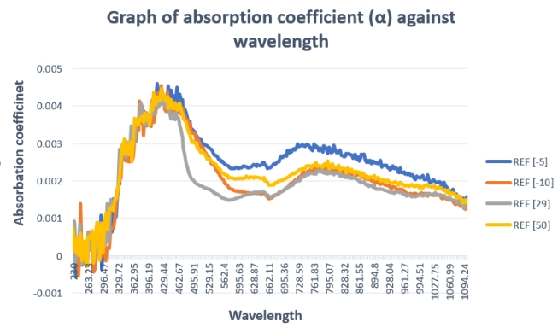

Figure 4: Graph of Absorption coefficient against wavelength.
At -5 ̊ C, the highest absorption coefficient of 0.0046 falls within the wavelength of 415.59nm. At -10 ̊ C, the highest absorption coefficient of 0.0045 falls within the wavelength of 423.89nm then at 29 ̊ C, the highest absorption coefficient of 0.0043 falls within the wavelength of 423.89nm. Also at 40 ̊ C, the highest absorption coefficient of 0.0044 falls within the wavelength of 423.89nm.
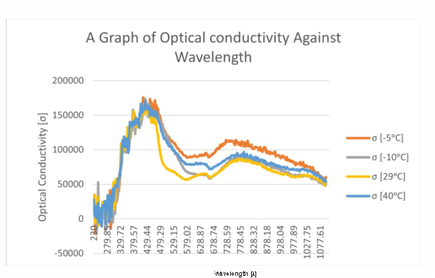
Figure 5: Graph of optical conductivity against wavelength.
At -5 ̊ C, the highest optical conductivity of 17996.21 falls within the wavelength of 263.23nm At -10 ̊ C, the highest optical conductivity of 167267.8 falls within the wavelength of 437.75nm then at 29 ̊ C, the highest optical conductivity of 164956.5 falls within the wavelength of 423.89nm. Also at 40 ̊ C, the highest optical conductivity of 170467.7 falls within the wavelength of 423.89nm.
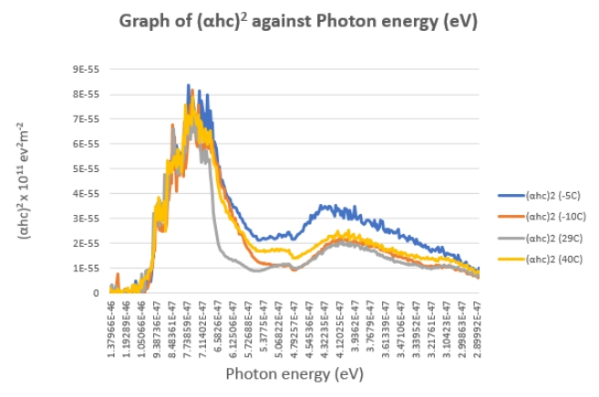
Figure 6: Graph of (αhc)2 against Photon energy
Fig 6 depicts the optical band gap spectrum of synthesized PANI: DBSA. To obtain the band gap energy of the PANI: DBSA material (αhc)2 values were plotted against photon energy (ev) for different temperature ranges as shown in the graph above. The band gap energies of the PANI: DBSA were obtained by extrapolating the linear portion of the curve to the point on the horizontal axis where (αhc)2 to zero. From Figure.6, the band gap was observed to be 1.37 eV, 1.20 eV, and 1.07 eV. The materials with a band gap of 1.37 eV exhibit a low band gap due to strong ICT (Intramolecular charge transfer) which has its application in organic photovoltaic.
Materials with band gap energies in the range of 1.37 eV, 1.20 eV, and as low as 1.07 eV have applications in thermoelectric devices or solar cells (Yao H et al.,, 2017).
Conclusion
PANI-DBSA was successfully synthesized by Self Dispersed Emulsion polymerization of Aniline, which was gradually grown into PANI-DBSA thin film. The study of the electrical properties and optical properties of PANI-DBSA over the temperature ranges was carried out by Four Points probe and UV-Spectroscopy. Electrical conductivity was found that temperature has a significant effect on the electrical properties likewise, in optical properties the absorbance of the PANI-DBSA sample (-5 ̊ C) was observed to be high in the infrared region which also has a significant effect in the increase in temperature with a decrease in wavelengths. The transmittance of all the deposited samples at different temperatures was high in the Ultraviolent ( UV) region.
The band gap energies of the optical properties were found to be 1.37eV, 1.20eV, and 1.07eV showing great application in electronic devices, photovoltaic devices, solar cells, and sensors. The results demonstrated that the band gap of PANI-DBSA decreased with increased temperature and morphological properties as shown.
Due to low cost and easy preparation routes, these PANI-DBSA composites at predetermined temperatures prove to be promising candidates for various applications in electronic devices, such as flexible electrodes, sensors, and charge storage devices like supercapacitors.
REFERENCES
1. Bhadra, J., Alkareem, A., & Al-Thani, N. (2020). A review of advances in the preparation and application of polyaniline-based thermoset blends and composites. Journal of Polymer Research, 27(2), 22. doi: 10.1007/s10965-020-02052
2. Blinova, N. V., Stejskal, J., Trchova, M., & Prokes, J. (2008). Control of polyaniline conductivity and contact angle by partial protonation. Polymer International, 57(2), 231-238. doi: 10.1002/pi.2312
3. Rafiqi, F. A., & Majid, K. (2017). Journal of Materials Science, 52, 6506–6524.
4. Nithyaprakash, D., Chandrasekaran, J., Punithaveni, B., & Sasikumar, L. (2014). Optik, 125, 5343–5346.
5. Zhang, Y., Park, Y. W., & Lee, K. H. (2010). Synthetic Metals, 160(11-12), 1131-1136.
6. Kumar, S. K., Mukherjee, A. K., & Meikap, A. K. (2012). Journal of Applied Physics, 111(10), 103701.
7. Wang, X., Zhang, Y., & Liu, J. (2019). Macromolecular Rapid Communications, 40(10), 1900275.
8. Li, X., Li, Y., & Yang, C. (2020). Polymer Reviews, 60(2), 257-283.
Yao, H., Wang, Y., Li, Y., Yan, X., Zheng, Z., Liu, X., & Chen, Y. (2017). ACS Applied Materials & Interfaces, 9(4), 3646-3655. doi: 10.1021/acsami.6b14111

