Differential Maltosazone Crystal Formation in Selected Packaged Food Products Using the Osazone Test

Abstract
This paper explores the application of the osazone test in maltose detection. The osazone test is a qualitative method performed for the detection of different sugars in food products. When performed for maltose, the osazone test leads to the production of maltosazone. This paper investigates the use of the osazone test for various readily available food products, primarily those found in grocery stores and used in bakery products, which are suspected to contain maltose or maltodextrin. Maltose consumption can exacerbate diet-induced obesity and related health issues, particularly when combined with a high-fat diet. Malt is utilized in chocolate-based products as a thickening agent, which correlates to potential health impacts. Other detection methods used in industries, such as gas chromatography, HPLC, and enzymatic methods, are time-consuming and cost-ineffective. Five different packaged food products were used for the study. Maltosazone crystals were observed in four of them. The presence and morphology of these crystals confirm the presence of maltose. This research paper demonstrates the application of the osazone test in the detection of maltose.
Keywords: Osazone test; Maltose detection; Maltosazone

Introduction:
Maltose is a disaccharide composed of two glucose units, commonly found in foods like raw cereals, vegetables, and chicken [1]. It is a reducing sugar that can be rapidly hydrolyzed in the human body, release it fast in blood as soon as consumption [1].
The effects of maltose on health are complex and context-dependent. In healthy individuals, maltose can moderate hunger sensations, even at lower dosages, suggesting it may play a role in appetite regulation [2]. However, its impact on blood sugar levels is less pronounced compared to glucose. In a study involving healthy subjects, intravenous maltose administration did not significantly influence blood sugar concentrations [3].
Maltose metabolism differs between healthy individuals and those with certain health conditions. In insulin-dependent diabetic patients, maltose metabolism is reduced, with only 3% of administered maltose being oxidized and 51% excreted in urine within 8 hours [3]. This suggests that maltose may not be a suitable carbohydrate source for parenteral nutrition in these patients. Children with glucose-6-phosphatase deficiency, maltose feeding has been shown to decrease blood lactate levels, in contrast to lactose and sucrose [4]. While maltose doesn't appear to have significant adverse effects on healthy individuals, its use as a sole substrate for parenteral nutrition is not recommended due to high renal loss and difficulty in achieving constant blood concentrations [5].

Ready-to-eat food processing companies use maltose in food products for several reasons:
Maltose serves as a valuable ingredient in food processing due to its unique properties and versatility. Maltose is a reducing sugar, which means it can form an aldehyde group in solution, contributing to flavor development and browning reactions during food processing [1].

One interesting aspect of maltose is its rapid biological hydrolysis in humans. When consumed, maltose is quickly broken down into glucose, which appears rapidly in the bloodstream after a meal [1]. This property makes maltose an attractive ingredient for food processors looking to provide quick energy sources in their products.
We can infer that its natural occurrence in many food sources, its role in flavor development, and its quick conversion to glucose in the human body make it a valuable ingredient in ready-to-eat food products. Additionally, maltose's importance in various scientific disciplines, including the food industry, suggests its continued relevance in food processing applications [6].
Effects of maltose on health:
Maltose consumption can exacerbate diet-induced obesity and related health issues, particularly when combined with a high-fat diet. A study on male C57BL/6J mice found that adding 7.0% maltose to a high-fat diet (HFD+Mal) resulted in significantly higher weight gain compared to a high-fat diet alone after 6 weeks [7]. The HFD+Mal group also showed higher body mass index, relative liver weight, blood glucose levels, and plasma cholesterol levels compared to both control and high-fat diet groups. Interestingly, the study noted that maltose content in raw sweet potatoes get increased by 40 times upon baking, suggesting that consuming maltose-rich cooked sweet potatoes as part of a high-fat diet might worsen diet-induced overweight [7]. This finding contradicts the common perception that sweet potatoes are a healthy food choice, highlighting the importance of considering food preparation methods and overall dietary context.
Maltose itself may not be inherently hazardous, its consumption in combination with a high-fat diet can lead to adverse health effects, including increased obesity, elevated blood glucose and cholesterol levels, and potential liver issues.

Osazone test:
The osazone test is an important reaction in carbohydrate chemistry used to identify and characterize reducing sugars. It involves the reaction of reducing sugars with phenylhydrazine to form crystalline osazone compounds [8].

The mechanism of osazone formation has been the subject of many studies over time. Recent theoretical findings have helped explain the factors that direct the regiochemistry of osazone formation [8]. The reaction proceeds through several steps, including initial formation of a phenylhydrazone, conversion to an N-glycoside, Amadori rearrangement to a 1-deoxy-1-amino-2-ketose derivative, and finally dehydrogenation and transamination to form the phenylosazone product [9].
Osazone reaction has analogies to other chemical systems. For example, the reaction of squaric acid with phenylhydrazine produces compounds analogous to intermediates in carbohydrate osazone formation [10]. The osazone test remains an important tool for sugar characterization and continues to be an area of mechanistic study in organic chemistry. Its inclusion in organic chemistry education helps fill gaps in understanding of carbohydrate reactivity [8].
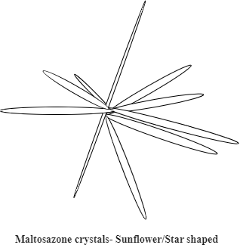
Figure 1: Illustration of the morphology of maltose crystals formed in the osazone test, referred to as maltosazone.
Accurate estimation of maltose is crucial for ensuring food safety and quality:
Accurate maltose estimation is essential for food safety and quality due to its role in various food products. In quality control, accurate maltose measurement ensures consistent product quality, influencing taste, texture, and nutritional value, which are integral to quality management and assurance in the agro-food industry. For process monitoring, maltose levels indicate the effectiveness of food processing steps, such as fermentation or enzymatic reactions. While not directly a safety concern, maltose measurement contributes to broader safety protocols, as unexpected changes in its levels could indicate microbial activity or improper storage, potentially compromising food safety. Technological advancements, including the use of cutting-edge sensing methods like Aggregation-Induced Emission (AIE), offer improved sensitivity and accuracy in maltose detection [11], Accurate maltose estimation supports food safety and quality assurance goals, forming a vital part of comprehensive quality management systems essential for producing safe and high-quality food products.
Other methods like Gas chromatography (GC) has been used to analyze maltose in apple juices. This method involves forming silylated oxime derivatives in a two-stage reaction, which allows for improved maltose analysis [12]. GC is known for its high sensitivity and specificity.

Also the High-performance liquid chromatography (HPLC) is widely used for maltose determination in various food products. It offers advantages such as simplicity, specificity, and reliability over a wide range of sugar concentrations in different food matrices. Sample preparation typically involves water-ethanol extraction and mini-column cleanup. HPLC can separate and quantify multiple sugars, including maltose, in less than 45 minutes [13].
Enzymatic methods have also been developed for maltose analysis. These methods are more selective than standard non-enzymatic procedures and can be applied to a broad range of food products. For instance, the Megazyme enzymatic method has shown good repeatability and reproducibility for available carbohydrate analysis, including maltose, in various food matrices [14].
In comparison, the osazone test is considerably more straightforward and effective than the aforementioned methods of maltose qualitative estimation.
Although the osazone test is a reliable method for the estimation of maltose, there is limited research on its application in diverse food products. The aim of this study is to evaluate the efficacy of the osazone test for the qualitative estimation of maltose in a variety of food products.
The objective of this study is to evaluate the osazone test as a potential tool for screening maltose in various food products.

Materials and Methods:
Packed food products, both branded and unbranded, were categorized into solids (e.g., Chochalates, Coco powder, etc) and liquids (e.g., juices, chochalate syrup, etc). Solid samples were crushed and diluted to 10% (w/v), while liquid samples were diluted 1:1 with distilled water. The osazone reagent, comprising phenylhydrazine hydrochloride, sodium acetate, and glacial acetic acid, was prepared. Each diluted sample was mixed with the reagent and heated in a boiling water bath for 10 minutes, then cooled to room temperature. Formation of maltosazone crystals was observed under an optical microscope, and images were captured using mobile phones. The presence of crystals was documented and compared across different food products.
Various food products were designated as A, B, C, and D to maintain brand anonymity. The generic nomenclature of the products was utilized for product identification.

Results and Discussion:

Table 1: Morphometric variations of Maltosazone crystals in different food products

Sr. No. | Food Products | Generic  name | State | Dilution  Factor* | Morphometric observations of Maltosazone crystals
 |  |  |  |  | Colour | Crystal shapes | Crystal pattern | Inference  +/- | Intensity  (+/++/+++)
 | A | Choco syrup | Liquid | 1:1 | Yellow | Sunflower shaped | 5-6 tubular stellar structure | + | ++
 | B | Cold coco | Liquid | 1:1 | Brown | Long needle  Shaped | 5-6 tubular stellar structure | + | +++
 | C | Almond shake | Liquid | 1:1 | Black | Asymmetric shaped | Asymmetrical shape | - | +
 | D | Cold coffee | Solid | 1:10 | Peach yellow | Sunflower shaped | Fern like  Dendrites | + | ++
 | E | Coco powder | Solid | 1:10 | Brown | Sunflower shaped | 2-3 tubular Stellar crystals | + | +

{Note: *Dilution factor (Product: Distilled Water); Inference- + (matlosazone confirmed), - (matlosazone absent); Crystal Intensity- + (less dense crystals), ++ (more dense crystals), +++ (highest dense crystals)}

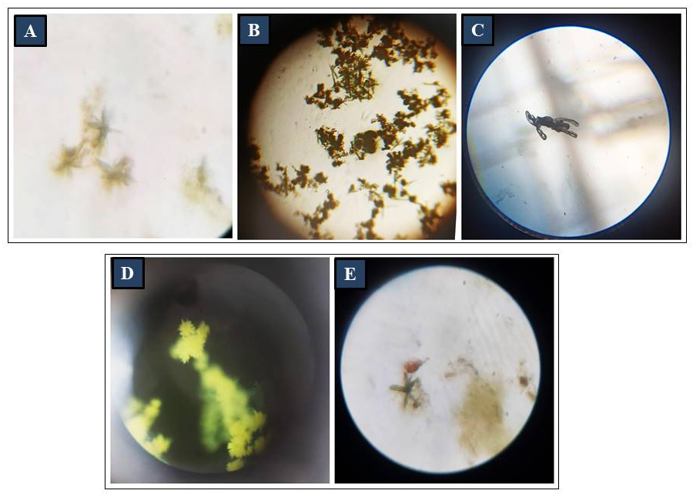

Figure 2: Microscopic observations of Maltosazone crystals in different food products
{Note: Maltosazone crystals observed in; A: Choco syrup, B: Cold coco, C: Almond shake, D: Cold coffee, E: Coco powder}

Significant variations in crystal formation were observed across different food products analyzed in this study. Despite being categorized into liquid and solid forms, all products consistently exhibited sunflower-shaped maltosazone crystals. However, the color of the crystals varied among the samples. Choco syrup formed yellow-colored crystals, cold coco produced brown-colored crystals, almond shake yielded black-colored crystals, cold coffee exhibited peach-colored crystals, and cocoa powder generated brown-colored crystals. These color variations are likely attributed to the inherent differences in the color of the food products themselves.
Notable differences were also observed in the intensity of crystal formation. The highest intensity was recorded in cold coco, followed by choco syrup, cold coffee, cocoa powder, and almond shake. Crystals in almond shake were less defined, which suggests the possible absence of maltose in the sample.
Variations in crystal shapes were evident across the samples. In choco syrup and cold coco, 5–6 stellar-shaped crystals were identified, likely indicating the presence of maltose due to their similar composition. In contrast, almond shake exhibited asymmetric, undefined crystal structures, further supporting the absence of maltose in this product. Cold coffee showed clustered fern-like dendrites, representing the presence of maltose. Meanwhile, cocoa powder formed 2–3 tubular stellar crystals, also indicative of maltose.
Sugars exhibit close similarities in their properties, rendering the differentiation of various carbohydrate members challenging. Consequently, the osazone test is employed, reveals distinct crystalline structures under microscopic examination [15]. The acid hydrolysis of starchy products results in the formation of maltose crystals, demonstrating its extensive industrial applications [16]. The presence of maltose can also be detected effectively using osazone technique in the presence of other sugars like dextrose [17]. Research conducted by Percival and Percival (1937) [18] demonstrated that crystalline maltosazone formed two distinct types of needles: elongated lemon-yellow needles and pointed yellow plates, which aligns with our observations. This technique also demonstrates applicability in the detection of sugar in urine for glycosuria and maltosuria [19].
Osazone tests are potentially unreliable when analyzing mixtures of sugar samples, such as those found in plant cells. Additionally, these tests can result in various crystal aggregations due to combinations of sugar crystals [20]. Consequently, further research is recommended to investigate the complex crystal formations that occur in such scenarios.
These findings highlight the potential for using maltosazone crystal morphology and color as qualitative indicators of maltose content in diverse food products.

Conclusion:
The study demonstrates significant variations in maltosazone crystal morphology, intensity, and coloration across different food products, reflecting their unique compositions. While sunflower-shaped crystals were a common feature, differences in colour and structure can formed due to product nature and other compositions. Notably, cold coco and choco syrup exhibited the highest intensity and well-defined stellar crystals, confirming the presence of maltose, whereas almond shake lacked definitive crystal structures, indicating its potential absence. The observed variations highlights the utility of maltosazone crystal analysis as a simple and effective method for the qualitative estimation of maltose in diverse food products, clearing the way for broader applications in food quality control and screening.

AI Disclosure Statement
AI tools were used in this study for data processing, analysis, and drafting assistance. All interpretations and conclusions were made by the authors, with AI serving as a supplementary tool to enhance efficiency. This disclosure ensures transparency regarding the role of AI in supporting this study.

Data Availability Statement
This research did not involve any data processing.

References
- Gaspar, E. M. S. M., Nunes, I. S., Gyamfi, D., & Lopes, J. F. (2012). CHAPTER 24. Food Sources and Analytical Approaches for Maltose Determination (pp. 405–424). royal society of chemistry. https://doi.org/10.1039/9781849734929-00405
- Poothullil, J. M. (1992). Maltose: The primary signal of hunger and satiation in human beings. Physiology & Behavior, 52(1), 27–31. https://doi.org/10.1016/0031-9384(92)90429-6
- Finke, C., & Reinauer, H. (1976). Über den Abbau von infundierter Maltose beim Menschen. Zeitschrift Für Ernährungswissenschaft, 15(2), 231–245. https://doi.org/10.1007/bf02018446
- Fernandes, J. (1974). The effect of disaccharides on the hyperlactacidaemia of glucose-6-phosphatase-deficient children. Acta Paediatrica, 63(5), 695–698. https://doi.org/10.1111/j.1651-2227.1974.tb16992.x
- Förster, H., Hoos, I., & Boecker, S. (1976). Tests with human volunteers on parenteral utilization of maltose. Zeitschrift Fur Ernahrungswissenschaft, 15(3), 284–293. https://doi.org/10.1007/bf02022005
- Crow, R. R., Varela, M. F., & Kumar, S. (2012). CHAPTER 7. Maltose Chemistry and Biochemistry (pp. 101–114). royal society of chemistry. https://doi.org/10.1039/9781849734929-00101
- Shibazaki, N., Matsuyama, H., Sakakibara, H., Yokoyama, D., Kubota, H., Ogawa, K., Suzuki, Y., & Tanaka, W. (2022). Maltose consumption exacerbates high-fat diet-induced overweight and related parameters in mice. Functional Foods in Health and Disease, 12(11), 680. https://doi.org/10.31989/ffhd.v12i11.997
- Sánchez-Viesca, F., & Gómez G, R. (2017). Reactivities Involved in the Regioselectivity of Osazone Formation. World Journal of Organic Chemistry, 5(1), 11–16. https://doi.org/10.12691/wjoc-5-1-3
- Micheel, F., & Dijong, I. (1963). ON THE MECHANISM OF THE OSAZONE REACTION. Experientia, 19(7), 338–339. https://doi.org/10.1007/bf02152304
- El Khadem, H. S., Shalaby, M. A., Coxon, B., & Fatiadi, A. J. (1993). The reaction of phenylhydrazine with squaric acid: a model for carbohydrate osazone formation. Carbohydrate Research, 239, 85–93. https://doi.org/10.1016/0008-6215(93)84205-k
- Huang, X., Guo, Q., Tang, B. Z., Lam, J. W. Y., Leng, Y., Xiong, Y., Zhang, R., & Zhao, Z. (2020). AIEgens: An emerging fluorescent sensing tool to aid food safety and quality control. Comprehensive Reviews in Food Science and Food Safety, 19(4), 2297–2329. https://doi.org/10.1111/1541-4337.12591
- Woźniak, Ł., Szczepańska, J., Roszko, M., & Skąpska, S. (2020). Occurrence of maltose in apple juices: Improved method of analysis, typical levels, and factors affecting it. LWT, 124, 109154. https://doi.org/10.1016/j.lwt.2020.109154
- Dunmire, D. L., & Otto, S. E. (1979). High Pressure Liquid Chromatographic Determination of Sugars in Various Food Products. Journal of AOAC INTERNATIONAL, 62(1), 176–185. https://doi.org/10.1093/jaoac/62.1.176
- Mcloughlin, C., Mccleary, B. V., & Mckie, V. A. (2022). Validation of the Test Method-Determination of Available Carbohydrates in Cereal and Cereal Products, Dairy Products, Vegetables, Fruit, and Related Food Products and Animal Feeds: Collaborative Study, Final Action 2020.07. Journal of AOAC International, 106(2), 370–383. https://doi.org/10.1093/jaoacint/qsac116
- Hassid, W., & McCready, R. (1942). Identification of Sugars by Microscopic Appearance of Crystalline Osazones. Industrial & Engineering Chemistry Analytical Edition, 14(8), 683–686. https://doi.org/10.1021/i560108a025
- Rolfe, Geo. W., & Haddock, I. T. (1903). THE PRESENCE OF MALTOSE IN ACID-HYDROLYZED STARCH PRODUCTS. Journal of the American Chemical Society, 25(10), 1015–1019. https://doi.org/10.1021/ja02012a002
- Baker, J. L., & Dick, W. D. (1905). The detection and estimation of small quantities of maltose in the presence of dextrose. Analyst, 30(348), 79–85. https://doi.org/10.1039/AN9053000079
- Percival, E. E., & Percival, E. G. v. (1937). 268. Sugar osazones and their anhydrides. Journal of the Chemical Society (Resumed), 0, 1320–1325. https://doi.org/10.1039/JR9370001320
- Herzfeld, E. (1932). Glycosuria and maltosuria.
- Jöroensen, I., & Stilbs, W. (1918). THE OSAZONE METHOD FOR DETECTING SUGARS IN PLANT TISSUES. New Phytologist, 17(1‐2), 45-45.

