Original Research Article
Statistical Modelling of Nigeria’s Gross Fixed Capital Formation Using Fréchet-Based Distributions

Abstract
This study investigates the statistical modelling of Nigeria’s Gross Fixed Capital Formation (NGFCF) using Fréchet-based distributions to analyze its distributional properties and economic implications. NGFCF, a key indicator of investment trends and economic growth, represents the total value of fixed asset acquisitions by businesses, governments, and households. The dataset, spanning from 1981 to 2020, was obtained from the Central Bank of Nigeria’s Statistical Bulletin and the World Bank national accounts data. A log transformation was applied to NGFCF to stabilize variance, and various sample sizes were simulated to examine alignment with empirical data. The study employed the Maximum Likelihood Estimation (MLE) for parameter estimation, and model performance was evaluated using the Akaike Information Criterion (AIC), Bayesian Information Criterion (BIC), and the Likelihood Ratio Test (LRT). Four Fréchet-based distributions Kumaraswamy Fréchet (KF), Exponentiated Fréchet (EF), Beta Fréchet (BF), and standard Fréchet (F) were considered for modelling. The Exponentiated Fréchet distribution demonstrated the best fit, as evidenced by the lowest AIC and BIC values and the highest LRT statistics, making it the most suitable model for capturing the heavy-tailed nature of NGFCF. The findings provide insights into investment behaviour and economic fluctuations, particularly in response to crude oil price volatility and macroeconomic conditions. The findings underscore the importance of flexible statistical models in economic forecasting and risk assessment, offering a more refined approach to understanding Nigeria’s capital formation patterns.
Keywords: Gross Fixed Capital Formation, Fréchet-Based Distributions, Exponentiated Fréchet, Maximum Likelihood Estimation, Likelihood Ratio Test, Investment Behavior, Economic Forecasting, Heavy-Tailed Distributions
- Introduction
Probability distributions are crucial in statistical modelling, particularly in understanding and forecasting extreme events across diverse domains, including econometrics, reliability analysis, and environmental studies (Akalagboro et al., 2025). Among these, the Fréchet distribution and its extensions have garnered significant attention due to their ability to model skewed and heavy-tailed data effectively. The Bayesian estimation of a two-component mixture of transmuted Fréchet distribution, for instance, has been highlighted for its reliability in handling dependability data, as demonstrated by Aslam et al. (2021). Their approach employed Markov Chain Monte Carlo (MCMC) techniques to enhance prediction accuracy, particularly for right-censored sampling datasets. The development of generalized families of distributions from the Fréchet base model has further advanced statistical methodologies, as illustrated in studies by Omekam et al. (2022) and Alyami et al. (2022). These works underscore the adaptability of Fréchet-derived distributions, such as the Fréchet binomial (FB), for diverse data types, emphasizing their utility in econometric modelling. Additionally, innovative extensions like the odd Lomax Fréchet (OLxF) distribution, proposed by Hamed et al. (2020), and the harmonic mixture Fréchet model by Ocloo et al. (2022), demonstrate enhanced performance in real-world applications by incorporating additional parameters to improve flexibility and goodness-of-fit.

Recent advancements, such as the odd log-logistic Lindley-Weibull (OLLW) distribution introduced by Al-Sobhi (2022), have further broadened the scope of statistical modelling, offering superior adaptability for various practical domains, including survival analysis and economic decision-making. Likewise, Phaphan et al. (2023) explored innovative methodologies combining the Fréchet distribution with mixture models, presenting promising results for skewed survival data using advanced estimation techniques. Building on these developments, this study conducts a comparative analysis of Fréchet distribution variants, focusing on parameter estimation and model performance evaluation.

Using Maximum Likelihood Estimation (MLE), Akaike Information Criterion (AIC), Bayesian Information Criterion (BIC) and Likelihood Ratio Test (LRT), the study systematically evaluated the distributions based on their efficiency and consistency. Four variants of the Fréchet distribution were selected for modelling: Kumaraswamy Fréchet (KF), Exponentiated Fréchet (EF), Beta Fréchet (BF), and the standard Fréchet (F) distribution. These distributions were chosen based on their theoretical flexibility and ability to model extreme-value data. This approach seeks to provide valuable insights into the suitability of these variants for modelling the Nigeria’s Gross Fixed Capital Formation (NGFCF), contributing to the growing body of knowledge in econometric and statistical modelling.

Nigeria’s economic growth and stability are significantly influenced by capital formation, which serves as a crucial determinant of investment trends and infrastructural development (Onwuemeka et al., 2021). Gross Fixed Capital Formation (GFCF) is a fundamental indicator of economic performance, reflecting the total value of asset acquisitions by businesses, governments, and households, excluding disposals (Otolorin and Oniwoduokit, 2021). Variations in Nigeria's GFCF can be attributed to numerous macroeconomic factors, including changes in government policies, economic cycles, fluctuations in global oil prices, political instability, and broader macroeconomic conditions (Otolorin and Oniwoduokit, 2021; Ibrahim et al., 2023). Understanding the statistical properties of GFCF is essential for policymakers and economists to develop informed strategies for fostering sustainable economic growth.

Despite the critical role of GFCF in economic development, previous studies have primarily relied on classical time series models and traditional probability distributions to analyze GFCF (Ugwuegbe and Uruakpa, 2013). However, these approaches often fail to capture the extreme fluctuations and heavy-tailed nature of economic data. The Fréchet distribution and its extensions provide a robust framework for modelling such extreme-value data, making them particularly suitable for analyzing GFCF trends in Nigeria (Hosking & Wallis, 1987; Castillo et al., 2005). Given Nigeria's economic susceptibility to external shocks, particularly fluctuations in crude oil prices, an advanced statistical approach is necessary to improve inference accuracy and forecasting reliability (Abanikanda and Dada, 2024). This study aims to bridge the gap by applying Fréchet-based distributions to model Nigeria’s GFCF, thereby enhancing the precision of statistical inferences and forecasting models. By leveraging advanced estimation techniques such as Maximum Likelihood Estimation (MLE), Akaike Information Criterion (AIC), and Bayesian Information Criterion (BIC), this study seeks to identify the most suitable Fréchet-based model for GFCF analysis. The findings will offer valuable insights into investment patterns, economic resilience, and risk assessment, particularly in the context of crude oil price volatility and capital inflows. This research contributes to econometric modelling by introducing novel statistical approaches tailored to Nigeria’s economic landscape, ultimately facilitating data-driven policy formulation and economic planning.

2. Methods

2.1 Source of Data collection for the study
This study relies on secondary data obtained from reputable sources, including the Central Bank of Nigeria's Statistical Bulletin (2021) (Available at: https://dc.cbn.gov.ng/cbn_statistical_bulletin/) and the World Bank national accounts data in conjunction with the OECD National Accounts data files. The primary indicator for analysis is Nigeria’s Gross Fixed Capital Formation (NGFCF) from 1981 to 2020, comprising 40 observations in chronological order. The NGFCF represents the total value of new or existing fixed asset acquisitions by businesses, governments, and households (excluding own-use assets), adjusted for disposals. This measure provides insights into investment trends and economic growth dynamics in Nigeria. Fluctuations in NGFCF can be attributed to several macroeconomic factors, including: Changes in government policies, Economic cycles, Variations in global oil prices (given Nigeria's reliance on oil revenue), Political instability, and broader macroeconomic conditions

To evaluate the statistical properties and distributional behaviour of NGFCF, a synthetic dataset is generated using a normal distribution approximation. The simulation employs varying sample sizes (10, 20, 30, 50, 100, 200, 500, 1000, and 5000) to assess alignment with real-world data.

2.1.1 Methodology for Simulation
- Log transformation is applied to NGFCF to stabilize variance and improve normality.
- Skewness and Kurtosis are computed using the moment’s package in R to assess data distribution.
- A random seed (123) is set for reproducibility.
- Simulated values are generated using $X∼N(μ,σ)$ where μ and σ represent the mean and standard deviation of the log-transformed NGFCF values.
This simulation framework enables a robust examination of NGFCF’s statistical properties, contributing to better economic modelling, forecasting, and risk assessment, particularly in the context of crude oil price volatility and investment behaviour.

2.2 Methods

The probability density functions (PDFs) of Fréchet-based distributions play a crucial role in modelling extreme values and heavy-tailed data. Table 1 presents four such distributions, highlighting their structural differences.
Table 1. Probability Density Functions (PDFs) of Fréchet-Based Distributions

S/No. | Distribution | PDF
1. | Kumaraswamy Fréchet (KF) | $$αβba^{b}x^{-(b+1)}exp\left[-α{\left(\frac{a}{x}\right)}^{b}\right]{\left\{1-exp\left[-α{\left(\frac{a}{x}\right)}^{b}\right]\right\}}^{β-1}$$
2 | Exponentiated Fréchet (EF) | $$θba^{b}x^{-(b+1)}exp\left[-{\left(\frac{a}{x}\right)}^{b}\right]{\left\{1-exp\left[-{\left(\frac{a}{x}\right)}^{b}\right]\right\}}^{θ-1}$$
3 | Beta Fréchet (BF) | $$\frac{ba^{b}}{B(α,β)}x^{-(b+1)}exp\left[-α{\left(\frac{a}{x}\right)}^{b}\right]{\left\{1-exp\left[-{\left(\frac{a}{x}\right)}^{b}\right]\right\}}^{β-1}$$
4 | Fréchet (F) | $$αba^{b}x^{-\left(b+1\right)}exp\left[-{\left(\frac{a}{x}\right)}^{b}\right]{\left\{1-exp\left[-{\left(\frac{a}{x}\right)}^{b}\right]\right\}}^{α-1}$$  $$\left(1+β-2β{\left\{1-exp\left[-{\left(\frac{a}{x}\right)}^{b}\right]\right\}}^{α}\right)$$
Source: Akalagboro et al. (2025)

Table 1 presents the probability density functions (PDFs) of four Fréchet-based distributions, including the Kumaraswamy Fréchet (KF), Exponentiated Fréchet (EF), Beta Fréchet (BF), and standard Fréchet (F) distributions. These distributions are commonly used in modelling extreme values and reliability analysis, particularly in cases where heavy-tailed behaviour is observed (Nadarajah & Kotz, 2004). The Kumaraswamy Fréchet (KF) and Beta Fréchet (BF) distributions introduce additional shape parameters (α, β), allowing for greater flexibility in capturing tail behaviour. The Exponentiated Fréchet (EF) distribution extends the standard Fréchet model by incorporating an exponentiation parameter (θ), enhancing its adaptability for real-world data. The standard Fréchet (F) distribution, a special case of the others, is widely applied in extreme value theory. The presence of exponentiated terms and shape parameters in these distributions enables better modelling of skewed and heavy-tailed data, making them useful in financial risk analysis and environmental studies (Hosking & Wallis, 1987).
2.2.1 Parameter Estimation
Parameter estimates for each distribution were derived using the Maximum Likelihood Estimation (MLE) method, which maximizes the likelihood function $L(θ∣x)$ given by:
$$L\left(θ ∣ x\right)=\prod_{i=1}^{n}{f\left(x_{i};θ\right)} (1)$$
where $f\left(x_{i};θ\right)$represents the Probability Mass Function (PMF) of the distribution, θ is the vector of parameters, and $x_{i}$ are the observed data points (Casella and Berger, 2002). MLE implementation was performed in the R programming language (R Core Team, 2023) using the maxLik package (Henningsen & Toomet, 2011), which provides flexible optimization routines for likelihood-based estimation.
.
2.2.2 Model Performance Measures of the distributions
The model performance was evaluated using the following criteria:
i. Akaike Information Criterion (AIC):
$$AIC=-2ln\left(L\right)+2k (2)$$
where L Where likelihood of the model, and k is the number of estimated parameters (Akaike, 1974).
ii. Bayesian Information Criterion (BIC):
$$BIC=-2ln\left(L\right)+kln\left(n\right) (3)$$
where n is the sample size (Schwarz, 1978).
iii. The Likelihood Ratio Test (LRT) is a statistical hypothesis test used to compare the goodness of fit between two nested models: a more complex (unrestricted) model and a simpler (restricted) model. It evaluates whether additional parameters in the unrestricted model significantly improve the model's explanatory power (Casella & Berger, 2002). Given a parametric statistical model $f\left(x;θ\right)$, where $θ$ represents the parameter vector, the LRT is based on the likelihood function $L\left(θ;x\right)$ , which measures the probability of observing the given data under specific parameter values. The LRT statistic is formulated as (Wilks, 1938):
$$λ=\frac{{Sup}_{θ_{0}∈Θ_{0}}L\left(θ_{0};x\right)}{{Sup}_{θ∈Θ }L\left(θ;x\right)} (4)$$
Where:
$Θ_{0}$ represents the parameter space under the null hypothesis,
$Θ$ represents the parameter space under the alternative hypothesis,
Sup denotes the supremum (maximum likelihood estimate).
The test statistic presented in equation (4) can transforms into:
$$LRT=-2\log\left(λ\right)=2\left(l\left(\hat{θ}\right)-l\left({\hat{θ}}_{0}\right)\right) (5)$$
Where $l\left(\hat{θ}\right)$ and $l\left({\hat{θ}}_{0}\right)$ denote the log-likelihoods of the unrestricted and restricted models, respectively (Davidson & MacKinnon, 2004).
The LRT statistic follows a chi-square $χ^{2}$distribution with degrees of freedom equal to the difference in parameters between the unrestricted and restricted models.
$$p=P\left(χ_{df}^{2}>LRT\right) (6)$$
where df is the number of constraints imposed by the null hypothesis and p denotes the p-value associated with the test statistics (Greene, 2012).
Understanding these PDFs enhances the applicability of Fréchet-based distributions in statistical modelling. The subsequent sections focus on parameter estimation and model evaluation using likelihood-based methods and performance criteria.

3. Results
Table 2: Descriptive Statistics and Normality Test for NGFCF and log_NGFCF
Variable | Mean | St. Dev | Median | Skewness | Kurtosis | AD Test Statistic (A)
NGFCF | 35.74 | 19.19 | 32.04 | 1.1 | 1.1 | 1.02
log_NGFCF | 3.44 | 0.53 | 3.53 | 0.07 | 2.02 | 0.55

The descriptive statistics for NGFCF (Nigerian Gross Fixed Capital Formation) and its logarithmic transformation (log_NGFCF) in Table 2 indicate notable differences in distributional properties. The mean NGFCF is 35.74 with a standard deviation of 19.19, while log_NGFCF has a reduced dispersion (Mean = 3.44, SD = 0.53), suggesting a variance stabilization after transformation. The skewness of NGFCF (1.1) indicates a right-skewed distribution, which is substantially reduced in log_NGFCF (0.07), implying improved symmetry. Similarly, the kurtosis of NGFCF (1.1) suggests a relatively flatter distribution, whereas log_NGFCF (2.02) is closer to normality. The Anderson-Darling (AD) test statistic for NGFCF (A = 1.02) suggests a deviation from normality, while log_NGFCF (A = 0.55) exhibits a lower test statistic, implying a better fit to the normal distribution. This confirms the effectiveness of the logarithmic transformation in normalizing the data, which is crucial for ensuring the validity of parametric statistical analyses (Shapiro & Wilk, 1965).
Table 3: Model Selection Criteria and Parameter Estimates for Different Data Distributions
Data | Distributions | Parameter estimates | AIC | BIC | LRT
10 | KF | $α=52.8432, β=0.0939$, a=2.7774, b=69.3694 | -0.8118 | 0.3985 | 32.7928
10 | EF | a=2.9404, b=72.5008, $θ=0.0899$ | -2.75225 | -1.8445 | 140.5753
10 | BF | a=0.0010, b=0.5847, $α=570.7151, β=464.9938$ | 13991.33 | 13992.54 | 14132.66
10 | F | a=0.2883, b=2.9572, $α=4.8204, β=1.4195$ | 16.7513 | 17.9616 | 35.9967
20 | KF | $α=4.9004 , β=11.5509$, a= 2.9232, b= 2.9163 | -19.1687 | -15.1858 | 56.8734
20 | EF | a= 5.0413, b= 2.9162, $θ=11.5520$ | -21.1687 | -18.1815 | 275.9584
20 | BF | a=1.9638, b=1.4124, $α=609.5741 , β=431.8526$ | 17402.66 | 17406.64 | 17697.79
20 | F | a=0.5756, b=2.8583, $α=6.6804, β=1.5697$ | 24.2015 | 28.1844 | 2000016
30 | KF | $α=8.6004, β=0.9194$, a= 2.5441, b= 8.9667 | -32.9788 | -27.3740 | 133.7657
30 | EF | a= 3.2341, b= 8.9675, $θ=0.9193$ | -34.9788 | -30.7752 | 0.2184
30 | BF | a=0.1497, b=1.3989, $α=546.1973, β=481.4215$ | 41940.87 | 41946.47 | 42252.78
30 | F | a=0.6513, b=2.8608, $α=6.8740, β=1.8939$ | 36.2462 | 41.8509 | 48.2780
50 | KF | $α=7.8845, β=32.0003$, a=2.4011, b=2.1103 | -59.0904 | -51.4423 | 182.8053
50 | EF | a=6.3884, b=2.1102, $θ=32.0081$ | -61.0904 | -55.3543 | 249.7224
50 | BF | a=0.0010, b=0.5509, $α=551.9968 , β=445.7076$ | 67429.85 | 67437.50 | 68051.06
50 | F | a=1.0674, b=2.4671, $α=5.1460, β=1.5415$ | 15.7136 | 23.3616 | 174.1815
100 | KF | $α=27.2777, β=88.8842$, a= 1.1596, b= 1.5685 | -145.5939 | -135.1732 | 392.6884
100 | EF | a=9.5595, b=1.5669, $θ=89.3316$ | -147.5939 | -139.7784 | 700.7101
100 | BF | a=0.0010, b=0.5496, $α=560.6116, β=471.0604$ | 139898.70 | 139909.10 | 141156.20
100 | F | a=0.001, b=0.001, $α=0 , β=0$ | 3770.9880 | 3781.4090 | 4709.2010
200 | KF | $α=148.1957, β=494.2042$, a= 0.1486, b= 0.9912 | -357.7754 | -344.5822 | 13915.7400
200 | EF | a=92.5424, b=0.6857, $θ=9434.1028$ | -358.2757 | -348.3808 | 3261.0590
200 | BF | a=0.0223, b=0.8986, $α=593.8588, β=447.4496$ | 279963.30 | 279976.50 | 282297.70
200 | F | a=0.0010, b=0.001, $α=0.00 , β=5.1996$ | 6380.2990 | 6393.4920 | 8240.4090
500 | KF | $α=74.0237, β=294.2547$, a= 0.4678, b= 1.2501 | -761.3067 | -744.4483 | 13579.4600
500 | EF | a=16.0422, b=1.2015, $θ=375.5592$ | -763.2698 | -750.6259 | 4930.6640
500 | BF | a=1.9367, b=10.4049, $α=663.1523, β=394.6116$ | 491115.60 | 491132.50 | 495942.60
500 | F | a=1.3455, b=2.0608, $α=5.1353, β=2.4439$ | 40.6714 | 57.5299 | 1677.4370
1000 | KF | $α=134.1997, β=210.9880$, a= 0.2714, b= 1.2433 | -1635.1020 | -1615.4710 | 62963.6800
1000 | EF | a=16.5885, b=1.1544, $θ=325.9428$ | -1636.8280 | -1622.1050 | 9579.5560
1000 | BF | a=0.0074, b=0.7465, $α=621.6339, β=426.2412$ | 1392861.00 | 1392881.00 | 1405041.00
1000 | F | a=0.007, b=0.005, $α=0 , β=0$ | 23698.35 | 23717.98 | 32736.3200
5000 | KF | $α=152.6408, β=276.6803$, a= 0.2429, b= 1.2232 | -7880.3940 | -7854.3250 | 366651.00
5000 | EF | a=19.5742, b=1.0931, $θ=565.0236$ | -7879.2500 | -7859.6990 | 53386.5200
5000 | BF | a=0.0010, b=0.5730, $α=615.7027, β=434.7398$ | 7005885.00 | 7005911.00 | 7070320.00
5000 | F | a=2.4390, b= 1.1926, $α=1.5394 , β=1.6130$ | -13357.52 | -13331.45 | -1914.8320
Real life data (log_NGCFC) | KF | $α=48.9198, β=147.8036$, a=0.7072, b=1.3968 | -52.2600 | -45.6058 | 572.6604
Real life data (log_NGCFC) | EF | a=11.7845, b=1.3770, $θ=160.0084$ | -54.2597 | -49.2691 | 318.3551
Real life data (log_NGCFC) | BF | a=0.003, b=0.6643, $α=0.0609 , β=438.1886$ | 54628.1100 | 54634.7700 | 55102.0500
Real life data (log_NGCFC) | F | a=0.7381, b=2.6459, $α=7.5620, β=2.2722$ | 41.4419 | 48.0961 | 171.4736

The model selection criteria Akaike Information Criterion (AIC), Bayesian Information Criterion (BIC), and Likelihood Ratio Test (LRT) in Table 3 help evaluate the goodness of fit of different distributions. A lower AIC and BIC indicate a better model fit, while a higher LRT value suggests a more significant improvement over the null model. Across various sample sizes, the EF distribution consistently achieves the lowest AIC and BIC values, making it the preferred model. For instance, at n=10, EF has the lowest AIC (-2.75225) and BIC (-1.8445), indicating a superior fit compared to the Kumaraswamy Family (KF) and Beta Family (BF). Similarly, for real-life data, EF has an AIC of -54.2597 and a BIC of -49.2691, outperforming alternatives. The LRT values reinforce these findings, as EF generally exhibits the highest LRT values, such as 700.7101 at n=100, indicating strong statistical significance in model comparison. Hence, based on these criteria, EF emerges as the most appropriate distribution for modelling the given data. This can be observed in the distribution of the fitted PDFs against the actual dataset in Figures 1-4 for the simulation dataset at n=5000 and Figures 5-8 for the real-life data.
Table 4: Average value of Model Selection Criteria for the different Distributions
Model Selection Criteria | KF | EF | BF | F
AIC | -1094.45 | -1095.95 | 950511.6 | 2066.714
BIC | -1083.32 | -1087.6 | 950522.8 | 2077.842
LRT | 45848.15 | 7284.334 | 959199.4 | 204589.4

Table 4 presents the average values of model selection criteria (AIC, BIC, and LRT) for different distributions (KF, EF, BF, and F). The Akaike Information Criterion (AIC) values indicate that the EF model (-1095.95) has the lowest AIC, followed closely by KF (-1094.45), suggesting that these models provide the best fit among the distributions, whereas the BF model has an extremely high AIC (950511.6), indicating poor fit. Similarly, the Bayesian Information Criterion (BIC) values reinforce this ranking, with EF (-1087.6) and KF (-1083.32) having the most favourable values, while BF (950522.8) again performs worst. The Likelihood Ratio Test (LRT) results show that the BF model has the highest value (959199.4), implying strong evidence against the null model, followed by the F model (204589.4), whereas the EF (7284.334) and KF (45848.15) models have considerably lower LRT values. Hence, the results suggest that the EF model provides the best trade-off between model complexity and goodness-of-fit, while the BF model is the least favourable according to all criteria.
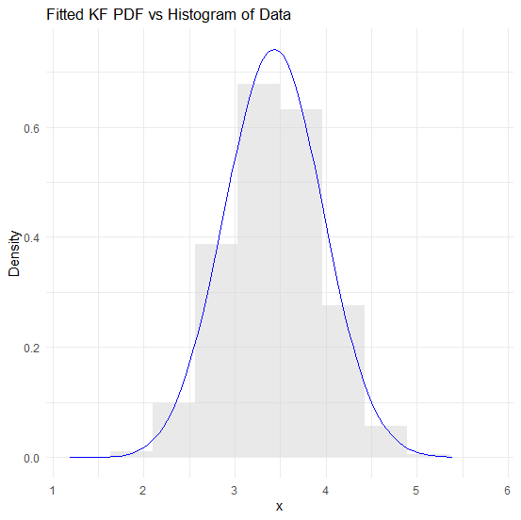
Figure 1. Fitted PDF of KF Distribution against Histogram of Actual Data for Simulated Data of n=5000
The result presented in Figure 1 compares the fitted KF probability density function (PDF) with the histogram of the simulated data at n=5000. The KF model closely follows the data distribution, indicating a good fit, though minor deviations exist in the tails.

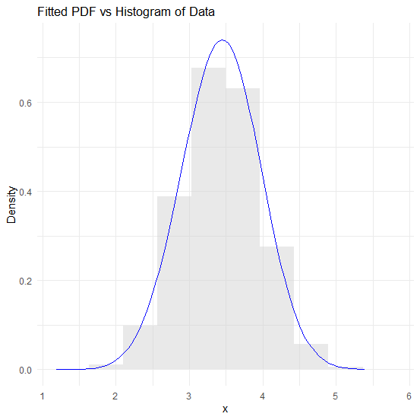
Figure 2. Fitted PDF of EF Distribution against Histogram of Actual Data for Simulated Data of n=5000
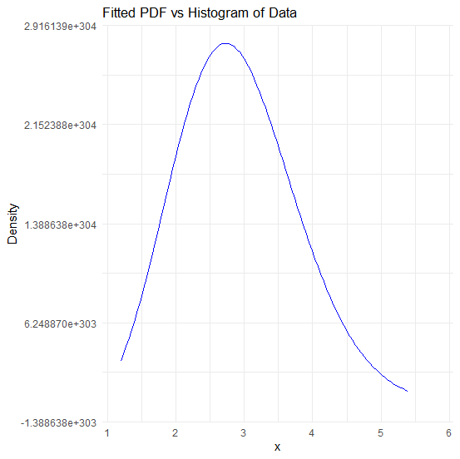
Figure 3. Fitted PDF of BF Distribution against Histogram of Actual Data for Simulated Data of n=5000

The result in Figure 2 shows the fitted probability density function (PDF) of the EF distribution closely follows the histogram of the simulated data (n=5000), indicating a strong fit. The EF model captures the central tendency and spreads well, though slight deviations in the tails suggest minor fitting discrepancies. Also, the result in Figure 3 shows that the fitted PDF of the BF distribution exhibits an extreme scale issue, as indicated by the unusually large density values. The mismatch between the fitted curve and the histogram suggests poor parameter estimation, as indicated by the study findings.

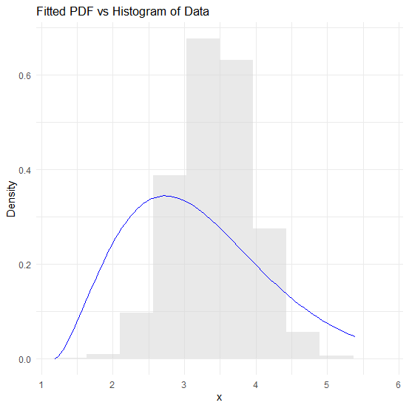
Figure 4. Fitted PDF of F Distribution against Histogram of Actual Data for Simulated Data of n=5000
The fitted PDF of the F distribution in Figure 4 closely follows the shape of the histogram, suggesting a reasonable fit to the simulated data. However, slight deviations, particularly in the peak and tail areas, indicate potential parameter estimation issues or data characteristics that might not fully align with the assumed distribution.
The fitted PDF of the KF distribution in Figure 5 aligns moderately with the histogram of the real-life log_NGCFC data, capturing its general shape. However, discrepancies in peak height and the spread suggest potential misspecifications or data irregularities. Further refinement in parameter estimation or alternative distributions may improve model fit and accuracy. The fitted EF distribution PDF in Figure 6 captures the general trend of the log_NGCFC data histogram but shows deviations in density at certain intervals. The peak alignment suggests a reasonable fit, though discrepancies in tail behaviour indicate potential model limitations. The fitted BF distribution PDF in Figure 7 shows a significant discrepancy with the histogram, particularly in the density scale, suggesting potential model misspecification. The extreme density values indicate parameter estimation issues. The fitted F distribution PDF in Figure 8 exhibits a steep decline, failing to align with the histogram of actual log_NGCFCF data. This mismatch suggests poor model fit, as the empirical distribution appears more spread out.

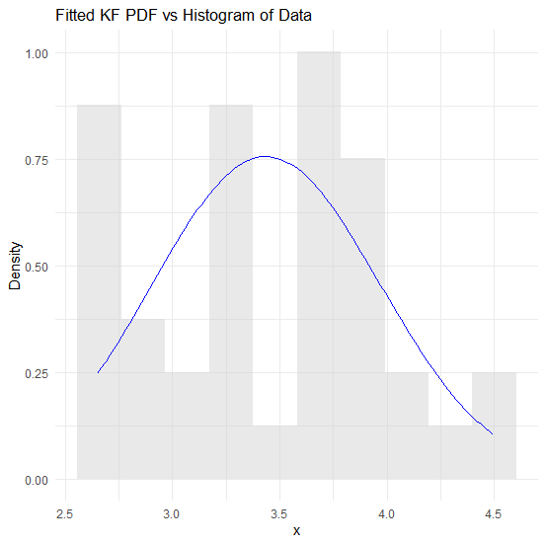
Figure 5. Fitted PDF of KF Distribution against Histogram of Actual Data for Real Life data log_NGCFC
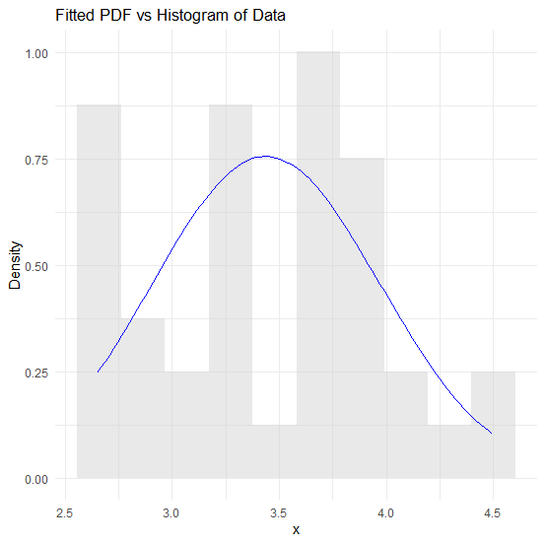
Figure 6. Fitted PDF of EF Distribution against Histogram of Actual Data for Real Life data log_NGCFC
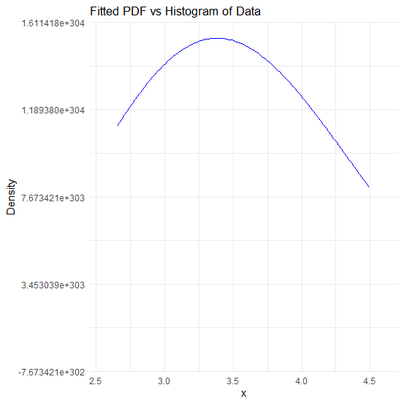

Figure 7. Fitted PDF of BF Distribution against Histogram of Actual Data for Real Life data log_NGCFC

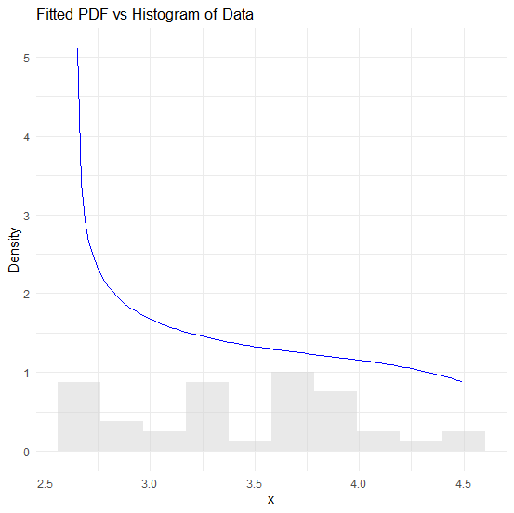
Figure 8. Fitted PDF of F Distribution against Histogram of Actual Data for Real Life data log_NGCFCF
- Conclusion
The findings of this study underscore the importance of selecting appropriate statistical models for analyzing Nigeria's Gross Fixed Capital Formation (NGFCF). Through an examination of distributional properties using Fréchet-based models, the Exponentiated Fréchet (EF) distribution emerged as the most suitable model based on multiple statistical criteria, including the Akaike Information Criterion (AIC), Bayesian Information Criterion (BIC), and Likelihood Ratio Test (LRT). The log transformation of NGFCF significantly improved normality, reducing skewness and stabilizing variance, which enhanced the reliability of parametric analysis. The EF model's superior performance, particularly in capturing the heavy-tailed nature of NGFCF data, provides a valuable tool for economic forecasting, investment decision-making, and risk assessment in Nigeria's economic landscape. Furthermore, the simulation framework using varying sample sizes demonstrated the robustness of the statistical approach, reinforcing the applicability of Fréchet-based distributions in economic modelling, especially in contexts influenced by macroeconomic volatility and policy shifts.
The study contributes to the growing body of literature on statistical modelling in macroeconomic analysis by demonstrating how extreme value theory and advanced probability distributions can enhance empirical research on investment trends. The insights from this research have practical implications for policymakers, financial analysts, and economists seeking to understand the determinants of capital formation and its broader impact on economic growth. Given the observed deviations in certain models, future research could explore alternative distributions with more flexible shape parameters to refine model selection. Additionally, integrating macroeconomic covariates such as inflation rates, interest rates, and government expenditure could provide a better understanding of NGFCF dynamics. As Nigeria continues to navigate economic fluctuations, the application of advanced statistical methodologies, such as those presented in this study, will be crucial in shaping data-driven policies that foster sustainable economic growth.

COMPETING INTERESTS DISCLAIMER:
Authors have declared that they have no known competing financial interests OR non-financial interests OR personal relationships that could have appeared to influence the work reported in this paper.
References
Abanikanda, E.O. and Dada, J.T. (2024), "External shocks and macroeconomic volatility in Nigeria: does financial development moderate the effect?. PSU Research Review, 8(3): 828-844. https://doi.org/10.1108/PRR-07-2022-0094
Akaike, H. (1974). A new look at the statistical model identification. IEEE Transactions on Automatic Control, 19(6): 716–723. https://doi.org/10.1109/TAC.1974.1100705
Akalagboro, I. O., Aronu, C. O., Mark, L. S. (2025). Comparative Analysis of Fréchet Distribution Variants: Parameter Estimation and Model Performance Evaluation. African Journal of Mathematics and Statistics Studies 8(1), 77-83. DOI: 10.52589/AJMSS-L3LZF5LA
Al-Sobhi, M. M. (2022). The extended Weibull distribution with its properties, estimation, and modeling skewed data. Journal of King Saud University - Science, 34(2), Article 101837.
Alyami, S. A., Elgarhy, M., Elbatal, I., Almetwally, E. M., Alotaibi, N., & El-Saeed, A. R. (2022). Fréchet Binomial Distribution: Statistical properties, acceptance sampling plan, statistical inference, and applications to lifetime data. Axioms, 11(8), Article 287.
Aslam, M., Yousaf, R., & Ali, S. (2021). Two-component mixture of transmuted Fréchet distribution: Bayesian estimation and application in reliability. Proceedings of the National Academy of Sciences India Section A - Physical Sciences, 91(2), 309–336. https://doi.org/10.1007/s40010-020-00722-8
Casella, G. and Berger, R.L. (2002) Statistical Inference. 2nd Edition, Duxbury Press, Pacific Grove.
Castillo, E., Hadi, A.S., Balakrishnan, N. and Sarabia, J.M. (2005). Extreme Value and Related Models with Applications in Engineering and Science. Wiley, New York.
Davidson, R. and MacKinnon, J.G. (2004) Econometric Theory and Methods. Oxford University Press, New York.
Greene, W. H. (2012). Econometric analysis (7th ed.). Pearson Education.
Hamed, M. S., Aldossary, F., & Afif, A. Z. (2020). The four-parameter Fréchet distribution: Properties and applications. Pakistan Journal of Statistics and Operation Research, 16(2), 249–264. https://doi.org/10.18187/pjsor.v16i2.2748
Henningsen, A. and Toomet, O. (2011.) Maxlik: A Package for Maximum Likelihood Estimation in R. Computational Statistics, 26, 443-458.
Hosking, J.R.M. and Wallis, J.R. (1987). Parameter and Quantile Estimation for the Generalized Pareto Distribution. Technometrics, 29, 339-349. https://doi.org/10.1080/00401706.1987.10488243
Ibrahim, T. R., Akinbobola, T. O., Odusanya, I. A. (2023). Macroeconomic Determinants of Capital Inflows Volatilities in Nigeria. LWATI: A Journal of Contemporary Research, 20 (2): 14-34.
Nadarajah, S. and Gupta, A.K. (2004) The β Fréchet Distribution. Far East Journal of Theoretical Statistics, 14, 15-24.
Ocloo, S. K., Brew, L., Nasiru, S., & Odoi, B. (2022). Harmonic Mixture Fréchet Distribution: Properties and Applications to Lifetime Data. International Journal of Mathematics and Mathematical Sciences, 2022. https://doi.org/10.1155/2022/6460362
Omekam, N. A., Ukaegbu, M. O., & Nnaji, G. N. (2022). A mixture model of Weibull and Fréchet distributions with applications to reliability data. Journal of Statistics and Management Systems, 25(4), 823–838. https://doi.org/10.1080/09720510.2022.2022093
Onwuemeka, I. O., Nwogwugwu, U. C. and Onwuka, E. (2022). Impact of Infrastructure Investment on Economic Growth in Nigeria: An Autoregressive Distributed Lag Approach. International Journal of Research and Innovation in Social Science (IJRISS), 6(1): 288-298
Otolorin, G. and Oniwoduokit, E. (2021). Capital Formation and Economic Growth in Nigeria: An empirical re-examination. CBN Bullion, 45(2): 58 – 72.
Phaphan, P., Sukjaroen, C., & Chankamnerd, N. (2023). Mixture models with Fréchet distribution: Innovations and applications to skewed survival data. Journal of Statistical Computation and Simulation, 93(4), 623–640.
R Core Team. (2023). R: A language and environment for statistical computing. R Foundation for Statistical Computing. https://www.R-project.org/
Schwarz, G. (1978) Estimating the Dimension of a Model. Annals of Statistics, 6(2): 461-464.
Shapiro, S.S. and Wilk, M.B. (1965) An Analysis of Variance Test for Normality (Complete Samples). Biometrika, 52, 591-611. https://doi.org/10.1093/biomet/52.3-4.591
Ugwuegbe, S.U., Uruakpa, P. C. (2013). The Impact of Capital Formation on the Growth of Nigerian Economy. Research Journal of Finance and Accounting, 4(9): 36-42.
Wilks, S.S. (1938) The Large Distribution of the Likelihood Ratio for Testing Composite Hypotheses. Annals of Mathematical Statistics, 9, 60-62.http://dx.doi.org/10.1214/aoms/1177732360

